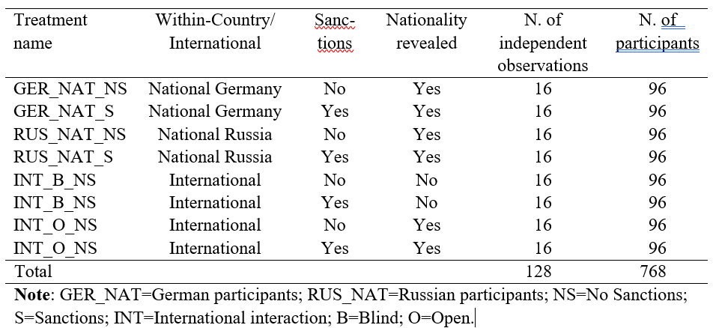
Table 1 | Summary of Experimental Design

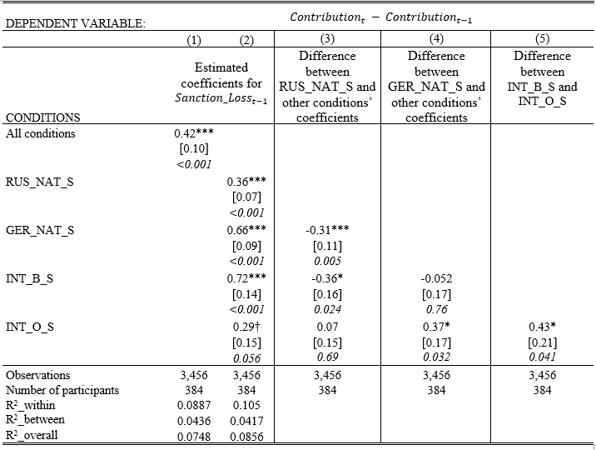
Table 2 | Econometric analysis of the impact of sanctions on cooperation.

