Table S1. Difference of estimated and measured 24-hour urine sodium excretion grouped by median measured 24-hour urine sodium excretion
Equation | Low sodium excretion group |  |  |  |  | High sodium excretion group
Equation | Mean of measured= 2632.53 ± 758.53 mg/24h |  |  |  |  | Mean of measured = 5498.03 ± 1637.38 mg/24h
Equation | Mean ± SD | Bias | r | P-value* |  | Mean ± SD | Bias | r | P-value*
Linear | 3720.66 ± 702.43 | -1088.13 ± 844.09 | 0.334 | ＜0.001 |  | 4323.70 ± 986.65 | 1174.33 ± 1621.33 | 0.317 | ＜0.001
Power-law | 3697.63 ± 810.98 | -1065.10 ± 867.51 | 0.391 | ＜0.001 |  | 4332.20 ± 898.93 | 1165.83 ± 1625.66 | 0.287 | ＜0.001
SMASH | 3645.40 ± 818.32 | -1012.87 ± 869.97 | 0.392 | ＜0.001 |  | 4367.31 ± 979.94 | 1130.72 ± 1579.12 | 0.361 | ＜0.001
Kawasaki | 4528.58 ± 1342.69 | -1896.05 ± 1270.25 | 0.375 | ＜0.001 |  | 5675.65 ± 1596.96 | -177.62 ± 1908.80 | 0.304 | 0.101
Tanaka | 3531.13 ± 817.00 | -898.60 ± 873.86 | 0.387 | ＜0.001 |  | 4186.82 ± 912.12 | 1311.20 ± 1616.57 | 0.341 | ＜0.001
INTERSALT | 3762.80 ± 833.73 | -1130.28 ± 990.36 | 0.229 | ＜0.001 |  | 4360.44 ± 950.06 | 1137.59 ± 1587.95 | 0.301 | ＜0.001
*P-value means paired t test for the estimated 24-HUNa and the measured 24-HUNa values
Bias is the difference between t the estimated 24-HUNa and the measured 24-HUNa values, expressed as mean ± standard deviation

Table S2. Difference of estimated and measured 24-hour urine sodium excretion grouped by hypertension
Equation | Non-hypertension group |  |  |  |  | Hypertension group
Equation | Mean of measured= 3985.3 ± 1807.86 mg/24h |  |  |  |  | Mean of measured = 4226.39 ± 2120.16 mg/24h
Equation | Mean ± SD | Bias | r | P-value* |  | Mean ± SD | Bias | r | P-value*
Linear | 4011.85 ± 878.14 | -26.54 ± 1574.02 | 0.492 | 0.731 |  | 4043.00 ± 965.44 | 183.39 ± 1971.74 | 0.376 | 0.182
Power-law | 4015.16 ± 879.35 | -29.86 ± 1565.31 | 0.501 | 0.697 |  | 4014.42 ± 977.89 | 211.97 ± 1976.80 | 0.372 | 0.124
SMASH | 3990.77 ± 942.92 | -5.46 ± 1516.80 | 0.545 | 0.941 |  | 4048.46 ± 1024.94 | 177.93 ± 1913.85 | 0.433 | 0.183
Kawasaki | 5092.39 ± 1524.87 | -1107.09 ± 1666.26 | 0.511 | ＜0.001 |  | 5121.71 ± 1694.74 | -895.32 ± 2129.79 | 0.394 | ＜0.001
Tanaka | 3850.77 ± 888.55 | 134.54 ± 1551.62 | 0.514 | 0.0773 |  | 3875.52 ± 997.26 | 350.87 ± 1975.58 | 0.375 | 0.0113
INTERSALT | 3993.46 ± 886.49 | -8.15 ± 1636.27 | 0.430 | 0.919 |  | 4198.95 ± 1033.06 | 27.44 ± 1942.89 | 0.408 | 0.839
*P-value means paired t test for the estimated 24-HUNa and the measured 24-HUNa values
Bias is the difference between t the estimated 24-HUNa and the measured 24-HUNa values, expressed as mean ± standard deviation

Table S3. Difference of 24-hour urine sodium excretion estimated by SMASH equation and measured 24-hour urine sodium excretion grouped by age
Age group | N | Mean ± SD | Bias | r | P-value*
(60,70] | 121 | 3857.24 ± 933.98 | 270.09 ± 1629.33 | 0.508 | 0.071
(50,60] | 159 | 3931.60 ± 958.04 | -155.62 ± 1387.9 | 0.601 | 0.159
(40,50] | 143 | 4136.23 ± 1001.89 | 166.54 ± 2035.68 | 0.441 | 0.330
(30,40] | 118 | 4115.55 ± 1015.07 | 35.00 ± 1657.7 | 0.471 | 0.819
[20,30] | 73 | 4023.71 ± 971.83 | 9.14 ± 1407.99 | 0.520 | 0.956
*P-value means paired t test for the estimated 24-HUNa and the measured 24-HUNa values
Bias is the difference between t the estimated 24-HUNa and the measured 24-HUNa values, expressed as mean ± standard deviation

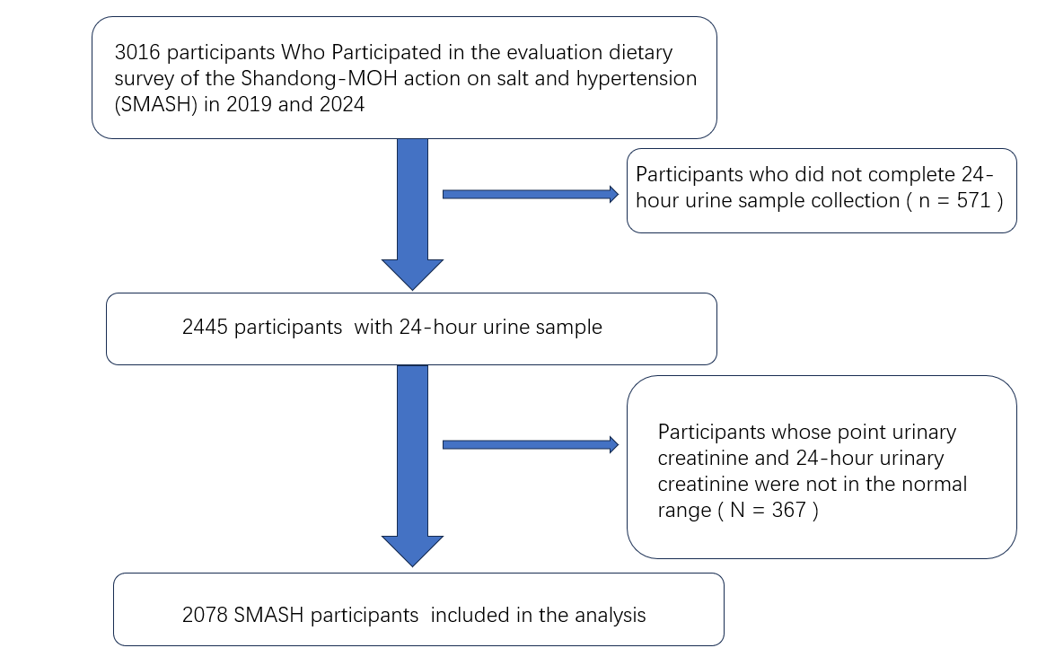
Figure S1. Inclusion exclusion criteria

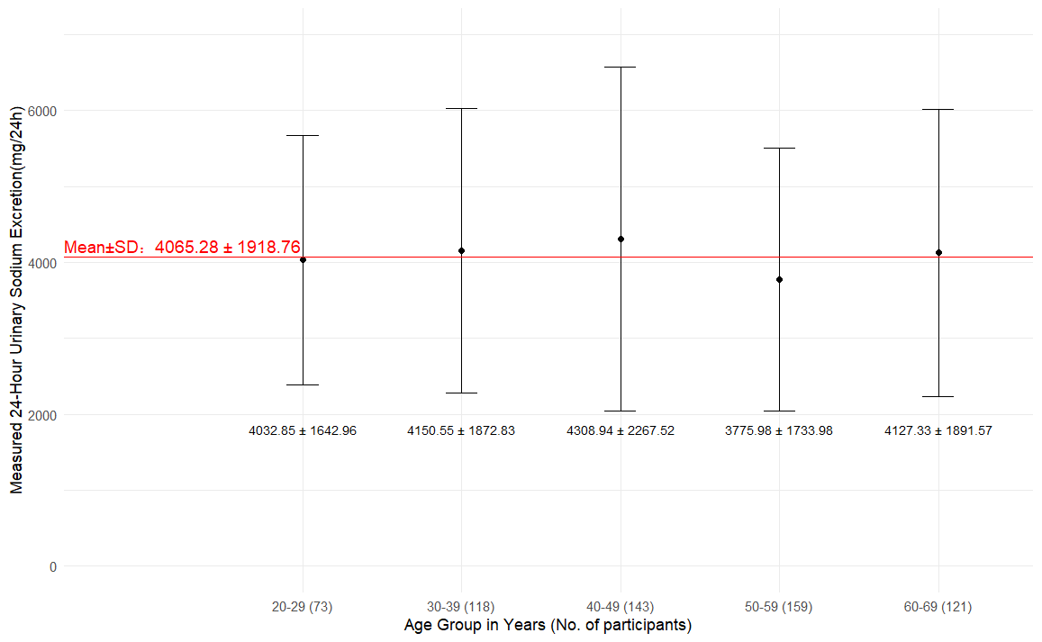
Figure S2. Measured 24-hour urine sodium excretion grouped by 10-Years age

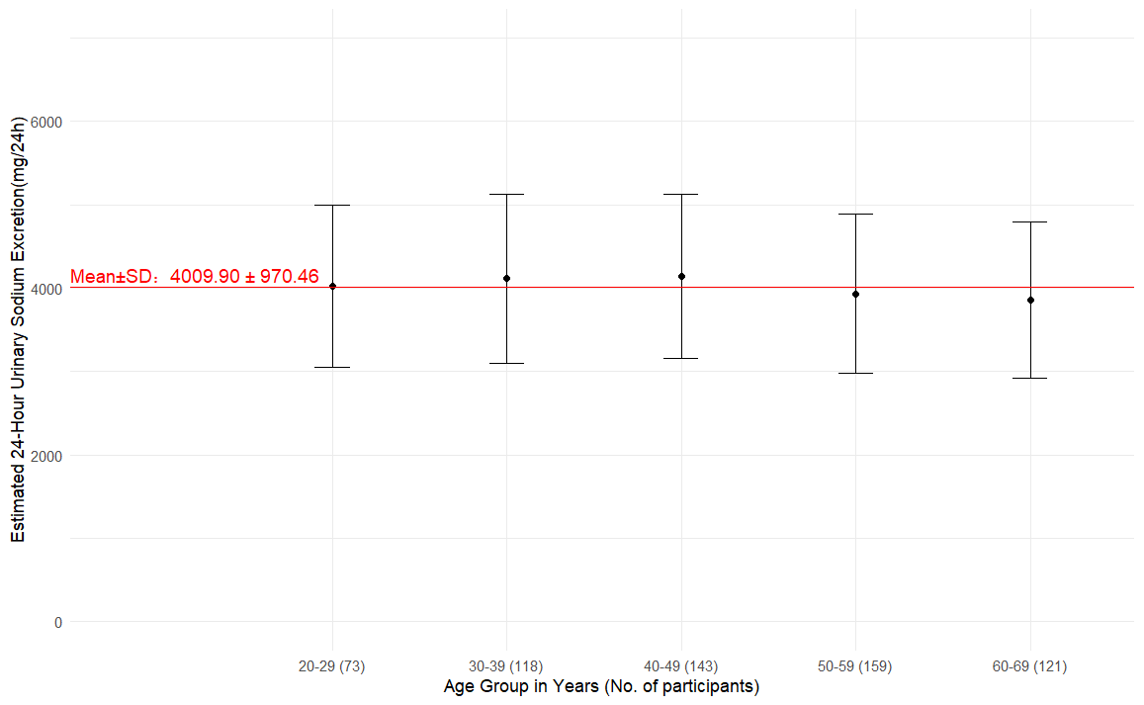
Figure S3. Estimated 24-hour urine sodium excretion by SMASH equation grouped by 10-Years age

