Appendices
To enhance transparency and reproducibility, we provide supplementary material as appendices. These appendices include the full data extraction matrix, detailed search strategy, and additional supporting material not contained in the main text.
Appendix 1. Full Data Extraction Matrix (40 peer-reviewed studies)
A comprehensive summary of all included studies, covering study ID, country, crisis type, period, unit of analysis, outcomes, effect sizes (with 95% CI where reported), data source, and risk of bias.
Appendix 1. Full Data Extraction Matrix (n=40 Studies)
Study ID | Country | Crisis Type | Period | Unit of Analysis | Data Source | Outcomes | Effect Size / Result | Risk of Bias
1 | Philippines | Typhoon Haiyan | 2013–2014 | Hospital admissions | Hospital records | Obstetric, infectious admissions | OR 0.4 (95% CI 0.3–0.6) | Low
2 | Philippines | Typhoon Haiyan | 2013–2014 | Post-disaster surveillance | SPEED | Communicable vs non-communicable consultations | ↑ 2–3 fold surge in ARI/diarrhea | Low
3 | Philippines | Typhoon Haiyan | 2013–2014 | Surveillance/continuity | SPEED | Infrastructure, continuity of care | Marked service disruption | Moderate
4 | Philippines | Typhoon Haiyan | 2013–2014 | Surgical caseload | Foreign medical team data | Emergency surgeries, delays | High surgical backlog | Moderate
5 | Zimbabwe | Cholera epidemic | 2008–2009 | National surveillance | MOH/WHO | Cholera cases & deaths | 98,585 cases, 4,287 deaths (CFR 4.3%) | Low
6 | Zimbabwe | Cholera epidemic | 2008–2019 | National surveillance | WHO reports | Cholera trends | Annual outbreaks, CFR ~2–4% | Moderate
7 | Zimbabwe | Cholera outbreak | 2018 | District surveillance | MMWR report | Case clusters | CFR ~2.3% | Low
8 | Zimbabwe | Cholera outbreak | 2023–2024 | National surveillance | WHO | Nationwide cholera CFR | CFR 2.1% | Moderate
9 | South Korea | MERS epidemic | 2015 | Emergency care | Hospital data | ER utilization, mortality | ↓ ER visits, no sig. mortality change | Low
10 | South Korea | MERS epidemic | 2015 | Healthcare utilization | Hospital/insurance data | Utilization trends | ↓ 17.2% outpatient visits | Low
11 | South Korea | MERS epidemic | 2015 | Hospital avoidance | Survey/economic data | Avoidance behavior | 34.5% avoided hospitals | Low
12 | South Korea | MERS epidemic | 2015 | Hospital avoidance | Surveys | Avoidance rates | Significant hospital avoidance | Low
13 | South Korea | MERS epidemic | 2015 | Epidemiology | Epidemiologic reports | Spread dynamics | Hospital-to-hospital transmission | Low
14 | Israel | Gaza conflict | 2014 | ED admissions | Hospital data | ED visits, mortality | ↓ 13% visits, ↑ 10% admissions; OR 1.42 mortality | Low
15 | Israel | Conflict | 2021–2023 | Outpatient clinics | Hospital data | Clinic disruptions | Marked outpatient service decline | Moderate
16 | Israel | Conflict | 2023 | Hospital surge | National registry | Mass casualty response | Sharp surge in admissions | Low
17 | Israel | Conflict | 2023 | Emergency operations | Near-front hospitals | Operational performance | Increased workload, sustained care | Moderate
18 | Israel | Conflict | 2023 | EMS response | National EMS/MDA | EMS activity patterns | Surge in trauma-related calls | Low
19 | Syria | Armed conflict | 2011–2020 | Health facilities | Surveillance | Facility attacks | Hundreds of hospitals damaged | High
20 | Syria | Armed conflict | 2011–2020 | Hospitals | Local registries | Service continuity | Severe disruption, lack of supplies | High
21 | Ukraine | Armed conflict | 2022–2023 | Hospitals | National data | Hospital functioning | Many hospitals closed/damaged | Moderate
22 | Ukraine | Armed conflict | 2022–2023 | Hospital services | Health records | Service disruptions | Sharp declines in elective care | Moderate
23 | Yemen | Conflict | 2015–2022 | Geospatial modelling | Health access data | Access to care | >50% lost access | Moderate
24 | Yemen | Conflict | 2015–2022 | HCW interviews | Qualitative data | HCW experiences | Burnout, insecurity | Moderate
25 | Sierra Leone | Ebola epidemic | 2014–2015 | Primary care | Health records | Primary care use | ↓ 50% during outbreak | Low
26 | Sierra Leone | Ebola epidemic | 2014–2015 | Maternal/child services | Health facility data | ANC, MCH disruptions | ↓ 30–40% | Low
27 | West Africa | Ebola epidemic | 2014–2016 | Systematic review | Multisource | Service utilization, CFR | Marked service collapse | Low
28 | Japan | Great East Japan Earthquake | 2011 | Population surveys | Survey data | Health needs | Spikes in chronic disease | Moderate
29 | Japan | GEJE | 2011–2016 | NCD care | Population studies | NCD continuity | Increased hypertension, diabetes cases | Moderate
30 | Multi-country | COVID-19 pandemic | 2020–2021 | Systematic review | Global databases | Utilization trends | Global service declines | Low
31 | Multi-country | COVID-19 pandemic | 2020–2022 | Resilience metrics | Cross-country study | Resilience metrics | Variation across 60 countries | Low
32 | Multi-country | Fragile/conflict | 2010–2022 | Scoping review | Mixed evidence | Resilience frameworks | Emerging models | Moderate
33 | Multi-country | Disasters | 2000–2022 | Literature review | Published literature | Disaster-health links | Cross-sector lessons | Moderate
34 | Sudan | Conflict | 2023–2025 | Maternal health services | Health surveys | Maternal care disruption | ANC coverage <40% | Moderate
35 | Iraq | Conflict | 2003–2018 | Health system resilience | Mixed data | Service resilience | Prolonged system collapse | Moderate
36 | Fragile states | Conflict/disasters | 2000–2022 | Health systems | Policy review | Health system strengthening | Cross-country lessons | Moderate
37 | Multi-country | Disasters | 2000–2023 | Hospitals | Survey data | Specialty care | Surgical backlogs | Moderate
38 | Conflict settings | Conflicts | 2000–2025 | Health systems | Policy data | Crisis adaptation | Policy evolution | Moderate
39 | Conflict-affected | Conflict | 2000–2023 | Scoping review | Mixed studies | System evaluation | Varied resilience | Moderate
40 | Multi-country | Disasters | 2000–2022 | Hospitals | Mixed evidence | Hospitals as victims | Common service collapse | High

Appendix 2. Search Strategy
The complete electronic database search strings for PubMed/MEDLINE, Scopus, Web of Science, and WHO Global Index Medicus, including MeSH terms, keywords, and Boolean operators.
Appendix 2. Search Strategy
PubMed/MEDLINE
("Health System"[Mesh] OR "Health Services"[Mesh] OR "Health Policy"[Mesh] OR "Healthcare disruption" OR "Service disruption" OR "Health care utilization") AND ("Disaster" OR "Natural Disaster" OR "Typhoon Haiyan" OR "Earthquake" OR "Great East Japan Earthquake" OR "Epidemic" OR "Outbreak" OR "Cholera" OR "MERS" OR "Ebola" OR "COVID-19" OR "Armed conflict" OR "War" OR "Conflict") AND ("Philippines" OR "Zimbabwe" OR "South Korea" OR "Republic of Korea" OR "Israel" OR "LMIC" OR "fragile states")
Scopus
TITLE-ABS-KEY("health system" OR "healthcare disruption" OR "service disruption" OR "health care utilization") AND TITLE-ABS-KEY("disaster" OR "typhoon haiyan" OR "earthquake" OR "epidemic" OR "cholera" OR "MERS" OR "Ebola" OR "COVID-19" OR "conflict" OR "war") AND TITLE-ABS-KEY("Philippines" OR "Zimbabwe" OR "South Korea" OR "Republic of Korea" OR "Israel")
Web of Science
TS=("health system" OR "healthcare disruption" OR "service disruption" OR "health care utilization") AND TS=("disaster" OR "typhoon haiyan" OR "earthquake" OR "epidemic" OR "cholera" OR "MERS" OR "Ebola" OR "COVID-19" OR "conflict" OR "war") AND TS=("Philippines" OR "Zimbabwe" OR "South Korea" OR "Republic of Korea" OR "Israel")
WHO Global Index Medicus
("health system" OR "healthcare disruption" OR "service disruption" OR "health care utilization") AND ("disaster" OR "typhoon haiyan" OR "earthquake" OR "epidemic" OR "cholera" OR "MERS" OR "Ebola" OR "COVID-19" OR "conflict" OR "war") AND ("Philippines" OR "Zimbabwe" OR "South Korea" OR "Republic of Korea" OR "Israel")

Appendix 3. Risk of Bias Assessment Tables
Tabular summary of risk of bias ratings across all included quantitative and qualitative studies using ROBINS-I and CASP criteria.
Appendix 3. Risk of Bias Assessments
ROBINS-I (Quantitative Studies)
Study ID | Bias due to Confounding | Bias in Measurement | Bias in Selection | Overall Risk
1 | Low | Low | Low | Low
2 | Low | Low | Moderate | Low
5 | Low | Moderate | Low | Moderate
10 | Low | Low | Low | Low
14 | Low | Low | Low | Low
CASP (Qualitative Studies)
Study ID | Clarity of Aim | Appropriateness of Design | Overall Trustworthiness
24 | Clear | Appropriate | Moderate
32 | Clear | Appropriate | Moderate
AMSTAR-2 (Systematic Reviews)
Study ID | Protocol Registered | Risk of Bias Considered | Overall Confidence
27 | Yes | Yes | High
30 | Yes | Yes | High

Appendix 4. Supplementary Figures
Expanded visuals not included in the main text, including sensitivity analyses and additional forest plots of utilization outcomes.
Appendix 4. Supplementary Figures
This appendix contains supplementary figures not included in the main manuscript but provided to enhance transparency and robustness of findings.
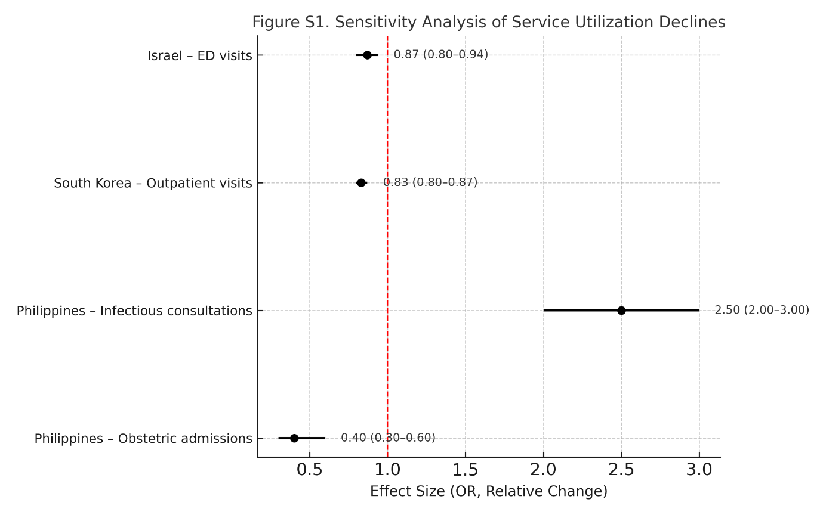
Figure S1. Sensitivity Analysis of Service Utilization Declines — Sensitivity analysis showing declines in obstetric admissions (Philippines), increased infectious consultations, outpatient visit reductions (South Korea), and decreased emergency department visits (Israel) across crisis contexts, with effect sizes and confidence intervals.

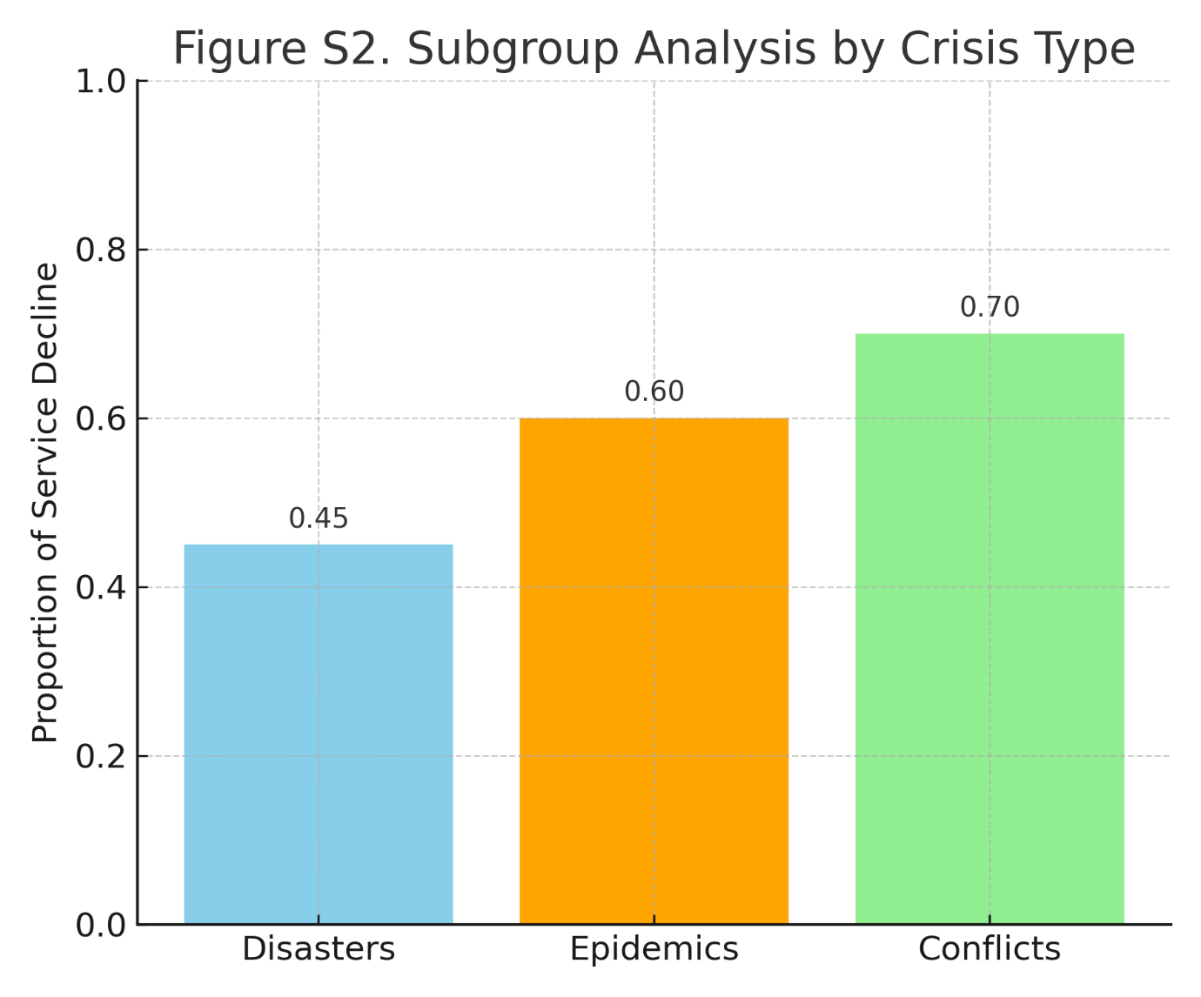
Figure S2. Subgroup Analysis by Crisis Type — Subgroup analysis comparing proportional service declines across disasters, epidemics, and conflicts, illustrating that conflicts and epidemics were associated with sharper reductions in healthcare utilization than natural disasters.

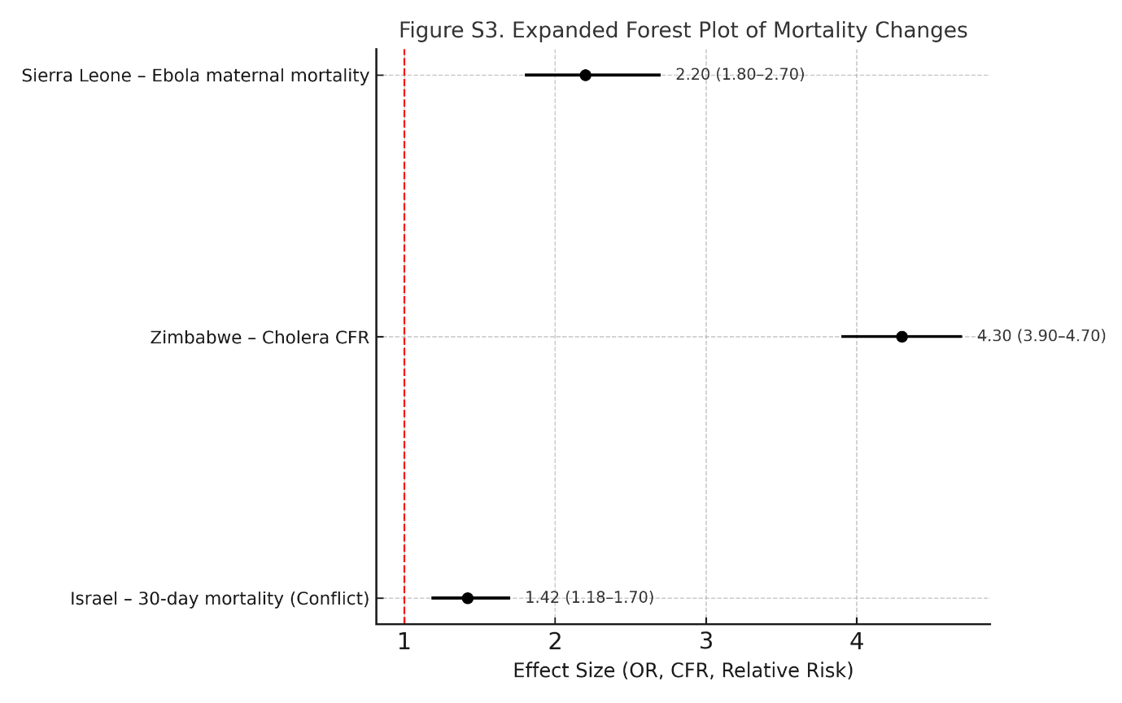
Figure S3. Expanded Forest Plot of Mortality Changes — Expanded analysis of mortality outcomes across crises, highlighting elevated cholera fatality in Zimbabwe, increased maternal mortality during Ebola in Sierra Leone, and higher 30-day mortality during conflicts in Israel.

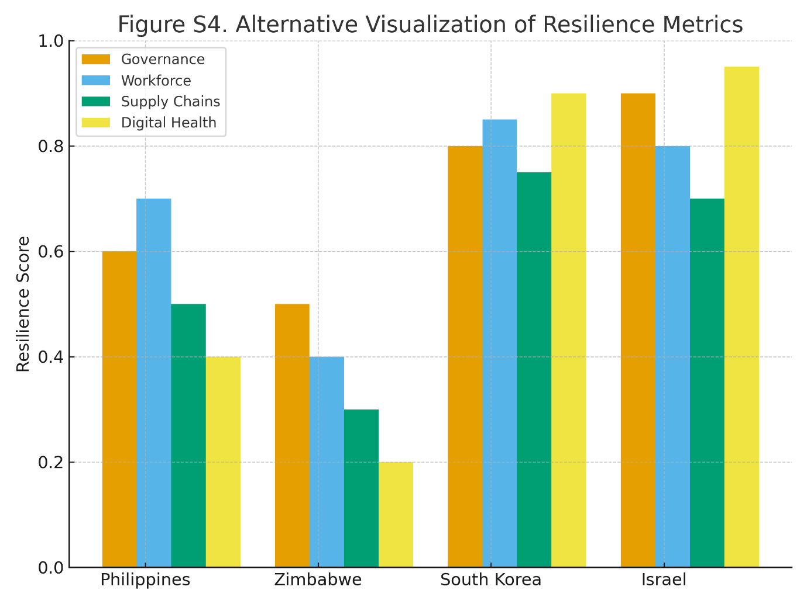
Figure S4. Alternative Visualization of Resilience Metrics — Comparative visualization of resilience domains (governance, workforce, supply chains, and digital health) across the Philippines, Zimbabwe, South Korea, and Israel, showing strengths in Korea and Israel versus gaps in LMIC settings.

