Supplementary Materials

Title: Linking Multi-Night Sleep Heart Rate to Vigilance: Insights from Antarctic Field Research
Authors: Lucie Ráčková^{1*}, Marek Brabec², Michael Klinka³, Miroslav Králík⁴, Milan Brázdil¹, and Julie Dobrovolná⁵
¹ 1st Department of Neurology, St. Anne´s University Hospital and Faculty of Medicine, Masaryk University, Brno, Czech Republic.
² Institute of Computer Science, Department of Statistical Modeling, Czech Academy of Sciences, Prague, 182 00, Czechia
³ CERIT-CS, Institute of Computer Science, Masaryk University, Brno, 602 00, Czechia
⁴ Department of Anthropology, Faculty of Science, Masaryk University, Brno, 602 00, Czechia
⁵ Incubator of Kinanthropology Research, Faculty of Sports, Masaryk University, Brno, 602 00, Czechia

*lucie.rackova@med.muni.cz

S1 Instructions for participants
Introduction
In this document you’ll find key information for the beginning of the study. Its composed from some of our colleagues’ suggestions and my experience – I’ll be measuring myself aswell using the methods I have prepared for you.
I know that for some the watches are uncomfortable, but I hope we all get used to them. If any problems occur, or if you have any suggestions, please let me know. I will do as much as I can to make the measurement fine and inobtrusive.
HOW TO WEAR THE WATCHES
The data are well only if you wear the watches well. The heart rate is measured using an optical sensor which detects a minimal change in blood flow on the wrist. To get the best estimate of your heart rate and its variability, you need to do this:
- The watches must be in close contact with the skin. There must not be a gap and they must not slide on the hand.
- The watches must not strangle your hand, they must be comfortable.
- The correct tightening can be checked as follows: the movement of the watches corresponds with the movement of the skin. The optical sensor is still on its place even if the hand moves.
- During the day, adjust the stap as needed.
  - We might be able to get a textile straps instead of the silicone ones, but it can not be guaranteed
- While showering, please clean your wrist properly. Ideally clean the watches using the water.
  - Creams etc. can be cleaned using alcohol based cleaning solution (for this purpose I bring 70% IPA on the expedition).
More here: Accuracy | Garmin, Forerunner 55 - Tips for Erratic Heart Rate Data (garmin.com)

PREPARE WATCHES BEFORE MEASURING
Step 1: Turn on heart rate variability storage
1. Hold down the UP button
2. Press the UP button once (or press DOWN 11 times) to move to System
3. Press the START button to select System
4. Select Data recording (Press 5x UP and confirm with START)
5. Switch on Log HRV (Press 1x DOWN and confirm with START).
Step 2: Add your yoga activity
Yoga activity is not in the preset activity selection, it must be added manually. Because it does not use GPS data, it is ideal in terms of battery life. It's easier than programming a special sleep activity.
1. Press the START button
2. Press the UP button once and the Add option will appear
3. Confirm with START
4. Press the DOWN button 4 times for Yoga activity
5. Press the START button and confirm the activity selection to favorites (START button again)
6. Use the UP button to place the Yoga activity position at the top of the list so that it is conveniently accessible
7. Confirm the position with START
Forerunner 55 - Adding an Activity (garmin.com)
Step 3: Turn off the watch light while moving
To prevent the watch from waking you up at night, turn it off.
1. Hold down the UP button
2. Press the UP button once to move to System
3. Press the START button to select System
4. Press the DOWN button twice and select Backlight (START button)
5. Select During Activity with the START button
6. Press the DOWN button twice and select Gesture
7. Press the UP button once and select Off
a. Alternatively, 1x DOWN and select After Sunset, to use the watch during the day good, but I do not know how it will work in Antarctica. If you choose this option, we may need to reset it at the airport.
Forerunner 45/45 Plus - Changing the Backlight Settings (garmin.com)
Step 4: take a card with your bed and a note in your alarm clock on your mobile phone!
The cards you received with the watch are used to remind you how to measure. Try use them in a way that suits you best. Below are my suggestions on how to use them so that you have the least chance of forgetting to measure:
• When you wake up, put the card on the pillow, when you go to bed you will find it there and it will remind you to turn it on.
• Before going to bed, place the card next to the alarm clock / phone so that it is the first thing you look at in the morning.
For those of you who use a cell phone to wake up, you can write in your alarm clock note that you have to mark waking up on your watch (by turning off the yoga activity).
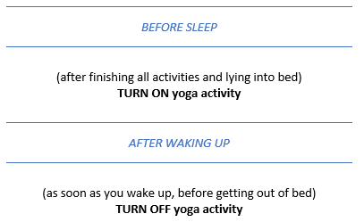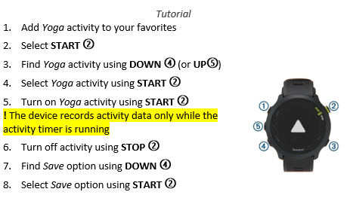
Step 5: Customize your watch to your liking!
If you are bothered by the look of the dial, are interested in other functions, or just enjoy the watch and want to make the most of it before you leave, take a look at the operating instructions, it contains all the important information: Forerunner 55 - Forerunner 55 (garmin.com)
CHARGING THE WATCH
Charge the watch as needed, it can be connected to a computer or adapter. In a classic 230V Czech socket and connected to a computer, they are from 0% to 100% charged in about 90 minutes.

S2 Potential Covariates for Heart Rate
Potential covariates are listed, following guidelines by Nelson et al. (2020).
Technical factors
Device manufacturer: Garmin
Device type: Forerunner 55
Device version: version 4.11 [DFU-5beea5] or 3.03 [DFU-5beea5]
Firmware version: No changes in software
Hardware (sensor type): Elevate V3 optical sensor
Sampling rate: 1Hz
Device reliability and justification for why this level of reliability is adequate for the study design: Previous studies have shown that devices using the Garmin Elevate V3 sensor (specifically Forerunner 235 (Gillnov et al., 2017; Støve et al., 2019); and Vivosmart HR+(Tedesco et al., 2019)) demonstrate acceptable agreement with electrocardiogram (ECG) readings at rest (r=.88) (Gillinov et al., 2020) and with the Polar RS400 chest strap (r=.99)( Støve et al., 2019). The reliability of heart rate measurements from the Garmin Vivosmart HR+ has also been reported as ranging from moderate to excellent for walking tests and daily household activities (Tedesco et al., 2019).

Participant Characteristics
Age:
Table S1: Descriptive statistics of age in the whole sample, men or Women only, and first timers or experienced expeditioners.
Variable | Variable categorical | Category | N | Nmiss | Mean | SD | SE | Median | MAD | Min | Max | Skewness | Kurtosis
Age |  |  | 16 | 1 | 35.406 | 10.5057 | 2.7126 | 33.083 | 10.502 | 24.16667 | 57.66667 | 0.8141 | 2.4724
Age | Sex | Men | 11 | 1 | 38.283 | 11.4485 | 3.6203 | 34.5 | 13.529 | 24.16667 | 57.66667 | 0.3863 | 1.8133
Age | Sex | Women | 5 | 0 | 29.65 | 5.4107 | 2.4197 | 26.417 | 1.483 | 25.41667 | 37.58333 | 0.6558 | 1.7245
Age | First.timer | No | 8 | 1 | 43.631 | 9.4802 | 3.5832 | 44.25 | 9.884 | 33 | 57.66667 | 0.1487 | 1.6585
Age | First.timer | Yes | 8 | 0 | 28.208 | 4.1043 | 1.4511 | 26.208 | 2.1 | 24.16667 | 35 | 0.8617 | 2.098

Race: Participants were not asked about their race.
Ethnicity:
 | British | Czech | Slovak | missing
n | 1 | 12 | 3 | 0
% | 6.25 | 75 | 18.75 | 0
% non-missing | 6.25 | 75 | 18.75

Biological sex:
 | Men | Women | missing
n | 11 | 5 | 0
% | 68.75 | 31.25 | 0
% non-missing | 68.75 | 31.25

Gender: Participants were not asked about their gender.
Skin tone (e.g. Fitzpatrick scale):
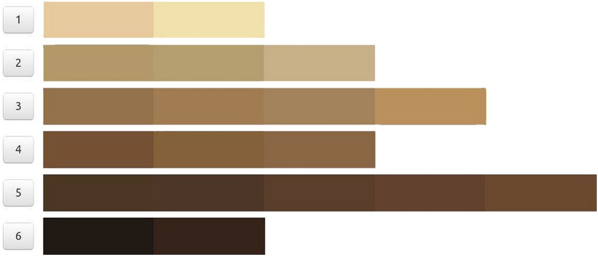
Source of the picture: Gupta et al. (2019).

Pictures of hands were taken between 18.1. and 21.1. 2022
We took a picture of hand on which the watches were worn, if participant agreed with it. Photography of hand with watches was taken too when possible.
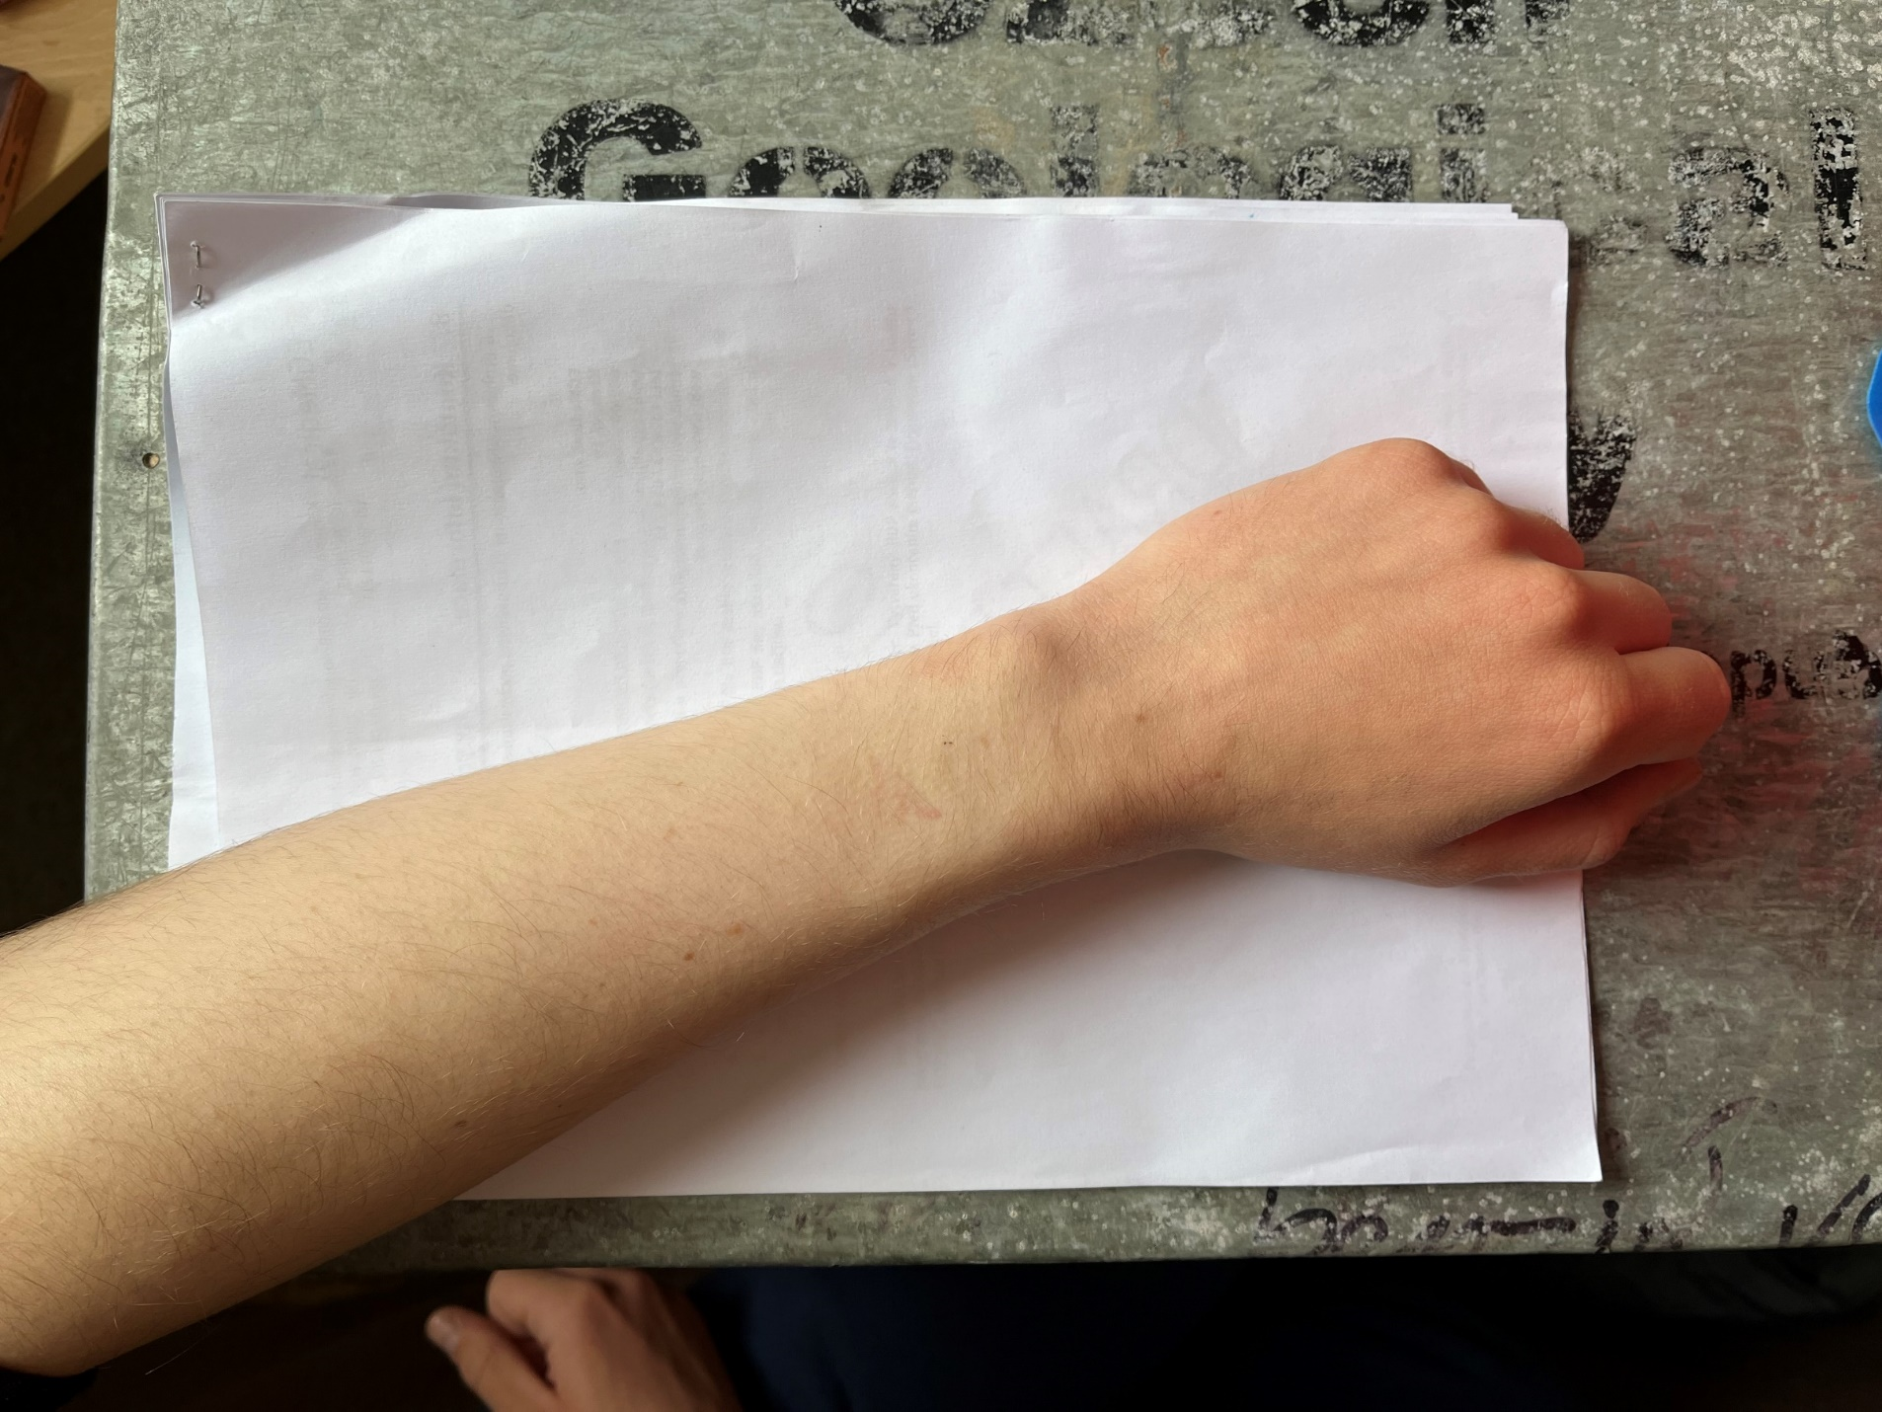
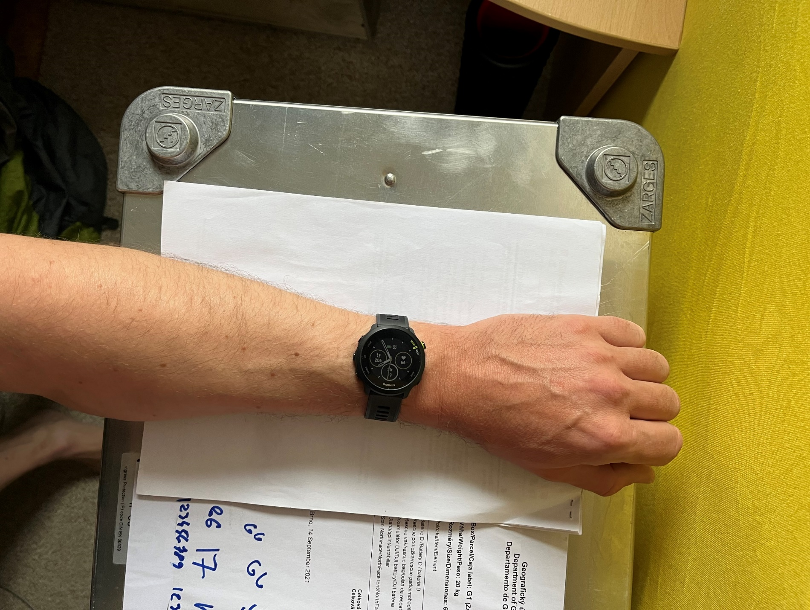
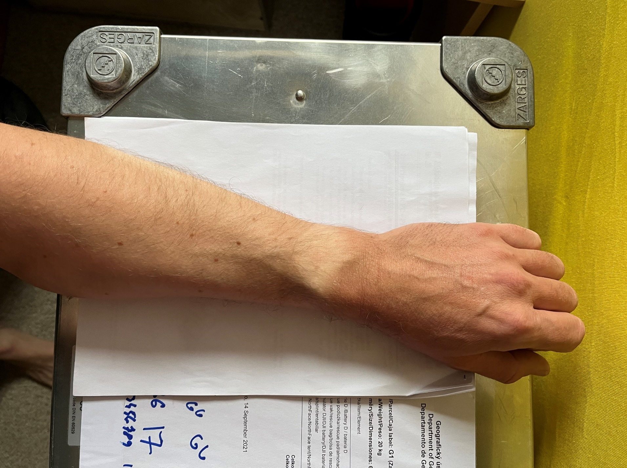
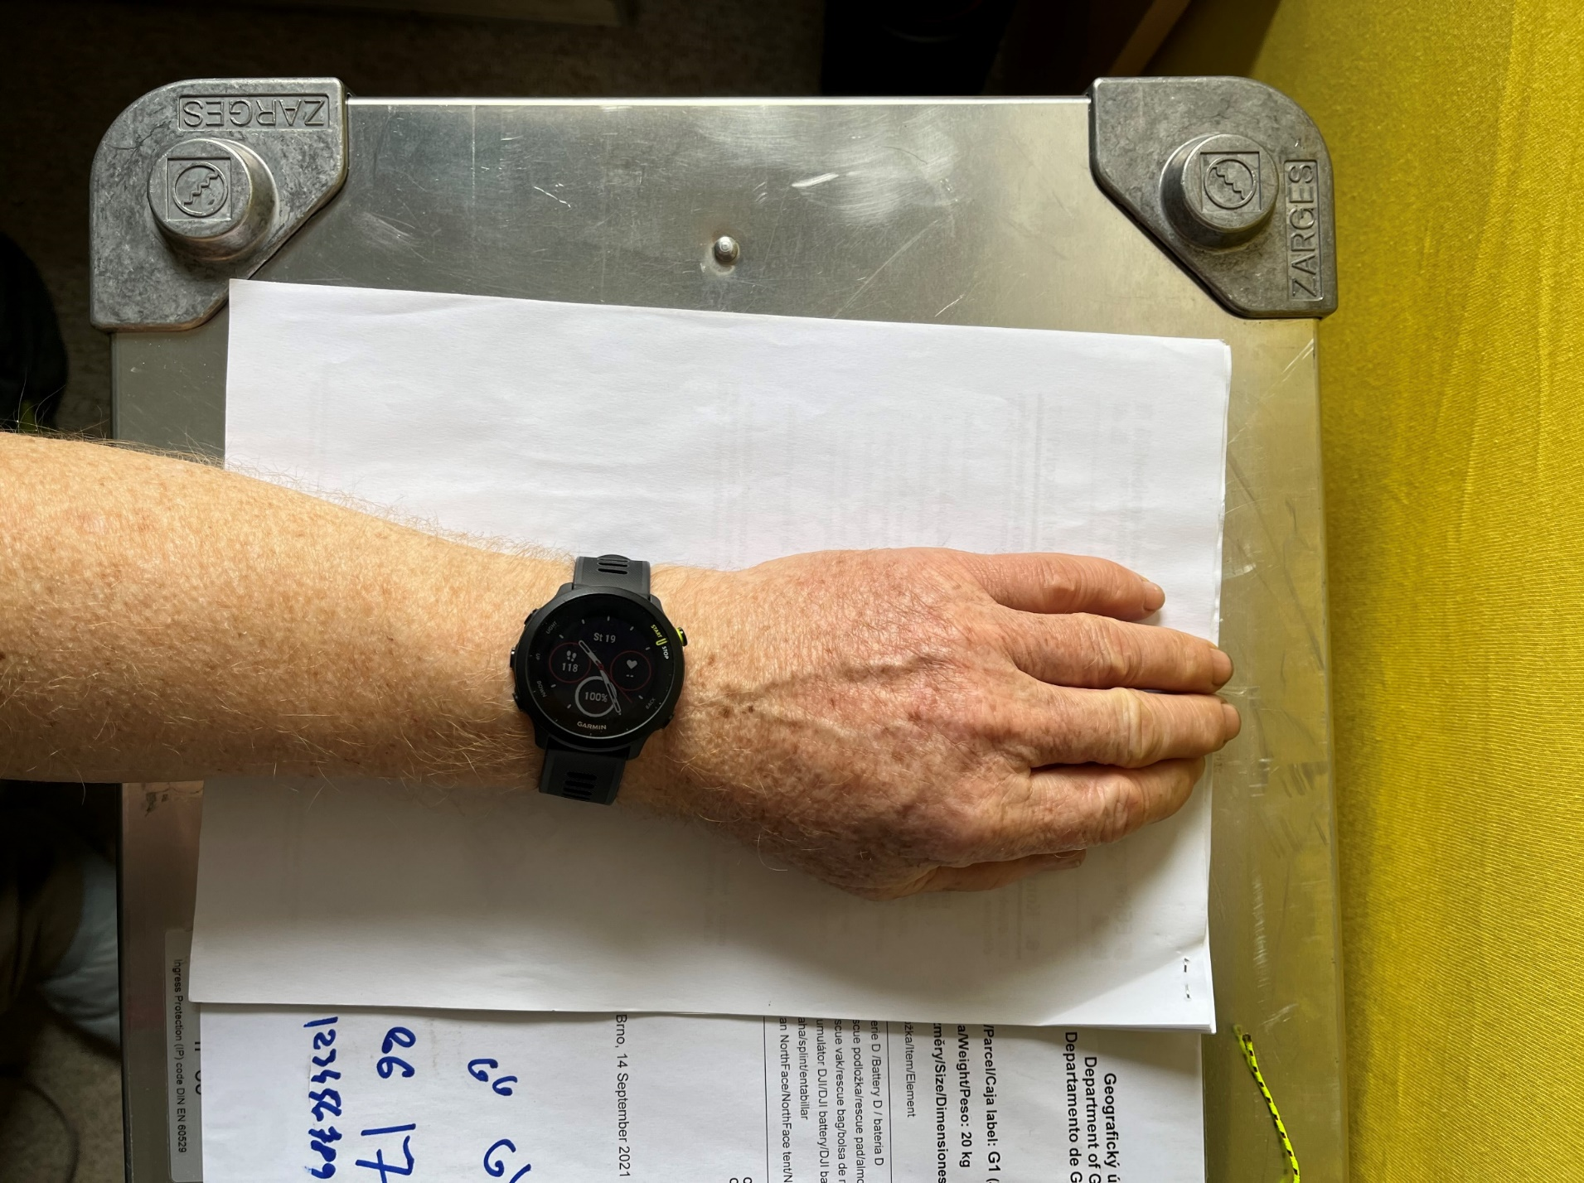
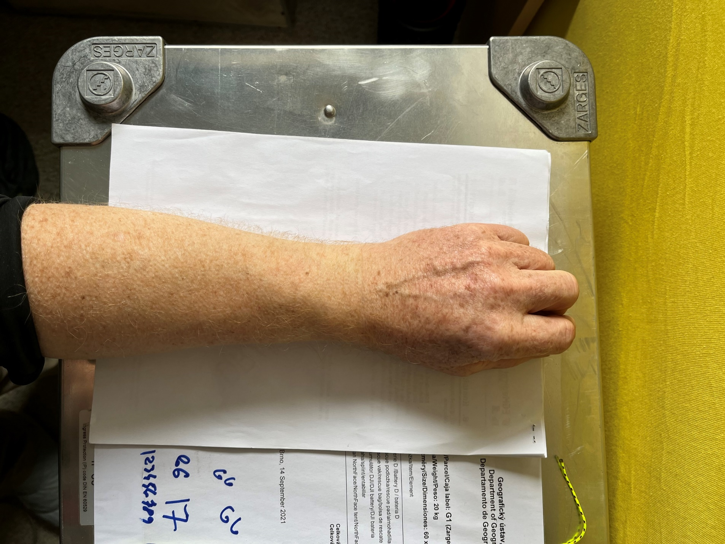
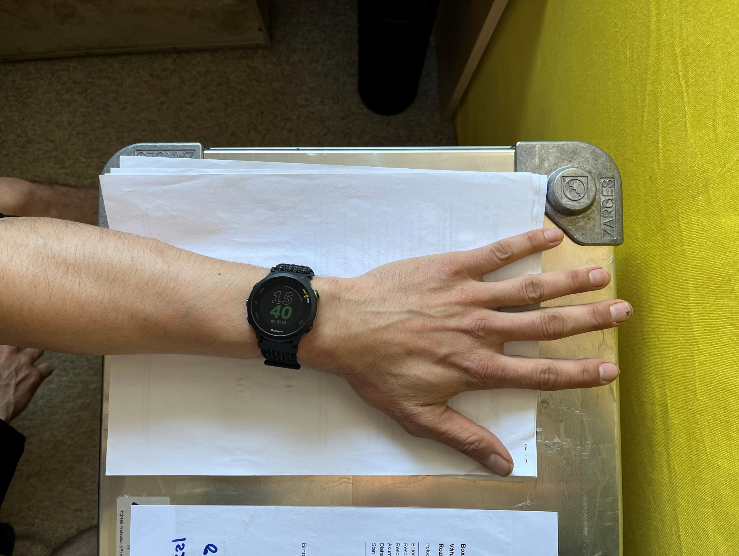
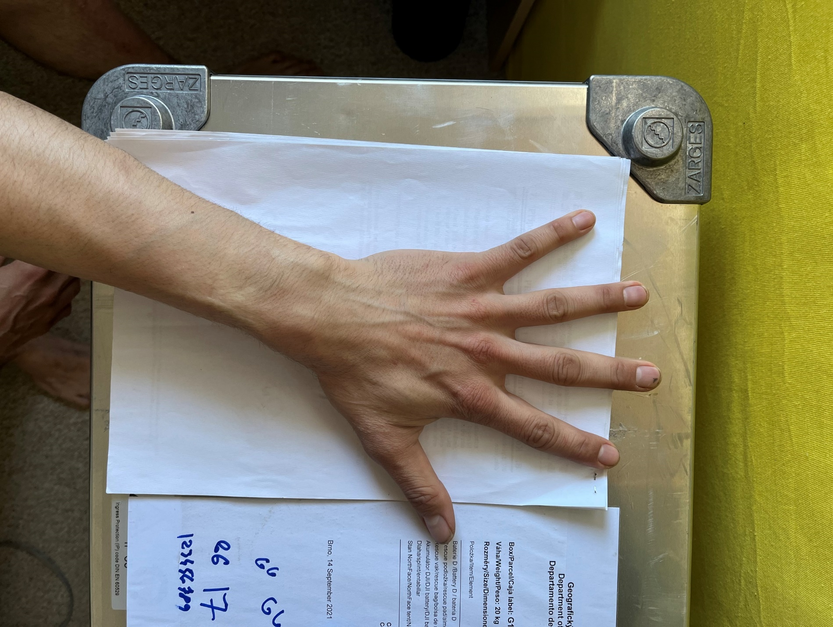
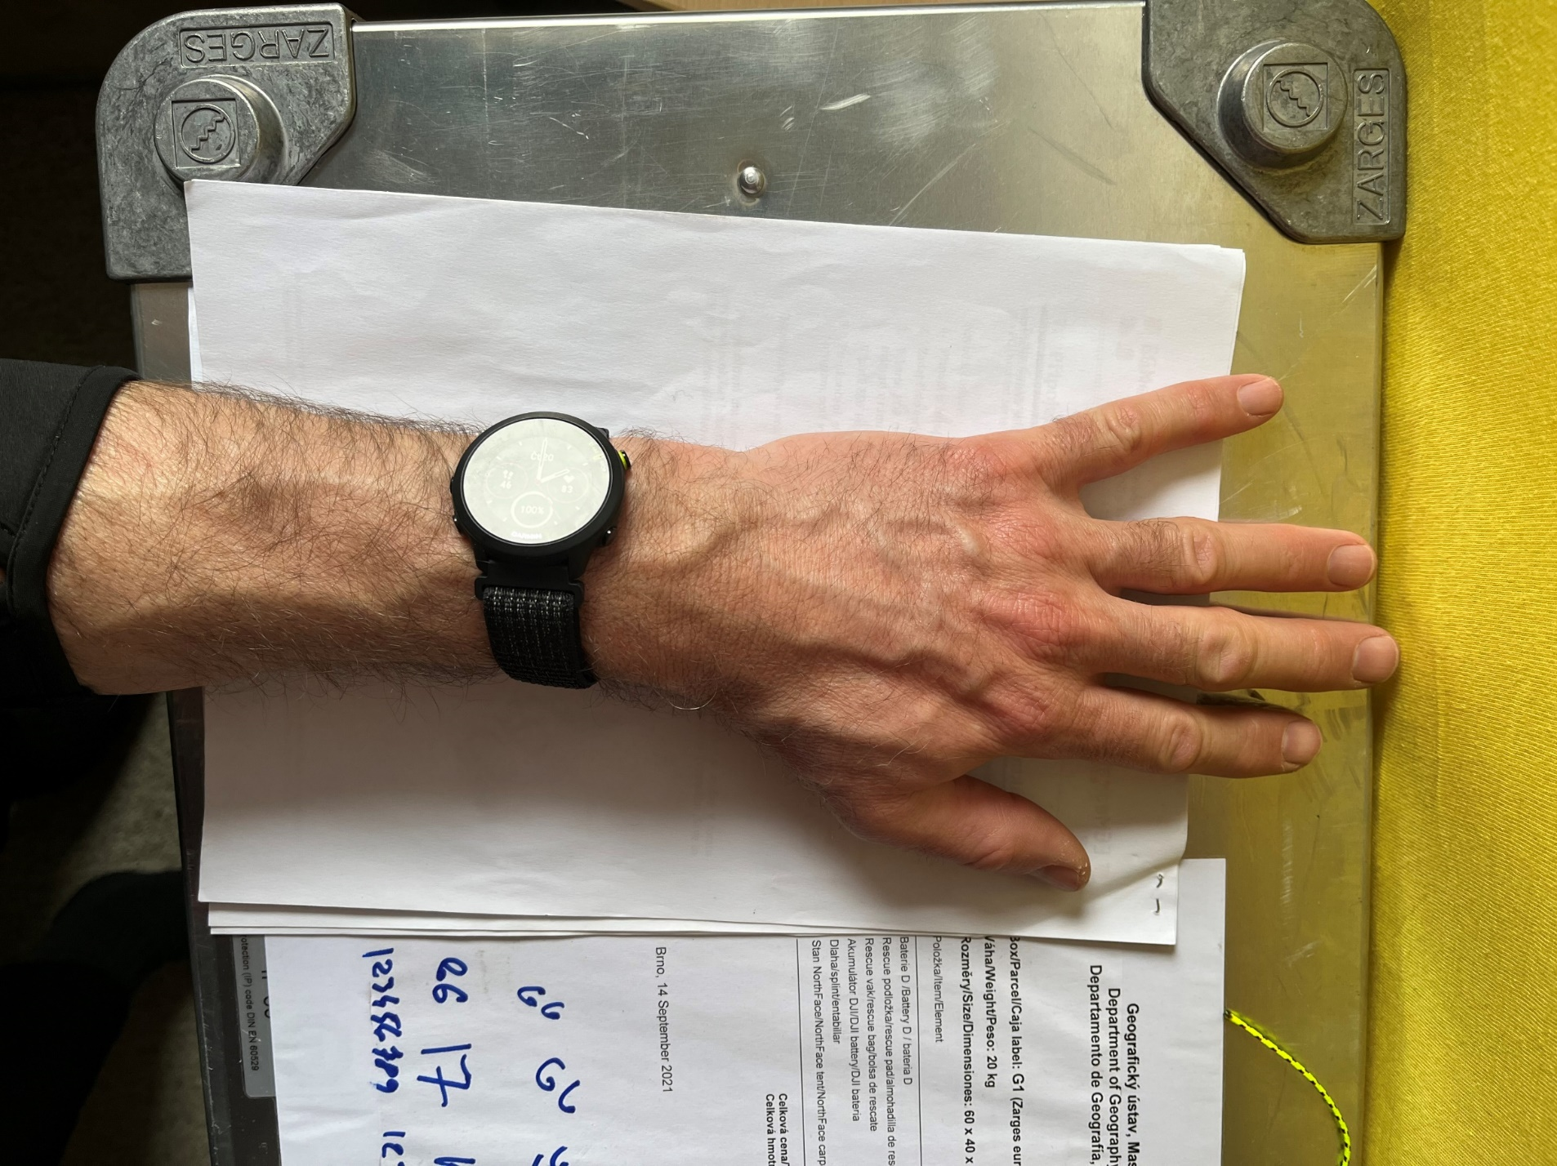
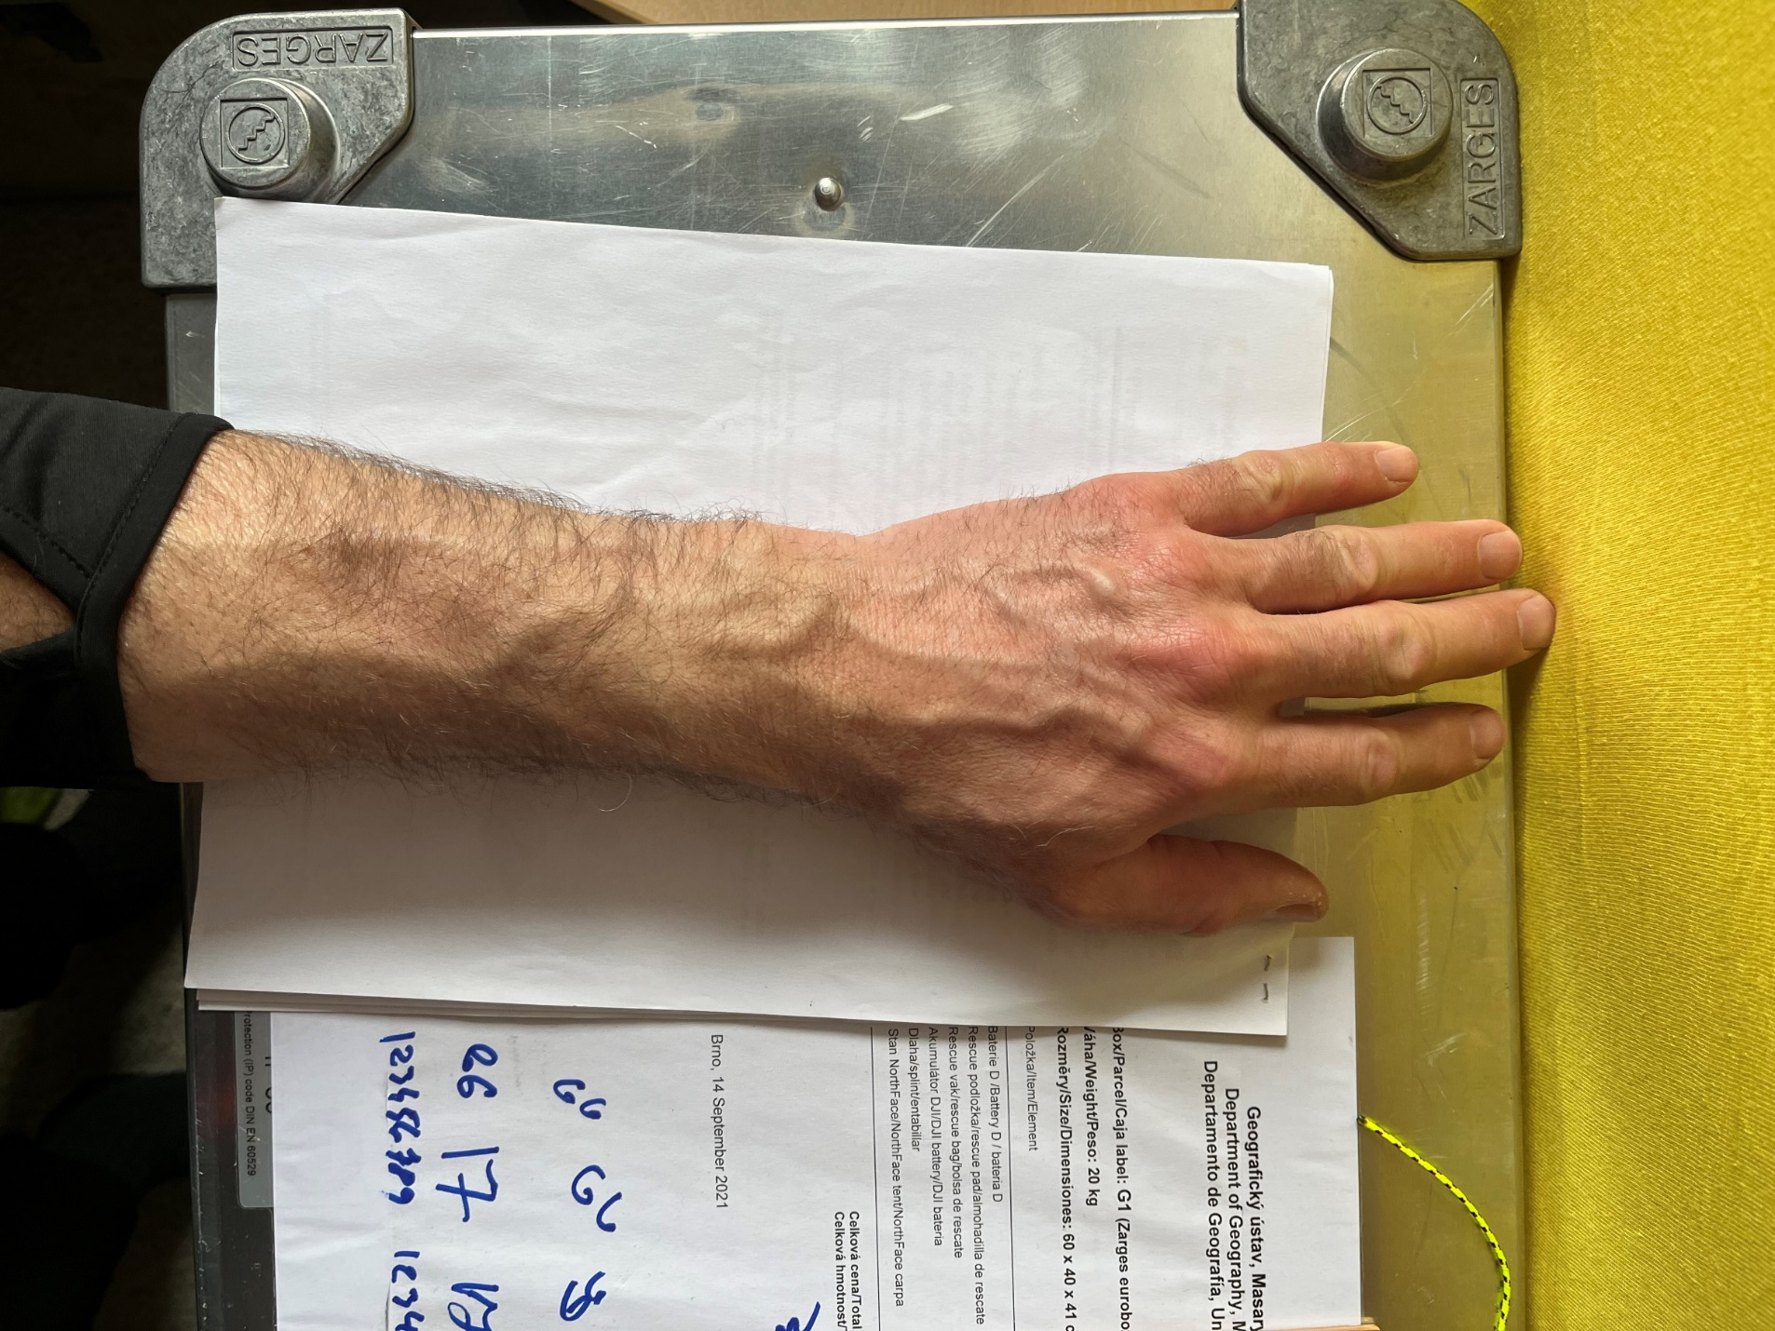
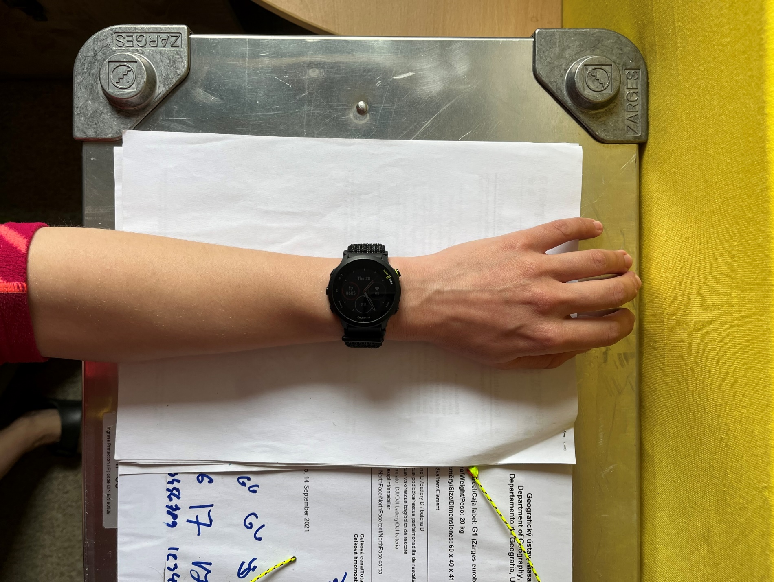
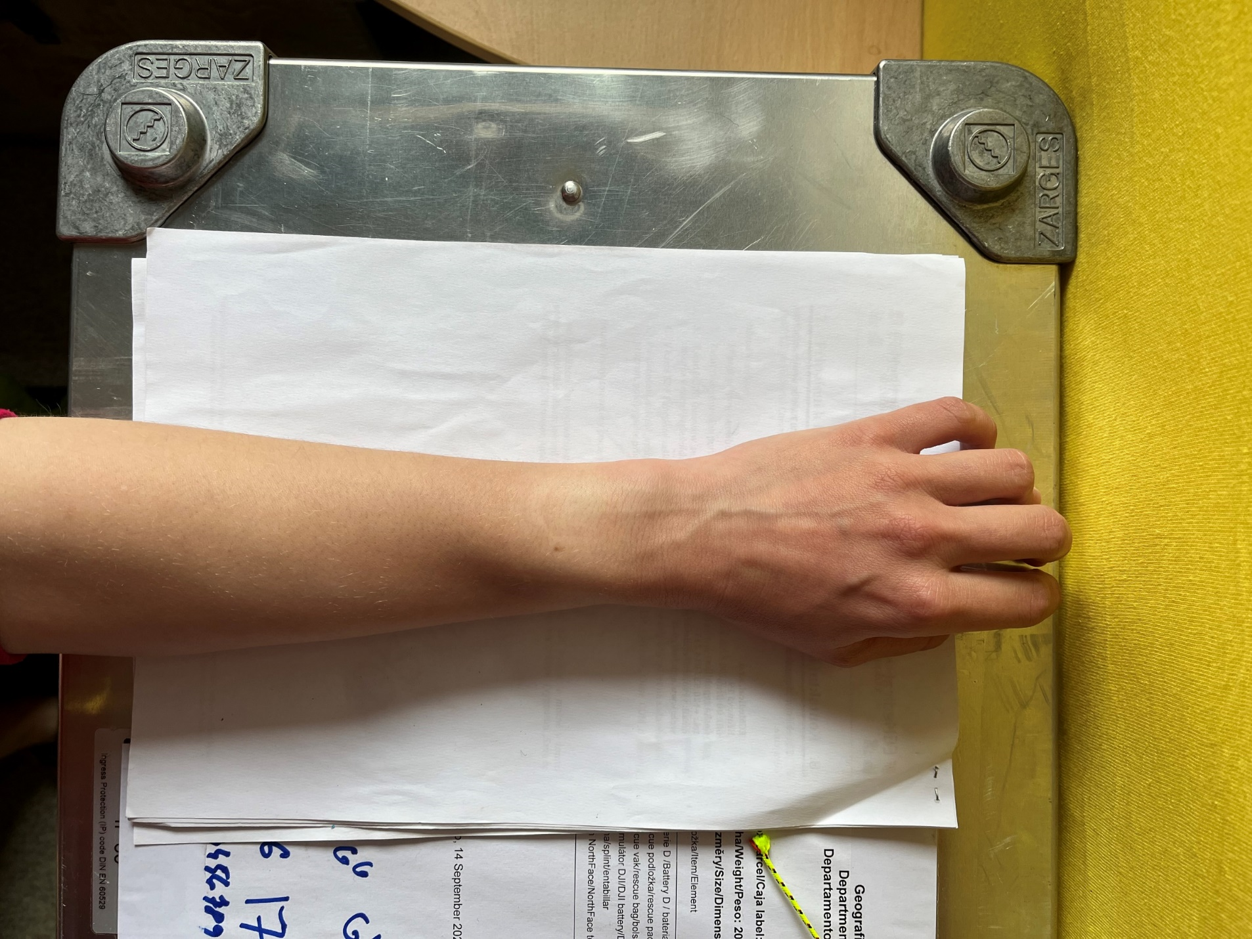
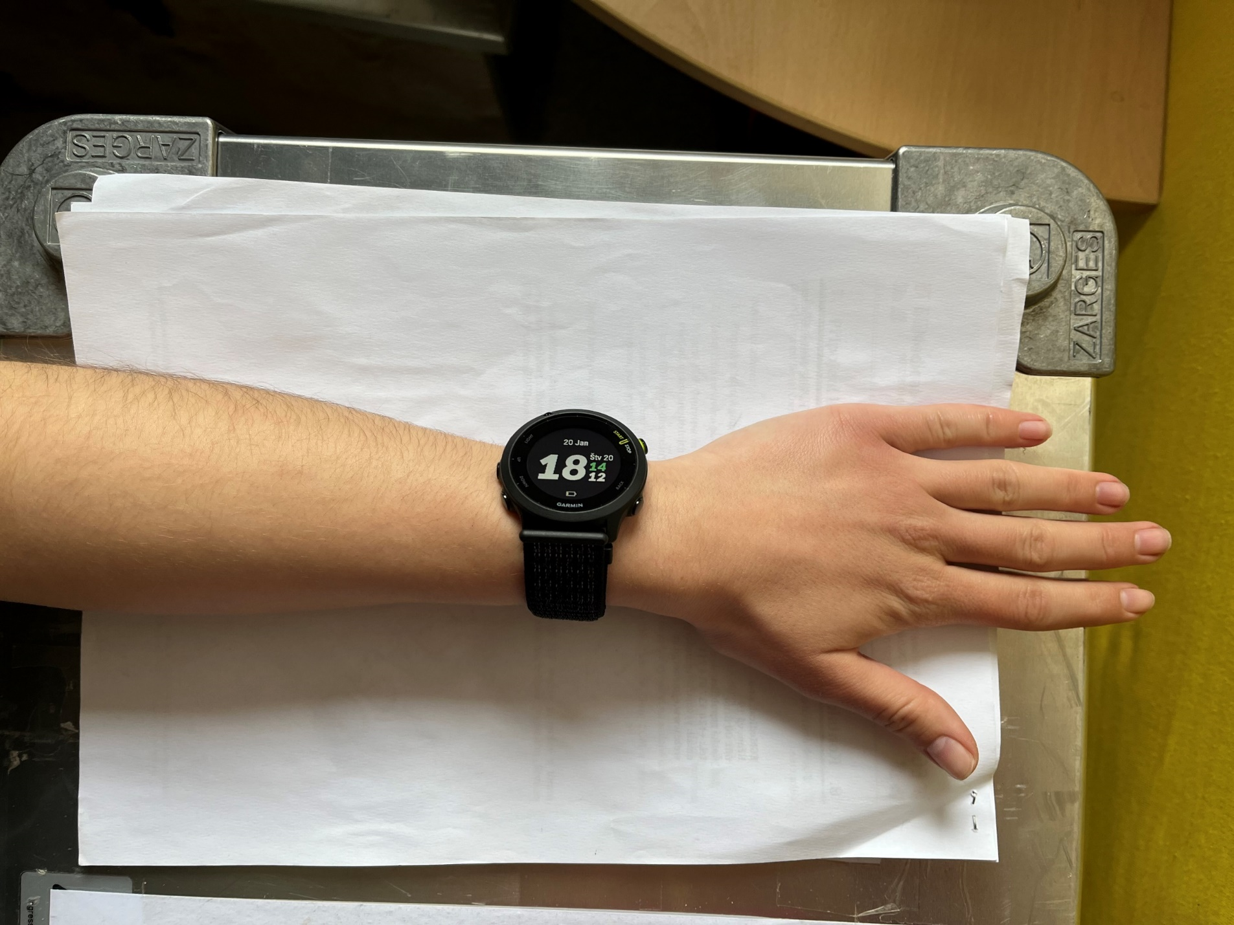
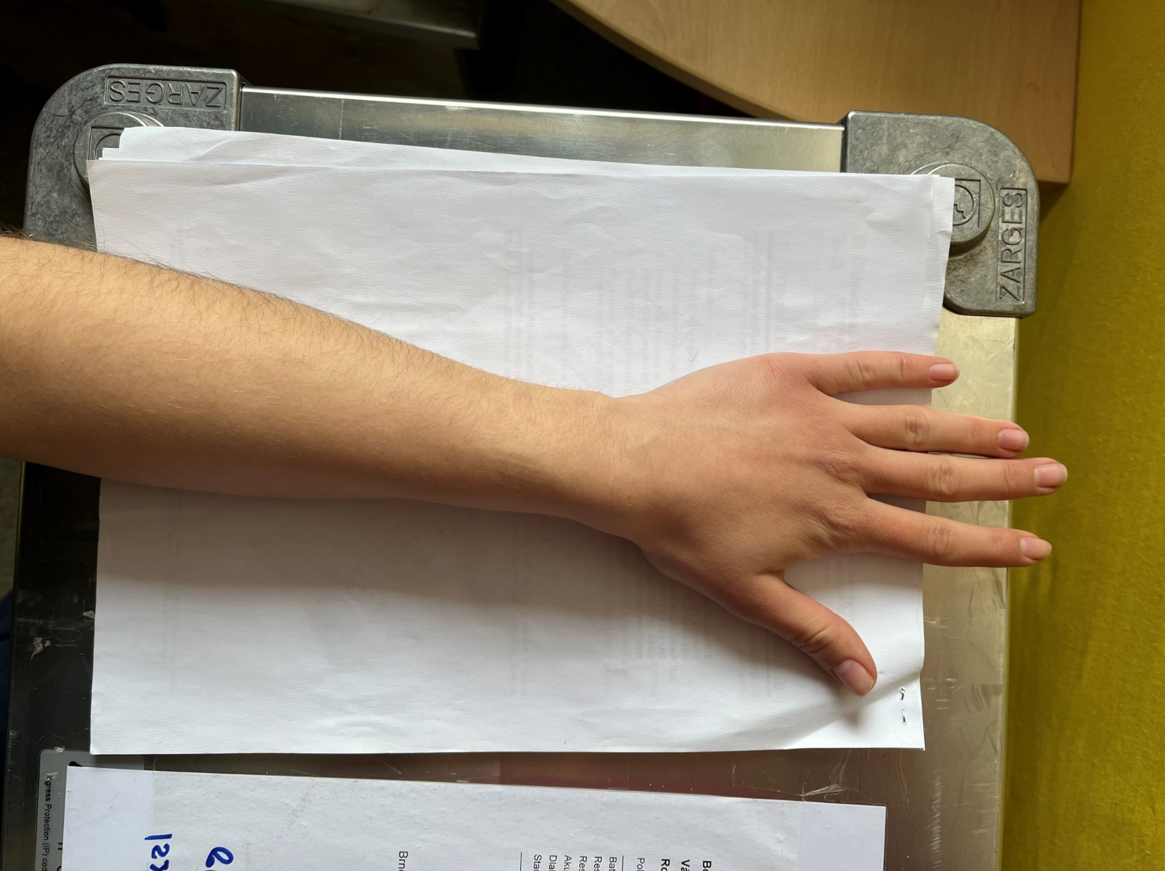
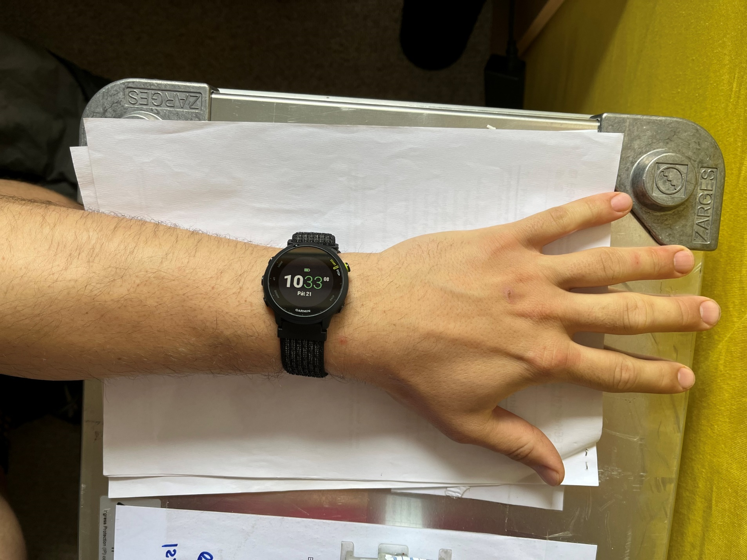
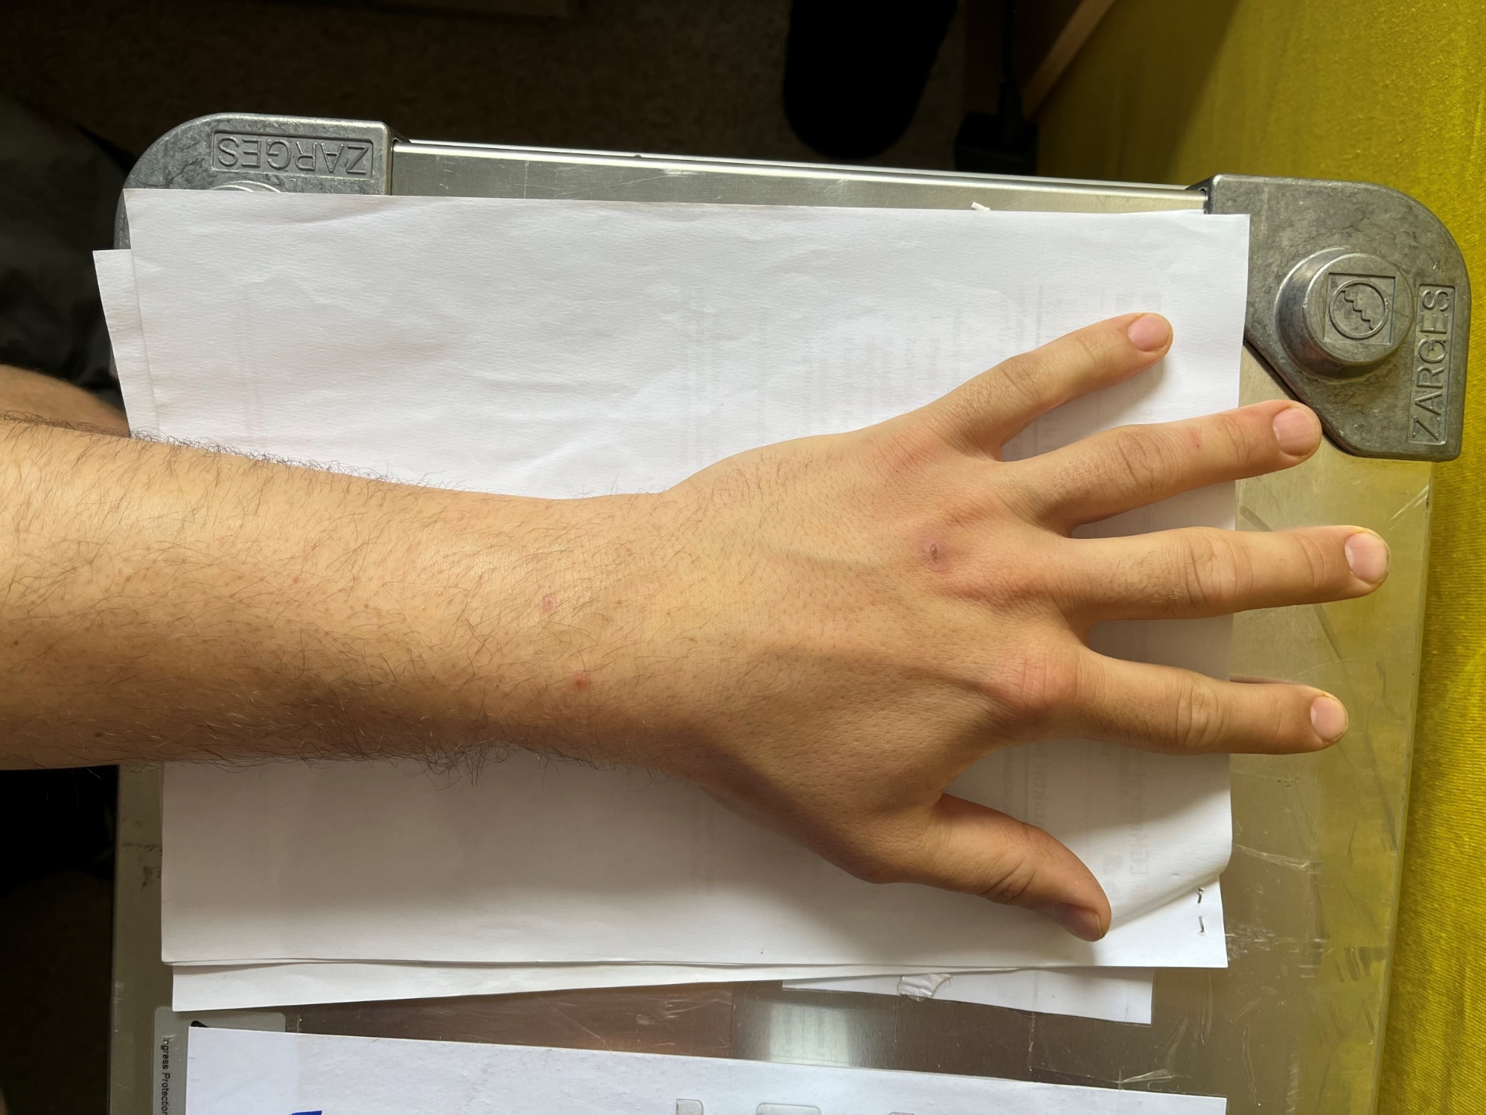
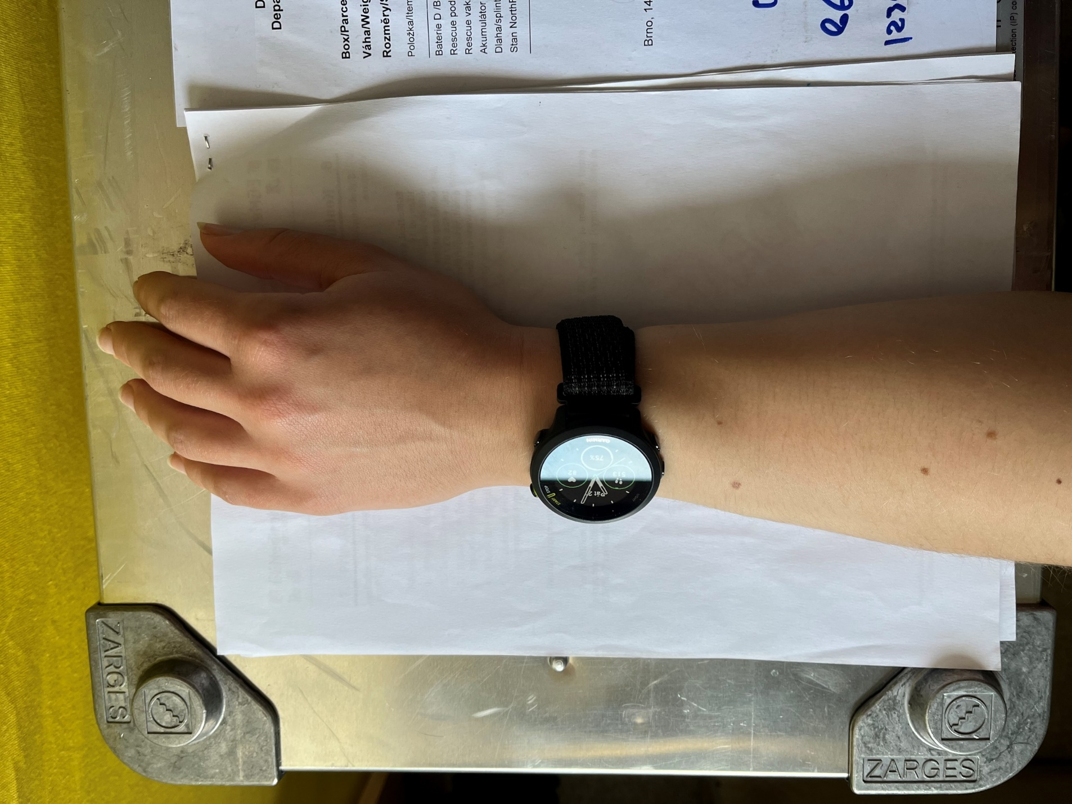
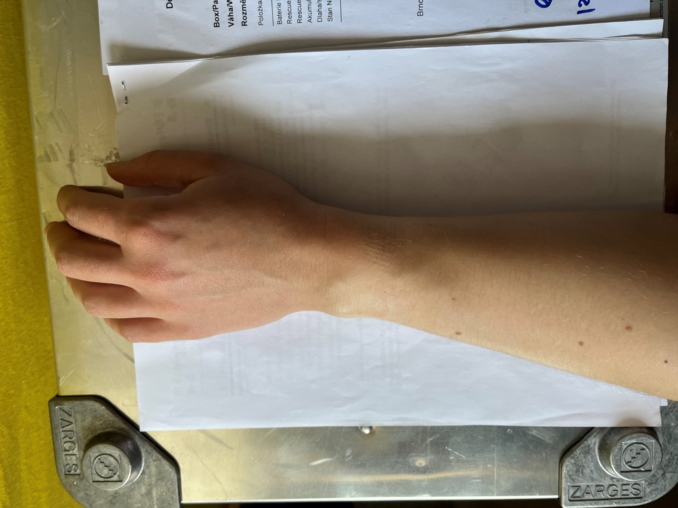
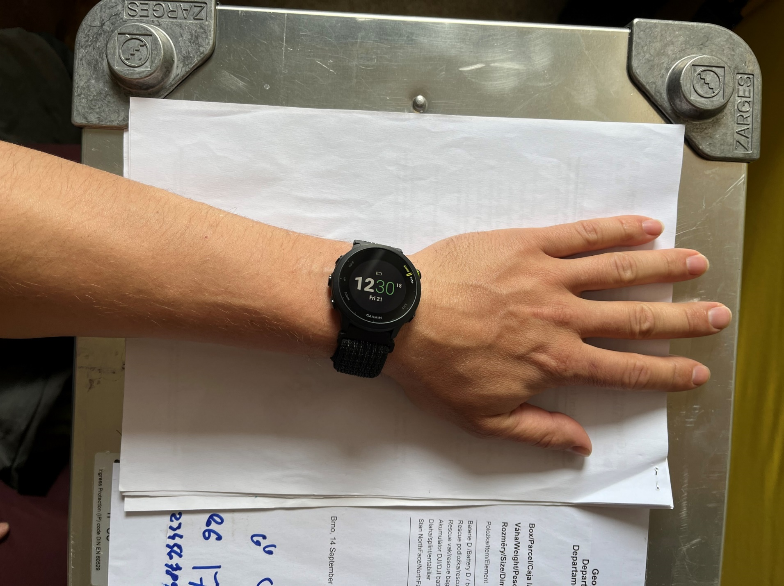
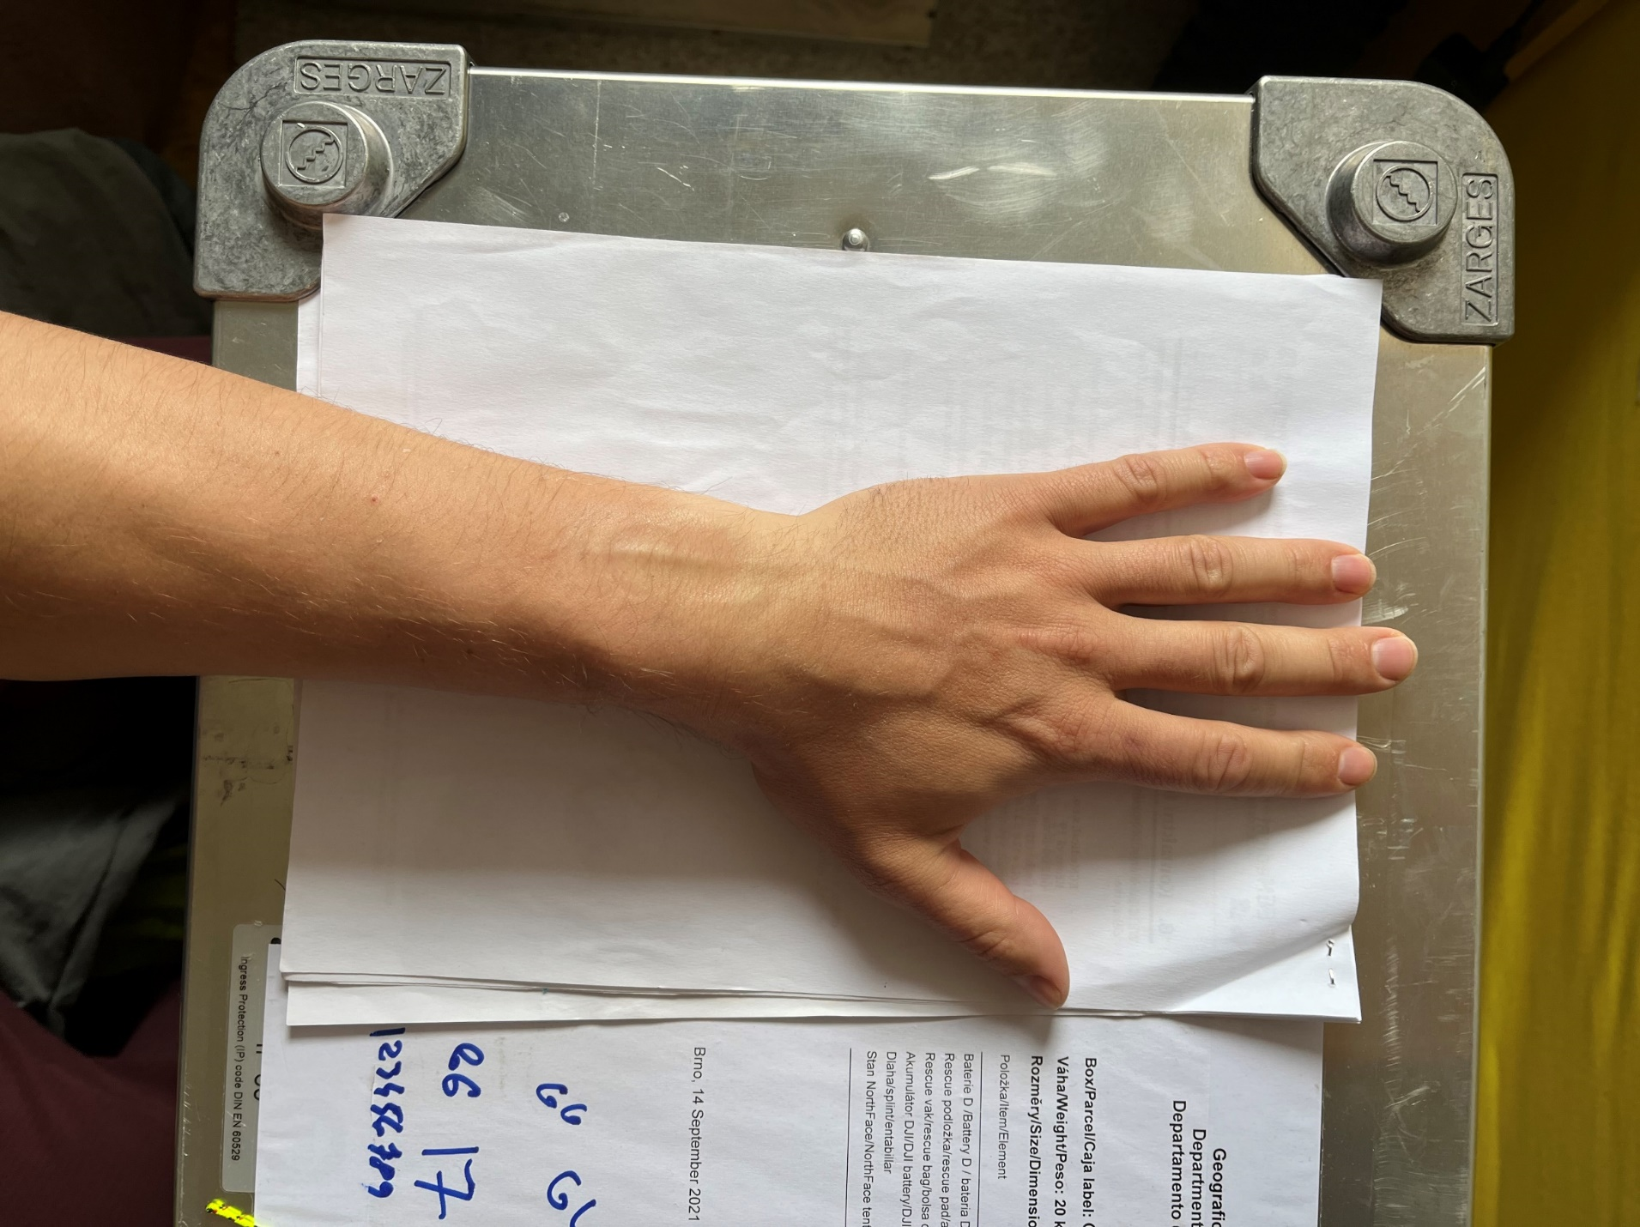
Body mass index
 |  | Height | Weight | BMI
Men | mean m | 181.45 | 80.91 | 24.54
Men | sd m | 6.15 | 9.52 | 2.37
Men | min m | 159 | 68 | 20.52892
Men | max m | 190 | 112 | 31.35411
Women | mean w | 164.80 | 57.40 | 21.13
Women | sd w | 1.36 | 4.48 | 1.83
Women | min w | 163 | 47 | 17.68979
Women | max w | 168 | 66 | 24.53896

Wrist circumference
 | Circumference
 | Processus styloideus radii | The narrowest area
Men | 18.02 | 18.16
Men | 0.91 | 0.89
Men | 16.1 | 15.9
Men | 19.85 | 20.5
Women | 15.80 | 15.90
Women | 0.86 | 0.80
Women | 14.15 | 14.8
Women | 16.8 | 16.9

Wrist placement
Placement of smart watches on the wrist can be assessed based on the photographs above.
Dominant or non-dominant
* one participant reported being ambidextrous, and one other participant reported changing placement if skin irritation emerged
Dominant* | Non-dominant
3 | 13
19% | 81%

Tight vs loose
Tight | Middle | Loose
6 | 6 | 4
38% | 38% | 25%

Naturalistic use by participants vs explicit instructions by experimenters
Instructions for heart rate measurement are explained in the Supplementary Section S1.
Instructions for the PVT were given before each measurement. Participants were instructed to watch the screen and press the spacebar as quickly as possible when a red circle appeared. They were informed that the task lasts 5 minutes.
Medical conditions and cardioactive medication use
At the time of the initial assessment, one participant reported use of cardiac medication, another use of medication for asthma and allergies, and another use of medication for thyroid hormone deficiency. Additionally, one individual reported using anticoagulant medication during the flight to Antarctica. During the expedition itself, one participant reported the use of sleeping pills. None of these participants were excluded, and we did not use medication as a covariate in the analysis.
References
Gillinov, S. et al. Variable Accuracy of Wearable Heart Rate Monitors during Aerobic Exercise. Med Sci Sports Exerc 49, 1697–1703 (2017).
Gupta, V. & Sharma, V. K. Skin typing: Fitzpatrick grading and others. Clin. Dermatol. 37, 430–436 (2019)
Nelson, B. W. et al. Guidelines for wrist-worn consumer wearable assessment of heart rate in biobehavioral research. NPJ Digit Med 3, 90 (2020).
Støve, M. P., Haucke, E., Nymann, M. L., Sigurdsson, T. & Larsen, B. T. Accuracy of the wearable activity tracker Garmin Forerunner 235 for the assessment of heart rate during rest and activity. J Sports Sci 37, 895–901 (2019).
Tedesco, S. et al. Accuracy of consumer-level and research-grade activity trackers in ambulatory settings in older adults. PLoS One 14, e0216891 (2019).

S3 PVT Software
Information about the PVT Software, which was programmed for this study is available under the following link: https://github.com/Kulivox/pvt

S4 R Studio GAMM Analysis output
Mean reaction time, orthogonalization for lag 1 and lag 2 days
Model with only linear effects
> summary(v)

Family: gaussian
Link function: identity

Formula:
RT_mean ~ mean_disrupted_HR_minus1 + mean_disrupted_HR_dif2.minus.1 +
duration_disrupted_minus1 + duration_disrupted_dif2.minus.1 +
s(f.id, bs = "re") + factor(sex) + factor(First_timer) +
factor(Laptop_type)

Parametric coefficients:
Estimate Std. Error t value Pr(>|t|)
(Intercept) 231.14062 34.50683 6.698 6.37e-08 ***
mean_disrupted_HR_minus1 1.51347 0.53987 2.803 0.00793 **
mean_disrupted_HR_dif2.minus.1 0.09557 0.39496 0.242 0.81011
duration_disrupted_minus1 -0.70727 1.57842 -0.448 0.65664
duration_disrupted_dif2.minus.1 -0.85804 1.11611 -0.769 0.44678
factor(sex)Male 2.09967 16.06386 0.131 0.89670
factor(First_timer)Yes -39.24324 15.85146 -2.476 0.01788 *
factor(Laptop_type)Lenovo 26.74064 4.25462 6.285 2.33e-07 ***
---
Signif. codes: 0 ‘***’ 0.001 ‘**’ 0.01 ‘*’ 0.05 ‘.’ 0.1 ‘ ’ 1

Approximate significance of smooth terms:
edf Ref.df F p-value
s(f.id) 11.07 12 17.75 <2e-16 ***
---
Signif. codes: 0 ‘***’ 0.001 ‘**’ 0.01 ‘*’ 0.05 ‘.’ 0.1 ‘ ’ 1

R-sq.(adj) = 0.882 Deviance explained = 92%
-ML = 244.41 Scale est. = 163.98 n = 57

Effect of mean sleep HR one night before PVT allowed to be nonlinear (smooth)
> summary(v1)

Family: gaussian
Link function: identity

Formula:
RT_mean ~ s(mean_disrupted_HR_minus1) + mean_disrupted_HR_dif2.minus.1 +
duration_disrupted_minus1 + duration_disrupted_dif2.minus.1 +
s(f.id, bs = "re") + factor(sex) + factor(First_timer) +
factor(Laptop_type)

Parametric coefficients:
Estimate Std. Error t value Pr(>|t|)
(Intercept) 322.24639 19.12310 16.851 < 2e-16 ***
mean_disrupted_HR_dif2.minus.1 0.09555 0.39494 0.242 0.8101
duration_disrupted_minus1 -0.70709 1.57837 -0.448 0.6567
duration_disrupted_dif2.minus.1 -0.85793 1.11607 -0.769 0.4468
factor(sex)Male 2.09983 16.06323 0.131 0.8967
factor(First_timer)Yes -39.24382 15.85084 -2.476 0.0179 *
factor(Laptop_type)Lenovo 26.73990 4.25451 6.285 2.33e-07 ***
---
Signif. codes: 0 ‘***’ 0.001 ‘**’ 0.01 ‘*’ 0.05 ‘.’ 0.1 ‘ ’ 1

Approximate significance of smooth terms:
edf Ref.df F p-value
s(mean_disrupted_HR_minus1) 1.001 1.001 7.853 0.00794 **
s(f.id) 11.067 12.000 17.751 < 2e-16 ***
---
Signif. codes: 0 ‘***’ 0.001 ‘**’ 0.01 ‘*’ 0.05 ‘.’ 0.1 ‘ ’ 1

R-sq.(adj) = 0.882 Deviance explained = 92%
-ML = 244.41 Scale est. = 163.97 n = 57

> AIC(v,v1)
df AIC
v 20.27506 469.7820
v1 20.30318 469.8328

Table S4-1. Comparison of linear and nonlinear GAMMs predicting mean reaction time (RT). Values are reported as estimate ± SE. HR = heart rate; PVT = Psychomotor Vigilance Task. Statistical significance codes: 0 ‘***’ 0.001 ‘**’ 0.01 ‘*’ 0.05. Edf = estimated degrees of freedom for smooth terms; Δ = difference.
Predictor | Linear GAMM | Non-linear GAMM
Intercept | 231.14 ± 34.51, t=6.70, p<0.001 | 322.25 ± 19.12, t=16.85, p<0.001
Mean sleep HR  (1 night before PVT) | 1.51 ± 0.54, t=2.80, p=0.008 ** | Smooth  edf=1.001, F=7.85, p=0.008 **
Δ Mean sleep HR  (2–1 nights before PVT) | 0.10 ± 0.39, t=0.24, p=0.810 | 0.10 ± 0.39, t=0.24, p=0.810
Mean sleep duration  (1 night before PVT) | -0.71 ± 1.58, t=-0.45, p=0.657 | -0.71 ± 1.58, t=-0.45, p=0.657
Δ Sleep duration  (2–1 nights before PVT) | -0.86 ± 1.12, t=-0.77, p=0.447 | -0.86 ± 1.12, t=-0.77, p=0.447
Sex (Male) | 2.10 ± 16.06, t=0.13, p=0.897 | 2.10 ± 16.06, t=0.13, p=0.897
First-timer (Yes) | -39.24 ± 15.85, t=-2.48, p=0.018 * | -39.24 ± 15.85, t=-2.48, p=0.018 *
Laptop type (Lenovo) | 26.74 ± 4.25, t=6.29, p<0.001 *** | 26.74 ± 4.25, t=6.29, p<0.001 ***
Random effect  (Participant ID) | edf=11.07, F=17.75, p<0.001 *** | edf=11.07, F=17.75, p<0.001 ***
Model fit | R²(adj)=0.882,  Deviance explained=92%,  AIC= 469.7820 | R²(adj)=0.882,  Deviance explained=92%,  AIC= 469.8328
ΔAIC | — | 0.05 (negligible)

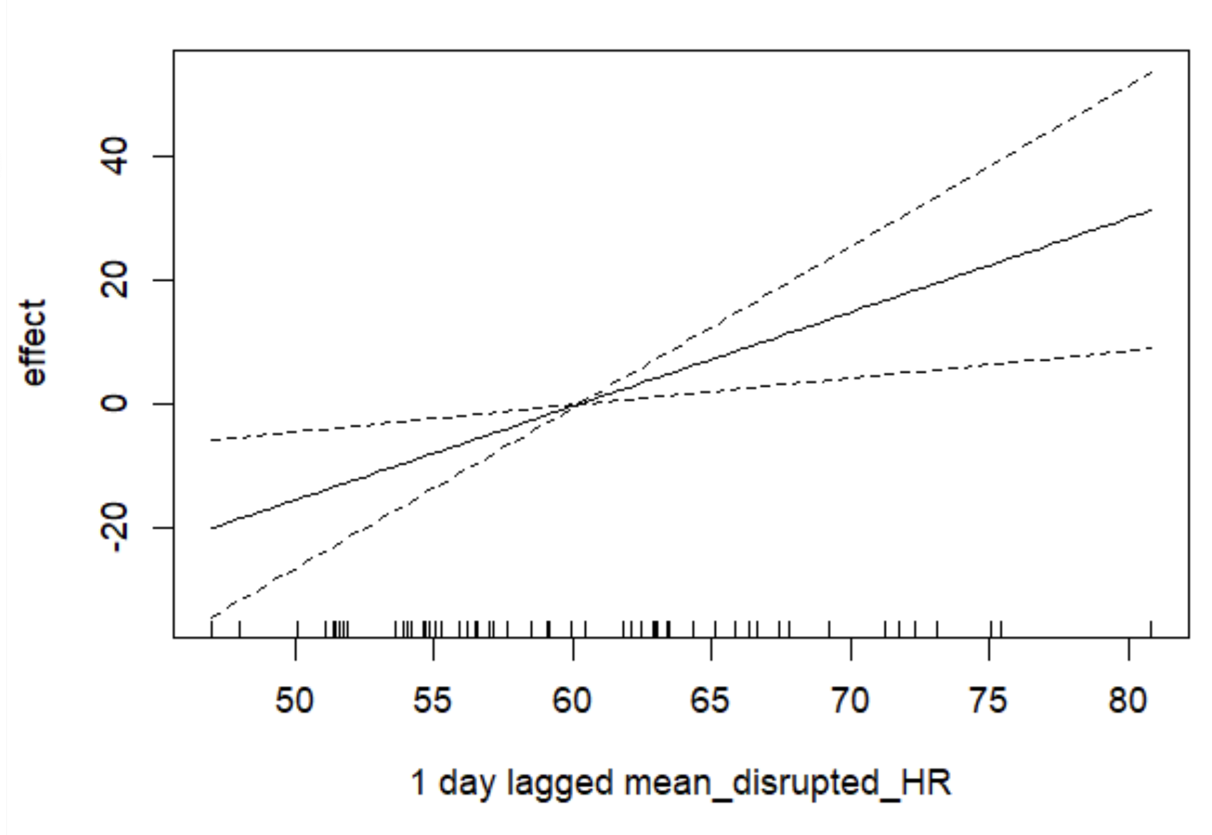
Figure S4-1.: Plot of a non-linear effect of a mean sleep HR from the night before PVT measurement on the RT, based on the GAMM.

