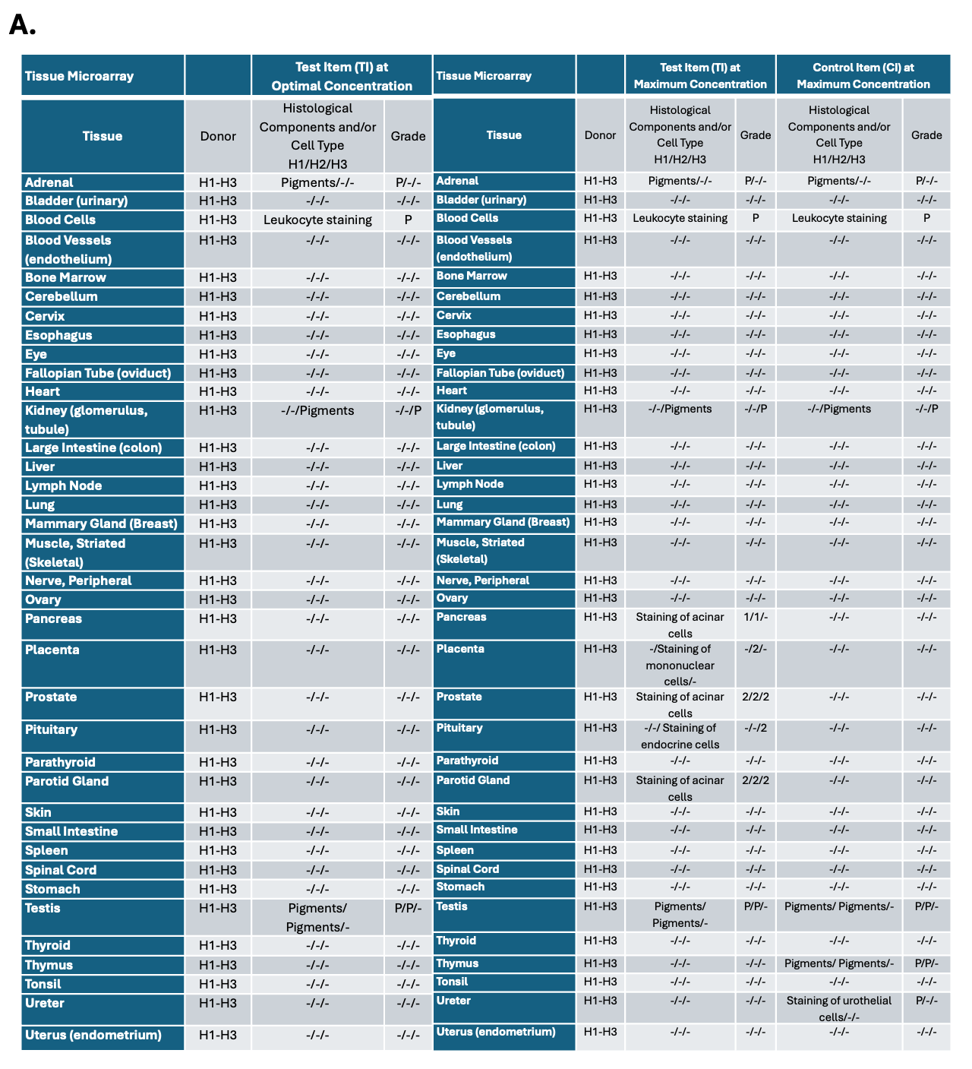
Table 1. CLEC2A shows no cell surface binding in tissue cross-reactivity assay
A. Results of tissue cross-reactivity assay conducted by Charles River Laboratories using anti-CLEC2A 3H10 antibody (test item) at optimal concentration (0.3 ug/mL) on left, maximum concentration (3 ug/mL) in the middle and isotype-matched anti-tetanus toxin antibody (control item) on the right against 37 different human tissues each from 3 donors (H1, H2, H3). Legend: - denotes negative, 1 = minimal staining, 2 =slight staining, P= background staining present (i.e. Seen in both test and control item)

