Supporting Information for
Development of Shelf Stable Formulation for Adenovirus Vectored Vaccines and Therapeutics

Jeremy A. Iwashkiw,¹* Aaisha Ameen^{1,} Natallia Kazhdan², Sam Afkhami³, Michael R. D'Agostino³, Kyle Amaral³, Matthew S Miller³, Jody E. Beecher¹, Carlos D. M. Filipe^{1,4}, Brian D. Lichty²

¹Elarex Inc. 4200 South Service Road, Burlington, Ontario L7L 4X5, Canada
² Robert E. Fitzhenry Vector Laboratory, McMaster Immunology Research Centre, Department of Pathology and Molecular Medicine, McMaster University, 1280 Main Street West, Hamilton, Ontario L8S 4K1, Canada
³McMaster Immunology Research Centre, M.G. DeGroote Institute for Infectious Disease Research, Department of Biochemistry and Biomedical Sciences, McMaster University, 1280 Main Street West, Hamilton, ON L8S 4K1, Canada.
⁴Department of Chemical Engineering, McMaster University, 1280 Main Street West, Hamilton, Ontario L8S 4K1, Canada
.
*Jeremy Iwashkiw.
Email: jeremy.iwashkiw@elarexinc.com

This PDF file includes:

Figures S1 to S1
Tables S1 to S1

Figures

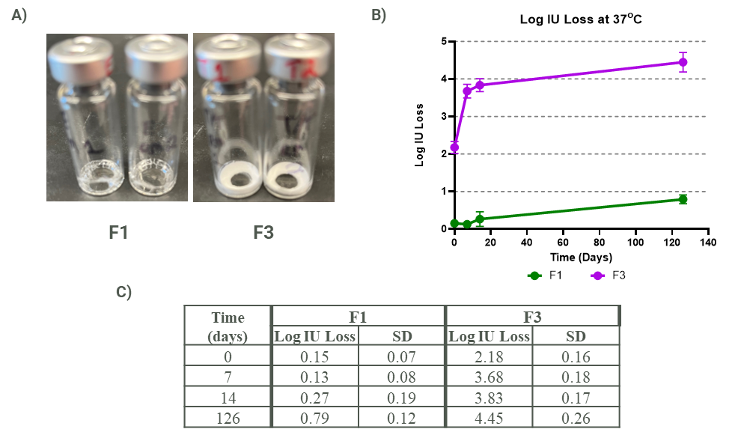

Fig. S1. Trehalose alone does not thermostabilize AdV vectored vaccines. A) Dried film morphology for both formulations F1 and F3 vacuum. B) Process and thermostability loss of titer incubated at 37ºC over 126 days as determined by ICW. C) Calculated means and standard deviation (SD) for each data point of accumulated Log PFU loss for each condition. Each data point is collected from duplicate serial dilution plating of biological duplicate vials.

Tables

Table S1. Summary of drying schedules utilized in this work.
Schedule Name | System | Pre-Incubation | Dry Schedule | Backfill
1 | SP Virtis AdVantage Pro | 25ºC | 10 hrs @ 4ºC; 5 hrs ramp to 25ºC; 6 hrs at 25ºC under constant 16 uBar pressure | Atmosphere; Manual Crimp
2 | SP Virtis AdVantage Pro | -50ºC | 10 hrs @ -50ºC; 6 hr ramp to 25ºC; 5 hr @ 25ºC under constant 16uBar pressure | Atmosphere; Manual Crimp
3 | SP Virtis AdVantage Pro | 4ºC | 24 hrs @ 25ºC under 16 uBar pressure | Atmosphere and Manual Crimp

