Supplementary Table 1 Notable amino acid annotations
seqName | gene | mutation | annotation
064_S23|SLE|2025 | E | I322V | Envelope domain hinge/EDIII N‚Äëterminus; may tune fusion triggering/epitope orientation.
064_S23|SLE|2025 | E | I462V | E stem helix (post‚Äëfusion/stability region); can affect fusion/assembly efficiency.
064_S23|SLE|2025 | E | I484V | E stem helix‚Äìmembrane interface; may modulate fusion and particle stability.
064_S23|SLE|2025 | E | N390S | EDIII FG‚Äëloop neutralizing epitope; can alter antigenicity/neutralization.
064_S23|SLE|2025 | E | T478S | E stem/transmembrane‚Äëproximal helix; implicated in virion maturation/fusion.
064_S23|SLE|2025 | NS2B | I116V | NS2B C‚Äëterminal region; influences protease dynamics/polyprotein processing.
064_S23|SLE|2025 | NS2B | T77A | NS2B cofactor central segment near NS3 interface; can modulate protease activity.
064_S23|SLE|2025 | NS4A | V64I | NS4A amphipathic helix (membrane remodeling); affects replication organelle formation.
064_S23|SLE|2025 | NS5 | G605V | NS5 RdRp fingers/palm interface; may alter polymerase kinetics/fidelity.
064_S23|SLE|2025 | NS5 | Y201H | NS5 methyltransferase domain near cap/SAM site; potential impact on RNA capping.
064_S23|SLE|2025 | prM | A152V | M ectodomain luminal face; can affect particle stability/secretion.
064_S23|SLE|2025 | prM | D29N | or peptide luminal region; maturation/antigenicity tuning.
064_S23|SLE|2025 | prM | H148Y | M ectodomain luminal face; can affect particle stability/secretion.
064_S23|SLE|2025 | prM | I127V | M ectodomain luminal face; can affect particle stability/secretion.
064_S23|SLE|2025 | prM | K52N | or peptide luminal region; maturation/antigenicity tuning.
064_S23|SLE|2025 | prM | M135I | M ectodomain luminal face; can affect particle stability/secretion.
064_S23|SLE|2025 | prM | M83T | pr peptide near furin‚Äëcleavage loop (approx.); may influence cleavage efficiency.
064_S23|SLE|2025 | prM | T162A | M ectodomain luminal face; can affect particle stability/secretion.
064_S23|SLE|2025 | prM | T82A | pr peptide near furin‚Äëcleavage loop (approx.); may influence cleavage efficiency.
064_S23|SLE|2025 | prM | V120A | M ectodomain luminal face; can affect particle stability/secretion.

Supplementary figures
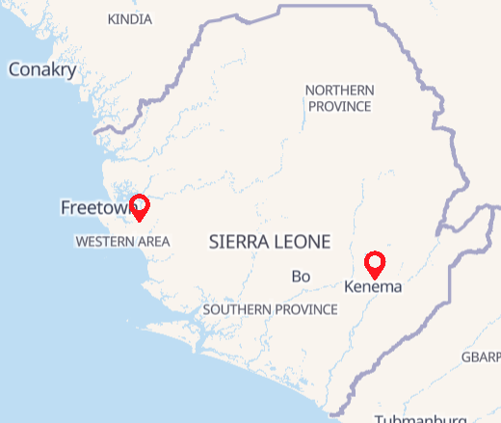
Figure 4: Map describing the 2 sentinel sites in Waterloo, Western Area and Kenema

