A novel transcription regulator of Azospirillum brasilense involved in Plant-Microbe Interactions

Mayara S. Torres de Souza †,*, Caroline Kulkolj †, Fabio O. Pedrosa, Eduardo Balsanelli, Anelis M. Marin, Adriano A. Stefanello, Helba C. de S. Barbosa, Rose Adele Monteiro
Department of Biochemistry and Molecular Biology, Federal University of Paraná, UFPR, P.O Box 19046, 81531980, Curitiba, PR, Brazil.
*Corresponding author:
E. M. Souza, e-mail: souzaem@ufpr.br
† These authors contributed equally to this work.

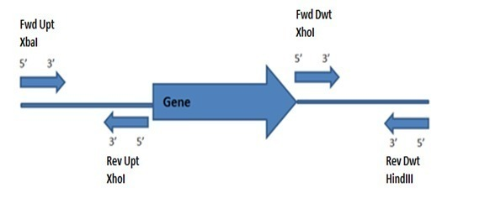
Fig. S1 Schematic representation of the primers designed upstream and downstream of the gene to be deleted. The restriction sites inserted in the sequence, XbaI, XhoI and HindIII, are indicated on the primers. Note: Fwd= forward; Rev= reverse; Upt = upstream; Dwt= downstream

Fig. S2 Schematic diagram of the deletion mutagenesis procedure. (A) Construction of the suicide plasmid using the pk18mobsacb vector. The constructed plasmid (pk18UD) contains the fragments flanking the target DNA region. (B) The first recombination event entailed the chromosomal integration of the vector into the target gene locus via homologous recombination. The constructed suicide plasmid was delivered by triparental conjugation using the prk6000 helper plasmid, generating a strain (containing both wild-type and mutant alleles) selected by kanamycin. (C) The second recombination event involved negative selection using 10% sucrose, in which only cells that have lost the plasmid (after successful recombination) can survive. The mutant strains were verified by PCR using primers that flank the recombination sites. WT - wild type; 1kb - 1kb ladder; Km^{R} - kanamycin resistance marker; sacB - 10% sucrose selection marker. NC - negative control; pk18UD - generic designation of the upstream and downstream regions of the flcA or narL-like gene cloned into the pK18mobsacB vector; ΔnarL-like - PCR of the mutant strain with the deleted narl-like gene (981 bp); ΔflcA - PCR of the mutant strain with the deleted flcA gene (972 bp)

.

Table S1 Primers used in PCR reactions. The designations A and B represent primers constructed upstream and downstream of the gene to be deleted, respectively. The signs, + and -, signify the forward and reverse directions of the primers, respectively. The restriction sites are highlighted in red
Primer | Restriction sites | Sequence (5´ 3´) | Application | Tm (⁰ C)
flcA A+ | XbaI | GGTTTCTAGAAAGCGATAACTCTTT | Amplify 496 bp upstream of flcA gene | 55
flcA A- | XhoI | CCCGCTCGAGTTCGTTTATAC |  | 55
flcA B+ | XhoI | CAGGCTCGAGAACAAAGAAA | Amplify 476 bp downstream of flcA gene | 52-55
flcA B- | HindIII | AGGGAAGCTTAAAGCCGTGT |  | 52-55
narL-like A+ | XbaI | GCCATCTAGAGCATCTGTCAGGA | Amplify 497 bp upstream of narL-like gene | 55
narl-like A- | XhoI | TCAGCTCGAGCGATTTTTGGA |  | 55
narL-like B+ | XhoI | CTCTCTCGAGATTTTTCCCACT | Amplify 484 bp downstream of narL-like gene | 55
narl-like B- | HindIII | GAGGAAGCTTGAACCGGAGTT |  | 55

Table S2. Location in the genome and general characteristics of the flcA and narL-like genes of the FP2 strain of Azospirillum brasilense
Gene | Locus Tag | Size | Location | Protein | Functions | Source or References¹
flcA | Id.0001.1094 | 648pb | 1106618…1107265 | transcriptional regulator member of the LuxR family | Controls flocculation of Azospirillum brasilense, both in culture and in association with plants. flcA-Sp7 mutants are devoid of some polysaccharide material on the cell surface | Pereg GerK et al. (1998)  Hou et al. (2014)
narL-like | Id.0001.1096 | 693pb | 1109011..1109703 | hypothetical transcriptional regulator | function unknown | This study
¹ References relating to functions already described for the protein.

¹ References relating to functions already described for the protein.

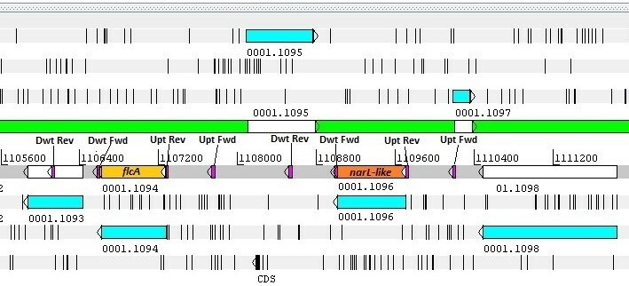
Fig. S3 Structural organization of the flcA and narL-like gene regions in the A. brasilense FP2 genome. Yellow and orange colors indicate the flcA and narL-like genes, respectively. Pink indicates the location of the primers designed upstream and downstream of the gene. The gene located between flcA and narL-like, id 0001.1095, encodes for a probable response regulator. Note: Upt = upstream; Dwt= downstream; Fwd= forward; Rev = reverse. Source: The author using the program Artemis version 16.0.0

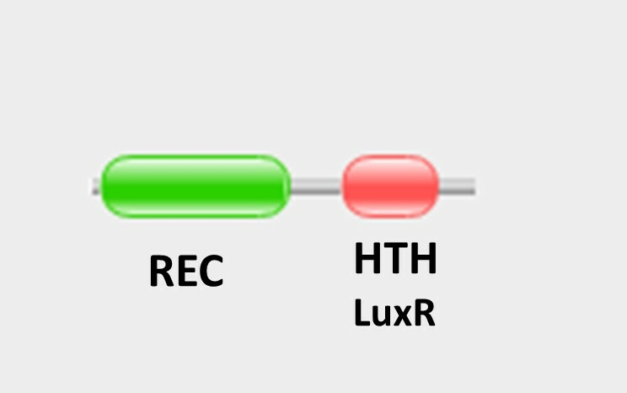

Fig. S4 NarL-like and FlcA protein domains.The abbreviation REC refers to the response receptor domain and HTH refers to the LuxR-type DNA-binding helix-turn-helix domain. Source: Pfam 31.0
Fig. S5 Population of A. brasilense adhering to the surface of wheat roots. Wheat seedlings were inoculated with the A. brasilense strains (10⁵ cells/seedling) and the number of CFUs (expressed in log) adhering to the root after washing was determined 30 min after inoculation
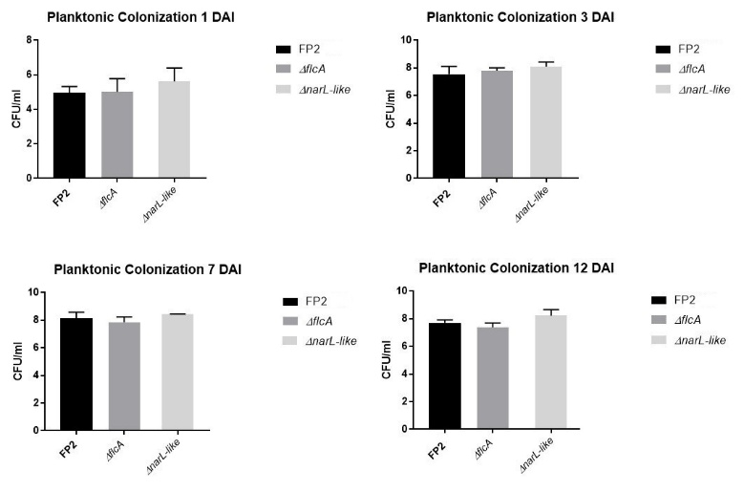
Fig. S6 Planktonic bacterial cell counts of wheat roots inoculated with A. brasilense strains. Wheat seedlings were inoculated with the A. brasilense strains (10⁵ cells CFU/seedling), and planktonic cell counts (CFU/ml medium) were determined at 1, 3, 7, and 12 DAI

Table S3 Statistical analysis for multiple comparisons between the treatments in the maize colonization assay

Multiple comparisons test  Adhesion assay in maize | Mean Diff. | 95.00% CI of diff. | Significant? | Summary | Adjusted P Value
FP2 vs. ΔnarL-like | -34790 | -52951 to -16629 | Yes | *** | 0.0005
FP2 vs. ΔflcA | 9860 | -11111 to 30830 | No | ns | 0.4849
Multiple comparisons test  Colonization 5 days in maize | Mean Diff. | 95.00% CI of diff. | Significant? | Summary | Adjusted P Value
FP2 vs. ΔnarL-like | -9930263 | -34357193 to 14496667 | No | ns | 0.5989
FP2 vs. ΔflcA | 2051690 | -21453134 to 25556514 | No | ns | 0.9917
Multiple comparisons test Colonization 7 days in maize | Mean Diff. | 95.00% CI of diff. | Significant? | Summary | Adjusted P Value
FP2 vs. ΔnarL-like | -5030363 | -10551055 to 490329 | No | ns | 0.0783
FP2 vs. ΔflcA | 1327733 | -4192959 to 6848424 | No | ns | 0.8708
In the analyses the Tukey´s test (p≤0.05) was used.

