- Supplementary methods
Blood samples
Blood samples were collected on acid-citrate dextrose (ACD) from patients with SCA (homozygous SS) and HDs (Etablissement Français du Sang (EFS)). Patients with SCA were children aged 3 to 17 years old, treated neither with HU nor chronic transfusions, and at a distance from any infection or vaso-occlusive event, having an exchange transfusion as preparation for surgery. Erythrapheresis blood bags were used for all experiments with CD34⁺ cells. All samples were processed within 8 hours. The study was approved by the French Ethical Evaluation Committee for Biomedical Research Projects (CPP n ° 2018-A02894-51). Consent was obtained from all participants prior to inclusion. The study adhered to the tenets of the Declaration of Helsinki. Demographic and biological parameters of patients included in this study are summarized in Table S5.
Isolation of CD34⁺ cells
Peripheral blood (PB) mononuclear cells (PBMCs) were purified from blood samples of HD and patients with SCA using a Ficoll density gradient separation (Pancoll 1.077 g/ml, PAN BIOTECH). PBMCs were treated with Ammonium-Chloride-Potassium (ACK) Lysing Buffer (ThermoFisher Scientific) for 5 minutes at 4°C to remove red blood cells and washed twice in PBS supplemented with 0.5% bovine serum albumin (BSA). Next, CD34⁺ cells were isolated using CD34MicroBead kit and cell separation columns following the supplier instructions (MACS Miltenyi Biotec). Briefly, PBMCs were incubated with anti-CD34 microbeads and FcR blocking reagent at 4°C for 30 minutes, then passed through a positive selection immunomagnetic LS column twice. CD34⁺ cell purity was analyzed by flow cytometry using an anti-human CD34 antibody (clone 563, BD Biosciences) on a FACS CantoII (BD Biosciences).

Human neutrophil isolation
Neutrophils were isolated from fresh whole blood within 4h after blood sampling using a MACSxpress Neutrophil Isolation Kit followed by a MACSxpress Erythrocyte Depletion Kit (Miltenyi Biotec, Paris, France) as previously described ¹.
Plasma analysis
Cytokines quantification was performed using the Luminex technique in accordance with the manufacturer’s instructions. Each plasma sample was tested in duplicate, and data were collected on a Human High Sensitivity Cytokine Luminex Performance Assay (R&D systems) and analyzed with Luminex xPonent Software.
Cell culture
Colony-forming assay. For colony-forming assays of CD34⁺ cells, 1.000 cells were plated in triplicate on 1.1 ml of Methocult™ H4435 Enriched (Stem Cell Technologies) containing SCF, IL3, IL6, EPO, GM-CSF, and G-CSF. After 14 days of culture at 37°C, CFU-GEMM, BFU-E, and CFU-GM colonies were counted.
For colony-forming assays of myeloid progenitors, 800 CMP and GMP, were sorted (see sorting section) directly in Methocult™ H4435 Enriched. Next, 200 cells were plated as triplicates in 1.1 ml of medium. After 14 days of culture at 37°C, CFU-GEMM, BFU-E, and CFU-GM colonies were counted.
For colony forming assay with IFNα (IFN-Alpha2B Human Recombinant, Tebubio), CD34⁺ cells were incubated overnight in serum-free StemSpan SFEM medium (Stem Cell Technologies) supplemented with IFNα (500U/mL) and StemSpan CD34⁺ expansion supplement (Stem Cell Technologies). Then, 1000 cells were plated as triplicates in 1.1 ml of Methocult™ SF H4436 (Stem Cell Technologies).
Ex-vivo granulopoiesis. CD34⁺ progenitors isolated from PB samples or sorted-CMP and GMP were cultured in serum-free StemSpan SFEM medium supplemented with 1% antibiotic-antimycotic (Gibco), 1% L-Glutamine (Gibco), SCF (50ng/mL) (Miltenyi Biotec), IL3 (10ng/mL) (Miltenyi Biotec), Flt3L (25ng/mL) (Peprotech), G-CSF (50ng/mL) (Nivestim) and 2% plasma for 19 days. Cells were diluted at a concentration of 3x10⁵/mL every 2-3 days. Myeloid differentiation was assessed by flow cytometry using surface proteins. For ex vivo granulopoiesis in presence of IFNα, CD34⁺ cells from patients with SCA were cultured in the same condition with IFNα (1ng/mL; IFN-Alpha2B Human Recombinant, Tebubio) from day 0. IFNα was added at every media change.
Flow cytometry
For all staining, cells were acquired on a FACSCanto II (BD Biosciences) using the Diva software (version 8.0.1) (BD Biosciences). Data were analyzed using FlowJo software (version 10) (BD Biosciences).
Surface staining. Expression levels of surface markers were monitored using antibodies listed in Table S6. Briefly, cells were washed in PBS-0.2% BSA and stained with cocktails of antibodies for 30 min at 4°C. Then, cells were washed twice, incubated with a viability marker (7-AAD or Sytox Blue), and analyzed.
Apoptotic cell staining. Apoptosis and necrosis were measured using Annexin V and Sytox blue. Briefly, 10⁵ cells were washed, resuspended in Annexin buffer (BD Biosciences), and stained with Annexin V for 20 min at room temperature (RT). Samples were then incubated with Sytox Blue and directly analyzed.
Cell cycle analysis. Cell cycle of myeloblasts was assessed with the cell-permeant DNA binding dye CytoPhase Violet (Biolegend). Briefly, 10⁵ cells were incubated with CytoPhase Violet (1:500) for 90 minutes in the culture media. Next, cells were directly analyzed by flow cytometry.
Cell-sorting
Multicolor flow cytometry was performed on CD34⁺ cells to characterize and sort CMP and GMP progenitors. Antibodies used are listed in Table S6. Briefly, 0.5-1 million cells were washed in PBS-0.2% BSA and incubated with anti-human CD34, CD38, CD123, and CD45RA antibodies for 30 min at 4°C. Cells were washed once, resuspended in PBS-0.2% BSA, and analyzed immediately on a Sony MA900 (Sony). CMP and GMP were sorted for colony-forming assays and ex vivo granulopoiesis.
Western Blot
Purified neutrophils or myeloblasts isolated at different days of ex-vivo granulopoiesis were lysed in 100 mM Tris/HCl (pH8.5), SDS 2%, 1 mM PMSF, Phosphatase Inhibitor 3 (Sigma) and complete EDTA-free (Roche). The total protein concentration was determined by the BCA method (Pierce, Thermo Fisher Scientific) and 50 μg of proteins were separated in reduced conditions in 4-15% SDS-PAGE using TGX Stain-Free Precast Gel (Biorad). Next, gels were imaged using the stain-free application on ChemiDoc MP (Biorad) to normalize loaded proteins and then transferred to nitrocellulose membranes with the Trans-Blot Turbo Transfer System (Biorad). Membranes were blocked and incubated overnight with anti-KLF4 (1:100, sc-393462, Santa Cruz Biotechnology), anti-ISG15 (1:500, MAB 4845, R&D Systems), anti-IFIT1 (1:2000, PA3-848, Thermofisher Scientific), anti-MX1 (HPA030917 – Sigma 0,4µg/ml), or anti-Stat1 (clone 10C4B40 – Biolegend 1µg/ml) antibodies. Immune complexes were revealed with secondary peroxidase-conjugated antibodies (Jackson ImmunoResearch), using Clarity Western ECL Substrate (Biorad). Protein expressions were normalized based on total protein in each sample.
Quantitative PCR.
Total RNA from isolated Neutrophil were extracted using the TRIzol (Invitrogen) procedure. The RNA yield were determined by absorbance and the reverse transcription was performed on 10 ng of RNA using the High-Capacity cDNA Reverse Transcription Kit (Applied Biosystems, Foster City, CA) according to the manufacturer’s instructions. ABsolute Blue qPCR SYBR Green Mix (Thermo Fisher Scientific) was then used to amplify specific cDNA fragments in the CFX96 Real Time System (Bio-Rad) using following primers (Sequence (5’- >3’)): Stat1: F : AATCTGTCCTTCTTCCTGACTC/R :GTTCTTTCTTCGTGTAGGGTTC;MX1:F:CTTGTGAACGAAGATAAGTGGAG/R :GTTATGCCAGGAAGGTCTATTAG;IFIT1:F :GGAGCAATATACTAGGACTGAG/R :GAGACCATAACGGATAACAATG;ISG15: F:ATGTCGGTGTCAGAGCTGAA/R:AGGATGCTCAGAGGTTCGTC.
May-Grünwald Giemsa staining (MGG)
Cytospins were performed using 10⁵ cells. Slides were stained for 5 minutes with May-Grünwald pure solution (Sigma), with May-Grünwald diluted solution for 5 minutes, and then with Giemsa solution (Sigma) for 15 min. Next, slides were washed three times in water. Pictures of cells were taken with a Nikon Eclipse Ti-S inverted microscope. For each condition, 100 cells were characterized and identified either as a monocyte or neutrophil precursor.
Single-cell RNA sequencing
Sample preparation. CD34⁺ cells frozen in SVF-10% DMSO were thawed, filtered, washed twice in PBS 0.04%BSA, and then resuspended in 100 μL PBS 0.04%BSA. Cell viability was assessed using an automated cell counter (Countess 300, Invitrogen).
Library preparation and sequencing. CD34⁺ cells were loaded on a Chromium Single Cell Chip (10x Genomics) following the supplier instructions for co-encapsulation with barcoded gel beads using a Chromium Controler (10x Genomics), at a target capture rate of 10.000 cells per sample. Following cell lysis, captured mRNAs were barcoded during cDNA synthesis using Chromium Next GEM Single Cell 3’GEM, Library and Gel Bead kit v3.1 (10xGenomics) according to the supplier’s instructions. The resulting libraries were prepared and pooled for sequencing in an Illumina flow cell. All libraries were sequenced with a 10-base index read (dual index), a 28-base Read1 containing cell-identifying barcodes and unique molecular identifiers (UMIs), and a 90-base Read2 containing transcript sequences, on an Illumina NovaSeq 6000 at Gustave Roussy (France). The scRNAseq reads were pseudoaligned to the GRCh38 (hg38) reference genome kallisto (version 0.46.2) ² using its 'bus' subcommand and parameters corresponding to the 10X Chromium 3' scRNA-Seq v3 chemistry. The index was made with the kb-python (version 0.24.4) wrapper of kallisto. Barcode correction using whitelist provided by the manufacturer (10X Genomics) and gene-based reads quantification was performed with BUStools (version 0.40.0) ³. For each sample, 12-14% of reads were pseudoaligned to a unique sequence.
Cell quality control. Cell barcodes were loaded in R (version 4.1.0) using the BUSpaRse package (version 1.7.1). Empty droplets were removed from the analysis using the dropletUtils package (emptyDrops () function) ⁴, while multiplet droplets were excluded using the scDblFinder and scds methods ⁵. Furthermore, genes detected in less than 5 cells, cells expressing less than 1.000 UMIs or fewer than 200 genes, and cells expressing more than 15% of mitochondrial genes were discarded.
Integration, dimension reduction, visualization and clustering. Datasets were integrated using the Harmony method ⁶: datasets were merged by the merge() function from Seurat (version 4.0.4), and the SCTransform normalization method was used to normalize, scale, and select 3000 Highly Variable Genes ⁷. Following integration, dimension reduction techniques implemented in Harmony package (version 0.1.0) were used. Specifically, the number of Harmony dimensions to keep for further analysis was evaluated by assessing a range of reduced Harmony spaces using 3 to 49 dimensions, with a step of 2. For each generated Harmony space, Louvain clustering of cells was performed at several resolutions. Results were visualized through a Uniform Manifold Approximation and Projection (UMAP). Dimension 11 and clustering 0.4 were chosen as they yielded the best clusters' homogeneity and compacity.
Annotation. The Louvain clusters were automatically annotated using Single R (version 1.6.1) ⁸and cluster marker genes. Marker genes were identified through a «one versus others» differential analysis using the Wilcoxon test through the FindAllMarkers() function from Seurat, considering only genes with a minimum log fold-change of 0.5 in at least 75% of cells from one of the clusters compared, and FDR-adjusted p-values <0.05 (Benjaminin-Hochberg method). In supplement, sc-RNAseq gene sets established from PB HSPCs by Mende et al. were used for cluster identification ⁹.
Differential expression analysis. Differential expression analysis was performed between clusters from SCA group compared to HD group, using the Wilcoxon test, via the FindMarkers() function in Seurat. Only genes expressed in at least 25% of cells from one group and with adjusted p-values < 0.05 were considered differentially expressed. Cerebro, a cell report browser, was used to visualize UMAP and histograms of gene expression interactively.
CS score. The co-expression relationship was assessed by CS-CORE statistical approach (version 0.0.0.9000). 5000 genes corresponding to the most expressed genes (based on the mean expression) were used for this analysis. CS-CORE was applied, on each condition separately, to calculate the coexpression scores between the 5000 genes, then the WGCNA algorithm (version 1.73) was used to group significantly coexpressed genes (Benjamini & Hochberg-adjusted p-values > 0.05) into modules ¹⁰. Then, a Gene Ontology enrichment analysis was carried out on the genes of each module with the clusterProfiler R package (version 4.2.2) in order to identify the signaling pathways. A Benjamini & Hochberg correction was applied on pathway p-values, and only pathways with an adjusted p-value > 0.05 were interpreted.
Proteomic
Neutrophil proteomic sample preparation and analysis were performed as previously described ¹¹. Briefly, purified neutrophils were lysed and sonicated in Tris-HCl/SDS buffer. Proteins were reduced with TCEP, alkylated with chloroacetamide, and digested with trypsin using the FASP protocol. Peptides were fractionated using SCX StageTips and analyzed by LC-MS/MS on an Orbitrap Fusion mass spectrometer (Thermos Scientific). Raw data were processed with MaxQuant (v1.6.1.0) using default parameters, including carbamidomethylation of cysteines as a fixed modification and methionine oxidation and N-terminal acetylation as variable modifications. Label-free quantification (LFQ) was performed with a minimum of two peptides per protein. Statistical analyses were conducted in Perseus (v1.6.2.3)
Statistical analysis
Longitudinal statistical analysis. First, a descriptive analysis of patients’ individual and biological characteristics was performed. Qualitative variables were described using numbers and percentages and quantitative variables were described with means (95% confidence interval) in figures and median (quartiles) in tables. The evolution of the children's biological parameters (Neutrophils, HbF, reticulocytes) over time was represented graphically. Next, we constructed mixed models for repeated measures to investigate the mean evolution of the neutrophil count over time (i.e. according to age range) and to evaluate the association with the explanatory variables (reticulocyte count, HbF level). These models considered the correlation between patients’ measures in the parameter estimation. Results are presented with beta coefficient and 95% confidence interval. Successive models were constructed to compare the association of explanatory variables (including age ranges by pair) with neutrophil count. Analyses were performed on complete cases. P-values less than 0.05 were considered statistically significant. The analyses were conducted using SAS 9.4 software.
Other statistical analysis. Statistical analyses were performed using GraphPad Prism (version 8). Comparisons were made using unpaired t-test, Mann-Whitney test, one-way ANOVA or two-way ANOVA, as mentioned in the legends. P-values less than 0.05 were considered statistically significant.

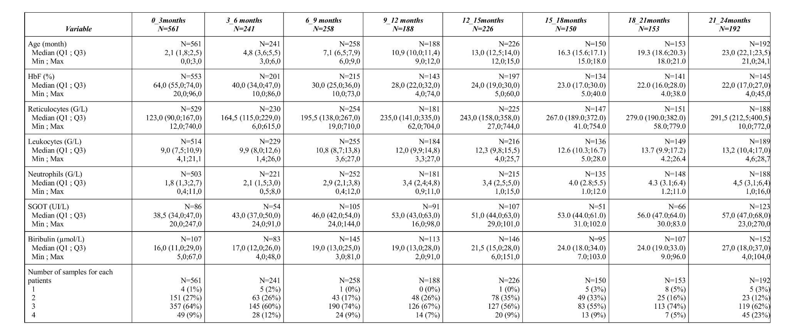
- Supplementary tables

Table S1. Description of the evolution of HbF, reticulocytes, leukocytes, neutrophils, SGOT, and bilirubin from 1 to 24 months in patients with SCA. HbF: fetal hemoglobin; SGOT: Serum glutamic-oxaloacetic transaminase. G/L = 10⁹/L. Median, Q1 and Q3 are shown.
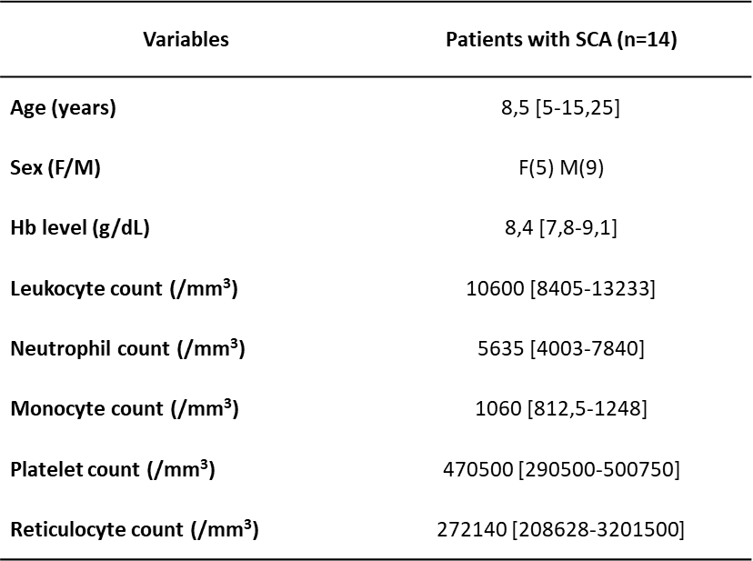
Table S5. Demographic and hematological parameters of patients with SCA. Median, Q1 and Q3 are shown.

Antibody | Fluorescence | Clone | Dilution | Supplier | Reference
CD34 | PE | 563 | 1/20 | BD Biosciences | 550761
CD38 | BV421 | HIT2 | 1/20 | BD Biosciences | 562444
CD123 | APC | 6H6 | 1/20 | Biolegend | 306011
CD45RA | FITC | HI100 | 1/20 | BD Biosciences | 555488
CD36 | PE-Cy7 | NL07 | 1/50 | Invitrogen | 25-0369-42
CD11b | APC | ICFR44 | 1/20 | Biolegend | 301310
CD62L | PeCy7 | DREG-56 | 1/20 | BD Biosciences | 565535
CD14 | FITC | M5E2 | 1/50 | BD Biosciences | 561712
SYTOX blue | Pacific Blue | N/A | 1/200 | Invitrogen | S34857
7AAD | PerCP | N/A | 1/100 | BD Biosciences | 559925
Annexin V | PE | N/A | 1/100 | BD Biosciences | 51-65875X
Table S6. Antibodies used for flow cytometry. N/A=not applicable

- Supplementary figures
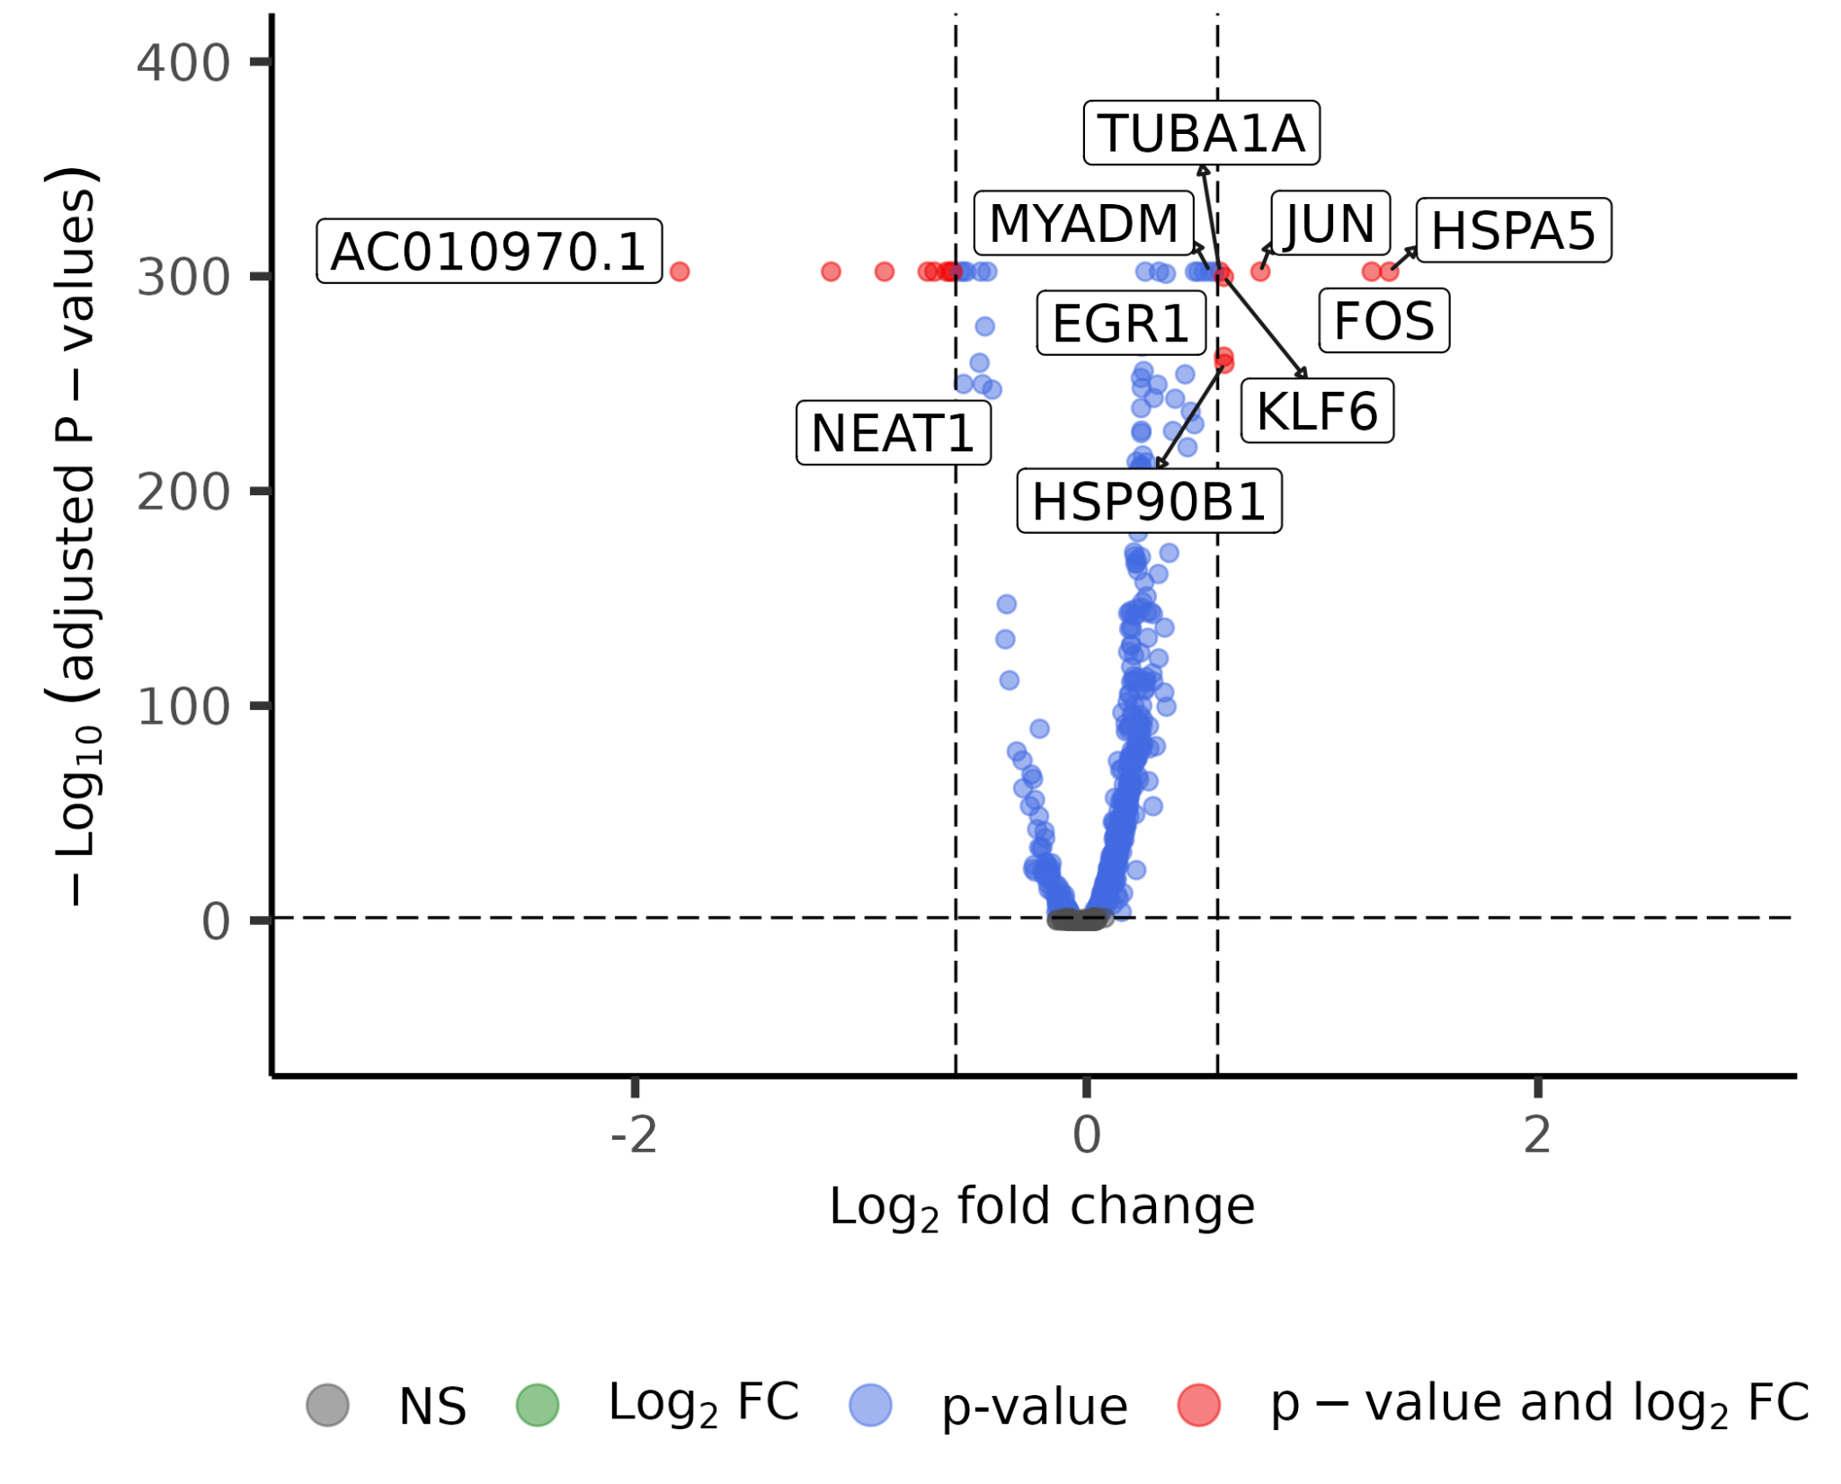
Figure S1. Volcano plot of upregulated and downregulated genes in CMP1 versus CMP2 (Wilcoxon test).

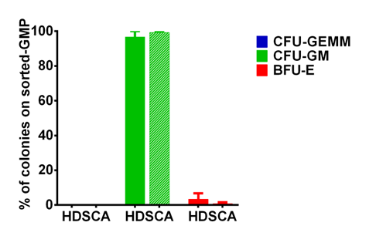
Figure S2. GMP from HD (n=3) and patients with SCA (n=4) were FACS-sorted based on CD34, CD38, CD123 and CD45RA and grown on Methocult™. Histograms represent the proportion of CFU-GEMM, CFU-GM, and BFU-E colonies at day 14. Statistical analysis performed using Mann-Whitney test did not show any significant difference.

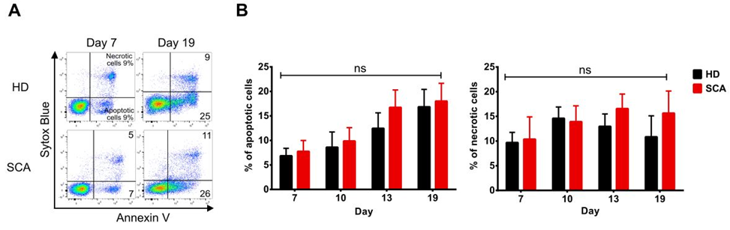
Figure S3. (A) Representative dot plots of apoptotic and necrotic cells monitored by Annexin V and Sytox Blue, at days 7 and 19 of HD and SCA ex vivo granulopoiesis. (B) Percentages of apoptotic (AnnexinV⁺Sytox Blue⁻) and necrotic (AnnexinV⁺Sytox Blue⁺) cells from HD (n=5) and SCA (n=4) ex vivo granulopoiesis, at days 7, 10, 13, and 19 of differentiation. Statistical analysis was performed using a Mann-Whitney test ; ns=non-significant.

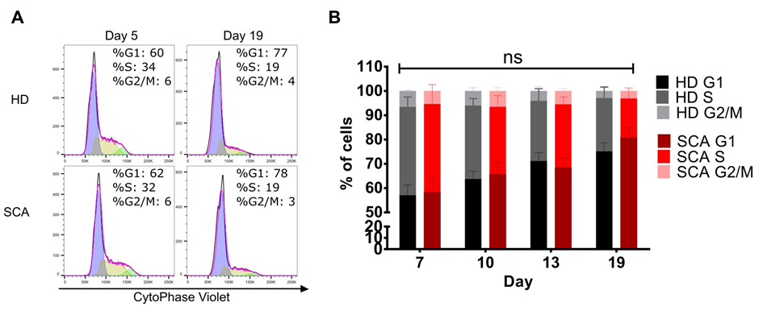
Figure S4. (A) Cell cycle was assessed by CytoPhase Violet staining at indicated days of HD and SCA ex vivo granulopoiesis. G1, S and G2/M phases are pictured in blue, yellow and green, respectively. (B) Percentages of cells in G1, S and G2/M phases are plotted in bar histograms at days 7, 10, 13, and 19 of HD and SCA ex vivo granulopoiesis. Statistical analysis was performed using a Mann-Whitney test; ns=non-significant.

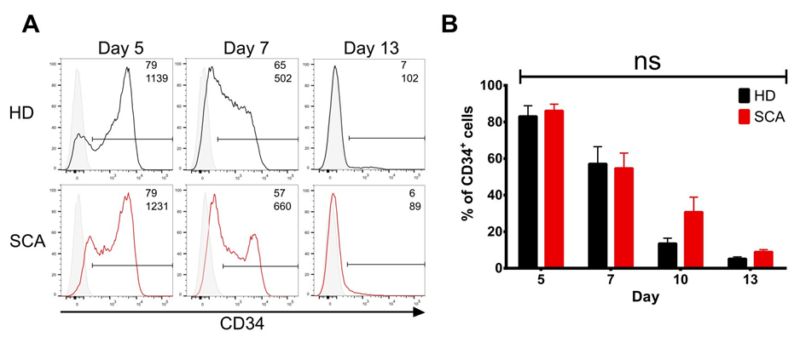
Figure S5. (A) Peak histograms of CD34 expression on cells from HD and SCA ex vivo granulopoiesis at indicated days. Grey histograms represent unstained controls. (B) Percentages of CD34-positive cells are plotted at days 5, 7, 10, and 13 with corresponding group color. Statistical analysis was performed using a Mann-Whitney test; ns=non-significant.

- Supplemental references
1. Koehl, B. et al. The endothelin B receptor plays a crucial role in the adhesion of neutrophils to the endothelium in sickle cell disease. Haematologica 102, 1161–1172 (2017).
2. Bray, N. L., Pimentel, H., Melsted, P. & Pachter, L. Near-optimal probabilistic RNA-seq quantification. Nat Biotechnol 34, 525–527 (2016).
3. Melsted, P., Ntranos, V. & Pachter, L. The barcode, UMI, set format and BUStools. Bioinformatics 35, 4472–4473 (2019).
4. Lun, A. T. L. et al. EmptyDrops: distinguishing cells from empty droplets in droplet-based single-cell RNA sequencing data. Genome Biology 20, 63 (2019).
5. Bais, A. S. & Kostka, D. scds: computational annotation of doublets in single-cell RNA sequencing data. Bioinformatics 36, 1150–1158 (2020).
6. Korsunsky, I. et al. Fast, sensitive and accurate integration of single-cell data with Harmony. Nat Methods 16, 1289–1296 (2019).
7. Hafemeister, C. & Satija, R. Normalization and variance stabilization of single-cell RNA-seq data using regularized negative binomial regression. Genome Biology 20, 296 (2019).
8. Aran, D. et al. Reference-based analysis of lung single-cell sequencing reveals a transitional profibrotic macrophage. Nat Immunol 20, 163–172 (2019).
9. Mende, N. et al. Unique molecular and functional features of extramedullary hematopoietic stem and progenitor cell reservoirs in humans. Blood 139, 3387–3401 (2022).
10. Langfelder, P. & Horvath, S. WGCNA: an R package for weighted correlation network analysis. BMC Bioinformatics 9, 559 (2008).
11. Hermand, P. et al. The proteome of neutrophils in sickle cell disease reveals an unexpected activation of interferon alpha signaling pathway. Haematologica 105, 2851–2854 (2020).

