Effective alternative host-guest separation strategies for mixed pyridine/methylpyridines with thioxanthenyl- and xanthenyl-derived host molecules

Danica B. Trollip,*ª Benita Barton,*ª Mino R. Caira*^{b} and Eric C. Hostenª

ªDepartment of Chemistry, PO Box 77000, Nelson Mandela University, Gqeberha (Port Elizabeth), 6031, South Africa. E-mail: s217468225@mandela.ac.za and benita.barton@mandela.ac.za.
^{b}Department of Chemistry, University of Cape Town, Rondebosch 7701, South Africa. E-mail: mino.caira@uct.ac.za

a) | 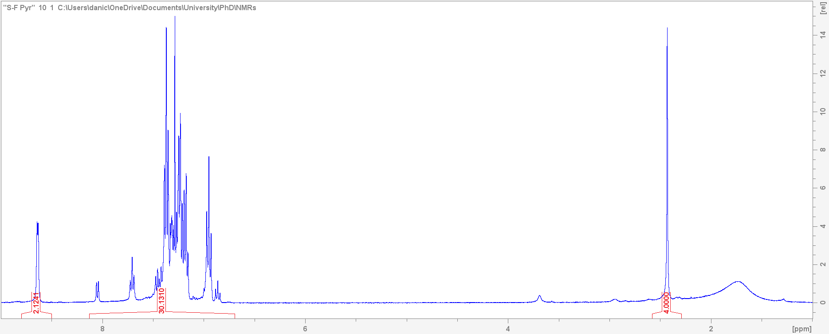 | b) |  | 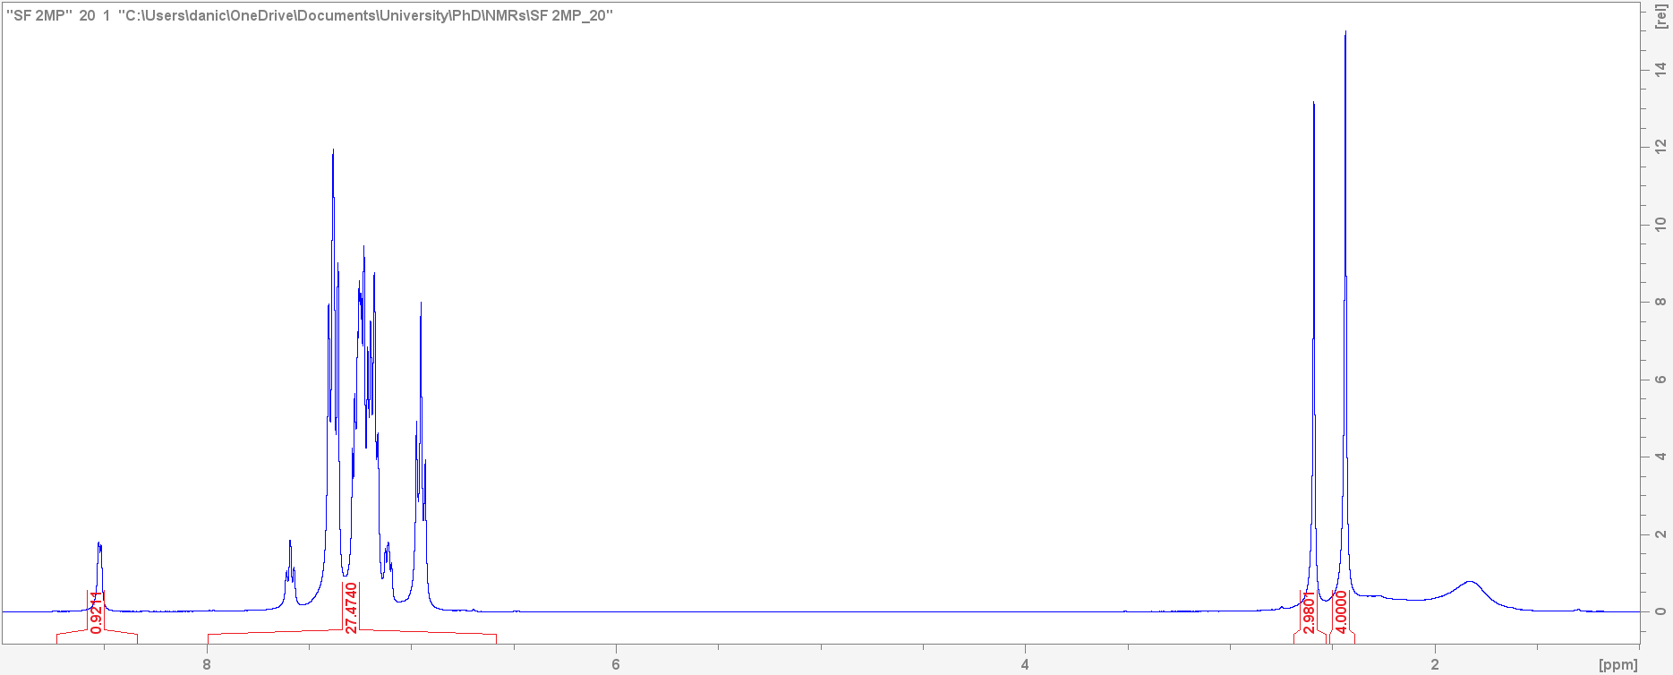
c) | 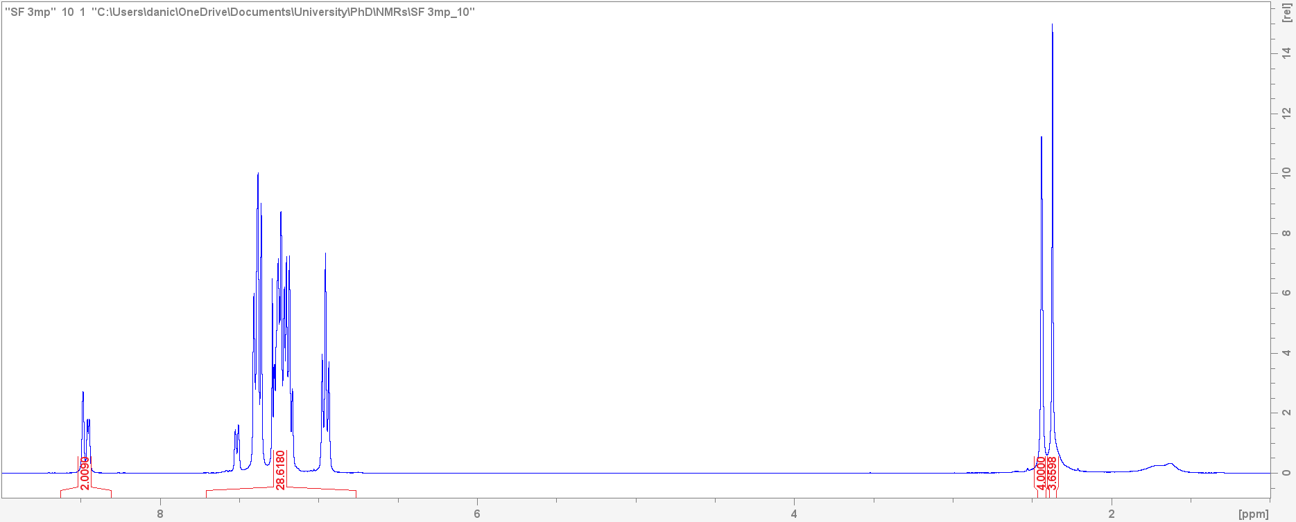 | d) |  | 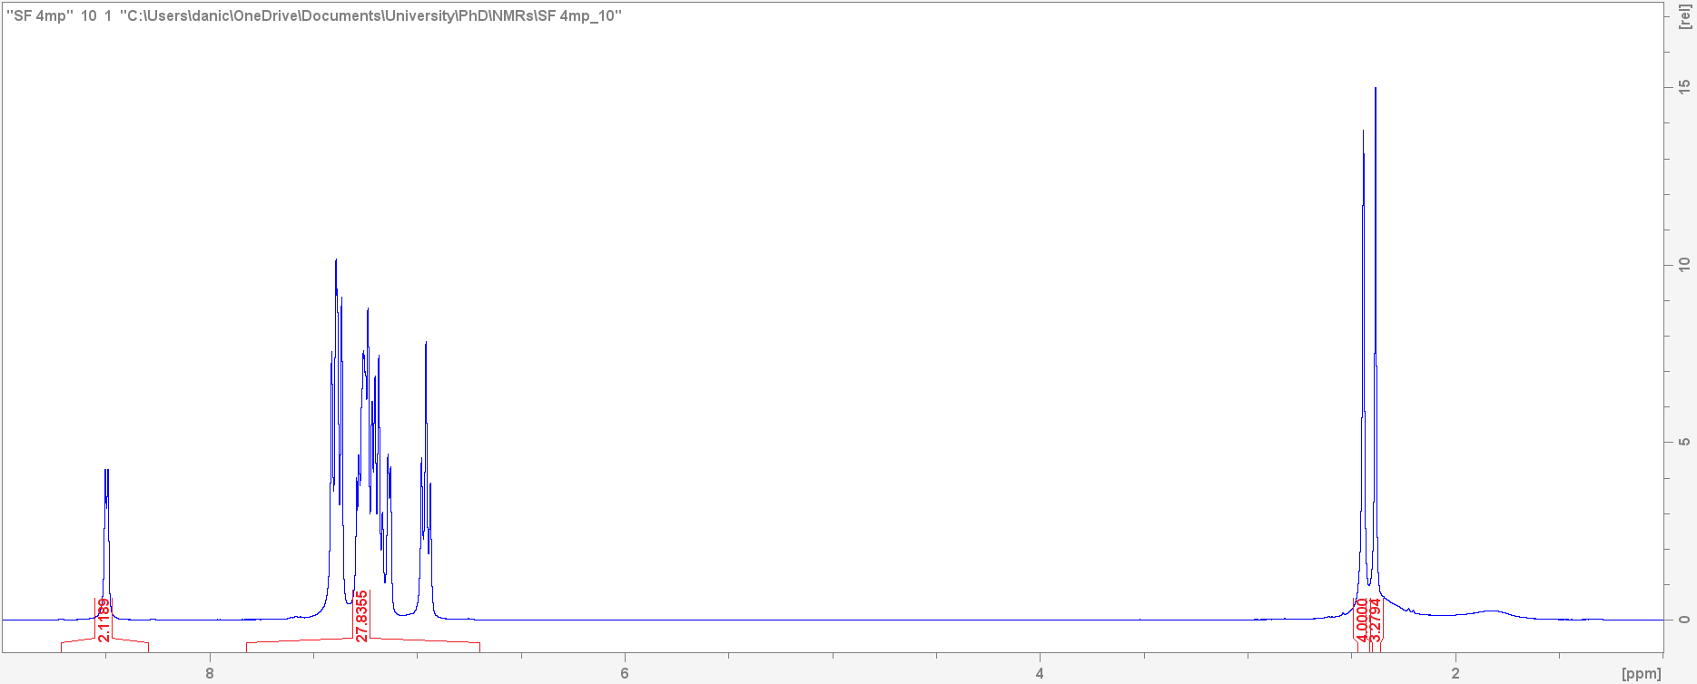
Figure S1 ¹H NMR for complexes a) H1·PYR, b) H1·2MP, c) H1·3MP and d) H1·4MP
a) | 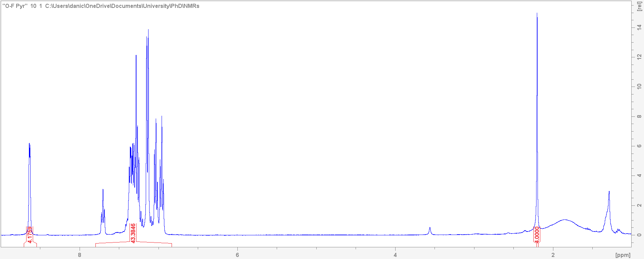 | b) |  | 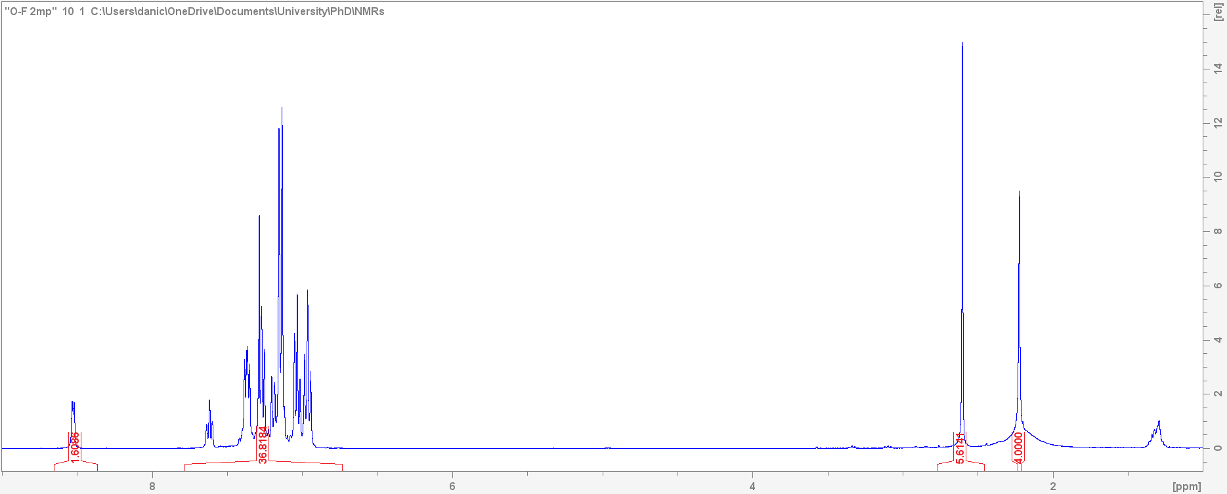
c) | 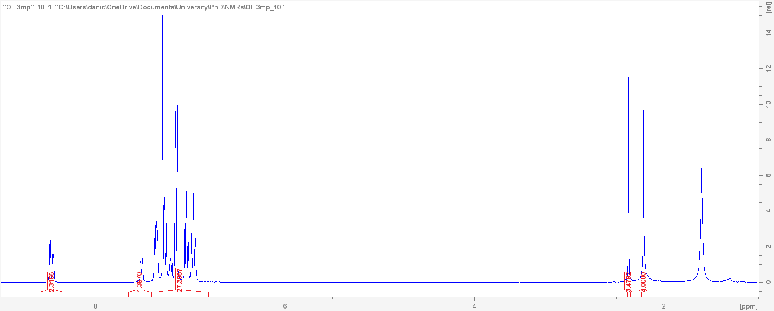 | d) |  | 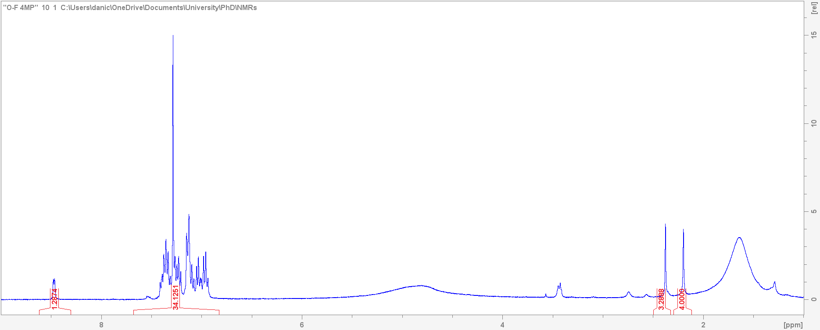
Figure S2 ¹H NMR for complexes a) H2·4(PYR), b) H2·2(2MP), c) H2·3MP and d) H2·4MP
a) | 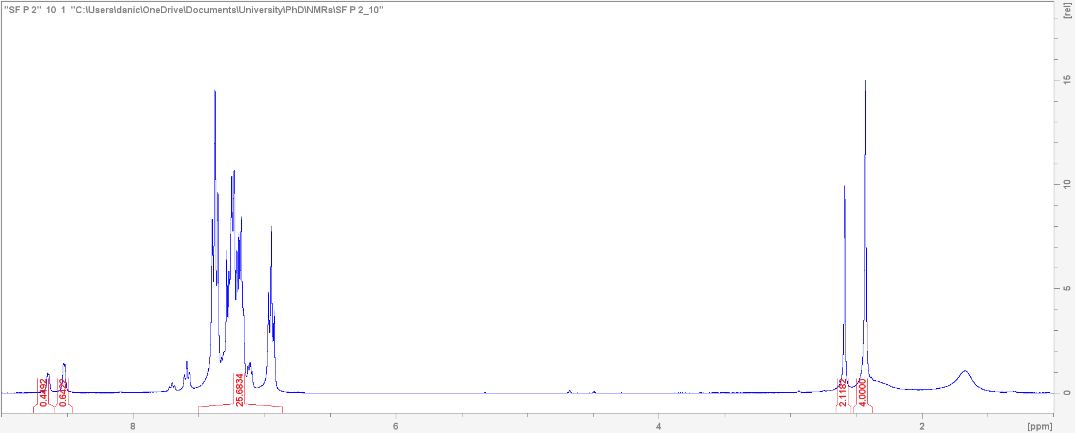 | b) |  | 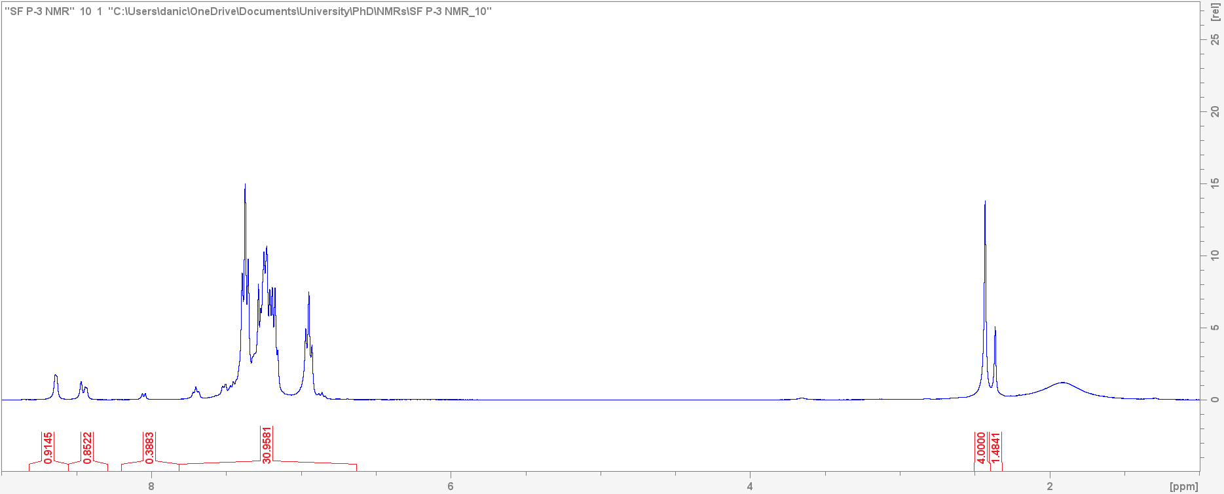
c) | 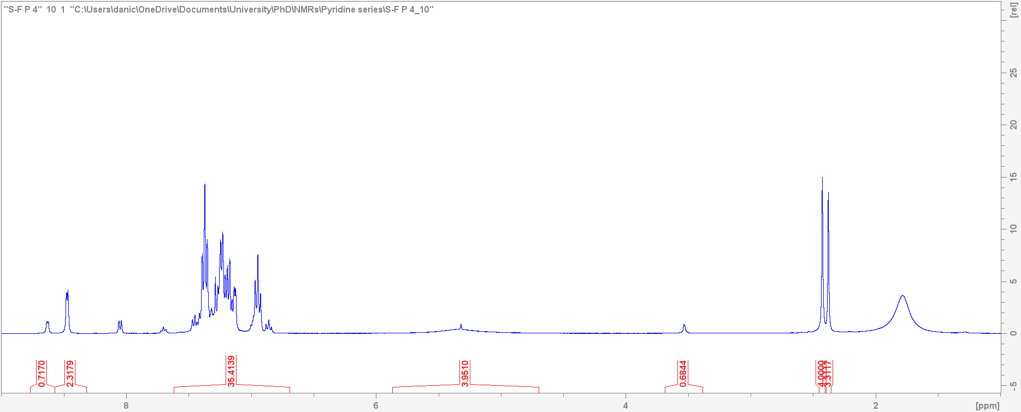 | d) |  | 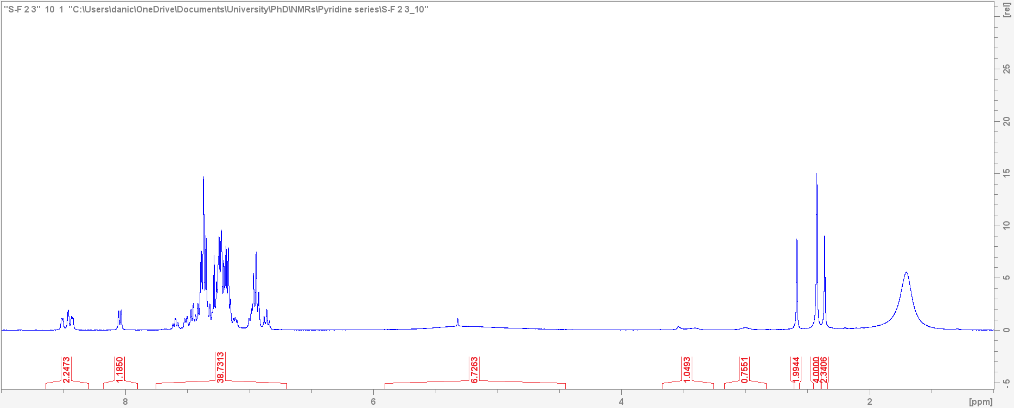
e) | 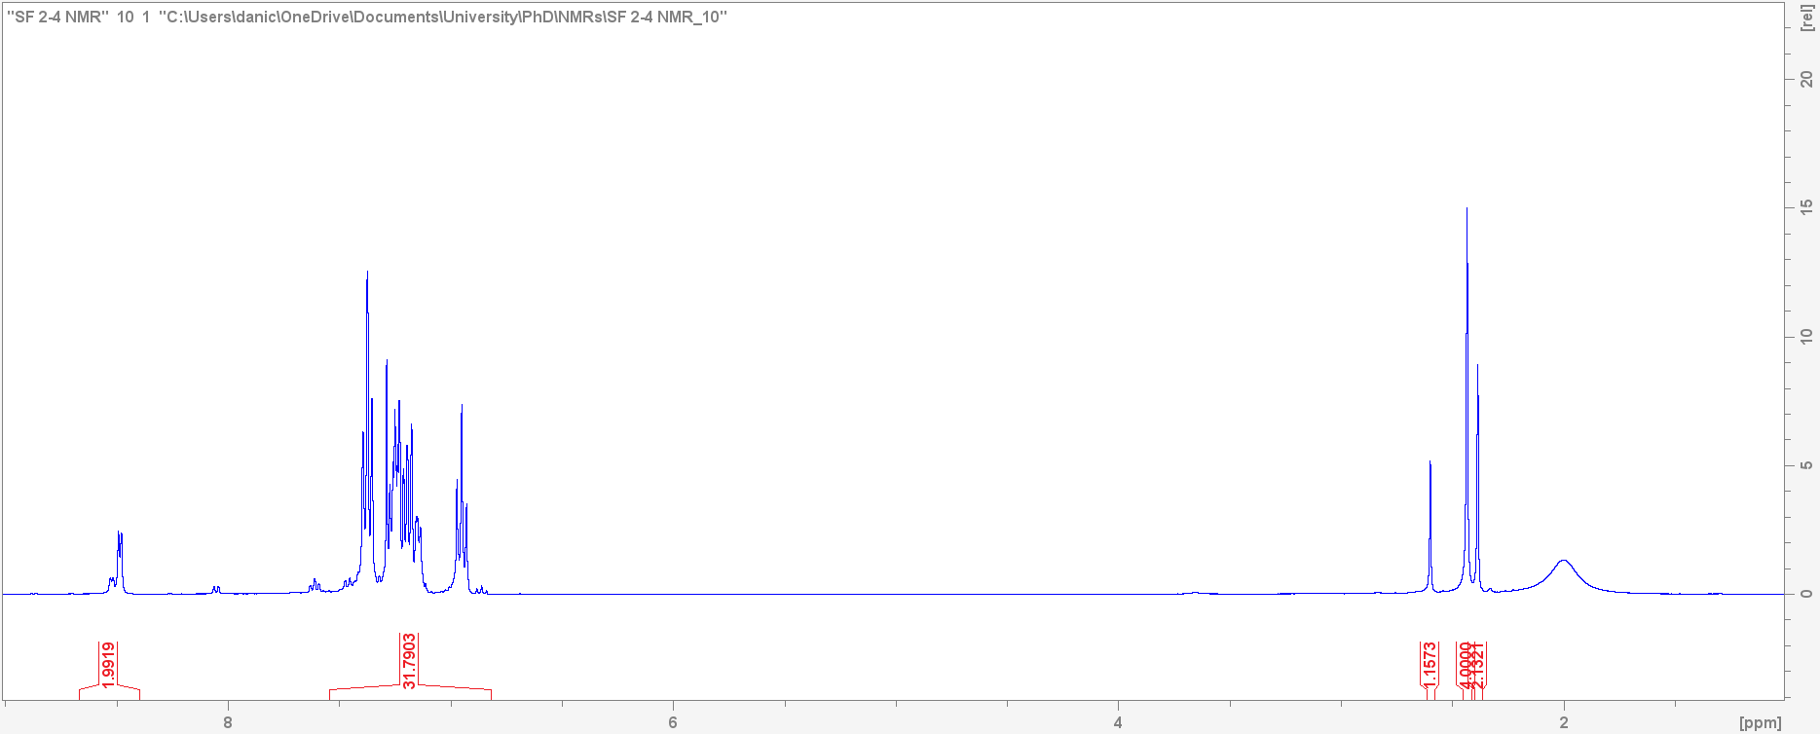 | f) |  | 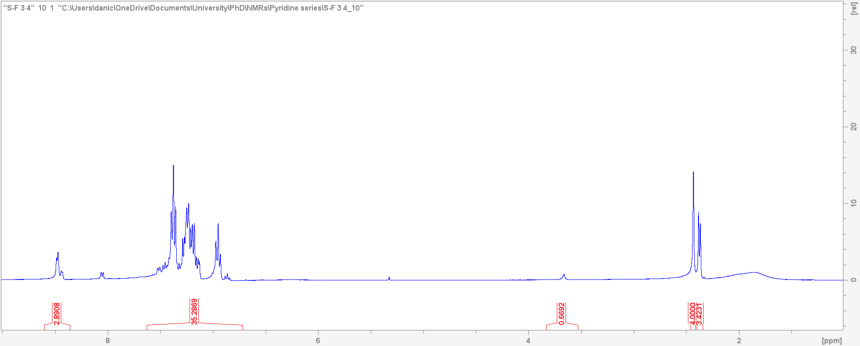
g) | 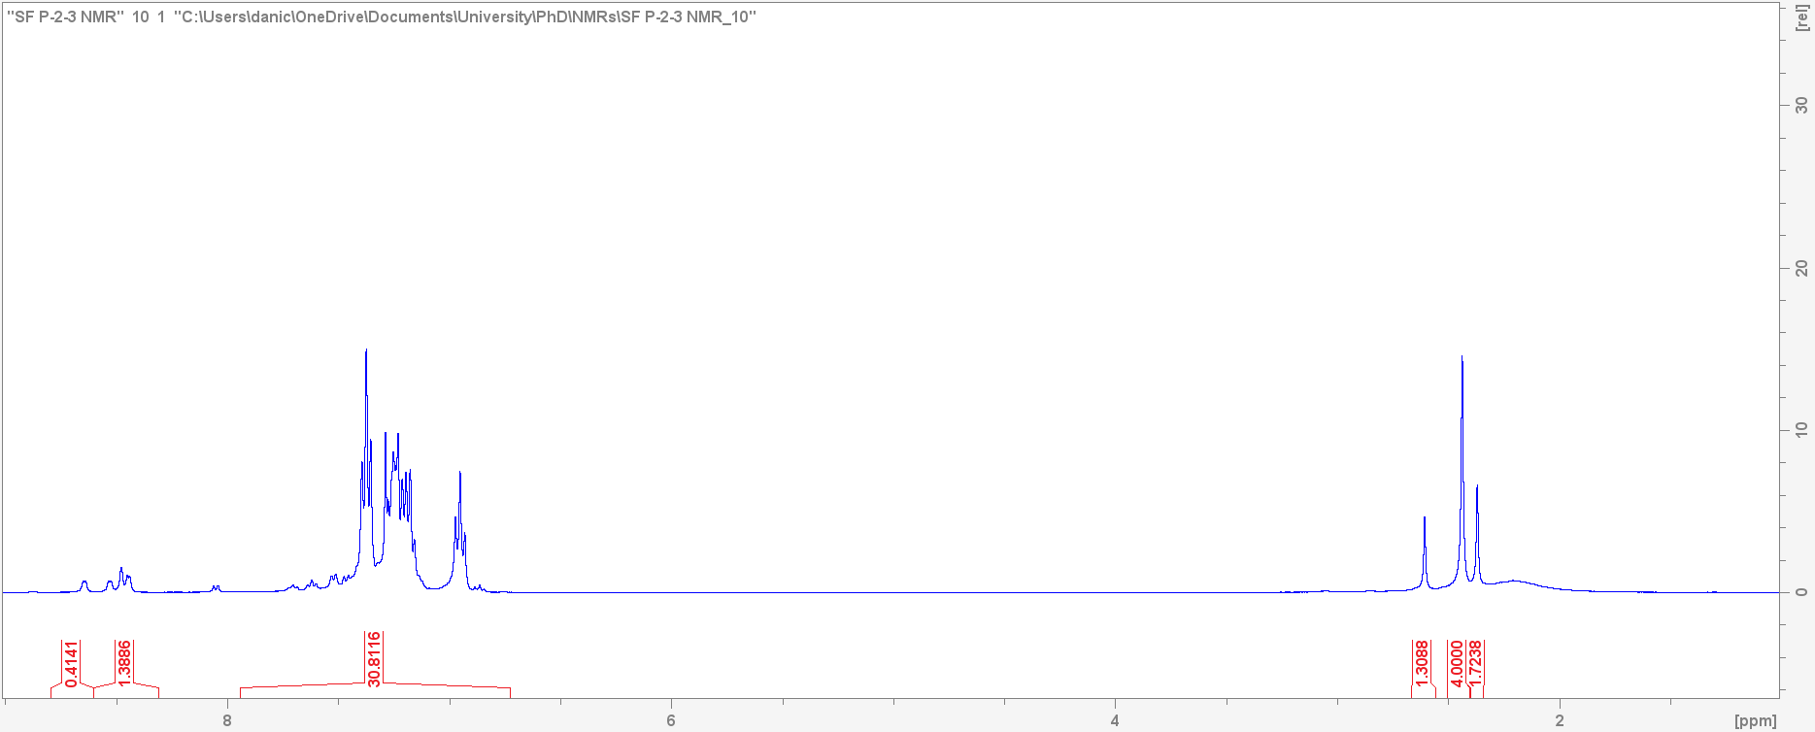 | h) |  | 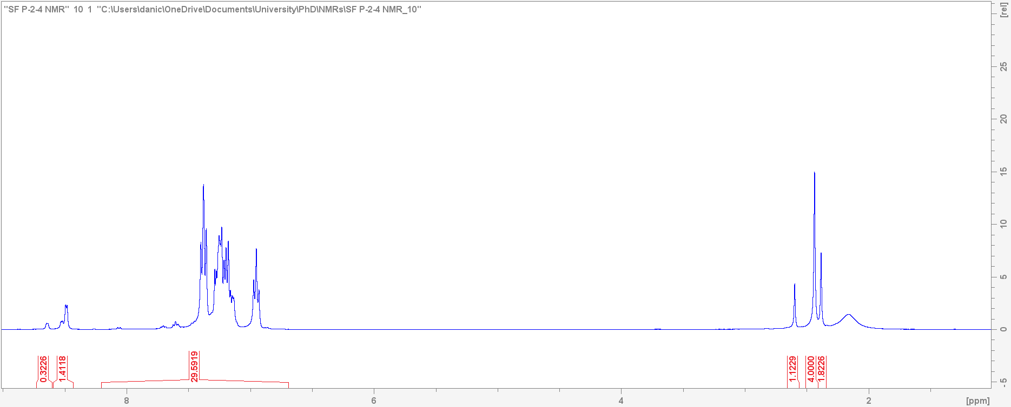
i) | 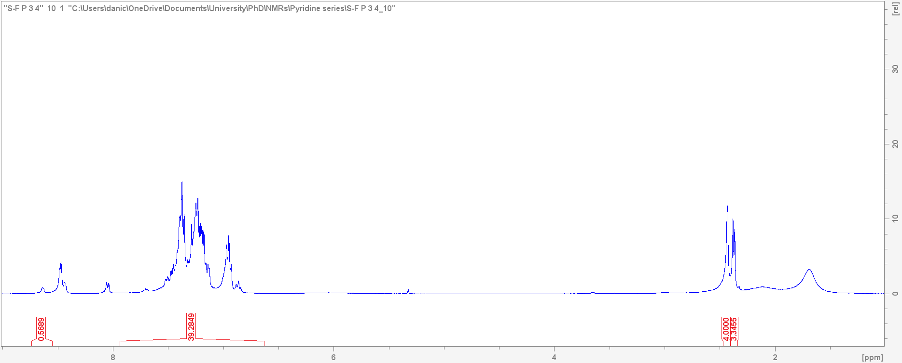 | j) |  | 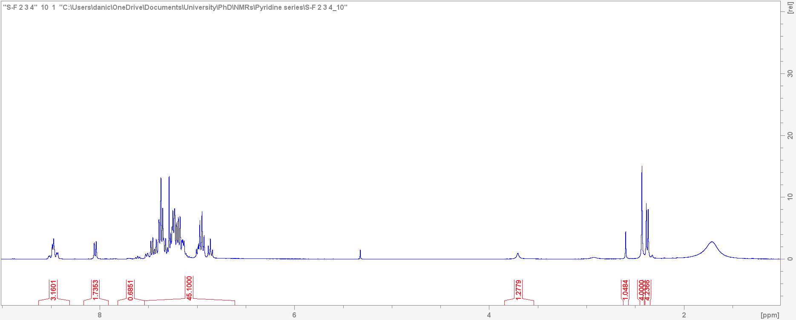
k) | 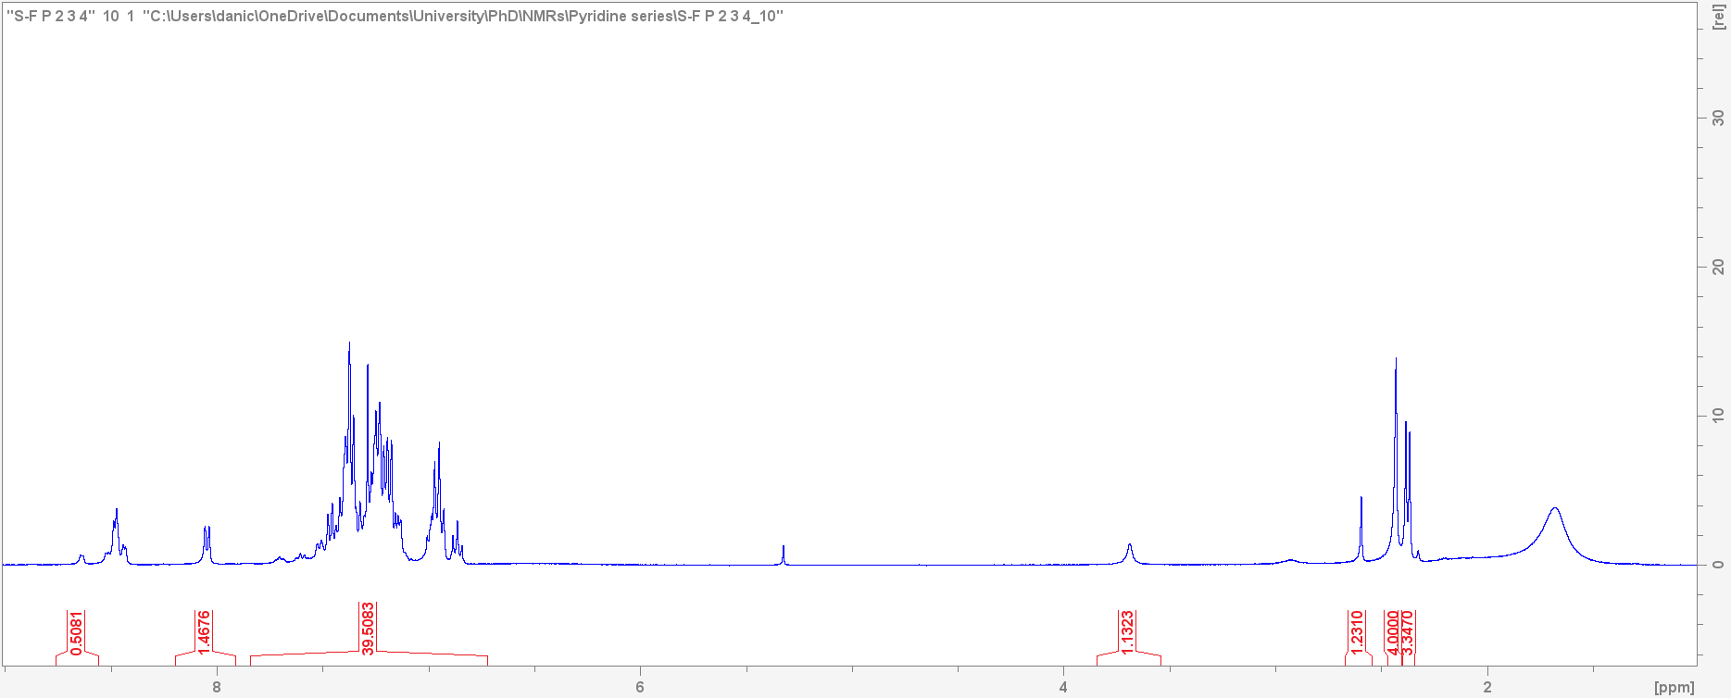
Figure S3 Host compound H1 ¹H NMR for equimolar mixtures a) PYR/2MP, b) PYR/3MP, c) PYR/4MP, d) 2MP/3MP, e) 2MP/4MP, f) 3MP/4MP, g) PYR/2MP/3MP, h) PYR/2MP/4MP, i) PYR/3MP/4MP, j) 2MP/3MP/4MP and k) PYR/2MP/3MP/4MP.
a) | 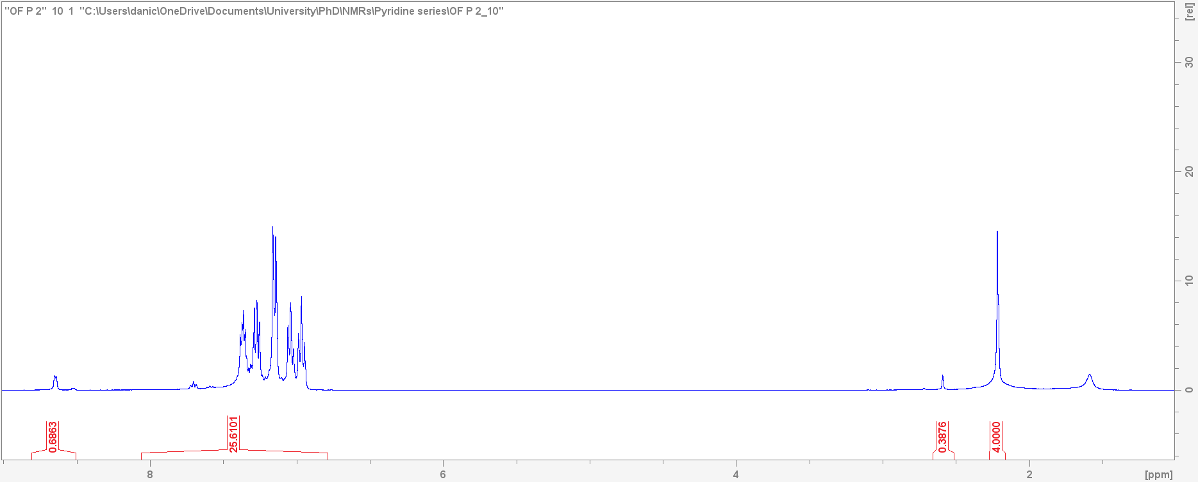 | b) |  | 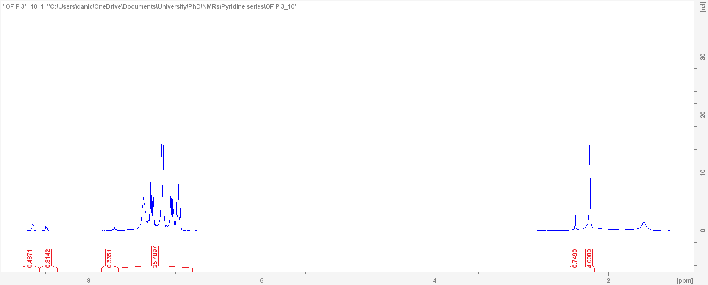
c) | 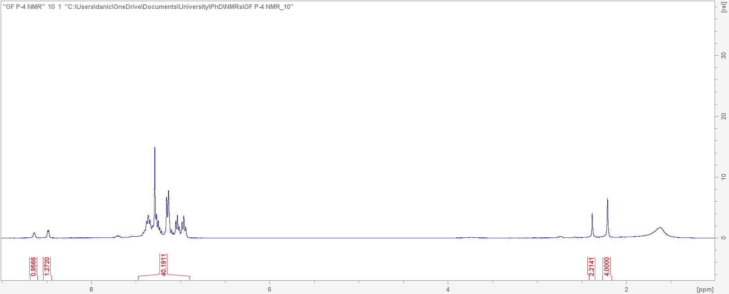 | d) |  | 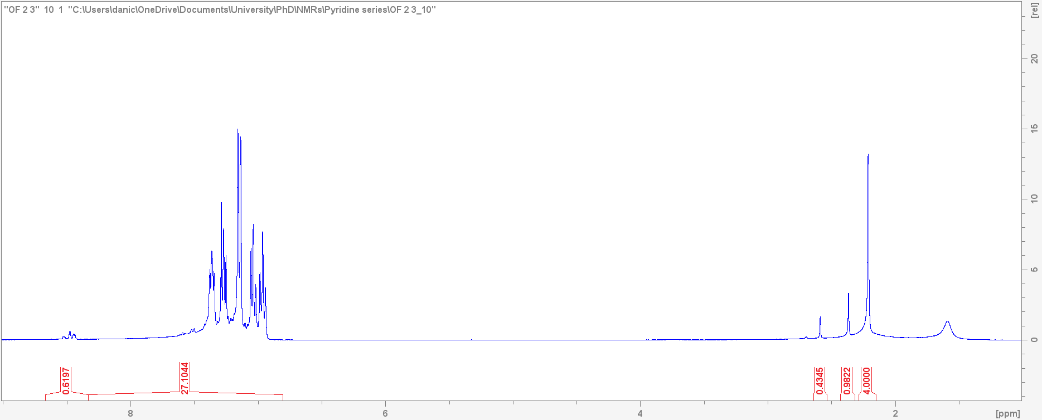
e) | 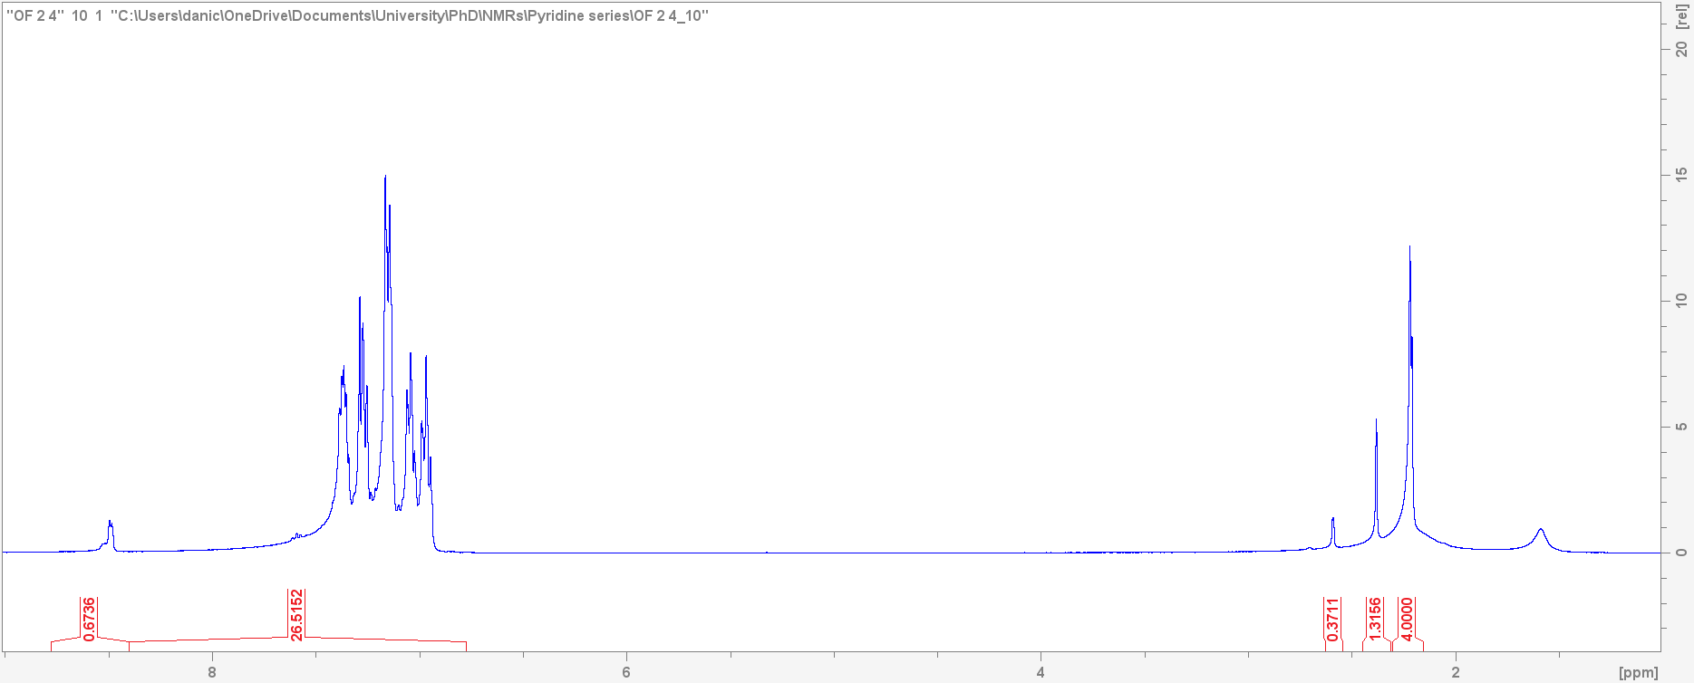 | f) |  | 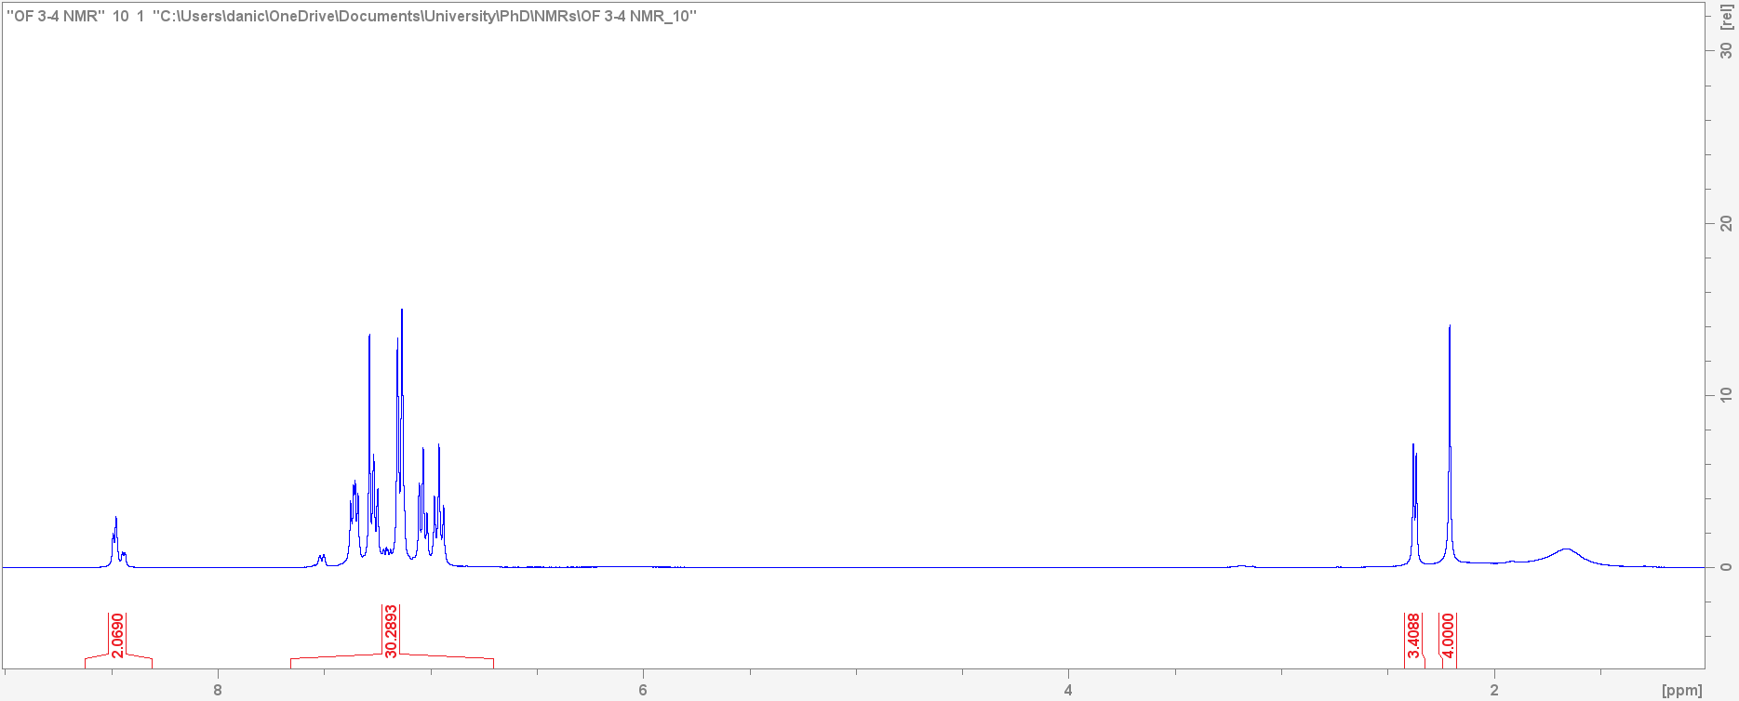
g) | 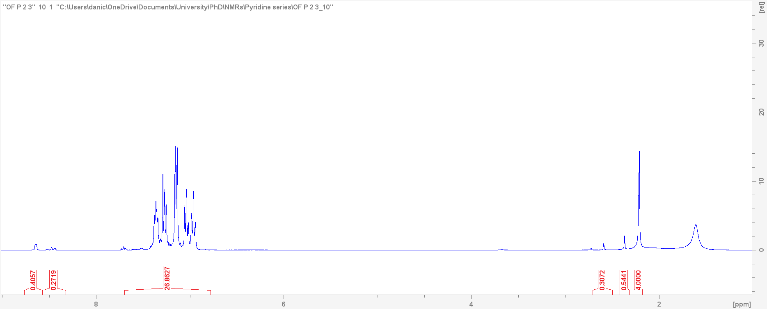 | h) |  | 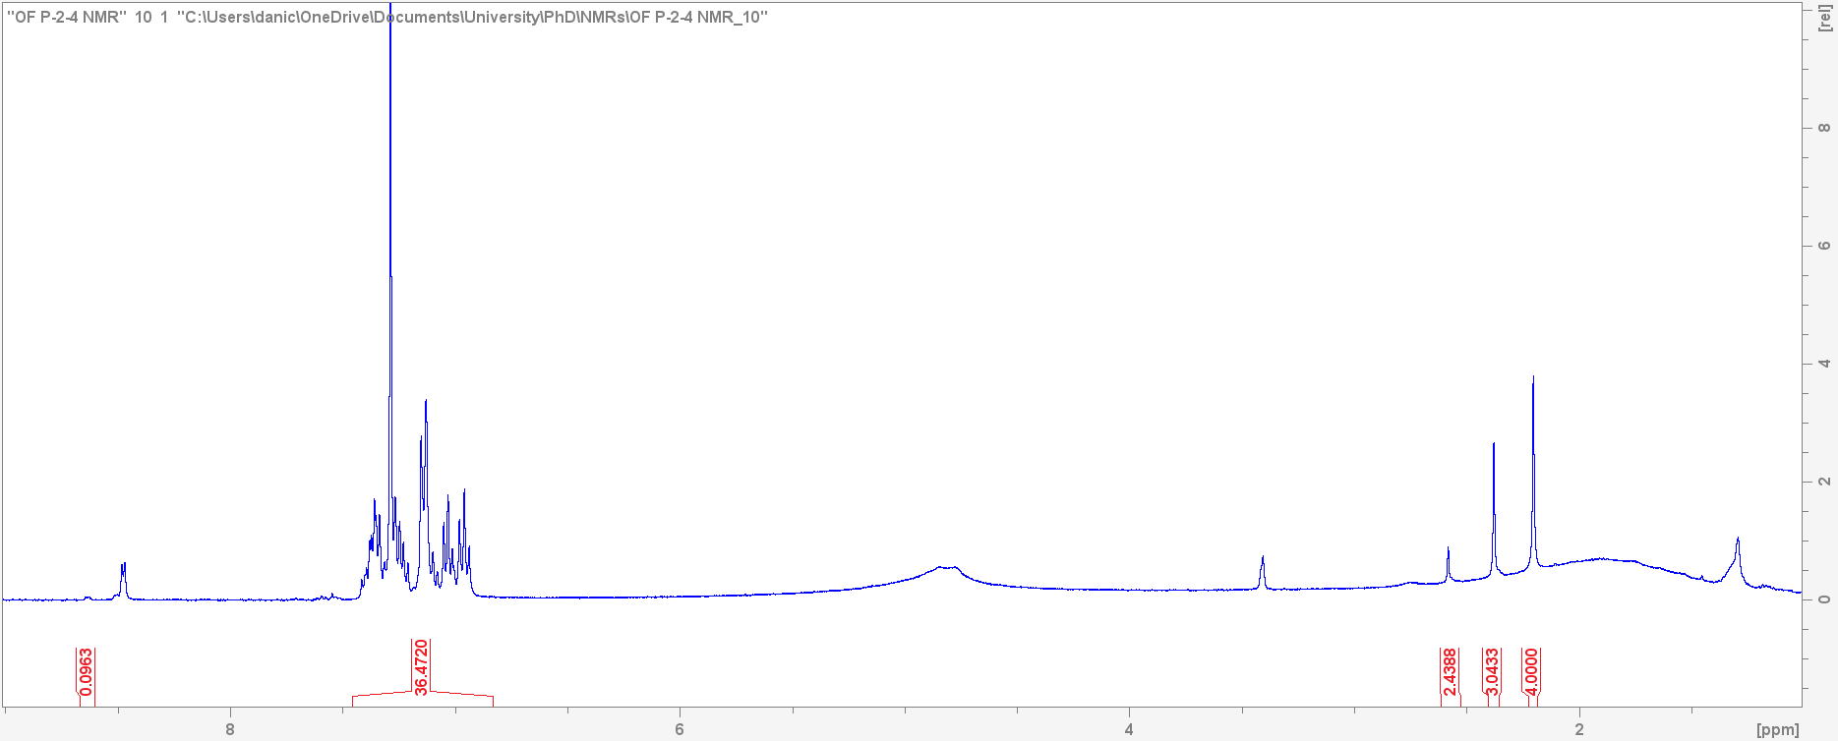
i) | 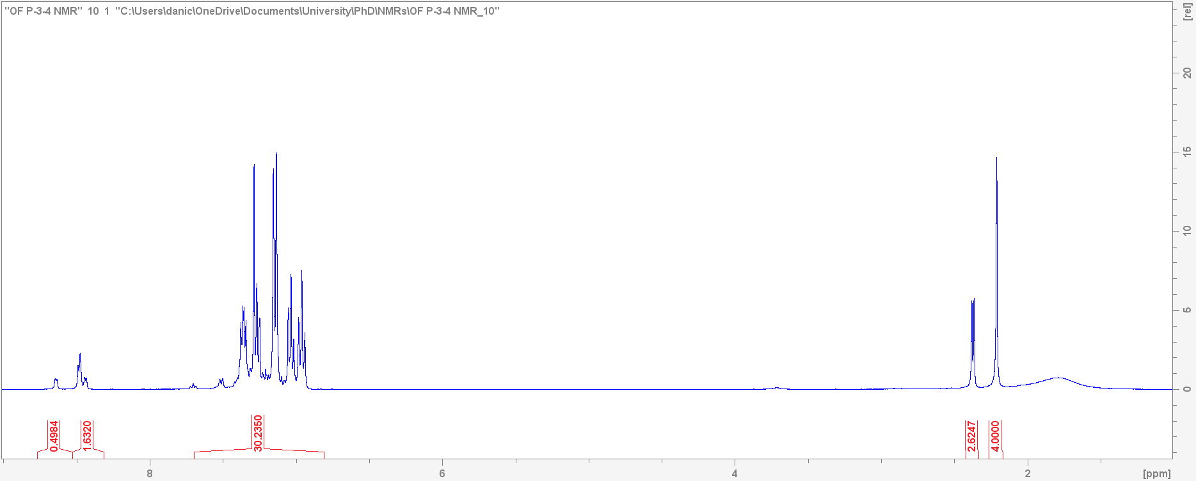 | j) |  | 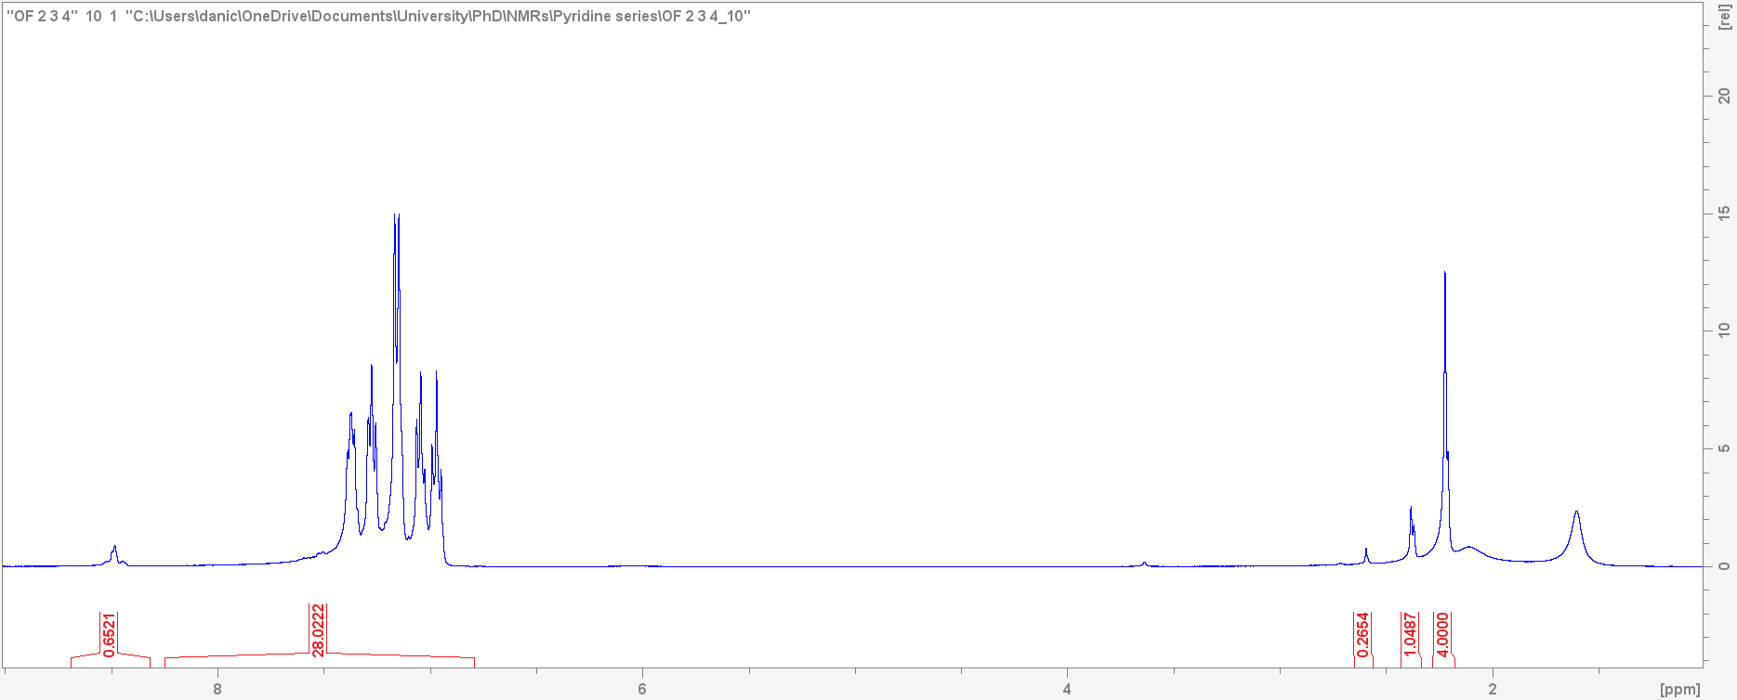
k) | 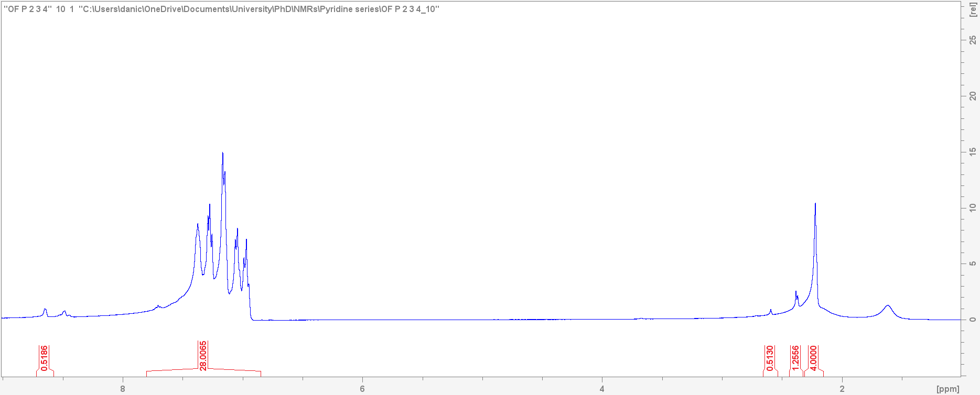
Figure S4 Host compound H2 ¹H NMR for equimolar mixtures a) PYR/2MP, b) PYR/3MP, c) PYR/4MP, d) 2MP/3MP, e) 2MP/4MP, f) 3MP/4MP, g) PYR/2MP/3MP, h) PYR/2MP/4MP, i) PYR/3MP/4MP, j) 2MP/3MP/4MP and k) PYR/2MP/3MP/4MP.
a) | 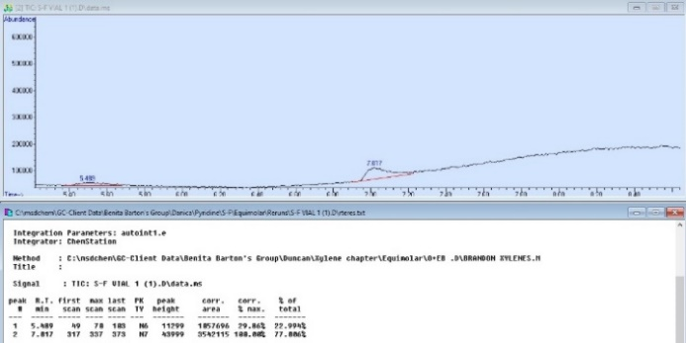 |  | b) | 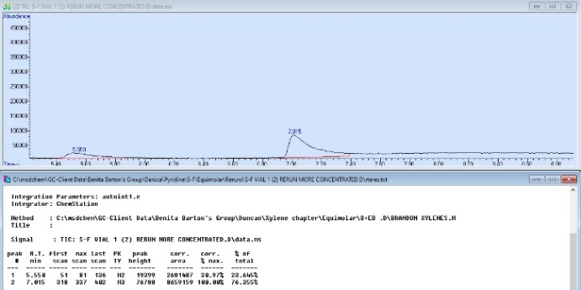
c) | 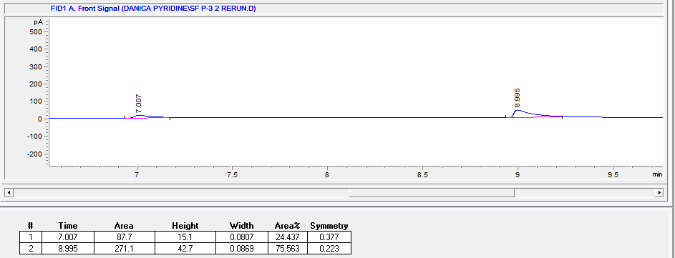 |  | d) | 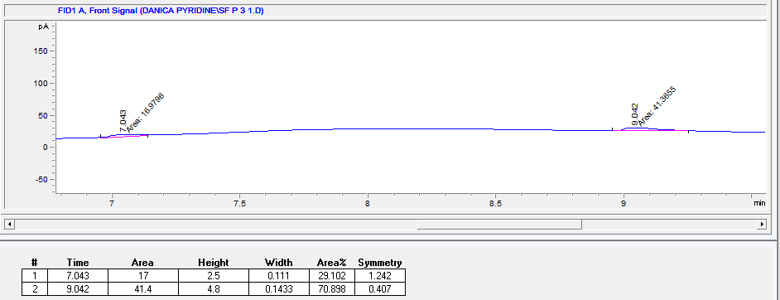
e) | 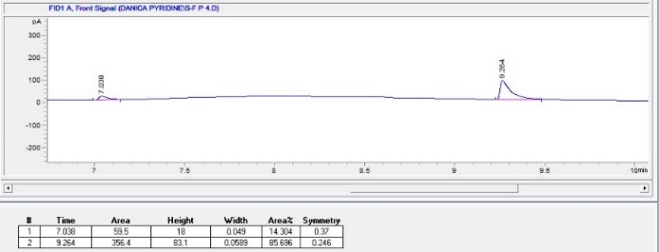 |  | f) | 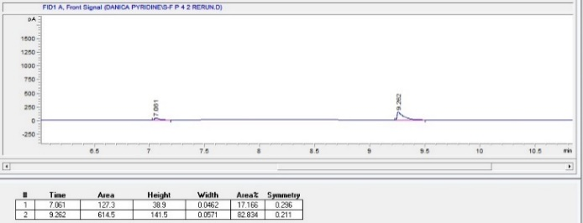
g) | 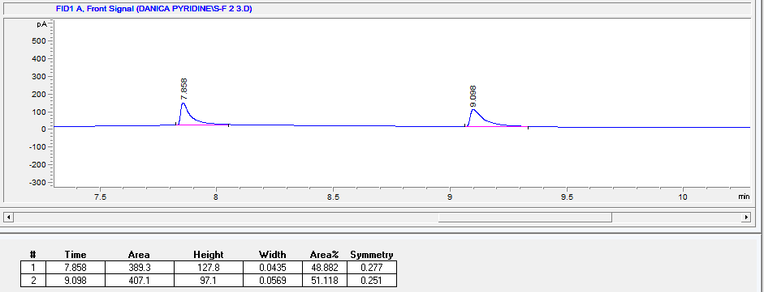 |  | h) | 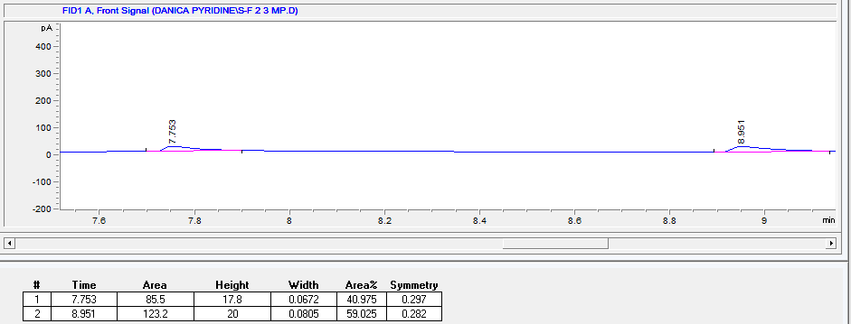
i) | 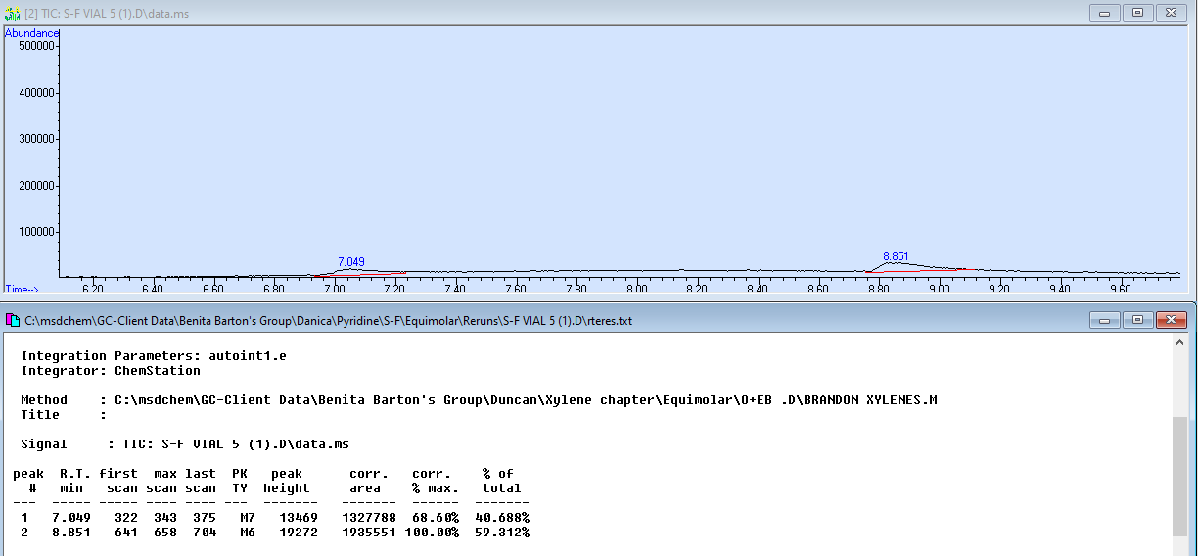 |  | j) | 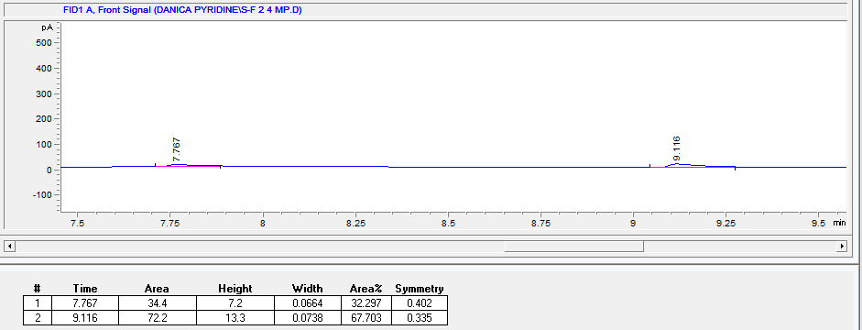
k) | 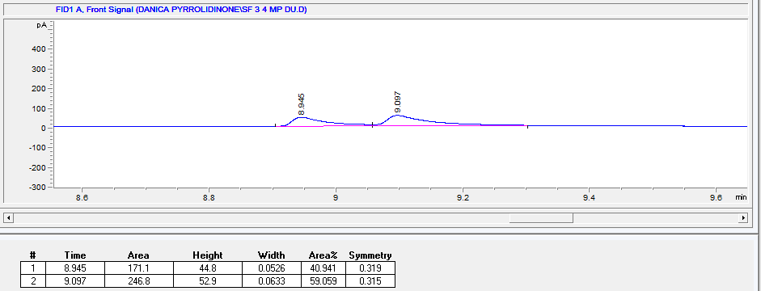 |  | l) | 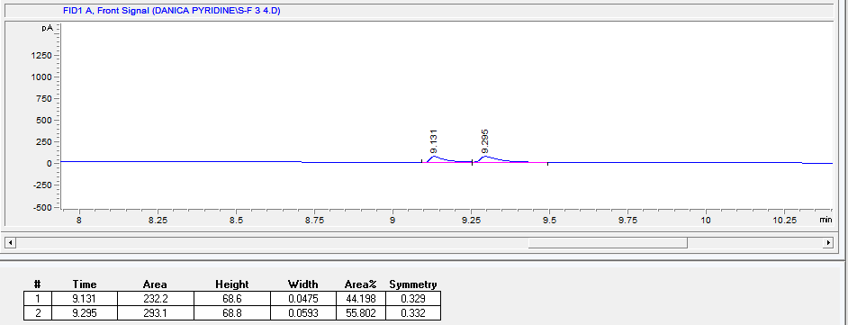
Figure S5 Host compounds H1 with the duplicate crystal data for the binary mixtures PYR/2MP in a) and b), for PYR/3MP in c) and d), for PYR/4MP in e) and f), for 2MP/3MP in g) and h), for 2MP/4MP in i) and j), and for 3MP/4MP in k) and l).
a) | 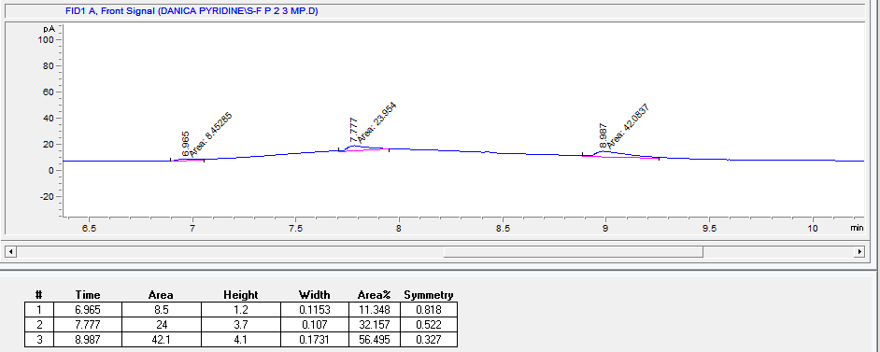 |  | b) | 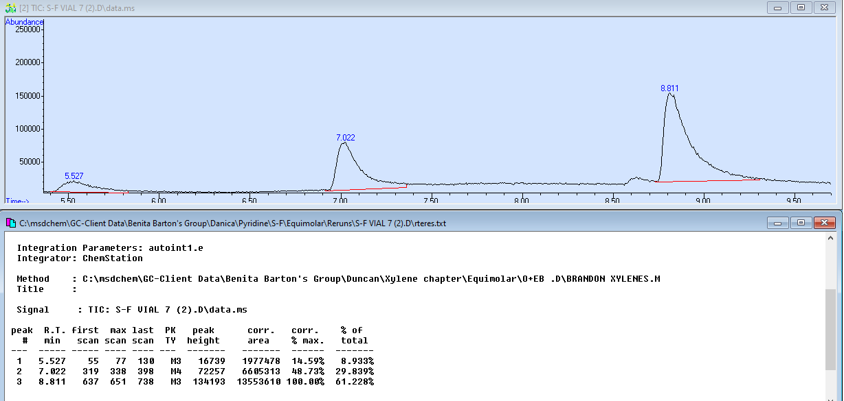
c) | 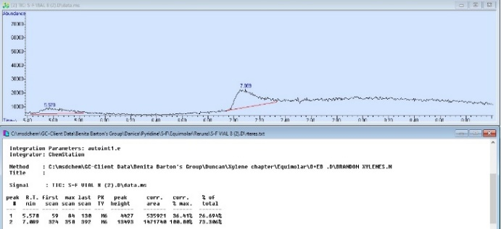 |  | d) | 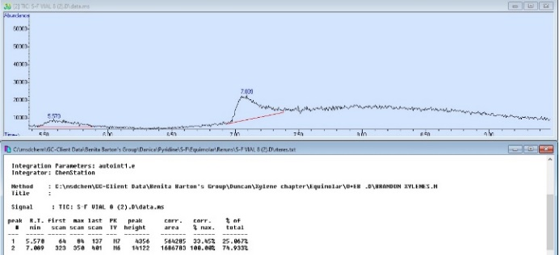
e) | 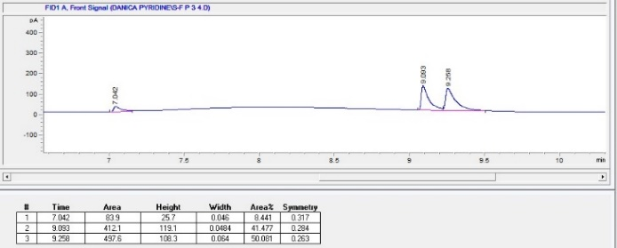 |  | f) | 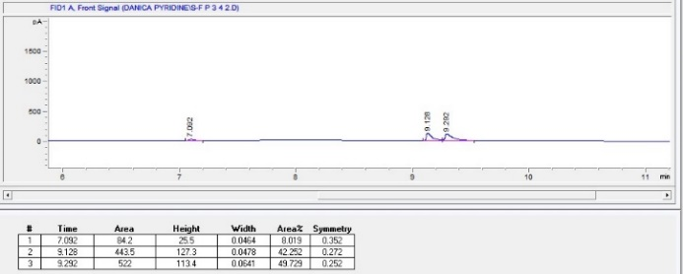
g) | 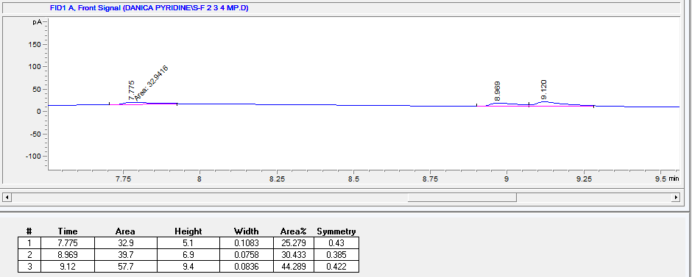 |  | h) | 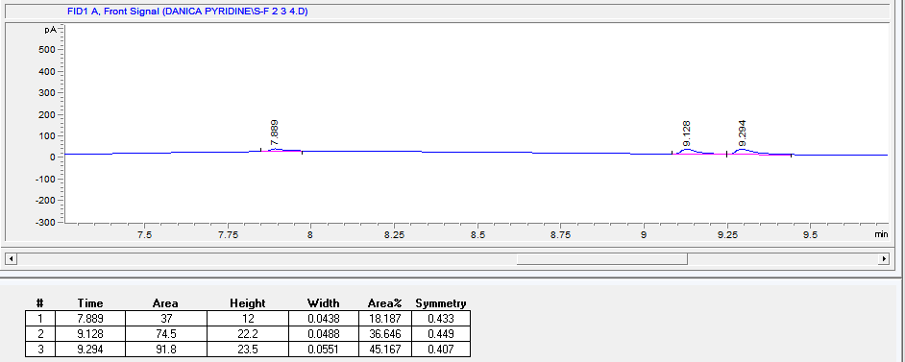
Figure S6 Host compounds H1 with the duplicate crystal data for the ternary mixtures PYR/2MP/3MP in a) and b), for PYR/2MP/4MP in c) and d), for PYR/3MP/4MP in e) and f), and for 2MP/3MP/4MP in g) and h).
a) | 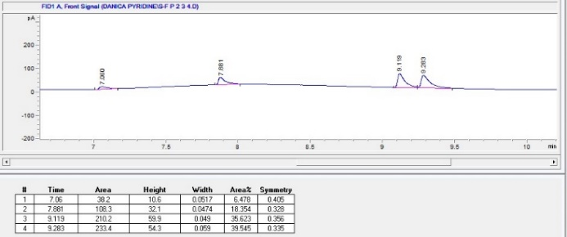 |  | b) | 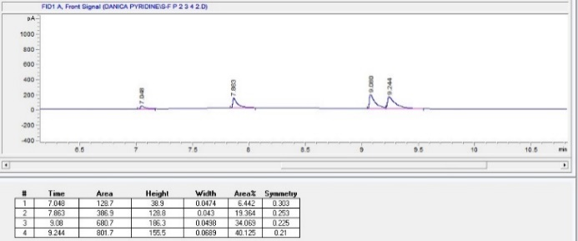
Figure S7 Host compounds H1 with the duplicate crystal data for the quaternary mixtures PYR/2MP/3MP/4MP in a) and b).
a) | 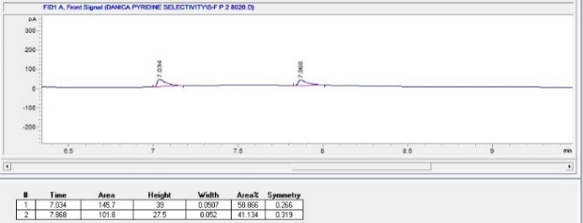 |  | b) | 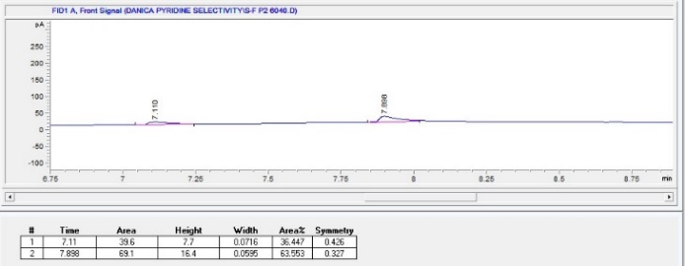
c) | 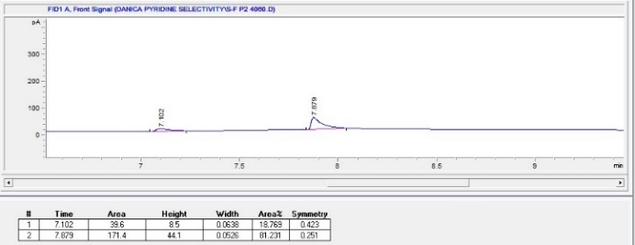 |  | d) | 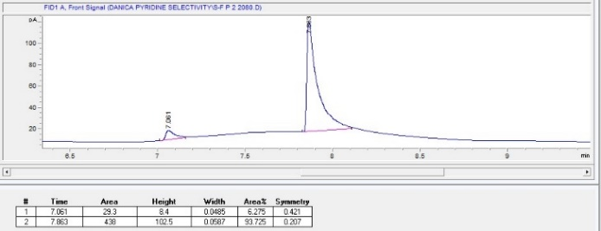
Figure S8 Host compounds H1 for the selectivity profile PYR/2MP for the crystals with a) 80/20, b) 60/40, c) 40/60, and d) 20/80 concentrations.
a) | 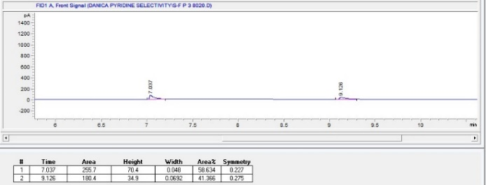 |  | b) | 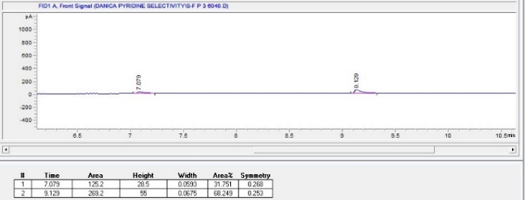
c) | 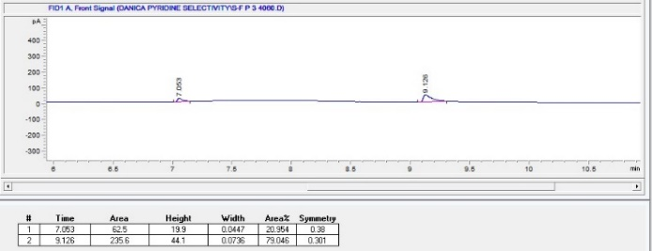 |  | d) | 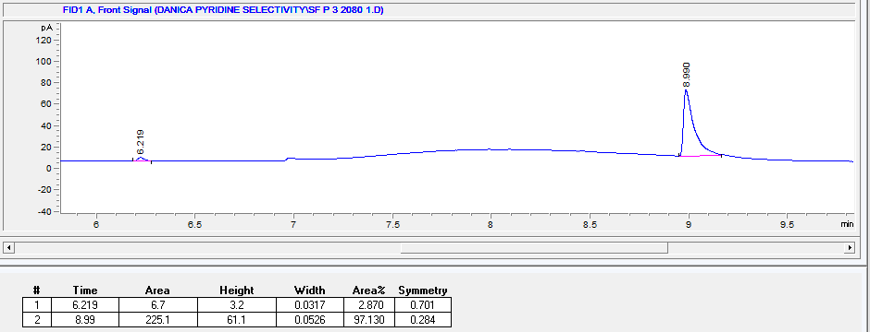
Figure S9 Host compounds H1 for the selectivity profile PYR/3MP for the crystals with a) 80/20, b) 60/40, c) 40/60, and d) 20/80 concentrations.
a) | 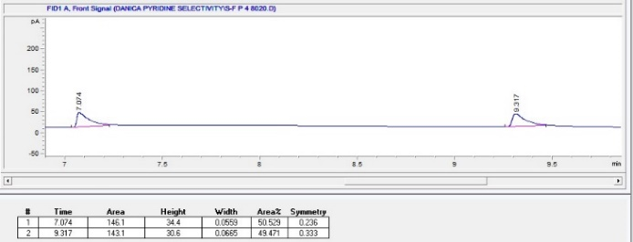 |  | b) | 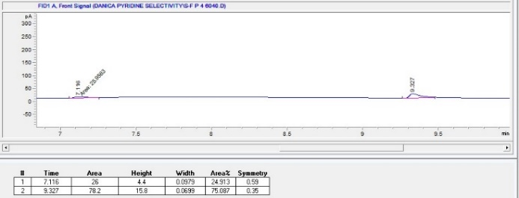
c) | 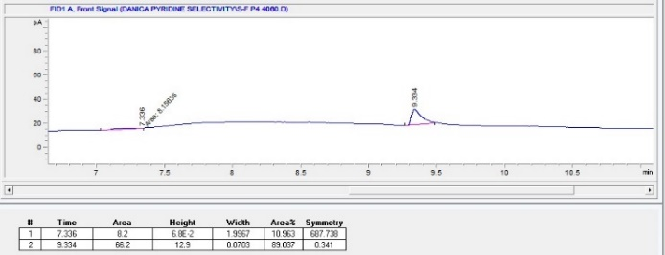 |  | d) | 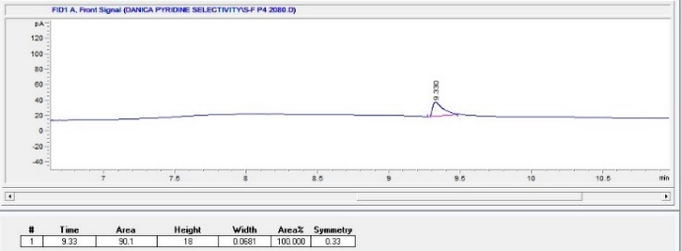
Figure S10 Host compounds H1 for the selectivity profile PYR/4MP for the crystals with a) 80/20, b) 60/40, c) 40/60, and d) 20/80 concentrations.
a) | 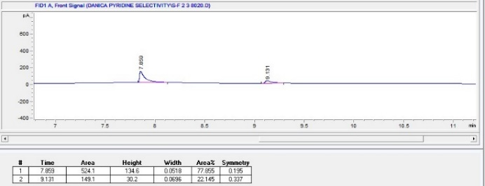 |  | b) | 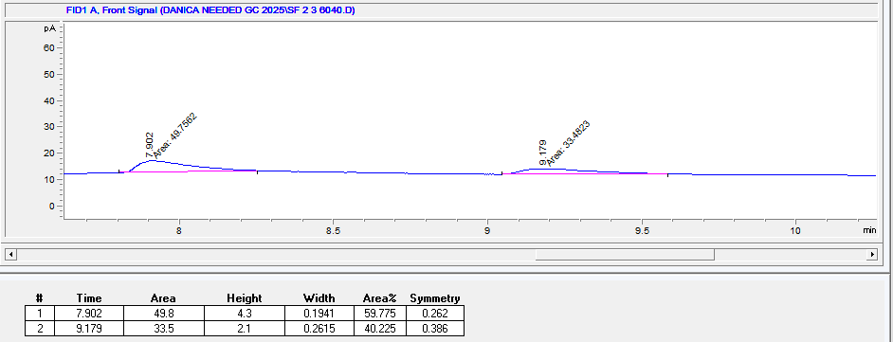
c) | 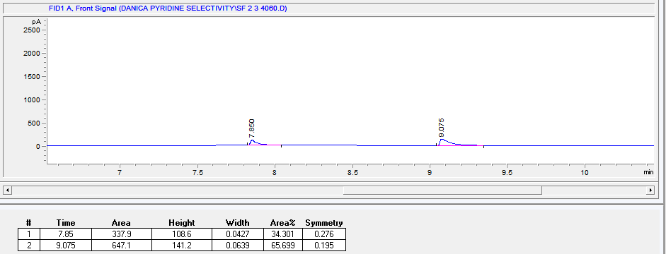 |  | d) | 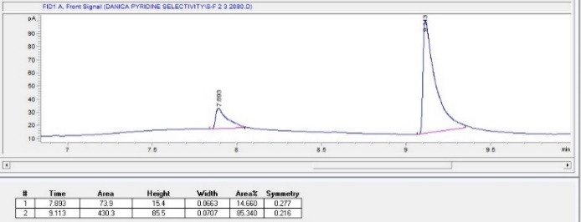
Figure S11 Host compounds H1 for the selectivity profile 2MP/3MP for the crystals with a) 80/20, b) 60/40, c) 40/60, and d) 20/80 concentrations.
a) | 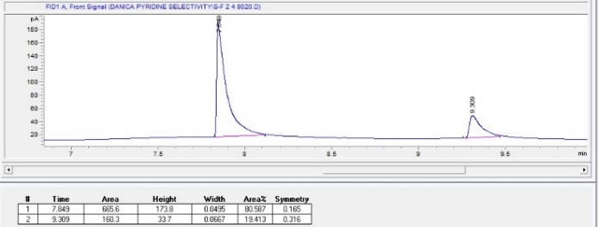 |  | b) | 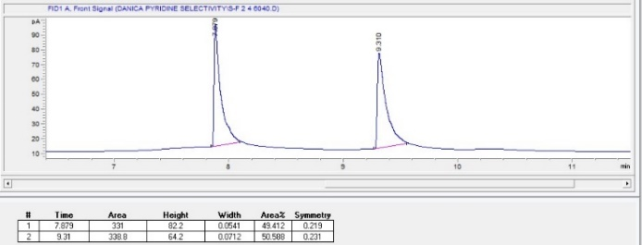
c) | 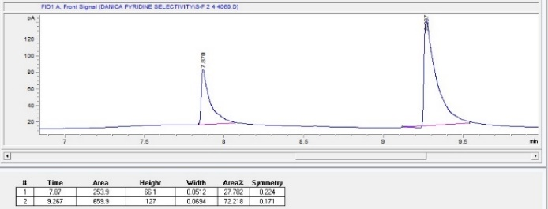 |  | d) | 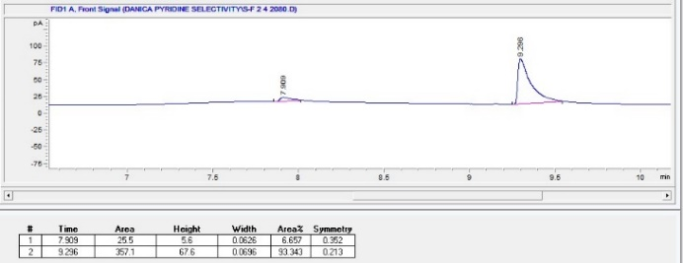
Figure S12 Host compounds H1 for the selectivity profile 2MP/4MP for the crystals with a) 80/20, b) 60/40, c) 40/60, and d) 20/80 concentrations.
a) | 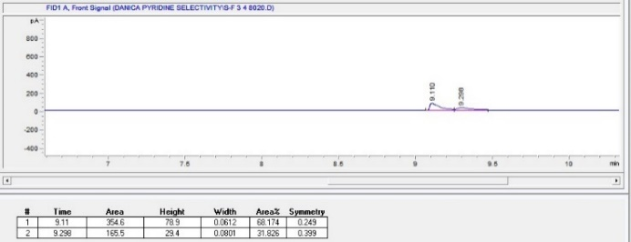 |  | b) | 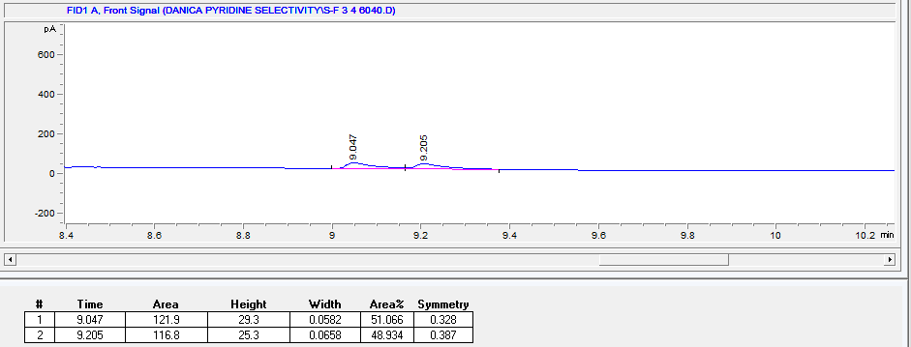
c) | 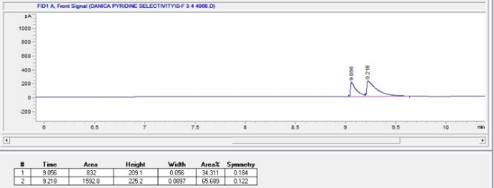 |  | d) | 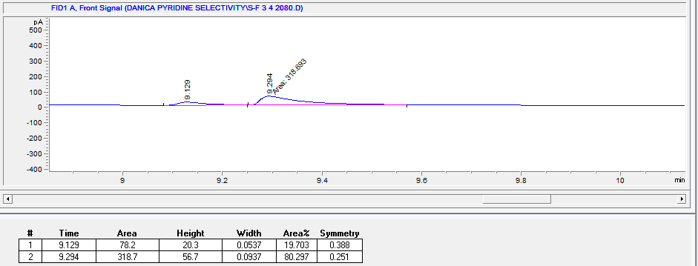
Figure S13 Host compounds H1 for the selectivity profile 3MP/4MP for the crystals with a) 80/20, b) 60/40, c) 40/60, and d) 20/80 concentrations.
a) | 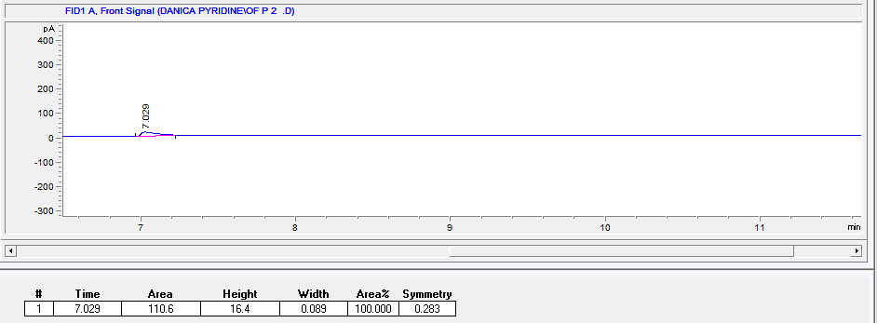 |  | b) | 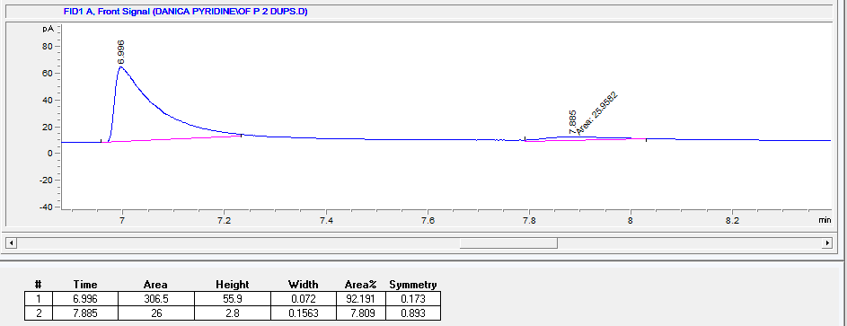
c) | 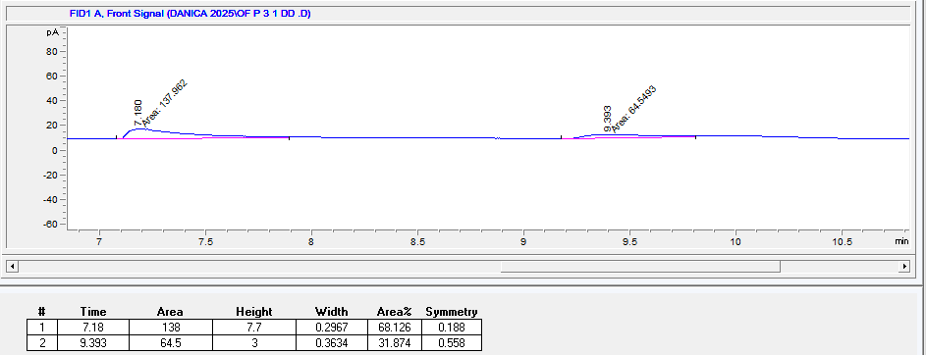 |  | d) | 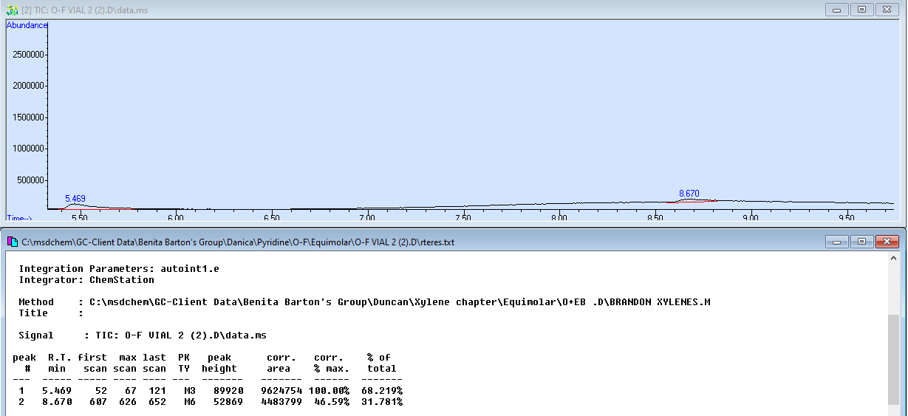
e) | 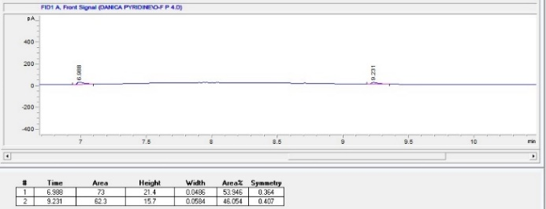 |  | f) | 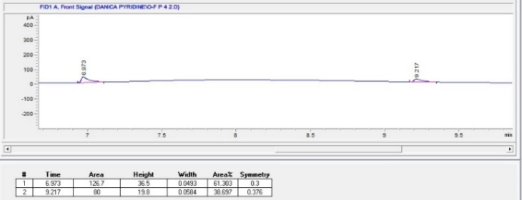
g) | 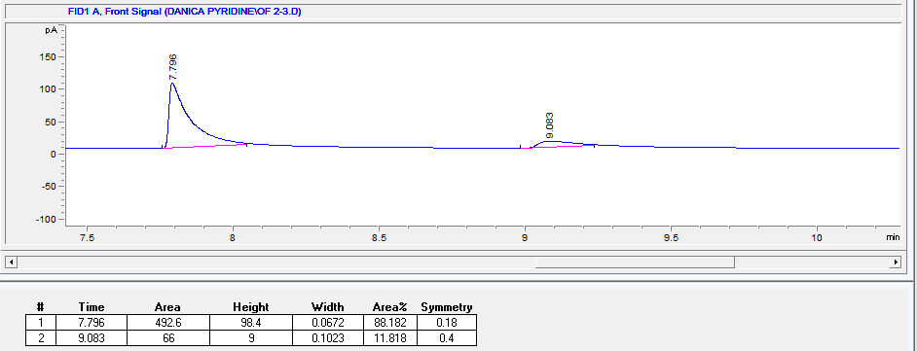 |  | h) | 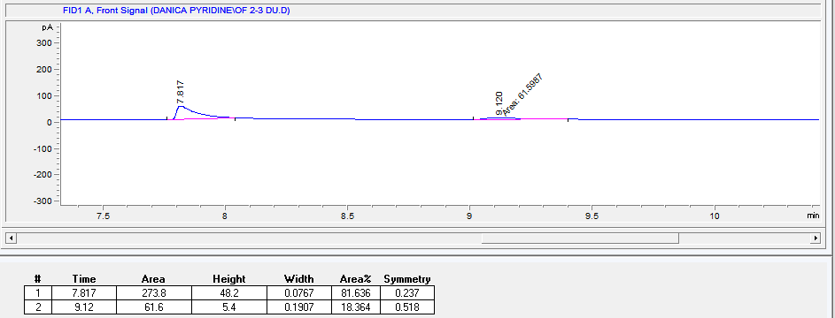
i) | 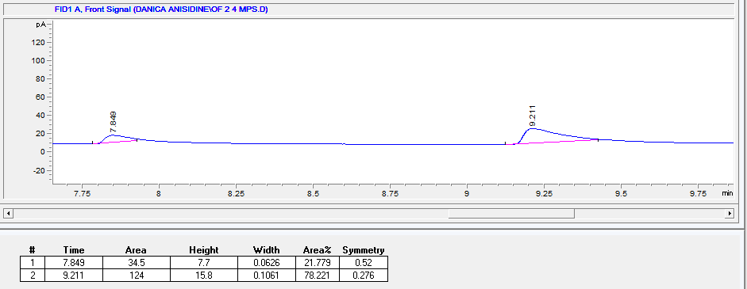 |  | j) | 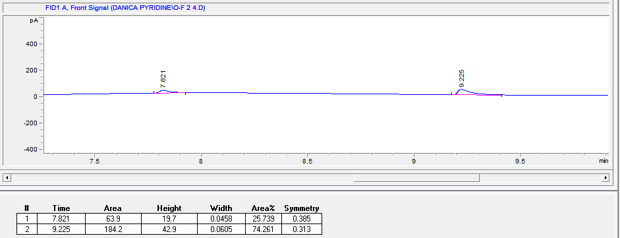
k) | 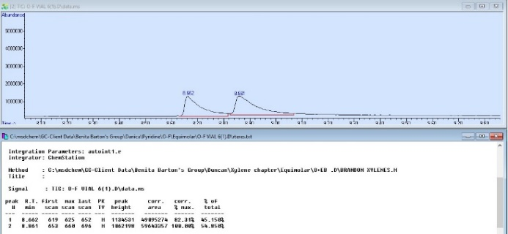 |  | l) | 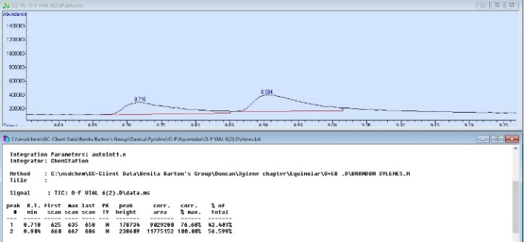
Figure S14 Host compounds H2 with the duplicate crystal data for the binary mixtures PYR/2MP in a) and b), for PYR/3MP in c) and d), for PYR/4MP in e) and f), for 2MP/3MP in g) and h), for 2MP/4MP in i) and j), and for 3MP/4MP in k) and l).

a) | 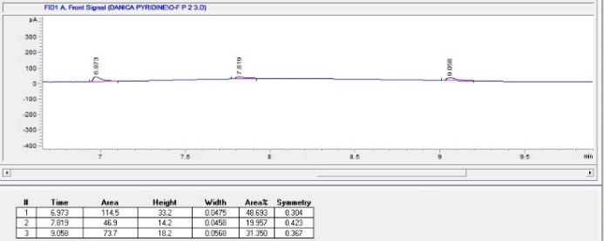 |  | b) | 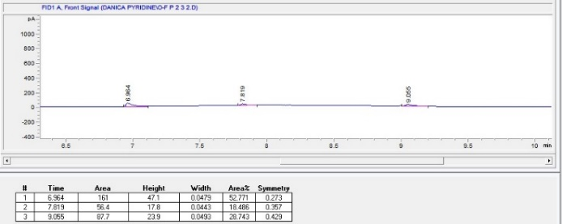
c) | 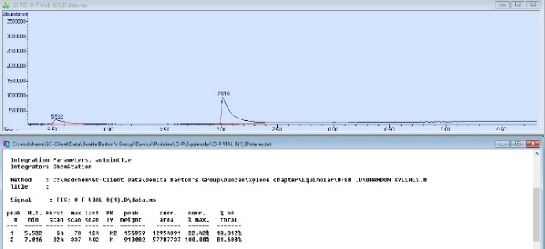 |  | d) | 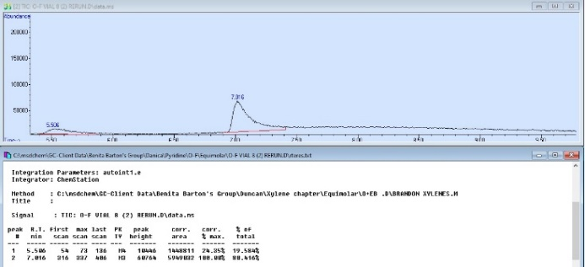
e) | 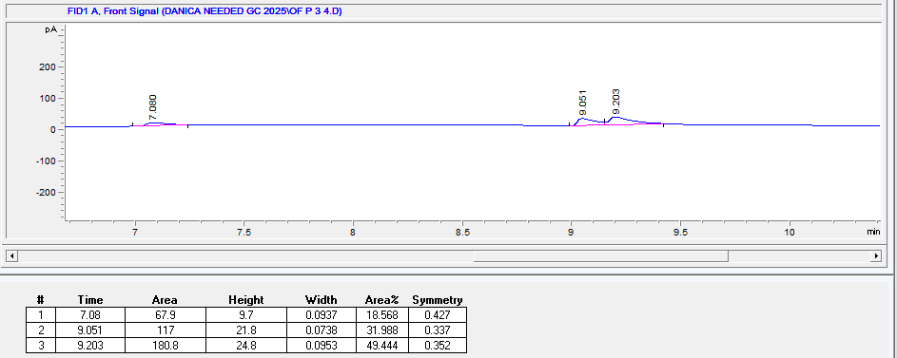 |  | f) | 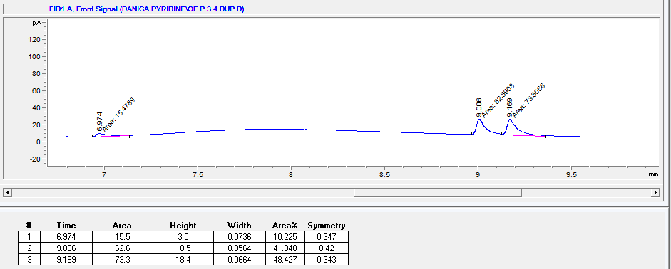
g) | 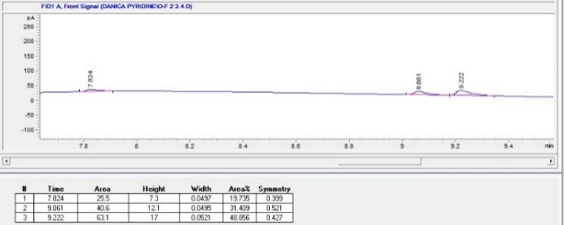 |  | h) | 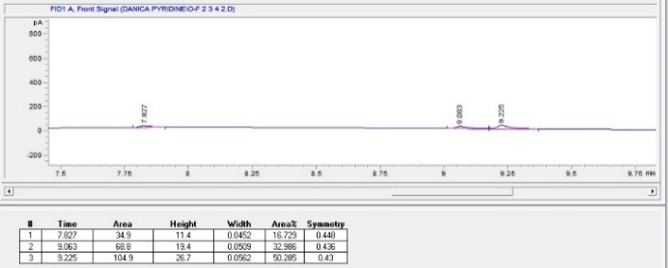
Figure S15 Host compounds H2 with the duplicate crystal data for the ternary mixtures PYR/2MP/3MP in a) and b), for PYR/2MP/4MP in c) and d), for PYR/3MP/4MP in e) and f), and for 2MP/3MP/4MP in g) and h).
a) | 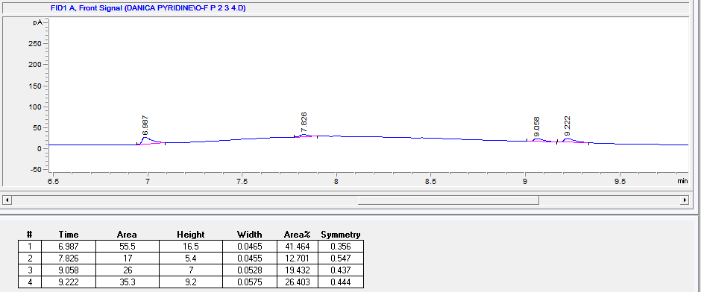 |  | b) | 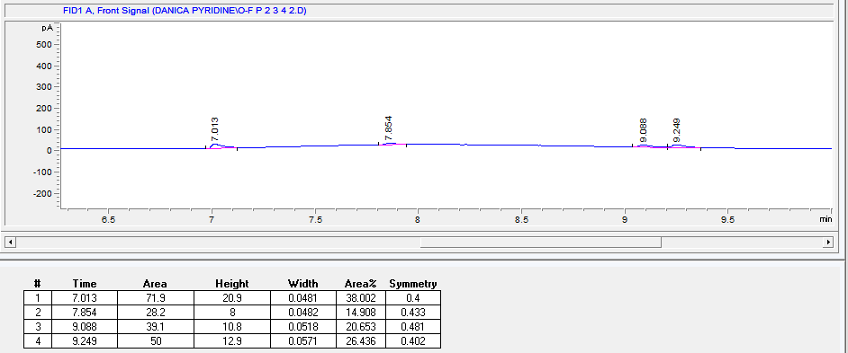
Figure S16 Host compounds H2 with the duplicate crystal data for the quaternary mixtures PYR/2MP/3MP/4MP in a) and b).

a) | 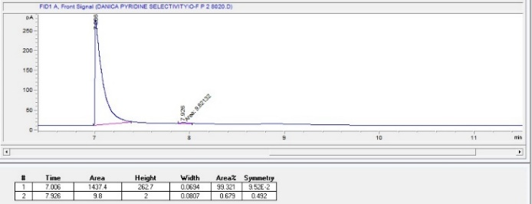 |  | b) | 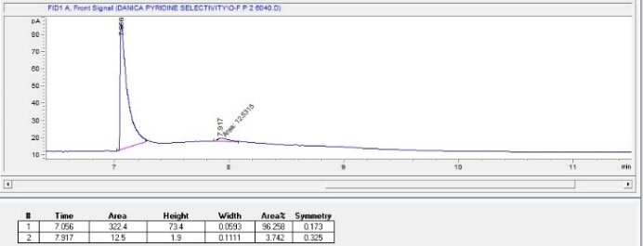
c) | 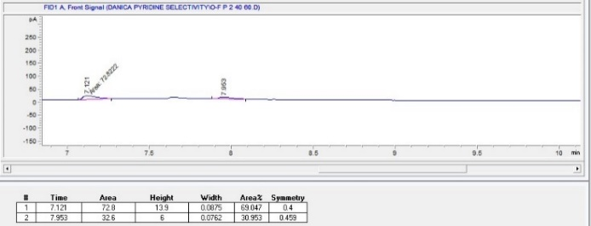 |  | d) | 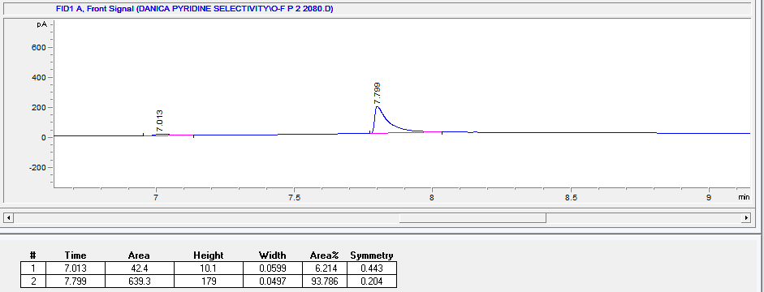
Figure S17 Host compounds H2 for the selectivity profile PYR/2MP for the crystals with a) 80/20, b) 60/40, c) 40/60, and d) 20/80 concentrations.
a) | 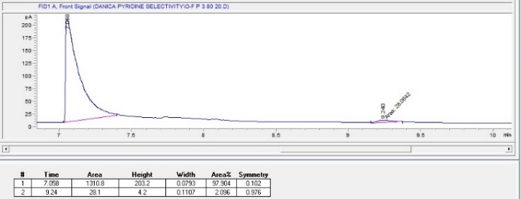 |  | b) | 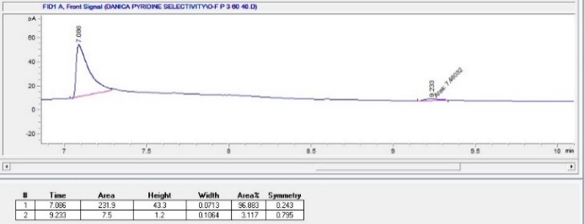
c) | 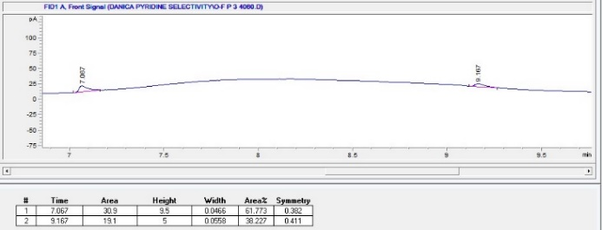 |  | d) | 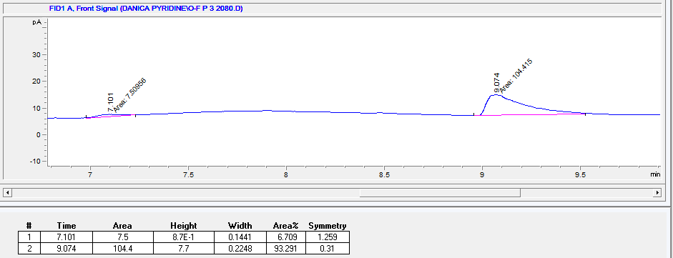
Figure S18 Host compounds H2 for the selectivity profile PYR/3MP for the crystals with a) 80/20, b) 60/40, c) 40/60, and d) 20/80 concentrations.
a) | 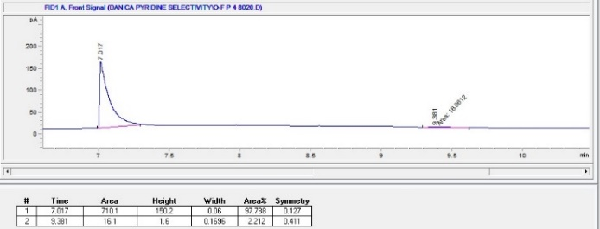 |  | b) | 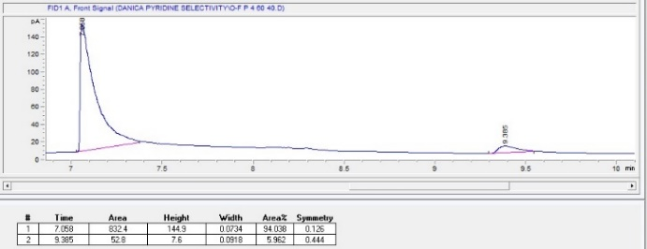
c) | 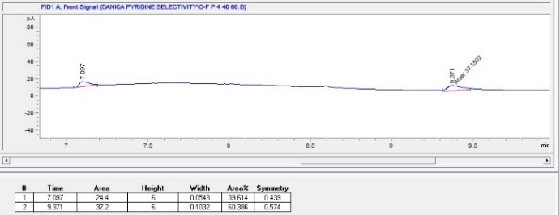 |  | d) | 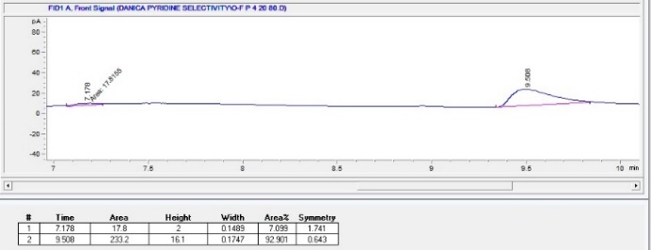
Figure S19 Host compounds H2 for the selectivity profile PYR/4MP for the crystals with a) 80/20, b) 60/40, c) 40/60, and d) 20/80 concentrations.
a) | 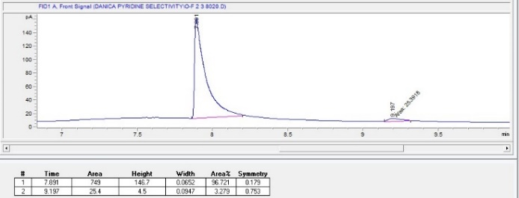 |  | b) | 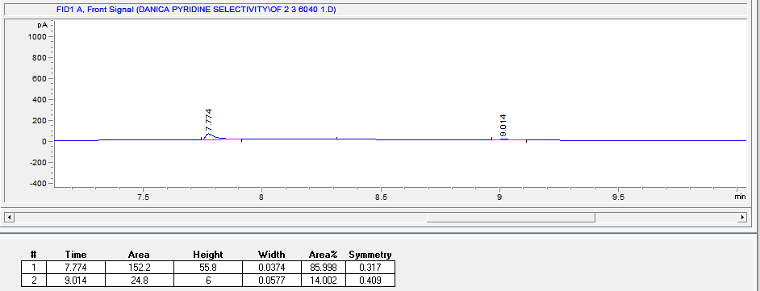
c) | 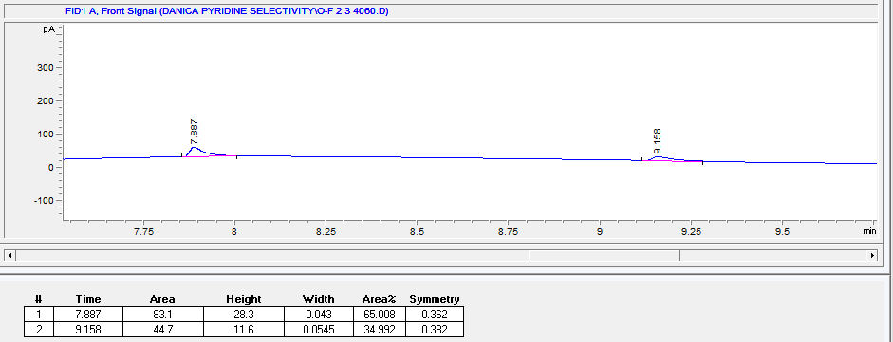 |  | d) | 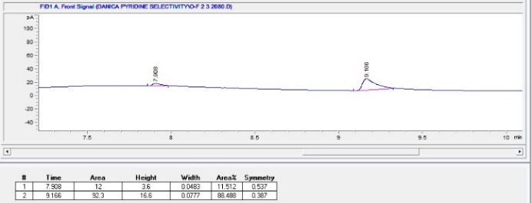
Figure S20 Host compounds H2 for the selectivity profile 2MP/3MP for the crystals with a) 80/20, b) 60/40, c) 40/60, and d) 20/80 concentrations.
a) | 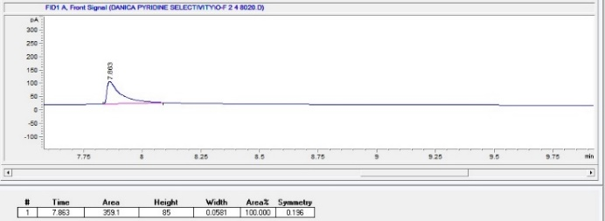 |  | b) | 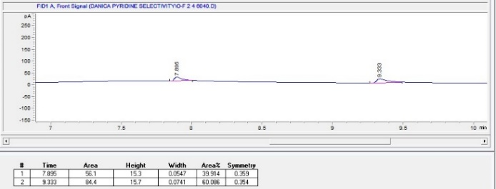
c) | 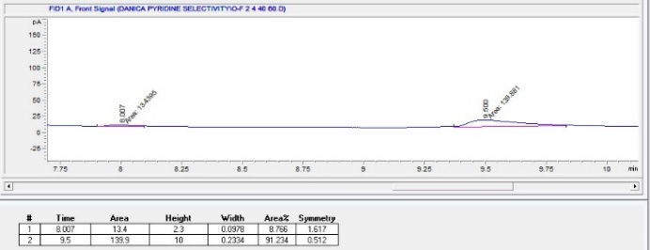 |  | d) | 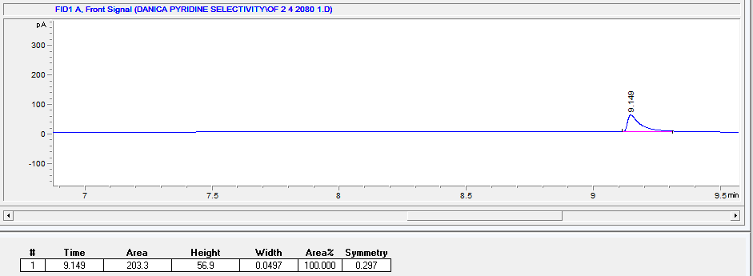
Figure S21 Host compounds H2 for the selectivity profile 2MP/4MP for the crystals with a) 80/20, b) 60/40, c) 40/60, and d) 20/80 concentrations.
a) | 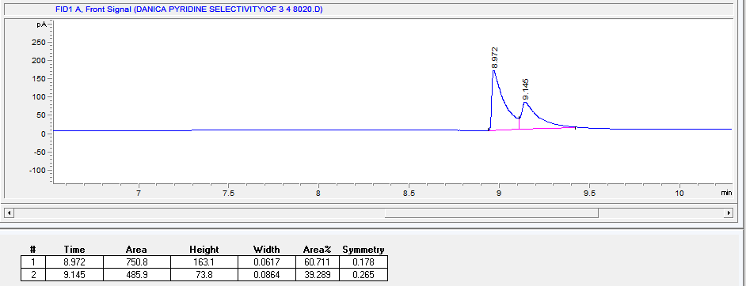 |  | b) | 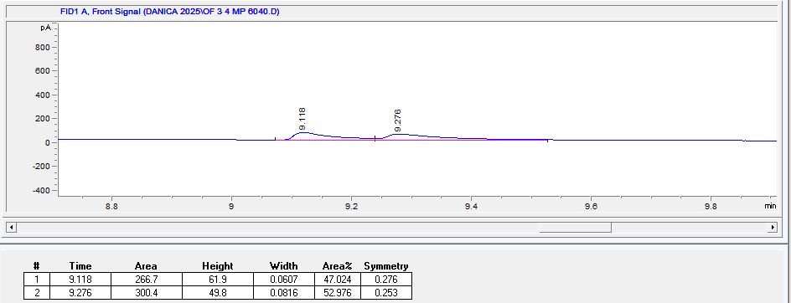
c) | 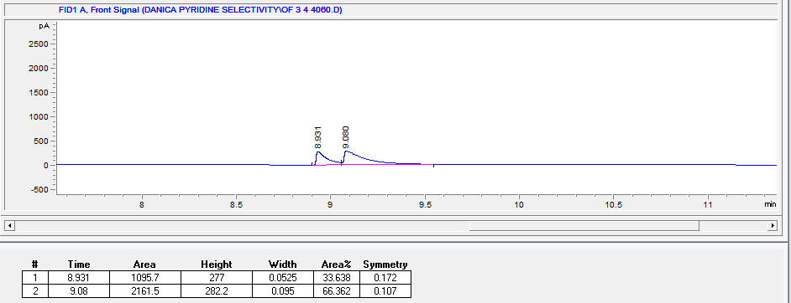 |  | d) | 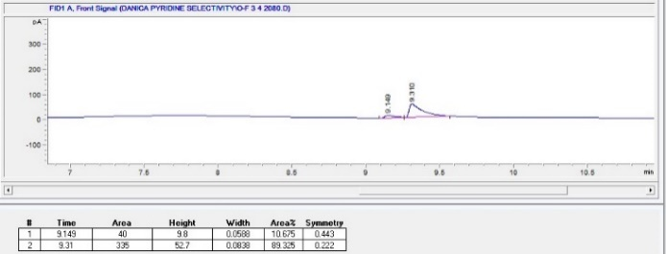
Figure S22 Host compounds H2 for the selectivity profile 3MP/4MP for the crystals with a) 80/20, b) 60/40, c) 40/60, and d) 20/80 concentrations.

Table S1 C─H···π interactions present in the eight complexes.
 | Interaction | H···π/Å | C─H···π/° | C···π/Å |  | Interaction | H···π/Å | C─H···π/° | C···π/Å
H1·PYR | (host)N─H···π(host)  (host)C─H···π(host)  (host)C─H···π(host)  (host)C─H···π(host) | 2.98(5)  2.92  2.99  3.00 | 155(4)  150  140  132 | 3.824(3)  3.774(4)  3.769(5)  3.703(6) | H2·4(PYR) | (host)C─H···π(host)  (host)C─H···π(guest)  (host)C─H···π(host)  (host)C─H···π(guest)  (host)C─H···π(guest)  (guest)C─H···π(host)  (host)C─H···π(host)  (guest)C─H···π(host)  (guest)C─H···π(host)  (guest)C─H···π(host)  (guest)C─H···π(host) | 2.80  3.00  2.92  2.66  2.68  2.96  2.76  2.95  2.98  2.95  2.90 | 152  129  148  169  168  140  157  129  141  147  128 | 3.6600(15)  3.669(8)  3.7602(14)  3.595(7)  3.610(7)  3.741(14)  3.654(9)  3.623(17)  3.773(15)  3.780(12)  3.565(17)
H1·2MP | (host)C─H···π(host)  (host)C─H···π(host)  (guest)C─H···π(host)  (guest)C─H···π(host)  (guest)C─H···π(host) | 2.71  3.00  2.92  2.42  2.95 | 170  144  155  171  134 | 3.646(2)  3.805(2)  3.795(3)  3.364(14)  3.682(18) | H2·2(2MP) | (host)C─H···π(host)  (host)C─H···π(guest)  (guest)C─H···π(host) | 2.77  2.94  2.76 | 172  152  158 | 3.7132(14)  3.7998(14)  3.6895(15)
H1·3MP | (host)C─H···π(host)  (host)C─H···π(guest)  (host)C─H···π(host)  (host)C─H···π(host)  (guest)C─H···π(host) | 2.80  2.92  2.87  2.94  2.80 | 151  142  172  144  166 | 3.6535(18)  3.714(2)  3.8102(14)  3.778(2)  3.758(3) | H2·3MP | (host)C─H···π(host)  (guest)C─H···π(host)  (guest)C─H···π(host)  (guest)C─H···π(host)  (guest)C─H···π(host) | 2.72  2.83  2.93  2.92  2.89 | 172  166  159  143  160 | 3.6612(17)  3.790(5)  3.863(5)  3.725(4)  3.833(6)
H1·4MP | (guest)C─H···π(host) | 2.72 | 169 | 3.6563(15) | H2·4MP | (host)C─H···π(guest)  (host)C─H···π(host)  (guest)C─H···π(host)  (guest)C─H···π(host) | 2.89  2.71  2.82  2.78 | 157  168  156  174 | 3.782(5)  3.6465(18)  3.711(2)  3.753(16)

Table S2 Inter- and intramolecular hydrogen bonding identified in the eight complexes.
Interaction | H···A/Å | D···A/Å | D─H···A/° | Interaction | H···A/Å | D···A/Å | D─H···A/°
H1·PYR  (host)N─H···N(guest)^{a,c}  (host)C─H···F(host)^{a,d}  (host)C─H···S(host)^{a,d}  (host)C─H···N(host)^{b,d}  (host)C─H···N(host)^{b,d}  (host)C─H···F(host)^{a,d}  (guest)C─H···F(host)^{a,,d} | 2.49(3)  2.52  2.87  2.45  2.43  2.61  2.57 | 3.377(4)  3.373(5)  3.752(3)  2.789(4)  2.783(4)  3.214(4)  3.425(6) | 169(3)  150  155  101  102  132  149 | H2·4(PYR)  (host)N─H···N(guest)^{a,c}  (host)N─H···N(guest)^{a,c}  (host)C─H···N(host)^{b,d} | 2.61  2.31  2.43 | 3.489(11)  3.271(13)  2.798(2) | 178  173  103
H1·2MP  (host)C─H···N(guest)^{a,d}  (host)C─H···N(host)^{b,d}  (host)C─H···N(host)^{b,d}  (host)C─H···F(host)^{a,d} | 2.60  2.42  2.44  2.56 | 3.403(5)  2.784(3)  2.787(3)  3.349(3) | 142  102  102  140 | H2·2(2MP)  (host)N─H···N(guest)^{a,c}  (host)C─H···N(guest)^{a,d}  (host)C─H···N(host)^{b,d} | 2.500(2)  2.51  2.48 | 3.403(2)  3.463(2)  2.805(2) | 173.8(13)  176  100
H1·3MP  (host)N─H···N(guest)^{a,c}  (host)C─H···N(host)^{b,d}  (host)C─H···N(host)^{b,d} | 2.524(17)  2.42  2.42 | 3.385(2)  2.774(2)  2.779(2) | 174.5(14)  102  102 | H2·3MP  (host)N─H···N(guest)^{a,c}  (host)N─H···N(guest)^{a,c}  (host)C─H···N(host)^{b,d}  (host)C─H···N(host)^{b,d}  (guest)C─H···O(host)^{a,d} | 2.371(18)  2.45(2)  2.42  2.41  2.67 | 3.280(8)  3.356(10)  2.774(2)  2.770(2)  3.490(2) | 175.6(15)  174.2(14)  102  102  142
H1·4MP  (host)N─H···N(guest)^{a,c}  (host)C─H···F(host)^{a,d}  (host)C─H···N(host)^{b,d}  (host)C─H···N(host)^{b,d} | 2.599(17)  2.52  2.44  2.43 | 3.466(2)  3.305(2)  2.784(2)  2.788(2) | 172.8(15)  140  101  102 | H2·4MP  (host)N─H···N(guest)^{a,c}  (host)C─H···N(host)^{b,d}  (host)C─H···N(host)^{b,d}  (host)C─H···F(host)^{a,d} | 2.44(2)  2.41  2.44  2.63 | 3.308(3)  2.774(2)  2.780(2)  3.263(2) | 171.7(19)  102  101  124
ª Intermolecular hydrogen bonding
^{b} Intramolecular hydrogen bonding
^{c} Classical hydrogen bonding
^{d} Non-classical hydrogen bonding

Table S3 Other short contacts present between host molecules, guest molecules, and host and guest molecules.ª
 | Interaction | Note | D(I···J)/Å | X─I···J/° |  | Interaction | Note | D(I···J)/Å | X─I···J/°
H1·PYR | (host)C─H···C─N(guest)  (host)C─H···C─C(host) | <  < | 2.85  2.80 | 134  159 | H2·4(PYR) | (host)C─H···C─N(guest)  (host)C─H···C─C(host)  (host)C─H···C─N(guest)  (guest)C─H···C─C(host)  (guest)C─H···C─C(host) | <  <  <  <  < | 2.83  2.89  2.88  2.87  2.79 | 155  155  141  131  151
H1·2MP | (host)C─H···C─C(guest)  (host)C─H···C─C(host)  (host)C─C···H─C(guest)  (host)C─H···C─C(host)  (guest)C─H···C─C(host)  (guest)C─H···C─C(host) | <  <  <<  <  <<  << | 2.80  2.84  2.54  2.83  2.46  2.54 | 169  142  111  133  169  140 | H2·2(2MP) | None | None | None | None
H1·3MP | (host)C─H···C─C(host)  (host)C─H···C─S(host)  (host)C─H···C─C(host)  (guest)C─H···C─F(host) | <  <  <  < | 2.83  2.82  2.87  2.87 | 135  152  176  139 | H2·3MP | (host)C─H···C─C(host)  (host)C─H···C─C(host)  (host)C─H···C─C(host)  (guest)C─H···C─F(host)  (guest)C─C···H─C(host)  (guest)C─H···C─C(host) | <  <  <  <  <  < | 2.86  2.76  2.76  2.81  2.82  2.49 | 147  138  175  139  127  155
H1·4MP | (host)C─H···C─S(host)  (host)C─H···C─C(host)  (host)C─H···C─C(host)  (guest)C─H···C─C(host) | <  <  <  << | 2.86  2.80  2.85  2.69 | 145  135  163  144 | H2·4MP | (host)C─H···C─C(host)  (host)C─H···C─C(host)  (guest)C─H···C─C(host) | <  <  < | 2.78  2.84  2.76 | 138  173  135
ª where I···J is the bond distance between atom 1 and atom 2, and X─I···J is the bond angle.

