Appendix A
Position Data Analysis
As follow-up analyses, we further analyzed specific aspects of the chess stimulus and their influence on RT2 and accuracies. Find multiple analyses in graphical representation and tables below.
Figure A1
Reaction times and accuracies by checking color
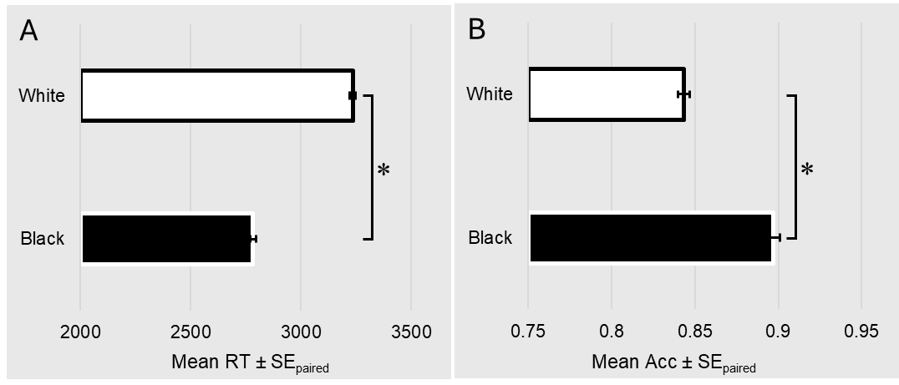
Note. Results for Performance Differences for Positions with Different Colors in Check. A. Mean Reaction Times. Participants showed faster reactions for positions with the black king in check (than when the white king was checked, t(452) = 34.30, p < .001, d = 1.61. B. Mean Accuracies. Participants showed worse accuracy for positions with the white king in check than when the black king was checked, t(452) = p < .001, d = 0.70.

Figure A2
Reaction times and accuracies by checking form

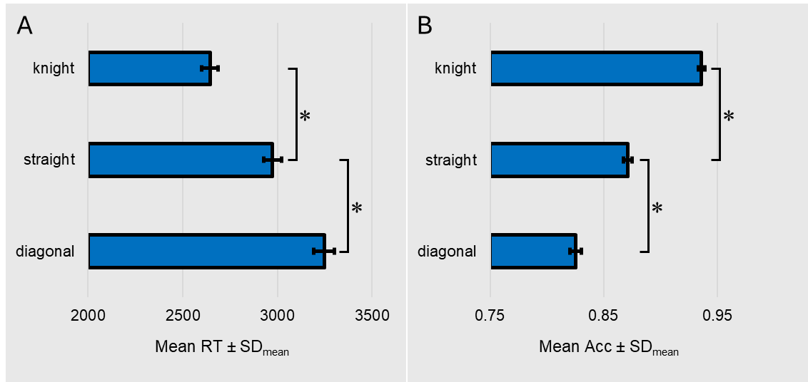Note. Results for Performance Differences for positions with different checking forms. A. Mean Reaction Times. Participants showed fastest reactions for knight checks, whereas straight checks were slower, t(452) = 26.17, p < .001, d = 1.23, and diagonal checks slower yet than straight checks, t(452) = 18.10, p < .001, d = 0.85.B. Mean Accuracies. The same pattern emerged for accuracies, which were highest for knight checks, decreased for straight checks, t(452) = 20.15, p < .001, d = 0.95, and decreased again for diagonal checks, t(452) = 11.41, p < .001, d = 0.54.

Figure A3
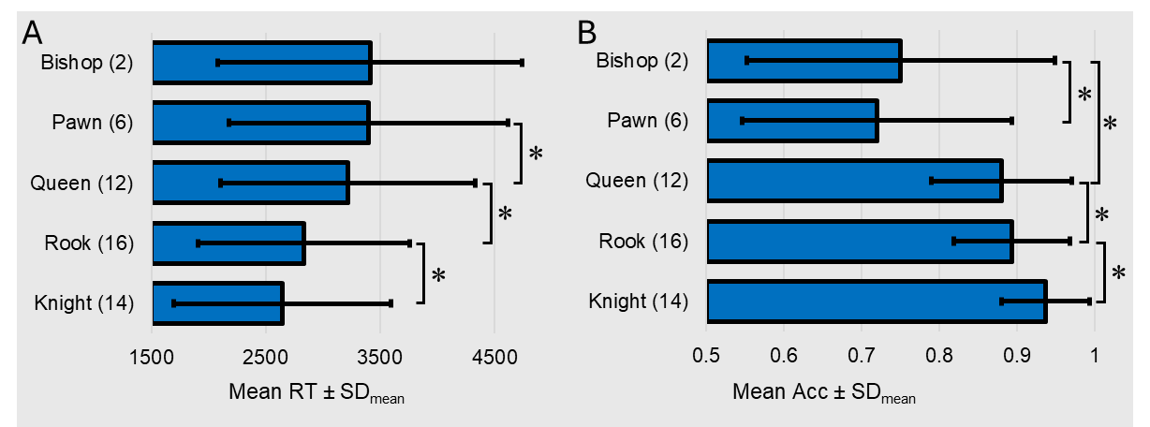
Note. The Pieces were used differently often in the chess stimuli which is shown in parenthesis after the piece. A Mean Reaction Times. Participants reacted fastest to checks given by a knight and slowest to checks given by a bishop. Pairwise comparisons revealed a significant decrease in RT from pawn to queen, t(452) = 9.75, p < .001, d = 0.45, from queen to rook, t(452) = 24.10, p < .001, d = 1.13, and from rook to knight, t(452) = 14.69, p < .001, d = 0.69. B Mean Accuracies. Participants detected checking positions least often if the checking piece was a pawn, closely followed by the bishop, t(452) = 3.03, p = .003, d = 0.14. Accuracies increased for the queen, t(452) = 15.87, p < .001, d = 0.75, were slightly better for the rook,t(452) = 3.63, p < .001, d = 0.17, and were best for the knight, t(452) = 13.28, p < .001, d = 0.62.

Table A1
Distance of checking piece to king and mean response times.
Distance | M | SD | n
Knight | 2643 | 949 | 14
0 | 308 | 1037 | 14
1 | 2944 | 1003 | 7
2 | 3015 | 1071 | 5
3 | 3377 | 1158 | 3
4 | 3346 | 1095 | 4
5 | 3276 | 1170 | 3

Note. Participants reacted fastest to checks in knight distance and slowest to checks from three squares away. M and SD are shown in ms, n shows number of used positions. Distance is shown in squares.

Table A2
Distance of checking piece to king and accuracies.
Distance | M | SD | n
Knight | 0.94 | 0.06 | 14
0 | 0.85 | 0.09 | 14
1 | 0.86 | 0.09 | 7
2 | 0.88 | 0.11 | 5
3 | 0.82 | 0.18 | 3
4 | 0.85 | 0.13 | 4
5 | 0.85 | 0.14 | 3

Note. Participants reacted most accurately to checks in knight distance and least accurately to checks from three squares away. n shows number of used positions. Distance is shown in squares.

Appendix B
There is an ongoing debate regarding the importance of response time data of the first stimulus in PRP paradigm. The histogram data of response times below should provide an overview regarding the distribution of reaction times to the color identification task (T1).
Figure B1
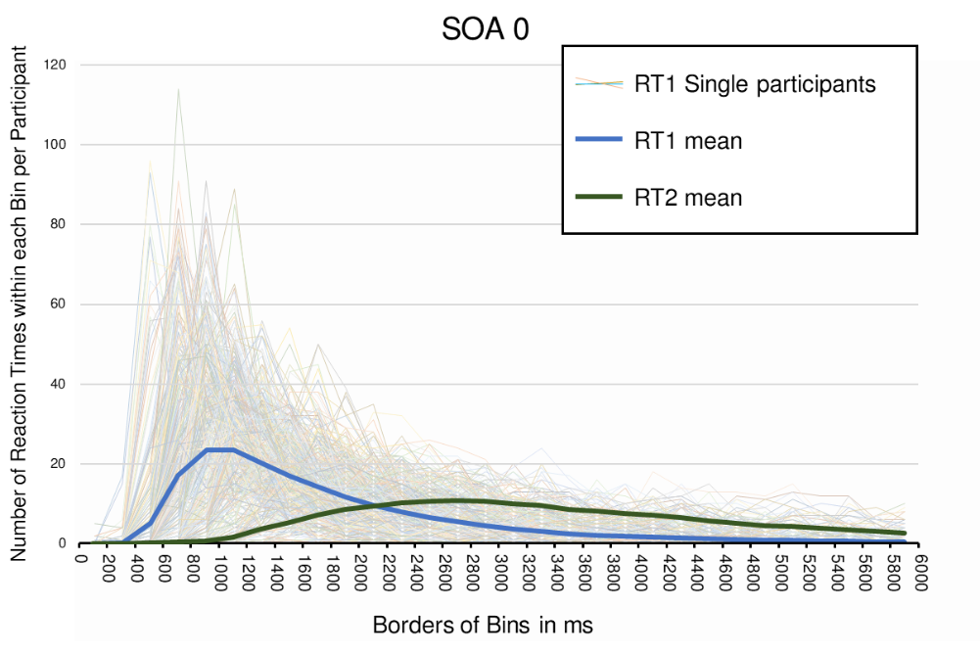
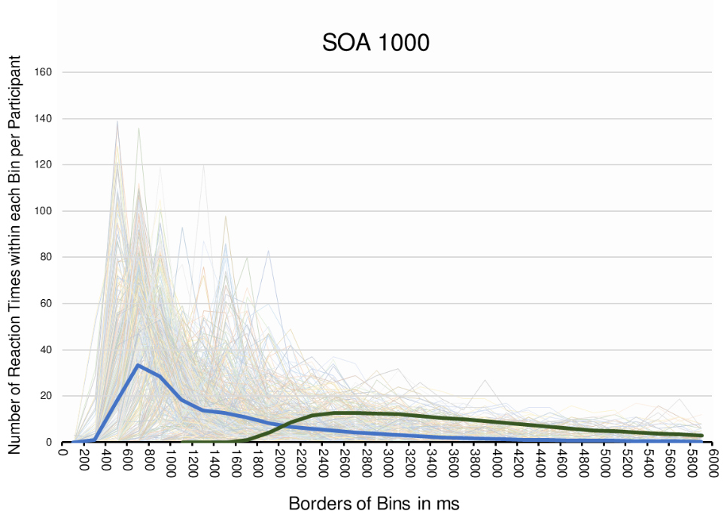
Note. Thin lines show distribution of response times to the color identification task (RT1) for single participants separated into 200 ms bins. They are accompanied by mean number of reactions within each time bin for the color identification task (RT1) in blue and the check detection task (RT2) in green.

