Assessing the Impact of Agricultural Droughts on Child Undernutrition in Varying Crop-Growing Periods and Agricultural Land Use: Analysis across 33 Sub-Saharan African Countries

Supplementary Material
Appendix 1
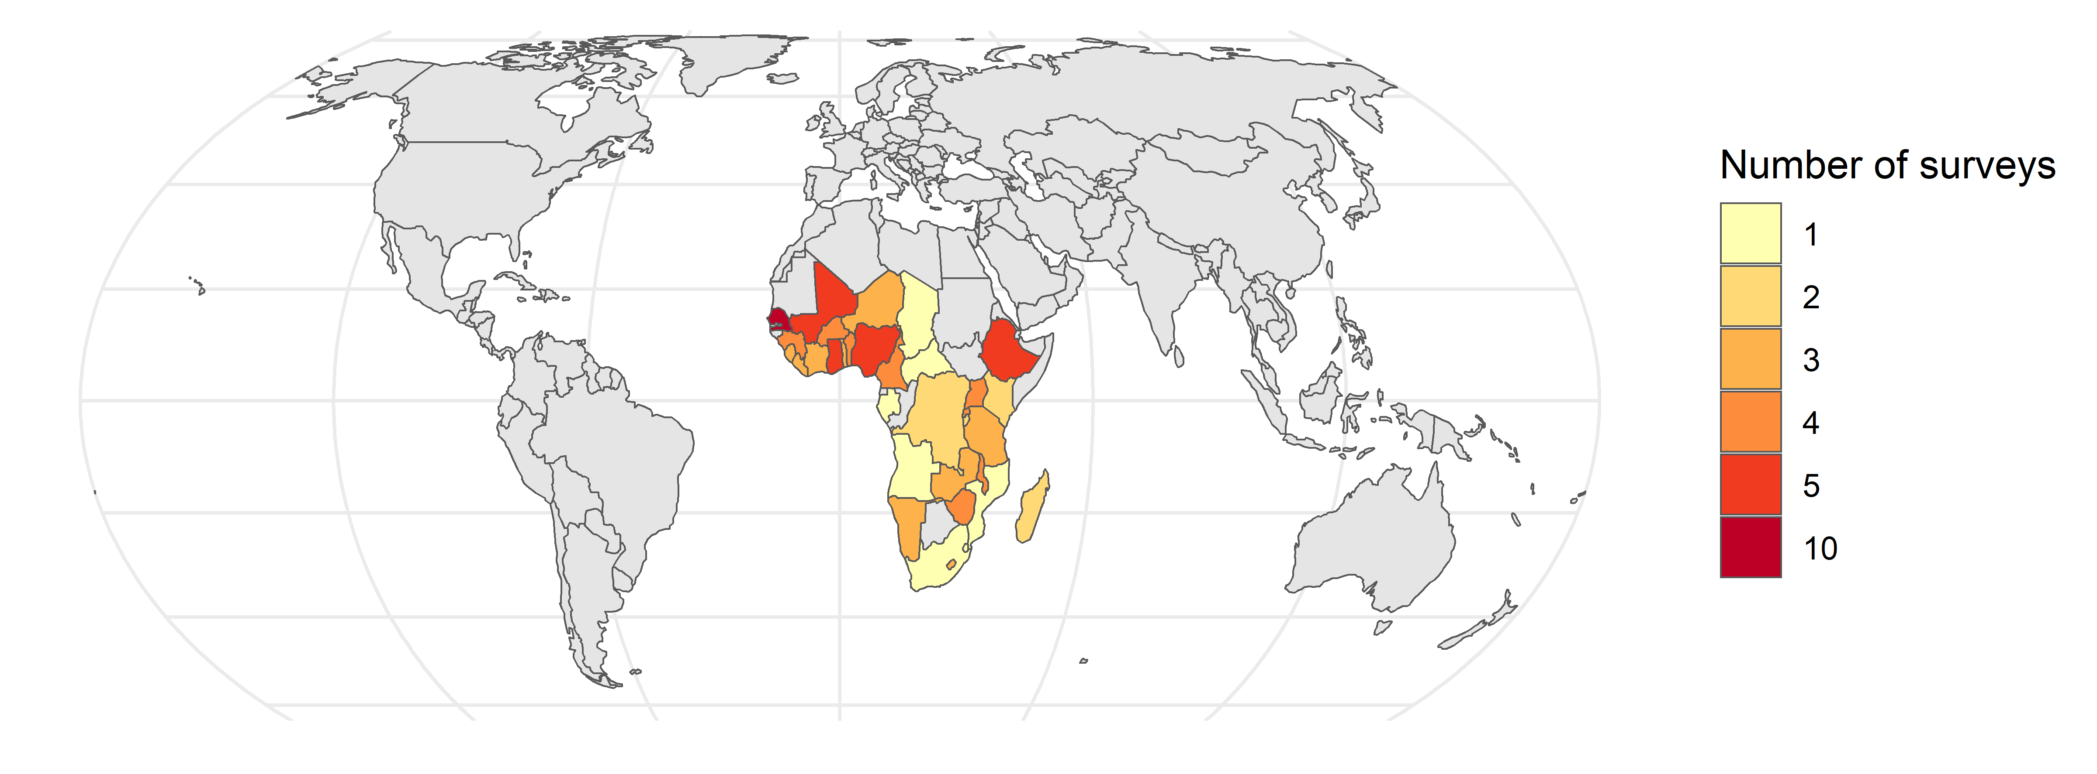
Fig. S1. Countries and number of DHS surveys included in the analysis. Data for 105 surveys from 33 countries collected between 1990 and 2022 were included in the analysis.

Table S1. List of countries and survey years included in the analysis. Samples include children ages 1 to 5 at the time of the interview.

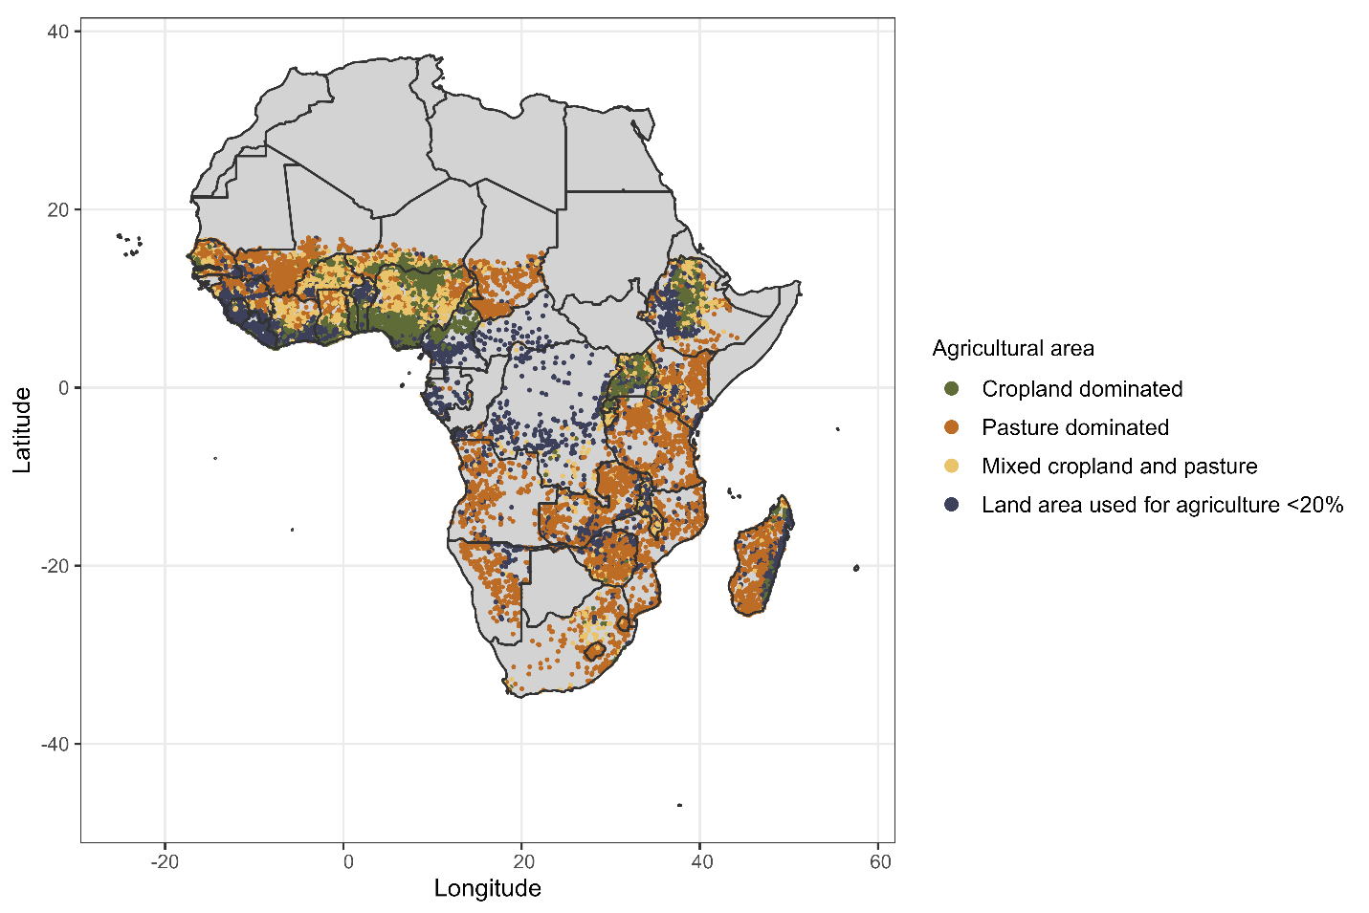
Fig. S2. Agricultural area per PSU inferred by the share of land area used for growing crops and pasture. 42,493 PSU across 34 countries in sub-Saharan Africa.

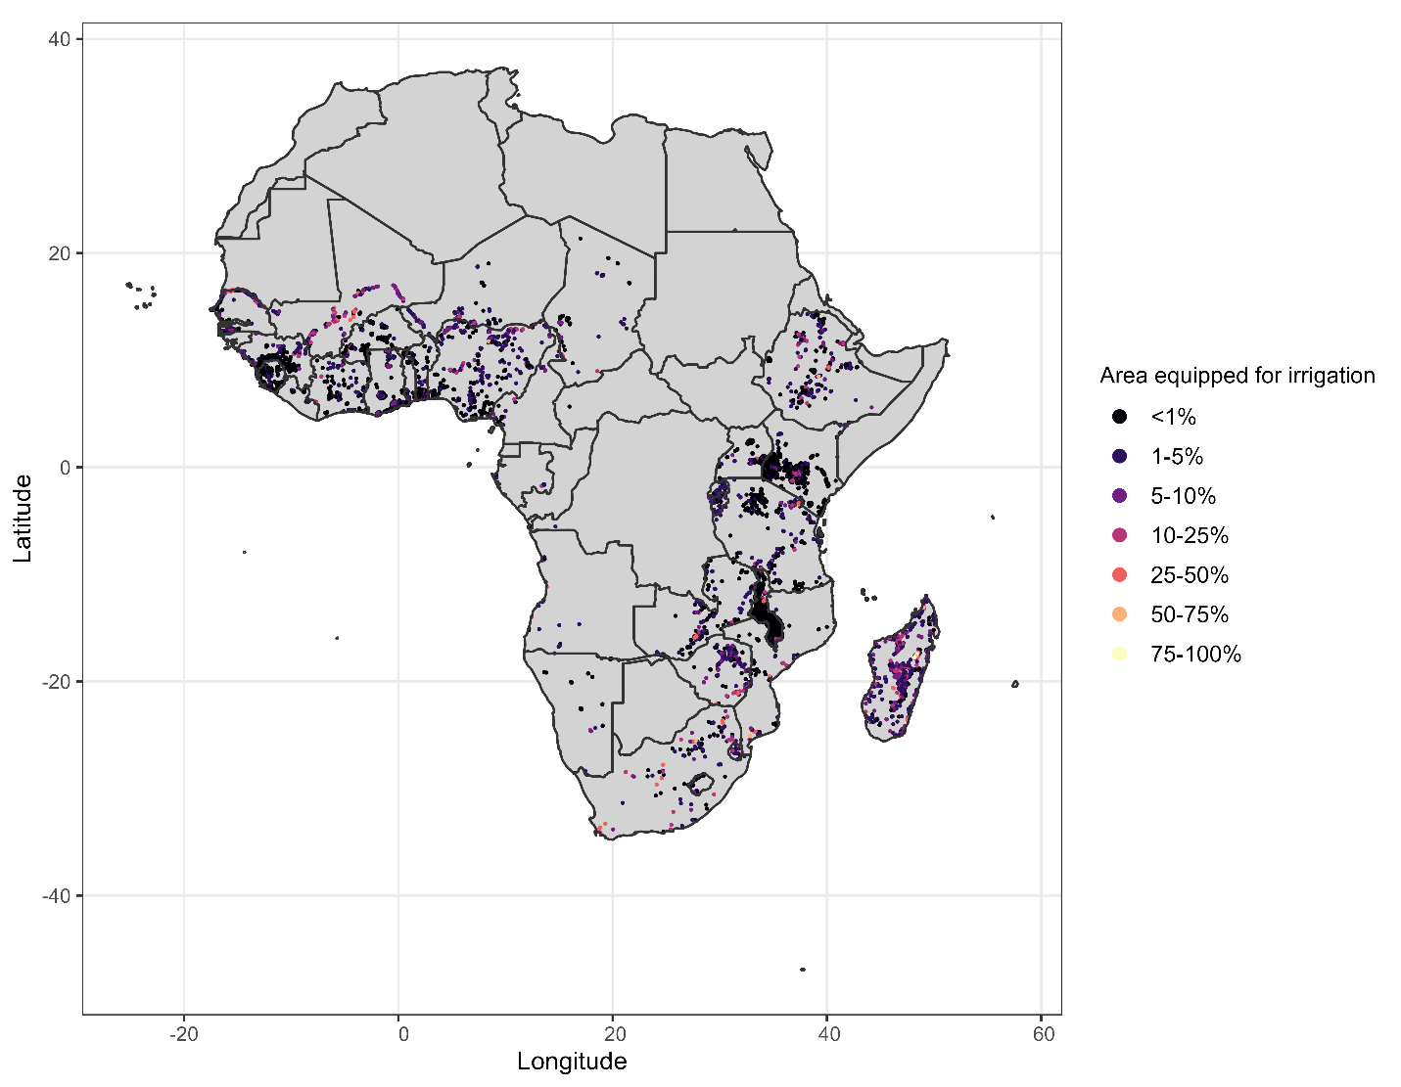
Fig. S3. Area equipped for irrigation (AEI) as a percentage of land area. Each dot represents a PSU. PSUs for which AEI is 0 are not included in the figure. Source: Stefan Siebert, Verena Henrich, Karen Frenken and Jacob Burke. Global Map of Irrigation Areas version 5. Rheinische Friedrich-Wilhelms-University, Bonn, Germany / Food and Agriculture Organization of the United Nations, Rome, Italy. 2013.

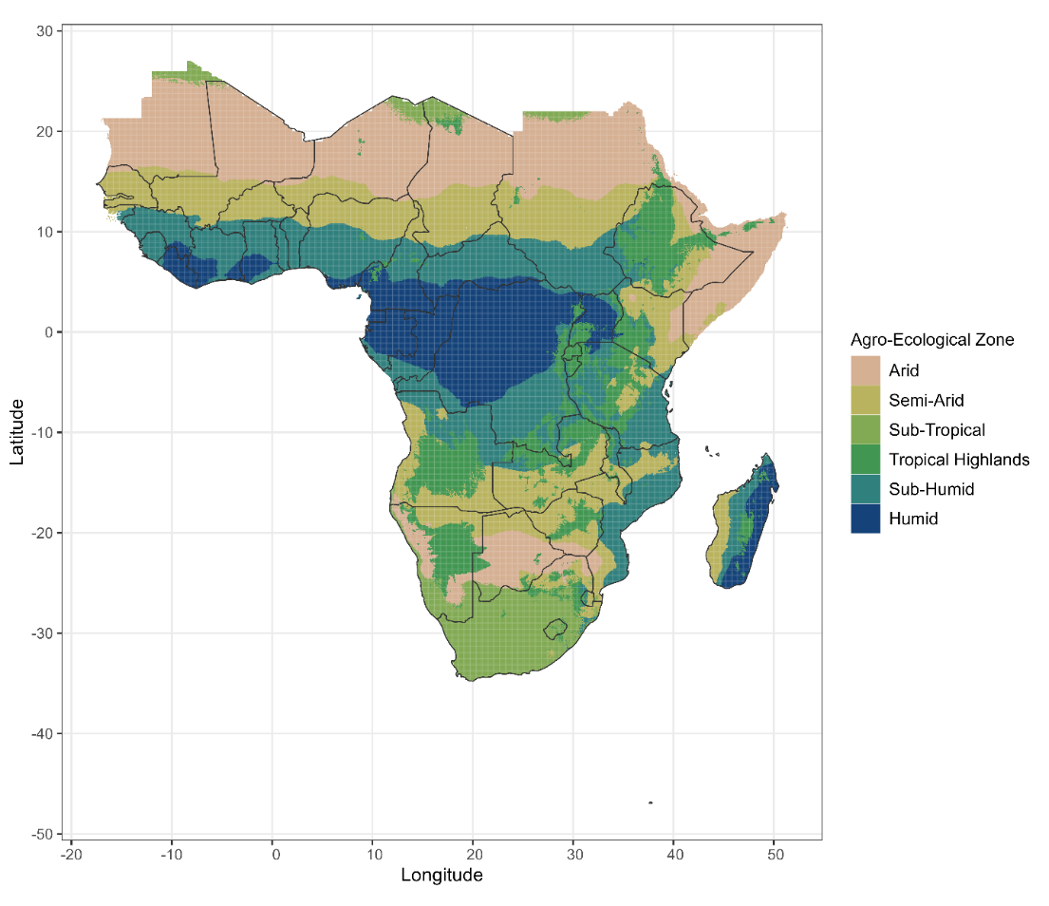
Fig. S4. Agro-ecological zones. Source: Harvest Choice; International Food Policy Research Institute (IFPRI). Agro-Ecological Zones for Africa South of the Sahara. 2015. https://doi.org/10.7910/DVN/M7XIUB, Harvard Dataverse.

Table S2: Descriptive statistics for crop growing season length across all PSUs. Note that some crops have two growing seasons in certain locations.
Crop | Number (PSUs) | Mean | Std. Dev. | Min | Max
Barley | 74732 | 6.31 | 0.462 | 6 | 7
Winter barley | 21520 | 6.17 | 0.376 | 6 | 7
Cassava | 228714 | 8.582 | 1.604 | 6 | 12
Cotton | 119061 | 6.957 | 0.536 | 5 | 8
Groundnut | 242948 | 6.118 | 0.609 | 5 | 7
Maize | 449174 | 5.697 | 1.461 | 3 | 8
Maize 2 | 225439 | 5.182 | 0.423 | 4 | 6
Millet | 358232 | 5.333 | 1.193 | 4 | 9
Potato | 102293 | 5.572 | 1.199 | 4 | 7
Pulses | 80670 | 5.356 | 1.481 | 4 | 7
Rice | 362108 | 5.96 | 0.998 | 3 | 8
Rice 2 | 86909 | 6.139 | 0.907 | 5 | 7
Sorghum | 418579 | 5.753 | 1.165 | 4 | 8
Sorghum 2 | 63931 | 5.604 | 0.489 | 5 | 6
Soybean | 57729 | 6.071 | 0.257 | 6 | 7
Sunflower | 74734 | 7.034 | 0.718 | 6 | 8
Sweet potato | 203357 | 5.604 | 0.826 | 4 | 7
Wheat | 119474 | 6.21 | 0.408 | 5 | 7
Winter wheat | 103281 | 6.125 | 0.433 | 5 | 7
Yam | 138039 | 6.085 | 0.279 | 6 | 7

Table S3: Descriptive statistics for the overall sample and across agricultural groups.
 | Full sample |  |  | Cropland-dominated area |  |  | Mixed area |  |  | Pasture-dominated area |  |  | Land area used for agriculture<20%
 | N | Mean or % | SD | N | Mean or % | SD | N | Mean or % | SD | N | Mean or % | SD | N | Mean or % | SD
Stunted | 380653 |  |  | 90458 |  |  | 83045 |  |  | 117659 |  |  | 89491
No | 220410 | 58% |  | 51538 | 57% |  | 46100 | 56% |  | 69363 | 59% |  | 53409 | 60%
Yes | 160243 | 42% |  | 38920 | 43% |  | 36945 | 44% |  | 48296 | 41% |  | 36082 | 40%
Wtd SPEI for multiple crop-growing seasons in infancy | 380653 | -0.09 | 0.77 | 90458 | -0.06 | 0.73 | 83045 | -0.1 | 0.79 | 117659 | -0.11 | 0.8 | 89491 | -0.08 | 0.76
Main crop-growing season SPEI in infancy | 342985 | -0.09 | 0.88 | 81563 | -0.08 | 0.86 | 75498 | -0.09 | 0.91 | 105523 | -0.12 | 0.88 | 80401 | -0.07 | 0.87
Cropland | 380653 | 0.21 | 0.22 | 90458 | 0.5 | 0.22 | 83045 | 0.24 | 0.13 | 117659 | 0.09 | 0.06 | 89491 | 0.06 | 0.05
Pasture | 380653 | 0.24 | 0.24 | 90458 | 0.06 | 0.07 | 83045 | 0.25 | 0.12 | 117659 | 0.51 | 0.19 | 89491 | 0.04 | 0.05
Sex | 380653 |  |  | 90458 |  |  | 83045 |  |  | 117659 |  |  | 89491
Female | 188524 | 50% |  | 44722 | 49% |  | 41059 | 49% |  | 58351 | 50% |  | 44392 | 50%
Male | 192129 | 50% |  | 45736 | 51% |  | 41986 | 51% |  | 59308 | 50% |  | 45099 | 50%
Age in months | 380653 | 34.25 | 13.88 | 90458 | 34.27 | 13.86 | 83045 | 34.29 | 13.88 | 117659 | 34.38 | 13.91 | 89491 | 34.02 | 13.87
Birth order | 380653 | 3.83 | 2.45 | 90458 | 3.9 | 2.48 | 83045 | 3.91 | 2.49 | 117659 | 3.85 | 2.47 | 89491 | 3.66 | 2.36
Age of the mother at giving birth | 380653 | 27.34 | 6.8 | 90458 | 27.69 | 6.73 | 83045 | 27.42 | 6.83 | 117659 | 27.09 | 6.88 | 89491 | 27.24 | 6.74
Mother's level of education | 380653 |  |  | 90458 |  |  | 83045 |  |  | 117659 |  |  | 89491
No education | 189166 | 50% |  | 43383 | 48% |  | 48870 | 59% |  | 59936 | 51% |  | 36977 | 41%
Primary | 119109 | 31% |  | 28014 | 31% |  | 23153 | 28% |  | 37506 | 32% |  | 30436 | 34%
Secondary and higher | 72378 | 19% |  | 19061 | 21% |  | 11022 | 13% |  | 20217 | 17% |  | 22078 | 25%
Household head's occupation | 380653 |  |  | 90458 |  |  | 83045 |  |  | 117659 |  |  | 89491
Agricultural | 181828 | 48% |  | 42080 | 47% |  | 44036 | 53% |  | 55539 | 47% |  | 40173 | 45%
Non-agricultural | 198825 | 52% |  | 48378 | 53% |  | 39009 | 47% |  | 62120 | 53% |  | 49318 | 55%
Wealth | 380653 |  |  | 90458 |  |  | 83045 |  |  | 117659 |  |  | 89491
Middle | 123955 | 33% |  | 25757 | 28% |  | 27414 | 33% |  | 42523 | 36% |  | 28261 | 32%
Poorer | 131474 | 35% |  | 30118 | 33% |  | 30522 | 37% |  | 40623 | 35% |  | 30211 | 34%
Richer | 125224 | 33% |  | 34583 | 38% |  | 25109 | 30% |  | 34513 | 29% |  | 31019 | 35%
Place of residence | 380653 |  |  | 90458 |  |  | 83045 |  |  | 117659 |  |  | 89491
Rural | 275611 | 72% |  | 65476 | 72% |  | 62154 | 75% |  | 89876 | 76% |  | 58105 | 65%
Urban | 105042 | 28% |  | 24982 | 28% |  | 20891 | 25% |  | 27783 | 24% |  | 31386 | 35%
Main crop season length | 380653 | 6.18 | 1.36 | 90458 | 6.1 | 1.44 | 83045 | 5.93 | 1.42 | 117659 | 6.1 | 1.34 | 89491 | 6.62 | 1.13
Main crop | 380653 |  |  | 90458 |  |  | 83045 |  |  | 117659 |  |  | 89491
Grains | 350752 | 92% |  | 79251 | 88% |  | 79109 | 95% |  | 112698 | 96% |  | 79694 | 89%
Oilseeds and pulses | 6878 | 2% |  | 2113 | 2% |  | 2244 | 3% |  | 1921 | 2% |  | 600 | 1%
Roots | 23023 | 6% |  | 9094 | 10% |  | 1692 | 2% |  | 3040 | 3% |  | 9197 | 10%
Agro-ecological zone | 380653 |  |  | 90458 |  |  | 83045 |  |  | 117659 |  |  | 89491
Arid | 7869 | 2% |  | 255 | 0% |  | 1379 | 2% |  | 5697 | 5% |  | 538 | 1%
Humid | 39307 | 10% |  | 11468 | 13% |  | 2260 | 3% |  | 2949 | 3% |  | 22630 | 25%
Semi-arid | 149275 | 39% |  | 29846 | 33% |  | 39887 | 48% |  | 60821 | 52% |  | 18721 | 21%
Sub-humid | 104430 | 27% |  | 29419 | 33% |  | 20558 | 25% |  | 24087 | 20% |  | 30366 | 34%
Sub-tropical | 2661 | 1% |  | 16 | 0% |  | 382 | 0% |  | 2244 | 2% |  | 19 | 0%
Tropical highland | 77111 | 20% |  | 19454 | 22% |  | 18579 | 22% |  | 21861 | 19% |  | 17217 | 19%
Area equipped for irrigation (pct) | 380653 | 0.93 | 3.85 | 90458 | 0.52 | 2.21 | 83045 | 1.17 | 4.53 | 117659 | 1.2 | 4.67 | 89491 | 0.76 | 3.2

Table S4: Distribution of child stunting in the overall sample and across groups.
 | Full sample [N=380,653 children] |  |  |  | Mixed area [N=83,045 children] |  |  |  | Cropland-dominated area [90,458 children]
 | Not stunted |  | Stunted |  | Not stunted |  | Stunted |  | Not stunted |  | Stunted
 | N | Percent | N | Percent | N | Percent | N | Percent | N | Percent | N | Percent
Drought (wtd SPEI<-1) | 220410 |  | 160243 |  | 46100 |  | 36945 |  | 51538 |  | 38920
No | 197351 | 90% | 141496 | 88% | 40564 | 88% | 32047 | 87% | 47409 | 92% | 34694 | 89%
Yes | 23059 | 10% | 18747 | 12% | 5536 | 12% | 4898 | 13% | 4129 | 8% | 4226 | 11%
Extreme pre (wtd SPEI≥1) | 220410 |  | 169243 |  | 46100 |  | 36945 |  | 51538 |  | 38920
No | 203657 | 92% | 147228 | 92% | 42289 | 92% | 33898 | 92% | 47800 | 93% | 35967 | 92%
Yes | 16753 | 8% | 13015 | 8% | 3811 | 8% | 3047 | 8% | 3738 | 7% | 2953 | 8%
Birth order | 220410 |  | 160243 |  | 46100 |  | 36945 |  | 51538 |  | 38920
First | 43203 | 20% | 27904 | 17% | 8860 | 19% | 6299 | 17% | 9986 | 19% | 6449 | 17%
Second | 41568 | 19% | 27927 | 17% | 8550 | 19% | 6231 | 17% | 9484 | 18% | 6568 | 17%
Third+ | 135639 | 62% | 104412 | 65% | 28690 | 62% | 24415 | 66% | 32068 | 62% | 25903 | 67%
Sex | 220410 |  | 160243 |  | 46100 |  | 36945 |  | 51538 |  | 38920
Female | 113378 | 51% | 75146 | 47% | 23657 | 51% | 17402 | 47% | 26447 | 51% | 18275 | 47%
Male | 107032 | 49% | 85097 | 53% | 22443 | 49% | 19543 | 53% | 25091 | 49% | 20645 | 53%
Mother's level of education | 220410 |  | 160243 |  | 46100 |  | 36945 |  | 51538 |  | 38920
No education | 100363 | 46% | 88803 | 55% | 25256 | 55% | 23614 | 64% | 21211 | 41% | 22172 | 57%
Primary | 67806 | 31% | 51303 | 32% | 12807 | 28% | 10346 | 28% | 16153 | 31% | 11861 | 30%
Secondary and higher | 52241 | 24% | 20137 | 13% | 8037 | 17% | 2985 | 8% | 14174 | 28% | 4887 | 13%
Place of residence | 220410 |  | 160243 |  | 46100 |  | 36945 |  | 51538 |  | 38920
Rural | 147497 | 67% | 128114 | 80% | 31595 | 69% | 30559 | 83% | 34297 | 67% | 31179 | 80%
Urban | 72913 | 33% | 32129 | 20% | 14505 | 31% | 6386 | 17% | 17241 | 33% | 7741 | 20%
Household head's occupation | 220410 |  | 160243 |  | 46100 |  | 36945 |  | 51538 |  | 38920
Agricultural | 91353 | 41% | 90475 | 56% | 21298 | 46% | 22738 | 62% | 20542 | 40% | 21538 | 55%
Non-agricultural | 129057 | 59% | 69768 | 44% | 24802 | 54% | 14207 | 38% | 30996 | 60% | 17382 | 45%
Wealth | 220410 |  | 160243 |  | 46100 |  | 36945 |  | 51538 |  | 38920
Middle | 59164 | 27% | 64791 | 40% | 12347 | 27% | 15067 | 41% | 11352 | 22% | 14405 | 37%
Poorer | 71384 | 32% | 60090 | 37% | 15930 | 35% | 14592 | 39% | 15989 | 31% | 14129 | 36%
Richer | 89862 | 41% | 35362 | 22% | 17823 | 39% | 7286 | 20% | 24197 | 47% | 10386 | 27%

Table S4 cont.: Distribution of child stunting in the overall sample and across groups.
 | Pasture-dominated areas [N=117,659 children] |  |  |  | Land area used for agriculture<20% [N=89,491 children]
 | Not stunted |  | Stunted |  | Not stunted |  | Stunted
 | N | Percent | N | Percent | N | Percent | N | Percent
Drought | 69363 |  | 48296 |  | 53409 |  | 36082
No | 61327 | 88% | 42449 | 88% | 48051 | 90% | 32306 | 90%
Yes | 8036 | 12% | 5847 | 12% | 5358 | 10% | 3776 | 10%
Extreme pre (wtd SPEI≥1) | 69363 |  | 48296 |  | 53409 |  | 36082
No | 64126 | 92% | 44254 | 92% | 49442 | 93% | 33109 | 92%
Yes | 5237 | 8% | 4042 | 8% | 3967 | 7% | 2973 | 8%
Birth order | 69363 |  | 48296 |  | 53409 |  | 36082
First | 13372 | 19% | 8451 | 17% | 10985 | 21% | 6705 | 19%
Second | 12903 | 19% | 8477 | 18% | 10631 | 20% | 6651 | 18%
Third+ | 43088 | 62% | 31368 | 65% | 31793 | 60% | 22726 | 63%
Sex | 69363 |  | 48296 |  | 53409 |  | 36082
Female | 35640 | 51% | 22711 | 47% | 27634 | 52% | 16758 | 46%
Male | 33723 | 49% | 25585 | 53% | 25775 | 48% | 19324 | 54%
Mother's level of education | 69363 |  | 48296 |  | 53409 |  | 36082
No education | 33870 | 49% | 26066 | 54% | 20026 | 37% | 16951 | 47%
Primary | 21376 | 31% | 16130 | 33% | 17470 | 33% | 12966 | 36%
Secondary and higher | 14117 | 20% | 6100 | 13% | 15913 | 30% | 6165 | 17%
Place of residence | 69363 |  | 48296 |  | 53409 |  | 36082
Rural | 50057 | 72% | 39819 | 82% | 31548 | 59% | 26557 | 74%
Urban | 19306 | 28% | 8477 | 18% | 21861 | 41% | 9525 | 26%
Household head's occupation | 69363 |  | 48296 |  | 53409 |  | 36082
Agricultural | 28740 | 41% | 26799 | 55% | 20773 | 39% | 19400 | 54%
Non-agricultural | 40623 | 59% | 21497 | 45% | 32636 | 61% | 16682 | 46%
Wealth | 69363 |  | 48296 |  | 53409 |  | 36082
Middle | 21446 | 31% | 21077 | 44% | 14019 | 26% | 14242 | 39%
Poorer | 22795 | 33% | 17828 | 37% | 16670 | 31% | 13541 | 38%
Richer | 25122 | 36% | 9391 | 19% | 22720 | 43% | 8299 | 23%

Table S5: Associations between child stunting and agricultural drought (wtd SPEI<-1) and extreme precipitation (wtd SPEI≥1) during the child’s infancy period by agricultural group. Wtd SPEI is constructed by combining the SPEI values over all crop-growing seasons in the area, where the weights are determined based on the share of land dedicated to each crop. The sample includes children ages 1 to 5. All estimates are adjusted for potential confounders (see Methods in the main text).
 | Full sample |  |  | Mixed cropland and pasture area |  |  | Cropland-dominated area |  |  | Pasture-dominated area |  |  | Land area used for agriculture <20%
 | OR | CI low | CI high | OR | CI low | CI high | OR | CI low | CI high | OR | CI low | CI high | OR | CI low | CI high
Drought | 1.067 | 1.026 | 1.110 | 1.082 | 1.020 | 1.148 | 1.176 | 1.074 | 1.287 | 1.029 | 0.982 | 1.079 | 1.041 | 0.970 | 1.117
Extreme pre | 1.020 | 0.975 | 1.067 | 1.025 | 0.957 | 1.098 | 0.984 | 0.905 | 1.071 | 1.012 | 0.949 | 1.080 | 1.053 | 0.968 | 1.146
Obs. | 380653 |  |  | 83017 |  |  | 90439 |  |  | 117657 |  |  | 89464

Table S6: Associations between child stunting and agricultural drought during the child’s infancy period by severity of the drought event with 95% confidence intervals. Droughts are defined as mild (-1 < wtd SPEI ≤ -0.5), moderate (-1.5 < wtd SPEI ≤ -1), and severe (wtd SPEI ≤ -1.5). Wtd SPEI is constructed by combining the SPEI values over all crop-growing seasons in the area, where the weights are determined based on the share of land dedicated to each crop. Samples consist of children ages 1 to 5. All estimates are adjusted for potential confounders (see Methods in the main text).
 | Full sample |  |  | Mixed cropland and pasture area |  |  | Cropland-dominated area |  |  | Pasture-dominated area |  |  | Land area used for agriculture <20%
 | OR | CI low | CI high | OR | CI low | CI high | OR | CI low | CI high | OR | CI low | CI high | OR | CI low | CI high
Mild drought | 1.008 | 0.969 | 1.048 | 1.021 | 0.970 | 1.075 | 1.028 | 0.942 | 1.123 | 1.021 | 0.972 | 1.073 | 0.945 | 0.892 | 1.000
Moderate drought | 1.052 | 1.000 | 1.107 | 1.060 | 0.984 | 1.142 | 1.140 | 1.010 | 1.287 | 1.018 | 0.968 | 1.071 | 1.026 | 0.942 | 1.119
Severe drought | 1.101 | 1.028 | 1.179 | 1.138 | 1.034 | 1.252 | 1.340 | 1.180 | 1.523 | 1.062 | 0.972 | 1.160 | 1.017 | 0.913 | 1.133
Obs. | 380653 |  |  | 83017 |  |  | 90439 |  |  | 117657 |  |  | 89464

Table S7: Associations between child stunting and agricultural drought (wtd SPEI<-1) during the child’s infancy period by agricultural land distribution with 95% confidence intervals. Wtd SPEI is constructed by combining the SPEI values over all crop-growing seasons in the area, where the weights are determined based on the share of land dedicated to each crop. Samples consist of children ages 1 to 5. All estimates are adjusted for potential confounders (see Methods in the main text).
 | Pasture: under 20% |  |  | Pasture: 20-40% |  |  | Pasture: over 40%
 | OR | CI low | CI high | OR | CI low | CI high | OR | CI low | CI high
Cropland: under 20% | 1.045 | 0.981 | 1.113 | 1.057 | 0.992 | 1.125 | 1.023 | 0.948 | 1.105
Cropland: 20-40% | 1.100 | 1.017 | 1.189 | 1.042 | 0.945 | 1.149 | 1.008 | 0.845 | 1.202
Cropland: over 40% | 1.189 | 1.051 | 1.345 | 1.045 | 0.899 | 1.215 | 1.014 | 0.689 | 1.492
Obs. | 232441 |  |  | 85286 |  |  | 60333

Table S8: Associations between child stunting and agricultural drought (wtd SPEI<-1) during the child’s infancy period by the area’s irrigation status with 95% confidence intervals. Wtd SPEI is constructed by combining the SPEI values over all crop-growing seasons in the area, where the weights are determined based on the share of land dedicated to each crop. Samples consist of children ages 1 to 5. All estimates are adjusted for potential confounders (see Methods in the main text).
 | Full sample |  |  | Mixed cropland and pasture area |  |  | Cropland-dominated area
 | OR | CI low | CI high | OR | CI low | CI high | OR | CI low | CI high
No area equipped for irrigation | 1.069 | 1.022 | 1.119 | 1.111 | 1.039 | 1.187 | 1.182 | 1.071 | 1.303
Some area equipped for irrigation | 1.054 | 0.988 | 1.125 | 0.978 | 0.878 | 1.090 | 1.161 | 1.008 | 1.337
Obs. | 380653 |  |  | 83017 |  |  | 90439

Table S9 Associations between child stunting and agricultural drought (wtd SPEI≤-1) during the child’s infancy period by child’s individual and household characteristics. Wtd SPEI is constructed by combining the SPEI values over all crop-growing seasons in the area, where the weights are determined based on the share of land dedicated to each crop. Samples consist of children ages 1 to 5. All estimates are adjusted for potential confounders (see Methods in the main text). Wald test is used to determine statistically significant pairwise differences in effect estimates between effect modifier categories. § and þ indicate pairwise differences that are statistically significant at 0.1 significance level or higher.
 |  | Full sample |  |  | Mixed cropland and pasture area |  |  | Cropland-dominated area
Effect modifier | Effect modifier category | OR | CI low | CI high | OR | CI low | CI high | OR | CI low | CI high
Birth order | First | 1.044 | 0.979 | 1.114 | 1.055 | 0.935 | 1.192 | 1.168 | 0.990 | 1.377
Birth order | Second | 1.046 | 0.979 | 1.118 | 1.095 | 0.968 | 1.239 | 1.189 | 1.041 | 1.358
Birth order | Third+ | 1.079 | 1.035 | 1.124 | 1.084 | 1.012 | 1.161 | 1.183 | 1.079 | 1.297
Sex of the child | Female | 1.077 | 1.035 | 1.120 | 1.084 | 1.012 | 1.161 | 1.160 | 1.043 | 1.289
Sex of the child | Male | 1.054 | 1.004 | 1.107 | 1.077 | 0.998 | 1.162 | 1.195 | 1.083 | 1.318
Mother's education | None | 1.083 | 1.038 | 1.131 | 1.105 | 1.038 | 1.177 | 1.206 | 1.087 | 1.338
Mother's education | Primary | 1.036 | 0.975 | 1.100 | 1.051 | 0.944 | 1.171 | 1.161 | 1.030 | 1.308
Mother's education | Secondary and higher | 1.049 | 0.962 | 1.144 | 0.956 | 0.794 | 1.152 | 1.082 | 0.949 | 1.234
Place of residence | Rural | 1.069 | 1.024 | 1.116 | 1.089 | 1.019 | 1.164 | 1.206 | 1.097 | 1.325
Place of residence | Urban | 1.054 | 0.994 | 1.118 | 1.049 | 0.948 | 1.162 | 1.091 | 0.957 | 1.244
Occupation of the household head | Agricultural | 1.082 | 1.028 | 1.139 | 1.134 | 1.055 | 1.220 | 1.192 | 1.068 | 1.331
Occupation of the household head | Non-agricultural | 1.046 | 1.002 | 1.092 | 1.007 | 0.935 | 1.085 | 1.158 | 1.056 | 1.270
Household wealth | Poorer | 1.093 | 1.033 | 1.157 | 1.122 | 1.033 | 1.218 | 1.267 | 1.127 | 1.426
Household wealth | Middle | 1.074 | 1.022 | 1.127 | 1.062 | 0.974 | 1.157 | 1.198 | 1.087 | 1.322
Household wealth | Wealthier | 1.015 | 0.963 | 1.070 | 1.046 | 0.923 | 1.186 | 1.035 | 0.918 | 1.166

