Supplementary Table 1. Significantly altered metabolites in non-polar fraction.
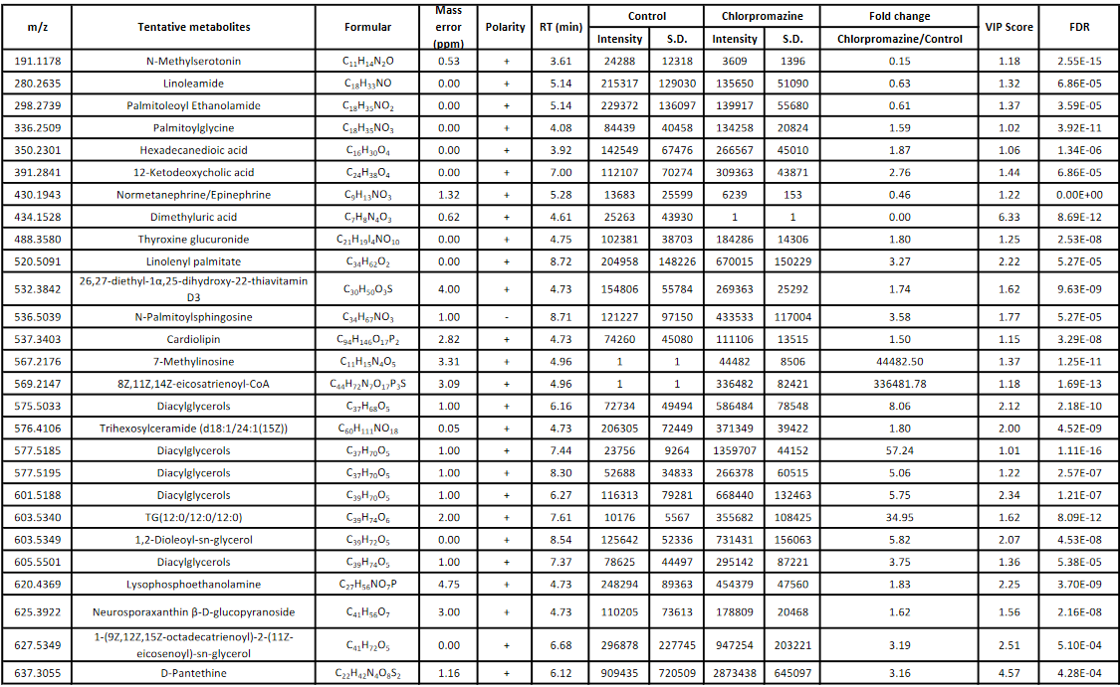

Supplementary Table 1 (Cont.). Significantly altered metabolites in non-polar fraction.
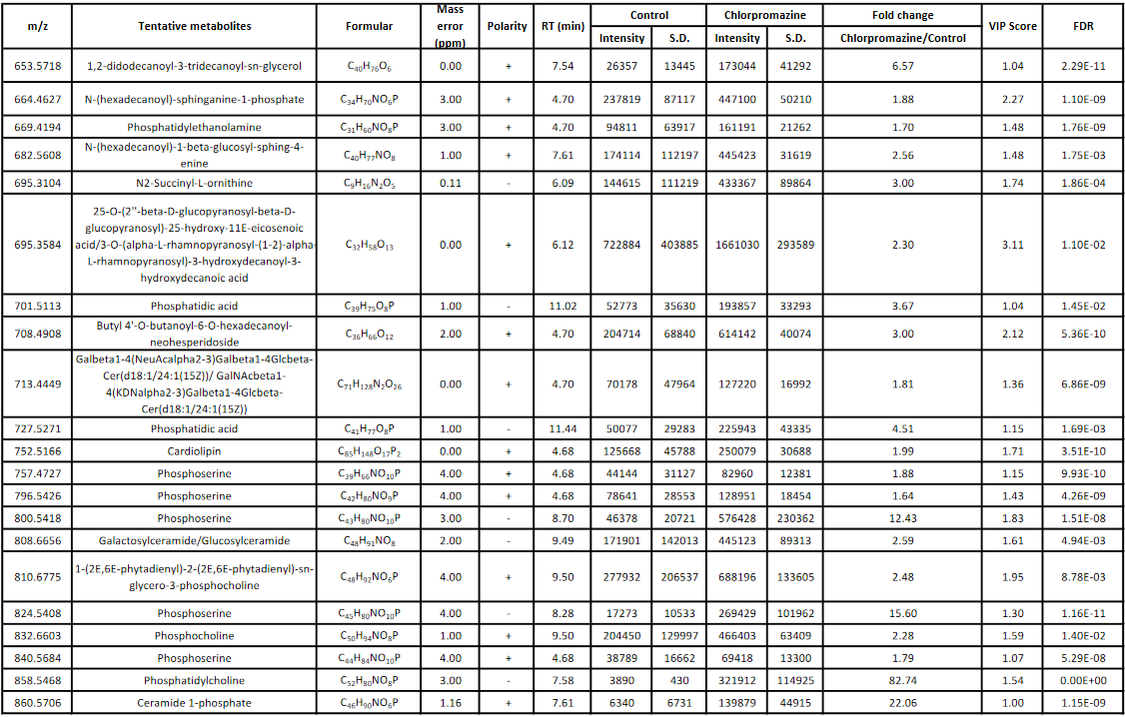
Supplementary Table 1 (Cont.). Significantly altered metabolites in non-polar fraction.
