Supporting Information
Synergistic Photothermal Antibacterial Effects of Silver-Coated Upconversion Nanoparticles: Experimental Insights and DFT Calculations

Synergistic Photothermal Antibacterial Effects of Silver-Coated Upconversion Nanoparticles
Zhou You^{a#}, Ali Mohsin^{b#}, Sobia Niazi^{c}, Ali Hussan^{d}, Reesha Khan^{e}, Tehmina Azam^{d}, Muhammad Sajjad^{d}, Faizan ul Haq^{c}, Ali Raza^{c}, Khubaib Ali^{f}, Muhammad Shoaib^{g}, Ibrahim Khan^{d}, Qi Shou^{h*}, Shahid Iqbal^{d} Imran Mahmood Khan^{d*},
ª Institute of Food Safety and Nutrition, Jiangsu Academy of Agricultural Sciences, Nanjing 210014, P.R. China.
^{b} State Key Laboratory of Bioreactor Engineering, East China University of Science and Technology, Shanghai 200237, P.R. China.
^{c} School of Food Science and Technology, Jiangnan University, Wuxi, China.
^{d} Nottingham Ningbo China Beacons of Excellence Research and Innovation Institute, University of Nottingham Ningbo China, Ningbo 315100, P.R. China.
^{e} Food Science and Technology, University of Narowal, Pakistan.
^{f} College of Food Science and Engineering, Yangzhou University, Yangzhou, Jiangsu 225127, China
^{g} College of Biosystems Engineering and Food Science, Zhejiang University 866 Yuhangtang Road, Hangzhou 310058, P.R. China
^{h} College of Light Industry and Food Engineering, Nanjing Forestry University, Nanjing, 210037, China.
# The first two authors have equal contributions.
Corresponding Authors:
Imran Mahmood Khan
Emails: imran-mahmood.khan@nottingham.edu.cn

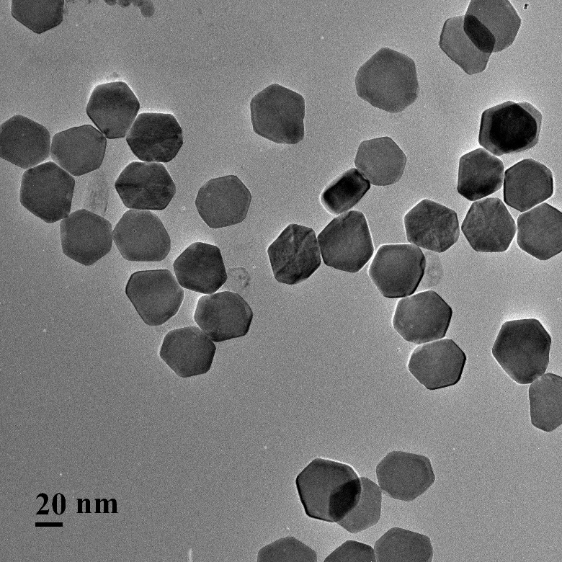
Figure S1. The TEM image of the UCNP, with an average diameter of 41.7 nm.

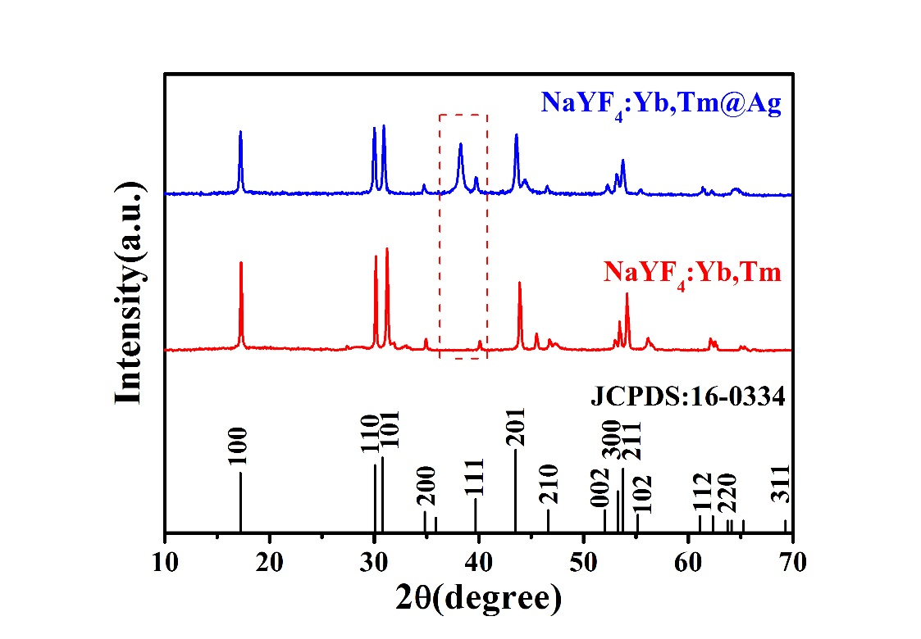
Figure S2. The X-ray diffraction patterns (XRD) of UCNP and UCNP@AgNPs.
Figure S3. The TEM image of individual silver nanoparticles with the average particle size was estimated as 61.5 nm.
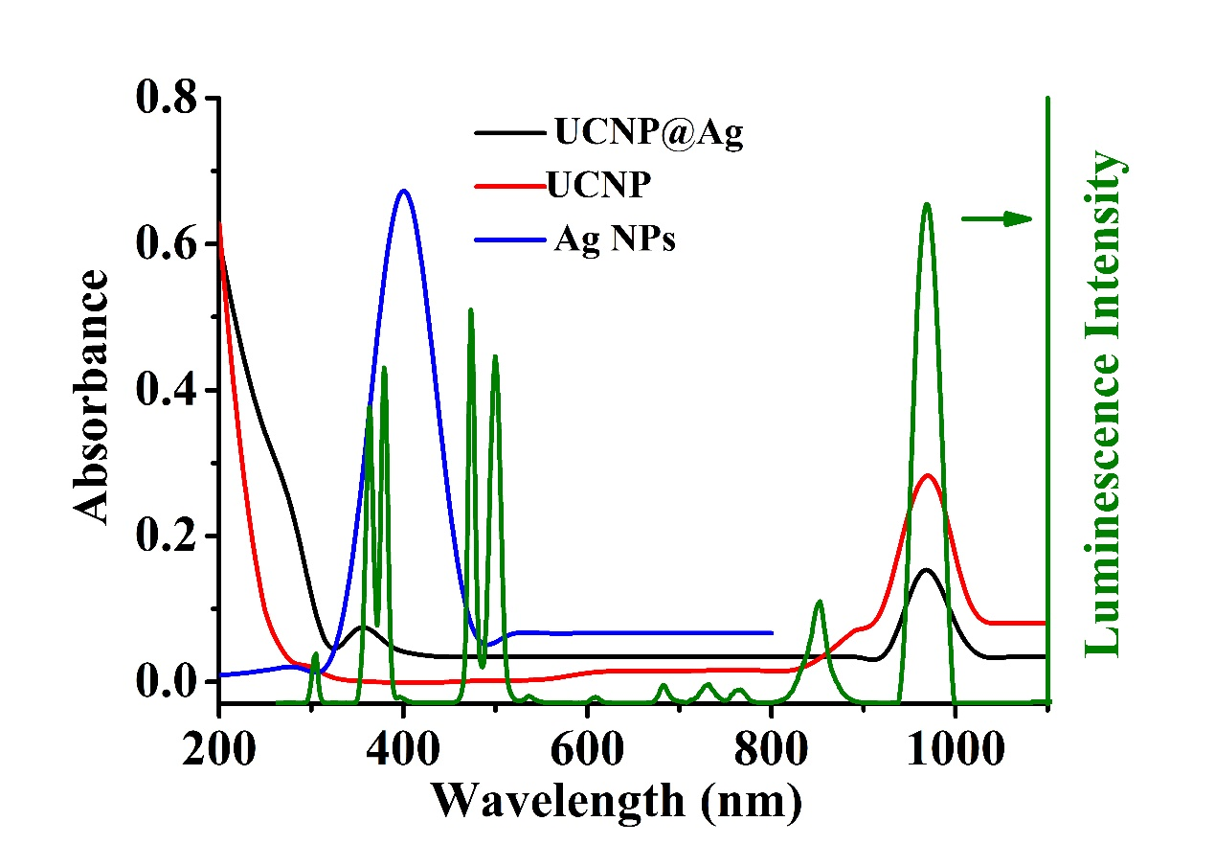
Figure S4. The UV-vis absorption spectrum of UCNP, AgNPs, and UCNP@Ag nanoparticles as well as the luminescence spectrum of UCNP (green line).
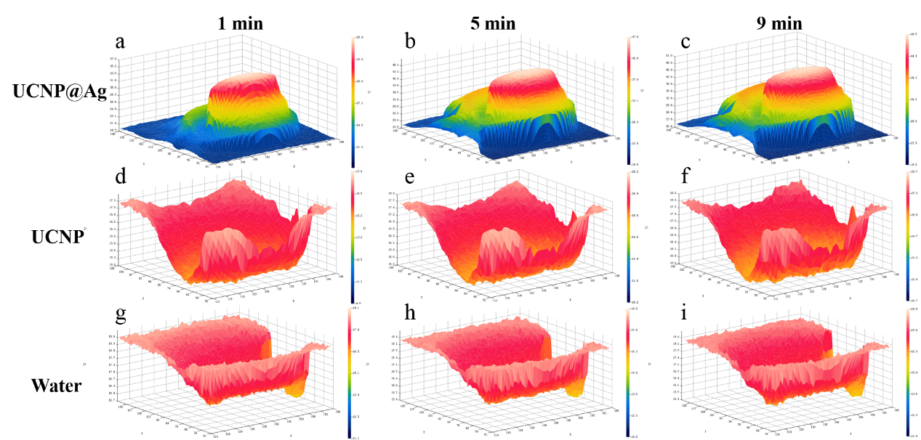
Fig S5. The photothermal performance of the UCNP@Ag nanoparticle (20 µg mL⁻¹) and the control group, irradiated by a 980-nm NIR laser (1.0 W/cm²) for 9 min, monitored electronically using an Infrared Camera (FOTRIC-225). The corresponding temperature distribution maps of the measured solution with different irradiation times (a-c, the UCNP@Ag; d-f, UCNP; g-i, Water).
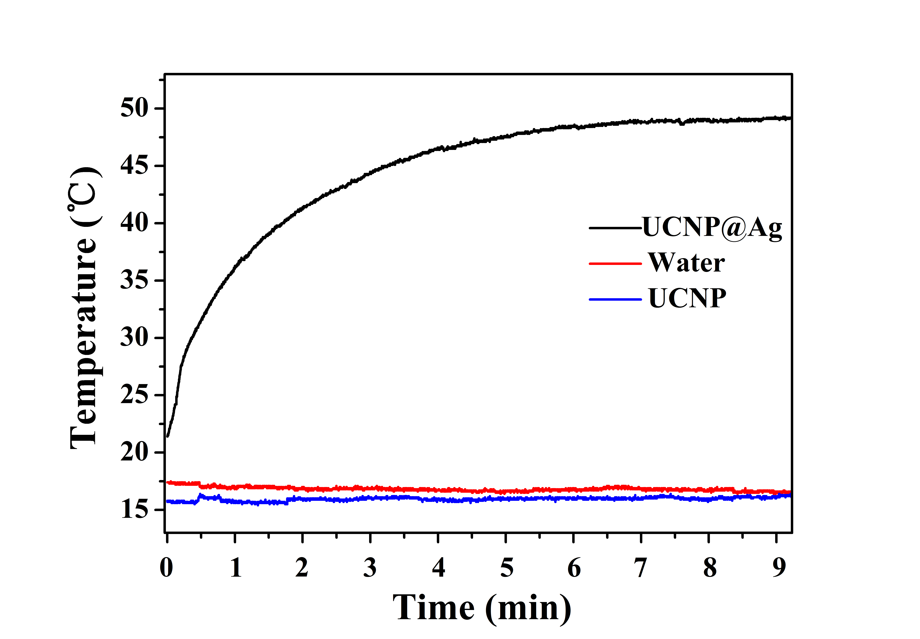
Figure S6. The temperature-time curves of the UCNP@Ag (20 µg mL⁻¹), UCNP, and water.

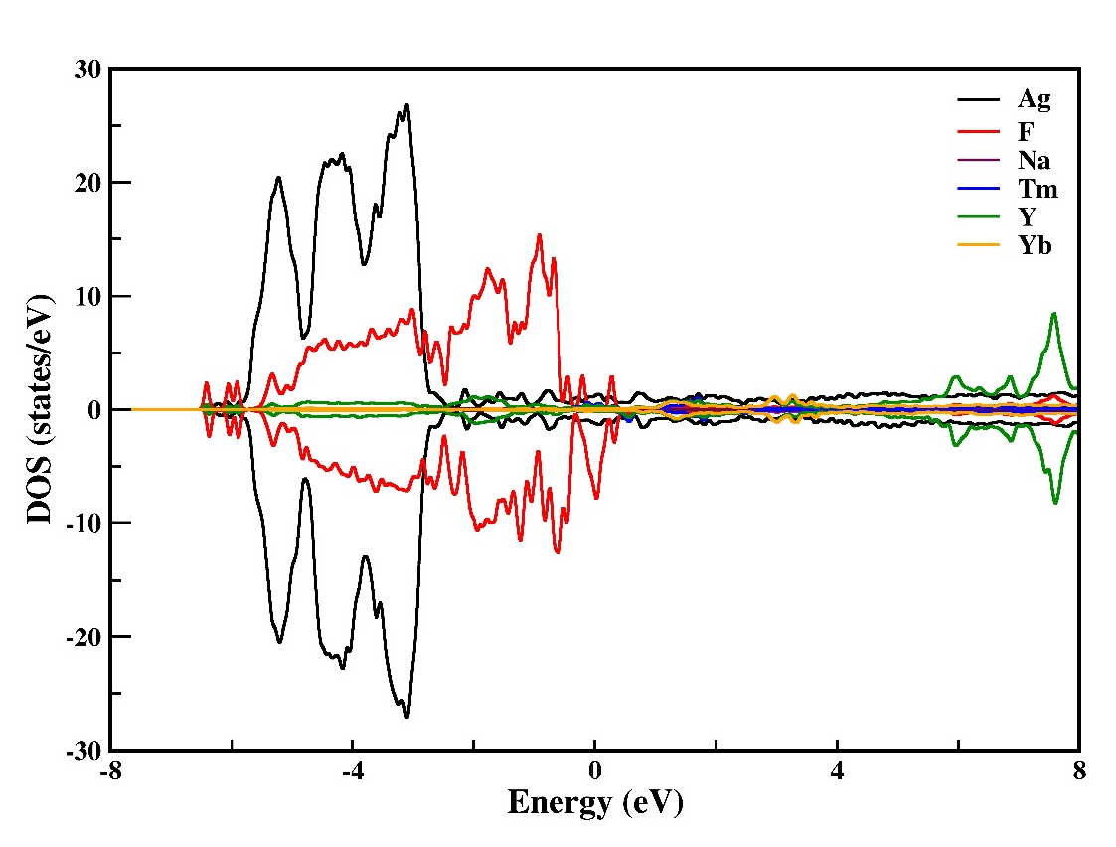
Figure S7 :PDOS analysis for Ag@UCNPs

