Supplementary materials
Skin-Replaceable Antifouling Cellulose Ceramic Membranes from Jute Agro-Waste for Sustainable and Efficient Oily Wastewater Treatment
Nadeem Baig *^{[a]}, Tauqir Ahmad,^{[a]} Ali Sufyan,^{[b]} Muhammad Bilal Asif ^{[c]}, Kawthar Alqudaihi,^{[d]} Balqees Alrwaily,^{[d]} Md. Sabbir Ahmed,^{[e]} Md. Maniruzzaman,^{[e]} Arshad Hussain,^{[f]} Syed Shaheen Shah,^{[g]}, J. Andreas Larsson*^{[h,i]}, and Md. Abdul Aziz,*^{[f]}
^{[a]} Interdisciplinary Research Centre for Membranes and Water Security, King Fahd University of Petroleum and Minerals, Dhahran 31261, Saudi Arabia
^{[b]} NanoLund and Division of Mathematical Physics, Department of Physics, Lund University, Lund, Sweden
^{[c]} Department for Civil, Maritime and Environmental Engineering Faculty of Engineering and Physical Sciences, University of Southampton, UK
^{[d]} Chemistry Department, College of Science, Imam Abdulrahman Bin Faisal University (IAU), Dammam, Saudi Arabia.
^{[e]} Department of Chemistry, Khulna University of Engineering & Technology, Khulna 9203, Bangladesh
^{[f]} Interdisciplinary Research Center for Hydrogen Technologies and Carbon Management (IRC-HTCM), King Fahd University of Petroleum & Minerals (KFUPM), Dhahran, 31261 Saudi Arabia
^{[g]} Socio-Environmental Energy Science Department, Graduate School of Energy Science, Kyoto University, Yoshida Honmachi, Sakyo-ku, Kyoto 606-8501, Japan
^{[h]} Applied Physics, Division of Materials Science, Department of Engineering Sciences and Mathematics, Luleå University of Technology, Luleå, SE-97187, Sweden.
^{[i]} Wallenberg Initiative Materials Science for Sustainability, Luleå University of Technology, Luleå SE-97187, Sweden

* Corresponding Authors
Email Addresses: nadeembaig@kfupm.edu.sa (N. Baig); andreas.1.larsson@ltu.se (J. A. Larsson) and maziz@kfupm.edu.sa (M. A. Aziz)

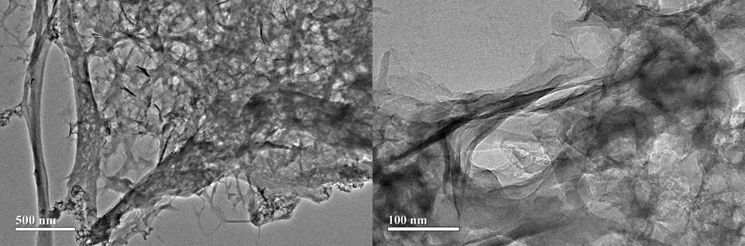
Figure S1. TEM images of the cellulose dispersion reveal sheet-like and fiber-like structures.

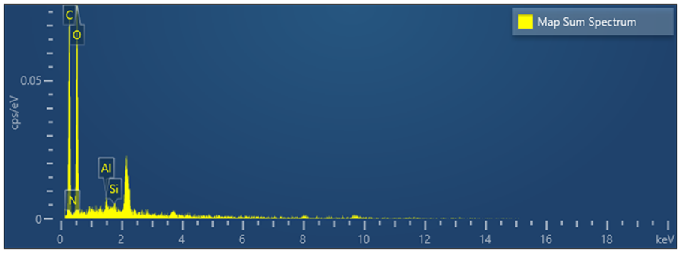
Figure S2. EDX analysis of the SRC-M membranes.

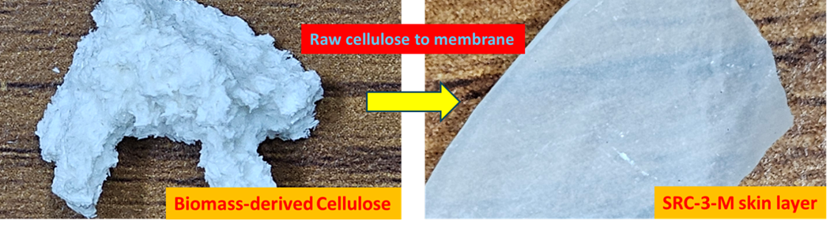
Figure S3. Photographs of the SRC-3-M skin layer, which is formed from the biomass-derived cellulose.
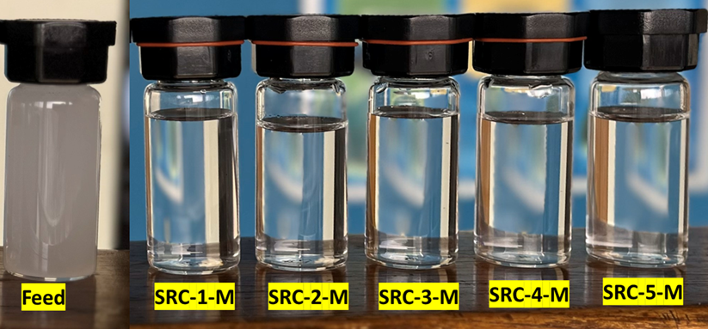
Figure S4. The camera captured images of the feed and the permeate collected from different membranes.

Table S1. Comparison of the SRC-3-M membranes with other membranes for the separation of the oil-in-water emulsion.
Membrane | Type of emulsion | Permeability (LMH/bar) | Rejection (%) | FRR (%) | Skin replaceability | Ref.
SRC-3-M | Oil-in-water emulsion | 487 | 98 | 99 | Yes | This work
PVDF + PEG | Oil-in-water emulsion | 5 | 99 | 54 | No | [S1]
PVDF+ AP | Oil-in-water emulsion | 16.5 | 99 | 99 | No | [S1]
PSf/NMP/PVP | Oil-in-water emulsion | 120 | 97.8 | 98 | NO | [S2]
PSf/DMAc/PVP (M6) | Oil-in-water emulsion | 50 | 97.2 | 98 | NO | [S2]
PSf/NMP/PEG | Oil-in-water emulsion | 90 | 97.1 | 98 | NO | [S2]
PSf/DMAc/PEG | Oil-in-water emulsion | 120 | 95.5 | 98 | NO | [S2]
GO/PDA/MCEM | Oil-in-water emulsion | ~90 | 96 | 63 | NO | [S3]
PZGS-M2-PVDF | Oil-in-water emulsion | 10 | 99.3 | 83 | NO | [S4]
PVDF | Oil-in-water emulsion | 1.9 | 90 | 59 | NO | [S4]
Poly(vinyl alcohol) (PVA) membrane | Oil-in-water emulsion | 425 | 94.5 | 95 | NO | [S5]
PSf/SiO₂ membranes | Oil-in-water emulsion | 7 | 98.38 | 34.01 | No | [S6]
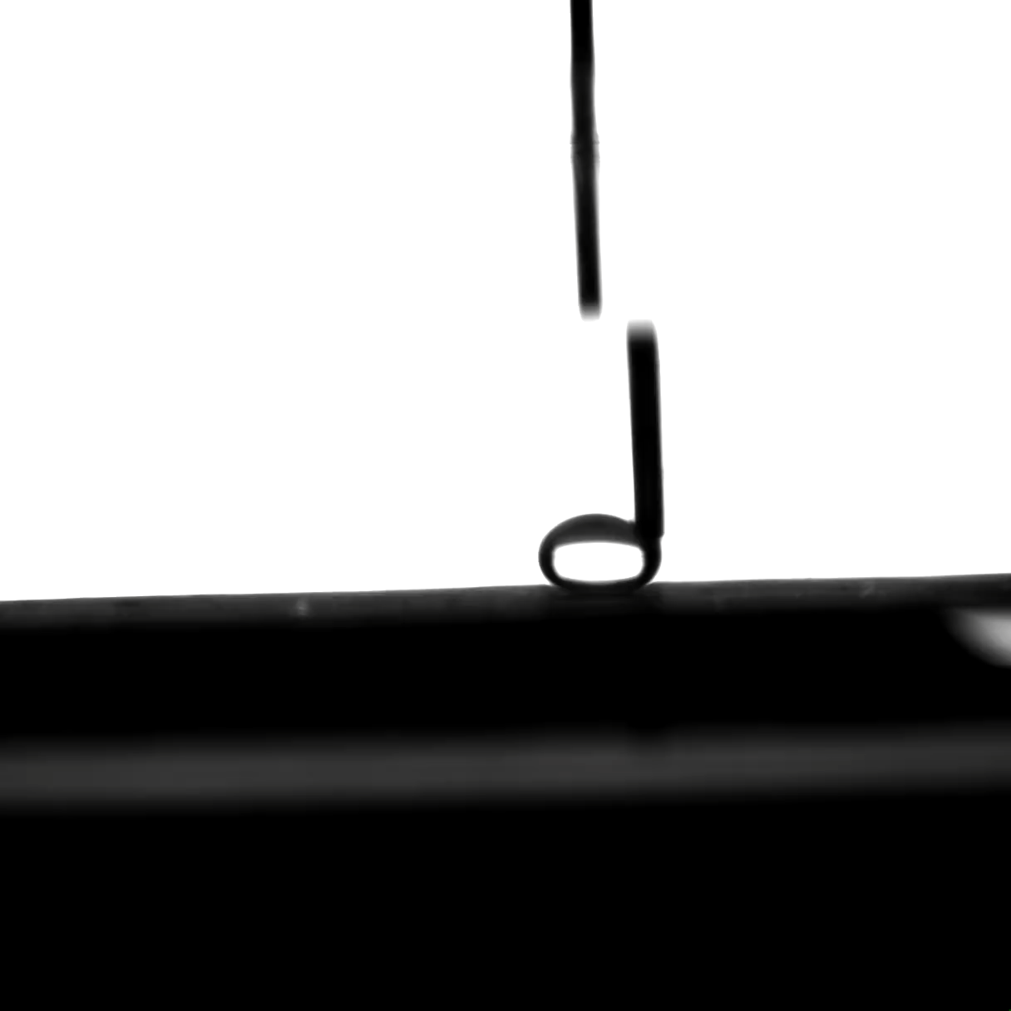

Video S1 | Oil-repellence and antifouling behavior of SRC-M. The oil repellence of the SRC-M membrane was evaluated by immersing the membrane underwater and introducing a ∼5 µL oil droplet (chloroform) onto its surface. The interaction between the oil droplet and the membrane was recorded to assess the underwater oil-repellent and antifouling characteristics of SRC-3-M.

References
[S1] X. Zhu, W. Tu, K. H. Wee, R. Bai, J Memb Sci 2014, 466, 36–44.
[S2] B. Chakrabarty, A. K. Ghoshal, M. K. Purkait, J Memb Sci 2008, 325, 427–437.
[S3] Z. Liu, W. Wu, Y. Liu, C. Qin, M. Meng, Y. Jiang, J. Qiu, J. Peng, Sep Purif Technol 2018, 199, 37–46.
[S4] M. Mansha, B. Salhi, S. Ali, S. A. Khan, N. Baig, J Environ Chem Eng 2022, 10, 107935.
[S5] C. Wu, A. Li, L. Li, L. Zhang, H. Wang, X. Qi, Q. Zhang, Desalination 2008, 225, 312–321.
[S6] A. L. Ahmad, M. A. Majid, B. S. Ooi, Desalination 2011, 268, 266–269.

