SUPPLEMENTAL MATERIAL

Sorting Nexin 3 Induces Myocardial Injury via Promoting Retromer-Dependent Nuclear Trafficking of STAT3

Jing Lu¹, Suowen Xu², Yuqing Huo³, Yuehuai Hu¹, Junjian Wang¹, Xiaolei Zhang¹, Duanping Sun⁴, Panxia Wang¹, Zhuoming Li¹, Mengya Liang⁵, Zhongkai Wu⁵*, Peiqing Liu¹*

¹ School of Pharmaceutical Sciences, Sun Yat-sen University, Guangzhou 510006, P.R.China
² Aab Cardiovascular Research Institute, University of Rochester School of Medicine and Dentistry, Rochester, New York 14642, USA
³ Vascular Biology Center, Department of Cellular Biology and Anatomy, Medical College of Georgia, Augusta University, Augusta, GA 30912, USA
⁴ Center for Drug Research and Development, Guangdong Pharmaceutical University, Guangzhou 510006, P.R.China
⁵ Department of Cardiac Surgery, First Affiliated Hospital, Sun Yat-sen University, Guangzhou 510080, P.R.China

* Address for Correspondence:
Prof. Peiqing Liu, PhD
School of Pharmaceutical Sciences, Sun Yat-sen University
132# East Wai-huan Road, Higher Education Mega Center
Guangzhou 510006, Guangdong, P.R.China.
E-mail: liupq@mail.sysu.edu.cn (P. Liu)

Prof. Zhongkai Wu, PhD
Department of cardiac Surgery
First Affiliated Hospital, Sun Yat-sen University
58# Zhongshan 2 Road
Guangzhou 510080, Guangdong, P.R.China.
E-mail: wuzhk@mail.sysu.edu.cn (Z. Wu)
Table of contents:
- Supplemental Table S1
- Supplemental Table S2
- Supplemental Table S3
- Supplemental Table S4
- Supplemental Table S5
- Supplemental Table S6
- Supplemental Table S7
- Supplemental Figure S1
- Supplemental Figure S2
- Supplemental Figure S3
- Supplemental Figure S4
- Supplemental Figure S5
- Supplemental Figure S6
- Supplemental Figure S7
- Supplemental Figure S8
- Supplemental Figure S9
- Supplemental Figure S10
- Supplemental Figure S11

Supplemental Table S1 Clinical characteristics of patients with heart failure
Patient  No. | Gender | Age | Heart rate | EF  (%) | FS  (%) | LVPW  (mm) | LVDs  (mm) | LVDd  (mm) | Clinical diagnosis
30350414 | male | 42 | 84 | 20.7 | 9.9 | 6.7 | 75.6 | 83.9 | Dilated cardiomyopathy
1192628 | male | 67 | 90 | 13 | 6.08 | 10 | 82 | 87 | Dilated cardiomyopathy
30381613 | male | 48 | 72 | 51 | 27 | 87.6 | 57.3 | 78.2 | Dilated cardiomyopathy
30433755 | male | 53 | 104 | 29.6 | 14.2 | 9.6 | 51.6 | 60.1 | Dilated cardiomyopathy
30445449 | male | 39 | 63 | 24 | 12.3 | 9 | 63.2 | 70 | Dilated cardiomyopathy
30432502 | male | 37 | 80 | 24.7 | 11.8 | 5.4 | 59 | 67 | Dilated cardiomyopathy
30449749 | male | 60 | 71 | 32.1 | 15.9 | 8 | 69 | 82 | Coronary heart disease
30457360 | male | 11 | 84 | 15.2 | 6.98 | 9.7 | 57.3 | 82.3 | Dilated cardiomyopathy
30461745 | male | 60 | 72 | 17.9 | 8.38 | 7.7 | 66.7 | 72.8 | Coronary heart disease

Supplemental Table S2 The primer sequences were used for genotyping the correct 5' and 3' homology arm recombination of Snx3-floxed mice
Primer | Sequences
P1 | 5'-TCTCCATCCTTGTCAACCGTGTAT-3'
P2 | 5'-ATTTGGGAGCCTGTTTCTTCATCT-3'
P3 | 5'-GGCTGGCCTTGAGTTCTTGAT-3'
P4 | 5‘-CAGCTGTGCCCTTTACTTACTTGA-3'

Supplemental Table S3 The primer sequences were used for genotyping Snx3-flox and the activity of Myh6-Cre
Genotype | Primer | Sequences
Snx3-flox | P5 (Forward) | 5'-CTTTTAGAGGAGACGATGGAATA-3'
Snx3-flox | P6 (Reverse) | 5'-AGAAAGGCTGGAAGTGGCTAAA-3'
Myh6-Cre | P7 (COM) | 5'- TTCCCAAGGGCATTTTATTAG-3'
Myh6-Cre | P8 (WT) | 5‘-CTTTGGGCTTGGCATCATCTGGT-3'
Myh6-Cre | P9 (Mut) | 5‘-CAGCCCCTTGTTGAATACG-3'
Abbreviations: Myh6-Cre, C57BL/6J-Myh6^{em1(IRES-Cre)Smoc}.

Supplemental Table S4 The primer sequences of mouse Snx3 gene for genotyping Snx3-cTg mice
Primer | Sequences
Forward | 5'- GCGTTGGCTACCCGTGATATT -3'
Reverse | 5'- CACGACATTCAACAGACCTT -3'

Supplemental Table S5 The duplex shRNAs for rats Snx3 gene
Primer | Sequences
shRNA-1 | GGTCAAGACCAATCTTCCTATTTCAAGAGAATAGGAAGATTGGTCTTGACCTTTTTT
shRNA-2 | GACTTTGAGTGGCTTCGAAGTTTCAAGAGAACTTCGAAGCCACTCAAAGTCTTTTTT
shRNA-3 | GAGGAGACGATGGAATATTTGTTCAAGAGACAAATATTCCATCGTCTCCTCTTTTTT
shRNA-4 | GGAACAGTTCATAAACAAGGTTTCAAGAGAACCTTGTTTATGAACTGTTCCTTTTTT
scrambled shRNA | GCCTAAGGTTAAGTCGCCCTCGTTCAAGAGACGAGGGCGACTTAACCTTAGGCTTTTTT

Supplemental Table S6 The duplex shRNAs for rats importin α3 gene
Primer | Sequences
shRNA-1 | GCCAGGAAGTCAAAGTTCAAACTTCAAGAGAGTTTGAACTTTGACTTCCTGGCTTTTTT
shRNA-2 | GGCGATAAGACAGCAAGCAACATTCAAGAGATGTTGCTTGCTGTCTTATCGCCTTTTTT
shRNA-3 | GGCTATATTACAGAATGCTACATTCAAGAGATGTAGCATTCTGTAATATAGCCTTTTTT
scrambled shRNA | GCCTAAGGTTAAGTCGCCCTCGTTCAAGAGACGAGGGCGACTTAACCTTAGGCTTTTTT
Supplemental Table S7 The primer sequences for qPCR analysis
Species | Gene | Gene sequence | Primer sequence
Rattus norvegicus | Snx3 | NM_001044283.1 | FP: 5' -AAGAGGCAAACCCCAAGACC-3'  RP: 5'- TTAGTACATCCAGGGCGTGC-3'
Rattus norvegicus | Anf | NM_012612.2 | FP: 5' -CCGTATACAGTGCGGTGTCC-3'  RP: 5'- CAGAGAGGGAGCTAAGTGCC-3'
Rattus norvegicus | Bnp | NM_031545.1 | FP: 5' -AGCTGCTTTGGGCAGAAGAT-3'  RP: 5'-AAAACAACCTCAGCCCGTCA-3'
Rattus norvegicus | β-Mhc | NM_017240.2 | FP: 5'-GACAACGCCTATCAGTACATG-3'  RP: 5'-TGGCAGCAATAACAGCAAAA-3'
Rattus norvegicus | c-Fos | NM_022197.2 | FP: 5'-GGGAGCTGACAGATACGCTC-3'  RP: 5'-TCAAGTCCAGGGAGGTCACA-3'
Rattus norvegicus | c-Jun | NM_021835.3 | FP: 5'- GCACATCACCACTACACCGA-3'  FP: 5'- TATGCAGTTCAGCTAGGGCG-3'
Rattus norvegicus | Gapdh | NM 017008.4 | FP: 5'- TGCCACTCAGAAGACTGTGG -3'  RP: 5'- TTCAGCTCTGGGATGACCTT -3'
Mus musculus | Snx3 | NM_017472.4 | FP: 5' - TCGCTCCAGCCTCTCTAAGT-3'  RP: 5'- AGCAAGTCGGCAGCTTTAGT-3'
Mus musculus | Anf | NM_008725.3 | FP: 5' - TCGGAGCCTACGAAGATCCA-3'  RP: 5'- GTGGCAATGTGACCAAGCTG-3'
Mus musculus | Bnp | NM_008726.5 | FP: 5' - AAGGACCAAGGCCTCACAAA -3'  RP: 5'- GCCAGGAGGTCTTCCTACAAC-3'
Mus musculus | β-Mhc | NM_080728.3 | FP: 5' - CGCTACGCTTCCTGGATGAT-3'  RP: 5'- TCCGGTGATGAGGATGGACT-3'
Mus musculus | Gapdh | NM_001289726.1 | FP: 5' - CCCTTAAGAGGGATGCTGCC-3'  RP: 5'- TACGGCCAAATCCGTTCACA-3'
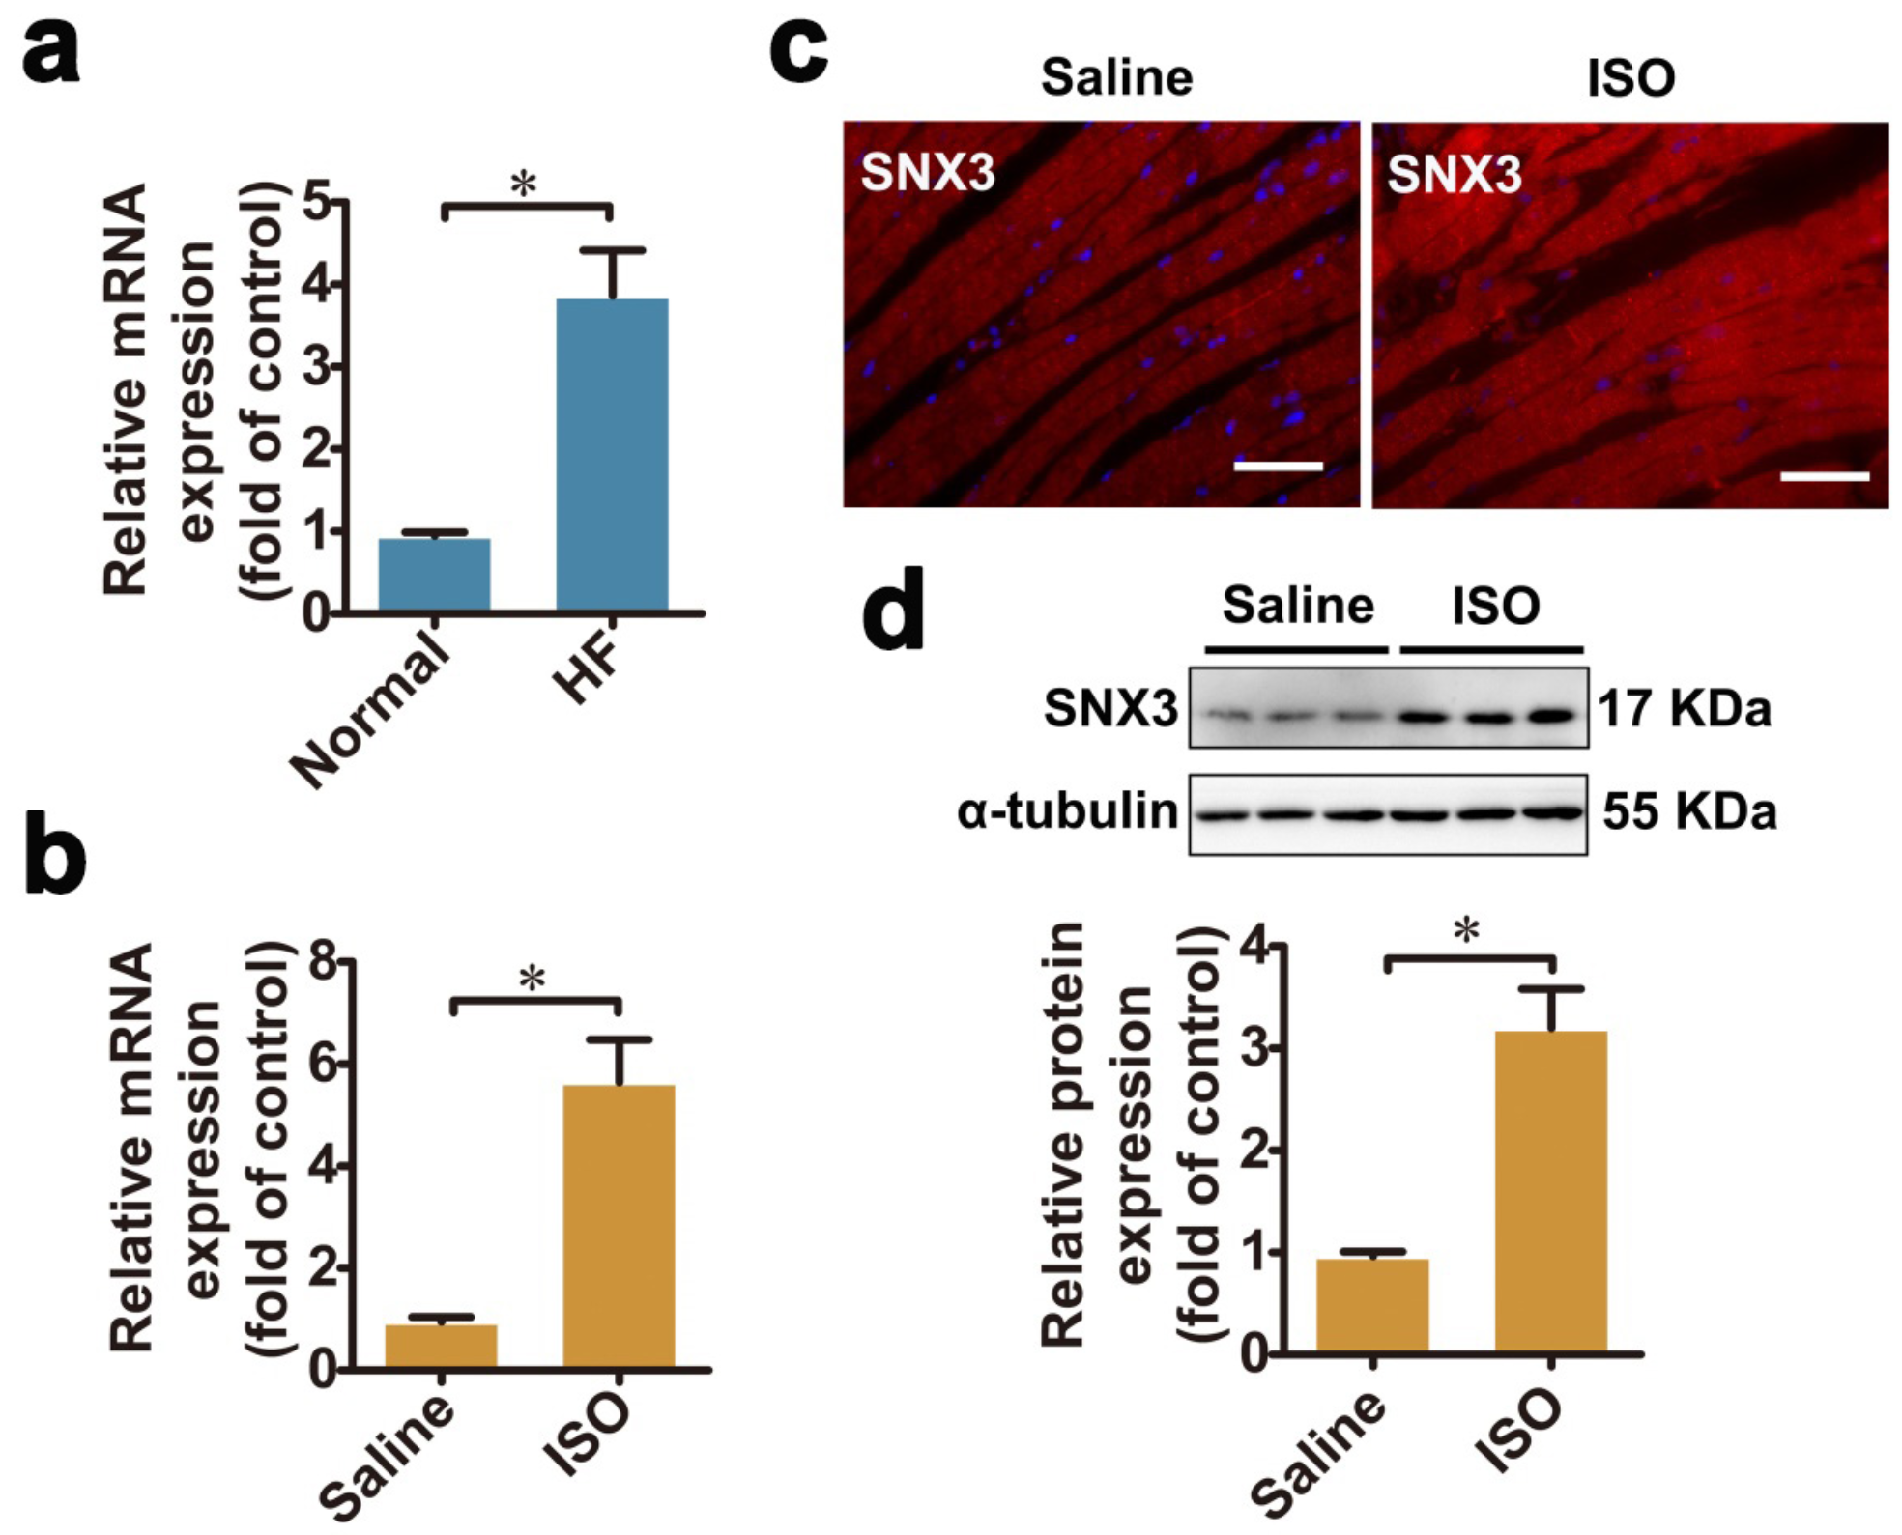
Figure S1 SNX3 expression was increased in human and mouse failing hearts, related to Figure 1. a qPCR results showing the SNX3 mRNA expression in end-stage failing human heart tissues and normal control. b-d qPCR, western blot and IF assay (Scale bar: 100 μm) results showing the mRNA and protein expression of SNX3 in the myocardium of a mouse model of myocardial injury by injected with ISO (s.c., 3 mg/kg/day) for four weeks. Representative images of five independent experiments were presented. The data were presented as the means ± SEM. *P < 0.05 vs. Normal or Saline group, n = 9 per HF, n = 3 per Normal control, n = 8-12 per ISO (or Saline). Abbreviations: HF, heart failure; IF, immunofluorescence; ISO, isoproterenol; qPCR, quantitative polymerase chain reaction; s.c., subcutaneously.

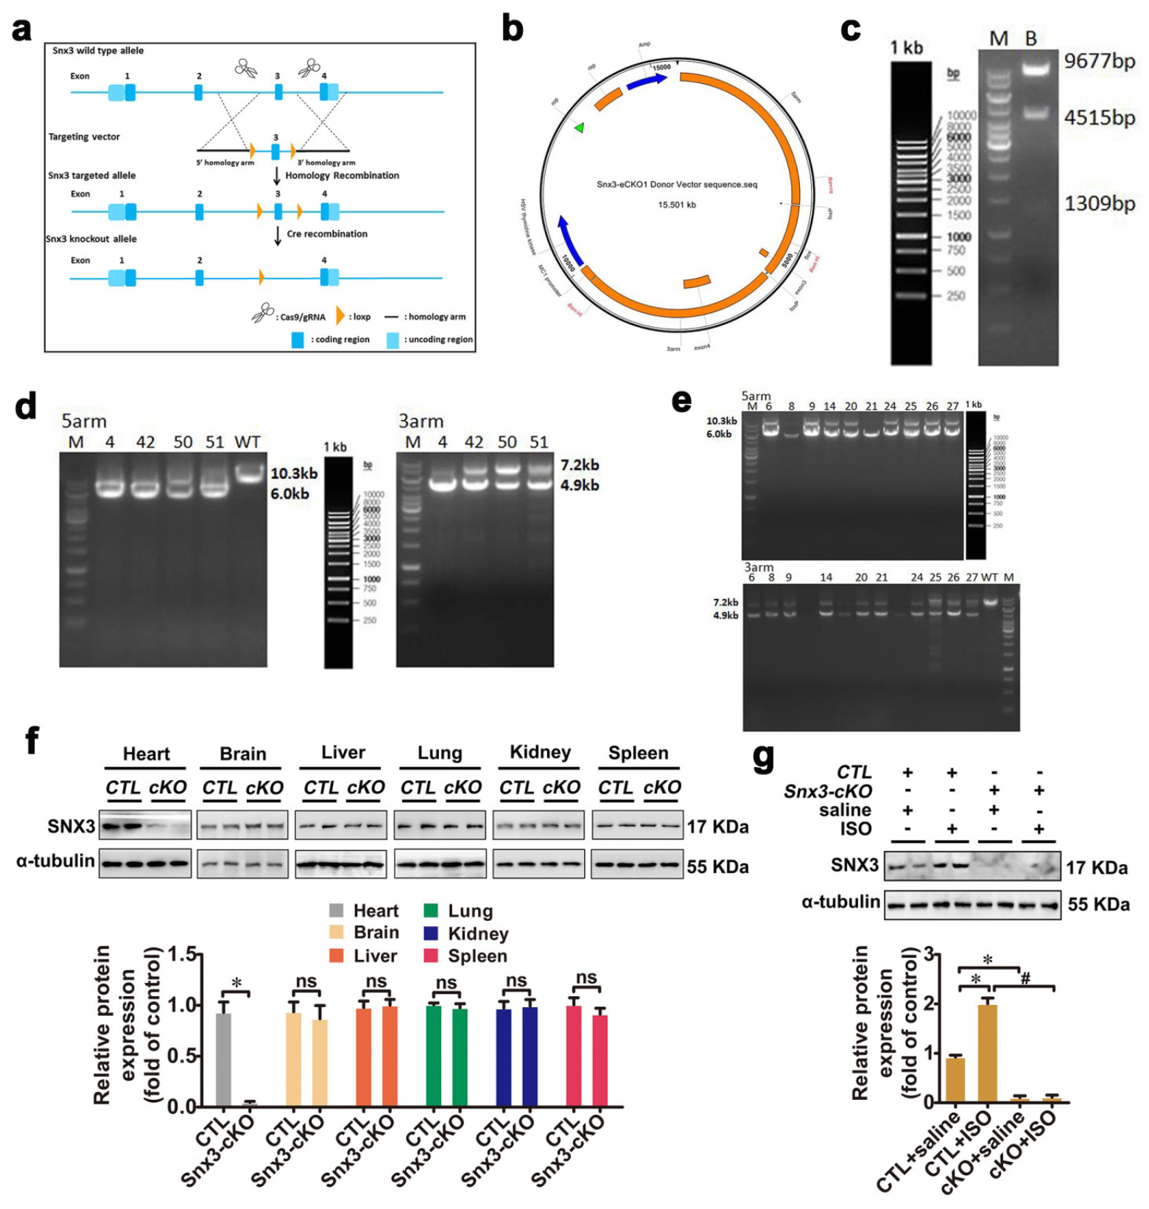
Figure S2 Generation and validation of Snx3-cKO mice, related to Figure 1. The donor vector with four gRNAs and Cas9 mRNA targeting Snx3 introns 2 and 3 was microinjected into the fertilized egg of C57BL/6 mouse, and the obtained Snx3-floxed mice were crossed with Myh6-Cre mice to generate cardiac-specific Snx3-cKO mice. a The scheme of Snx3-cKO mice construction strategy. b The plasmid profiles of donor vector carring four gRNAs and Cas9 mRNA were presented. c The plasmid vector was evaluated by extracting with BamHI mono-restriction endonuclease enzyme and the agar gel electrophoresis. Marker: 1 kb DNA ladder. d PCR electrophoresis of homologous recombinant positive F0 generation mice. Marker: 1 kb DNA ladder. e PCR electrophoresis of homologous arm of F1 generation mice. Marker: 1 kb DNA ladder. f The protein expression of SNX3 in the indicated tissues of Snx3-cKO mice at 12 weeks was measured by western blot analysis. Besides, Snx3-cKO mice and their respective littermate negative controls (CTL) at 11 weeks were injected with ISO (3 mg/kg/day, s.c.) or an equal volume of sterile normal saline for one week. g The protein expression of SNX3 was measured by western blot analysis. The data were presented as the means ± SEM. *P < 0.05 vs. CTL group, #P < 0.05 vs. CTL + ISO group, n = 8-12. Abbreviations: CTL, littermate negative control; ISO, isoproterenol; Myh6-Cre, C57BL/6J-Myh6^{em1(IRES-Cre)Smoc}; ns, no statistical difference; PCR, polymerase chain reaction; s.c., subcutaneously; Snx3-cKO, cardiac-specific Snx3 knockout.

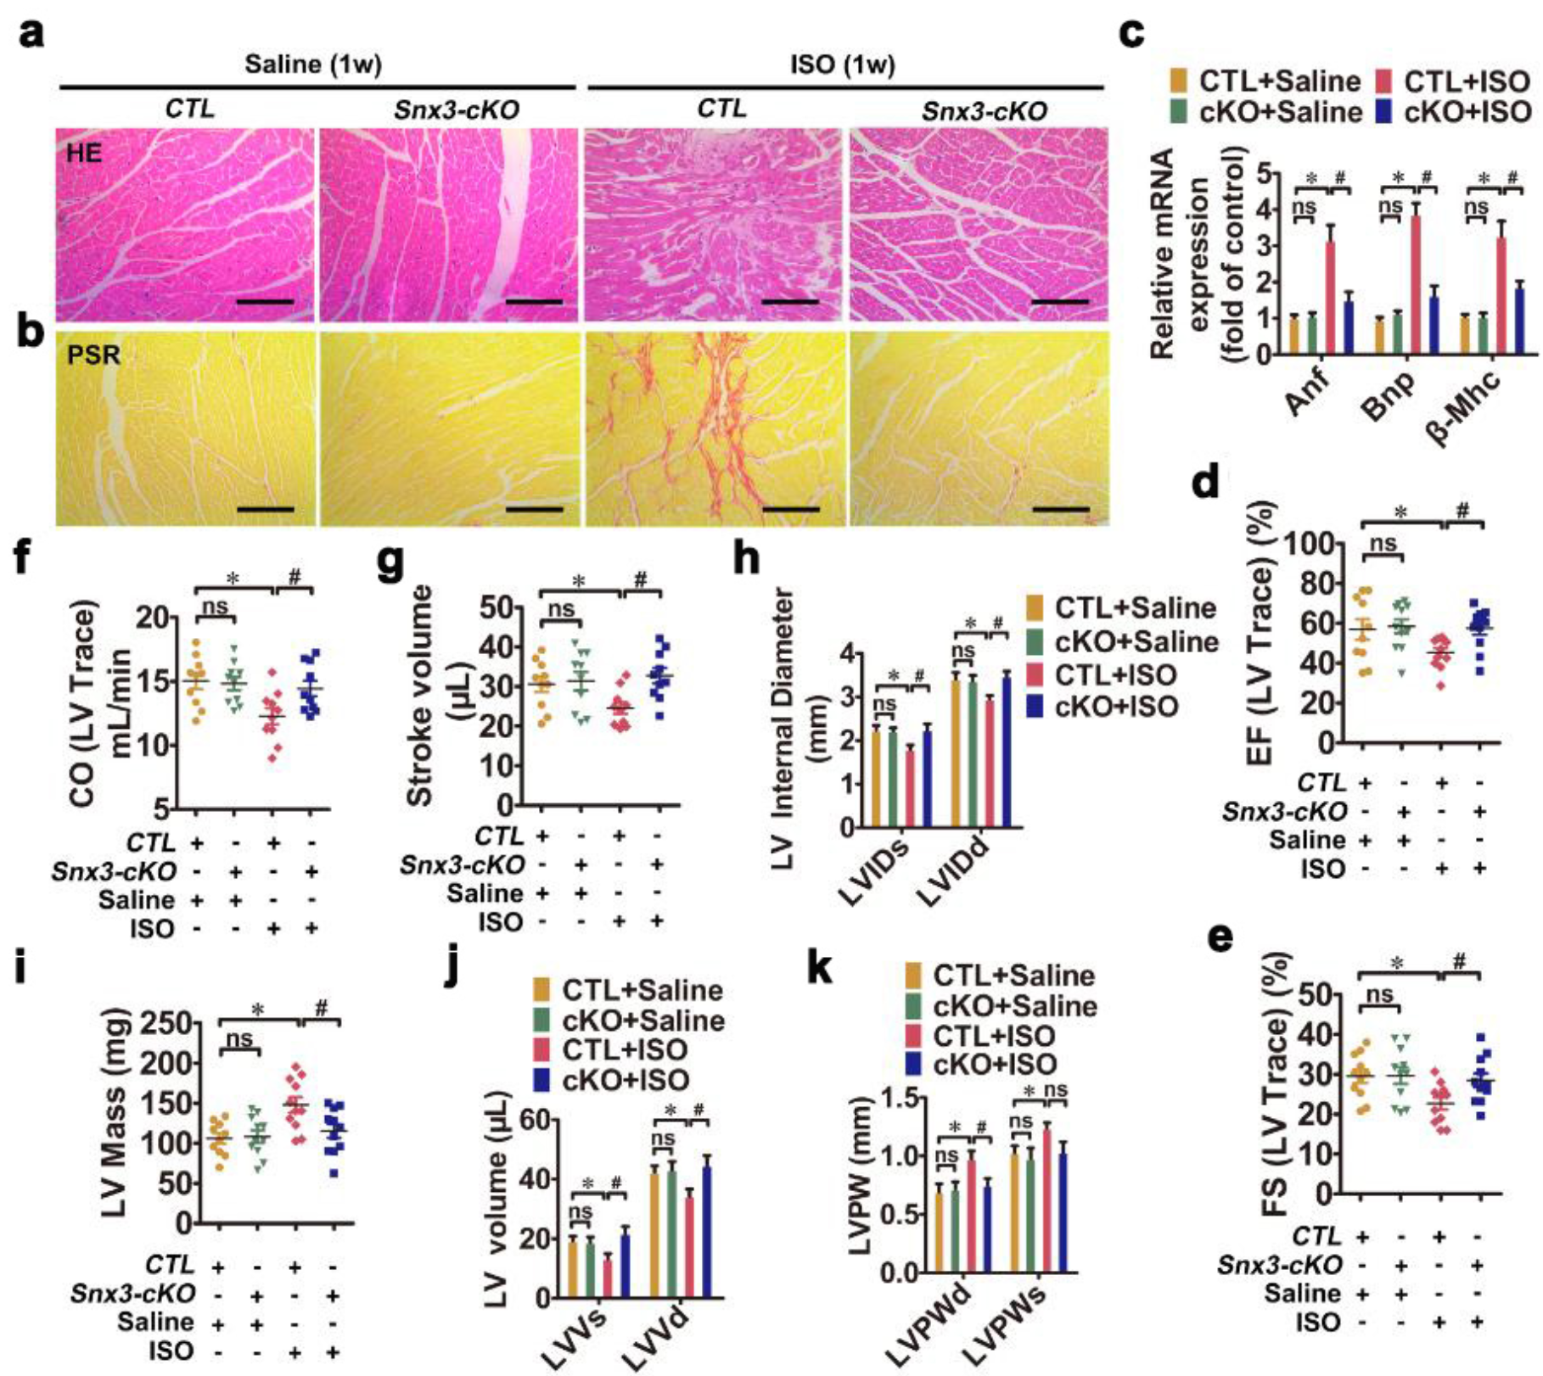
Figure S3 Snx3-cKO mice were protected from ISO-induced cardiac injury, related to Figure 1. Male C57BL/6 Snx3-cKO mice and their respective littermate negative controls (CTL) at 11 weeks were injected with ISO (3 mg/kg/day, s.c.) or an equal volume of sterile normal saline for one week. a and b HE staining (Scale bar: 100 μm) and PSR staining (Scale bar: 100 μm) -stained cross sections of heart tissues were shown. c The mRNA levels of Anp, Bnp and β-Mhc were determined by qPCR. d-k The echocardiographic parameters were measured, including EF, FS, CO, SV, LVID, LVM, LVV and LVPW. Representative images of five independent experiments were presented. The data were presented as the means ± SEM. *P < 0.05 vs. CTL + Saline group, #P < 0.05 vs. CTL + ISO group, n = 8-12. Abbreviations: Anf, atrial natriuretic factor; Bnp, brain natriuretic polypeptide; CO, cardiac output; CTL, littermate negative control; EF, ejection fraction; FS, fractional shortening; HE, hematoxylin-eosin; ISO, isoproterenol; LVID, left ventricular diameter; LVM, left ventricular mass; LVPW, left ventricular posterior wall thickness; LVV, left ventricular volume; Myh6-Cre, C57BL/6J-Myh6^{em1(IRES-Cre)Smoc}; ns, no statistical difference; PSR, picric sirius red; qPCR, quantitative polymerase chain reaction; s.c., subcutaneously; Snx3-cKO, cardiac-specific Snx3 knockout; SV, stroke volume; β-Mhc, β-myosin heavy chain; 1w, 1 week.

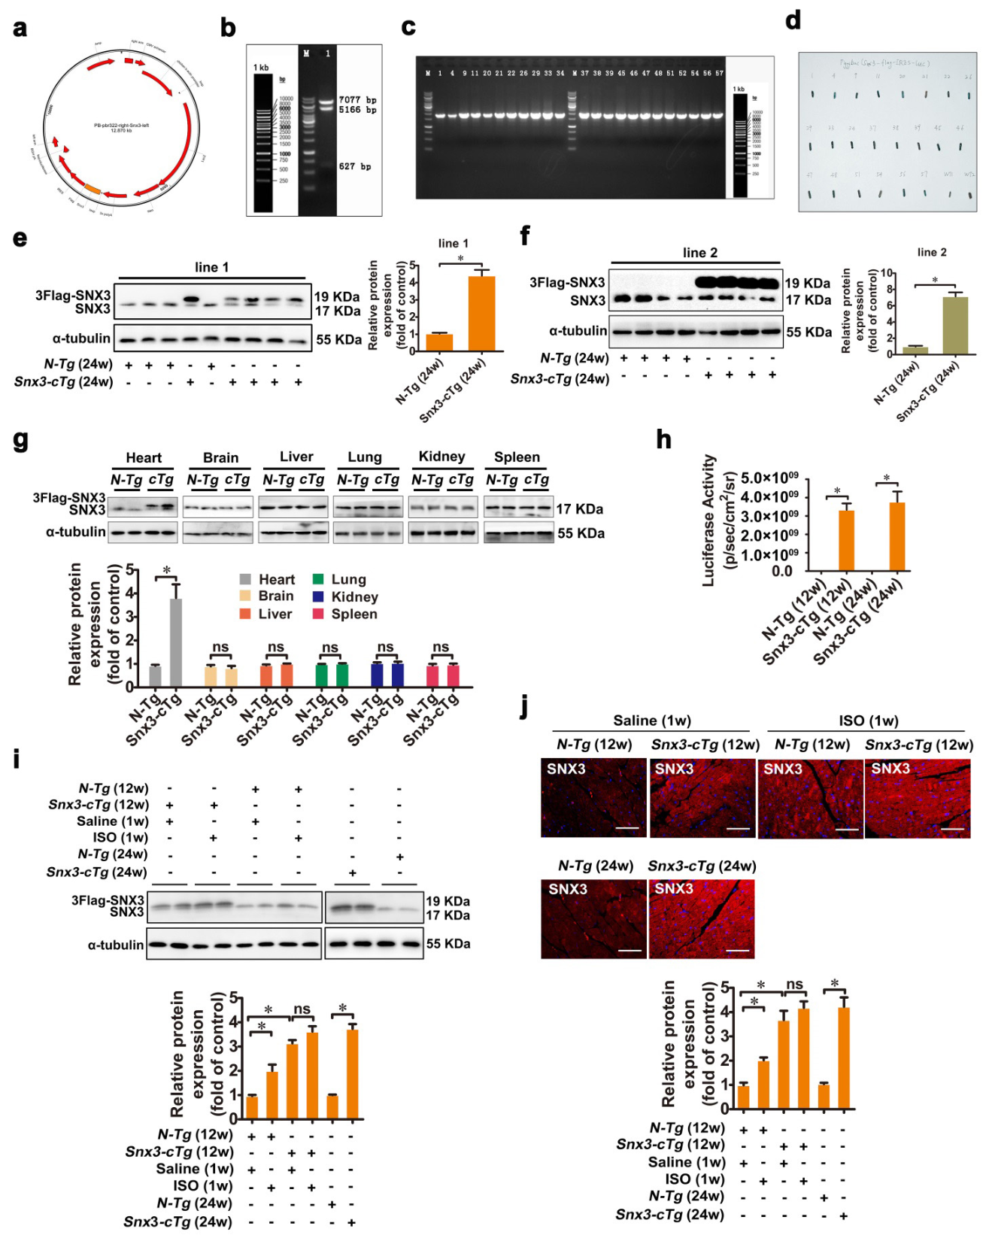
Figure S4 Generation and validation of Snx3-cTg mice, related to Figure 2. The Piggybac vector harboring mouse SNX3 cDNA was microinjected into the fertilized egg of C57BL/6 mouse, and the transgenic founder mice were obtained. a The plasmid profiles of Piggybac vector carring mouse SNX3 cDNA were presented. b Piggybac-Snx3 plasmid vector were evaluated by extracting with EcoRV mono-restriction endonuclease enzyme and the agar gel electrophoresis. Marker: 1 kb DNA ladder. c The genotype was identified by PCR of mouse tail DNA. Marker: 1 kb DNA ladder. d The tail of the mouse with the positive splicing genotype was fixated, cleaned, penetrated, lacZ stained and observed. Two Snx3 transgenic mouse lines were respectively crossed with B6.FVB-Tg(Myh6-Cre)2182Mds/J line to generate cardiac-specific overexpressed Snx3 mice: Snx3-cTg-1 mice and Snx3-cTg-2 mice. e The protein expression of SNX3 of Snx3-cTg-1 mice (at 24 weeks) was examined by western blot analysis. f The protein expression of SNX3 of Snx3-cTg-2 mice (at 24 weeks) was examined by western blot analysis. g The protein expression of SNX3 in the indicated tissues of Snx3-cTg-1 mice (at 12 weeks) was measured by western blot analysis. Besides, Snx3-cTg-1 mice (at 11 weeks) were injected with 3 mg kg⁻¹ d⁻¹ ISO (s.c.) or an equal volume of sterile normal saline for one week. h The protein level of SNX3 detected by live imaging was calculated. i and j The protein level of SNX3 was detected by western blot and IF assay (Scale bar: 100 μm). Representative images of five independent experiments were presented. The data were shown as the means ± SEM. *P < 0.05 vs. N-Tg (12w) + Saline or N-Tg (24w) group, #P < 0.05 vs. N-Tg (12w) + ISO group, &P < 0.05 vs. Snx3-cTg (12w) + Saline group, n = 8-12. Abbreviations: IF, immunofluorescence; ISO, isoproterenol; Myh6-Cre, B6.FVB-Tg(Myh6-Cre)2182Mds/J; ns, no statistical difference; N-Tg, non-transgenic; s.c., subcutaneously; Snx3-cTg, cardiac-specific Snx3 transgenic mice; 1w, 1 week; 12w, 12 weeks; 24w, 24 weeks.

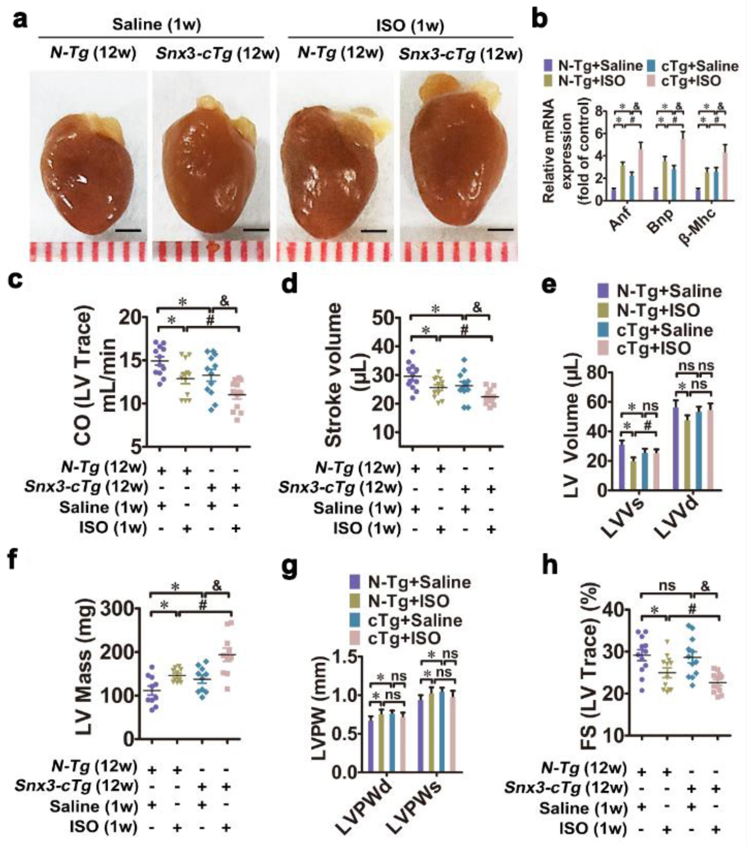
Figure S5 Snx3-cTg mice were hypersensitive to ISO-induced cardiac hypertrophy, related to Figure 2. Snx3-cTg mice (at 11 weeks) were injected with 3 mg kg⁻¹ d⁻¹ ISO (s.c.) or an equal volume of sterile normal saline for one week. a Gross observation of heart morphology was shown (Scale bar: 2 mm). b The mRNA levels of Anp, Bnp and β-Mhc were determined by qPCR. c-h The echocardiographic parameters were measured, including CO, SV, LVV, LVM, LVPW and FS. Representative images of five independent experiments are shown. The data were presented as the means ± SEM. *P < 0.05 vs. N-Tg (12w) + Saline group, #P < 0.05 vs. N-Tg (12w) + ISO group, &P < 0.05 vs. Snx3-cTg (12w) + Saline group, n = 8-12. Abbreviations: Anf, atrial natriuretic factor; Bnp, brain natriuretic polypeptide; CO, cardiac output; FS, fractional shortening; ISO, isoproterenol; LVM, left ventricular mass; LVPW, left ventricular posterior wall thickness; LVV, left ventricular volume; ns, no statistical difference; N-Tg, non-transgenic; qPCR, quantitative polymerase chain reaction; s.c., subcutaneously; SV, stroke volume; Snx3-cTg, cardiac-specific Snx3 transgenic mice; β-Mhc, β-myosin heavy chain; 1w, 1 week; 12w, 12 weeks.

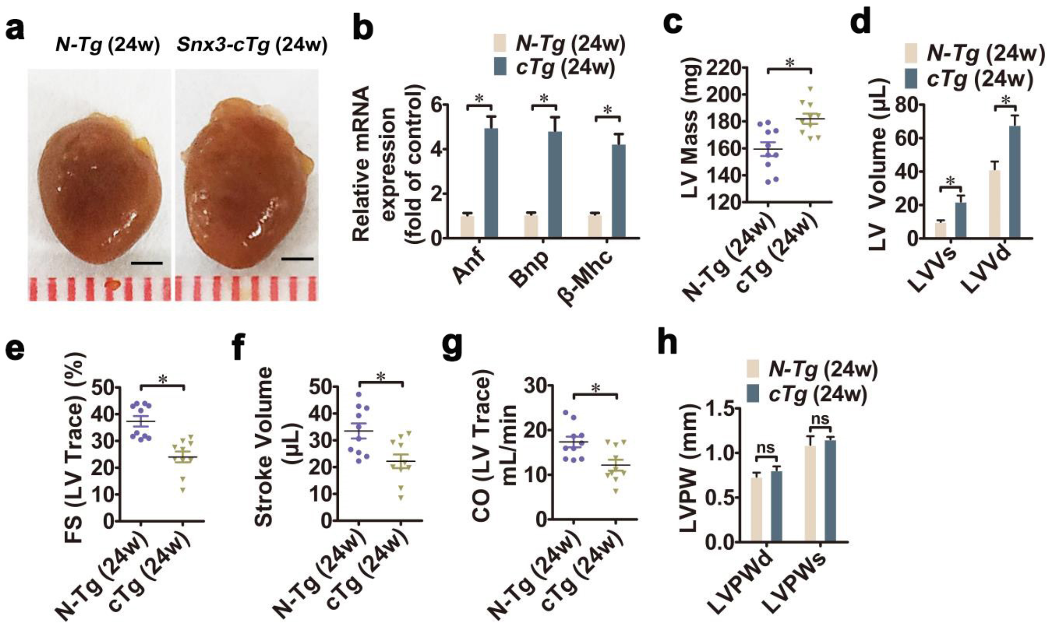
Figure S6 Snx3-cTg mice at 24 weeks exhibited obvious myocardial injury, related to Figure 2. a Gross observation of heart morphology was shown (Scale bar: 2 mm). b The mRNA levels of Anp, Bnp and β-Mhc were determined by qPCR. c-h The echocardiographic parameters were measured, including LVM, LVV, FS, SV, CO and LVPW. Representative images of five independent experiments are shown. The data were presented as the means ± SEM. *P < 0.05 vs. N-Tg (24w) group, n = 8-12. Abbreviations: Anf, atrial natriuretic factor; Bnp, brain natriuretic polypeptide; CO, cardiac output; FS, fractional shortening; LVM, left ventricular mass; LVPW, left ventricular posterior wall thickness; LVV, left ventricular volume; ns, no statistical difference; N-Tg, non-transgenic; qPCR, quantitative polymerase chain reaction; SV, stroke volume; Snx3-cTg, cardiac-specific Snx3 transgenic mice; β-Mhc, β-myosin heavy chain; 24w, 24 weeks.

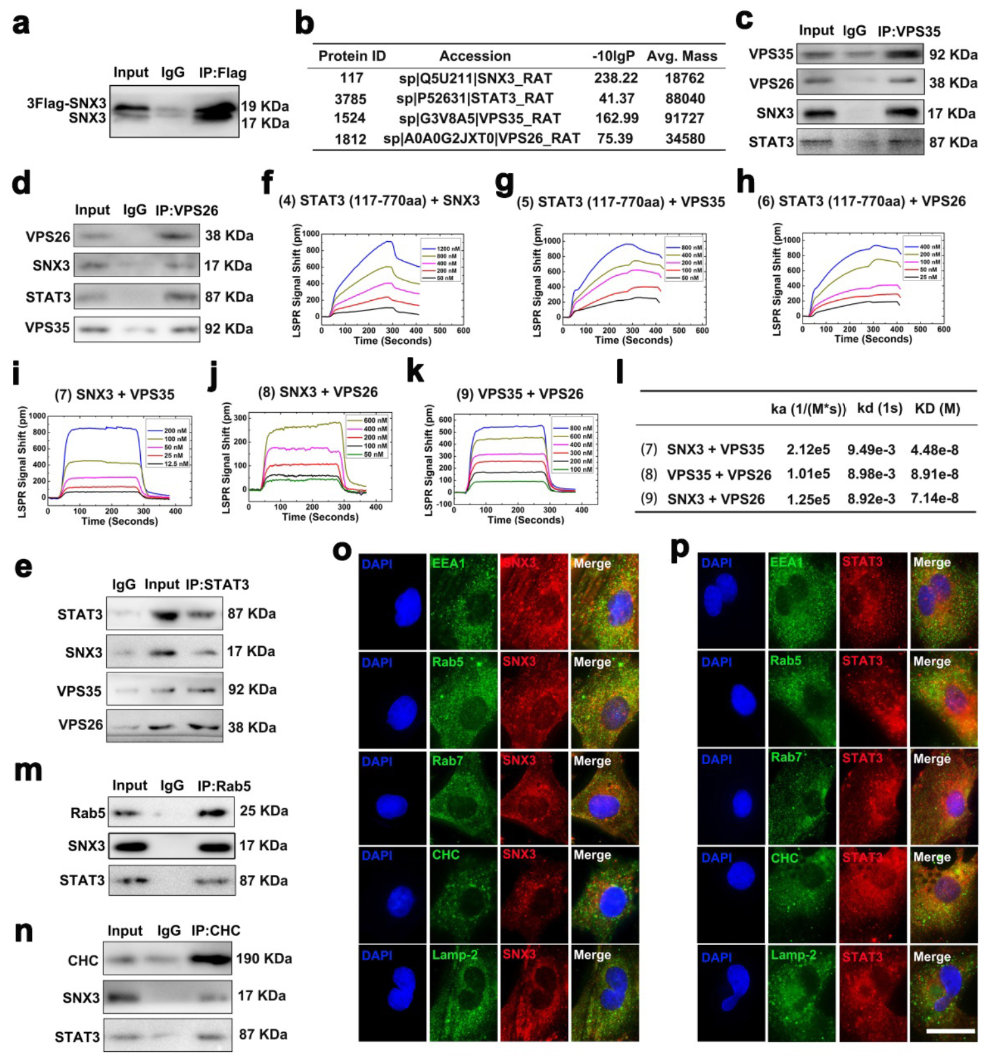
Figure S7 SNX3-retromer interacted with STAT3 at early endosomes in vivo and in vitro, related to Figure 3. a and b NRCMs were infected with Ad-SNX3 (Flag-tagged) and were precipitated by anti-Flag antibody, followed by subjection to IP-MS assays. c and d NRCMs were precipitated by anti-VPS35 or anti-VPS26, followed by subjection to co-IP assays. e Mouse heart tissues were immunoprecipitated with anti-STAT3 and subsequently subjected to western blot analysis. f-l The binding curves of STAT3 (117-770aa), SNX3, VPS35 and VPS26 were measured by LSPR analysis, and the KD values for STAT3, SNX3, VPS35 and VPS26 were calculated by TraceDrawer™. m and n NRCMs were precipitated by anti-Rab5 or anti-CHC for SNX3 and STAT3 detection in reciprocal co-IP assays. o and p NRCMs were infected with Ad-SNX3 (Flag-tagged) or Ad-STAT3 (HA-tagged), and the intracellular co-localization of SNX3 (or STAT3) and EEA1, Rab5, Rab7, CHC, Lamp-2 was detected by confocal microscopy (Scale bar: 20 μm). Representative images of five independent experiments are shown. n = 5. Abbreviations: CHC, clathrin heavy chain; co-IP, co-immunoprecipitation; EEA1, early endosome antigen 1; IF, immunofluorescence; IP-MS, immunoprecipitation-based mass spectrometry; LSPR, localized surface plasmon resonance; NRCMs, neonatal rat cardiomyocytes.

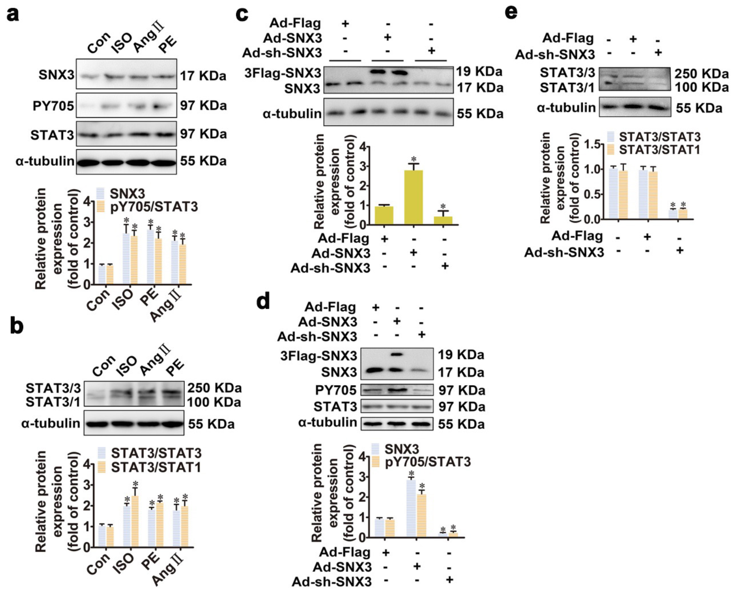
Figure S8 SNX3-retromer acted as a platform for STAT3 activation in NRCMs, related to Figure 4. NRCMs were treated with three hypertrophic stimulants, including ISO (10 μmol/L), Ang Ⅱ (1 μmol/L) and PE (100 μmol/L), respectively, for the times indicated. a Western blot analysis was performed to determine the phosphorylated STAT3 (pY705), protein expression of SNX3 and STAT3. b Low-temperature SDS-PAGE was conducted for examination of STAT3/3 or STAT3/1 dimer. NRCMs were infected with Ad-SNX3 or Ad-sh-SNX3 followed by incubation with ISO (10 μmol/L for 1 h). c and d Western blot analysis was conducted to determine the phosphorylated STAT3 (pY705), protein expression of SNX3 and STAT3. e Low-temperature SDS-PAGE was conducted for examination of STAT3/3 or STAT3/1 dimer. The data were presented as the means ± SEM. *P < 0.05 vs. control group, Ad-NC or Ad-Flag group, n = 5. Abbreviations: Ang Ⅱ, angiotensin Ⅱ; co-IP, co-immunoprecipitation; Con, control; ISO, isoproterenol; NC, negative control; NRCMs, neonatal rat cardiomyocytes; PE, phenylephrine; 1 h, 1 hour.

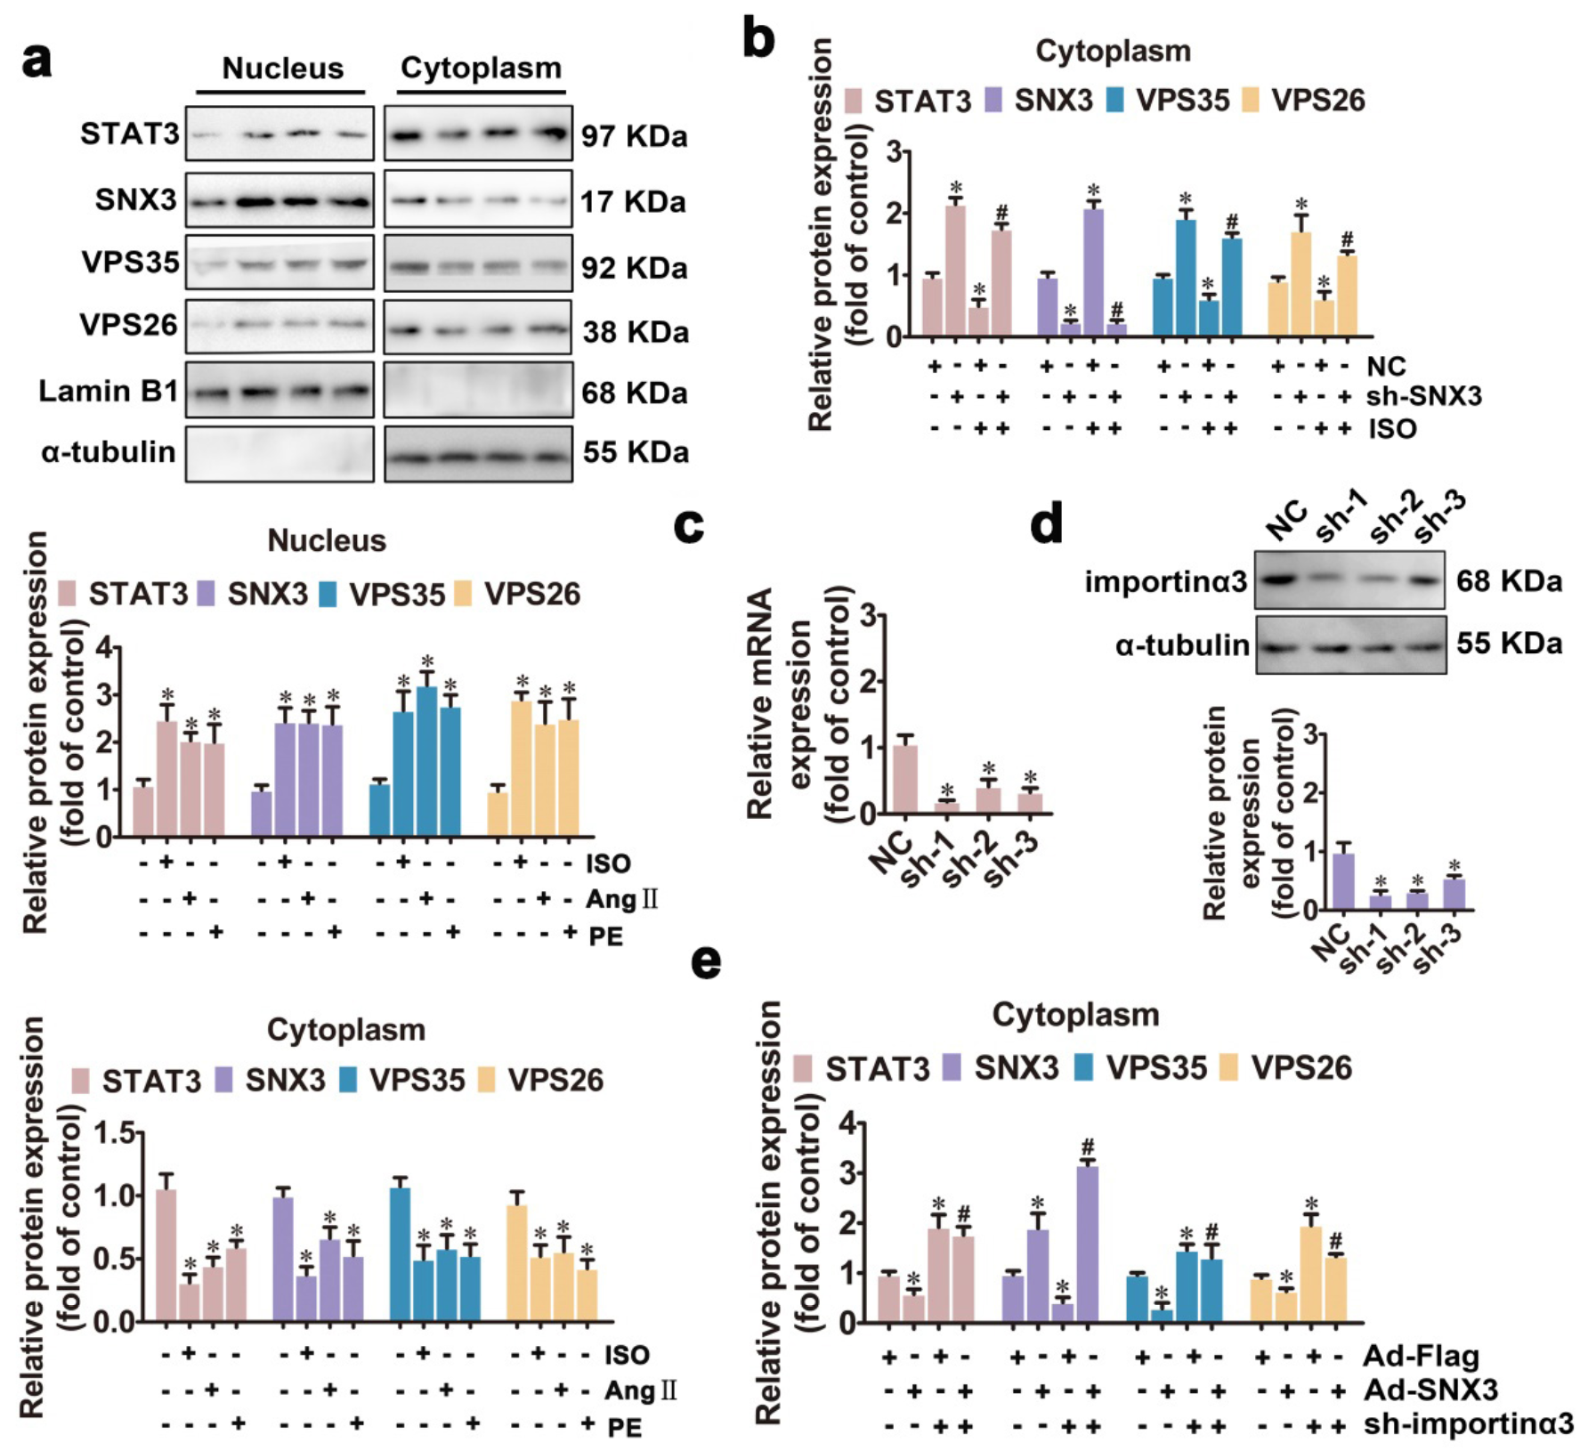
Figure S9 SNX3-retromer promoted the nuclear localization of STAT3 in NRCMs, related to Figure 5. NRCMs were treated with ISO, AngⅡ or PE, or were transfected with shRNAs of importin α3. a The nuclear and cytoplasmic proteins were respectively extracted from NRCMs, and were observed by western blot analysis. b NRCMs were treated with ISO followed by infection with Ad-sh-SNX3, the nuclear and cytoplasmic protein were respectively extracted from NRCMs, and were observed by western blot analysis. c and d The mRNA and protein expression of importin α3 were measured by qPCR and western blot analysis. e NRCMs was infected with Ad-SNX3 followed by transfection with shRNAs of importin α3, the nuclear and cytoplasmic protein were respectively extracted from NRCMs, and were observed by western blot analysis. The results were normalized to those of α-tubulin/Lamin B1. The data were presented as the means ± SEM. *P < 0.05 vs. control group, NC or Ad-Flag group, #P < 0.05 vs. Ad-SNX3 group, n = 5. Abbreviations: Ang Ⅱ, angiotensin Ⅱ; Con, control; ISO, isoproterenol; NC, negative control; NRCMs, neonatal rat cardiomyocytes; PE, phenylephrine; qPCR, quantitative polymerase chain reaction.

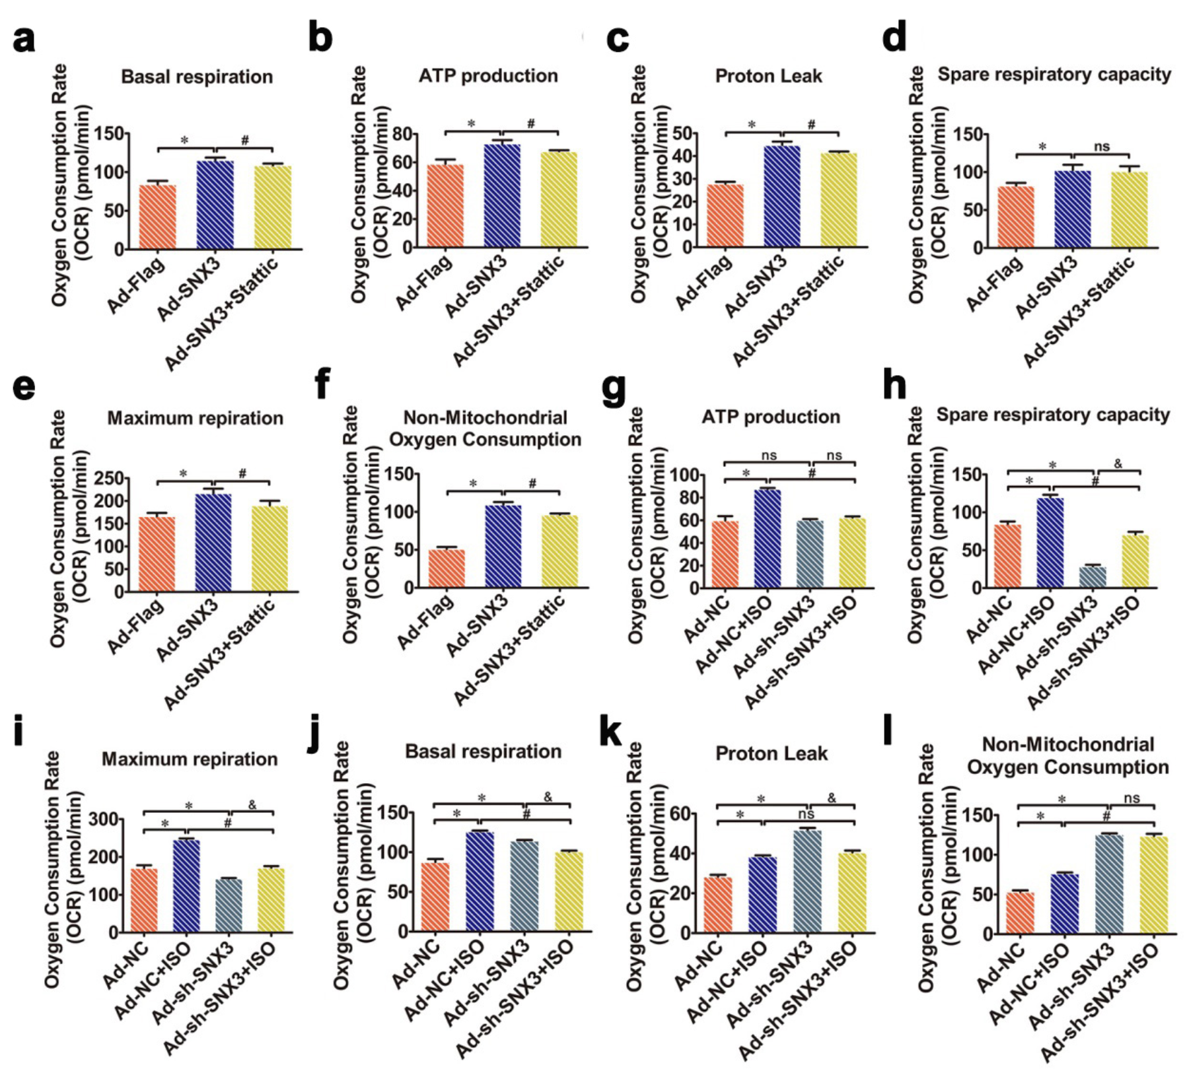

Figure S10 STAT3 was involved in SNX3-mediated the disturbance of mitochondrial energy metabolism in NRCMs, related to Figure 6. NRCMs were infected with Ad-sh-SNX3 before ISO treatment for 1 h. In addition, another group of NRCMs was infected with Ad-SNX3 followed by treatment with 5 μmol/L Stattic (a specific inhibitor of STAT3). The rates of OCR was measured by the high-throughput analyzer Seahorse XF96, including basal respiration, ATP production, proton leak, spare respiratory capacity, maximum repiration and non-mitochondrial oxygen consumption. The data were presented as the means ± SEM. *P < 0.05 vs. control or Ad-NC group, #P < 0.05 vs. ISO group, &P < 0.05 vs. Ad-SNX3 or Ad-sh-SNX3 group, n = 5. Abbreviations: ISO, isoproterenol; NC, negative control; NRCMs, neonatal rat cardiomyocytes; ns, no statistical difference; OCR, oxygen consumption.

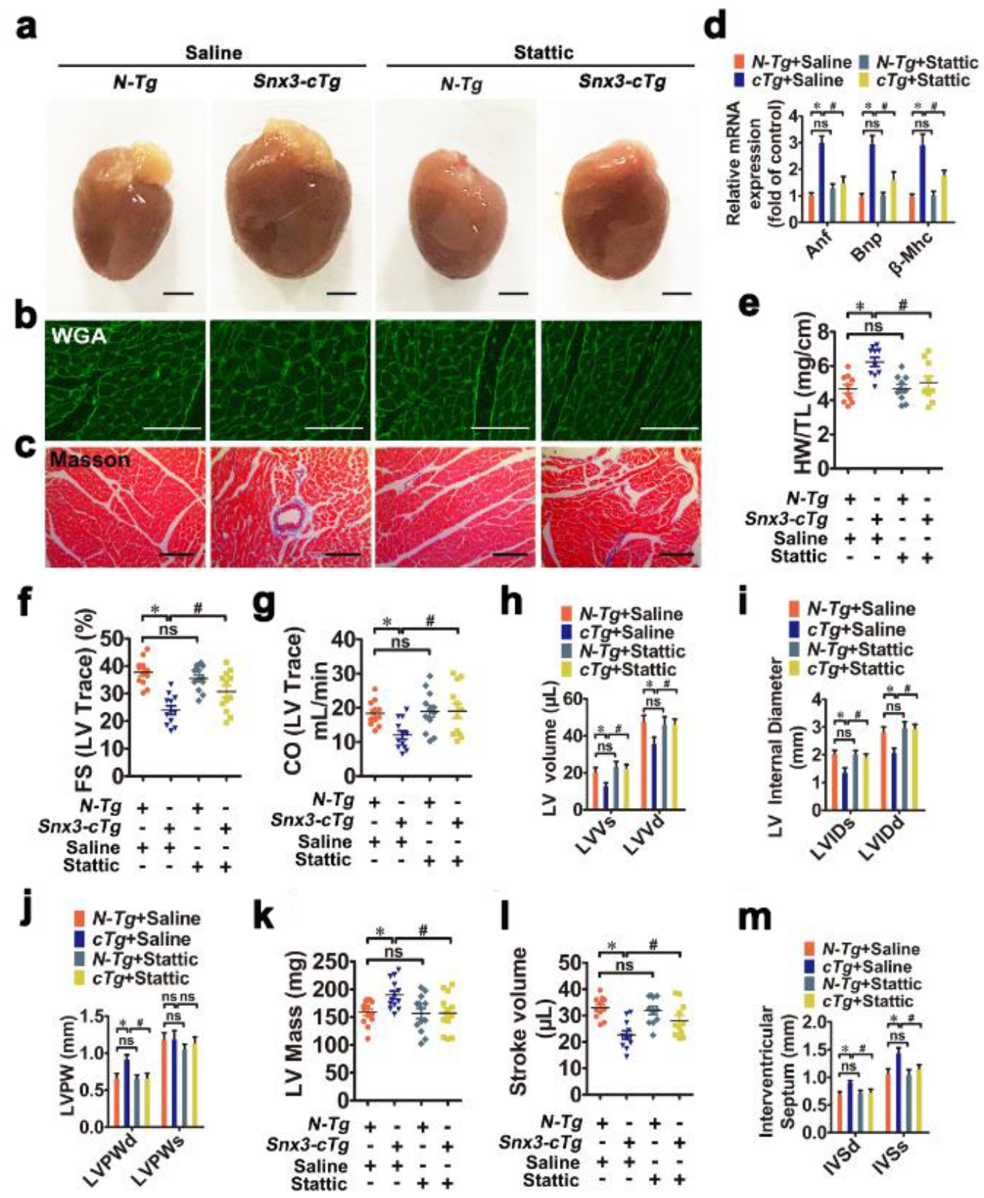
Figure S11 STAT3 was involved in SNX3-mediated cardiac injury in Snx3-cTg mice, related to Figure 6. Male Snx3-cTg mice (10-weeks-old) were treated with Stattic (a selective inhibitor of STAT3, 40 mg/kg/d, i.p.) or an equal volume of vehicle for 2 weeks. a Gross observation of heart morphology was shown (Scale bar: 2 mm). b and c WGA staining (Scale bar: 50 μm) and Masson staining (Scale bar: 100 μm) -stained cross sections of heart tissues were shown. d The mRNA levels of Anp, Bnp and β-Mhc were determined by qPCR. e The HW/TL ratio was calculated. f-m The echocardiographic parameters (FS, CO, LVV, LVID, LVPW, LVM, SV and IVS) were measured. Representative images of five independent experiments were presented. The data were presented as the means ± SEM. *P < 0.05 vs. control, Ad-Flag, Ad-NC or N-Tg + Saline, group, #P < 0.05 vs. ISO, Ad-SNX3 or Snx3-cTg + Saline group, &P < 0.05 vs. Ad-sh-SNX3 or Ad-SNX3 group, n = 5 or 12. Abbreviations: Anf, atrial natriuretic factor; Bnp, brain natriuretic polypeptide; CO, cardiac output; FS, fractional shortening; HW/TL, the heart weight to the tibia length ratio; IF, immunofluorescence; i.p., intraperitoneally; IVS, interventricular septum; LVID, left ventricular diameter; LVM, left ventricular mass; LVPW, left ventricular posterior wall thickness; LVV, left ventricular volume; ns, no statistical difference; N-Tg, non-transgenic; qPCR, quantitative polymerase chain reaction; SV, stroke volume; Snx3-cTg, cardiac-specific Snx3 transgenic mice; WGA, wheat germ agglutinin; β-Mhc, β-myosin heavy chain.

