Preparation of ZIF-67:
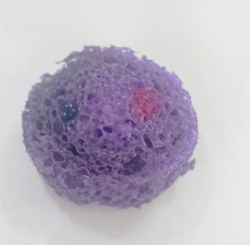
Cobalt nitrate hexahydrate (0.80 g, 2.6 mmol) and 2-methylimidazole (0.96 g, 11.8 mmol) were dissolved in 40 mL of anhydrous ethanol. The suspension was vigorously stirred at room temperature until homogeneous. The solution was subsequently transferred into a Teflon-lined stainless-steel autoclave and aged at 25 °C for 24 h. Upon completion, the precipitate was collected by centrifugation and washed three times with methanol to remove residual ligand and unreacted salts. Finally, the material was dried under vacuum at 60 °C for 12 h to yield ZIF-67 as a microcrystalline powder.
Fig. 1 illustrates the comparative wettability of deionized water and cyclohexane on the sponge substrate. The left panel displays a deionized water droplet (stained with methylene blue), while the right panel presents a cyclohexane droplet (stained with Sudan III).
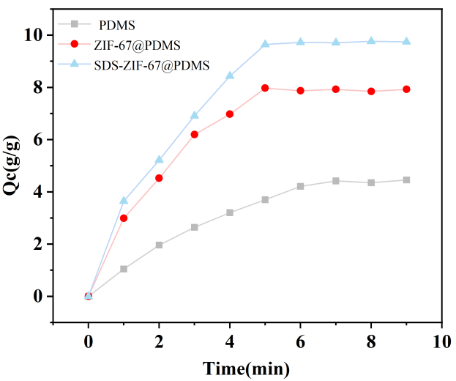
Fig. 2 illustrates the time required for three distinct poly(dimethylsiloxane) (PDMS)-based sponges to reach saturation during cyclohexane adsorption.

