Supplementary Information

Scalable and sustainable N-Si-Ge-Te Ovonic threshold switching devices for energy-efficient artificial neuron applications

Park et al.
*e-mail: jongsoukyeo@yonsei.ac.kr

Table of Contents

Supplementary Table T1 | Comparative table for the state-of-the-art device performances 3
Supplementary Table T2 | Comparative performance table of state-of-the-art artificial neuron devices 3
Supplementary Table T3 | Deconvoluted peaks from Raman spectra 4
Supplementary Figure S1 | Device fabrication process and top view of fabricated device 5
Supplementary Figure S2 | Device-to-device variation of DC I-V characteristics 6
Supplementary Figure S3 | Delay time measurement 7
Supplementary Figure S4 | X-ray photoelectron spectroscopy (XPS) spectra and deconvoluted peaks 8
Supplementary Figure S5 | Radial distribution function (RDF) 9
Supplementary Figure S6 | Density of states (DoS) from –16 eV to 12 eV (eV) 10
Supplementary Figure S7 | Bond angle distribution for Ge-related bonds 11
Supplementary Figure S8 | Spiking characteristic of artificial NSGT-based neuron depending on synapse resistor 12
Supplementary Method C1 | Calculating T_{g} based on Lankhorst’s model 13

Supplementary Information

Composition | Feature size (nm) | Device area (cm²) | I_{off}  (A) | J_{off} (MA/cm²) | T_{x}  (°C)
Si-Te (This Work) | 5000 | 2.5∙10⁻⁷ | 6.0∙10⁻⁵ | 2.4∙10⁻⁴ | 400
Si-Ge-Te (This Work) | 5000 | 2.5∙10⁻⁷ | 5.29∙10⁻⁶ | 2.1∙10⁻⁵ | 300
N-Si-Ge-Te (This Work) | 5000 | 2.5∙10⁻⁷ | 5.8∙10⁻⁹ | 2.3∙10⁻⁸ | 400
Si-Te¹ | 100 | 10⁻¹⁰ | 8.0∙10⁻¹⁰ | 8.0∙10⁻⁶ | -
Zn-Te² | 200 | 4.0∙10⁻¹⁰ | 6.0∙10⁻⁶ | 1.5∙10⁻² | -
C-Te³ | 30 | 9.0∙10⁻¹² | 5.0∙10⁻⁹ | 5.5∙10⁻⁴ | 450
B-Te³ | 30 | 9.0∙10⁻¹² | 10⁻⁸ | 1.1∙10⁻³ | 450
Ge-S⁴ | 130 | 1.7∙10⁻¹⁰ | 10⁻⁹ | 5.9∙10⁻⁶ | 350
N-Si-Te-As-Ge⁵ | 30 | 9.0∙10⁻¹² | 10⁻⁶ | 1.1∙10⁻¹ | 600
Si-Te-As-Ge-Sb⁶ | 350 | 1.2∙10⁻⁹ | 1.9∙10⁻⁹ | 1.6∙10⁻⁶ | 350
Ge-Se⁷ | 50 | 2.5∙10⁻¹¹ | 10⁻⁶ | 4.0∙10⁻² | 350
Ge-Se-Si⁸ | 200 | 4.0∙10⁻¹⁰ | 2.0∙10⁻⁷ | 5.0∙10⁻⁴ | -
Ge-Se-As⁹ | 350 | 1.2∙10⁻⁹ | 10⁻⁸ | 8.3∙10⁻⁶ | 450
Ge-Se-N¹⁰ | 50 | 2.5∙10⁻¹¹ | 2.0∙10⁻⁹ | 8.0∙10⁻⁵ | 600
GSSN¹¹ | 350 | 1.2∙10⁻⁹ | 10⁻¹⁰ | 8.3∙10⁻⁸ | 400
Supplementary Table T1: Comparative performance table of state-of-the-art selector devices.¹⁻¹¹

Composition | Device area (um²) | Energy  (pJ/spike) | Normalization  (pJ/um²) | Frequency  (MHz)
N-Si-Ge-Te (This Work) | 25 | 14 | 0.56 | 1.4-8.6
Ge-Se¹² | 100 | 1000 | 10 | 0.1-100
NbO_{x}¹³ | 0.0007069 | 50 | 70740.4 | 0.01-0.1
B-Te¹³ | 0.0007069 | 30 | 42444.2 | 0.01-0.1
Ag/HfO₂¹³ | 0.04909 | 20 | 407.3 | 0.01-0.1
NbO_{x}¹⁴ | 25 | 50 | 2 | 0.1-1
ZnO¹⁵ | 100 | 1.442 | 14.42 | 0.00030-0.000185
WSe₂¹⁶ | 0.2 | 2.26 | 11.30 | 1.77
MOSFET¹⁷ | 0.25 | 10 | 40.00 | 0.00002
SONOS¹⁸ | 0.25 | 30 | 120.00 | 3
PD-SOI¹⁹ | 1.8 | 35 | 19.44 | 20
PCM²⁰ | 0.5 | 5 | 10 | 0.05
Supplementary Table T2: Comparative performance table of state-of-the-art artificial neuron devices.¹²⁻²⁰
System |  | Peak A | Peak B | Peak C | Peak D | Peak E | Peak G
ST | 1/$λ$(cm⁻¹) | 88.5$±$0 | 103.0$±$0 |  | 122.1$±$0 | 139.3$±$0 | 160.0$±$0
ST | Area% | 5.97% | 4.43% |  | 55.03% | 27.69% | 6.89%
SGT | 1/$λ$(cm⁻¹)\ | 88.5$±$0 | 103.0$±$0 | 120.0$±$0 | 123.3$±$0 | 138.5$±$0 | 154.2$±$0
SGT | Area% | 4.50% | 7.19% | 18.79% | 32.91% | 19.85% | 16.75%
NSGT | 1/$λ$(cm⁻¹) | 91.29$±$0 | 100.4$±$0 | 120.8$±$0 | 123.9$±$0 | 140.4$±$0 | 153.0$±$0
NSGT | Area% | 4.10% | 5.28% | 21.58% | 41.43% | 17.31% | 10.31%
Supplementary Table T3: Deconvoluted peaks from Raman spectra of ST, SGT, and NSGT. Peak A, B, D and E correspond to Te-Te bonds. Peak C corresponds to Ge-Te units in SGT and NSGT. Peak G is related with Si-Te units.

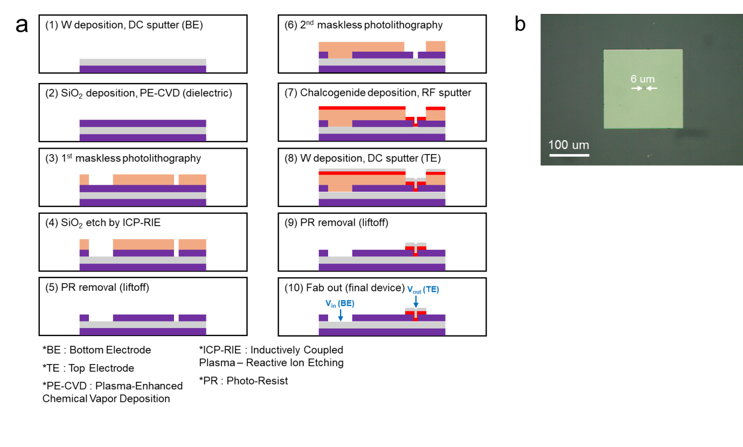
Supplementary Fig. S1 | Device fabrication process and top view of fabricated device. a, Schematic of the single OTS selector’s fabrication procedure from a bare SiO₂ wafer to the final device. The purple substrate represents the SiO₂ wafer, the orange film represents the photoresist (AZ5214E), the red film represents the chalcogenide film, and the grey film represents tungsten electrode. b, Optical microscope image of the top view of the fabricated device.

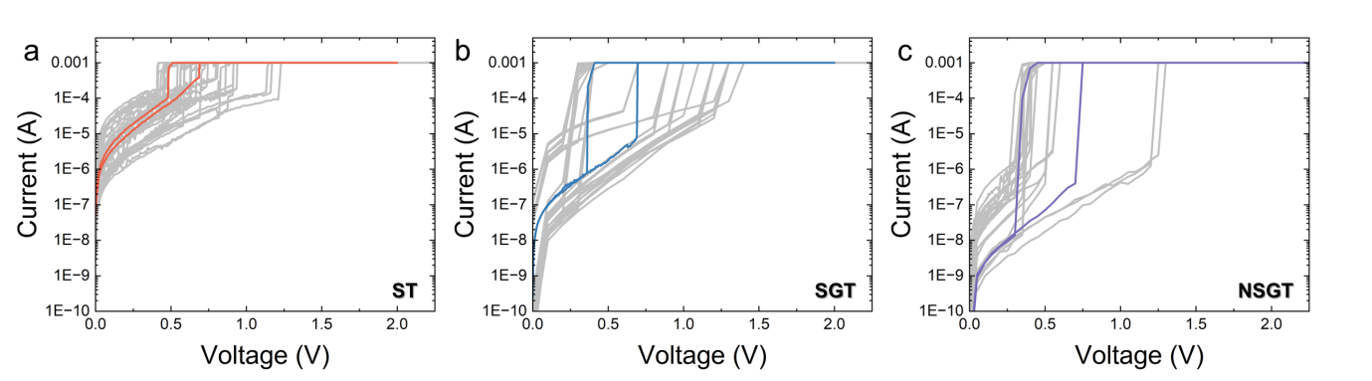
Supplementary Fig. S2 | Device-to-device variation of DC I-V characteristics of a, ST, b, SGT, and c, NSGT devices.

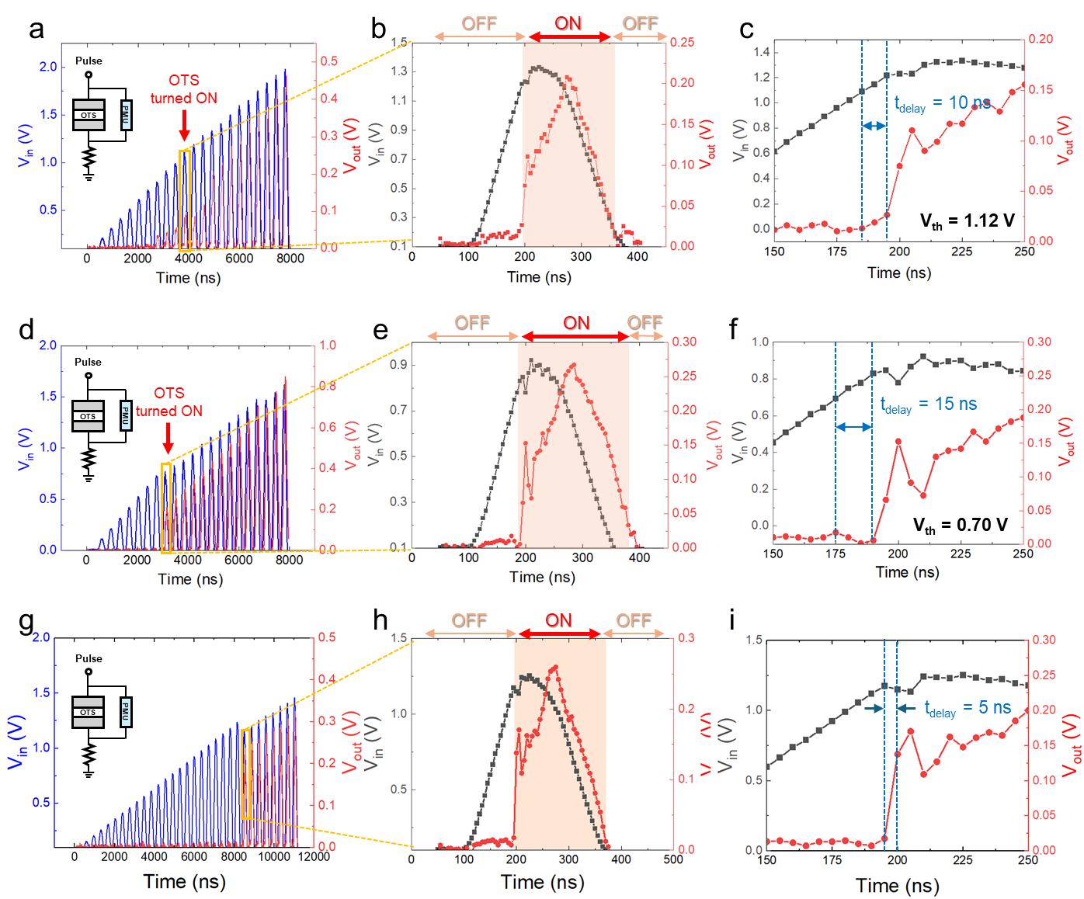
Supplementary Fig. S3 | Delay time measurements of ST, SGT, and NSGT OTS selectors. OTS selector’s response to trapezoidal voltage pulse train with increasing pulse amplitudes with a, binary ST (0.1 V~2.0 V), d, ternary SGT (0.1 V~1.5 V), and g, quaternary NSGT (0.1 V~1.2 V) devices, with an equivalent test circuit shown in the inset. Enlarged views of the first device response with input pulse and output device response showing discrete on/off states in b, ST, e, SGT, and h, NSGT. Enlarged views of the panels b,e, and h for delay time evaluation, highlighting the device response to V_{th} and the corresponding rise in V_{out}. c, ST (t_{d}=10 ns), f, SGT (t_{d}=15 ns), and i, NSGT (t_{d}=5 ns).
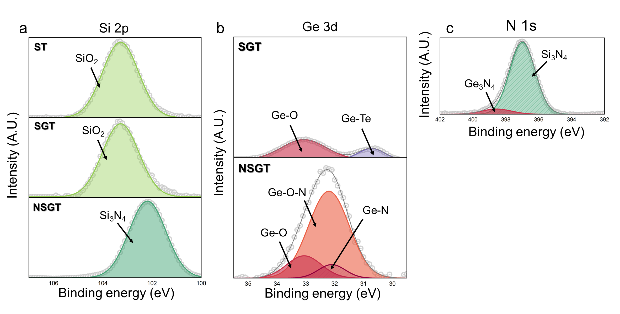
Supplementary Fig. S4 | X-ray photoelectron spectroscopy (XPS) spectra and deconvoluted spectral peaks for a, Si 2p, b, Ge 3d and c, N 1s. In SGT, the Ge–O bond was commonly detected in both the Ge 3d^{21,22}. In NSGT, N-related bonds were formed with Si and Ge. The Si–N bond was consistently observed in the Si 2p²³ and N 1s regions²³, while the Ge–N bond was commonly identified in the Ge 3d and N 1s²⁴ regions.

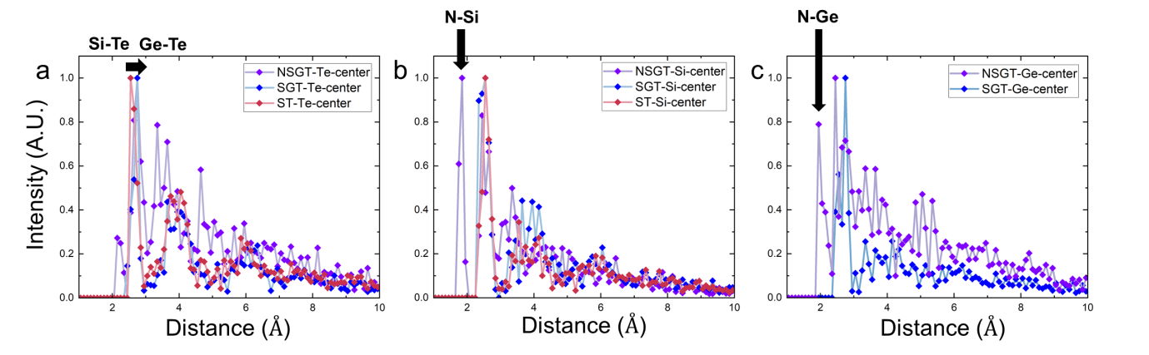
Supplementary Fig. S5 | Radial distribution function (RDF) of a, ST, b, SGT, and c, NSGT. Prominent peaks corresponding to the dominant bonds are observed, with the appearance of a peak associated with the Ge–Te bond length induced by Ge-doping, and additional shorter bond-length peaks arising from N-doping. All RDF results are calculated using the ASE Python library from amorphous structural models.

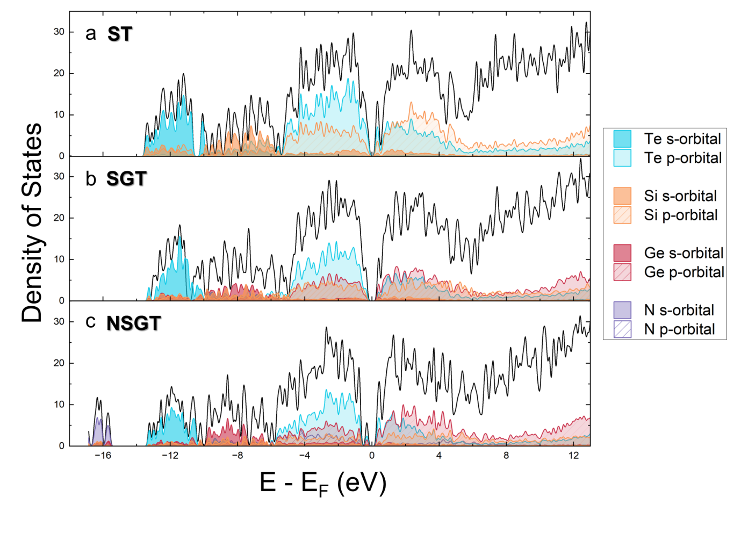
Supplementary Fig. S6 | Density of states (DoS) from –16 eV to 12 eV (eV) a, ST, b, SGT, and c, NSGT. In all three materials, the Te p-orbitals dominate near the band edges, while the Te s-orbitals are located in deep-lying states.

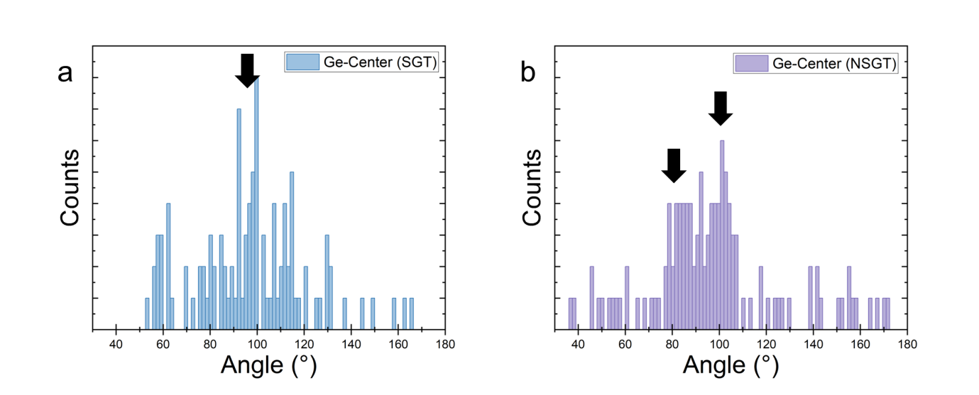
Supplementary Fig. S7 | Bond angle distributions for Ge-related bonds in a, SGT and b, NSGT. In the amorphous SGT structural model, the bond angles of Ge–Te bonds are centered on Ge around 100°. After N-doping, this distribution shifts to 80° and 110°, indicating distortion of the Ge–Te structure.

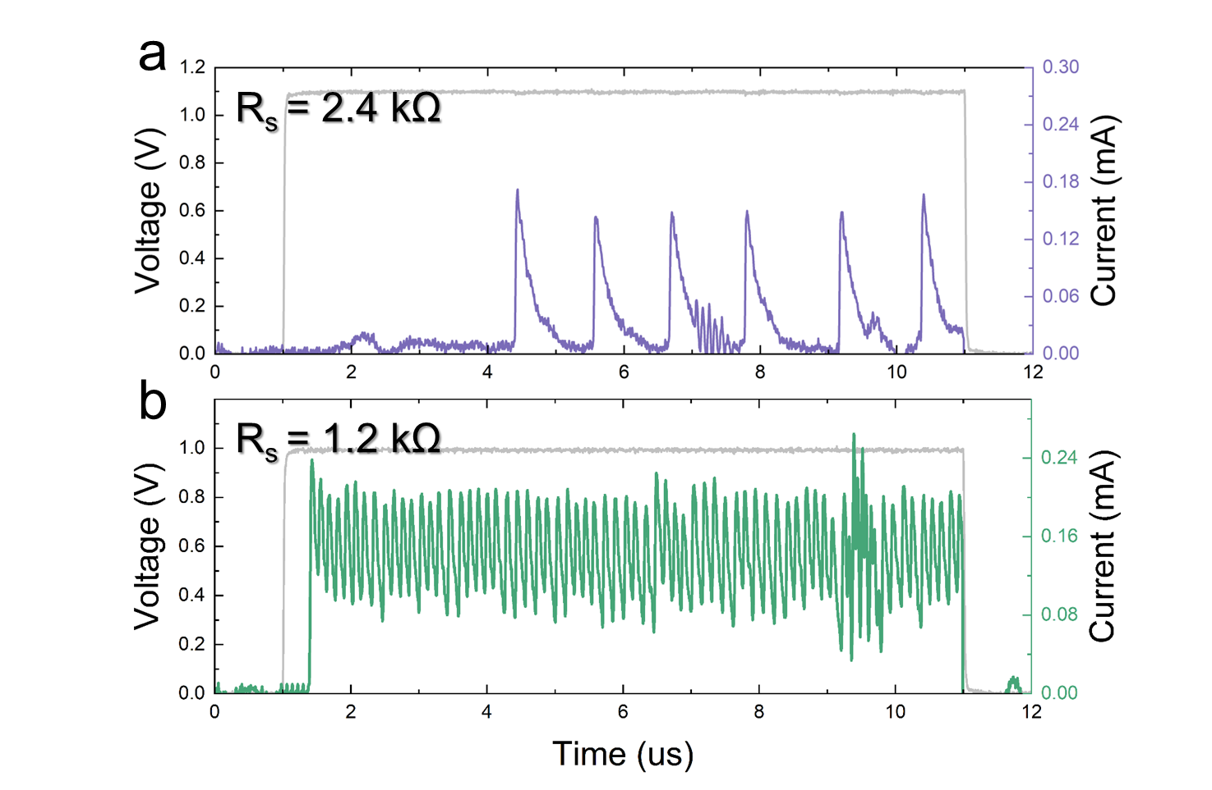Supplementary Fig. S8 | Spiking characteristics of artificial NSGT-based neuron depending on synapse resistor, a, R_{s} = 2.4 k Ω and b, 1.2 k Ω. (with identical load resistance R_{L} = 10 kΩ) An increase in resistance resulted in a decrease in spiking frequency.

Supplementary Method C1 | Computation of glass transition temperature (T_{g}) based on Lankhorst’s model
The T_{g} for a binary chalcogenide system A₁₋_{x}Bₓ is determined through the following steps:
- The constituent elements and their relative composition ratios are calculated.
- The dominant element in terms of compound composition, $x_{c}$, where $m_{x}$ represents the coordination number of element $x$ is identified as follows:
$$x_{c}=\frac{m_{A}}{m_{A}+m_{B}}$$
- The bond concentration around this dominant element $x$ is determined as follows:
  - If 0 < $x$ < $x_{c}$, A-rich system:
$$N_{AA}=\frac{m_{A}-\left(m_{A}-m_{B}\right)x}{2}, N_{AB}=m_{B}x$$

  - If $x_{c}$, < $x$ < 1, B-rich system:
$$N_{BB}=\frac{\left(m_{A}-m_{B}\right)x-m_{A}}{2}, N_{AB}=m_{A}(1-x)$$

- The heterogeneous bond enthalpy $H_{AB}$ is computed as:
$$H_{AB}=\frac{{H_{AA}+H}_{BB}}{2}+96.14{\left(S_{A}-S_{B}\right)}^{2} (K)$$
- The atomization enthalpy $H_{a}$ is calculated as:
$$H_{a}=\sum{N_{x}H_{x}}$$
- The glass-transition temperature TgT is estimated using Lankhorst’s equation:
$$T_{g}=3.44∙H_{a}-480 (K)$$
Major bond enthalpies for homopolar and heteropolar bonds in ST, SGT, and NSGT are summarized in Table a, and the calculated T_{g} based on the Lankhorst model and the measured crystallization temperature (T_{x}) are presented in Table b.
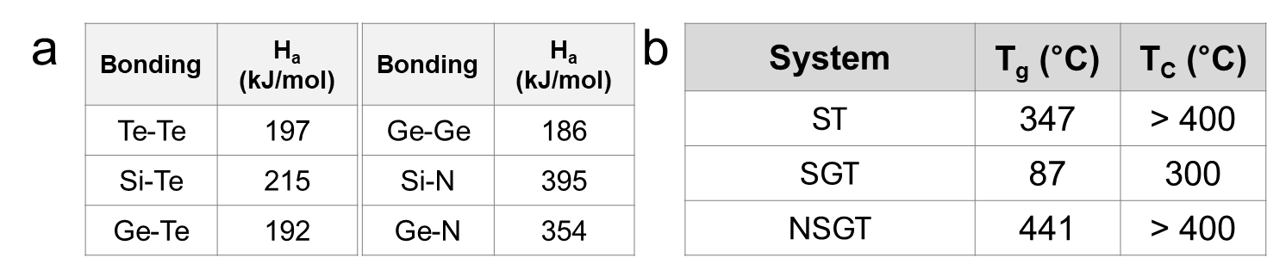

Supplementary References
1 Koo, Y., Lee, S., Park, S., Yang, M. & Hwang, H. Simple binary ovonic threshold switching material SiTe and its excellent selector performance for high-density memory array application. IEEE Electron Device Letters 38, 568-571 (2017).
2 Koo, Y. & Hwang, H. Zn1− xTex ovonic threshold switching device performance and its correlation to material parameters. Scientific Reports 8, 11822 (2018).
3 Yoo, J. et al. 3D stackable and scalable binary ovonic threshold switch devices with excellent thermal stability and low leakage current for high‐density cross‐point memory applications. Advanced Electronic Materials 5, 1900196 (2019).
4 Jia, S. et al. Ultrahigh drive current and large selectivity in GeS selector. Nature Communications 11, 4636 (2020).
5 Lee, M.-J. et al. A plasma-treated chalcogenide switch device for stackable scalable 3D nanoscale memory. Nature communications 4, 2629 (2013).
6 Cheng, H.-Y. et al. in 2017 IEEE International Electron Devices Meeting (IEDM). 2.2. 1-2.2. 4 (IEEE).
7 Govoreanu, B. et al. in 2017 Symposium on VLSI Technology. T92-T93 (IEEE).
8 Li, X., Yuan, Z., Lv, S., Song, S. & Song, Z. Extended endurance performance and reduced threshold voltage by doping Si in GeSe-based ovonic threshold switching selectors. Thin Solid Films 734, 138837 (2021).
9 Cheng, H. et al. in 2018 IEEE International Electron Devices Meeting (IEDM). 37.33. 31-37.33. 34 (IEEE).
10 Avasarala, N. S. et al. in 2018 IEEE Symposium on VLSI Technology. 209-210 (IEEE).
11 Verdy, A. et al. in 2018 IEEE International Memory Workshop (IMW). 1-4 (IEEE).
12 Lee, M. et al. Simple artificial neuron using an ovonic threshold switch featuring spike-frequency adaptation and chaotic activity. Physical Review Applied 13, 064056 (2020).
13 Lee, D. et al. Various threshold switching devices for integrate and fire neuron applications. Advanced Electronic Materials 5, 1800866 (2019).
14 Ding, Y. et al. Engineering spiking neurons using threshold switching devices for high-efficient neuromorphic computing. Frontiers in neuroscience 15, 786694 (2022).
15 Wang, L., Zhang, L., Hua, S., Fu, Q. & Guo, X. Leaky integrate-and-fire and oscillation neurons based on ZnO diffusive memristors for spiking neural networks. Science China Materials 68, 1212-1219 (2025).
16 Choi, H. et al. Spiking neural network integrated with impact ionization field‐effect transistor neuron and a ferroelectric field‐effect transistor synapse. Advanced Materials 37, 2406970 (2025).
17 Han, J.-K. et al. Mimicry of excitatory and inhibitory artificial neuron with leaky integrate-and-fire function by a single MOSFET. IEEE Electron Device Letters 41, 208-211 (2019).
18 Han, J.-K. et al. Cointegration of single-transistor neurons and synapses by nanoscale CMOS fabrication for highly scalable neuromorphic hardware. Science Advances 7, eabg8836 (2021).
19 Dutta, S., Kumar, V., Shukla, A., Mohapatra, N. R. & Ganguly, U. Leaky integrate and fire neuron by charge-discharge dynamics in floating-body MOSFET. Scientific reports 7, 8257 (2017).
20 Tuma, T., Pantazi, A., Le Gallo, M., Sebastian, A. & Eleftheriou, E. Stochastic phase-change neurons. Nature nanotechnology 11, 693-699 (2016).
21 Robert, B., Flaud, V., Escalier, R., Mehdi, A. & Vigreux, C. XPS study of Ge-Se-Te surfaces functionalized with organosilanes. Applied Surface Science 607, 154921 (2023).
22 Lan, W., Cao, L., Fu, Y., Fang, J. & Wang, J. Structure and optical properties of GeTe film controlled by amorphous to crystalline phase transition. Vacuum 197, 110847 (2022).
23 Matsuoka, M., Isotani, S., Sucasaire, W., Zambom, L. d. S. & Ogata, K. Chemical bonding and composition of silicon nitride films prepared by inductively coupled plasma chemical vapor deposition. Surface and Coatings Technology 204, 2923-2927 (2010).
24 Maeda, T. et al. Ge metal-insulator-semiconductor structures with Ge3N4 dielectrics by direct nitridation of Ge substrates. Applied physics letters 85, 3181-3183 (2004).

