Supporting Information for
Palladium/phosphoramidite-selenide-catalyzed enantioselective allylic amination
Bin Fengª,‡ Yuan-Cheng Liª,‡ Tang-Ling Hou^{b}, Cui-Zhen Wangª, Hong-Kai Huangª, Ge-Yun You^{a*}
ªGuangxi Key Laboratory of Urban Water Environment, College of Chemistry and Environmental
Engineering, Baise University, Baise 533000, Guangxi, China
^{b} The Second Middle School of Rongan County, Liuzhou 545400, Guangxi, China
*Corresponding author, e-mail: yougeyun1988@163.com
‡ These authors contributed equally to this work

Table of Contents
1. General Information 2
2. Detailed Optimization of Reaction Conditions 2
3. General Procedure for Pd-Catalyzed Enantioselective Allylic Substitution Reactions and Spectral Data 3
3.1 General procedure for Pd-catalyzed enantioselective allylic substitution reactions 3
3.2 Spectral Data of Allylic AminationProducts 3
4. NMR spectra of the products 6
5. HPLC spectra of the products 15

1. General Information
Unless otherwise noted, materials were purchased from commercial suppliers and used without further purification. All the solvents were treated according to general methods. Flash column chromatography was performed using 200-300 mesh silica gel. ¹H NMR spectra were recorded on 400 or 600MHz spectrophotometers. Chemical shifts were reported on the delta (δ) scale in parts per million (ppm) relative to the singlet (0 ppm) for tetramethylsilane (TMS). Data are reported as follows: chemical shift, multiplicity (s = singlet, d = doublet, t = triplet, dd = doublet of doublets, m = multiplet), coupling constants (Hz) and integration. ¹³C NMR spectra were recorded on 100 MHz with complete proton decoupling spectrophotometers (CDCl₃:77.0 ppm). Enantiomeric excess was determined by chiral HPLC with chiral columns (chiralpak AS-H column, chiralpak AD column, chiralcel OJ-H column, chiralpak IC-H column or chiralcel OD-H column) with hexane and i-PrOH as solvents.

2. Detailed Optimization of Reaction Conditions
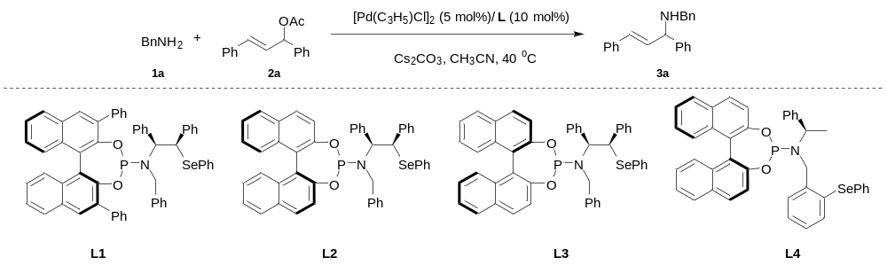
entryª | solvent^{b} | ligand | base | time (h) | yield^{b} | ee^{c}
1 | CH₃CN | L1 | Cs₂CO₃ | 5 | 95 | 83
2 | THF | L1 | Cs₂CO₃ | 10 | 90 | 50
3 | DME | L1 | Cs₂CO₃ | 10 | 93 | 40
4 | DCE | L1 | Cs₂CO₃ | 10 | 85 | 67
5 | DCM | L1 | Cs₂CO₃ | 10 | 88 | 63
6 | Toluene | L1 | Cs₂CO₃ | 10 | 80 | 51
7 | CH₃CN | L2 | Cs₂CO₃ | 5 | 93 | 83
8 | CH₃CN | L3 | Cs₂CO₃ | 5 | 89 | 79
9 | CH₃CN | L4 | Cs₂CO₃ | 24 | - | -
10 | CH₃CN | L2 | K₂CO₃ | 5 | 96 | 83
11 | CH₃CN | L2 | BaCO₃ | 10 | 55 | 70
12 | CH₃CN | L2 | K₃PO₄ | 8 | 87 | 82
ª Unless otherwise noted, reactions were carried out with 1a (0.6 mmol), 2a (0.2 mmol), [Pd(C₃H₅)Cl]₂ (5 mol%), L (10 mol%), and base (0.6 mmol) in solvent (2.0 mL) at 40 ºC. ^{b} Isolated yield. ^{c} Determined by chiral HPLC.

3. General Procedure for Pd-Catalyzed Enantioselective Allylic Substitution Reactions and Spectral Data

3.1 General procedure for Pd-catalyzed enantioselective allylic substitution reactions
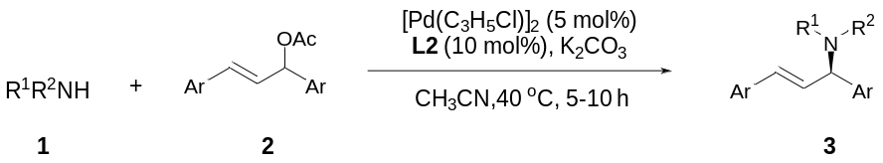
Ligand L2 (10 mol%) and [Pd(C₃H₅)Cl]₂ (5 mol%) were dissolved in CH₃CN (2.0 mL) in a Schlenk tube under Ar at room temperature. After stirring at room temperature for 1 h, allylic acetate 2 (0.2 mmol) was added, followed by K₂CO₃ (85 mg, 0.6 mmol), stirred for 10 min. 1 (0.6 mmol) was added and stirred until 2 was totally consumed, and then the above reaction system was purified by flash column chromatrography, eluting with petroleum ether and ethyl acetate to afford the corresponding product 3.

3.2 Spectral Data of Allylic AminationProducts
(R,E)-N-benzyl-1,3-diphenylprop-2-en-1-amine (3aa)
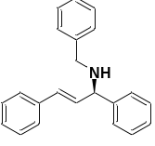
Yield:92%. The ee was determined by chiral HPLC (Chiralpak IA, hexane/isopropanol 99:1 v/v, flow rate 1.0 mL/min, λ = 254 nm, 25 ºC). Retension times: t_{R} = 9.404 min (major) , t_{R} = 10.209 min (minor), ee = 83%. ¹H NMR (400 MHz, CDCl₃ ) δ 7.52 – 7.39 (m, 2H), 7.36-7.32 (m, 7H), 7.30 (s, 1H), 7.29 – 7.12 (m, 5H). 6.58 (d, J = 15.8 Hz, 1H), 6.32 (dd, J = 15.9, 7.5 Hz, 1H), 4.40 (d, J = 7.5 Hz, 1H), 3.79 (dd, J = 17.6 Hz, J = 9.2 Hz, 2H).¹³C NMR (100 MHz, CDCl₃) δ 142.76, 140.26, 136.85, 132.47, 130.34, 128.59, 128.47, 128.39, 128.15, 127.42, 127.33, 127.27, 126.92, 126.37, 64.53, 51.32.
(R,E)-N-(4-methoxybenzyl)-1,3-diphenylprop-2-en-1-amine (3ba)
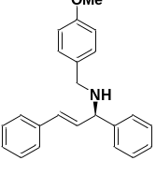
Yield: 78%. The ee was determined by chiral HPLC (CHIRALPAK IB, hexane/isopropanol 90:10 v/v, flow rate 1.0 mL/min, λ = 254 nm, 25 ºC). Retension times: t_{R} = 5.257 min (minor), t_{R} = 6.299 min (major). ee = 78%. ¹H NMR (400 MHz, CDCl₃) δ 7.41 (d, J = 7.3 Hz, 2H), 7.33 (t, J = 7.5 Hz, 4H), 7.29 – 7.11 (m, 6H), 6.85 (d, J = 8.6 Hz, 2H). 6.56 (d, J = 10.5 Hz, 1H), 6.31 (dd, J = 10.5, 5 Hz, 1H), 4.37 (d, J = 7.6 Hz, 1H), 3.75 (s, 3H), 3.70 (dd, J = 9.8, 5.8 Hz, 2H). ¹³C NMR (100 MHz, CDCl₃) δ158.47, 142.80, 136.83, 132.54, 132.38, 130.14, 129.19, 128.45, 128.35, 127.23, 127.10, 126.26, 113.67, 64.33, 55.11, 50.64.

(R,E)-1,3-diphenyl-N-(4-(trifluoromethyl)benzyl)prop-2-en-1-amine (3ca)
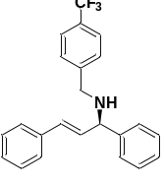
Yield: 85%. The ee was determined by chiral HPLC (Chiralpak IA, hexane/isopropanol 98:2 v/v, flow rate 1.0 mL/min, λ = 254 nm, 25 ºC). Retension times: t_{R} = 5.600 min (major) , t_{R} = 5.927 min (minor). ee =81%. ¹H NMR (400 MHz, CDCl₃) δ 7.57 (d, J = 7.9 Hz, 2H), 7.44 (t, J = 9.4 Hz, 4H), 7.39 -7.32 (m, 4H), 7.27 (t, J = 7.2 Hz, 3H), 7.22 -7.18 (m, 1H), 6.57 (d, J = 15.8 Hz, 1H), 6.31 (dd, J = 15.8, 7.5 Hz, 1H), 4.37 (d, J = 7.4 Hz, 1H), 3.84 (s, 2H). ¹³C NMR (100MHz, CDCl₃) δ144.59, 142.57, 136.74, 132.24, 130.51, 129.24, 128.92, 128.62, 128.47, 128.26, 127.49, 127.37, 127.24, 126.36, 125.62, 125.26, 125.22, 125.19, 125.15, 122.92, 64.60, 50.74.
(R,E)-N-(1,3-diphenylallyl)aniline (3da)
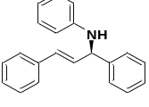
Yield: 90%. The ee was determined by chiral HPLC (CHIRALPAK IB, hexane/isopropanol 90:10 v/v, flow rate 1.0 mL/min, λ = 254 nm, 25 ºC). Retension times: t_{R} = 7.274 min (minor), t_{R}= 7.800 min (major).ee = 86%. ¹H NMR (600 MHz, CDCl3) δ 7.43 (d, J = 7.5 Hz, 2H), 7.36 (dd, J = 7.3, 5.5 Hz, 4H), 7.29 (dd, J = 9.6, 5.5 Hz, 3H), 7.22 (t, J = 7.3 Hz, 1H), 7.14 (t, J = 7.9 Hz, 2H), 6.71 (t, J = 7.3 Hz, 1H), 6.65-6.60 (m, 3H), 6.40 (dd, J = 15.8, 6.2 Hz, 1H), 5.08 (d, J = 6.1 Hz, 1H), 4.11 (s, 1H). ¹³C NMR (100MHz, CDCl₃) δ 147.17, 141.99, 136.56, 130.99, 130.63, 129.10, 128.78, 128.50, 127.62, 127.48, 127.17, 126.47, 117.64, 113.53, 60.60.
(R,E)-4-chloro-N-(1,3-diphenylallyl)aniline (3ea)
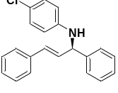
Yield: 83%. The ee was determined by chiral HPLC (CHIRALPAK IB, hexane/isopropanol 90:10 v/v, flow rate 1.0 mL/min, λ = 254 nm, 25 ºC). Retension times: t_{R} = 10.617 min (minor), t_{R}= 12.086 min (major). ee = 90%.¹H NMR (400 MHz, CDCl3) δ 7.44 – 7.34 (m, 7H), 7.33 – 7.27 (m, 3H), 7.24 (d, J = 7.8 Hz, 1H), 7.11 – 7.04 (m, 2H), 6.66 – 6.53 (m, 3H), 6.36 (dd, J = 15.9, 6.1 Hz, 1H), 5.03 (d, J = 6.1 Hz, 1H), 4.13 (s, 1H). ¹³C NMR (100MHz, CDCl₃) δ 145.68, 141.56, 136.43, 131.30, 130.16, 128.95, 128.90, 128.58, 127.79, 127.69, 127.15, 126.51, 122.29, 114.67, 60.70,
(R,E)-2-(1,3-diphenylallyl)-1,2,3,4-tetrahydroisoquinoline (3fa)
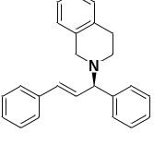
Yield: 80%. The ee was determined by chiral HPLC (CHIRALCEL IA, hexane/isopropanol 90:0 v/v, flow rate 1.0 mL/min, λ = 254 nm, 30 ºC). Retension times: t_{R} = 3.806 min (major), t_{R} = 4.023min (minor). ee = 6%.¹H NMR (600 MHz, CDCl₃) δ 7.46 (d, J = 7.6 Hz, 2H), 7.41 – 7.32 (m, 4H), 7.27 (dt, J = 18.5, 7.4 Hz, 3H), 7.23 – 7.19 (m, 1H), 7.10 (h, J = 7.4 Hz, 3H), 6.96 (d, J = 7.4 Hz, 1H), 6.63 (d, J = 15.8 Hz, 1H), 6.40 (dd, J = 15.8, 8.9 Hz, 1H), 4.01 (d, J = 8.8 Hz, 1H), 3.80 (d, J = 15.1 Hz, 1H), 3.60 (d, J = 15.0 Hz, 1H), 2.93 – 2.81 (m, 2H), 2.77 (t, J = 5.9 Hz, 2H). ¹³C NMR (100 MHz, CDCl₃) δ 142.05, 136.80, 134.98, 134.56, 131.71, 131.14, 128.65, 128.60, 128.50, 127.87, 127.50, 127.23, 126.78, 126.39, 126.05, 125.54, 73.73, 54.66, 48.47, 29.12.
(R,E)-4-(1,3-diphenylallyl)morpholine (3ga)
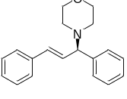
Yield: 80%. The ee was determined by chiral HPLC (CHIRALPAK IB, hexane/isopropanol 90:10 v/v, flow rate 1.0 mL/min, λ = 254 nm, 25 ºC). Retension times: t_{R} = 4.862 min (minor), t_{R} = 7.263 min (major). ee = 58%. ¹H NMR (600 MHz, CDCl₃) δ 7.40 (d, J = 7.3 Hz, 2H), 7.37 – 7.30 (m, 4H), 7.28 (s, 2H), 7.25 – 7.13 (m, 2H), 6.57 (d, J = 15.8 Hz, 1H), 6.28 (dd, J = 15.8, 8.9 Hz, 1H), 3.78 (d, J = 8.9 Hz, 1H), 3.71 (t, J = 4.6 Hz, 4H), 2.54 (s, 2H), 2.42 – 2.33 (m, 2H). ¹³C NMR (100 MHz, CDCl₃) δ141.45, 136.64, 131.51, 131.30, 128.63, 128.47, 127.97, 127.53, 127.28, 126.33, 74.81, 67.10, 52.15.
(R,E)-N-(1,3-diphenylallyl)-4-methylbenzenesulfonamide (3ha)
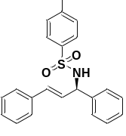
Yield: 82%. The ee was determined by chiral HPLC (CHIRALPAK IB, hexane/isopropanol 90:10 v/v, flow rate 1.0 mL/min, λ = 254 nm, 25 ºC). Retension times: t_{R} = 12.574 min (major), t_{R}= 15.620 min (minor). ee = 84%. ¹H NMR (600 MHz, CDCl₃) δ 7.65 (d, J = 8.1 Hz, 2H), 7.40-7.22 (m, 6H), 7.21-6.99 (m, 6H), 6.35 (d, J = 16.6 Hz, 1H), 6.07 (dd, J = 16.2, 6.7 Hz, 1H), 5.11 (t, J = 6.9 Hz, 1H), 4.95 (s, 1H), 2.33 (s, 3H).¹³C NMR (100 MHz, CDCl₃) δ143.14, 139.59, 137.60, 136.00, 131.90, 129.35, 128.59, 128.35, 128.09, 127.76, 127.69, 127.21, 126.98, 126.45, 59.70, 21.34.
(R,E)-N-(1,3-diphenylallyl)-2-methylpropane-2-sulfonamide (3ia)
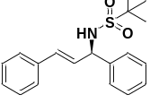
Yield: 80%. The ee was determined by chiral HPLC (CHIRALPAK IA, hexane/isopropanol 95:5 v/v, flow rate 1.0 mL/min, λ = 254 nm, 25 ºC). Retension times: t_{R} = 15.724 min (minor), t_{R} = 18.914 min (major). ee = 82%. ¹H NMR (400 MHz, CDCl₃) δ 7.51 – 7.17 (m, 10H), 6.53 (dd, J = 15.9, 1.4 Hz, 1H), 6.37 (dd, J = 15.9, 6.1 Hz, 1H), 5.30 (ddd, J = 9.0, 6.1, 1.4 Hz, 1H), 4.63 (d, J = 9.1 Hz, 1H), 1.34 (s, 9H).¹³C NMR (100 MHz, CDCl₃) δ 140.91, 136.15, 131.57, 130.00, 128.88, 128.57, 127.93, 127.82, 127.03, 126.60, 59.96, 24.16.

NMR spectra of the products

¹H NMR (400 MHz, CDCl₃) and ¹³C NMR (100 MHz, CDCl₃) spectra of product 3aa

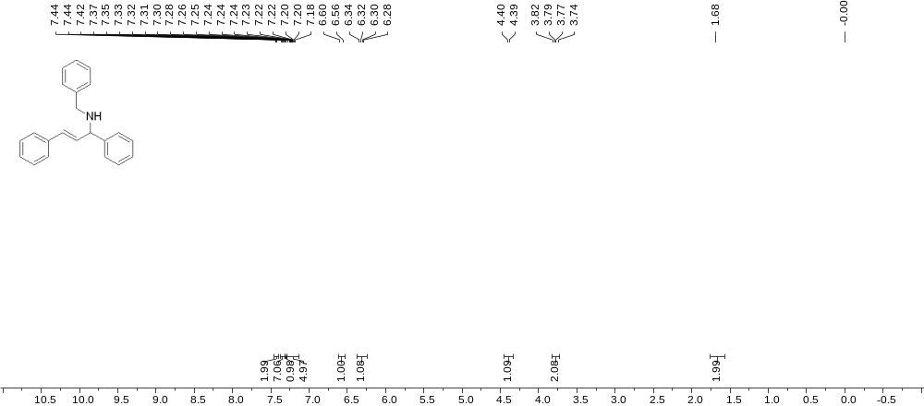

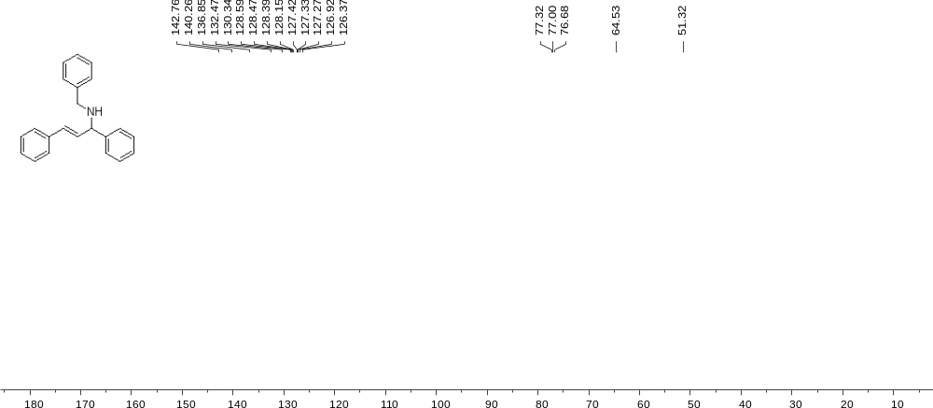

¹H NMR (400 MHz, CDCl₃) and ¹³C NMR (100 MHz, CDCl₃) spectra of product 3ba

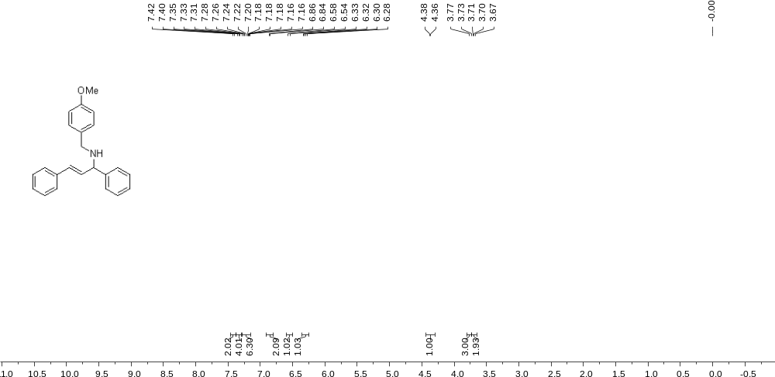
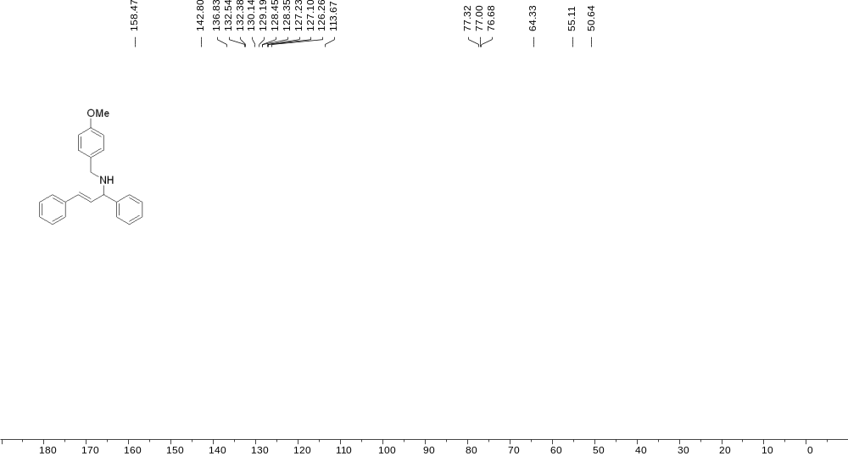

¹H NMR (400 MHz, CDCl₃) and ¹³C NMR (100 MHz, CDCl₃) spectra of product 3ca

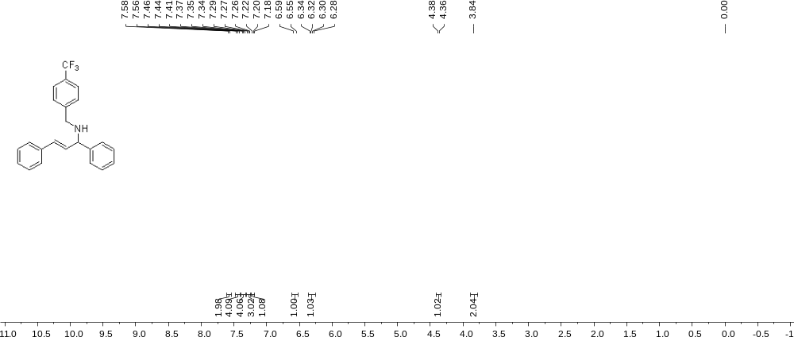

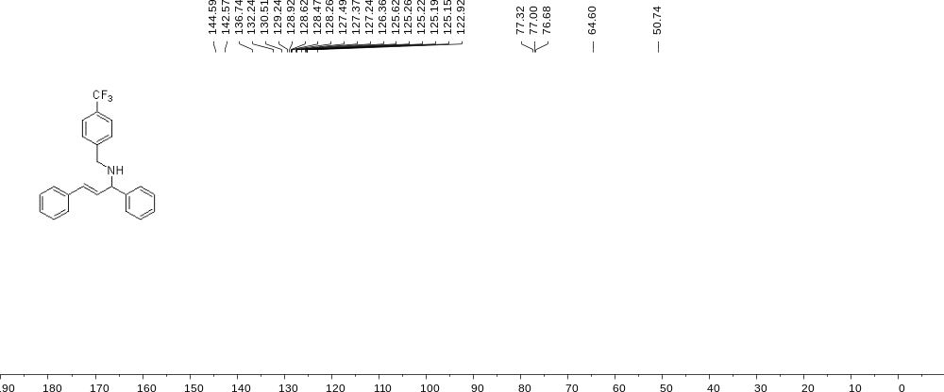

¹H NMR (600 MHz, CDCl₃) and ¹³C NMR (100 MHz, CDCl₃) spectra of product 3da

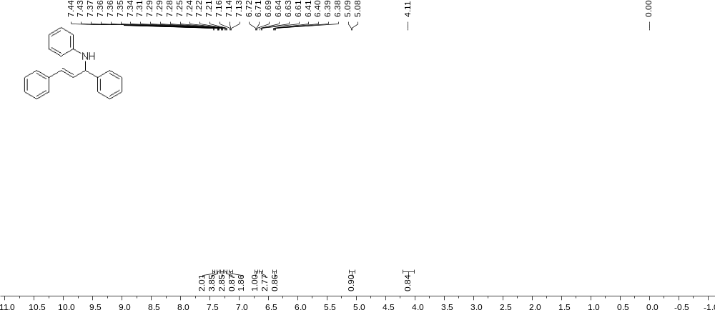

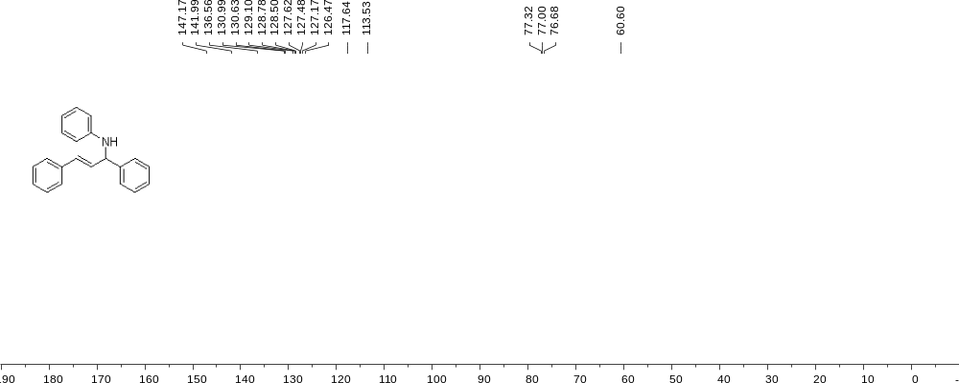

¹H NMR (400 MHz, CDCl₃) and ¹³C NMR (100 MHz, CDCl₃) spectra of product 3ea

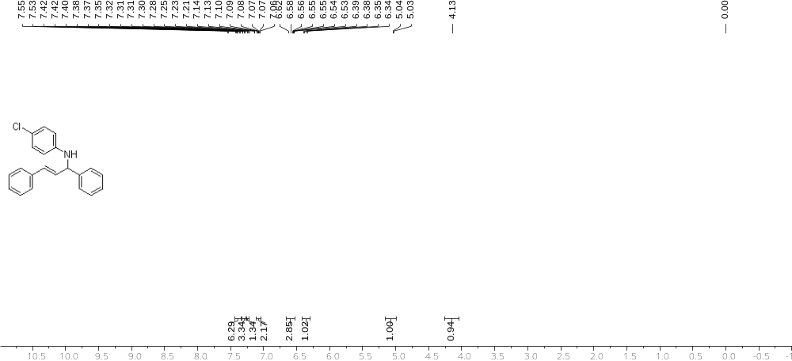

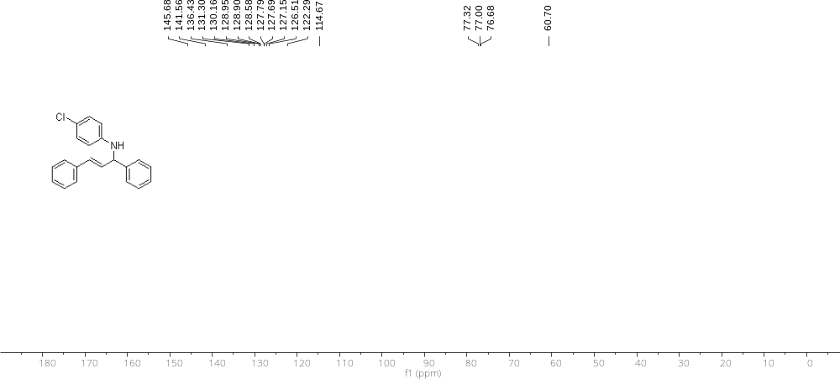

¹H NMR (600 MHz, CDCl₃) and ¹³C NMR (100 MHz, CDCl₃) spectra of 3fa

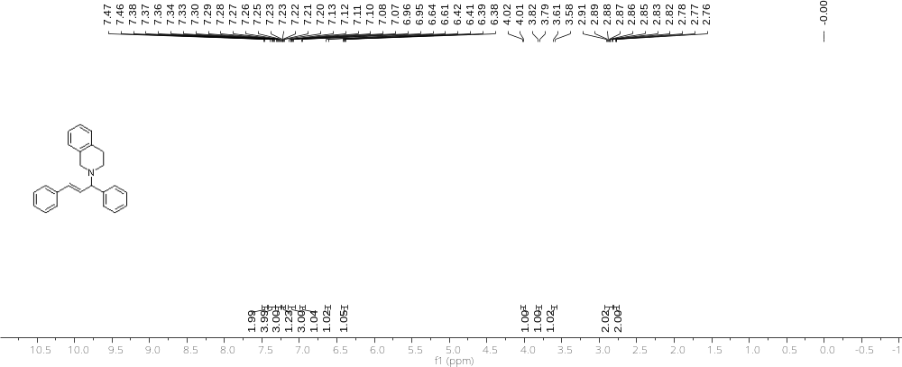
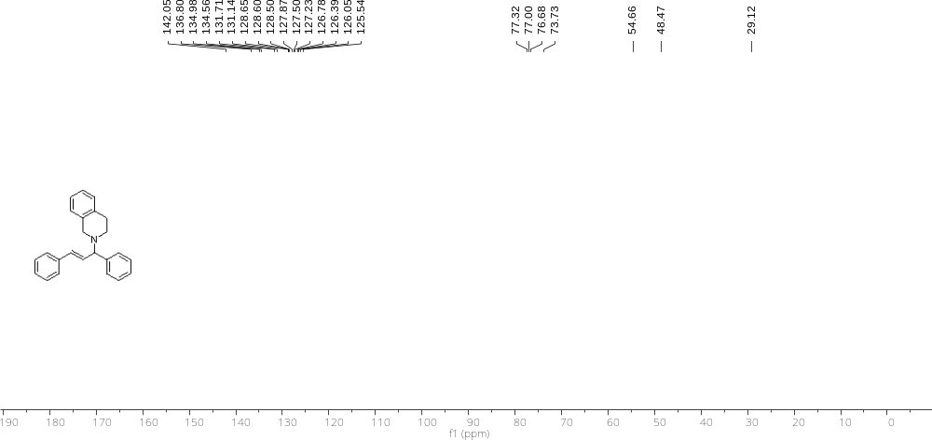

¹H NMR (600 MHz, CDCl₃) and ¹³C NMR (100 MHz, CDCl₃) spectra of 3ga
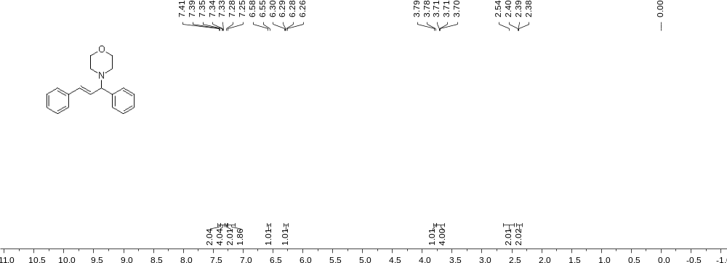

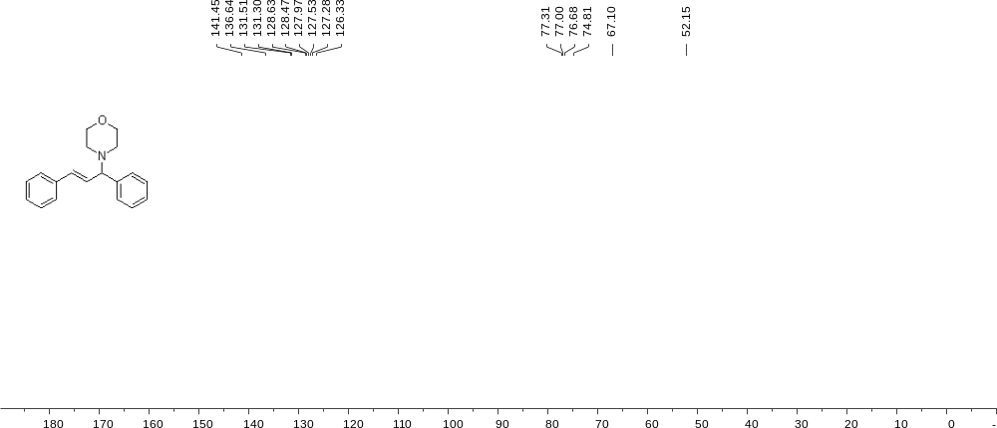

¹H NMR (600 MHz, CDCl₃) and ¹³C NMR (100 MHz, CDCl₃) spectra of product 3ha

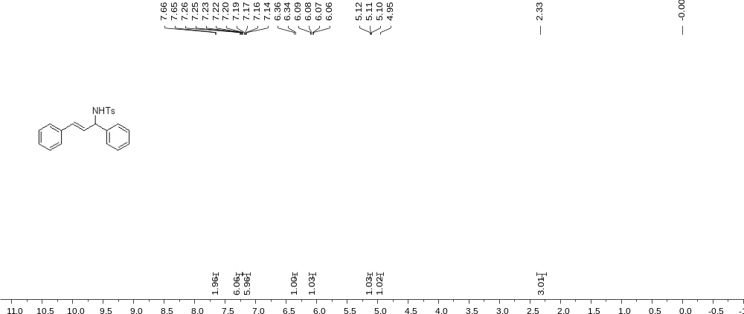
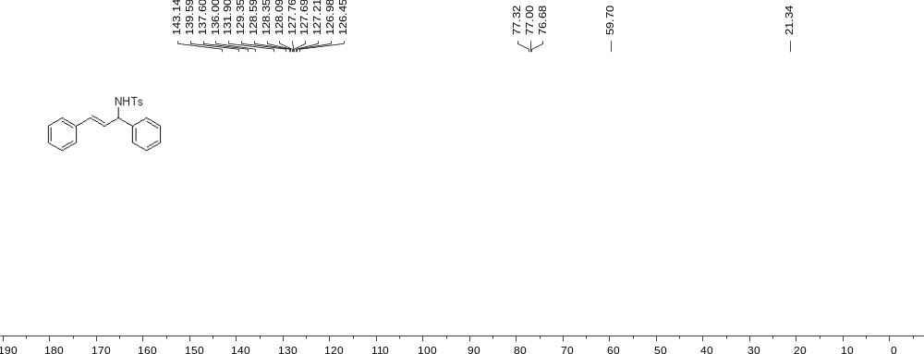

¹H NMR (400 MHz, CDCl₃) and ¹³C NMR (100 MHz, CDCl₃) spectra of product 3ia
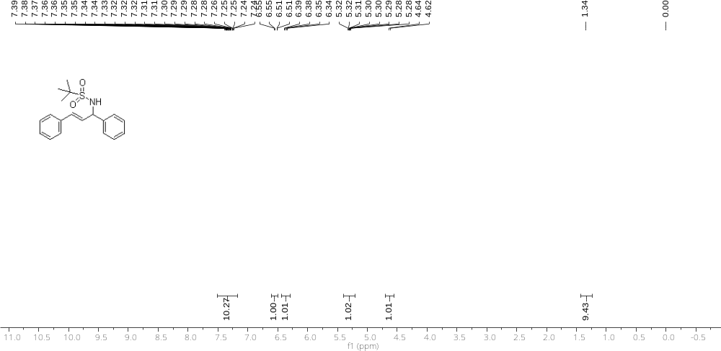

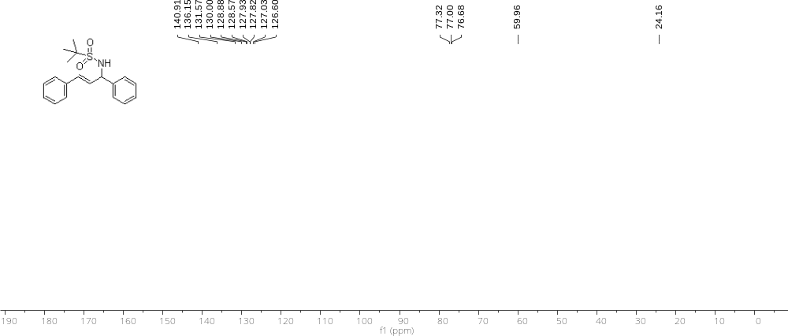

HPLC spectra of the products
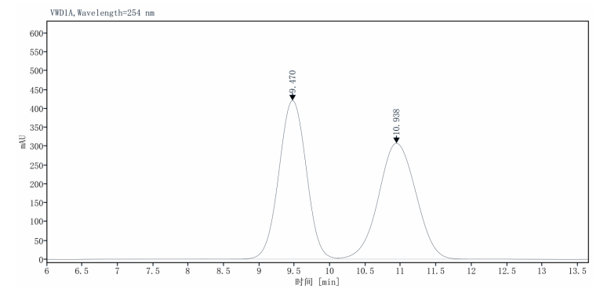 | 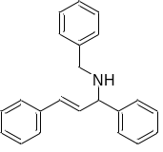  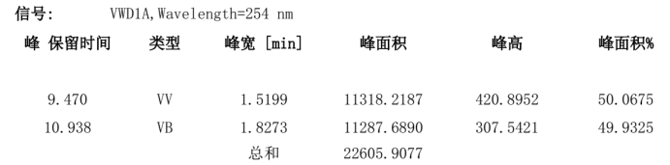
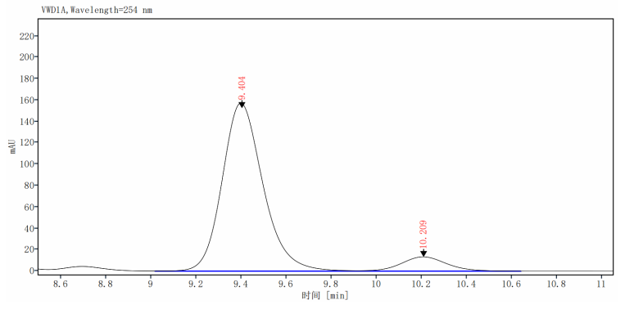 | 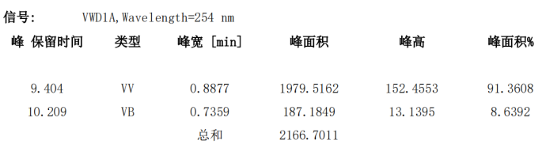
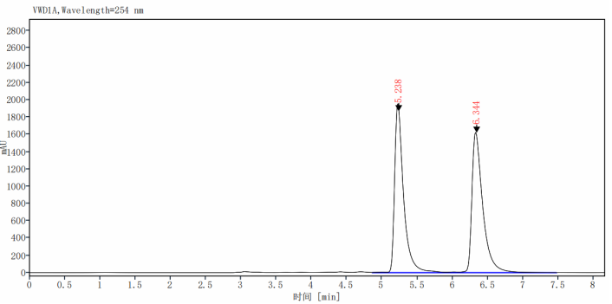 | 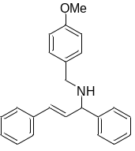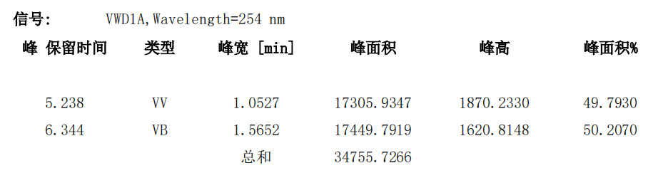
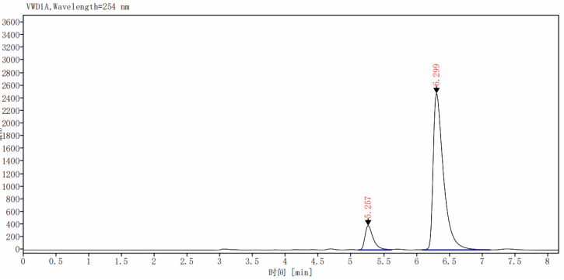 | 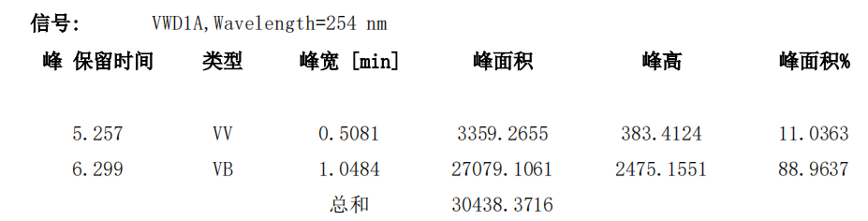

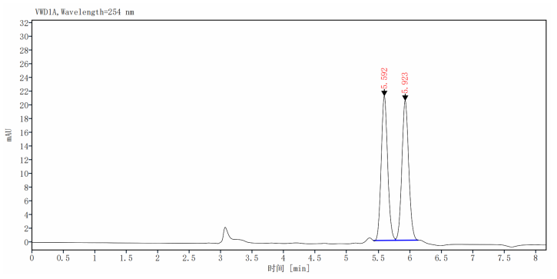 | 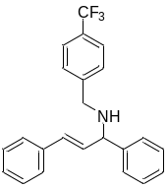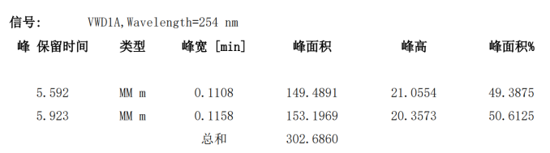
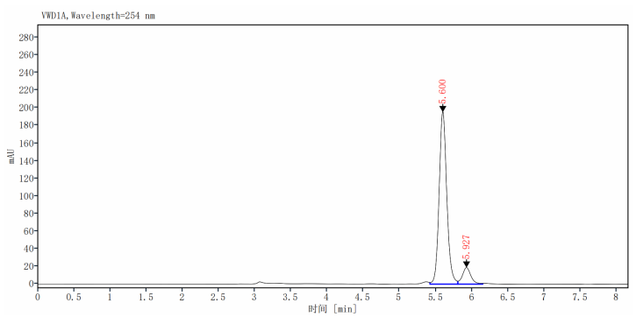 | 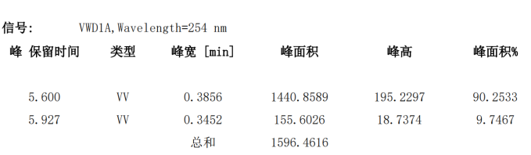
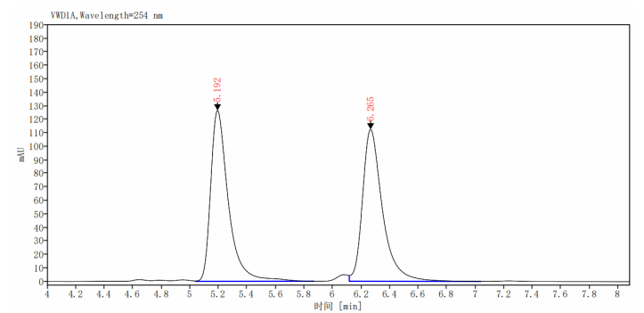 | 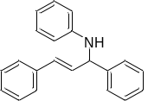  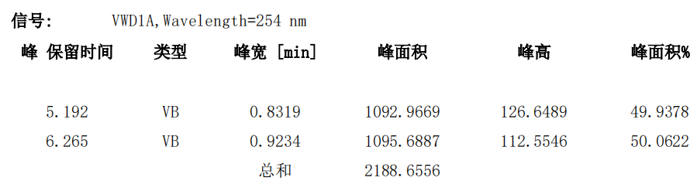
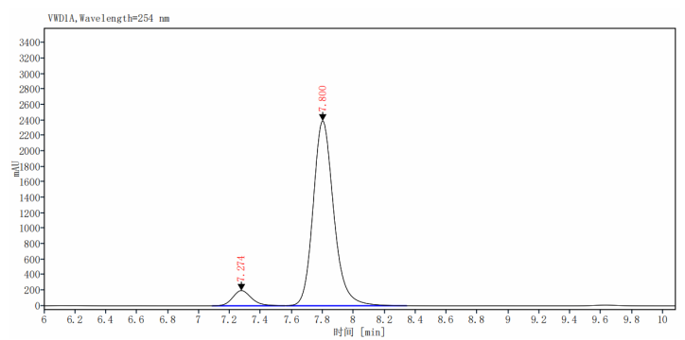 | 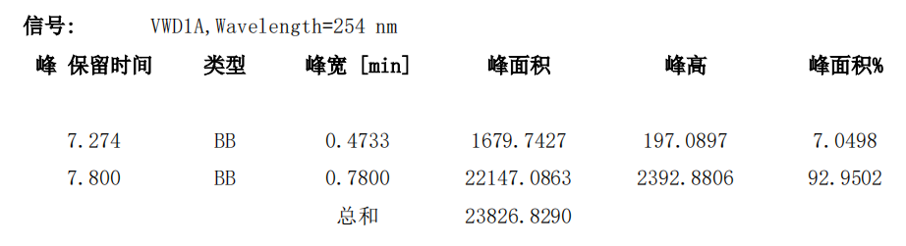

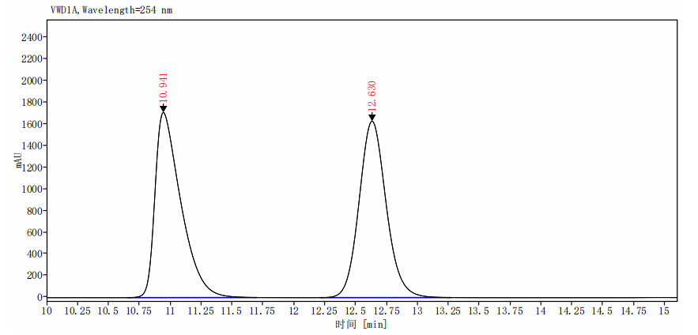 | 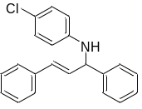  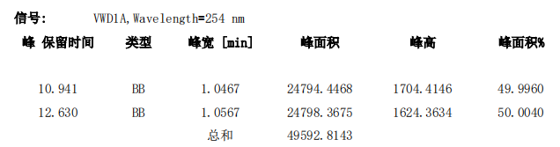
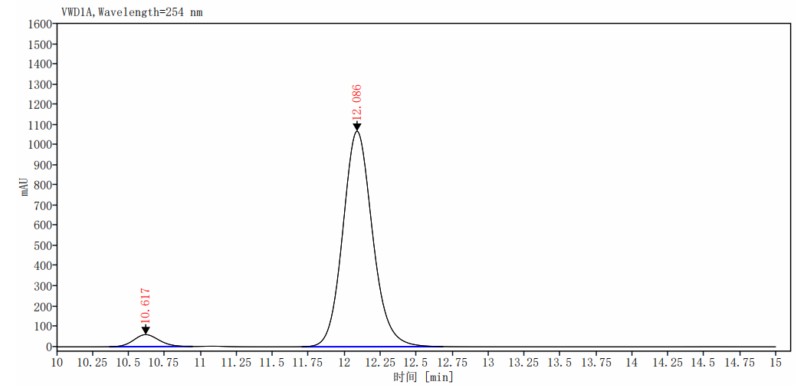 | 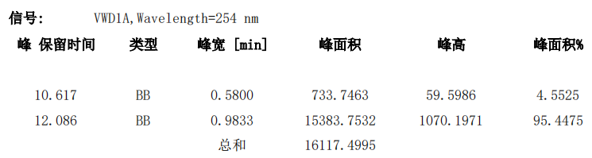
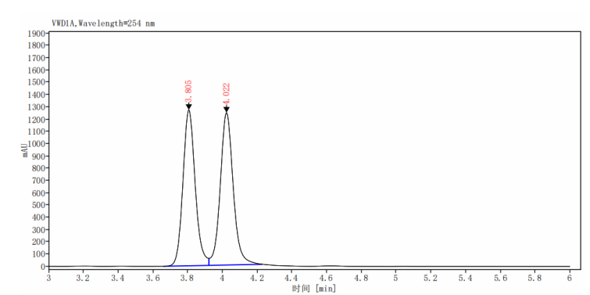 | 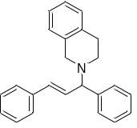  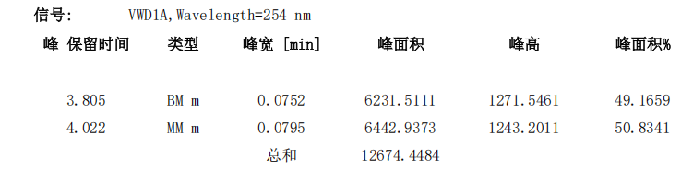
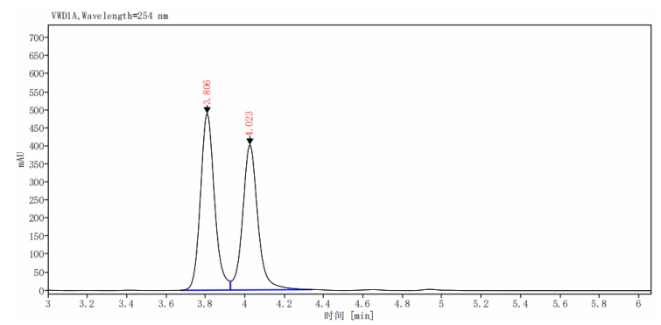 | 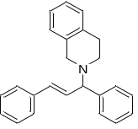  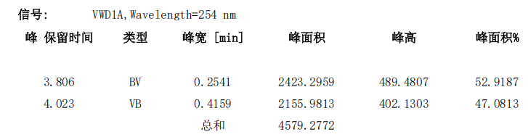

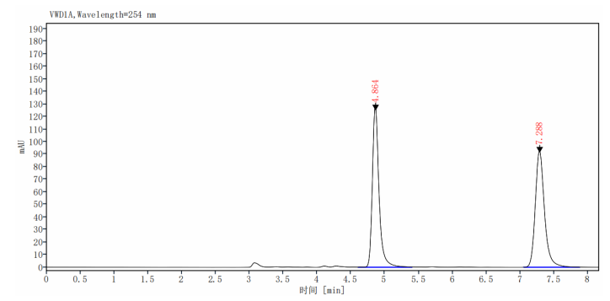 | 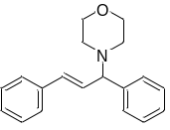  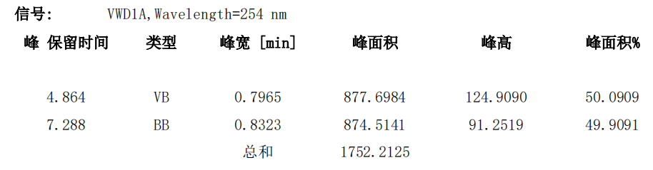
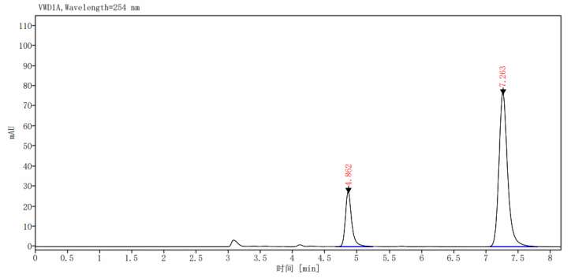 | 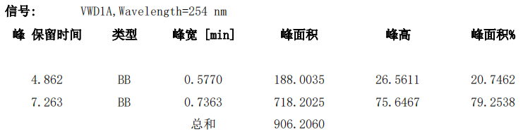
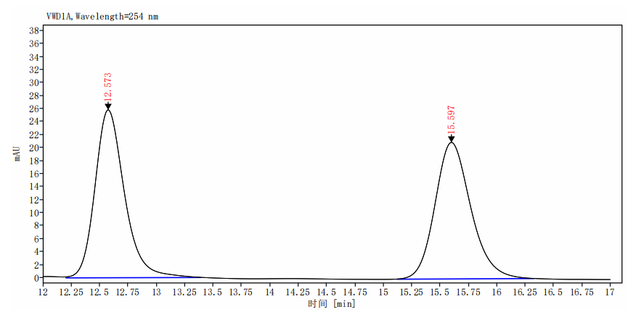 | 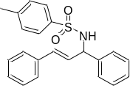  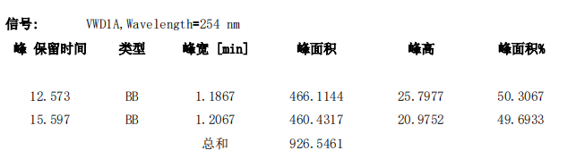
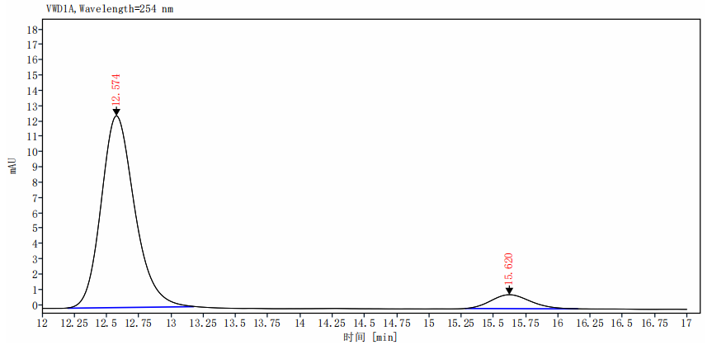 | 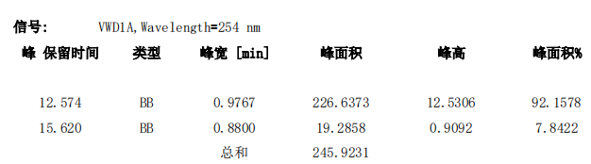

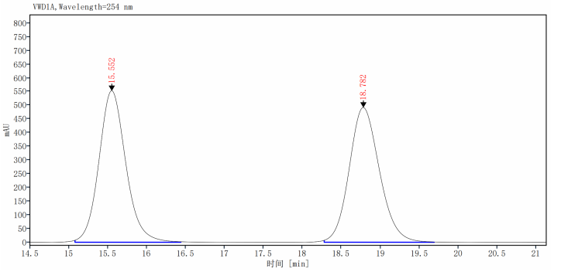 | 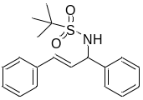  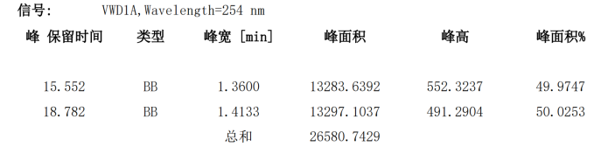
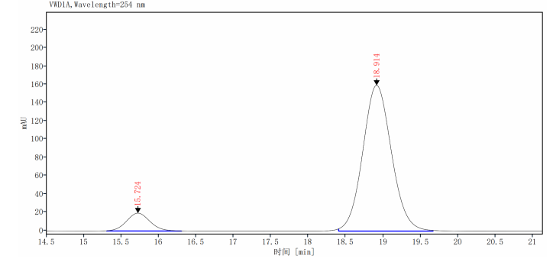 | 