Supplementary Information
1. Multi-frequency mixing processes controlled by diverse quasi-monochromatic tunable lasers.
Four tunable lasers (TLs) were combined by a 1×4 coupler to realize the multi-frequency mixing processes, involving the generation of ten converted nonlinear signals. The TL₁ is set to 10 mW. By tuning the pump powers of TL₂, TL₃, or TL₄ in the range of 0~15 mW or 10 mW, similar spectral evolutions are obtained in Figs. S1(a)-(c). The power-dependences for ω₂, ω₃, or ω₄-related frequency-conversion signals are fitted in Figs. S1(d)-(f), with their slopes summarized in Table S1.
Figure S1. (a)-(c) Spectra evolutions of the multi-frequency mixing processes modulated by tuning the power of different TLs.
Table S1. Power-dependence slopes of SHG and SFG in the multi-frequency mixing.
ω_{i} | ω_{i}-related SHG | ω_{i}-related SFG
ω₂ | 1.75±0.02  (2ω₂) | 0.97±0.02  (ω₁+ω₂) | 0.98±0.01  (ω₂+ω₃) | 0.88±0.01  (ω₂+ω₄)
ω₃ | 1.83±0.04  (2ω₃) | 0.95±0.01  (ω₁+ω₃) | 1.00±0.01  (ω₂+ω₃) | 1.08±0.01  (ω₃+ω₄)
ω₄ | 1.77±0.05  (2ω₄) | 0.94±0.01  (ω₁+ω₄) | 1.02±0.01  (ω₂+ω₄) | 1.01±0.01  (ω₃+ω₄)
2. The spectral details of two superluminescent light-emitting diode sources and the supercontinuum light source.
Figures S2(a) and S2(b) display the original spectra of two superluminescent light-emitting diode (SLED) sources. The power of SLED₁ centering 1550 nm is operated at 25.5 mW, with about 102.7 nm of 10-dB bandwidth. The SLED₂ working together is set to 12.9 mW, with the central wavelength at 1300 nm and about 83.9 nm of 10-dB bandwidth.
Figure S2. Spectral information of two SLED sources (a) SLED₁; (b) SLED₂
In addition, the pristine spectrum of the employed supercontinuum light source ranges from 660 to 1690 nm, as shown in Fig. S3(a). The pre-filter system consists of a filter (long pass, 1100 nm) and a dichroic mirror (short pass, 1500 nm). Its transmission is shown in Fig. S3(b), and a fluctuation of about 5.3 dB is observed within such a large wavelength range of 1100~1530 nm.
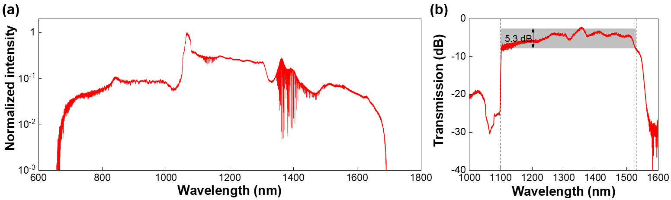
Figure S3. (a) Pristine spectrum of the supercontinuum light source. (b) Transmission of the pre-filter system.
3. Power-dependence of ultra-BSHG in the hybrid microfiber.
We investigated the evolved spectrum of the ultra-BSHG continuum by increasing the pump power of the SC source from 0.45 to 6.5 mW. Fig. S4(a) shows that the ultra-BSHG exhibits a consistent spectral shape during the power modulation process, and similar fitting slopes of power-dependences are demonstrated whether it is derived based on the maximum intensity (1.82±0.02) in the spectrum or the intensity integration (1.84±0.02) within the range of 520~800 nm, as illustrated in Fig. S4(b).
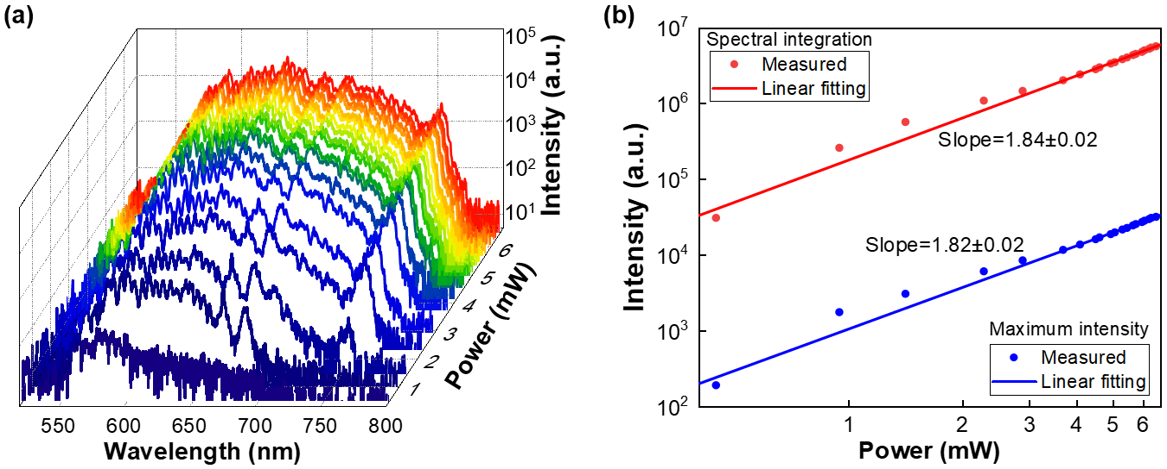
Figure S4. (a) Evolved spectrum of the broadband SHG when the pump power of the SC source is increased from 0.45 to 6.5 mW. (b) Corresponding power-dependence of the ultra-SHG continuum, and the fitting slope is 1.82±0.02 or 1.84±0.02 when it is calculated from the maximum intensity in the spectrum or the integration of intensities within 520~800 nm.
4. Dry transfer method of the GaSe-transferred microfiber.
Firstly, a multilayer GaSe single crystal was mechanically exfoliated from a bulk GaSe crystal using scotch tape. Secondly, the Scotch tape was pressed onto a planar polydimethylsiloxane (PDMS), resulting in the multilayered GaSe being transferred onto the PDMS surface. Lastly, under a microscope, the PDMS with GaSe adhered to its surface was carefully pressed onto the tapered region of the microfiber. This pressing state was maintained for a few minutes until it was empirically determined that the GaSe had successfully transferred onto the microfiber. Subsequently, the PDMS was lifted away.

