From resource-rich to resource-poor grasslands: A shift in β-diversity assembly mechanisms from biotic control to abiotic dominance

Tao Liu^{1,2, #}, Qingqing Wang^{1,2, #}, Chengzhen Jia³, Ziqing Gong⁴, Xu Wang⁵, Zhiyong Li^{1,2}, Huamin Liu^{1,2}, Lixin Wang^{1,2}, Yang Wang⁶, Lei Dong⁷, Cunzhu Liang^{1,2}, Jinghui Zhang^{1,2*}

Affiliations
¹Ministry of Education Key Laboratory of Ecology and Resource Use of the Mongolian Plateau & Inner Mongolia Key Laboratory of Grassland Ecology and the Candidate State Key Laboratory of Ministry of Science and Technology & Observation and Research Station for the Typical Steppe Ecosystem of the Ministry of Education, Hohhot, China;
²School of Ecology and Environment, Inner Mongolia University, Hohhot, China;
³Inner Mongolia Institute of Meteorological Sciences, Hohhot, China;
⁴Bureau of Housing and Urban-Rural Development, Kundulun District, Baotou City, Inner Mongolia Autonomous Region, China
⁵State Key Laboratory of Herbage Improvement and Grassland Agro-ecosystems, College of Ecology, Lanzhou University, Lanzhou, China
⁶College of Life Science and Technology, Inner Mongolia Normal University, Hohhot, China;
⁷Institute of Water Resources for Pastoral Areas, Ministry of Water Resources, Hohhot, China
#These authors contributed equally to this work.
*Corresponding author: Jinghui Zhang, Email: jhzhang1001@126.com.

This file includes: Supplementary Figures 1- 7

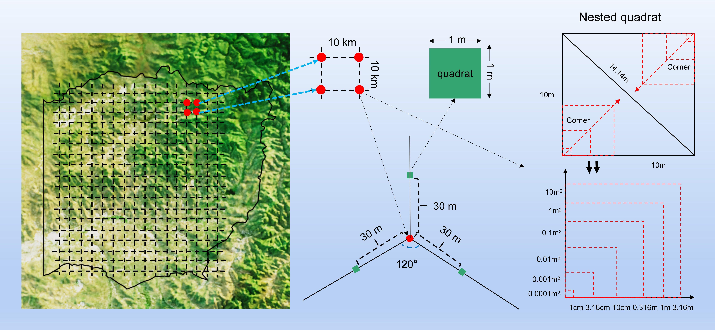
Supplementary Fig 1. Spatial design and nested quadrat structure for vegetation sampling. Sampling sites were systematically arranged across a 10 × 10 km grid, with nested plots established at selected locations. Each core plot consisted of a 160 m² circular area (14.14 m diameter), within which a series of nested quadrats (from 10 m² to 0.0001 m²) were placed concentrically to capture multi-scale vegetation patterns. The smallest quadrats were positioned using point-intercept methods. Sampling arms extended in three directions at 120° angles for spatial replication. Green squares indicate 1 m² quadrats used for species composition, and red dots represent selected grid sites.

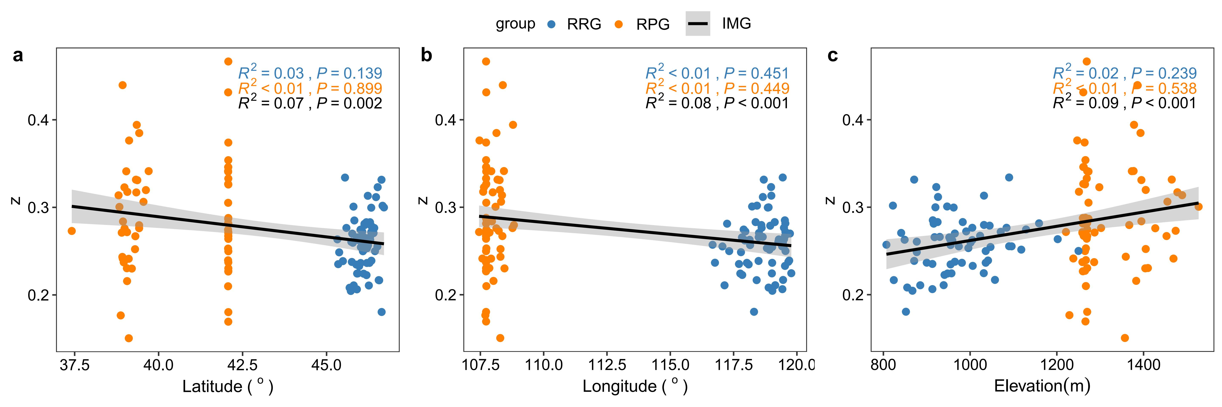
Supplementary Fig 2. Geographic patterns of community β-diversity (z-values) across steppe types. Relationships between z-values and (a) latitude, (b) longitude, and (c) elevation in resource-rich (RRG, blue), resource-poor grassland (GPG, orange) and integrated grassland (IMG, black). Solid lines represent linear regressions for each steppe type, with the overall trend shown in black with 95% confidence intervals (shaded area). Coefficients of determination (R²) and P-values are given for each regression.

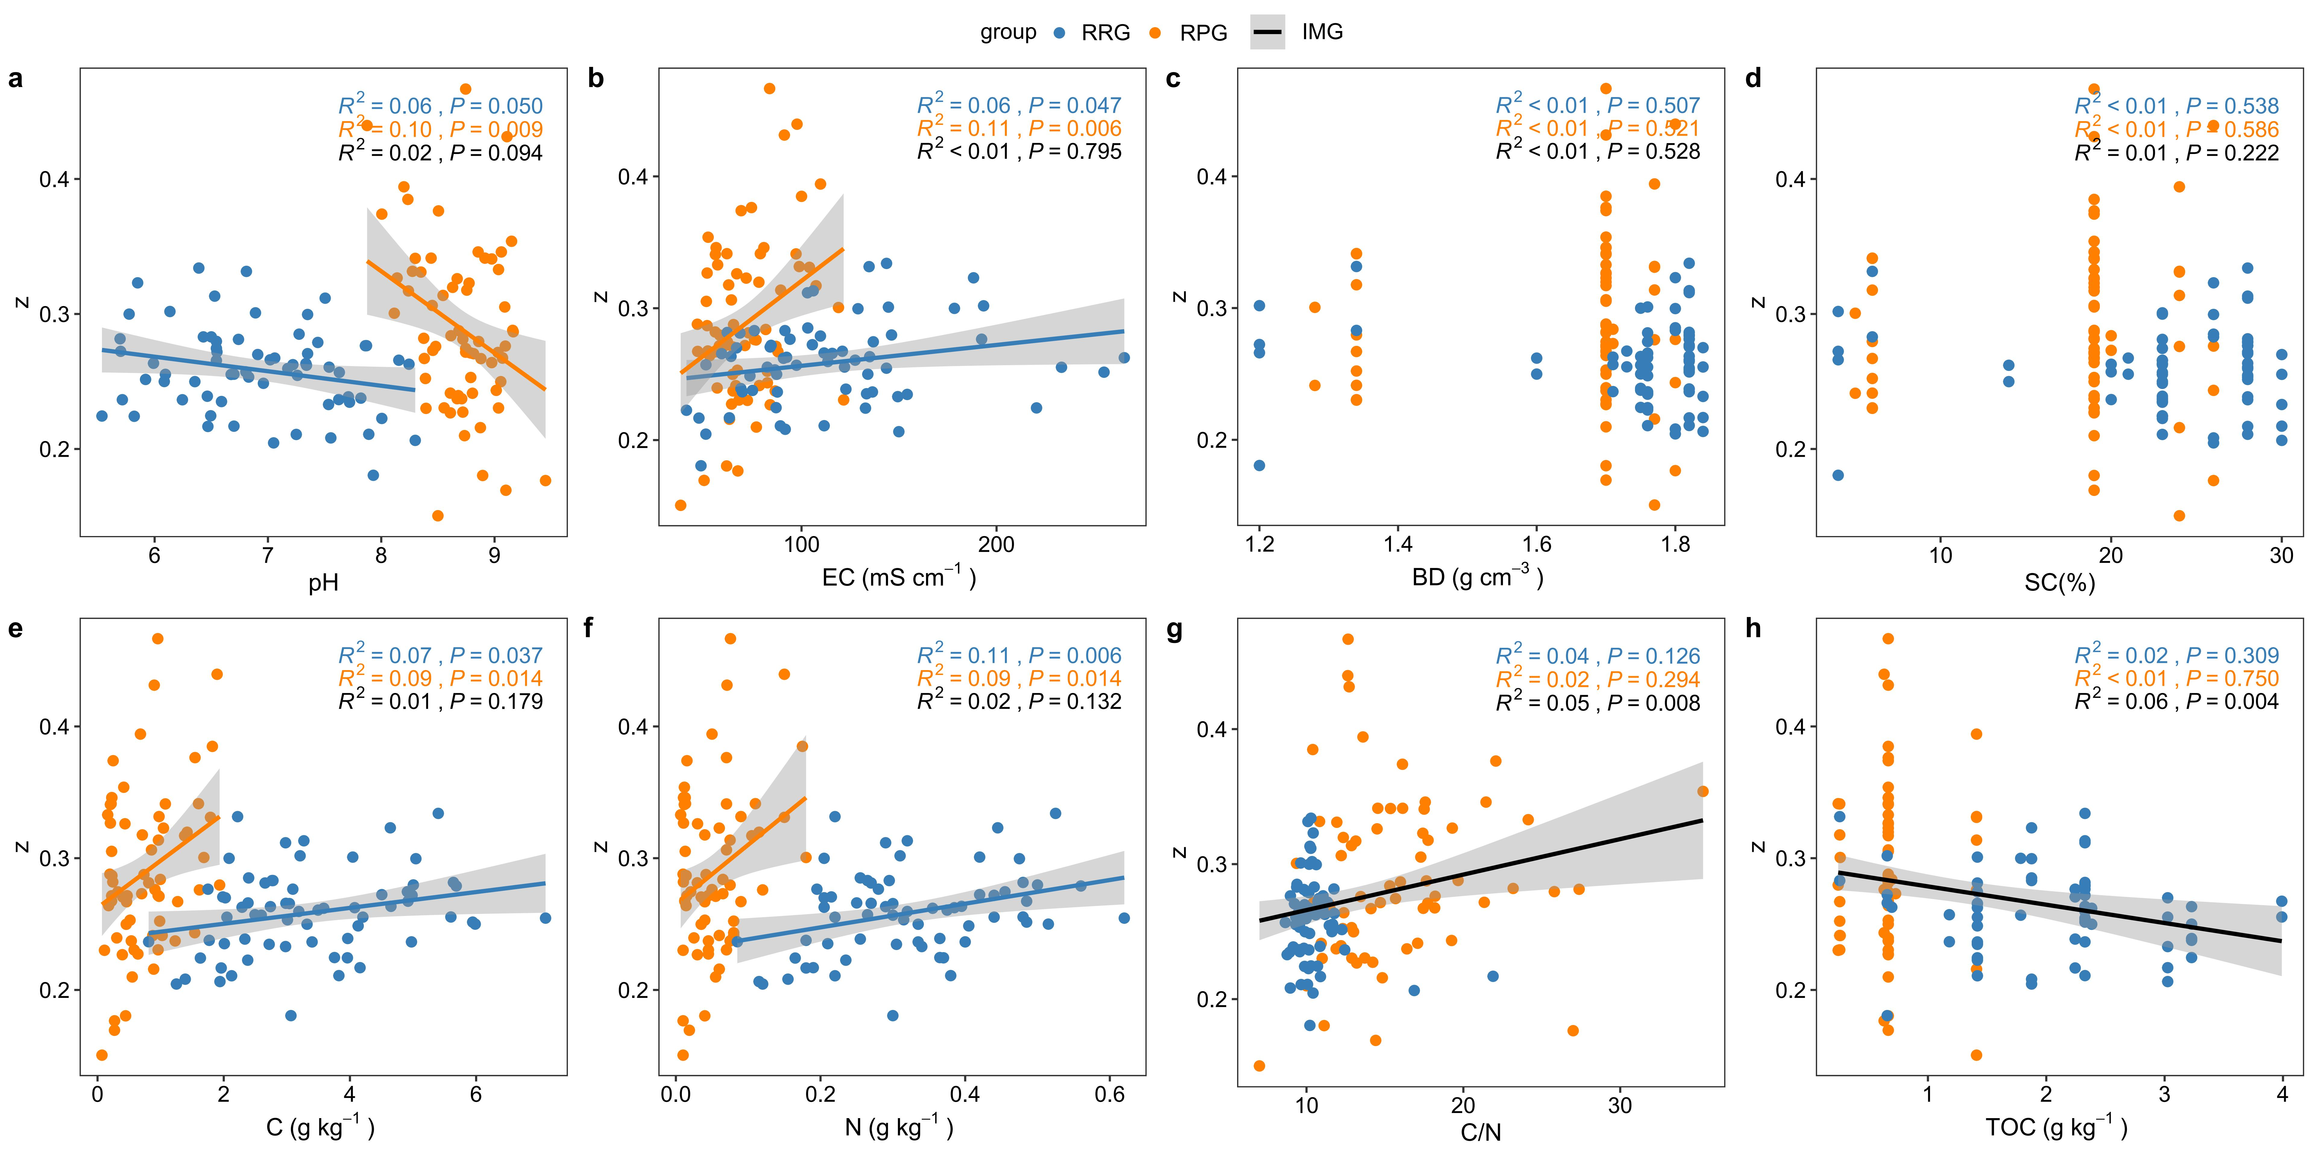
Supplementary Fig 3. Relationships between soil properties and community β-diversity. Linear regressions between z-values and (a) pH, (b) electrical conductivity (EC), (c) soil bulk density (BD), (d) soil clay content (SC), (e) total carbon (C), (f) total nitrogen (N), (g) C/N ratio (C/N), and (h) total organic carbon (TOC) in resource-rich (RRG, blue), resource-poor grassland (GPG, orange) and integrated grassland (IMG, black). Shaded bands denote 95% confidence intervals.
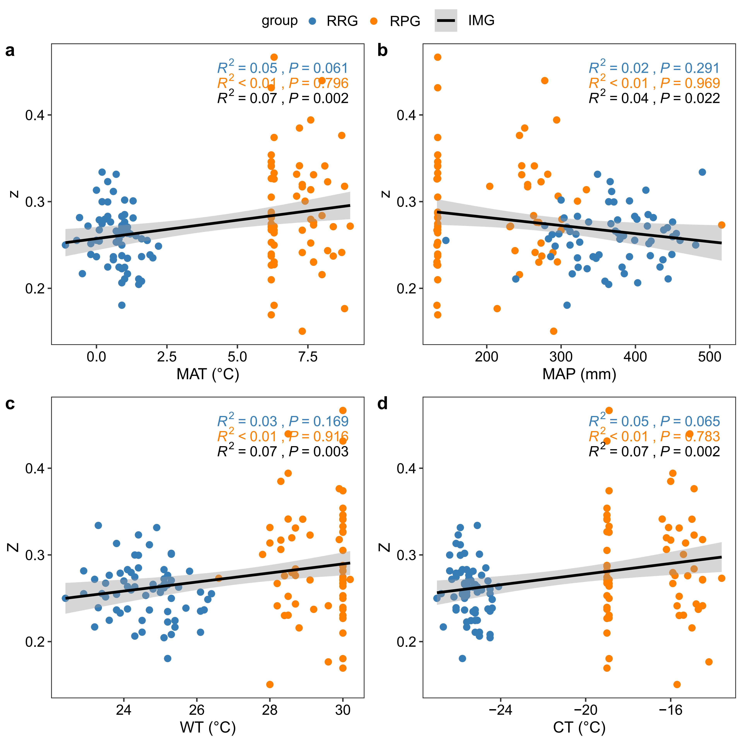
Supplementary Fig 4. Climatic controls on community β-diversity. Relationships between z-values and (a) mean annual temperature (MAT), (b) mean annual precipitation (MAP), (c) winter temperature (WT), and (d) continentality (CT) across resource-rich (RRG, blue), resource-poor grassland (GPG, orange) and integrated grassland (IMG, black). Solid lines represent linear regressions with 95% confidence intervals.
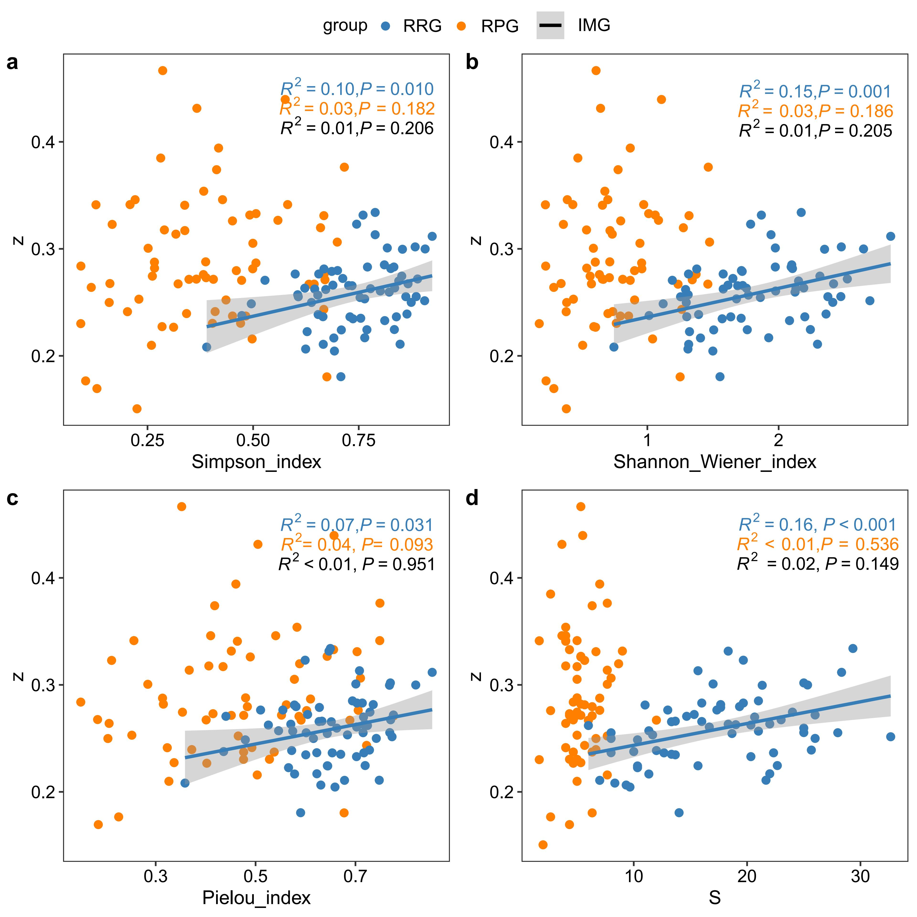
Supplementary Fig 5. Associations between α-diversity and β-diversity across grassland types. Relationships between z-values and (a) Simpson index, (b) Shannon–Wiener index, (c) Pielou evenness, and (d) species richness (S) in resource-rich (RRG, blue), resource-poor grassland (GPG, orange) and integrated grassland (IMG, black). Solid lines represent linear regressions with 95% confidence intervals (grey bands).
Supplementary Fig 6. Functional trait influences on community β-diversity. Relationships between z-values and community-weighted means (CWM) of (a) leaf dry matter content (LDMC), (b) leaf carbon content (LCC), (c) leaf nitrogen content (LNC), (d) leaf phosphorus content (LPC), (e) leaf C:N ratio (LCNR), (f) leaf N:P ratio (LNPR), (g) stem dry matter content (SDMC), (h) stem carbon content (SCC), (i) stem nitrogen content (SNC), (j) stem phosphorus content (SPC), (k) stem C:N ratio (SCNR), (l) stem N:P ratio (SNPR), (m) root dry matter content (RDMC), (n) root carbon content (RCC), (o) root nitrogen content (RNC), (p) root phosphorus content (RPC), (q) root C:N ratio (RCNR), (r) root N:P ratio (RNPR), (s) specific leaf area (SLA), (t) water-use efficiency (WUE), (u) leaf length (LL), and (v) leaf thickness (LT). RRG, resource-rich grassland; GPG, resource-poor grassland; IMG, integrated grassland. Lines and shaded bands represent linear fits with 95% confidence intervals.

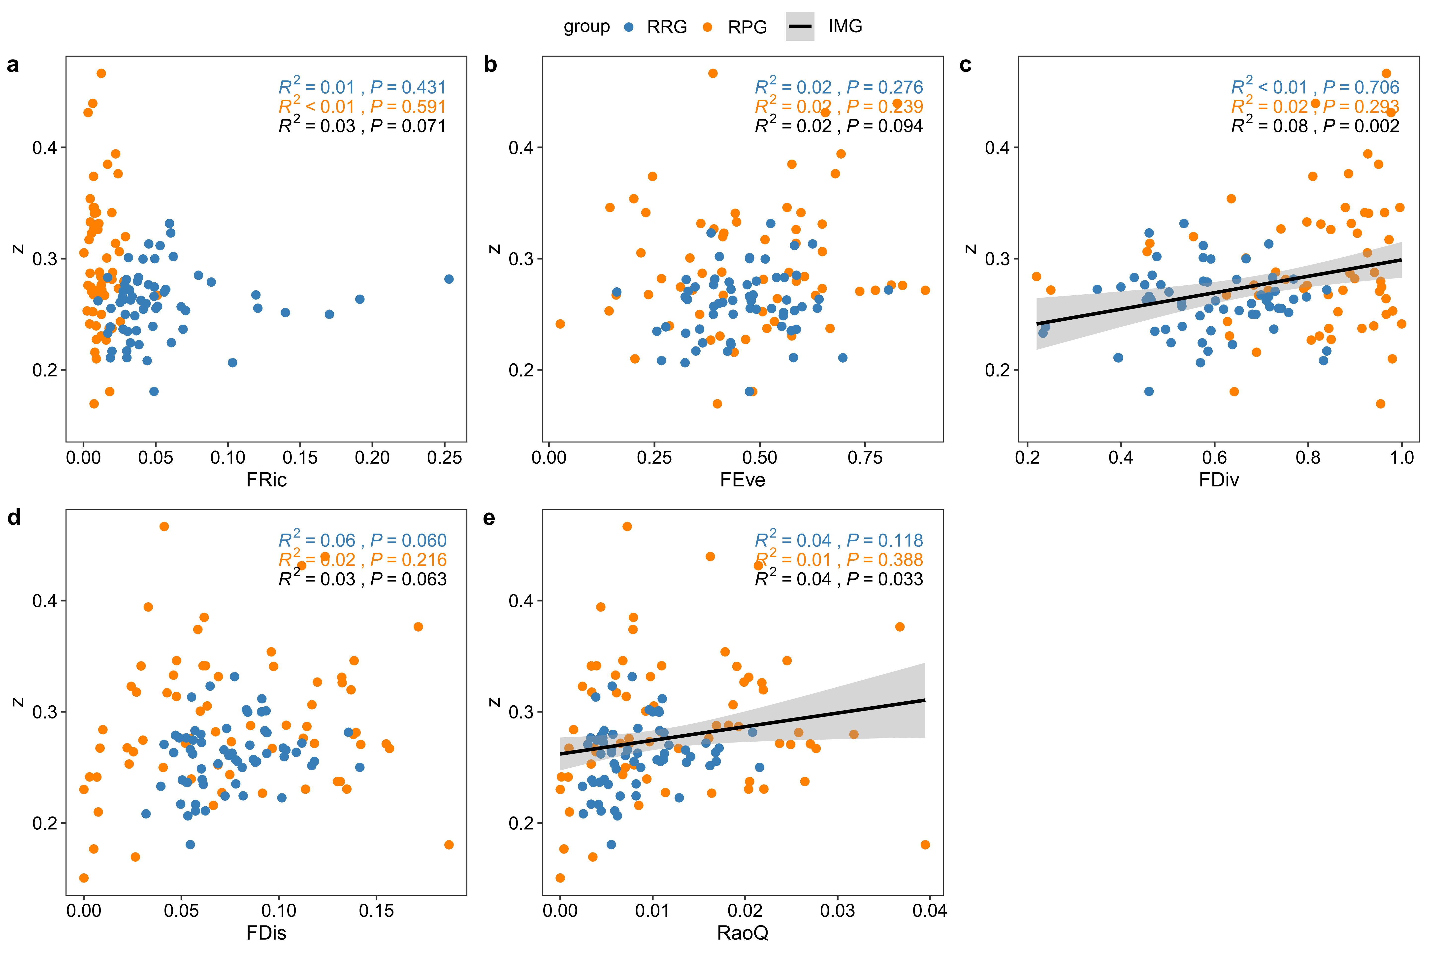
Supplementary Fig 7. Effects of functional diversity on community β-diversity. Relationships between z-values and five functional diversity metrics: (a) Functional Richness (FRic), (b) Functional Evenness (FEve), (c) Functional Divergence (FDiv), (d) Functional Dispersion (FDis), and (e) Rao’s Quadratic Entropy (RaoQ). RRG, resource-rich grassland; GPG, resource-poor grassland; IMG, integrated grassland. Solid lines represent linear regressions with 95% confidence intervals.

