Extended data: Gut translocation of antimicrobial resistant pathogens in patients undergoing haematopoietic stem cell transplantation in India

Extended data 1: Random forest classification to identify main clinical predictors of discharge post-HSCT

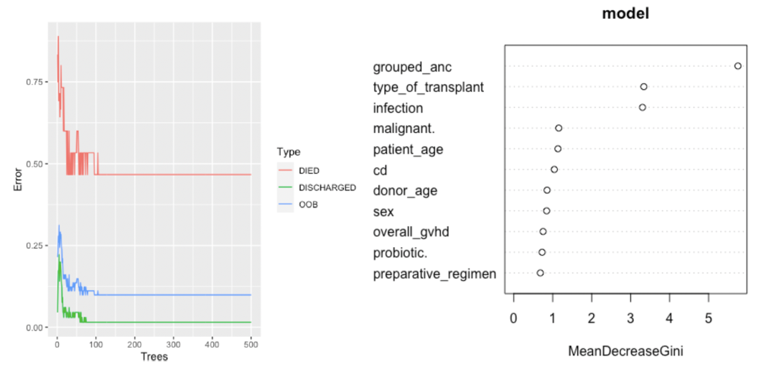

A) Out-of-bag error rates in Random Forest classification algorithm. Red line depicts the model’s error in predicting patients who died based on available clinical variables and the number of bootstrapped decision trees, green line depicts the error in predicting patients who were discharged. Blue line depicts the overall accuracy of the model. B) Random Forest model weighing the importance of clinical variables on transplant outcome. The model showed that the absolute neutrophil count recovery date was the most important predictor of outcome post HSCT. Occurrence of post-transplant infection episodes and a haploidentical transplant type were also associated with worse outcomes in our patient cohort.

Extended data 2: Summary of all clinically significant organisms detected post-HSCT

Patient number | Clinically significant organism | Source | Day
1 | CONS | Blood | 64
2 | E. coli | Blood | 5
5 | Enterococcus faecium | Blood | 14
5 | Chryseobacterium indologenes | Blood | 27
10 | Pseudomonas aeruginosa | Blood | 56
14 | Klebsiella pneumoniae | Blood | 43
21 | CONS | Blood | 4
22 | CONS | Blood | 3
24 | Pseudomonas aeruginosa | Blood | 5
31 | Klebsiella pneumoniae | Blood | 3
41 | CONS | Blood | 12
43 | CONS | Blood | 94
44 | Pseudomonas aeruginosa | Blood | 12
53 | Enterococcus faecium | Blood | 35
53 | Acinetobacter baummannii | Blood | 75
53 | Stenotrophomonas maltophila | Blood | 91
61 | E. coli | Blood | 2
75 | Klebsiella pneumoniae | Blood | 8
79 | Ralstonia manitolytica | Blood | 2
81 | Klebsiella pneumoniae | Blood | 7
26 | CONS | CLABSI | 39
70 | CONS | CLABSI | 3
66 | Acinetobacter baumannii | CRBSI | 18
10 | Clostridioides difficile | Stool | 32
12 | Clostridioides difficile | Stool | 28
18 | Clostridioides difficile | Stool | 35
25 | Clostridioides difficile | Stool | 14
26 | Clostridioides difficile | Stool | 37
29 | Clostridioides difficile | Stool | 18
40 | Clostridioides difficile | Stool | 7
42 | Clostridioides difficile | Stool | 17
50 | Clostridioides difficile | Stool | 158
57 | Clostridioides difficile | Stool | 15
60 | Clostridioides difficile | Stool | 111
15 | E. coli | Urine | 8
33 | Enterococcus faecium | Urine | 26
33 | Acinetobacter baummannii | VAP | 57
83 | Pseudomonas aeruginosa | VAP | 6

Extended data 3: Shannon alpha-diversity at species-level
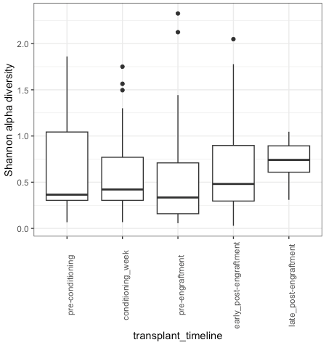

Extended data 4: Significance tests for beta diversity (ANOSIM and pairwise adonis)
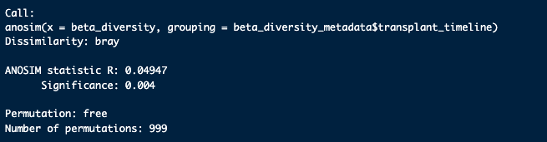

$parent_call
[1] "beta_dist_2[, 1:252] ~ transplant_timeline , strata = Null , permutations 9999"

$`pre-engraftment_vs_early_post-engraftment`
Df SumOfSqs R2 F Pr(>F)
transplant_timeline 1 0.1190 0.01572 2.46 0.11
Residual 154 7.4476 0.98428
Total 155 7.5666 1.00000

$`pre-engraftment_vs_conditioning_week`
Df SumOfSqs R2 F Pr(>F)
transplant_timeline 1 1.2100 0.15624 30.554 0.001 ***
Residual 165 6.5341 0.84376
Total 166 7.7441 1.00000
---
Signif. codes: 0 ‘***’ 0.001 ‘**’ 0.01 ‘*’ 0.05 ‘.’ 0.1 ‘ ’ 1

$`pre-engraftment_vs_pre-conditioning`
Df SumOfSqs R2 F Pr(>F)
transplant_timeline 1 0.0776 0.01515 1.5231 0.205
Residual 99 5.0437 0.98485
Total 100 5.1213 1.00000

$`pre-engraftment_vs_late_post-engraftment`
Df SumOfSqs R2 F Pr(>F)
transplant_timeline 1 0.0654 0.01405 1.3248 0.272
Residual 93 4.5921 0.98595
Total 94 4.6575 1.00000

$`early_post-engraftment_vs_conditioning_week`
Df SumOfSqs R2 F Pr(>F)
transplant_timeline 1 0.5794 0.10514 16.802 0.001 ***
Residual 143 4.9310 0.89486
Total 144 5.5104 1.00000
---
Signif. codes: 0 ‘***’ 0.001 ‘**’ 0.01 ‘*’ 0.05 ‘.’ 0.1 ‘ ’ 1

$`early_post-engraftment_vs_pre-conditioning`
Df SumOfSqs R2 F Pr(>F)
transplant_timeline 1 0.0111 0.0032 0.2474 0.698
Residual 77 3.4406 0.9968
Total 78 3.4516 1.0000

$`early_post-engraftment_vs_late_post-engraftment`
Df SumOfSqs R2 F Pr(>F)
transplant_timeline 1 0.10819 0.03493 2.57 0.107
Residual 71 2.98897 0.96507
Total 72 3.09716 1.00000

$`conditioning_week_vs_pre-conditioning`
Df SumOfSqs R2 F Pr(>F)
transplant_timeline 1 0.09031 0.0345 3.1448 0.069 .
Residual 88 2.52710 0.9655
Total 89 2.61741 1.0000
---
Signif. codes: 0 ‘***’ 0.001 ‘**’ 0.01 ‘*’ 0.05 ‘.’ 0.1 ‘ ’ 1

$`conditioning_week_vs_late_post-engraftment`
Df SumOfSqs R2 F Pr(>F)
transplant_timeline 1 0.3976 0.16077 15.709 0.001 ***
Residual 82 2.0755 0.83923
Total 83 2.4731 1.00000
---
Signif. codes: 0 ‘***’ 0.001 ‘**’ 0.01 ‘*’ 0.05 ‘.’ 0.1 ‘ ’ 1

$`pre-conditioning_vs_late_post-engraftment`
Df SumOfSqs R2 F Pr(>F)
transplant_timeline 1 0.11804 0.16789 3.2282 0.074 .
Residual 16 0.58502 0.83211
Total 17 0.70306 1.00000
---
Signif. codes: 0 ‘***’ 0.001 ‘**’ 0.01 ‘*’ 0.05 ‘.’ 0.1 ‘ ’ 1

attr(,"class")
[1] "pwadstrata" "list"
Extended data 5: Taxa contributing to shifts in diversity relative to HSCT timeline
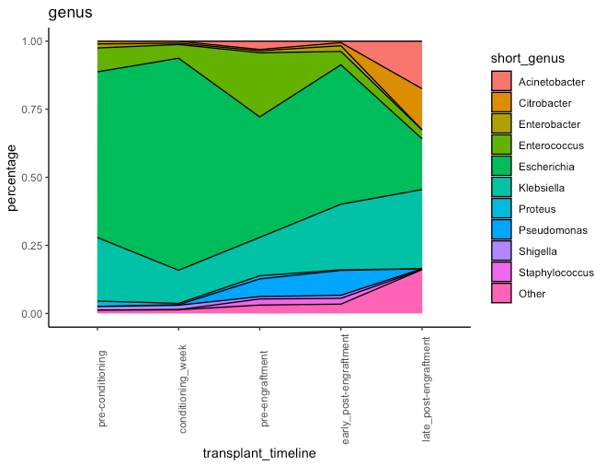

Relative abundances of the 10 most abundant taxa detected in the enriched stool samples. The relative abundance of Escherichia spiked during the conditioning week, accounting for 78.1% (403,582,054/516,955,793) of all OTUs assigned at that timepoint. At the pre-engraftment timepoint (n=586,882,141), the abundance of Escherichia dropped to 44.3% (260,182,871/586,882,141) of assigned OTUs and the relative abundance of Enterococcus peaked at 23.6% (n = 138,504,185) – representing the highest abundance of this genus throughout the transplant timeline. After neutrophil recovery in the early post-engraftment phase (n = 434,551,157), the abundance of Enterococcus declined to 4.93% relative abundance, but there was a notable increase in the abundance of Klebsiella (24.2%) and Pseudomonas (9.18%) compared to their abundances at the pre-transplant and pre-engraftment timepoints. At the late post-engraftment timepoint, Escherichia dropped to its lowest abundance (18.6%) compared to all previous timepoints. Klebsiella spp. dominate instead at the late post-engraftment timepoint, accounting for 29.1% of OTUs assigned at this timepoint (n = 36,390,898), followed by the Acinetobacter (17.5%) and Citrobacter (15.1%). Notably, organisms classified under the “Other” genera occupied the largest relative abundance at the late post-engraftment compared to previous timepoints, comprising 16.1% of all OTUs detected among samples collected at that timepoint.

Extended data 6: Significance tests for AMR gene abundance and diversity relative to the transplant timeline

Pairwise comparisons using t-tests with pooled SD
P-value adjustment method: Bonferroni
All AMR genes - abundance
 | pre-conditioning | conditioning_week | pre-engraftment | early_post-engraftment
conditioning_week | 1.00000 | - | - | -
pre-engraftment | 0.22524 | 0.00018 | - | -
early_post-engraftment | 1.00000 | 1.00000 | 0.00255 | -
late_post-engraftment | 1.00000 | 1.00000 | 0.11154 | 1.00000
All AMR genes - diversity
 | pre-conditioning | conditioning_week | pre-engraftment | early_post-engraftment
conditioning_week | 1.00000 | - | - | -
pre-engraftment | 0.20278 | 0.00045 | - | -
early_post-engraftment | 1.00000 | 1.00000 | 0.00011 | -
late_post-engraftment | 1.00000 | 1.00000 | 0.41162 | 1.00000
Non-efflux AMR genes - abundance
 | pre-conditioning | conditioning_week | pre-engraftment | early_post-engraftment
conditioning_week | 1.000 | - | - | -
pre-engraftment | 1.000 | 0.208 | - | -
early_post-engraftment | 1.000 | 1.000 | 0.003 | -
late_post-engraftment | 0.489 | 0.186 | 0.014 | 0.734
Non-efflux AMR genes - diversity
 | pre-conditioning | conditioning_week | pre-engraftment | early_post-engraftment
conditioning_week | 1.00000 | - | - | -
pre-engraftment | 0.48991 | 0.01392 | - | -
early_post-engraftment | 1.00000 | 1.00000 | 0.00037 | -
late_post-engraftment | 1.00000 | 1.00000 | 0.30098 | 1.00000
Non-efflux AMR genes - subset of participants with late post-engraftment samples
 | pre-conditioning | conditioning_week | pre-engraftment | early_post-engraftment
conditioning_week | 1.000 | - | - | -
pre-engraftment | 1.000 | 1.000 | - | -
early_post-engraftment | 1.000 | 1.000 | 0.801 | -
late_post-engraftment | 0.154 | 1.000 | 0.041 | 1.000
ESBL/carbapenemase genes (blaOXA, blaTEM, blaNDM, bla,SHV, bla,CTX) - abundance
 | pre-conditioning | conditioning_week | pre-engraftment | early_post-engraftment
conditioning_week | 1.00000 | - | - | -
pre-engraftment | 1.00000 | 1.00000 | - | -
early_post-engraftment | 1.00000 | 0.00061 | 0.00888 | -
late_post-engraftment | 0.49984 | 0.06842 | 0.13554 | 1.00000

Extended data 7: Hi-C AMR to host summary

SampleID | gene_id | bin_id | origin | bin_taxonomy | mash_reference | origin_contig | origin_contig_length | gene_class
P02BT0031 | rmtB1 | bin_1 | plasmid | f__Enterobacteriaceae (UID5103) (bin_1) | Escherichia_coli_str._K_12_substr._MC4100.fna | NODE_1623_length_1929_cov_5.632337 | 1929 | AMINOGLYCOSIDE
P02BT0031 | aac(6')-Ib-cr5 | bin_1 | plasmid | f__Enterobacteriaceae (UID5103) (bin_1) | Escherichia_coli_str._K_12_substr._MC4100.fna | NODE_1685_length_1844_cov_41.626048 | 1844 | AMINOGLYCOSIDE/QUINOLONE
P02BT0031 | blaCMY-42 | bin_1 | plasmid | f__Enterobacteriaceae (UID5103) (bin_1) | Escherichia_coli_str._K_12_substr._MC4100.fna | NODE_1126_length_2803_cov_284.521470 | 2803 | BETA-LACTAM
P02BT0031 | blaCTX-M-15 | bin_1 | plasmid | f__Enterobacteriaceae (UID5103) (bin_1) | Escherichia_coli_str._K_12_substr._MC4100.fna | NODE_2116_length_1399_cov_575.293155 | 1399 | BETA-LACTAM
P02BT0031 | blaDHA-1 | bin_1 | plasmid | f__Enterobacteriaceae (UID5103) (bin_1) | Escherichia_coli_str._K_12_substr._MC4100.fna | NODE_352_length_7673_cov_88.611053 | 7673 | BETA-LACTAM
P02BT0031 | blaNDM-5 | bin_1 | plasmid | f__Enterobacteriaceae (UID5103) (bin_1) | Escherichia_coli_str._K_12_substr._MC4100.fna | NODE_536_length_5322_cov_133.444276 | 5322 | BETA-LACTAM
P02BT0031 | blaOXA-1 | bin_1 | plasmid | f__Enterobacteriaceae (UID5103) (bin_1) | Escherichia_coli_str._K_12_substr._MC4100.fna | NODE_1685_length_1844_cov_41.626048 | 1844 | BETA-LACTAM
P02BT0031 | blaOXA-232 | bin_1 | plasmid | f__Enterobacteriaceae (UID5103) (bin_1) | Escherichia_coli_str._K_12_substr._MC4100.fna | NODE_434_length_6203_cov_3332.689655 | 6203 | BETA-LACTAM
P02BT0031 | ble | bin_1 | plasmid | f__Enterobacteriaceae (UID5103) (bin_1) | Escherichia_coli_str._K_12_substr._MC4100.fna | NODE_536_length_5322_cov_133.444276 | 5322 | BLEOMYCIN
P02BT0031 | erm(B) | bin_1 | plasmid | f__Enterobacteriaceae (UID5103) (bin_1) | Escherichia_coli_str._K_12_substr._MC4100.fna | NODE_1336_length_2379_cov_16.043029 | 2379 | MACROLIDE
P02BT0031 | mph(A) | bin_1 | plasmid | f__Enterobacteriaceae (UID5103) (bin_1) | Escherichia_coli_str._K_12_substr._MC4100.fna | NODE_2433_length_1153_cov_312.689435 | 1153 | MACROLIDE
P02BT0031 | qacE | bin_1 | plasmid | f__Enterobacteriaceae (UID5103) (bin_1) | Escherichia_coli_str._K_12_substr._MC4100.fna | NODE_2471_length_1134_cov_340.784059 | 1134 | QUATERNARY AMMONIUM
P02BT0031 | qnrB4 | bin_1 | plasmid | f__Enterobacteriaceae (UID5103) (bin_1) | Escherichia_coli_str._K_12_substr._MC4100.fna | NODE_352_length_7673_cov_88.611053 | 7673 | QUINOLONE
P02BT0031 | qnrS1 | bin_1 | plasmid | f__Enterobacteriaceae (UID5103) (bin_1) | Escherichia_coli_str._K_12_substr._MC4100.fna | NODE_1339_length_2376_cov_52.355881 | 2376 | QUINOLONE
P02BT0031 | sul1 | bin_1 | plasmid | f__Enterobacteriaceae (UID5103) (bin_1) | Escherichia_coli_str._K_12_substr._MC4100.fna | NODE_2471_length_1134_cov_340.784059 | 1134 | SULFONAMIDE
P02BT0031 | sul3 | bin_1 | plasmid | f__Enterobacteriaceae (UID5103) (bin_1) | Escherichia_coli_str._K_12_substr._MC4100.fna | NODE_1053_length_2968_cov_95.952283 | 2968 | SULFONAMIDE
P02BT0031 | tet(A) | bin_1 | plasmid | f__Enterobacteriaceae (UID5103) (bin_1) | Escherichia_coli_str._K_12_substr._MC4100.fna | NODE_844_length_3565_cov_177.202564 | 3565 | TETRACYCLINE
P02BT0031 | tet(B) | bin_1 | plasmid | f__Enterobacteriaceae (UID5103) (bin_1) | Escherichia_coli_str._K_12_substr._MC4100.fna | NODE_927_length_3350_cov_69.841578 | 3350 | TETRACYCLINE
P02BT0031 | dfrA12 | bin_1 | plasmid | f__Enterobacteriaceae (UID5103) (bin_1) | Escherichia_coli_str._K_12_substr._MC4100.fna | NODE_2694_length_1023_cov_101.612603 | 1023 | TRIMETHOPRIM
P02BT0031 | dfrA17 | bin_1 | plasmid | f__Enterobacteriaceae (UID5103) (bin_1) | Escherichia_coli_str._K_12_substr._MC4100.fna | NODE_2717_length_1003_cov_215.528481 | 1003 | TRIMETHOPRIM
P05AT0063 | aac(6')-I | bin_1 | plasmid | o__Lactobacillales (UID544) (bin_1) | Enterococcus_faecium.fna | NODE_11_length_65008_cov_470.923098 | 65008 | AMINOGLYCOSIDE
P05AT0063 | ant(6)-Ia | bin_2 | plasmid | root (UID1) (bin_2) | Enterococcus_faecium_EnGen0180.fna | NODE_764_length_1339_cov_128.181464 | 1339 | AMINOGLYCOSIDE
P05AT0063 | aph(3')-IIIa | bin_2 | plasmid | root (UID1) (bin_2) | Enterococcus_faecium_EnGen0180.fna | NODE_589_length_1658_cov_135.447910 | 1658 | AMINOGLYCOSIDE
P05AT0063 | vanA | bin_1 | plasmid | o__Lactobacillales (UID544) (bin_1) | Enterococcus_faecium.fna | NODE_27_length_36046_cov_676.891528 | 36046 | GLYCOPEPTIDE
P05AT0063 | vanH-A | bin_1 | plasmid | o__Lactobacillales (UID544) (bin_1) | Enterococcus_faecium.fna | NODE_27_length_36046_cov_676.891528 | 36046 | GLYCOPEPTIDE
P05AT0063 | vanR-A | bin_1 | plasmid | o__Lactobacillales (UID544) (bin_1) | Enterococcus_faecium.fna | NODE_27_length_36046_cov_676.891528 | 36046 | GLYCOPEPTIDE
P05AT0063 | vanS-A | bin_1 | plasmid | o__Lactobacillales (UID544) (bin_1) | Enterococcus_faecium.fna | NODE_27_length_36046_cov_676.891528 | 36046 | GLYCOPEPTIDE
P05AT0063 | vanX-A | bin_1 | plasmid | o__Lactobacillales (UID544) (bin_1) | Enterococcus_faecium.fna | NODE_27_length_36046_cov_676.891528 | 36046 | GLYCOPEPTIDE
P05AT0063 | vanY-A | bin_1 | plasmid | o__Lactobacillales (UID544) (bin_1) | Enterococcus_faecium.fna | NODE_27_length_36046_cov_676.891528 | 36046 | GLYCOPEPTIDE
P05AT0063 | vanZ-A | bin_1 | plasmid | o__Lactobacillales (UID544) (bin_1) | Enterococcus_faecium.fna | NODE_27_length_36046_cov_676.891528 | 36046 | GLYCOPEPTIDE
P05AT0063 | eat(A) | bin_1 | plasmid | o__Lactobacillales (UID544) (bin_1) | Enterococcus_faecium.fna | NODE_23_length_44885_cov_450.839795 | 44885 | PLEUROMUTILIN
P05AT0063 | tet(M) | bin_2 | plasmid | root (UID1) (bin_2) | Enterococcus_faecium_EnGen0180.fna | NODE_83_length_11630_cov_38.830497 | 11630 | TETRACYCLINE
P05AT0063 | tet(S) | bin_1 | plasmid | o__Lactobacillales (UID544) (bin_1) | Enterococcus_faecium.fna | NODE_78_length_12346_cov_1270.410056 | 12346 | TETRACYCLINE
P10AT0324 | aadA1 | bin_1 | plasmid | k__Bacteria (UID203) (bin_1) | Klebsiella_pneumoniae_UCI_60.fna | NODE_158_length_7767_cov_101.315353 | 7767 | AMINOGLYCOSIDE
P10AT0324 | aadA5 | bin_2 | plasmid | f__Enterobacteriaceae (UID5103) (bin_2) | Escherichia_coli_LAU_EC8.fna | NODE_338_length_1610_cov_276.416720 | 1610 | AMINOGLYCOSIDE
P10AT0324 | aph(3')-Ia | bin_1 | plasmid | k__Bacteria (UID203) (bin_1) | Klebsiella_pneumoniae_UCI_60.fna | NODE_381_length_1145_cov_83.492661 | 1145 | AMINOGLYCOSIDE
P10AT0324 | aac(6')-Ib-cr5 | bin_2 | plasmid | f__Enterobacteriaceae (UID5103) (bin_2) | Escherichia_coli_LAU_EC8.fna | NODE_292_length_2293_cov_212.168007 | 2293 | AMINOGLYCOSIDE/QUINOLONE
P10AT0324 | blaDHA-1 | bin_1 | plasmid | k__Bacteria (UID203) (bin_1) | Klebsiella_pneumoniae_UCI_60.fna | NODE_161_length_7674_cov_45.660454 | 7674 | BETA-LACTAM
P10AT0324 | blaNDM-5 | bin_3 | plasmid | root (UID1) (bin_3) | Escherichia_coli_UMEA_3314_1.fna | NODE_190_length_5704_cov_89.238980 | 5704 | BETA-LACTAM
P10AT0324 | blaOXA-1 | bin_2 | plasmid | f__Enterobacteriaceae (UID5103) (bin_2) | Escherichia_coli_LAU_EC8.fna | NODE_292_length_2293_cov_212.168007 | 2293 | BETA-LACTAM
P10AT0324 | ble | bin_3 | plasmid | root (UID1) (bin_3) | Escherichia_coli_UMEA_3314_1.fna | NODE_190_length_5704_cov_89.238980 | 5704 | BLEOMYCIN
P10AT0324 | erm(B) | bin_2 | plasmid | f__Enterobacteriaceae (UID5103) (bin_2) | Escherichia_coli_LAU_EC8.fna | NODE_224_length_4175_cov_338.273786 | 4175 | MACROLIDE
P10AT0324 | mph(A) | bin_2 | plasmid | f__Enterobacteriaceae (UID5103) (bin_2) | Escherichia_coli_LAU_EC8.fna | NODE_225_length_4174_cov_723.752853 | 4174 | MACROLIDE
P10AT0324 | catA1 | bin_2 | plasmid | f__Enterobacteriaceae (UID5103) (bin_2) | Escherichia_coli_LAU_EC8.fna | NODE_205_length_5140_cov_289.069027 | 5140 | PHENICOL
P10AT0324 | catB3 | bin_2 | plasmid | f__Enterobacteriaceae (UID5103) (bin_2) | Escherichia_coli_LAU_EC8.fna | NODE_292_length_2293_cov_212.168007 | 2293 | PHENICOL
P10AT0324 | cmlA1 | bin_1 | plasmid | k__Bacteria (UID203) (bin_1) | Klebsiella_pneumoniae_UCI_60.fna | NODE_158_length_7767_cov_101.315353 | 7767 | PHENICOL
P10AT0324 | qacEdelta1 | bin_2 | plasmid | f__Enterobacteriaceae (UID5103) (bin_2) | Escherichia_coli_LAU_EC8.fna | NODE_361_length_1316_cov_745.006344 | 1316 | QUATERNARY AMMONIUM
P10AT0324 | qacL | bin_1 | plasmid | k__Bacteria (UID203) (bin_1) | Klebsiella_pneumoniae_UCI_60.fna | NODE_158_length_7767_cov_101.315353 | 7767 | QUATERNARY AMMONIUM
P10AT0324 | qnrB4 | bin_1 | plasmid | k__Bacteria (UID203) (bin_1) | Klebsiella_pneumoniae_UCI_60.fna | NODE_161_length_7674_cov_45.660454 | 7674 | QUINOLONE
P10AT0324 | qnrS13 | bin_1 | plasmid | k__Bacteria (UID203) (bin_1) | Klebsiella_pneumoniae_UCI_60.fna | NODE_244_length_3518_cov_476.626336 | 3518 | QUINOLONE
P10AT0324 | sul1 | bin_2 | plasmid | f__Enterobacteriaceae (UID5103) (bin_2) | Escherichia_coli_LAU_EC8.fna | NODE_361_length_1316_cov_745.006344 | 1316 | SULFONAMIDE
P10AT0324 | sul3 | bin_1 | plasmid | k__Bacteria (UID203) (bin_1) | Klebsiella_pneumoniae_UCI_60.fna | NODE_158_length_7767_cov_101.315353 | 7767 | SULFONAMIDE
P10AT0324 | tet(A) | bin_1 | plasmid | k__Bacteria (UID203) (bin_1) | Klebsiella_pneumoniae_UCI_60.fna | NODE_216_length_4339_cov_146.093137 | 4339 | TETRACYCLINE
P10AT0324 | tet(B) | bin_2 | plasmid | f__Enterobacteriaceae (UID5103) (bin_2) | Escherichia_coli_LAU_EC8.fna | NODE_226_length_4164_cov_258.233147 | 4164 | TETRACYCLINE
P10AT0324 | dfrA12 | bin_3 | plasmid | root (UID1) (bin_3) | Escherichia_coli_UMEA_3314_1.fna | NODE_395_length_1023_cov_90.989669 | 1023 | TRIMETHOPRIM
P10AT0324 | dfrA17 | bin_2 | plasmid | f__Enterobacteriaceae (UID5103) (bin_2) | Escherichia_coli_LAU_EC8.fna | NODE_338_length_1610_cov_276.416720 | 1610 | TRIMETHOPRIM
P24BT0081 | blaDHA | bin_2 | plasmid | root (UID1) (bin_2) | Escherichia_coli_BIDMC_49a.fna | NODE_191_length_2405_cov_6.549787 | 2405 | BETA-LACTAM
P24BT0081 | erm(B) | bin_2 | plasmid | root (UID1) (bin_2) | Escherichia_coli_BIDMC_49a.fna | NODE_102_length_4174_cov_7.510318 | 4174 | MACROLIDE
P24BT0081 | qnrB4 | bin_2 | plasmid | root (UID1) (bin_2) | Escherichia_coli_BIDMC_49a.fna | NODE_71_length_5376_cov_6.877843 | 5376 | QUINOLONE
P24BT0081 | dfrA17 | bin_2 | plasmid | root (UID1) (bin_2) | Escherichia_coli_BIDMC_49a.fna | NODE_398_length_1060_cov_5.542289 | 1060 | TRIMETHOPRIM
P31AT0103 | aac(3)-IIe | bin_1 | plasmid | k__Bacteria (UID203) (bin_1) | Klebsiella_pneumoniae.fna | NODE_371_length_2704_cov_66.447716 | 2704 | AMINOGLYCOSIDE
P31AT0103 | aadA2 | bin_1 | plasmid | k__Bacteria (UID203) (bin_1) | Klebsiella_pneumoniae.fna | NODE_187_length_9478_cov_1258.296084 | 9478 | AMINOGLYCOSIDE
P31AT0103 | aadA5 | bin_1 | plasmid | k__Bacteria (UID203) (bin_1) | Klebsiella_pneumoniae.fna | NODE_586_length_1608_cov_69.401803 | 1608 | AMINOGLYCOSIDE
P31AT0103 | aph(3'')-Ib | bin_1 | plasmid | k__Bacteria (UID203) (bin_1) | Klebsiella_pneumoniae.fna | NODE_317_length_3486_cov_44.015447 | 3486 | AMINOGLYCOSIDE
P31AT0103 | aph(6)-Id | bin_1 | plasmid | k__Bacteria (UID203) (bin_1) | Klebsiella_pneumoniae.fna | NODE_317_length_3486_cov_44.015447 | 3486 | AMINOGLYCOSIDE
P31AT0103 | rmtB1 | bin_1 | plasmid | k__Bacteria (UID203) (bin_1) | Klebsiella_pneumoniae.fna | NODE_460_length_2066_cov_240.039284 | 2066 | AMINOGLYCOSIDE
P31AT0103 | aac(6')-Ib-cr5 | bin_1 | plasmid | k__Bacteria (UID203) (bin_1) | Klebsiella_pneumoniae.fna | NODE_421_length_2270_cov_74.034312 | 2270 | AMINOGLYCOSIDE/QUINOLONE
P31AT0103 | blaCMY-145 | bin_2 | plasmid | f__Enterobacteriaceae (UID5103) (bin_2) | Escherichia_coli.fna | NODE_112_length_23139_cov_982.498137 | 23139 | BETA-LACTAM
P31AT0103 | blaCTX-M-15 | bin_1 | plasmid | k__Bacteria (UID203) (bin_1) | Klebsiella_pneumoniae.fna | NODE_310_length_3616_cov_113.024431 | 3616 | BETA-LACTAM
P31AT0103 | blaNDM-5 | bin_1 | plasmid | k__Bacteria (UID203) (bin_1) | Klebsiella_pneumoniae.fna | NODE_187_length_9478_cov_1258.296084 | 9478 | BETA-LACTAM
P31AT0103 | blaOXA-1 | bin_1 | plasmid | k__Bacteria (UID203) (bin_1) | Klebsiella_pneumoniae.fna | NODE_421_length_2270_cov_74.034312 | 2270 | BETA-LACTAM
P31AT0103 | blaOXA-232 | bin_1 | plasmid | k__Bacteria (UID203) (bin_1) | Klebsiella_pneumoniae.fna | NODE_526_length_1759_cov_2526.975352 | 1759 | BETA-LACTAM
P31AT0103 | blaTEM | bin_1 | plasmid | k__Bacteria (UID203) (bin_1) | Klebsiella_pneumoniae.fna | NODE_632_length_1502_cov_274.111956 | 1502 | BETA-LACTAM
P31AT0103 | ble | bin_1 | plasmid | k__Bacteria (UID203) (bin_1) | Klebsiella_pneumoniae.fna | NODE_187_length_9478_cov_1258.296084 | 9478 | BLEOMYCIN
P31AT0103 | erm(B) | bin_1 | plasmid | k__Bacteria (UID203) (bin_1) | Klebsiella_pneumoniae.fna | NODE_285_length_4173_cov_327.092035 | 4173 | MACROLIDE
P31AT0103 | mph(A) | bin_1 | plasmid | k__Bacteria (UID203) (bin_1) | Klebsiella_pneumoniae.fna | NODE_286_length_4168_cov_926.066132 | 4168 | MACROLIDE
P31AT0103 | catA1 | bin_1 | plasmid | k__Bacteria (UID203) (bin_1) | Klebsiella_pneumoniae.fna | NODE_239_length_6284_cov_134.877669 | 6284 | PHENICOL
P31AT0103 | catB3 | bin_1 | plasmid | k__Bacteria (UID203) (bin_1) | Klebsiella_pneumoniae.fna | NODE_421_length_2270_cov_74.034312 | 2270 | PHENICOL
P31AT0103 | qacEdelta1 | bin_1 | plasmid | k__Bacteria (UID203) (bin_1) | Klebsiella_pneumoniae.fna | NODE_187_length_9478_cov_1258.296084 | 9478 | QUATERNARY AMMONIUM
P31AT0103 | qnrS1 | bin_2 | plasmid | f__Enterobacteriaceae (UID5103) (bin_2) | Escherichia_coli.fna | NODE_347_length_3013_cov_455.911089 | 3013 | QUINOLONE
P31AT0103 | qnrS1 | bin_1 | plasmid | k__Bacteria (UID203) (bin_1) | Klebsiella_pneumoniae.fna | NODE_347_length_3013_cov_455.911089 | 3013 | QUINOLONE
P31AT0103 | sul1 | bin_1 | plasmid | k__Bacteria (UID203) (bin_1) | Klebsiella_pneumoniae.fna | NODE_187_length_9478_cov_1258.296084 | 9478 | SULFONAMIDE
P31AT0103 | sul2 | bin_1 | plasmid | k__Bacteria (UID203) (bin_1) | Klebsiella_pneumoniae.fna | NODE_317_length_3486_cov_44.015447 | 3486 | SULFONAMIDE
P31AT0103 | tet(A) | bin_2 | plasmid | f__Enterobacteriaceae (UID5103) (bin_2) | Escherichia_coli.fna | NODE_288_length_4030_cov_732.532327 | 4030 | TETRACYCLINE
P31AT0103 | tet(B) | bin_1 | plasmid | k__Bacteria (UID203) (bin_1) | Klebsiella_pneumoniae.fna | NODE_406_length_2421_cov_178.202451 | 2421 | TETRACYCLINE
P31AT0103 | dfrA12 | bin_1 | plasmid | k__Bacteria (UID203) (bin_1) | Klebsiella_pneumoniae.fna | NODE_187_length_9478_cov_1258.296084 | 9478 | TRIMETHOPRIM
P31AT0103 | dfrA17 | bin_1 | plasmid | k__Bacteria (UID203) (bin_1) | Klebsiella_pneumoniae.fna | NODE_586_length_1608_cov_69.401803 | 1608 | TRIMETHOPRIM
P44AT0042 | blaTEM-1 | bin_1 | plasmid | f__Enterobacteriaceae (UID5103) (bin_1) | Klebsiella_pneumoniae.fna | NODE_21_length_36103_cov_607.786951 | 36103 | BETA-LACTAM
P44AT0042 | tet(D) | bin_1 | plasmid | f__Enterobacteriaceae (UID5103) (bin_1) | Klebsiella_pneumoniae.fna | NODE_21_length_36103_cov_607.786951 | 36103 | TETRACYCLINE
P53AT0274 | aadA2 | bin_1 | plasmid | f__Enterobacteriaceae (UID5103) (bin_1) | Klebsiella_pneumoniae.fna | NODE_172_length_1811_cov_326.653189 | 1811 | AMINOGLYCOSIDE
P53AT0274 | aadA5 | bin_2 | plasmid | f__Enterobacteriaceae (UID5103) (bin_2) | Escherichia_coli_908555.fna | NODE_178_length_1610_cov_621.870740 | 1610 | AMINOGLYCOSIDE
P53AT0274 | rmtB1 | bin_1 | plasmid | f__Enterobacteriaceae (UID5103) (bin_1) | Klebsiella_pneumoniae.fna | NODE_145_length_4057_cov_310.020490 | 4057 | AMINOGLYCOSIDE
P53AT0274 | aac(6')-Ib-cr5 | bin_2 | plasmid | f__Enterobacteriaceae (UID5103) (bin_2) | Escherichia_coli_908555.fna | NODE_161_length_2816_cov_753.087287 | 2816 | AMINOGLYCOSIDE/QUINOLONE
P53AT0274 | aac(6')-Ib-cr5 | bin_1 | plasmid | f__Enterobacteriaceae (UID5103) (bin_1) | Klebsiella_pneumoniae.fna | NODE_150_length_3317_cov_407.725628 | 3317 | AMINOGLYCOSIDE/QUINOLONE
P53AT0274 | blaCMY-42 | bin_2 | plasmid | f__Enterobacteriaceae (UID5103) (bin_2) | Escherichia_coli_908555.fna | NODE_87_length_28681_cov_361.184518 | 28681 | BETA-LACTAM
P53AT0274 | blaCTX-M-15 | bin_1 | plasmid | f__Enterobacteriaceae (UID5103) (bin_1) | Klebsiella_pneumoniae.fna | NODE_174_length_1728_cov_353.098027 | 1728 | BETA-LACTAM
P53AT0274 | blaNDM-1 | bin_1 | plasmid | f__Enterobacteriaceae (UID5103) (bin_1) | Klebsiella_pneumoniae.fna | NODE_176_length_1637_cov_634.087863 | 1637 | BETA-LACTAM
P53AT0274 | blaOXA-1 | bin_2 | plasmid | f__Enterobacteriaceae (UID5103) (bin_2) | Escherichia_coli_908555.fna | NODE_161_length_2816_cov_753.087287 | 2816 | BETA-LACTAM
P53AT0274 | blaOXA-232 | bin_1 | plasmid | f__Enterobacteriaceae (UID5103) (bin_1) | Klebsiella_pneumoniae.fna | NODE_162_length_2812_cov_4502.956837 | 2812 | BETA-LACTAM
P53AT0274 | blaTEM-1 | bin_1 | plasmid | f__Enterobacteriaceae (UID5103) (bin_1) | Klebsiella_pneumoniae.fna | NODE_145_length_4057_cov_310.020490 | 4057 | BETA-LACTAM
P53AT0274 | ble | bin_1 | plasmid | f__Enterobacteriaceae (UID5103) (bin_1) | Klebsiella_pneumoniae.fna | NODE_176_length_1637_cov_634.087863 | 1637 | BLEOMYCIN
P53AT0274 | erm(B) | bin_2 | plasmid | f__Enterobacteriaceae (UID5103) (bin_2) | Escherichia_coli_908555.fna | NODE_144_length_4174_cov_1147.307356 | 4174 | MACROLIDE
P53AT0274 | mph(A) | bin_2 | plasmid | f__Enterobacteriaceae (UID5103) (bin_2) | Escherichia_coli_908555.fna | NODE_149_length_3344_cov_768.149894 | 3344 | MACROLIDE
P53AT0274 | catB | bin_1 | plasmid | f__Enterobacteriaceae (UID5103) (bin_1) | Klebsiella_pneumoniae.fna | NODE_150_length_3317_cov_407.725628 | 3317 | PHENICOL
P53AT0274 | catB3 | bin_2 | plasmid | f__Enterobacteriaceae (UID5103) (bin_2) | Escherichia_coli_908555.fna | NODE_161_length_2816_cov_753.087287 | 2816 | PHENICOL
P53AT0274 | qacEdelta1 | bin_2 | plasmid | f__Enterobacteriaceae (UID5103) (bin_2) | Escherichia_coli_908555.fna | NODE_198_length_1043_cov_907.814777 | 1043 | QUATERNARY AMMONIUM
P53AT0274 | qnrB1 | bin_1 | plasmid | f__Enterobacteriaceae (UID5103) (bin_1) | Klebsiella_pneumoniae.fna | NODE_173_length_1759_cov_392.288146 | 1759 | QUINOLONE
P53AT0274 | qnrS1 | bin_2 | plasmid | f__Enterobacteriaceae (UID5103) (bin_2) | Escherichia_coli_908555.fna | NODE_135_length_5920_cov_392.500085 | 5920 | QUINOLONE
P53AT0274 | arr | bin_2 | plasmid | f__Enterobacteriaceae (UID5103) (bin_2) | Escherichia_coli_908555.fna | NODE_161_length_2816_cov_753.087287 | 2816 | RIFAMYCIN
P53AT0274 | sul1 | bin_2 | plasmid | f__Enterobacteriaceae (UID5103) (bin_2) | Escherichia_coli_908555.fna | NODE_198_length_1043_cov_907.814777 | 1043 | SULFONAMIDE
P53AT0274 | tet(B) | bin_2 | plasmid | f__Enterobacteriaceae (UID5103) (bin_2) | Escherichia_coli_908555.fna | NODE_155_length_2975_cov_347.798288 | 2975 | TETRACYCLINE
P53AT0274 | dfrA12 | bin_1 | plasmid | f__Enterobacteriaceae (UID5103) (bin_1) | Klebsiella_pneumoniae.fna | NODE_172_length_1811_cov_326.653189 | 1811 | TRIMETHOPRIM
P53AT0274 | dfrA17 | bin_2 | plasmid | f__Enterobacteriaceae (UID5103) (bin_2) | Escherichia_coli_908555.fna | NODE_178_length_1610_cov_621.870740 | 1610 | TRIMETHOPRIM
P53AT0536 | aadA2 | bin_1 | plasmid | f__Enterobacteriaceae (UID5103) (bin_1) | Klebsiella_pneumoniae.fna | NODE_64_length_6342_cov_11178.931446 | 6342 | AMINOGLYCOSIDE
P53AT0536 | blaCMY | bin_1 | plasmid | f__Enterobacteriaceae (UID5103) (bin_1) | Klebsiella_pneumoniae.fna | NODE_53_length_24847_cov_523.413117 | 24847 | BETA-LACTAM
P53AT0536 | blaNDM-5 | bin_1 | plasmid | f__Enterobacteriaceae (UID5103) (bin_1) | Klebsiella_pneumoniae.fna | NODE_70_length_3552_cov_2757.059480 | 3552 | BETA-LACTAM
P53AT0536 | ble | bin_1 | plasmid | f__Enterobacteriaceae (UID5103) (bin_1) | Klebsiella_pneumoniae.fna | NODE_70_length_3552_cov_2757.059480 | 3552 | BLEOMYCIN
P53AT0536 | mph(A) | bin_1 | plasmid | f__Enterobacteriaceae (UID5103) (bin_1) | Klebsiella_pneumoniae.fna | NODE_68_length_4222_cov_871.765059 | 4222 | MACROLIDE
P53AT0536 | qacEdelta1 | bin_1 | plasmid | f__Enterobacteriaceae (UID5103) (bin_1) | Klebsiella_pneumoniae.fna | NODE_64_length_6342_cov_11178.931446 | 6342 | QUATERNARY AMMONIUM
P53AT0536 | sul1 | bin_1 | plasmid | f__Enterobacteriaceae (UID5103) (bin_1) | Klebsiella_pneumoniae.fna | NODE_64_length_6342_cov_11178.931446 | 6342 | SULFONAMIDE
P53AT0536 | tet(A) | bin_1 | plasmid | f__Enterobacteriaceae (UID5103) (bin_1) | Klebsiella_pneumoniae.fna | NODE_63_length_10107_cov_12672.042579 | 10107 | TETRACYCLINE
P53AT0536 | dfrA12 | bin_1 | plasmid | f__Enterobacteriaceae (UID5103) (bin_1) | Klebsiella_pneumoniae.fna | NODE_64_length_6342_cov_11178.931446 | 6342 | TRIMETHOPRIM
P61AT0042 | aadA5 | bin_1 | plasmid | f__Enterobacteriaceae (UID5103) (bin_1) | Escherichia_coli_CUMT8.fna | NODE_414_length_1658_cov_418.863381 | 1658 | AMINOGLYCOSIDE
P61AT0042 | mef(A) | bin_2 | plasmid | o__Lactobacillales (UID544) (bin_2) | Enterococcus_hirae_ATCC_9790.fna | NODE_77_length_22114_cov_18.410309 | 22114 | MACROLIDE
P61AT0042 | sul2 | bin_1 | plasmid | f__Enterobacteriaceae (UID5103) (bin_1) | Escherichia_coli_CUMT8.fna | NODE_235_length_6153_cov_374.449820 | 6153 | SULFONAMIDE
P61AT0042 | tet(A) | bin_1 | plasmid | f__Enterobacteriaceae (UID5103) (bin_1) | Escherichia_coli_CUMT8.fna | NODE_252_length_5490_cov_1345.650966 | 5490 | TETRACYCLINE
P61AT0042 | tet(L) | bin_2 | plasmid | o__Lactobacillales (UID544) (bin_2) | Enterococcus_hirae_ATCC_9790.fna | NODE_77_length_22114_cov_18.410309 | 22114 | TETRACYCLINE
P61AT0042 | tet(M) | bin_2 | plasmid | o__Lactobacillales (UID544) (bin_2) | Enterococcus_hirae_ATCC_9790.fna | NODE_77_length_22114_cov_18.410309 | 22114 | TETRACYCLINE
P61AT0042 | dfrA17 | bin_1 | plasmid | f__Enterobacteriaceae (UID5103) (bin_1) | Escherichia_coli_CUMT8.fna | NODE_414_length_1658_cov_418.863381 | 1658 | TRIMETHOPRIM
P75BT0061 | aac(3)-IIe | bin_1 | plasmid | f__Enterobacteriaceae (UID5103) (bin_1) | Escherichia_coli_UCI_53.fna | NODE_121_length_2708_cov_545.420279 | 2708 | AMINOGLYCOSIDE
P75BT0061 | aadA2 | bin_1 | plasmid | f__Enterobacteriaceae (UID5103) (bin_1) | Escherichia_coli_UCI_53.fna | NODE_75_length_9665_cov_18.711342 | 9665 | AMINOGLYCOSIDE
P75BT0061 | aac(6')-Ib-cr5 | bin_1 | plasmid | f__Enterobacteriaceae (UID5103) (bin_1) | Escherichia_coli_UCI_53.fna | NODE_127_length_2294_cov_573.087986 | 2294 | AMINOGLYCOSIDE/QUINOLONE
P75BT0061 | blaCMY-145 | bin_1 | plasmid | f__Enterobacteriaceae (UID5103) (bin_1) | Escherichia_coli_UCI_53.fna | NODE_63_length_16061_cov_8.059228 | 16061 | BETA-LACTAM
P75BT0061 | blaCTX-M-15 | bin_1 | plasmid | f__Enterobacteriaceae (UID5103) (bin_1) | Escherichia_coli_UCI_53.fna | NODE_100_length_4872_cov_594.078680 | 4872 | BETA-LACTAM
P75BT0061 | blaNDM-5 | bin_1 | plasmid | f__Enterobacteriaceae (UID5103) (bin_1) | Escherichia_coli_UCI_53.fna | NODE_75_length_9665_cov_18.711342 | 9665 | BETA-LACTAM
P75BT0061 | blaOXA-1 | bin_1 | plasmid | f__Enterobacteriaceae (UID5103) (bin_1) | Escherichia_coli_UCI_53.fna | NODE_127_length_2294_cov_573.087986 | 2294 | BETA-LACTAM
P75BT0061 | ble | bin_1 | plasmid | f__Enterobacteriaceae (UID5103) (bin_1) | Escherichia_coli_UCI_53.fna | NODE_75_length_9665_cov_18.711342 | 9665 | BLEOMYCIN
P75BT0061 | mph(A) | bin_1 | plasmid | f__Enterobacteriaceae (UID5103) (bin_1) | Escherichia_coli_UCI_53.fna | NODE_105_length_4050_cov_547.385232 | 4050 | MACROLIDE
P75BT0061 | catB3 | bin_1 | plasmid | f__Enterobacteriaceae (UID5103) (bin_1) | Escherichia_coli_UCI_53.fna | NODE_127_length_2294_cov_573.087986 | 2294 | PHENICOL
P75BT0061 | qacEdelta1 | bin_1 | plasmid | f__Enterobacteriaceae (UID5103) (bin_1) | Escherichia_coli_UCI_53.fna | NODE_75_length_9665_cov_18.711342 | 9665 | QUATERNARY AMMONIUM
P75BT0061 | sul1 | bin_1 | plasmid | f__Enterobacteriaceae (UID5103) (bin_1) | Escherichia_coli_UCI_53.fna | NODE_75_length_9665_cov_18.711342 | 9665 | SULFONAMIDE
P75BT0061 | tet(A) | bin_1 | plasmid | f__Enterobacteriaceae (UID5103) (bin_1) | Escherichia_coli_UCI_53.fna | NODE_61_length_16658_cov_616.753779 | 16658 | TETRACYCLINE
P75BT0061 | dfrA12 | bin_1 | plasmid | f__Enterobacteriaceae (UID5103) (bin_1) | Escherichia_coli_UCI_53.fna | NODE_75_length_9665_cov_18.711342 | 9665 | TRIMETHOPRIM
P81BT0071 | aac(3)-IIe | bin_2 | plasmid | root (UID1) (bin_2) | Escherichia_coli_LR09.fna | NODE_257_length_2707_cov_22.564857 | 2707 | AMINOGLYCOSIDE
P81BT0071 | aadA2 | bin_1 | plasmid | f__Enterobacteriaceae (UID5103) (bin_1) | Escherichia_coli.fna | NODE_103_length_9781_cov_690.322640 | 9781 | AMINOGLYCOSIDE
P81BT0071 | aadA5 | bin_2 | plasmid | root (UID1) (bin_2) | Escherichia_coli_LR09.fna | NODE_361_length_1608_cov_36.948487 | 1608 | AMINOGLYCOSIDE
P81BT0071 | aac(6')-Ib-cr5 | bin_1 | plasmid | f__Enterobacteriaceae (UID5103) (bin_1) | Escherichia_coli.fna | NODE_294_length_2292_cov_620.851587 | 2292 | AMINOGLYCOSIDE/QUINOLONE
P81BT0071 | blaCMY-42 | bin_2 | plasmid | root (UID1) (bin_2) | Escherichia_coli_LR09.fna | NODE_270_length_2540_cov_18.444668 | 2540 | BETA-LACTAM
P81BT0071 | blaCTX-M-15 | bin_1 | plasmid | f__Enterobacteriaceae (UID5103) (bin_1) | Escherichia_coli.fna | NODE_191_length_4164_cov_651.528839 | 4164 | BETA-LACTAM
P81BT0071 | blaNDM-5 | bin_1 | plasmid | f__Enterobacteriaceae (UID5103) (bin_1) | Escherichia_coli.fna | NODE_103_length_9781_cov_690.322640 | 9781 | BETA-LACTAM
P81BT0071 | blaOXA-1 | bin_1 | plasmid | f__Enterobacteriaceae (UID5103) (bin_1) | Escherichia_coli.fna | NODE_294_length_2292_cov_620.851587 | 2292 | BETA-LACTAM
P81BT0071 | blaTEM-1 | bin_2 | plasmid | root (UID1) (bin_2) | Escherichia_coli_LR09.fna | NODE_216_length_3446_cov_20.166028 | 3446 | BETA-LACTAM
P81BT0071 | ble | bin_1 | plasmid | f__Enterobacteriaceae (UID5103) (bin_1) | Escherichia_coli.fna | NODE_103_length_9781_cov_690.322640 | 9781 | BLEOMYCIN
P81BT0071 | erm(B) | bin_1 | plasmid | f__Enterobacteriaceae (UID5103) (bin_1) | Escherichia_coli.fna | NODE_190_length_4173_cov_628.492958 | 4173 | MACROLIDE
P81BT0071 | mph(A) | bin_1 | plasmid | f__Enterobacteriaceae (UID5103) (bin_1) | Escherichia_coli.fna | NODE_192_length_4146_cov_1275.933757 | 4146 | MACROLIDE
P81BT0071 | catA1 | bin_2 | plasmid | root (UID1) (bin_2) | Escherichia_coli_LR09.fna | NODE_167_length_5141_cov_15.180495 | 5141 | PHENICOL
P81BT0071 | catB3 | bin_1 | plasmid | f__Enterobacteriaceae (UID5103) (bin_1) | Escherichia_coli.fna | NODE_294_length_2292_cov_620.851587 | 2292 | PHENICOL
P81BT0071 | qacEdelta1 | bin_1 | plasmid | f__Enterobacteriaceae (UID5103) (bin_1) | Escherichia_coli.fna | NODE_103_length_9781_cov_690.322640 | 9781 | QUATERNARY AMMONIUM
P81BT0071 | sul1 | bin_1 | plasmid | f__Enterobacteriaceae (UID5103) (bin_1) | Escherichia_coli.fna | NODE_103_length_9781_cov_690.322640 | 9781 | SULFONAMIDE
P81BT0071 | tet(B) | bin_2 | plasmid | root (UID1) (bin_2) | Escherichia_coli_LR09.fna | NODE_157_length_5688_cov_28.839340 | 5688 | TETRACYCLINE
P81BT0071 | dfrA12 | bin_1 | plasmid | f__Enterobacteriaceae (UID5103) (bin_1) | Escherichia_coli.fna | NODE_103_length_9781_cov_690.322640 | 9781 | TRIMETHOPRIM
P81BT0071 | dfrA17 | bin_2 | plasmid | root (UID1) (bin_2) | Escherichia_coli_LR09.fna | NODE_361_length_1608_cov_36.948487 | 1608 | TRIMETHOPRIM

Extended data 9: AST data for select enteric MDR bacteria identified as E.coli, Klebsiella pneumoniae or Enterococcus faecium isolated from stool, and corresponding AMR genes from enriched stool sample resistomes.

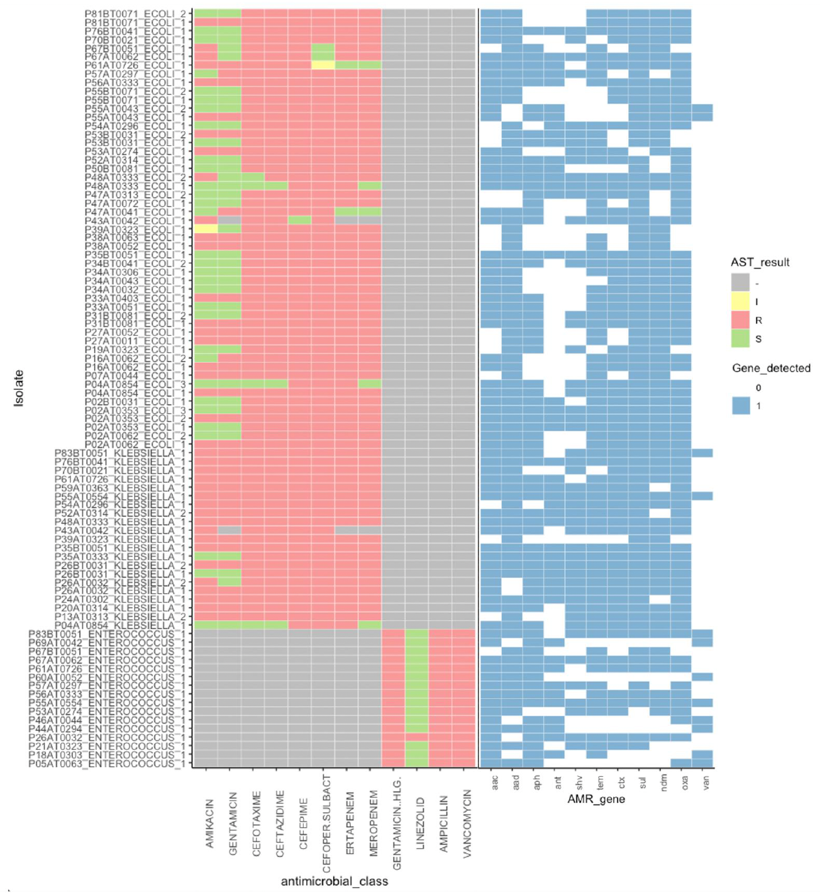

Antimicrobial susceptibility testing results (left) and non-efflux AMR genes which could be linked with mediating resistance to the antimicrobials tested against (right). AST results: S – sensitive, I – intermediate, R – resistant. Greyed out boxes indicate that the isolates were not tested against that antimicrobial. Blue coloured boxes indicate that the AMR gene was present, and white denotes absence. The figure shows antibiograms for each of the 90 isolates classified as MDR, grouped by organism, next to the most common AMR genes that could be associated with the resistance phenotype. Note that the AMR gene detection was conducted using metagenomic scaffolds constructed from the enriched microbiome data instead of the consensus genome bins, so the resistome is repeated in cases where two or three MDR isolates were detected in the same sample. Furthermore, while the AMR genes depicted were selected for their prominent roles in conferring resistance to the depicted antimicrobial classes, these genes do not constitute an exhaustive list and neither does their presence alone guarantee expression of the corresponding phenotype. The 90 enteric MDR isolates were detected across 57 unique samples from 41 patients, suggesting that over half of the patients (50.6%) included in the HSCT cohort had at least one MDR organism isolated from their stool during the transplant timeline. Five samples (P02AT0353, P04AT0854, P26AT0032, P48AT0333 and P61AT0726) each had three MDR organisms isolated from them, all collected post-HSCT. In general, isolated Klebsiella spp. possessed phenotypic resistance to a broader range of antimicrobial classes, also reflected in the resistomes of samples containing the organism. At least one aminoglycoside resistance gene was identified in all 90 samples, despite most E. coli showing susceptibility to amikacin and gentamicin.
Extended data 10: Antimicrobial sensitivity and AMR gene profiles for 5 BSI isolates that likely translocated from the gut
 | P02AT005BP2 | P05AT014BA1 | P14AT043BA1 | P44AT012BA1 | P55BT045BA1
 | E.coli | E.faecium | K.pneumoniae | P.aeruginosa | K.pneumoniae
Antimicobials tested | AST
Piperacillin/tazobactam | R |  | Participant died before AST was performed | R | R
Netilmicin | R |  | Participant died before AST was performed | R | R
Meropenem | R |  | Participant died before AST was performed | R | R
Gentamicin | R | R | Participant died before AST was performed |  | R
Ciprofloxacin |  |  | Participant died before AST was performed |  | R
Amikacin | R |  | Participant died before AST was performed | R | R
Cefoperazone/sulbactam | R |  | Participant died before AST was performed | R | R
Ertapenem |  |  | Participant died before AST was performed |  | R
Cefotaxime |  |  | Participant died before AST was performed |  | R
Ceftazidime | R |  | Participant died before AST was performed | R | R
Tigecycline | R |  | Participant died before AST was performed
Cefepime |  |  | Participant died before AST was performed | R
Levofloxacin |  | R | Participant died before AST was performed | R
Aztreonam |  |  | Participant died before AST was performed | R
Ampicillin |  | R | Participant died before AST was performed
Vancomycin |  | R | Participant died before AST was performed
Linezolid |  | S | Participant died before AST was performed
AMR gene drug classes | AMR gene detection
Aminoglycoside | 2 | 5 | 4 | 7 | 3
Cephalosporin | 1 | 0 | 0 | 1 | 0
Cephalosporin; penam | 0 | 0 | 1 | 0 | 1
Cephamycin | 1 | 0 | 0 | 0 | 0
Diaminopyrimidine | 1 | 1 | 1 | 1 | 1
Fluoroquinolone | 1 | 0 | 1 | 1 | 1
Glycopeptide | 0 | 1 | 0 | 0 | 0
Glycylcycline; tetracycline | 0 | 1 | 0 | 0 | 0
Lincosamide | 0 | 2 | 0 | 0 | 1
Macrolide | 1 | 2 | 2 | 0 | 1
Macrolide; streptogramin | 0 | 1 | 1 | 1 | 0
Multidrug | 4 | 4 | 4 | 5 | 5
Nucleoside | 0 | 1 | 0 | 0 | 0
Peptide | 4 | 0 | 3 | 1 | 3
Phenicol | 0 | 1 | 1 | 1 | 1
Phosphonic acid | 0 | 1 | 1 | 1 | 1
Rifamycin | 0 | 0 | 1 | 0 | 1
Sulfonamide | 1 | 1 | 1 | 2 | 1
Tetracycline | 0 | 3 | 1 | 0 | 0

