Extended Data Figures

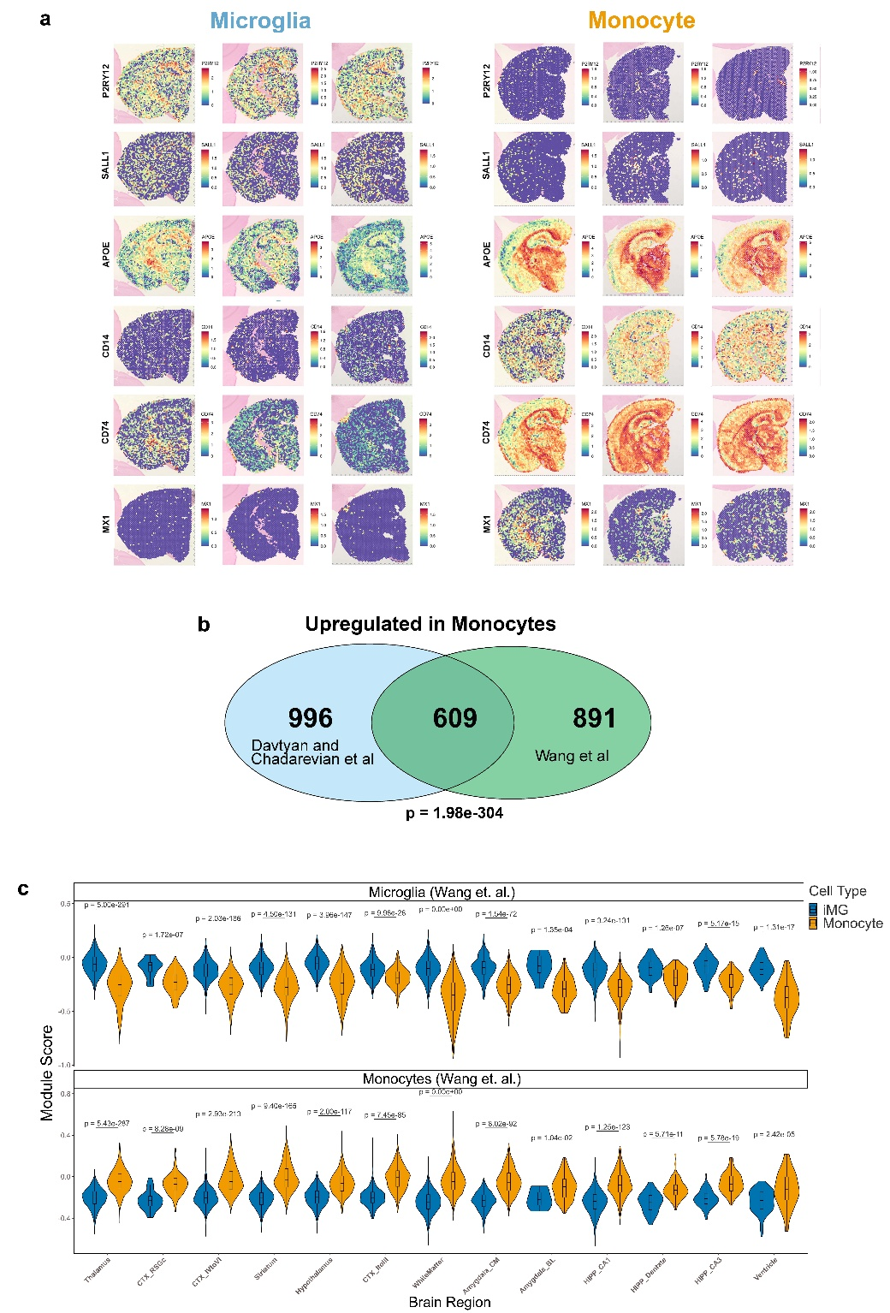
Extended Data Figure 1. Spatial sequencing reveals brain wide expression differences in microglia versus monocyte engrafted mice that are highly consistent with those detected by Wang and colleagues. (a) P2RY12, SALL1, APOE, CD14, CD74, and MX1 mRNA expression between brain-wide xenografted human microglia and monocytes in three individual mice per group (normalized and scaled expression). (b) Overlapping upregulated DEGs (Log2FC >1, FDR<0.05) detected in two independent studies using two distinct sequencing approaches (Spatial-seq versus scSeq) reveal significant overlap via (hypergeometric p=1.98e⁻³⁰⁴). (c) Module scores calculated from microglia or monocytes scSeq analysis by Wang et. al., exhibit corresponding enrichment in microglia or monocytes across all brain regions. P values calculated by two-sided Wilcoxon test and adjusted using the Benjamini–Hochberg (BH) method.
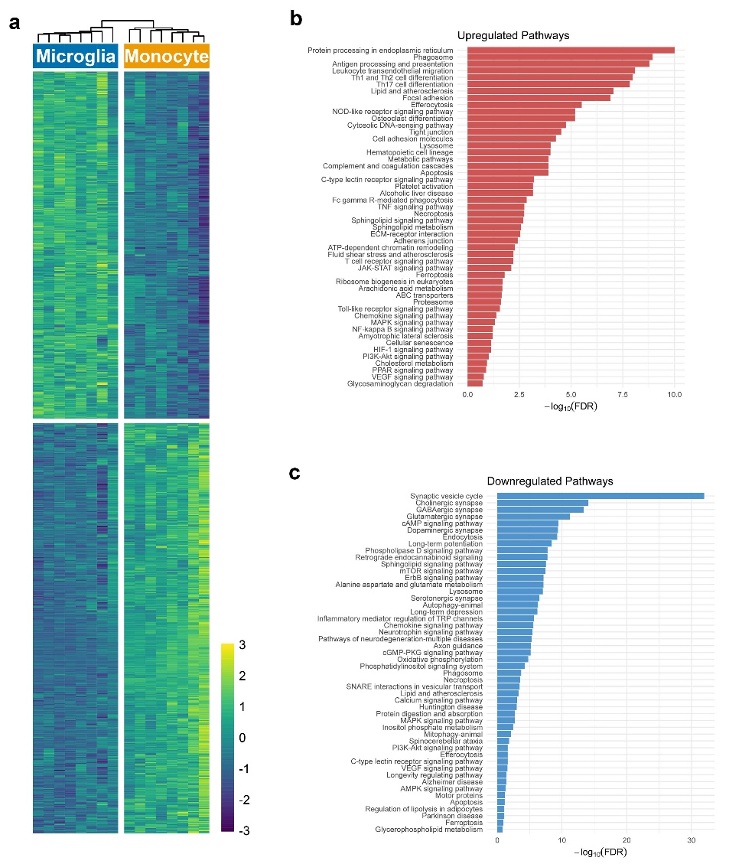

Extended Data Figure 2. Gene ontology analysis of proteomic data reveals upregulation of proinflammatory signaling, but downregulation of synaptic pathways. (a) Heatmap showing log2-transformed intensities of 1185 significant DEPs between brain-wide xenografted microglia and monocytes. Enrichment analysis of proteomic data demonstrating a subset of KEGG pathways that are significantly upregulated (b, red) or downregulated (c, blue) with monocyte engraftment. Representative upregulated and downregulated KEGG pathways via over-representation analysis (ShinyGO) of DEGs, The full list of 143 significantly upregulated and 175 significantly downregulated pathways are provided in Table 3. Enrichment p values were computed using a hypergeometric test and adjusted for multiple comparisons with the Benjamini–Hochberg (BH) method; pathways with FDR (q) < 0.05 were considered significant.

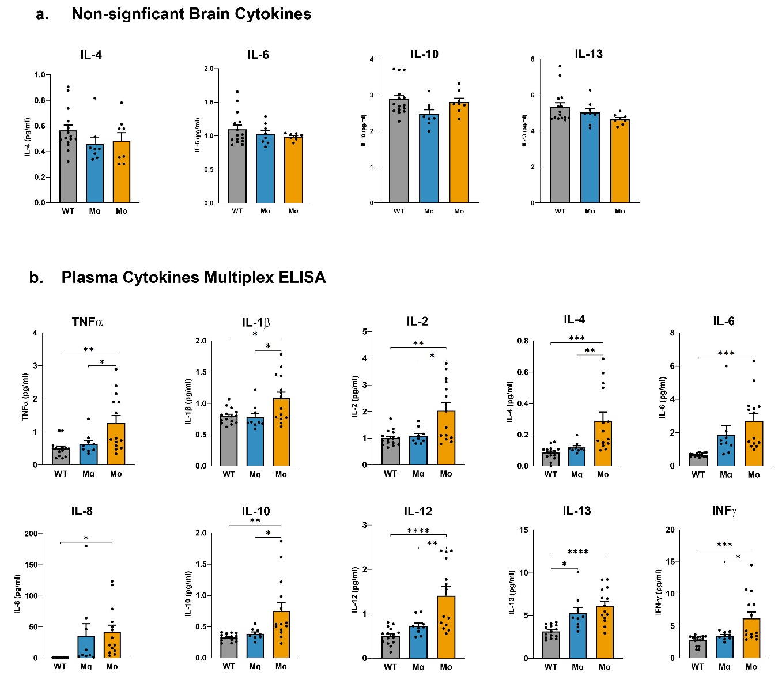

Extended Data Figure 3. Multiplex ELISA analysis of plasma cytokines. (a) While six of the ten analytes examined by multiplex ELISA were increased in monocyte engrafted brains (Fig. 4b), the remaining four cytokines, IL-4, IL-6, IL-10, and IL-13 showed no significant differences. (b) In contrast, all ten cytokines were significantly increased in plasma samples collected from monocyte engrafted mice. p values from one-way ANOVA, ∗p < 0.05, ∗∗p < 0.01, ∗∗∗p < 0.0001, and ∗∗∗∗p < 0.0001. Comparisons not shown are not significant.

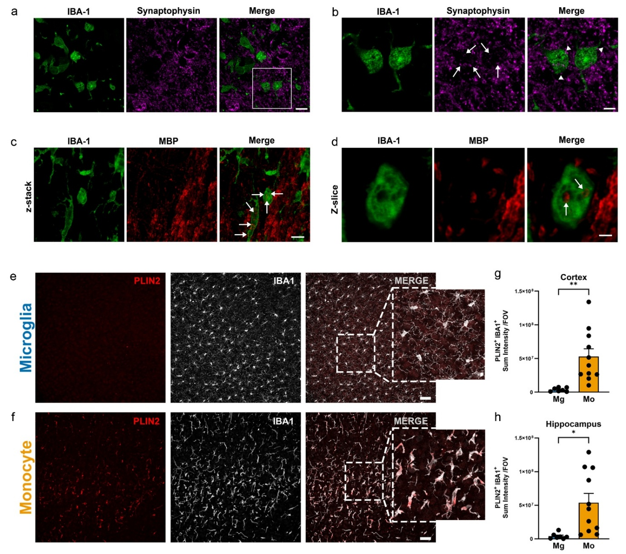

Extended Data Figure 4. Human monocytes exhibit internalized synaptic and myelin associated proteins and increased levels of lipid droplets. (a) Representative immunofluorescence imaging of IBA-1+ monocytes (green) and the presynaptic protein synaptophysin (purple). (b) Higher power image of two representative monocytes show evidence of synaptic internalization (arrows) or synaptic puncta that are directly adjacent to the plasma membrane of monocytes (arrowheads). (c) Confocal Z-stack image of IBA-1+ monocytes (green) within the corpus collosum that have internalized myelin basic protein immunoreactive puncta (red, arrows). (d) A higher power single confocal Z-slice of the monocyte shown in the center of (c), provides two examples of internalized MBP immunoreactive puncta (arrows). Representative confocal microscopy of PLIN-2+ lipid droplets (red) within cortical IBA1+ (white) microglia (e) or monocytes (f). IMARIS based quantification of PLIN2+ microglia and monocytes within the cortex (g) and hippocampus (h) of engrafted mice. p values from unpaired, two-sided t test (Cortex: t(16) = 3.368, **P=0.0039) (Hippocampus: t(16)= 2.851; *P=0.0116). Data represented as average mean value ± SEM (Mg, n = 7; Mo, n = 12). ∗p < 0.05 and ∗∗p < 0.01.

