Supplementary Materials for
3D Printing of Air
Deepak Gupta^{1,2}, Henrique Luis Piva^{1,2,3†}, Vaibhav Pal^{2,4†}, Suihong Liu^{1,2}, Syed Hasan Askari Rizvi^{1,2}, Mecit Altan Alioglu^{1,2,5}, Yasar Ozer Yilmaz^{1,2,6}, Annie Smith⁷, Logan Haugh^{2,7}, Joao Vitor Silva Robazzi^{1,2,8,9}, Jade Sency^{2,7}, Myoung Hwan Kim^{2,7}, Thomas Neuberger^{2,7}, Francesco Costanzo¹, Ibrahim T. Ozbolat ^{1,2,7,10,11,12*}
¹Engineering Science and Mechanics Department, Penn State University; University Park, 16802, USA
²The Huck Institutes of Life Sciences, Penn State University; University Park, 16802, USA
³Department of Chemistry, Faculty of Philosophy, Sciences and Letters of Ribeirão Preto - University of São Paulo; Ribeirão Preto, 14040-901, Brazil
⁴Department of Chemistry, Penn State University; University Park, PA, 16802, USA
⁵Department of Nuclear Engineering, Penn State University; University Park, 16802, USA
⁶Department of Nanoscience and Nanoengineering, Istanbul Technical University; Istanbul, 34469, Turkey
⁷Biomedical Engineering Department, Penn State University; University Park, 16802, USA
⁸Department of Electrical and Computer Engineering, Federal Institute of Sao Paulo; Sertaozinho, Brazil
⁹Department of Electrical and Computer Engineering, University of Sao Paulo, Sao Carlos, Brazil
¹⁰Materials Research Institute, Penn State University; University Park, PA, 16802, USA
¹¹Neurosurgery Department, Penn State University; University Park, PA, 16802, USA
¹²Cancer Institute, Penn State University; University Park, PA, 16802, USA
†Authors contributed equally
Corresponding author: Ibrahim T. Ozbolat, ito1@psu.edu

The PDF file includes:
Materials and Methods
Supplementary Text
Figs. S1 to S33
Tables S1 to S2
Movie captions

Other supplementary material for this manuscript includes the following:
Movies S1 to S13
Materials
PDV-0525 and SMS-142 were purchased from Gelest, Morrisville, PA, USA. Silica powder (AEROSIL R812S) was procured from Evonik, Essen, Germany. THI-VEXTM (83940B) was purchased from Reynolds Advanced Materials, Macungie, PA, USA. Spherical carbon particles were purchased from US Research Nanomaterials, Houston, TX, USA. EF1 tdTomato lentiviral vector was purchased from Vectalys, Toulouse, France. hMSCs were obtained from Rooster Bio, Frederick, MD, USA. Dulbecco's Modified Eagle's Medium (DMEM) was purchased from R&D Systems, MN, USA. microRNA (miR-196a-5p: 5’- UAGGUAGUUUCAUGUUGUUGGG-3’) was purchased from Integrated DNA Technologies, USA. Opti-MEM medium was purchased from Gibco, Carlsbad, CA, USA. Invitrogen Lipofectamine RNAiMAX transfection reagent (13778150) was purchased form Thermo Fisher Scientific, Waltham, MA, USA. Fetal bovine serum (FBS), trypsin-0.1% ethylenediaminetetraacetic acid (EDTA), and penicillin-streptomycin were purchased from Life Technologies, Grand Island, NY, USA. Glutamine was purchased from Life Technologies, Carlsbad, CA, USA. MCDB 131 medium was purchased from Corning, NY, USA. Heparin was bought from Millipore Sigma, St. Louis, MO. Bovine brain extract was purchased from Lonza, Walkersville, MD.
Methods
Silicone-based material for 3DAirP
To prepare the silicone-based material, 16.8 g of PDV-0525 was added to a Flacktek SpeedMixer® (DAC 330-100 SE, Greenville, SC, USA) container, followed by 1.6 g of SMS-142. The contents were mixed for 1 min at a speed of 2,500 rpm using the Flacktek SpeedMixer®. Subsequently, 1.8 g of silica powder was added and mixed for 1 min at the same speed. The sides of the container were then scraped down and the mixture was mixed for an additional minute. Next, 40 µL of 10% 2,2-Dimethoxy-2-phenylacetophenone photoinitiator solution (prepared in 100% ethanol) was added and mixed for 1 min at 2,500 rpm. Finally, 1.2 g of THI-VEXTM was added and mixed for 5 min at 2,500 rpm. The container was then covered with aluminum foil until use. The amount of silicon powder and THI-VEXTM were tuned to achieve different formulations from M1 to M3, mentioned as follows in Table S1:
Table S1: Material formulations from M1 to M3
Material | Silicon (g) | THI-VEXTM (g)
M1 | 0.8 | 0.80
M1A | 0.85 | 0.82
M1B | 0.925 | 0.85
M1C | 1.05 | 0.9
M1D | 1.3 | 1
M2 | 1.8 | 1.2
M3 | 2.2 | 1.6

Following 3DAirP, the construct underwent photo-crosslinking via exposure to 405 nm light for 5 min.
Gelatin µG
For the preparation of gelatin µG, a blending technique was employed. Initially, 100 mL of 10% gelatin solution was prepared. For this, 10 g of gelatin was dissolved in 95 mL of MilliQ water at 37 °C. Parallelly, 2g transglutaminase (Modernist Pantry LLC, Eliot, ME, USA) was dissolved in 5 mL of MilliQ water at 37 °C. The two solutions were mixed and vortexed. The mixed solution was kept at 37 °C overnight for crosslinking. After crosslinking, the gel was blended with extra water for 3 min to achieve gelatin µG. To eliminate any uncrosslinked gelatin and excess transglutaminase, µG were washed three times with deionized (DI) water, with each wash followed by centrifugation at 3,000 rpm for 5 min and removal of the supernatant. After the final washing step, an additional centrifugation was performed at 5,000 rpm for 5 min, and the supernatant was meticulously removed using a pipette, yielding gelatin µG.
Gelatin-based material for 3DAirP
For the formulation of the 3DAirP bath, a 10% (w/v) gelatin hydrogel solution was prepared and sterilized via autoclaving. Subsequently, it was incorporated into the purified µG prepared above at a ratio of 7:1 (µG:hydrogel, v/v). The mixture was homogenized using a FlackTek SpeedMixer® at 2,500 rpm for 1 min. 2% (w/v) transglutaminase was added to the blend for enzymatic crosslinking, followed by an additional 1-min mixing step. The resulting material exhibited distinct rheological transitions over time: it maintained the characteristics of material state M1 for approximately 10 min post preparation, gradually transitioned to a semi-gelled state (M2) over the next 15 min and ultimately reached a fully gelled state (M3) after 30 min. Following 3DAirP in M2, the construct was subjected to physical gelation by incubation at 4 °C for 15 min. Subsequently, enzymatic crosslinking was induced by incubating the construct at 37 °C for 4 h.
Gelatin methacryloyl (GelMA) synthesis
GelMA was synthesized following a previously reported protocol ¹ . Briefly, 20 g of gelatin (porcine, Type A, G2500) was dissolved in 200 mL of 0.1 M carbonate buffer at 55 °C under continuous stirring until complete dissolution was achieved. pH of the solution was then adjusted to 9 using 1N NaOH. Subsequently, 2.5 mL of methacrylic anhydride was added in five equal portions at 10-min intervals, with pH readjustment to 9 after each addition. The reaction mixture was maintained under stirring at 55 °C for 3 h to ensure efficient methacrylation. Following the reaction, pH was adjusted to 7.4 with hydrochloric acid (Millipore Sigma, HX0603), and the mixture was purified using dialysis against deionized water through a 12–14 kDa molecular weight cutoff membrane (Repligen, 132684T). The final GelMA product was obtained by freeze-drying.
Preparation of GelMA µG
For the preparation of GelMA µG, a blending technique was employed. Initially, a predefined concentration of GelMA solutions, containing 5 mg/mL lithium phenyl-2,4,6-trimethylbenzoylphosphinate (LAP) (TCI America, Portland, OR, USA), was sterilized via autoclaving. The sterilized GelMA solution was then subjected to ultraviolet light exposure for 10 min to induce crosslinking and subsequently stored at 4 °C overnight to ensure complete crosslinking. Following this, the crosslinked GelMA was blended with extra autoclaved water using a sterilized blender (Magic-bullet, Los Angeles, CA, USA) for 2 min to achieve µG. To eliminate any uncrosslinked GelMA and excess LAP, µG were washed three times with deionized (DI) water, with each wash followed by centrifugation at 4,182 ×g for 5 min and removal of the supernatant. After the final washing step, an additional centrifugation was performed at 19,632 ×g for 5 min, and the supernatant was meticulously removed using a pipette, yielding purified GelMA µG.
GelMA-based material for 3DAirP
First, µG of 15% (w/v) GelMA were prepared using the blending approach as mentioned earlier. For the formulation of the 3DAirP bath, a 20% (w/v) GelMA hydrogel with 5 mg/mL LAP was prepared. GelMA was sterilized via autoclaving while LAP sterilized using an 0.22-µm filter. The purified µG were then mixed with bulk GelMA in a 7:2 ratio (µG: bulk GelMA). To ensure a homogenous mixture, it was vortexed thoroughly before undergoing centrifugation at 9,410 ×g for 5 min. The supernatant was carefully removed to obtain the µG-bulk gelMA composite bath suitable for 3DAirP applications. After performing 3DAirP, the construct was crosslinked by exposing it to 405 nm light for 1 min. The exposure time increases with the increase in the thickness of constructs.
GelMA-based material (for AAB of spheroids and 3DAirP)
Due to the fragility of spheroids, the above-prepared high yield-stress GelMA-based material was found to be inefficient for the precise placement of spheroids. It was observed that the soft spheroids were unable to penetrate the gel during bioprinting and often detached from the nozzle at the gel/air interface. To address this issue, a GelMA-based material of lower yield stress was prepared and utilized for spheroid bioprinting to ensure precise and reproducible deposition using AAB. For this preparation, µG from 10% (w/v) GelMA were prepared and mixed with a 20% (w/v) bulk GelMA solution in a 7:2 ratio (µG:bulk GelMA). The mixture was vortexed thoroughly to achieve homogeneity and subsequently centrifuged at 9,410 ×g for 5 min. The supernatant was then carefully removed to yield the final µG-bulk GelMA composite, which was further used for spheroid bioprinting and 3DAirP applications. Following the 3DAirP, the construct underwent photocrosslinking via exposure to 405 nm light for 1 min. The duration of light exposure was adjusted proportionally to the construct's thickness to ensure uniform crosslinking throughout the volume.
(Troubleshooting step: Due to the variation in batch-to-batch difference in gelatin and µG preparation, we observed that the final centrifugation speed of µG and bulk GelMA mixture before executing 3DAirP may vary in the range of 4,182-19,632 ×g).
µG size distribution
The volume-weighted mean particle size of µG was quantified using a Mastersizer 3000 (Malvern Panalyticals, Worcester, UK). To ensure accuracy, µG were independently prepared in triplicate using the previously described methods, and their size distribution was subsequently analyzed.
Rheology
Rheological properties of the prepared baths were characterized using an MCR 302 rheometer (Anton Paar, Austria) equipped with a 25-mm parallel plate geometry and maintained at 22 °C via a Peltier temperature control system. Shear thinning behavior was assessed through a flow sweep test, varying the shear rate from 0.1 to 100 s⁻¹. Viscoelastic properties were evaluated using amplitude sweep tests at a constant frequency of 1 Hz, with shear strain ranging from 0.1% to 100%. A self-healing test was conducted by measuring the viscosity under alternating low (0.1 s⁻¹ for 60 s) and high (100 s⁻¹ for 10 s) shear rates. Additionally, a self-recovery test was performed by measuring the storage and loss moduli under alternating low (0.1 s⁻¹ for 60 s) and high (100 s⁻¹ for 60 s) shear rates.
Table S2: Rheological properties of materials (M2) for 3DAirP
Material | Yield stress (Pa) | Storage modulus (Pa) | Stationary viscosity (mPa-s)
GelµP/Gel | 243.2 ± 27.9 | 1632.6 ± 309.4 | 2.09×10⁶ ± 2×10⁵
GelMAµP/GelMA | 143.7 ± 12.3 | 2326.8 ± 399.4 | 1.09×10⁶ ± 6×10⁴
GelMAµP/GelMA (for AAB) | 14.3 ± 2.3 | 94.9 ± 0.9 | 9.29×10⁴ ± 3.1×10⁴
GelµP/GelMA | 471.0 ± 26.8 | 704.3 ± 223.2 | 1.34×10⁶ ± 1.7 × 10⁵
Silicon | 83.4 ± 6.3 | 417.0 ± 127.8 | 7.83×10⁵ ± 1.8×10⁴

Gel tearing test
Rheological tests indicated that all the materials (from M1 to M3) possessed self-healing and self-recovery capabilities. However, M3 was found to be incompatible with 3DAirP, as the material was torn by the moving nozzle and did not fully recover post-nozzle passage, resulting in air escaping from the crevice. Consequently, a new test, termed the 'gel tearing test,' was designed by modifying the 25-mm parallel plate geometry of the rheometer to investigate the self-recovery properties of the material during nozzle movement. A nozzle holder was engineered to accommodate a 3DAirP nozzle, which was then affixed to the 25-mm plate of the rheometer, ensuring that the horizontal segment of the nozzle aligned tangentially with the rheometer's plate (Fig. S18). The material was filled in a Petri dish, which was placed on the bottom plate of the rheometer. The top plate, equipped with the attached nozzle and holder, was lowered until the nozzle was inserted into the material. The top-plate was then rotated at a specific speed to complete one revolution, with torque measurements taken at predefined locations throughout the rotation. The nozzle was held at this location for a predefined wait period before executing a second revolution. The time interval between the two revolutions, when the nozzle reached the same position on its orbit, was noted. Torque (ʈ₂) was measured again at those predefined positions and the percentage of ʈ₂ relative to ʈ₁ was considered as the percentage of gel recovery.
µCT scanning
To visualize dimensions, uniformity, topography, and connectivity at junctions of the air printed channels in 3D, especially in gelatin- and GelMA-based materials due to their poor transparency, µCT scanning was conducted using a µCT SKYSCAN 1176 (Bruker, Billerica, MA, USA) with a voxel size of 35 µm, operating at 40 kV, 450 µA, and an exposure time of 100 ms. Image reconstruction was performed using NRecon reconstructing software (Bruker). Rendering, smoothening, and visualization were carried out with Avizo3D software (Thermo Fisher Scientific, Waltham, MA, USA).
Particle image velocimetry (PIV)
PIV tests were conducted to analyze the disturbance created by a moving 3DAirP nozzle within materials. Spherical carbon particles, 25 µm in diameter, were dispersed in mineral oil at a concentration of 20% (w/v). Subsequently, 30 µL of this suspension was added to 5 mL of the sample material and homogenized using a Flacktek SpeedMixer® at 2,500 rpm for 5 min. This concentration and mixing ratio of carbon particles were optimized through multiple trials to ensure adequate particle density for PIV image processing. Lower concentrations could yield unreliable results, while higher concentrations might lead to particle agglomeration and reduced material transparency. The addition of carbon particles did not alter the rheological properties of the material. The prepared material was transferred to a 35-mm Petri dish, which is then placed in a custom-designed motion stage. The 3DAirP nozzle was inserted into the material and held stationery while the Petri dish was moved relative to the nozzle by controlling the motion stage. A 4K microscope camera (HAYEAR, Shenzhen, China) was installed vertically below the Petri dish, capturing videos of the nozzle and the surrounding tracer carbon particles in the material at 60 frames per sec. The videos were analyzed with an open-source PIVlab tool in MATLAB (MathWorks, MA, USA).
Cell culture
GFP⁺MDA-MB-231: GFP⁺MDA-MB-231 breast cancer cells were provided by Dr. Danny Welch, from the University of Kansas (Kansas City, KS). The cells were cultured in DMEM supplemented with 10% FBS, 1% penicillin-streptomycin, and 1 mM glutamine.
HDFs: HDFs were obtained from Lonza (Walkersville, MD). They were cultured in DMEM supplemented with 10% FBS, 1% penicillin-streptomycin, 1% sodium pyruvate, and 1% glutamine, and used between passages 2 and 8. All the cells were kept at 37 °C with 5% CO₂ in a humidified environment, with the medium changed every 2–3 days. The cells were detached from the cell culture flasks when they reached approximately 80 % confluency using 0.25% trypsin-0.1% EDTA solution and split to sustain growth.
HUVECs: HUVECs were obtained from Lonza (Walkersville, MD). MCDB 131 medium was used to culture HUVECs, and the medium supplements included 10% FBS, 0.5% bovine brain extract (BBE, Lonza, Walkersville, MD), 0.25% endothelial cell growth supplement (ECGS, Millipore Sigma), 1% penicillin-streptomycin, 1200 U mL⁻¹ heparin, and 1% glutamine. These cells were used at passages 2 through 7. HUVECs were additionally transduced with a tdTomato lentiviral vector to facilitate visualization in all experiments.
Transduction of HUVECs: At passage 2, when HUVECs reached around 50% confluency, they were transduced with EF1 tdTomato lentiviral vector, maintaining a multiplicity of infection of 20. To prepare the transduction mix, a precise amount of the viral vector solution was combined with complete culture media and 800 µg mL⁻¹ polybrene. This mixture was then added to a cell flask at about 50% confluency and incubated for 8 h. After the incubation period, the transduction mix was removed, the flask was washed with 1X Dulbecco's phosphate-buffered saline (DPBS), and fresh culture medium was added. The cells were then allowed to grow for another 48 h before being sorted using a MoFlo Astrios sorter (Beckman Coulter, Pasadena, CA) to select the brightest cells, which were subsequently collected for further culture.
Human mesenchymal stem cells (hMSCs): hMSCs were cultured and expanded in DMEM with 10% FBS and 1% penicillin/streptomycin (P/S, i.e., 100 U mL⁻¹ penicillin and 100 µg mL⁻¹ streptomycin) in a humidified incubator with 5% CO₂ at 37 °C.
Transfection of hMSCs: After reaching 80% confluency, hMSCs were transfected with microRNA (miR-196a-5p: 5’- UAGGUAGUUUCAUGUUGUUGGG- 3’), in opti-MEM medium for 48 h. Invitrogen Lipofectamine RNAiMAX transfection reagent was used for the transfection and was mixed with miR-196a-5p according to the manufacturer's protocol. The final concentration of miR-196a-5p transfections in the opti-MEM medium was determined to be 200 nM for a volume of 10 mL.
Spheroid formation for 3D bioprinting
Spheroids were generated using 4,000 GFP⁺ MDA-MB-231 cells and 2,000 HDFs. Prior to spheroid formation, MDA-MB-231cells were labelled with CellTracker Green CMFDA. A 1 mM stock solution of CellTracker was prepared and subsequently diluted to a working concentration of 25 µM. The cells were cultured in 75 cm² culture flasks until they reached approximately 80% confluency. At this point, the medium containing the CellTracker working solution was added and the cells were incubated overnight. Following incubation, the cells were individually trypsinized, combined, and seeded into a 96-well U-bottom cell-repellent plate (Greiner Bio-One, Monroe, NC). The cells were cultured in the U-bottom plate for 24 h to facilitate spheroid formation.
3DAirP of channels and AAB of spheroids
A poly-lactic acid (PLA)-based 3D printed cuboidal structure was used as the perfusable chamber. This structure was designed using Fusion 360 (2024, Autodesk Inc., CA, US), and printed with X-MAX (Qidi Technology, China). The device was designed with holes on opposing widths to accommodate the insertion of perfusion needles and tubing (Fig. 4A). Additionally, it incorporated chambers and slits along opposing lengths to store culture medium, thereby ensuring initial nourishment of spheroids. The devices were glued to glass sides, followed by thorough rinse with sterile DI water three times, dried, and further sterilized with UV. GelMA-based material was filled in the devices. 3DAirP was performed with a 27G bent nozzle to create a straight channel of diameter approximately 750 µm, ensuring alignment with the container's holes. The device was transferred to an in-house developed aspiration-assisted bioprinter, maintaining sterility throughout the process. Prior to bioprinting, the spheroids were suspended in their culture medium. A 32G nozzle was used to individually pick and bioprint spheroids within the gel on both sides of the channel. The inter-spheroid distance was maintained at 1.5 mm, and the distance between each spheroid and the air channel was kept at 1 mm. The gel was subsequently crosslinked by exposing it to 405 nm light for 30 s from the top and bottom surfaces. The assembled device was placed in a 100-mm Petri dish and connected to perfusion tubing and cultured for 3 days. Following that, the gel was carefully taken out of the devices and washed gently with PBS. Thin slices of the gel were cut using a single edged razor blade (Canopus, CA, USA). The sample slices were cleared (made transparent) using a clearing solution, which was prepared according to the protocol ² . The slices were then imaged using a Zeiss LSM880 confocal microscope (Oberkochen, Germany).
DOX test
Doxorubicin hydrochloride (DOX) from Tocris Biosciences, Minneapolis, MN, was dissolved in dimethyl sulfoxide (DMSO) to create a 50 mM stock solution, which was then aliquoted and stored at −30 °C. In this study, DOX concentration was serially diluted by 10 folds, starting from a high concentration of 10 µM down to a low concentration of 0.1 µM. The control group, which was not treated with DOX, contained only the vehicle (DMSO) diluted in EGM-2MV media (0.1%). GFP⁺MDA-MB-231 cells were mixed with GelMA-based material at a concentration of 10⁷ cells/mL. The cell-laden gel was transferred into the 3D printed cuboidal shaped container equipped with perfusion holes on opposed sides. 3DAirP was performed with a 30G bent nozzle to create an air channel of diameter approximately 500 µm, aligning with the container’s holes. The gel was subsequently crosslinked by exposing it to 405 nm light for 30 s from the top and bottom surfaces. The assembled device was placed in a 100-mm Petri dish and connected to perfusion tubing. A few drops of culture medium were added atop the gel to provide initial nourishment to the cells before incubating the setup. The perfusion rate was kept at 0.7 µL/min, and the devices were cultured under perfusion for 3 days. Following this period, the gel was carefully extracted from the device and washed three times with PBS. Fluorescent images of GFP⁺MDA-MB-231 cells were captured using the Zeiss LSM880 confocal microscope.
Bone tissue model
Transfected cells were collected by trypsinization and centrifuged at 300 × g for 5 min, the collected cells were mixed into gel at a concentration of 5 × 10⁶ cells per mL of the gel to prepare transfected hMSCs-laden bath for 3DAirP. The cell-laden gel was transferred to the perfusion device and 3DAirP was performed to create channels. The gel was exposed to 405 nm blue light for 30 sec from top and bottom to crosslink the gel. The perfusion tubes were connected, and the medium was perfused at a rate of 0.7 µL/min. The devices were cultured in DMEM for 7 and 14 days.
CAM assay
The air printed channels were utilized to direct angiogenesis through channels in an in-ovo model using the chick embryo chorioallantoic membrane (CAM) assay. Fertilized chick eggs, generously provided by the Poultry Education and Research Center at Penn State (University Park, PA, USA), were incubated horizontally in controlled atmosphere with 60% humidity using a universal egg hatching incubator (Peatend, China) equipped with automatic rotation. The incubation process commenced on embryonic Day 0 and continued for 7 days. Meanwhile, cubical samples of the GelMA-based material were fabricated with dimensions 1 cm × 1 cm × 1 cm. A matrix of 4 × 4 channels, each spaced 2.5 mm apart, was created using 3DAirP. The gel block was crosslinked by exposing each face to 405 nm light for at least 1 min. Following crosslinking, the gel block was sectioned into 2-mm thick slices along the cross-sectional plane of the channels, resulting in each slice containing 16 channels. After 7 days of embryonic incubation of the eggs, a window was created at the air chamber between eggshell and CAM, under sterile conditions, and the prepared samples were carefully placed on the CAM of the chick embryo (fig. S30). The windows on eggshells were then sealed with sterilized transparent parafilm tape, and the eggs were returned to the incubator for continued incubation without rotation. After 14 days of incubation, the parafilm tape was removed, and the implanted samples were harvested and imaged with a camera (Pixel 8, Google, USA). The embryos were euthanized by prolonged exposure of carbon dioxide (~30 min), followed by freezing at -20 °C for 4 h, and subsequently autoclaved. The quantitative analysis of the samples was performed using ImageJ and Angio tool to characterize total vessel length, average vessel length, total number of junctions, and percentage area of constructs covered by vessels.
Microfluidic device for µG fabrication
3DAirP in the silicone-based material was utilized to fabricate microfluidic devices for generating GelMA µG. Initially, 3DAirP was carried out with 34G bent nozzle equipped with a plastic sheath on its horizontal segment to generate a straight channel with a diameter of 1 mm. Subsequently, a thinner branch of the air channel was printed, with a diameter of 250 µm, which was connected to the main channel at a 90° angle using a 34G bent nozzle without the plastic sheath, thereby forming a T-shaped channel. The device was crosslinked by exposing it to 405 nm light for 5 min under water. After crosslinking, the device was washed three times with DI water to remove any uncrosslinked material from the surface. Then, perfusion tubes were connected to the device. Mineral oil (with 4% SPAN-80) was perfused through the main channel, while a 10% (w/v) of GelMA solution was perfused through the thinner branched channel at predefined flow rates. µG were passed through long transparent coiled tubes, which were exposed to 405 nm light. The crosslinked GelMA µG were collected, washed three times with DI water, and their particle size was analyzed.
Supplementary Text
- Nozzles
There were three different nozzle types used in this study. The first was a bent nozzle, which was created by bending a conventional blunt needle to 90°. It created an air channel when it was moved in the direction of the horizontal segment opposite to the nozzle opening. The nozzle needs to be rotated to print air in a freeform manner within a gel. We used a 6-axis robot (C8, EPSON, CA, USA) to rotate the needle during printing to achieve freeform 3DAirP in x, y, and z axes. This nozzle worked with continuous phase materials, such as silicone and µG (i.e., GelMA-based µG with µG’ size being eight or more times smaller than needle diameter). The second was the bent nozzle with an attached sheath over the bent segment to perform 3DAirP in µG, which are comparable in size with the selected nozzle. To create this nozzle, first a needle was bent to 90°, followed by gluing a sheath to its bent segment. The sheath diameter was bigger than the µG size by at least four times. Three types of µG were characterized in this study– 10% (w/v) gelatin, 10% (w/v) GelMA, and 15% (w/v) GelMA, and the size distributions of these three µG types are shown in Fig. S3.
The third type of nozzle was the ball nozzle, which was created by dipping the tip of a straight blunt needle into a photo-crosslinkable resin and passing air through the needle during crosslinking of the resin to prevent the needle from getting clogged. This process was repeated until the desired ball diameter was achieved. This nozzle could print in all directions using conventional 3D printers in a freeform manner.
- COMSOL Simulation
The physical system we model consists of air regions within a gel. These constituents are immiscible. The interface between gel and air is evolving and we adopt a phase field method to track the motion of the interface. In phase field methods, the overall system is modeled as a mixture occupying all points in the domain of interest. A scalar field $ϕ$ that takes on values in the interval $\left[-1,1\right]$ is used to distinguish between one phase and another. As the constituents are immiscible, the phase field will have either value $1$ or $-1$ except at the interface. The latter is assumed to be diffuse, that is, to occupy a region of finite thickness through which the phase field goes from one limit value to the other. Governing equations for the system as a whole are obtained by enforcing momentum and mass balance laws. The phase field evolution is governed through an equation which accounts for the jump conditions across the interface and the effect of the interfacial surface tension air/gel interface (28, 29). In their pure form, we model air as an incompressible Newtonian fluid (see, e.g., (25)) and we model the gel as a Hershel–Bulkley incompressible yield-stress material (26) , which we regularize using the approach in (27). The interface tracking model is based on a Cahn-Hilliard system (24, 29). The COMSOL Multiphysics own implementation of this system is as follows:
$\left(\frac{∂}{∂t}+\underline{u}∙∇\right)ϕ=∇∙\frac{γλ}{ϵ_{pf}^{2}}∇ψ$ (1)
$ψ=-∇∙ϵ_{pf}^{2}∇ϕ+(ϕ^{2}-1)ϕ$ (2)
where 𝜙 is the (dimensionless) phase field variable, the quantity $λ$ (SI unit: N) denotes the mixing energy density, while $ϵ_{pf}$ (SI unit: m) represents the capillary width, which scales with the thickness of the interface. $\underline{u}$ denotes the velocity field vector, γ denotes mobility, $ψ$ denotes the free energy. The volume fraction of the fluid components within the diffuse interface are given by $\left(\frac{1+ϕ}{2}\right)$ and $\left(\frac{1-ϕ}{2}\right)$. The parameters $λ$ and $ϵ_{pf}$ are related to the surface tension $σ_{s}$ (SI unit: N/m), through the equation:
$σ_{s}=\frac{2\sqrt{2}}{3}\frac{λ}{ϵ_{pf}}$ (3)
The Cahn Hilliard system can be combined to the equations of motion of the fluids to yield the remaining equations of motion of the system as a whole. The latter is sometimes referred to as the Cahn-Hilliard Navier-Stokes (CHNS) system (29). To account for the surface tension force in the momentum equation, a stress contribution $\left(-λ\left(∇ϕ⨂∇ϕ\right)\right)$ must be added to the stress term in the Navier-Stokes equations, which are then rewritten as follows:
$ρ\left(\frac{∂}{∂t}+\underline{u}∙∇\right)\underline{u}=-∇p+∇∙μ\left(\dot{γ}\right)\left(∇\underline{u}+{\left(∇\underline{u}\right)}^{T} \right)+ρ\underline{b}-∇∙λ\left(∇ϕ⨂∇ϕ\right)$ (4)
$∇∙\underline{u}=0$ (5)
where ρ denotes the fluid density, μ denotes the fluid viscosity, $\dot{γ}$ denotes shear rate, and $\underline{b}$ denotes body forces such as gravity.
In the binary fluid system, density and viscosity are defined as dependent field variables rather than fixed material parameters. These properties are expressed as functions of the volume fraction of the fluid components.
$V_{f,1}=\frac{1-ϕ}{2}, V_{f,2}=\frac{1+ϕ}{2}, V_{f,1}+V_{f,2}=1$ (6)
$ρ=ρ_{1}V_{f,1}+ρ_{2}V_{f,2}$ (7)
$μ=μ_{1}V_{f,1}+μ_{2}V_{f,2}$ (8)
where $μ_{1}$ and $μ_{2}$ represents the viscosities and $ρ_{1}$ and $ρ_{2}$ denote the densities of air and gel, respectively. Air is modeled as Newtonian and incompressible fluid. As already mentioned, the gel exhibits a yield phenomenon, and its rheology suggests incompressible Herschel-Bulkley (HB) behavior. For numerical implementation, we used a regularized version of the HB fluid model proposed by Papanastasiou (27),
$μ_{2}=K{\dot{γ}}^{n-1}+\frac{τ_{y}}{\dot{γ}}\left(1-e^{-m\dot{γ}}\right)$ (9)
$\dot{γ}={\left(2{(∇\underline{u})}^{s}∶{(∇\underline{u})}^{s}+eps\right)}^{\frac{1}{2}}$ (10)
where K is the consistency index, n is the flow behavior index, $τ_{y}$ denotes yield stress of the material, m is a constant used for regularization, ${\left(∇\underline{u}\right)}^{s}$ denotes the symmetric part of the gradient of $\underline{u}$, and eps is machine epsilon.
All the equations are solved via the finite element method³ in COMSOL Multiphysics (v6.2, 24) with a stabilized P1-P1 element pair for the interpolation of the velocity and pressure fields and a P1 element for the phase field. For the stabilization we adopted the consistent stabilization available through COMSOL Multiphysics.
Geometry and boundary conditions for 3DAirP simulation: The COMSOL Multiphysics in-built CAD geometry node was used to model the bent nozzle within the bath. A schematic with boundaries for the 3D computer-aided design (CAD) model is depicted in fig. S12. The inlet and outlet boundaries ($Γ_{in}$ and $Γ_{out}$) were assigned Dirichlet boundary conditions for the nozzle speed ($u_{n}$). The bottom and wall boundaries ($Γ_{bottom}$ and $Γ_{walls}$) were assigned slip condition, while the top boundary ($Γ_{top}$) was assigned a zero-flux condition. The nozzle print-head ($Γ_{print-head}$) was assigned a Dirichlet boundary condition for the air dispensing speed ($u_{d}$), and the remaining nozzle boundaries ($Γ_{nozzle}$) were assigned no-slip conditions. Gravitational forces were included in the model, whereas surface tension effects were neglected in the balance of momentum equation. Material properties for the gel were taken from rheological experimental results (ρ = 810 [kg/m³], K = 17.4443 [Pa.s], n = 0.5542, τ_{y} = 81.8 [Pa]) for the silicone-based M2.
The nozzle print-head ($Γ_{print-head}$) was assigned a Dirichlet boundary condition for the phase to be air ($ϕ=-1$), while all other boundaries were assigned the gel phase ($ϕ=1$).
Results: The air dispensing and nozzle movement (printing) speeds play a crucial role in controlling channel geometries. We defined a dimensionless quantity, the printability number (PN) as the ratio of the air dispensing speed $\left(u_{D}\right)$ to the nozzle speed $\left(u_{N}\right)$. A PN of zero indicated that the nozzle is moving in gel without dispensing air, representing no printing. Conversely, a very high PN approaching infinity indicated that the nozzle is stationary while dispensing air, creating a bubble. A PN of unity showed the printed channel diameter was approximately equal to the nozzle diameter, following the analytical relationship:
$\frac{u_{D}}{u_{N}}={\left(\frac{d_{N}}{d_{C}}\right)}^{2}$ (11)
where $d_{N}$ is the nozzle diameter and $d_{C}$ is the printed channel diameter. Intuitively a moderately higher PN, such as 10 resulted in a thicker channel than the nozzle, which was observed in simulations and experiments. Results were generated after 3 s of simulation.
Geometry and boundary conditions for time dependent response of air channels: A rectangular shaped box with an inner cylindrical domain was modeled in COMSOL Multiphysics using the built-in CAD geometry module. The inner cylinder was assigned the phase properties of air (ϕ = -1), while the exterior of the cylinder was assigned the phase properties of the gel (ϕ = 1). Surface tension and gravitational forces were incorporated into the calculations. The top boundary was assigned a zero-pressure boundary condition, and all remaining boundaries were assigned no-slip conditions. Results were generated after 3 s of simulation.
Results: The stability of the air channels is crucial for successful printing of intricate structures. The yield stress of the gel plays a pivotal role in maintaining the shape of the printed channel against surface tension forces. Through a parametric study of the gel's yield stress in numerical simulations, we observed that a very low yield stress value causes the air channel to break up into bubbles, while a higher yield stress helps retain the structure. Our observations indicated that a yield stress of 5 Pa is the critical threshold for bubble formation.
- Predicting air printability using machine learning
Machine learning (ML) is a widely recognized tool for predictive tasks, capable of analyzing historical data to forecast outcomes on unseen data⁴ . In this context, ML can be employed to predict the results of new tests for air printability, thereby minimizing the number of experimental trials required to identify the optimal parameter combinations for specific gel formulation. We built ML models that use data, such as yield stress, viscosity, and nozzle diameter to check if a gel is air printable. Various combinations of ML models were evaluated to identify those yielding the best predictive performance. This project was implemented using Python 3.9 programming language.
Data Preprocessing: The dataset went through preprocessing to ensure the optimal performance of the ML models. The following steps were applied:
Normalization: Features were normalized using MinMaxScaler to scale the data between 0 and 1. This process ensures that features with larger numeric ranges do not disproportionately influence the ML models. Normalization is particularly crucial for algorithms sensitive to feature magnitudes, such as k-nearest neighbors (k-NN), support vector machines (SVM), and artificial neural networks (ANN). The normalization was performed using the following equation:
$$X_{Normalized}=\frac{X-X_{min}}{X_{max}-X_{min}}$$
where:
- X is the original feature value,
- X_{min} is the minimum value of the feature,
- X_{max} is the maximum value of the feature,
- X_{normalized} is the scaled feature value between 0 and 1.
Data Splitting: The processed dataset was randomly partitioned into training (80%) and testing (20%) subsets. This random split ensures that the training and testing sets are representative of the overall dataset, preventing biases in model evaluation. Random splitting helps ML models generalize effectively by preventing overfitting, the tendency of a model to memorize training data instead of learning patterns that apply to unseen data .
Model Implementation: A diverse set of ML models was implemented using Python libraries, such as TensorFlow/Keras, scikit-learn, and XGBoost. Each model was evaluated across various hyperparameter combinations to identify the configurations that yielded the highest predictive accuracy for 3DAirP. Comprehensive testing of all combinations within the defined hyperparameter grids was conducted to ensure thorough and optimal evaluation.
Support Vector Machines (SVM): SVM is an ML algorithm originally developed for binary classification tasks. Its primary objective is to find the optimal decision boundary that maximizes the margin between different classes, ensuring better generalization to unseen data ⁵ . The following hyperparameters were tested:
- Regularization parameter (C): This parameter controls the trade-off between achieving a smooth decision boundary and correctly classifying training points. Higher values focus on minimizing classification errors, while lower values promote simpler models. The tested values were 0.1, 1.0, and 10.0.
- Kernels: Determines the shape of the decision boundary by applying a transformation to the input space. The tested options included linear, radial basis function (RBF), and polynomial kernels.
- Polynomial kernel degrees: This parameter defines the complexity of the decision function when utilizing a polynomial kernel. Higher degrees allow for more complex decision boundaries. The tested degrees were 2, 3, and 4.
Random Forest (RF): RF is a robust ensemble learning algorithm that enhances predictive accuracy by combining the outputs of multiple decision trees. It is widely used for both classification tasks due to its flexibility and resistance to overfitting ⁶ . The configurations of RF that were tested included:
- Number of trees: This parameter specifies the total number of individual decision trees in the ensemble. Increasing the number may improve performance at the cost of computation. The tested values were 50, 100, and 200.
- Maximum tree depth: This parameter limits the depth to which each tree can grow, thereby preventing overfitting by reducing model complexity. The tested depths were none (unlimited), 5, and 10.
- Minimum samples per split: This parameter defines the minimum number of samples required to split a node. Larger values result in simpler trees. The tested values were 2, 5, and 10.
XGBoost: XGBoost is a powerful ensemble learning technique that builds predictive models in a sequential manner, with each new model trained to correct the errors made by its predecessors ⁷ . The hyperparameters of XGBoost that were evaluated included:
- Number of estimators: This parameter specifies the number of trees added sequentially. Higher values improve learning but may increase training time. The tested values were 50, 100, and 200.
- Maximum depth of trees: This parameter determines the depth to which each tree is grown. Larger values allow the model to capture more complex interactions. The tested depths were 2, 3, and 5.
- Learning rate: Controls how much each new tree changes the model. Smaller values make the model learn more slowly and carefully, helping it move steadily toward the optimal solution without overstepping it. Tested values were 0.05, 0.1, 0.2.
Logistic Regression: Logistic Regression is employed for binary classification tasks, modeling the probability of class membership using a logistic function ⁸. The configurations of logistic regression that were evaluated included:
- Regularization parameter (C): This parameter is the inverse of regularization strength. Smaller values indicate stronger regularization, which helps prevent overfitting. The tested values were 0.01, 1.0, and 10.0.
- Solvers: These are algorithms used for optimization, each with distinct convergence properties and suitability for different data types. The tested options included lbfgs (Limited-memory Broyden–Fletcher–Goldfarb–Shanno), liblinear (Coordinate Descent), and saga (Stochastic Average Gradient Augmented).
k-NN: The k-NN algorithm is an ML technique for classification and regression. It classifies inputs based on the majority label among the k closest training samples (or neighbors), typically measured using Euclidean distance, where k is a user-defined parameter ⁹. The hyperparameters evaluated for k-NN included:
- Number of neighbors: This parameter specifies the number of closest data points considered when assigning a class label. The tested values were 3, 5, and 10.
- Weights: This parameter defines the strategy for assigning importance to neighbors. The "uniform" option gives equal weight to all neighbors, while the "distance" option assigns more influence on closer points.
Artificial Neural Networks: ANNs are predictive models inspired by the structure and functioning of the human brain. They can learn patterns and behaviors from data, making them well-suited for a variety of tasks ¹⁰, including pattern recognition, which is the focus of this study. Fully connected feedforward neural networks with two hidden layers were tested with the following hyperparameter grid:
- First hidden layer neurons: This parameter defines the network's capacity to model patterns in the data. The tested values were 8, 16, 32, and 64.
- Dropout rate after the first hidden layer: This regularization technique deactivates a percentage of neurons during training to prevent overfitting. The tested rates were 30, 50, and 60%.
- Second hidden layer neurons: This parameter adds depth to the model, enabling it to capture more complex representations. The tested values were 8, 16, 32, and 64.
- Dropout rate after second hidden layer: Additional dropout was applied to further increase model robustness. The tested rates were 30, 40, and 50%.
Training specifications for neural networks included:
- Activation functions: ReLU was used for the hidden layers to introduce non-linearity, while Sigmoid was used for the output layer for binary classification.
- Loss function: Binary cross-entropy was employed.
- Optimizer: Adam was utilized.
- Epochs: The models were trained for 500 epochs.
All trained models were saved for inference, and detailed performance metrics, including classification reports and confusion matrices, were generated to facilitate comprehensive analysis.
Results: The performance of each ML model was assessed on the specific test dataset. The highest and the average accuracy obtained by each model type is summarized below:
- XGBoost: Achieved a maximum accuracy of 100.00% and an average accuracy of 98.87%.
- Random Forest: Achieved a maximum accuracy of 100.00% and an average accuracy of 98.45%.
- Artificial Neural Networks: The optimal configuration attained an accuracy of 99.37%, with an average accuracy of 91.25%.
- k-Nearest Neighbors (k-NN): Achieved a maximum accuracy of 93.75%, with an average of 92.08%.
- Support Vector Machines (SVM): Reached up to 83.13%, with an average accuracy of
75.09%.
- Logistic Regression: Attained a maximum accuracy of 71.88%, and an average of
71.04%.
The results indicate that ensemble-based methods, such as XGBoost and RF, achieved superior predictive accuracy, followed by ANNs. In contrast, simpler linear and probabilistic models, such as Logistic Regression, exhibited lower accuracy, suggesting their limited suitability for predicting 3DAirP. Fig S22 presents a graphical comparison of the results.
The comparative analysis suggests that ensemble-based methods, particularly RF and XGBoost, are the most promising for this type of dataset. These models outperformed others and proved to be well-suited for predicting 3DAirP. ANNs also delivered acceptable results, and it is possible that increasing the number of neurons and hidden layers could push accuracy beyond 99%. However, this approach may introduce a greater risk of overfitting, potentially reducing the model’s ability to generalize to more diverse data. In contrast, methods such as SVM, Logistic Regression, and k-NN demonstrated lower performance, indicating that they are not the best fit for this kind of prediction task. Based on these findings, we conclude that ensemble models based on decision trees offer the most effective and reliable solution for supporting material selection in bioprinting workflows. Furthermore, as more experimental data are incorporated into the dataset, model performance may improve, enabling better predictions and enhanced generalization to a broader range of gel formulations.
All data used in this section, along with the source code, trained model files, and detailed results, are publicly available at the following GitHub repository: https://github.com/joaovrobazzi/AirPrintCheck
- Aspiration 3D printing of air
Aspiration 3D printing of air was utilized to fabricate branched structures from pre-printed channels. A nozzle was positioned adjacent to an existing air channel, and upon application of vacuum pressure, a junction was formed between the nozzle tip and the channel. The nozzle was then translated into 3D while maintaining vacuum, thereby enabling the formation of a branched channel extending from the pre-printed air channel. Experimental parameters included a vacuum pressure of 25 inHg (84.66 kPa), a needle length of 18 mm, and internal radii ranging from 0.08 mm (30-gauge needle) to 0.595 mm. It was observed that needles of internal radii ≥ 0.15 mm (24-gauge needle) and ≥ 0.3 mm (20-gauge needle) were capable of aspirating silicone-based and a gelatin-based M2, respectively, to form continuous channels (movie S13). However, translating a needle, which was lower than 25-gauge, within a silicone-based M2 created a cavity behind it.
The aspiration process was analyzed using the Hagen–Poiseuille equation, which describes the wall shear stress in a cylindrical tube under laminar flow conditions:
$$τ= \frac{r}{2}\frac{dP}{dL}$$ | (12)

where, τ is the wall shear stress of the needle, r is the internal radius of the needle, ∆P is the pressure differential (vacuum), and L is the needle length. For a needle with L = 18 mm and r = 0.08 mm, the calculated shear stress is approximately 188 Pa, which exceeds the yield stress of the silicone-based M2 (~80 Pa), suggesting that the material should yield. However, the experimental results indicate that aspiration did not occur until the needle radius was ≥ 0.15 mm, corresponding to a shear stress of ≥ 306 Pa. This discrepancy implies that factors beyond yield stress influence the aspiration process. Several mechanisms may explain this behavior. First, viscous resistance in narrow geometries significantly limits flow rate even after yielding. According to the Poiseuille’s law:
$$Q= \frac{πr^{4}}{8μ} \frac{dP}{dL}$$ | (13)
Where, μ is viscosity of the material (~780 Pa-s) and Q is flow rate. Since, Q is proportional to the fourth power of r, small increases in radius result in dramatic increases in flow rate. For instance, increasing the radius from 0.08 mm to 0.15 mm yields a ~14-fold increase in flow rate. Second, entrance effects at the needle tip can dominate at small diameters, where the fluid must deform substantially to enter the needle, potentially leading to plug formation or localized yielding without sustained flow. In this case, the fluid may yield locally but still does not enter the needle due to high resistance at the entrance. Third, yield-stress fluids often require higher pressure to transition from yielding to continuous flow, especially in confined geometries. Thus, the actual pressure required for aspiration may be significantly higher than the theoretical yield stress. These combined effects highlight the limitations of using thin needles for aspirating yield-stress fluids highlight the importance of considering both rheological and geometric factors in the design of aspiration-based air printing systems.

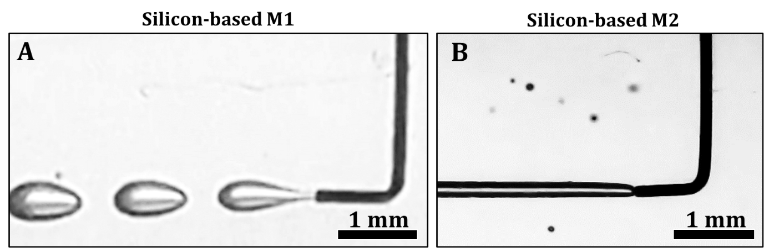
Fig. S1 3DAirP with a bent nozzle in silicone-based materials. (A) Formation of separate elliptical bubbles stretched in the direction of printing in a silicone-based M1. (B) Formation of a straight uniform channel in a silicone-based M2.

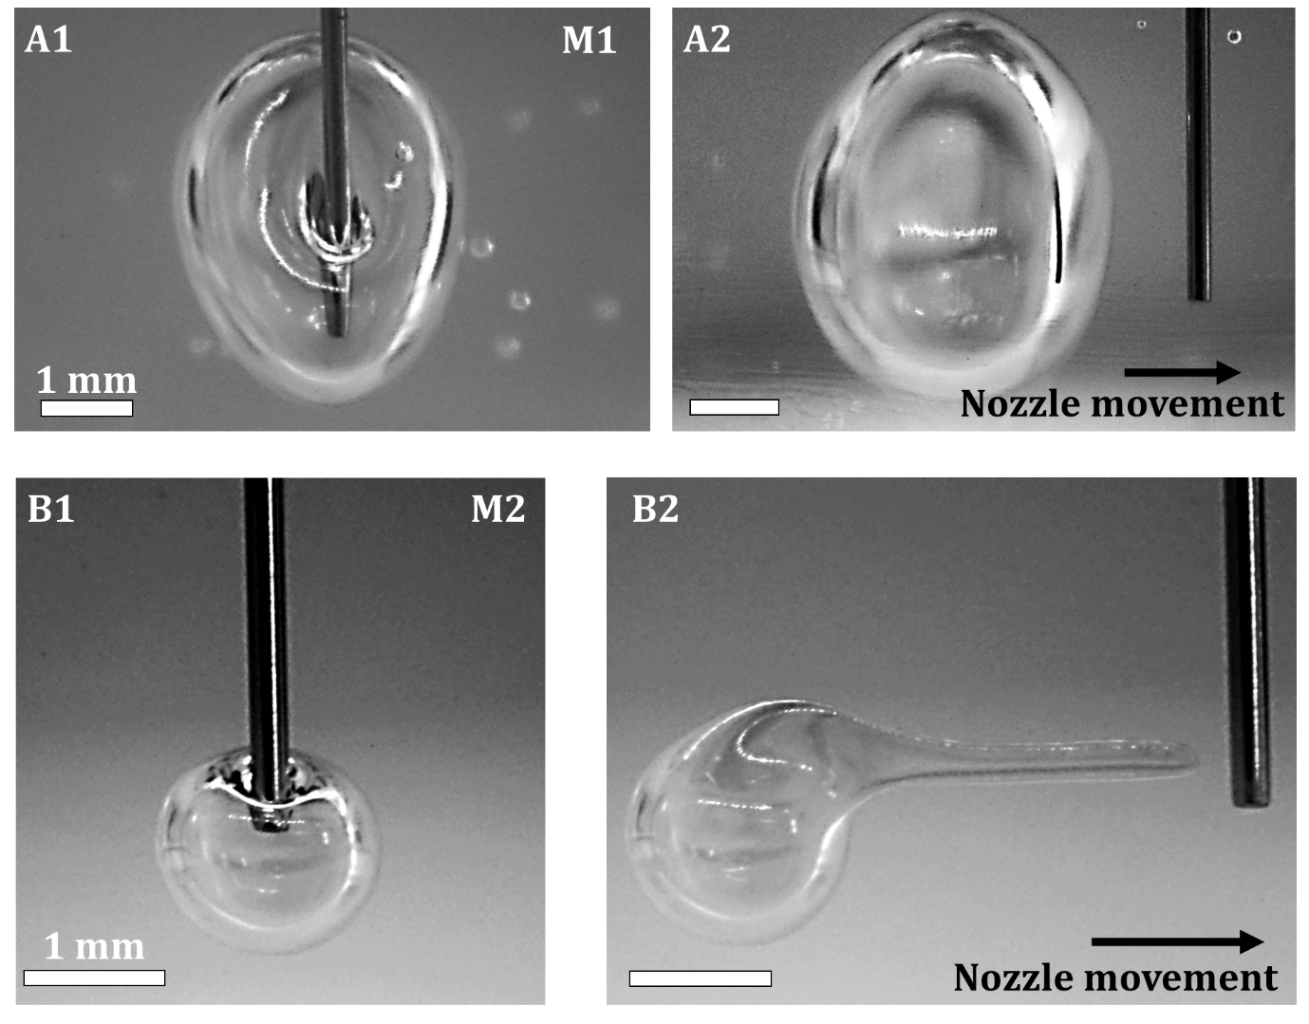
Fig. S2 Air bubble formation and their deformation under moving nozzle in a silicone-based M1 and M2. (A) Air bubble formation in M1. (B) The bubble holds its shape and stays nearly spherical, and the nozzle gets immediately separated from the bubble upon its movement. (C) Air bubble formation in M2. (D) The bubble deforms along the direction of the nozzle movement and can sustain a non-spherical shape.

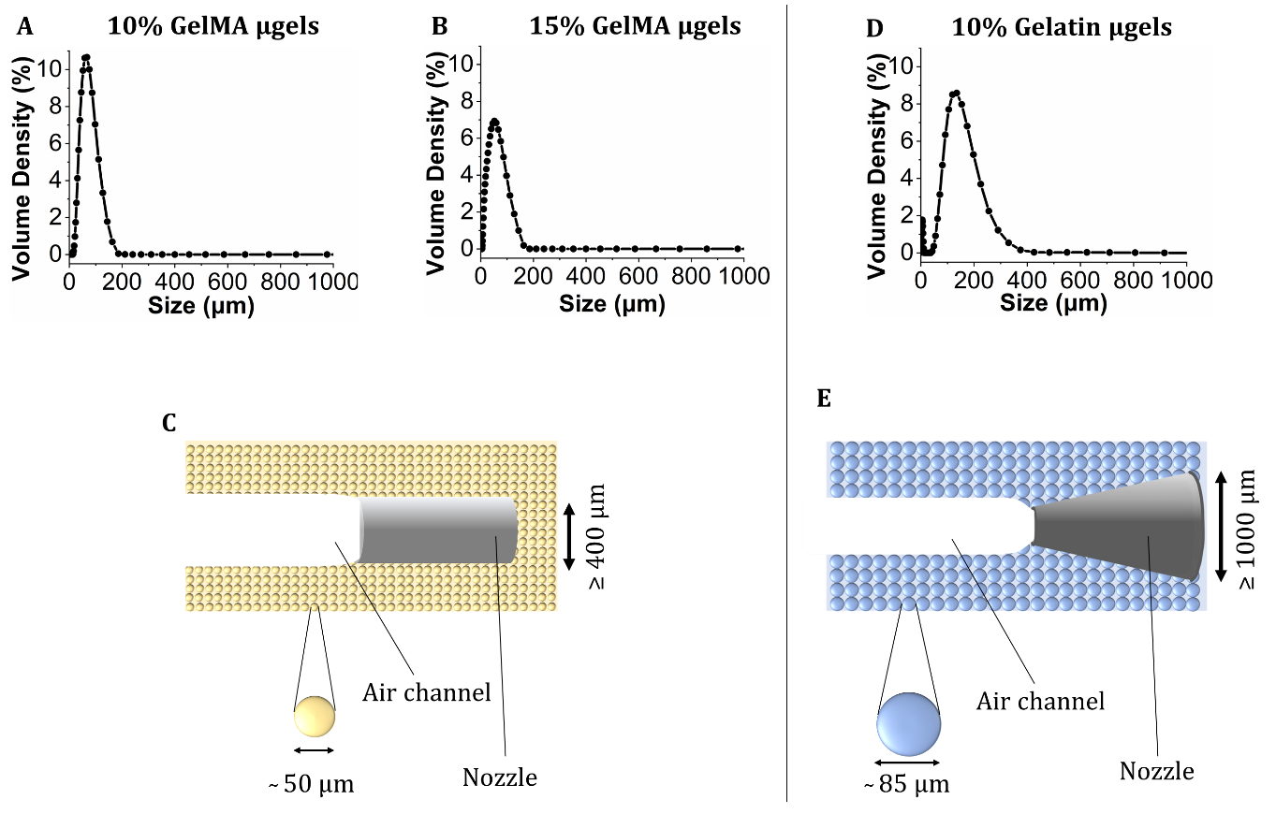
Fig. S3 Particle size distribution of (A) 10% (w/v) and (B) 15% (w/v) GelMA µG. (C) Schematics showing a nozzle of diameter of ≥ 400 µm was needed for 3DAirP in µG with an average size of 50 µm. (D) Particle size distribution of 10% (w/v) gelatin µG. (E) Schematics showing a nozzle of diameter of ≥ 1000 µm was needed for 3DAirP in µG of average size 85 µm.
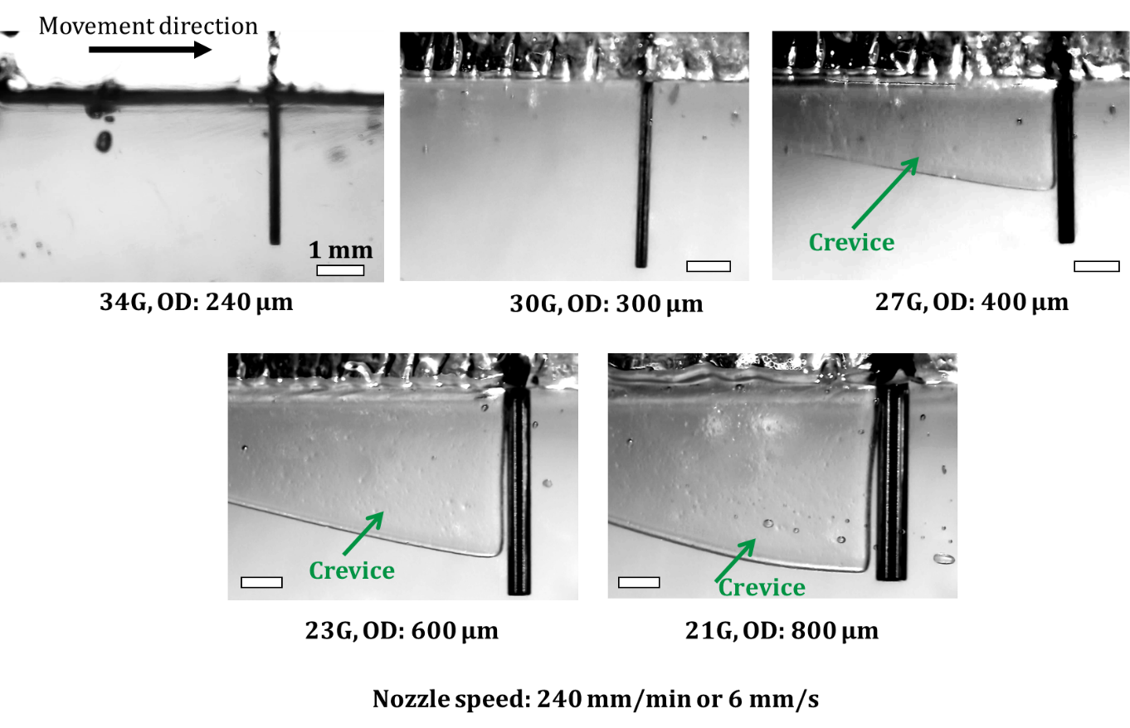
Fig. S4 Crevice formation in a silicone-based M2 with different nozzles moving at a constant speed of 240 mm/min. Nozzles from 34G to 21G were tested and crevice formation behind them during their movement was observed. Observations demonstrated no crevice formation occurred when nozzle outer diameter was less than 300 µm. Beyond 300 µm, the crevice height increased with increase in nozzle diameter.

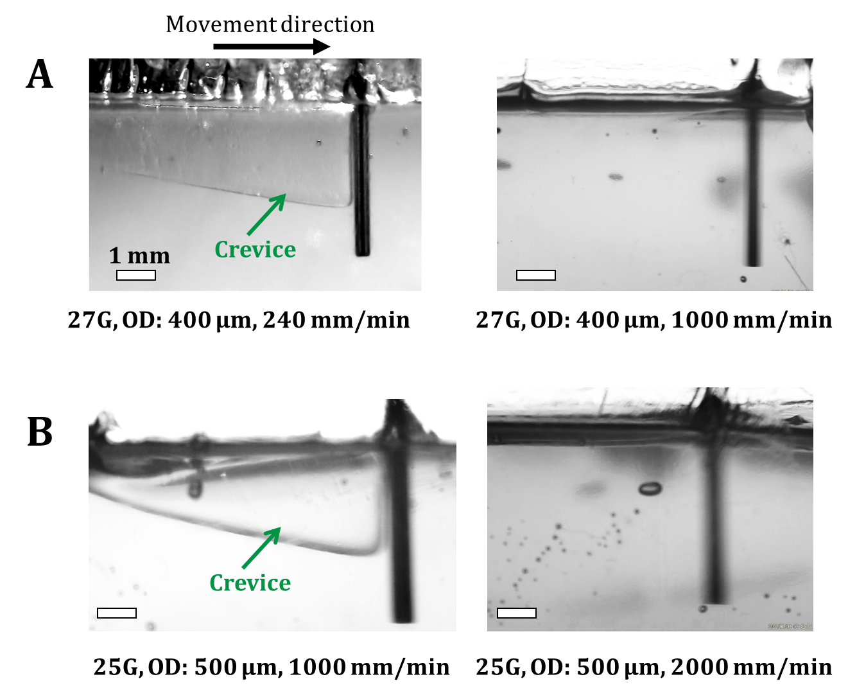
Fig. S5 Crevice formation in a silicone-based M2 with constant nozzle diameter moving at different speeds. Observations suggested that (A) nozzle with outer diameter of 400 µm created crevice at speed ≤ 240 mm/min, while moved without crevice formation beyond that speed. (B) A nozzle with outer diameter of 500 µm created crevices at speed ≤ 1,000 mm/min while it moved without crevice formation beyond that speed.

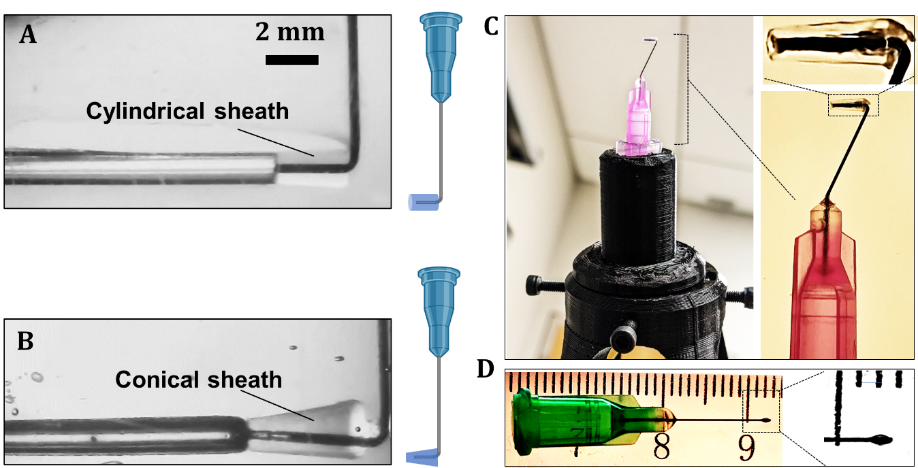
Fig. S6 Customized nozzle for 3DAirP. (A1) 3DAirP with a 34G bent nozzle equipped with cylindrical sheath. (A2) Schematic of a bent nozzle having a cylindrical sheath attached to its horizontal segment. (B1) 3DAirP with a 34G bent nozzle equipped with conical sheath. (B2) Schematic of a bent nozzle having a conical sheath attached to its horizontal segment. (C) Printing head designed for 6-axis robot. The design allows for x-y manipulation such that the nozzle tip aligns with the x-y origin of the robot. (D) A custom-made ball nozzle using a 34G needle intended for 3DAirP with conventional 3D printers.

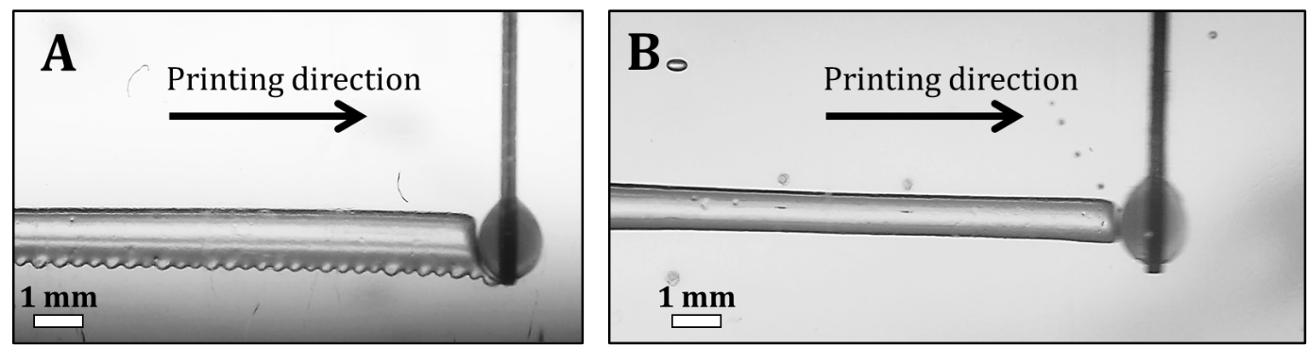
Fig. S7 Air3DP using a conventional 3D printer in a silicone-based M2 with a ball nozzle, fabricated with a 34G needle. The results demonstrated (A) a uniform channel with a rete peg pattern at low nozzle speed of 300 mm/min, (B) uniform smooth channel at higher nozzle speed of 2,000 mm/min.

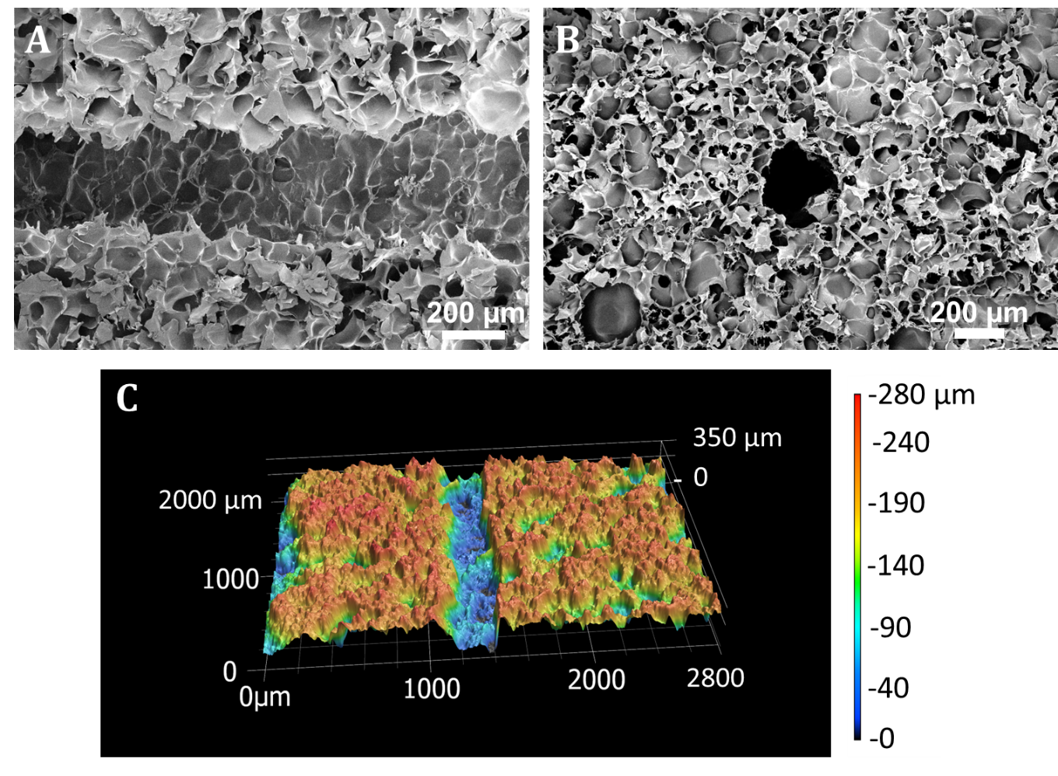
Fig. S8 Surface characterization of a gelatin-based M2. (A) Axial and (B) radial cross-sections of a channel produced with 3DAirP demonstrating the porous structure of the gel. (C) Profilometry surface characterization image demonstrating surface roughness.

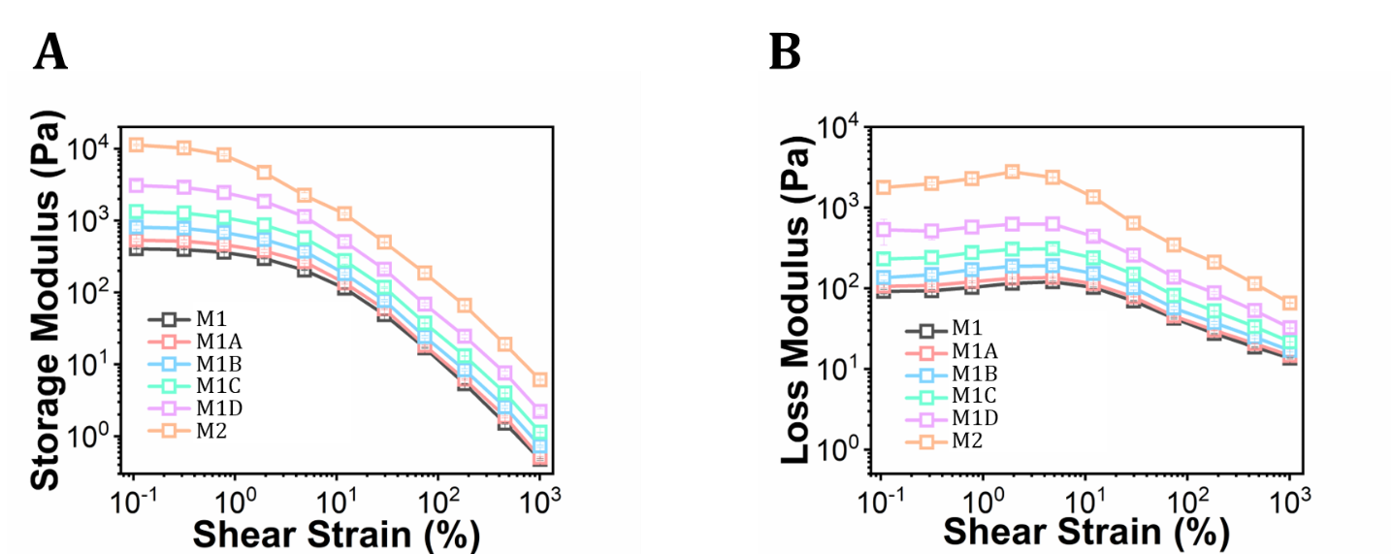
Fig. S9 (A, B) Amplitude sweeps of silicone-based materials from M1 to M2 with four intermediate material formulations demonstrating both storage and loss modulus increase from M1 to M2. These tests suggest that all the material formulations demonstrate yield stress properties with increasing values of yield stress from M1 to M2.

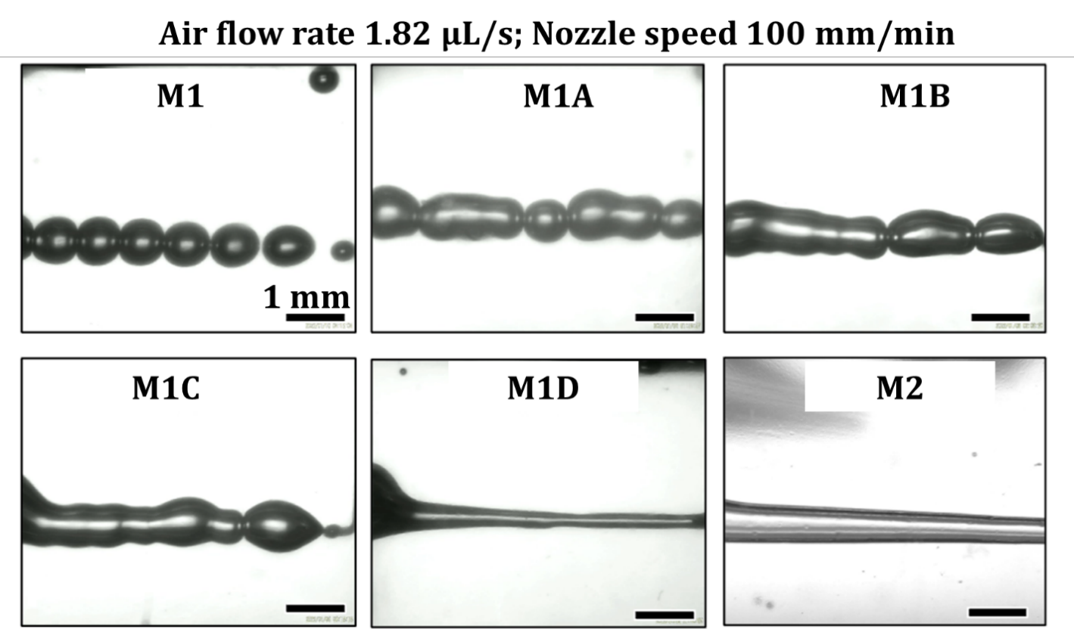
Fig. S10 3DAirP with a 34G bent nozzle in different material formulations from M1 to M2 at an air flow rate of 1.82 µL/s and nozzle speed of 100 mm/min. The results exhibited formation of separate spherical bubbles in M1, merged neighboring bubbles in M1A and M1B, irregular channel segments in M1C, and channels in M1D and M2.

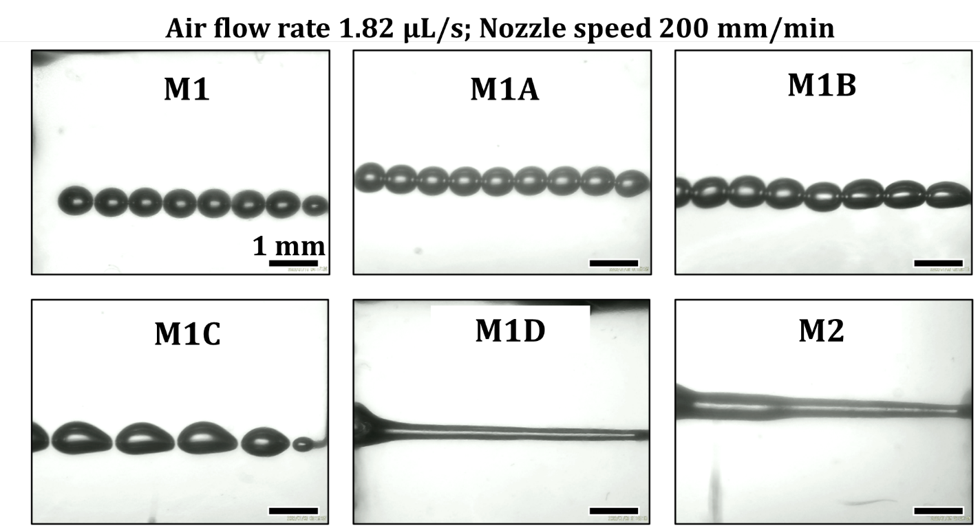
Fig. S11 3DAirP with a 34G bent nozzle in different material formulations from M1 to M2 at an air flow rate of 1.82 µL/s and a nozzle speed of 200 mm/min. The results exhibited formation of separate spherical bubbles in M1, M1A and M1B, elongated bubbles in M1B and M1C, and channel formation in M1D and M2.
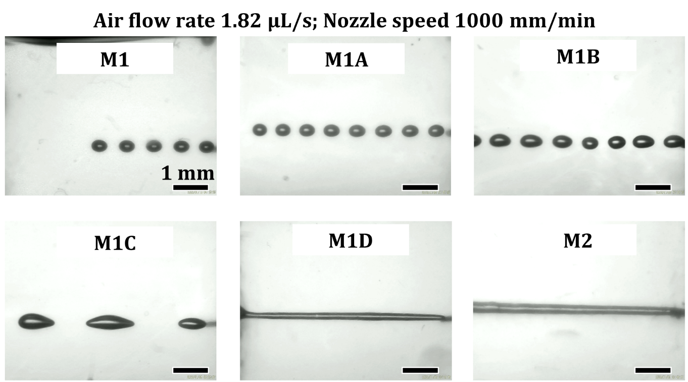
Fig. S12 3DAirP with a 34G bent nozzle in different material formulations from M1 to M2 at an air flow rate of 1.82 µL/s and nozzle speed of 1,000 mm/min. The results exhibited formation of separate spherical bubbles in M1 and M1A, slightly elongated bubbles in M1B, highly elongated bubbles in M1C, and channels in M1D and M2.
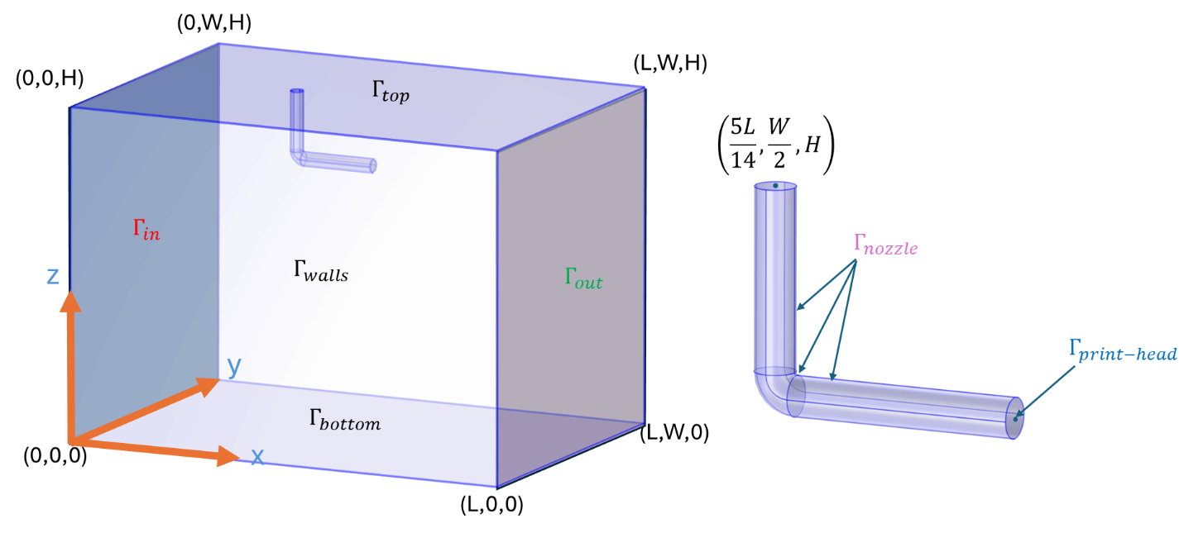
Fig. S13: CAD geometry of a 3DAirP nozzle in a support bath with an enlarged view of the nozzle.

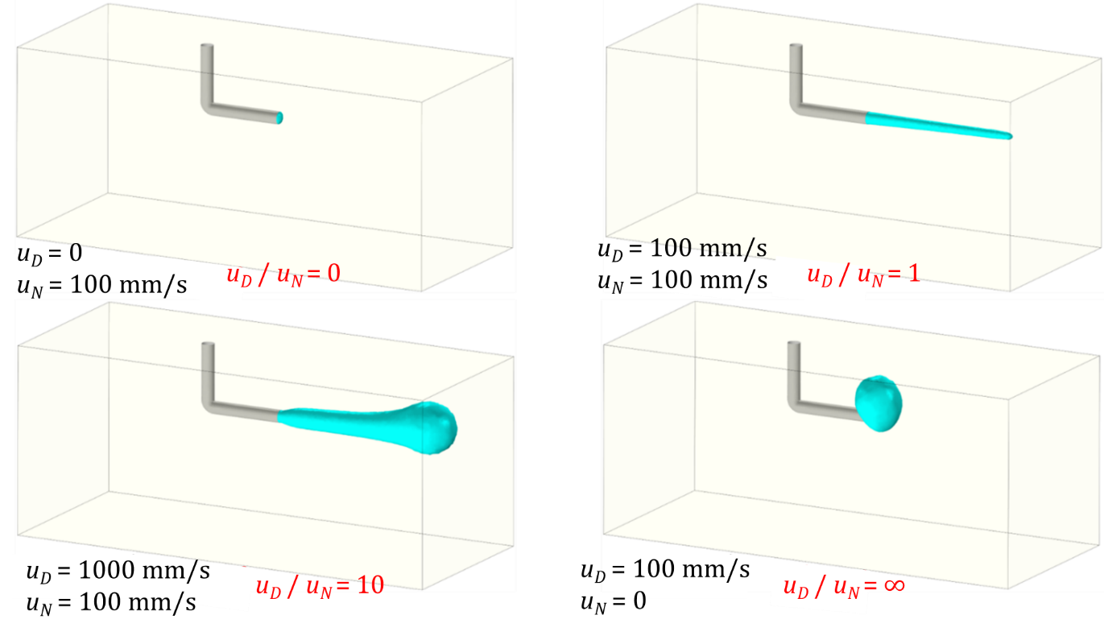
Fig. S14: 3DAirP simulations at different printability numbers (PN: ratio of air dispensing speed (u_{D}) to nozzle speed (u_{N})) demonstrating variation in channel diameter.

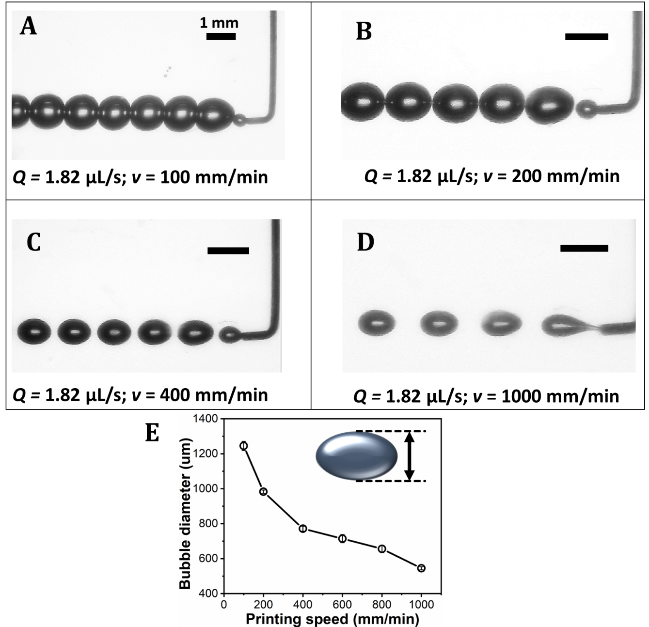
Fig. S15 Air3DP of bubbles in a silicone-based M1 at different nozzle speeds and a constant flow rate. (A) Nozzle speed of 100 mm/min resulted in spherical bubbles with neighboring bubbles in contact with each other. (B) Nozzle speed of 200 mm/s resulted in near spherical bubbles close to each other. (C) Nozzle speed of 400 mm/min resulted in elliptical bubbles equidistant from each other. (D) Nozzle speed of 1,000 mm/min resulted in elliptical bubbles equidistant from each other with larger gaps in between them. (E) Relationship between nozzle speed and bubble diameter demonstrating decrease in the bubble diameter with increased printing speed (n = 5).

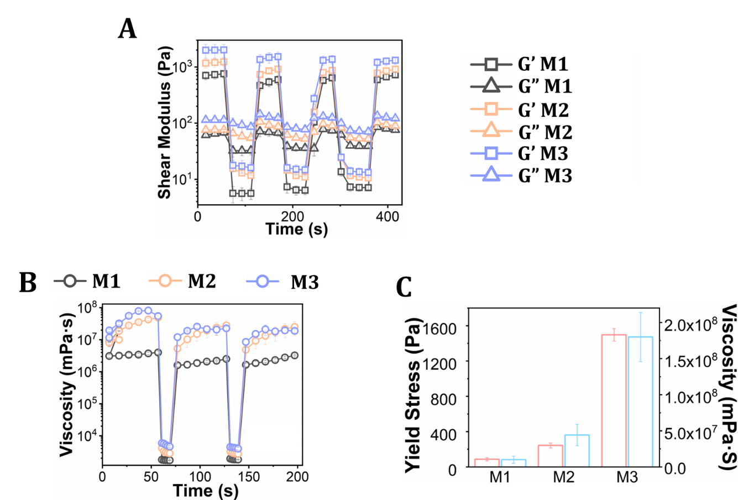
Fig. S16 Rheological characterization of gelatin-based materials (M1, M2, and M3) (n = 3). (A) A self-recovery test at cyclic high and low shear strains demonstrated that all materials recovered completely. (b) Self-healing test that demonstrated all materials healed completely after exposing them to cyclic high and low shear rates. (C) A plot of yield stress and viscosity demonstrated that both increased from M1 to M3.

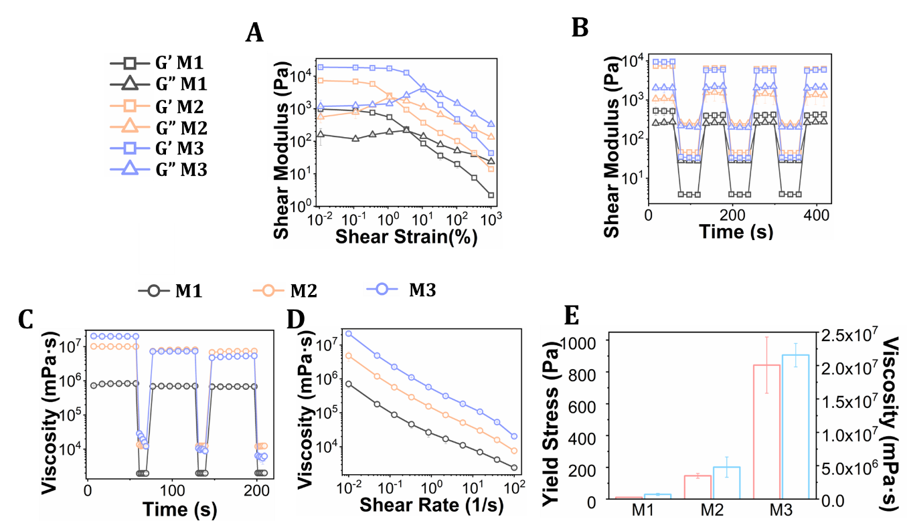
Fig. S17 Rheological characterization results for GelMA-based materials (M1, M2, and M3) (n = 3). (A) Amplitude sweep test demonstrated the variation in storage and loss moduli with shear strain. The data indicated that all the materials possessed yield stress properties, and the shear moduli increased from M1 to M3. (B) Self-recovery test results demonstrated complete recovery of storage and loss moduli for all materials M1, M2, and M3. (C) Self-healing test results demonstrated near complete healing of M1 and M2, while partial healing of M3. (D) Flow curve test results demonstrated all materials possessed shear thinning properties and the viscosity increased from M1 to M3. (E) Yield stress and viscosity of GelMA-based materials demonstrated their increasing values from M1 to M3.

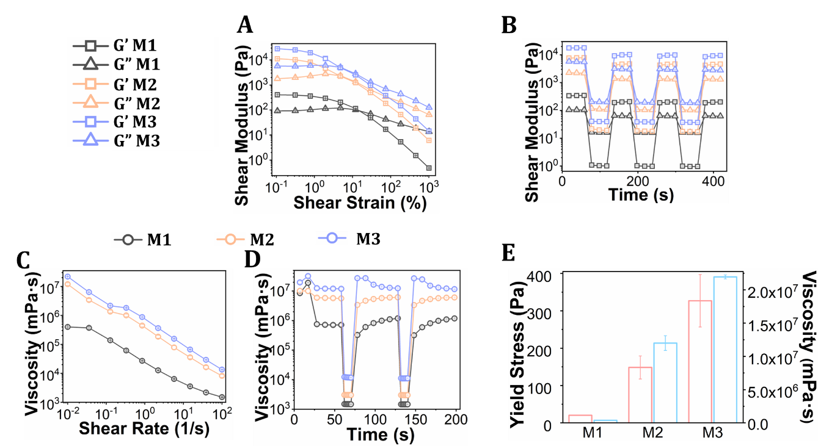
Fig. S18 Rheological characterization results for silicone-based materials (M1, M2, and M3) (n = 3). (A) An amplitude sweep test demonstrated all materials possessed yield stress properties. It also indicated an increase in storage and loss moduli from M1 to M3. (B) Self-recovery test validated complete recovery of all the materials. (C) Flow curve test measured viscosity under increasing shear rate and showed that all materials possessed shear thinning behavior, with viscosity increasing from M1 to M3. (D) Self-healing test under cyclic shear rates demonstrated all the materials self-healed completely. (E) Yield stress and viscosity plots showed that their values increased from M1 to M3.

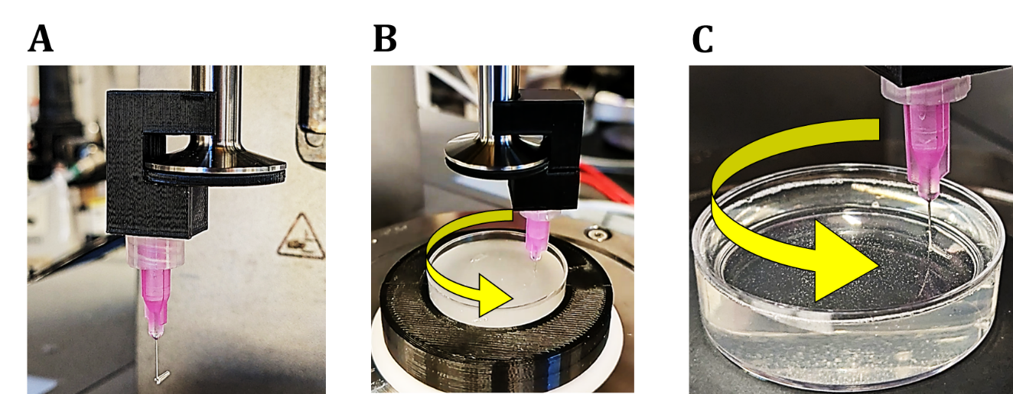
Fig. S19 Gel tearing test. A new test was designed to analyze the tearing of gels due to nozzle movement. (A) A photograph showing a nozzle holder attached to a 25-mm parallel plate of a rheometer, with a nozzle attached to it at the bottom. The bent segment of the nozzle was oriented such that it followed the tangential direction of the plate. Gel tearing test under action in (B) gelatin-based and (C) silicone-based materials.

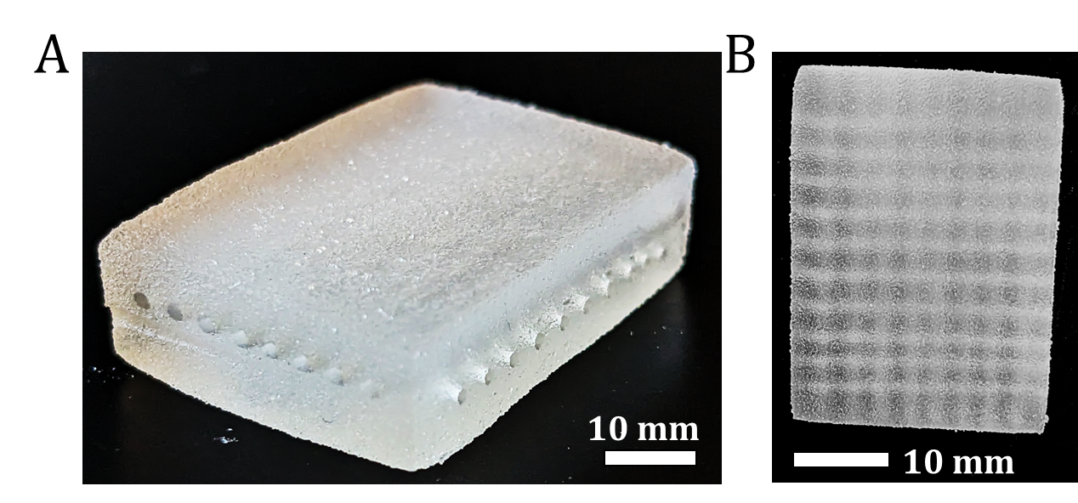
Fig. S20 3DAirP of two-layered 90° matrix in a gelatin-based M2 comprising of 10×8 straight channels.

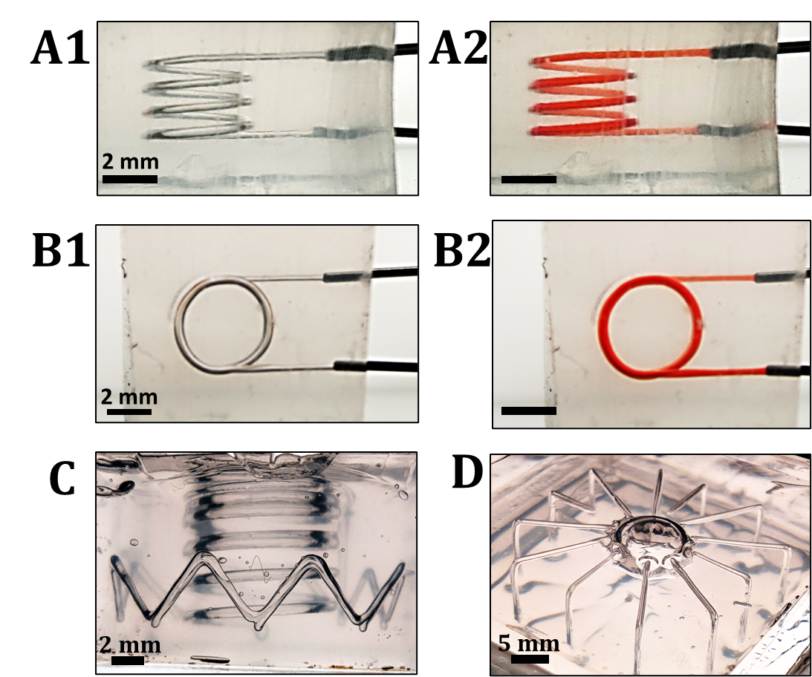
Fig. S21 3D complex-shaped air channels. (A1, A2) Side and (B1, B2) top view of 3D spiral shaped air channel of diameter ≈250 µm, printed inside a silicone-based M2, followed by crosslinking and perfusion with a red colored. (C) A 3D spiral air channel inside a 3D crown, (D) twelve uniform channel branches coming out from a central bubble.

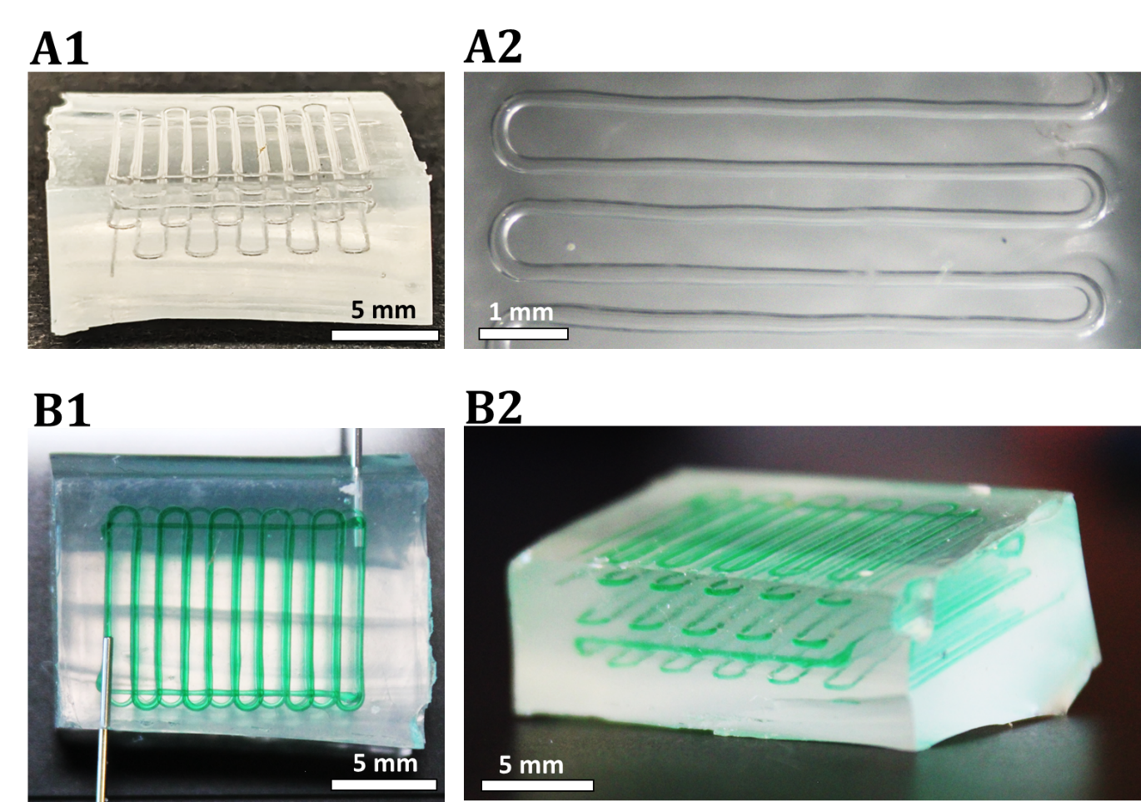
Fig. S22 Photos of a 3D serpentine of a uniform air channel of diameter ≈200 µm, having three layers, printed inside a silicone-based M2 followed by crosslinking and perfusion with a green colored dye.

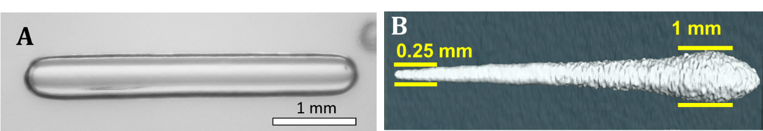
Fig. S23 Air channels closed from both ends, a capability of 3DAirP that advances over other conventional embedded printing techniques. (A) A photograph of a uniform channel, closed on both sides, in a silicone-based M2. (B) An µCT image of a tapered channel, closed on both sides, in a gelatin-based M2.

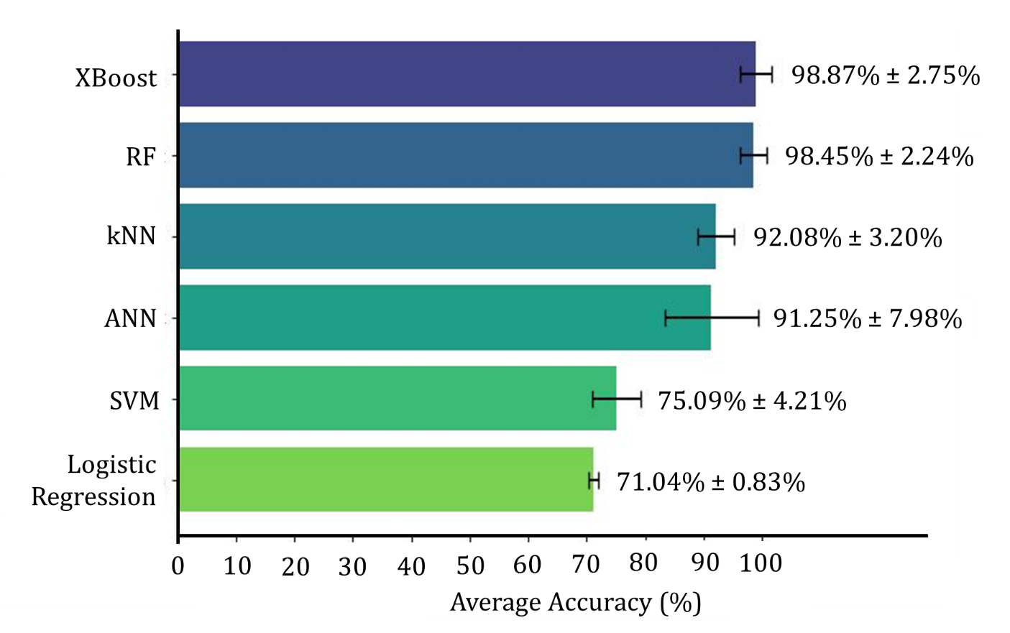
Fig. S24: Average accuracy and standard deviation for each ML model algorithm in predicting air printability.

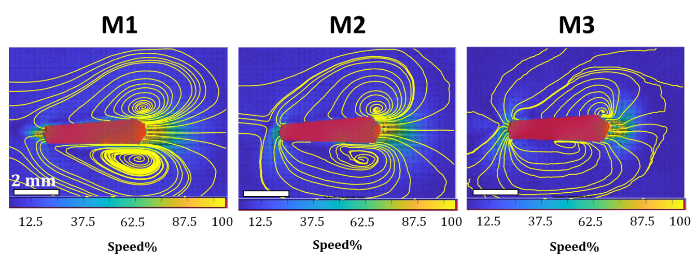
Fig. S25 PIV analyses results of gelatin-based materials. Streamlines in M1 and M2 showed vortices formation near the nozzle. These data were used to study the disturbances in the material around the nozzle caused by its movement. M3 demonstrated irregular contours of streamlines suggesting that the material did not behave like fluid.

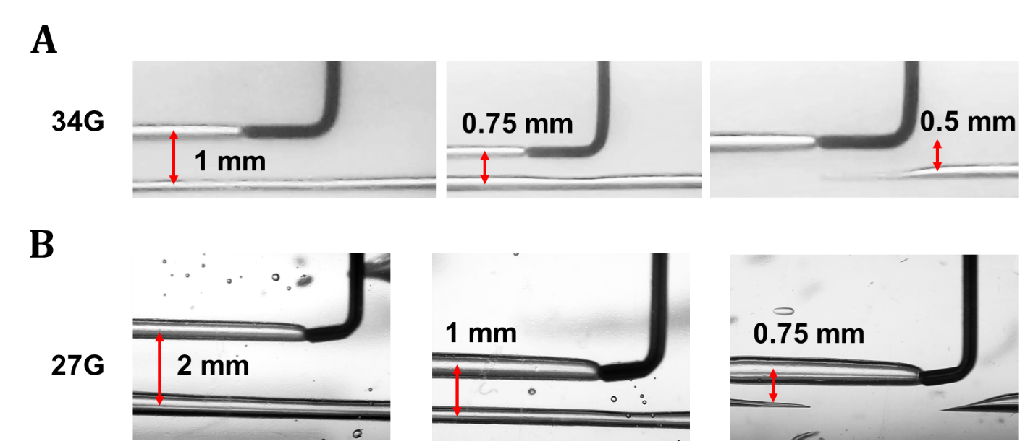
Fig. S26 Printing parallel channels. Fluidization around the moving nozzle disturbs the neighboring channel, which limits the minimum proximity between two channels. (A) 34G and (B) 27G bent nozzles could print parallel channels with a gap ≥ 0.5 mm and ≥ 0.75 mm, respectively, without inducing any permanent deformation into the previously printed channel.
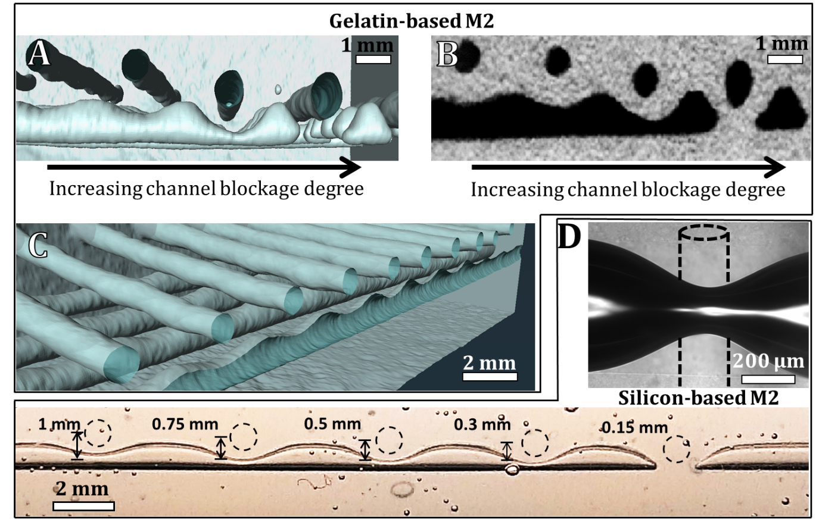
Fig. S27 Patterned channels. A channel printed in proximity and perpendicular to a previously printed channel could induce deformation in the previous channel. This deformation caused a local decrease in diameter, which can be controlled to achieve patterned channels. (A) An µCT image showing perpendicular channels printed inside a gelatin-based M2 with a 34G nozzle equipped with a sheath. The deformation in the diameter of the bottom horizontal channel was governed by changing the distance between horizontal and perpendicular channels. (B) An x-z slice from µCT images to measure the deformation ratio. (C) A uniform deformation induced by multiple perpendicular channels resulted in a sinusoidal patterned channel, shown with its µCT image. (D) Channel deformation induced in a silicone-based M2 by extruding material on top of a pre-printed air channel. (E) Gradual decrease in distance between the pre-printed air channel and deposited material to achieve precise channel blockage.
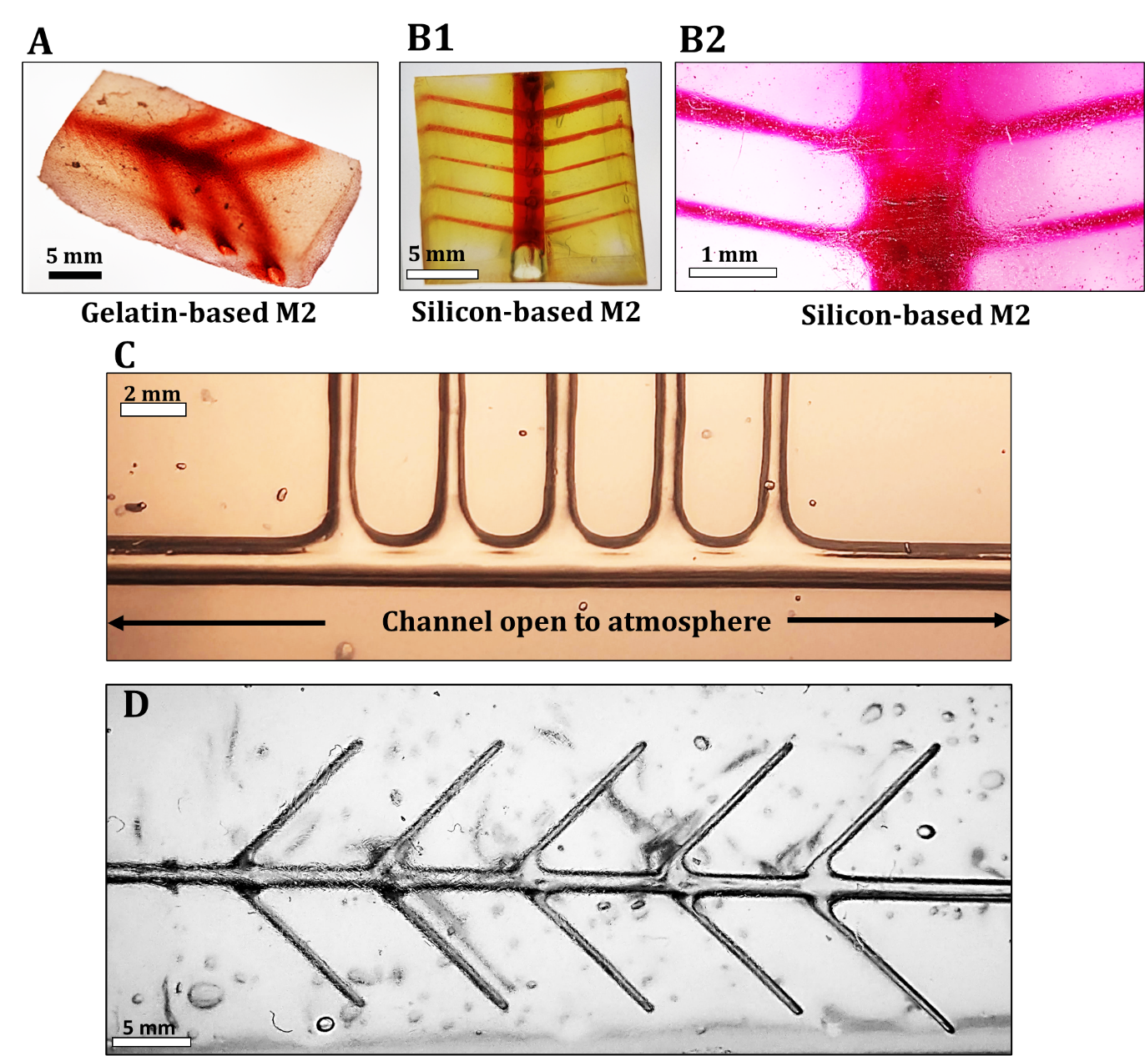
Fig. S28 Air printed branched channels. (A) Branched channels in a GelMA-based M2 with central main channel diameter of 1.5 mm, and branch diameter of 1 mm, perfused with red colored dye. (B1-B2) Branched channels in a silicone-based M2 with central main channel diameter of 1.25 mm and branch diameter of 200 µm, perfused with a red colored dye. (C-D) Branching achieved with air aspiration from the main channel, which is open to atmosphere, demonstrated in a silicone-based M2.

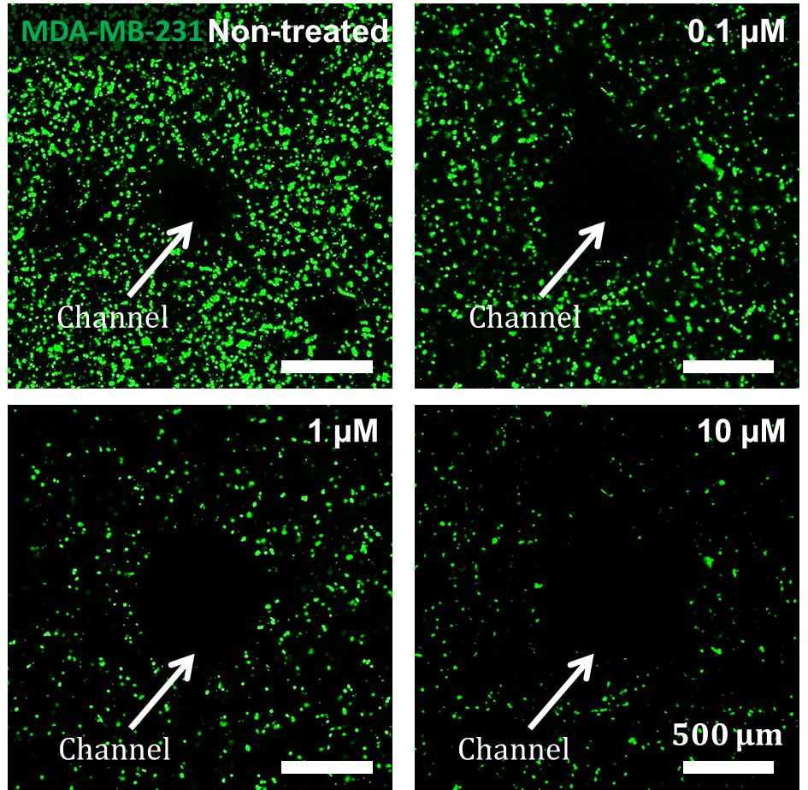
Fig. S29 Drug testing model. 3DAirP in an MDA-MB-231 breast cancer-laden GelMA-based M2 to create a channel of diameter ≈500 µm. Upon incubation under perfusion with DOX of predefined concentration for 3 days, the cancerous cell death was observed under confocal microscopy and found increasing with increased DOX concentration.

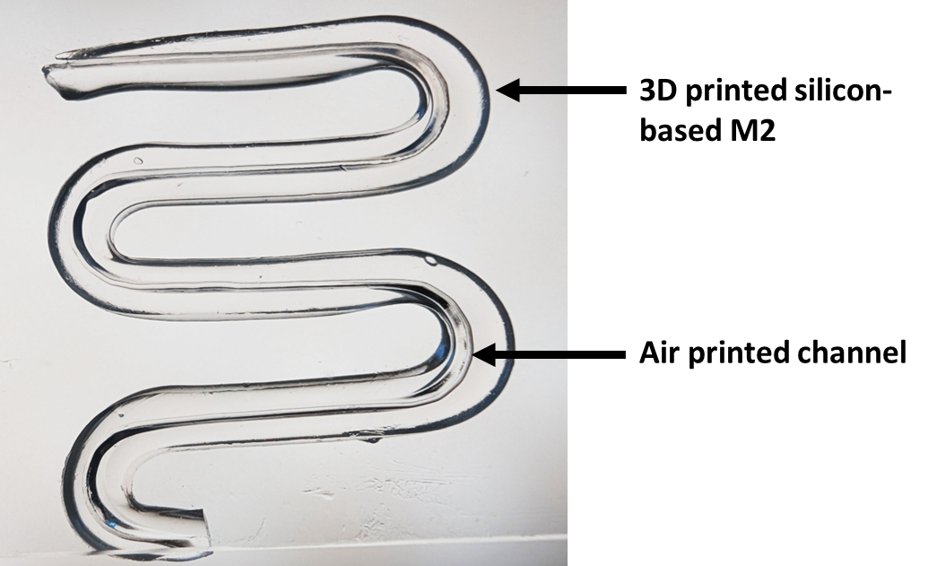
Fig. S30 Integration of 3DAirP with extrusion-based printing. First, a silicone-based M2 was 3D printed using a conventional 3D printer. It was followed by 3DAirP aligning with the 3D printed design to develop a perfusable 3D printed structure.

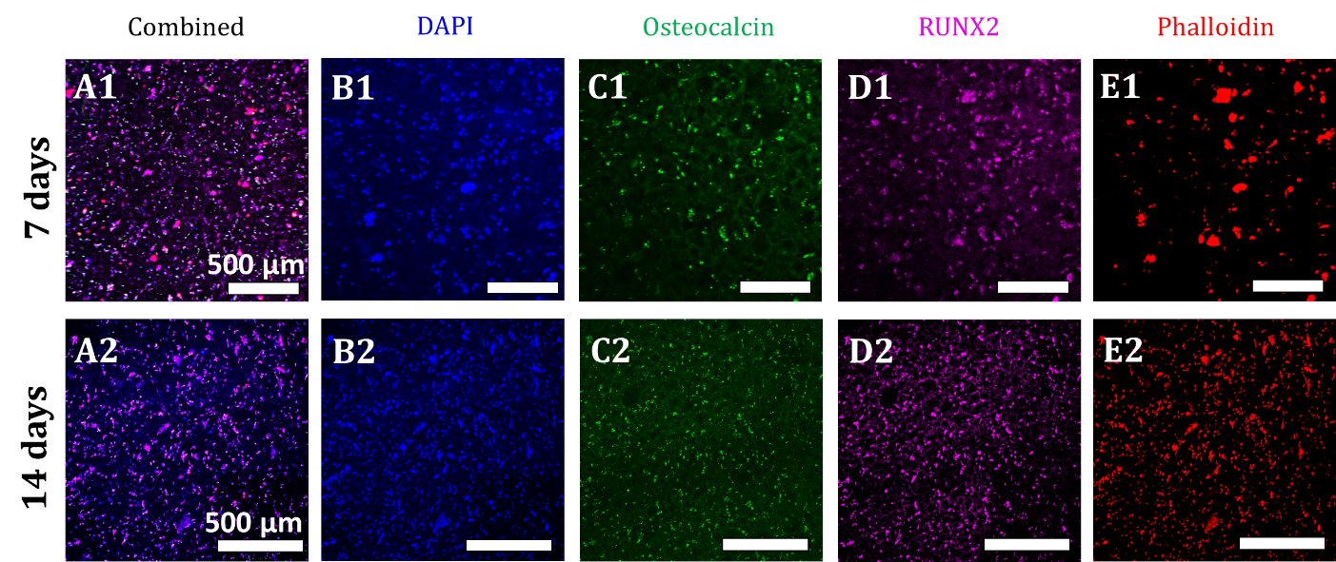
Fig. S31 Confocal images of miR-196a-5p transfected human bone mesenchymal stem cells (hBMSCs) differentiated into the osteogenically within a GelMA-based M2, maintained under static conditions. Images were taken after 7 and 14 days, showing combined staining (A1, A2), staining of DAPI (B1, B2), osteocalcin (C1, C2,) RUNX2 (D1, D2), and phalloidin (E1, E2).

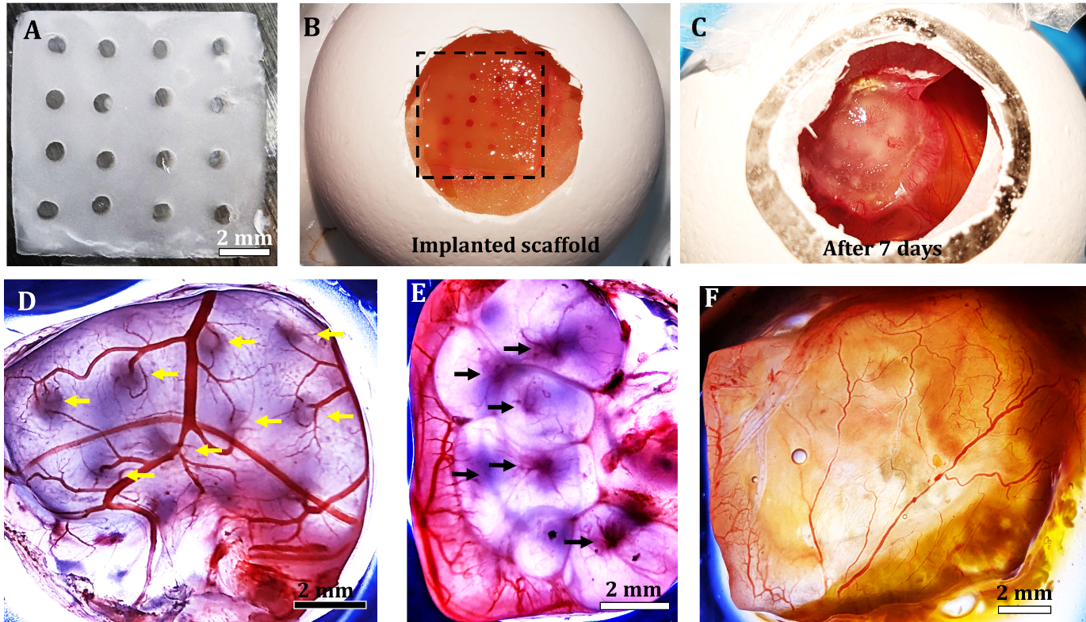
Fig. S32 In-ovo CAM assay. (A) A construct with 16 channels. (B) Construct implanted on egg CAM membrane. (B) Construct after 7 days of implantation, demonstrating the integration of the construct with surrounding tissue. The infiltration of vessels into the channels is shown in (D) with yellow arrows pointing to blood vessels going into the channels, and (E) black arrows pointing to blood vessels coming out from the channels from the other side. (F) Control construct (without channels) was encapsulated by the soft tissue and neo-vessels growing over the surface with minimal infiltration inside the construct.

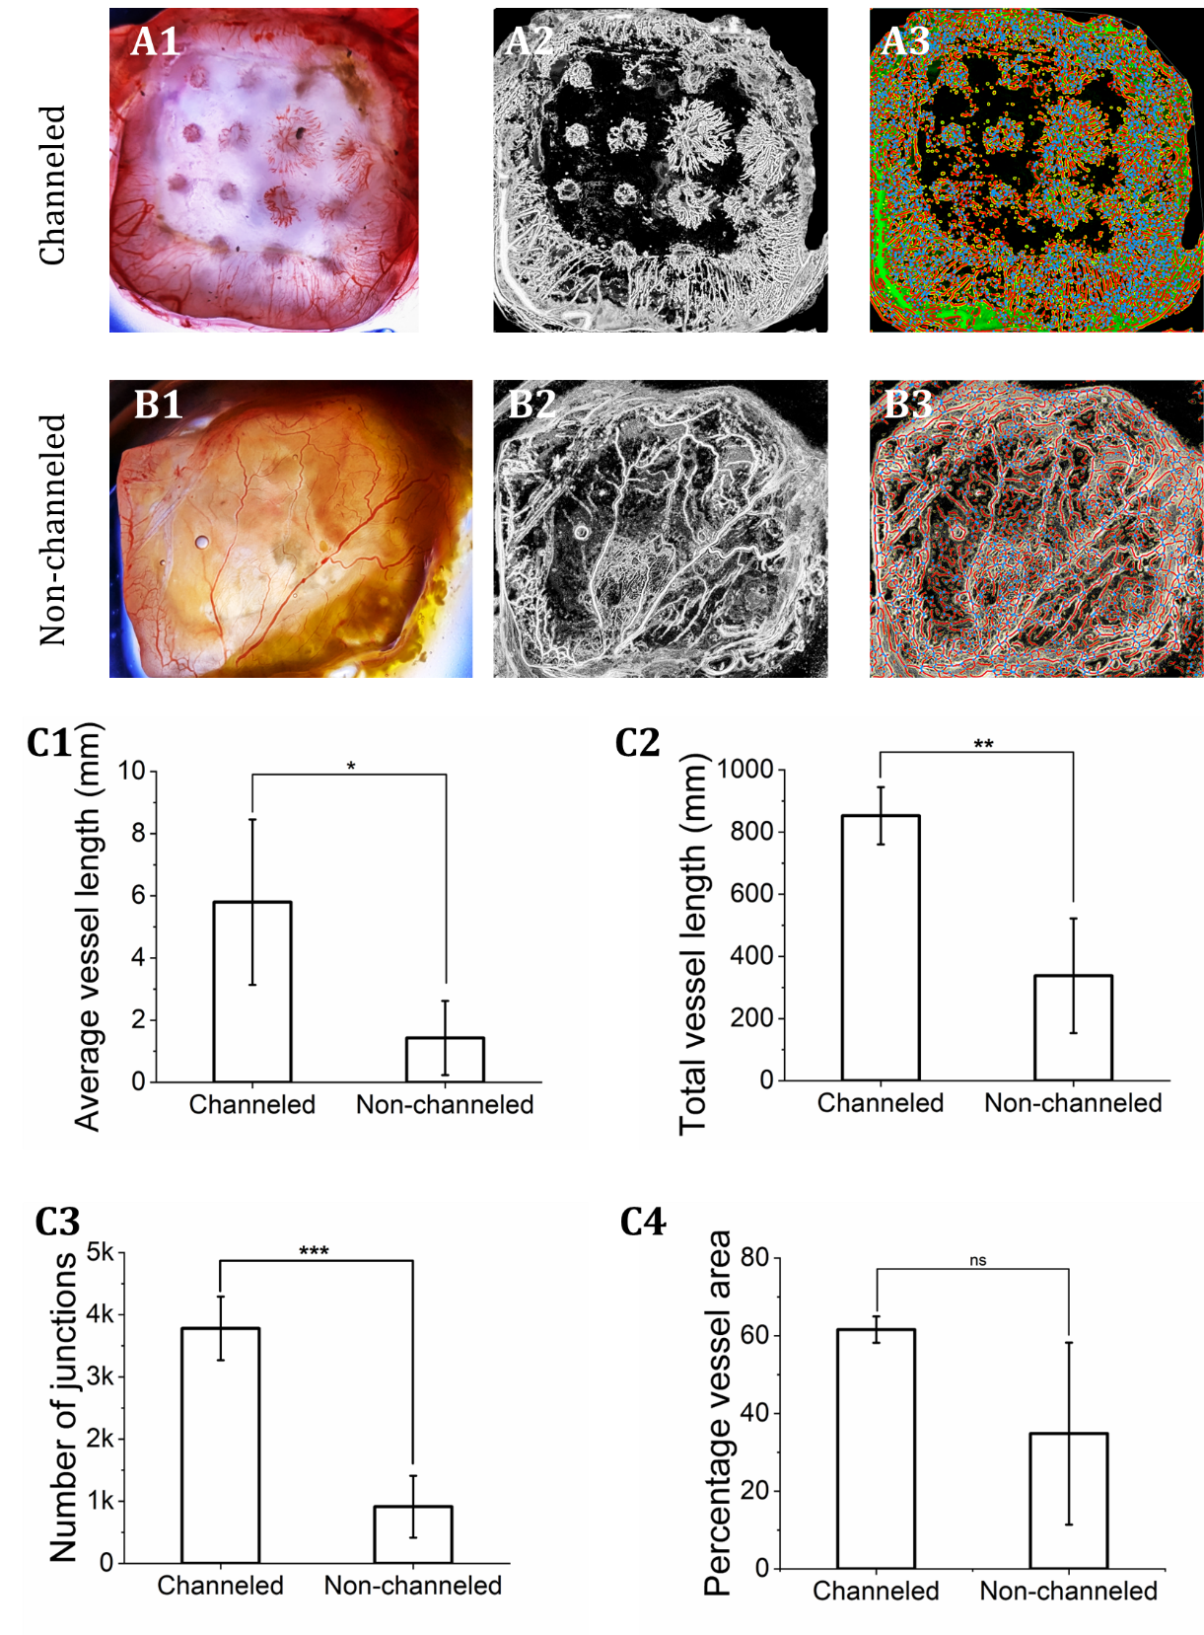
Fig. S33 Quantitative analysis of in-ovo CAM assay using ImageJ and AngioTool. Processed images of a channeled (A1-A3) and non-channeled construct (B1-B3). The average and total length of vessels grown on channeled constructs were significantly higher than non-channeled scaffolds (C1 and C2). The percentage construct area covered by vessels did not show significant difference (C3). The total number of vessel junctions were significantly higher in channeled constructs as compared to non-channeled ones (C4). Data were presented as mean ± SD, n ≥ 3, where *p < 0.05, **p < 0.01, ***p < 0.001, “ns” represents non-signiﬁcant.
Movie S1
3DAirP with a ball nozzle in a silicone-based M2. It created channels with rete peg patterns at low printing speeds (300 mm/min) and smooth, continuous channels at high speeds (2000 mm/min). Video playback speed: 1X and 0.25X.
Movie S2
3DAirP in silicone-based M1 to M2 and four intermediate material formulations namely M1A, M1B, M1C, and M1D. The printing was performed with 34G bent nozzle. The nozzle speed varied from 100 to 1000 mm/min. Video playback speed: 1X.
Movie S3
3DAirP bubbles in a silicone-based M1 with ball nozzle. The nozzle speed was varied to control the bubble size. Matrices of bubbles of uniform size, gradient sizes, and alternate sizes were achieved. Video playback speed: 1X and 0.5X.
Movie S4
3DAirP to create a 3D spiral made of uniform sized bubbles in a silicone-based M1. The printing was performed using a ball nozzle and a conventional 3D printer. Video playback speed: 1X.
Movie S5
Demonstration of reversible 3DAirP. Single or multiple bubbles were shown to be aspirated back into the nozzle to make the material ready for subsequent 3DAirP. Video playback speed: 1X and 2X.
Movie S6
Perfusion of green and blue colored dye through a 3DAirP uniform air channel serpentine loop within a silicone-based M2 made with bent nozzle and ball nozzle, respectively. Video playback speed: 2X.
Movie S7
3DAirP of a spiral-shaped uniform air channel in a silicone-based M2. The printing was performed using 1) a 34G bent nozzle fit with a 6-axis robot, and 2) a ball nozzle fit with a conventional 3D printer. Video playback speed: 1X.
Movie S8
µCT data demonstrating uniform sinusoidal patterns in the horizontal channels. The pattern was induced by printing perpendicular channels at uniform distance.
Movie S9
Branching of air printed channels. The nozzle was brought into or close to the pre-printed channel and new branches were created. Video playback speed: 2X.
Movie S10
Branching of air printed channels using aspiration. The aspirating nozzle was brought close to the pre-printed channel, which was open to atmosphere, and new branches were laid down following the nozzle direction. Video playback speed: 2X.
Movie S11
Diffusion into GelMA-based M2. PBS added with red dye was perfused and its radial diffusion into the gel over time was recorded. Video playback speed: 64X.
Movie S12
Aspiration-assisted bioprinting of spheroids near an air printed channel. Video playback speed: 17.5X.
Movie S13
Branching of air printed channels using aspiration with needles of different radii. Video playback speed: 1X.

Supplementary References

1 Pal, V. et al. High-throughput microgel biofabrication via air-assisted co-axial jetting for cell encapsulation, 3D bioprinting, and scaffolding applications. Biofabrication 15, 035001 (2023).
2 Kim, K. et al. Optimized single-step optical clearing solution for 3D volume imaging of biological structures. Communications Biology 5, 431 (2022).
3 Brenner, S. C. & Scott, L. R. The mathematical theory of finite element methods. (Springer, 2008).
4 Zhou, Z.-H. Machine learning. (Springer nature, 2021).
5 Gaye, B., Zhang, D. & Wulamu, A. Improvement of support vector machine algorithm in big data background. Mathematical Problems in Engineering 2021, 5594899 (2021).
6 Freeman, E. A., Moisen, G. G., Coulston, J. W. & Wilson, B. T. Random forests and stochastic gradient boosting for predicting tree canopy cover: comparing tuning processes and model performance. Canadian Journal of Forest Research 46, 323-339 (2016).
7 Chen, T. & Guestrin, C. in Proceedings of the 22nd ACM sigkdd International Conference on Knowledge Discovery and Data Mining. 785-794.
8 Kurt, I., Ture, M. & Kurum, A. T. Comparing performances of logistic regression, classification and regression tree, and neural networks for predicting coronary artery disease. Expert Systems with Applications 34, 366-374 (2008).
9 Kramer, O. Dimensionality reduction with unsupervised nearest neighbors. Vol. 51 (Springer, 2013).
10 Abiodun, O. I. et al. Comprehensive review of artificial neural network applications to pattern recognition. IEEE Access 7, 158820-158846 (2019).

