Supplementary Tables
Table S1. List of primers used in this study.
Table S2. Summary of SUVsum and relative lactate levels in xenografts from each metabolic imaging experiment.
Supplementary Figures
Figure S1. [¹⁸F]FDG uptake in CAM tumour xenografts.
Figure S2. Histological assessment of GBM-CAM tumours, in which no [¹⁸F]FDG uptake was noted but lactate was detected.
Figure S3. Representative MR spectra acquired from the GBM-CAM.
Figure S4. Histological characterisation of GBM-CAM tumour xenograft formed within the CAM, underneath the initial site of implantation.
Figure S5. CT values for housekeeping gene actin remained consistent between in vitro cell culture (2D) and CAM-xenografts, in normoxia and hypoxia conditions.

Table S1. List of primers used in this study. Primers were designed to be human specific so as not to cross react with chick CAM tissue.
Gene | Forward Primer (5'-3') | Reverse Primer (5'-3')
β-Actin | CACCTTCTACAATGAGCTGCGTGT | ATAGCACAGCCTGGATAGCAACGTAC
HIF-1α | ATAAAGTCTGCAACATGGAAGGT | TTTGATGGGTGAGGAATGGGTT
HIF-2α | CGGAGGTGTTCTATGAGCTGG | AGCTTGTGTGTTCGCAGGAA
VEGFA | CTCCACCATGCCAAGTGGTC | GCAGTAGCTGCGCTGATAGA
ADM | GGAAGAGGGAACTGCGGATGT | ACATCACTCTGGTGGGTATAG
GLUT1 | GTCCTTTGAGATGCTGATCC | GTGACACTTCACCCACATAC
PDK1 | ATTTTCCTCAAAGGAACGCC | CAACAGAGGTGTTTACCCCC
LDHA | GGAGATCCATCATCTCTCCC | GGCCTGTGCCATCAGTATCT

Table S2. Summary of SUVsum and relative lactate levels in xenografts from each metabolic imaging experiment.
0s included (n=25) |  | 0s excluded (n=8)
SUV_{sum} | Rel Lac | SUV_{sum} | Rel Lac
14.03699335 | 0 | 14.63104926 | 0.003335326
14.63104926 | 0.003335326 | 53.78914537 | 0.003651014
31.32948415 | 0 | 35.90169171 | 0.004599123
37.55262143 | 0 | 56.44217766 | 0.001813815
56.95857256 | 0 | 60.03736026 | 0.003676135
53.78914537 | 0.003651014 | 78.00183212 | 0.001874047
35.90169171 | 0.004599123 | 113.3078222 | 0.001652982
56.44217766 | 0.001813815 | 242.4085935 | 0.001222448
60.03736026 | 0.003676135
118.1992906 | 0
57.39336301 | 0
83.13018864 | 0
76.66806957 | 0
78.00183212 | 0.001874047
0 | 0.003512344
119.1493775 | 0
113.3078222 | 0.001652982
242.4085935 | 0.001222448
0 | 0
0 | 0
9.515798169 | 0
11.07322501 | 0
0 | 0
0 | 0
20.33171428 | 0

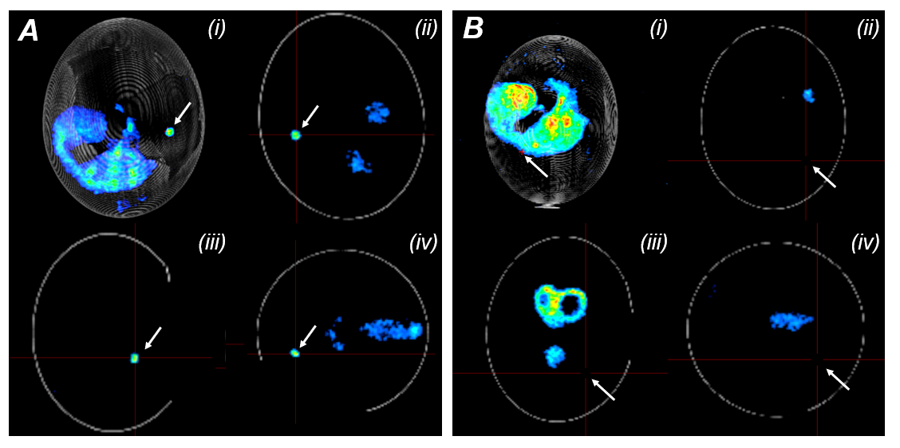
Figure S1. [¹⁸F]FDG uptake in CAM tumour xenografts. Representative [¹⁸F]FDG PET-CT images showing (A) a tumour xenograft with detectible FDG uptake and (B) a tumour without detectible FDG signal. Tumour position is marked using crosshairs (denoted by white arrows). For both examples, four imaging views are shown: (i) maximum intensity projection (MIP), (ii) sagittal, (iii) coronal, and (iv) transverse planes. Tumour location is indicated by white arrows, based on the known implantation site. These images highlight the variability in [¹⁸F]FDG uptake, including cases where the tumour is present but not metabolically active.

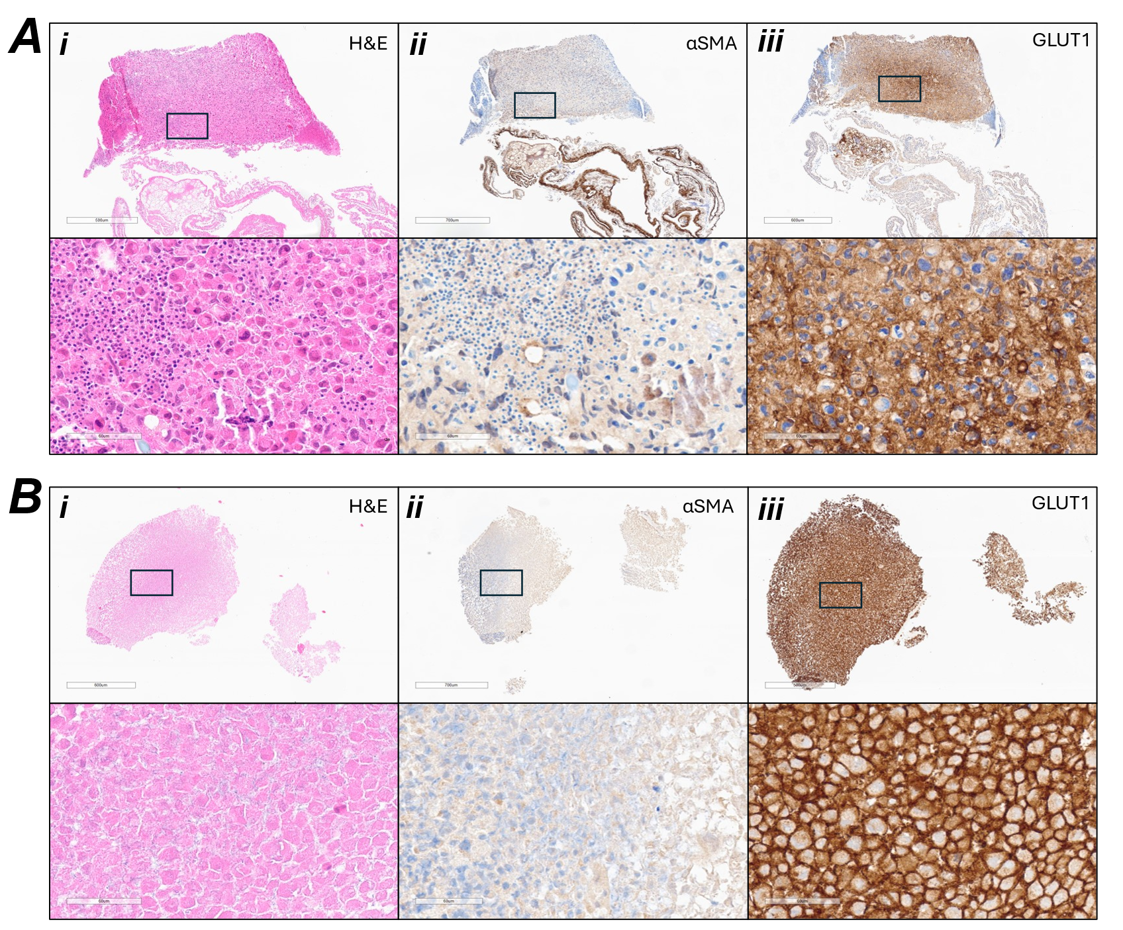
Figure S2. Histological assessment of GBM-CAM tumours, in which no [¹⁸F]FDG uptake was noted but lactate was detected. Representative images from two tumours from the metabolic imaging experiment (A, B). Tumours were stained with αSMA to assess vascularisation and GLUT1 to assess glycolytic activity. i) H&E staining (scale bars: (A) 500 μm, 60 μm (B) 600 μm, 60 μm. In panel A, the tumour remains partially attached to the CAM, while in panel B, the tumour is fully detached, indicating poor engraftment. ii) αSMA staining revealed vessels in the CAM attached to tumour (A), and no staining in tumour (B) (scale bars: (A) 700 μm, 60 μm (B) 700 μm, 60 μm). iii) GLUT1 staining was strong in both tumours, suggesting tumours are highly glycolytic, despite no detectable FDG uptake observed in vivo. (scale bar: (A) 600 μm, 60 μm (B) 500 μm, 60 μm).

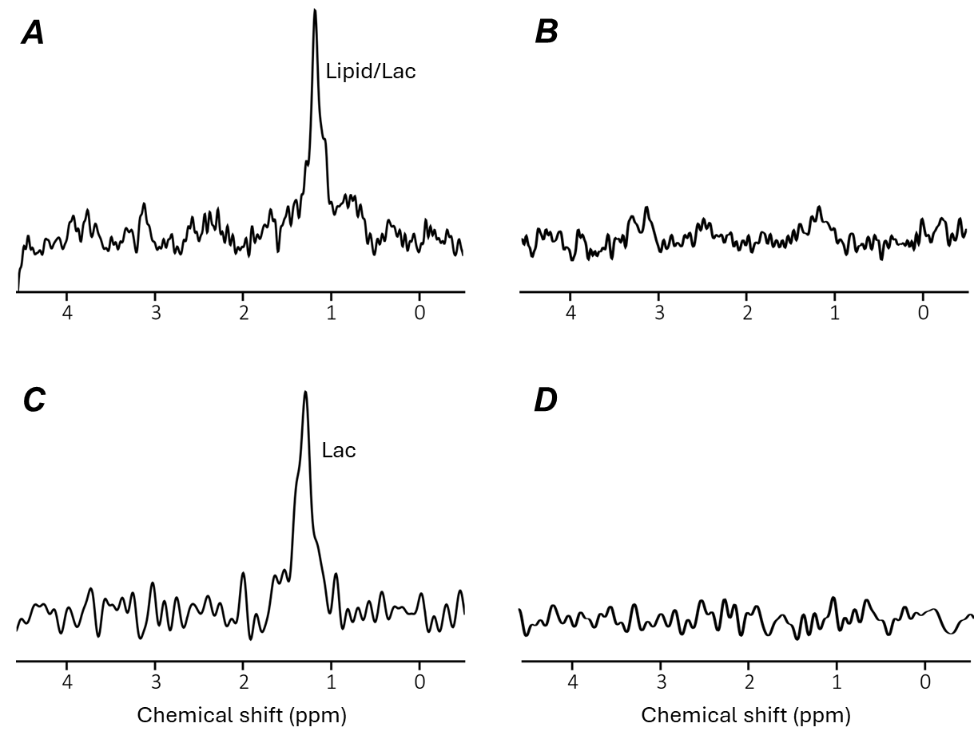
Figure S3. Representative MR spectra acquired from the GBM-CAM. A) PRESS spectrum acquired from the tumour region showing Lipid/Lac peak ~1.2 ppm. B) PRESS spectrum acquired from the control CAM region near the tumour with only a broad peak at ~1.2 ppm probably from lipids. C) selMQC (selective multiple quantum coherence) spectrum corresponding to the tumour region in A showing only the Lac peak at 1.3 ppm. D) selMQC spectrum from the CAM region corresponding to B showing only noise signal. Corresponding PRESS and ISIS-SelMQC spectra were acquired from the same voxel. Spectra are referenced to the water resonance at 4.7 ppm.
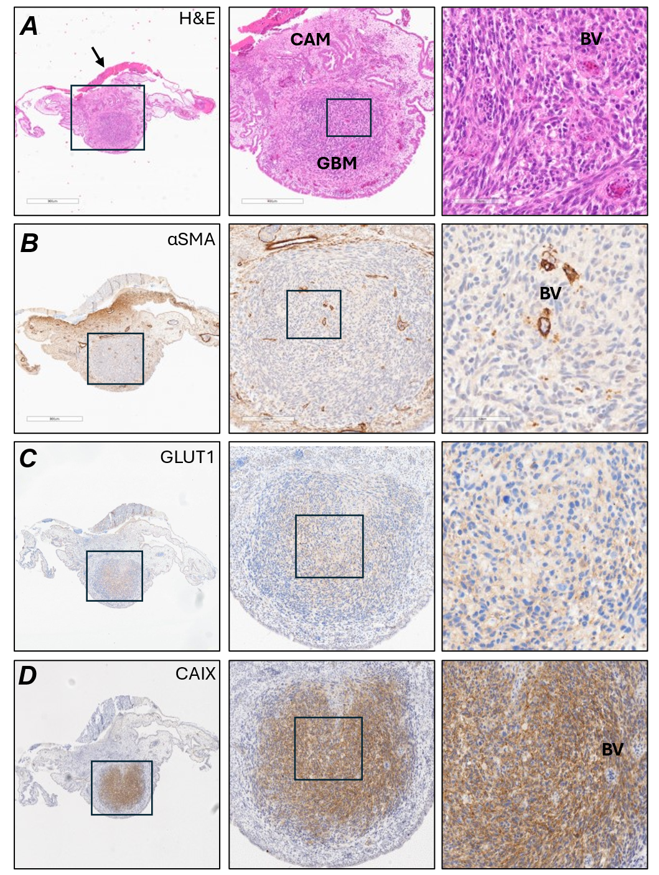
Figure S4. Histological characterisation of GBM-CAM tumour xenograft formed within the CAM, underneath the initial site of implantation. (A) H&E reveals tumour formation beneath the site of implantation (black arrow) (BV= Blood vessel) (scale bar: 900 μm, 400 μ m, 70 μm). (B) α-SMA staining shows chick fibroblast-like cells beneath the site of tumour implantation and blood vessels within tumour (scale bar: 800 μm, 200 μ m, 60 μm). (C) GLUT1 staining is localised to the centre of the tumour, corresponding to hypoxic core (scale bar: 800 μm, 300 μ m, 60 μm). (D) CAIX staining reveals hypoxic tumour cells (scale bar: 800 μm, 300 μm, 70 μm).

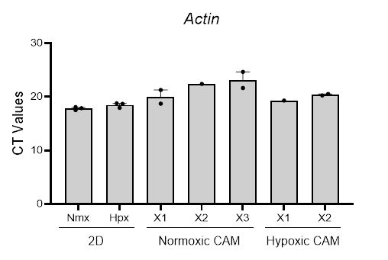
Figure S5. CT values for housekeeping gene actin remained consistent between in vitro cell culture (2D) and CAM-xenografts, in normoxia and hypoxia conditions. qRT-PCR to compare Ct values for actin expression in U251 cells grown in 2D culture in normoxic and hypoxic (72h) conditions in vitro (n=3) and in 3D culture in vivo on the CAM. (Normoxia-preconditioned CAM tumour values are taken from 3 independent experiments X1 (n=2), X2 (n=1) and X3 (n=2). Hypoxia preconditioned CAM tumour values taken from two independent experiments X1 (n=1) and X2 (n=2).

