SUPPORTING INFORMATION
Hybrid nanopores for real-time multiplexed sensing/delivery of biomolecules and logic computing
……..

Note 1. Device characterization

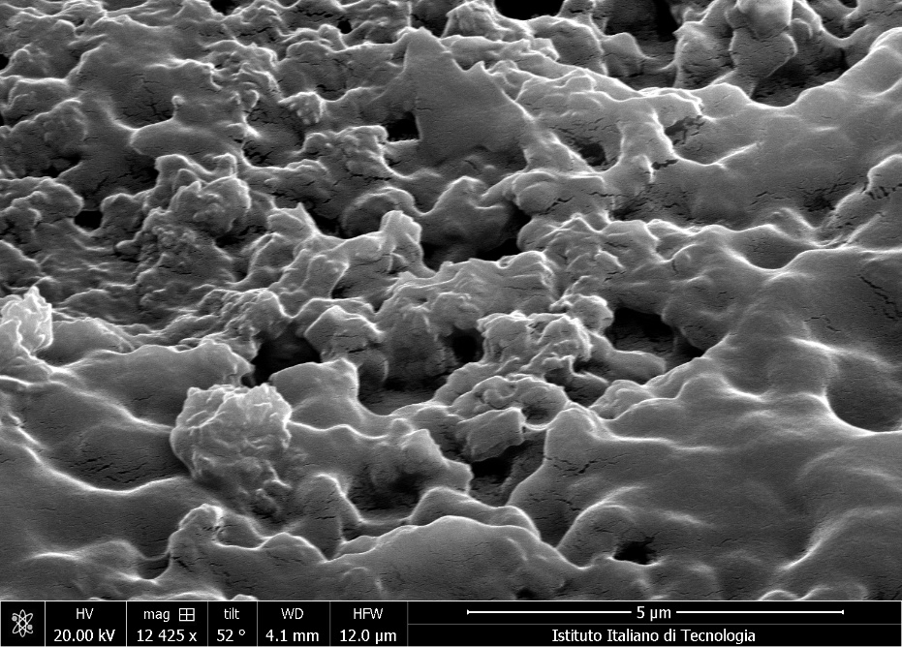
Figure S1. Scanning electron microscopy (SEM) image of the MIP for dopamine with the porous structure of the MIP, Scale bar, 5 um.

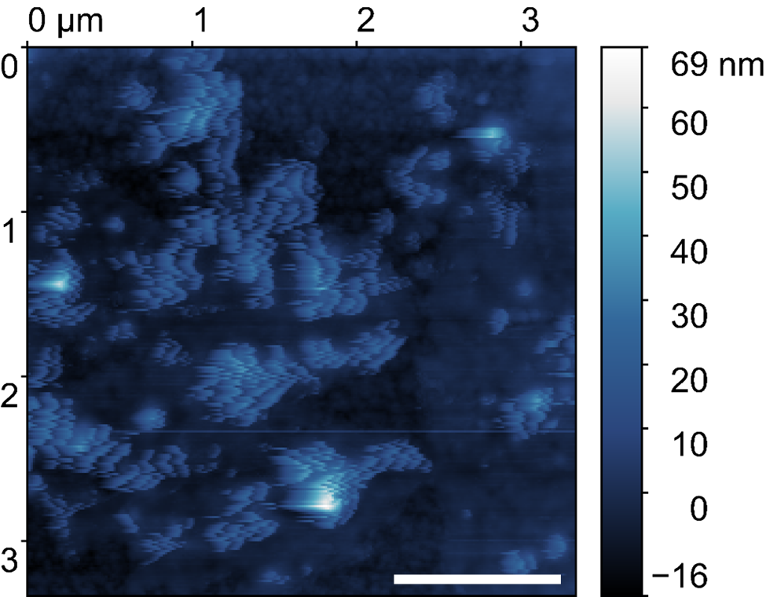
Figure S2. Atomic force microscope (AFM) image of the MIP for dopamine. Scale bar, 1µm.

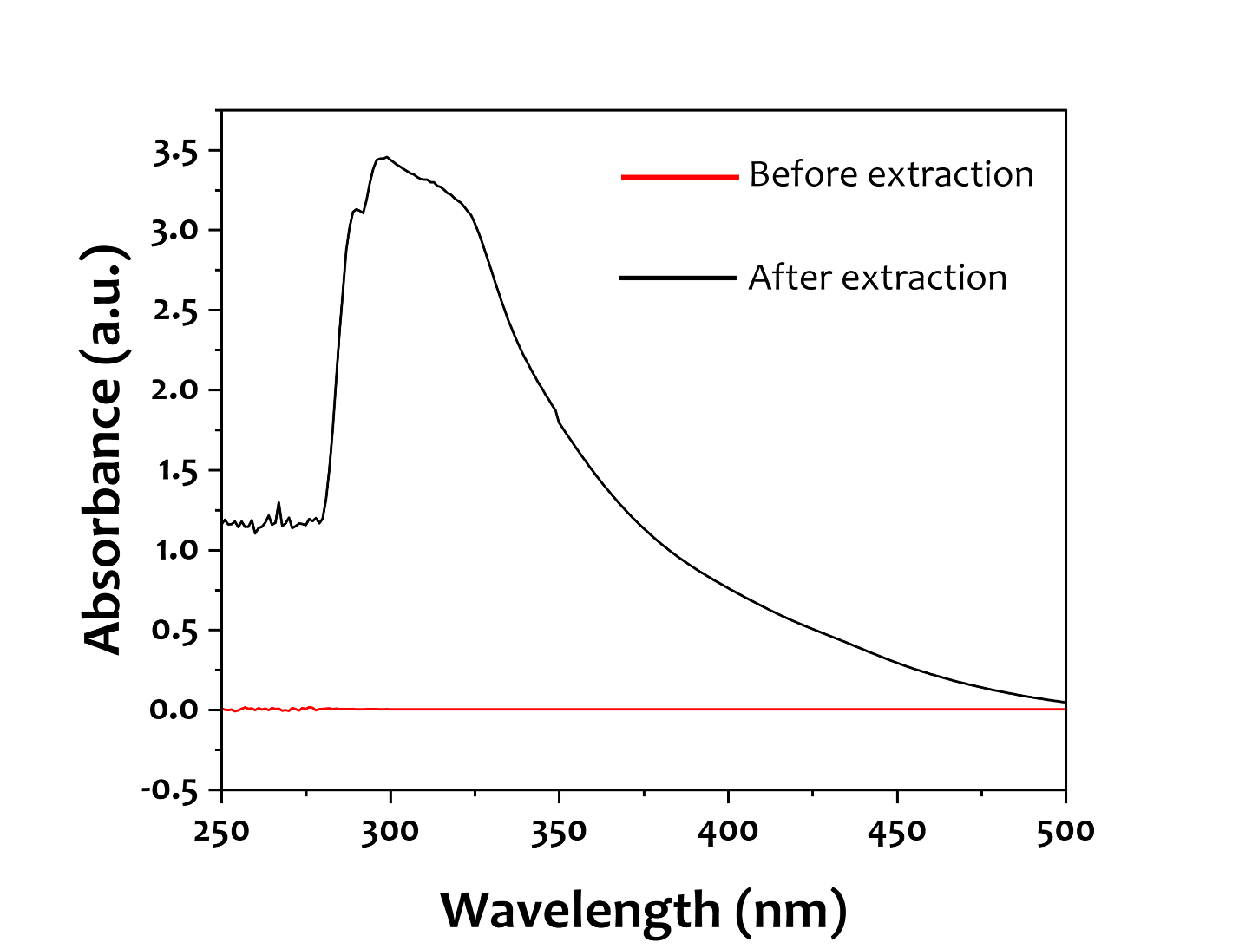
Figure S3. ultraviolet–visible spectroscopy (UV–vis) absorbance of dopamine MIP before and after template extraction

Note 2. Measurement setup

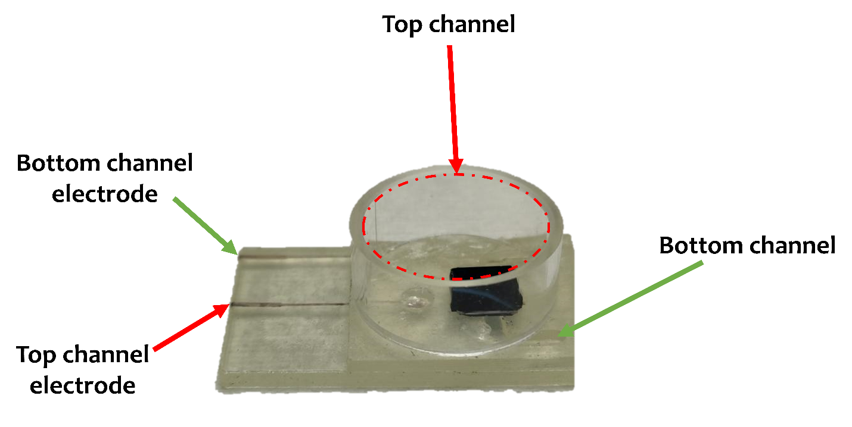
Figure S4. The microfluidic used in electrical measurements.
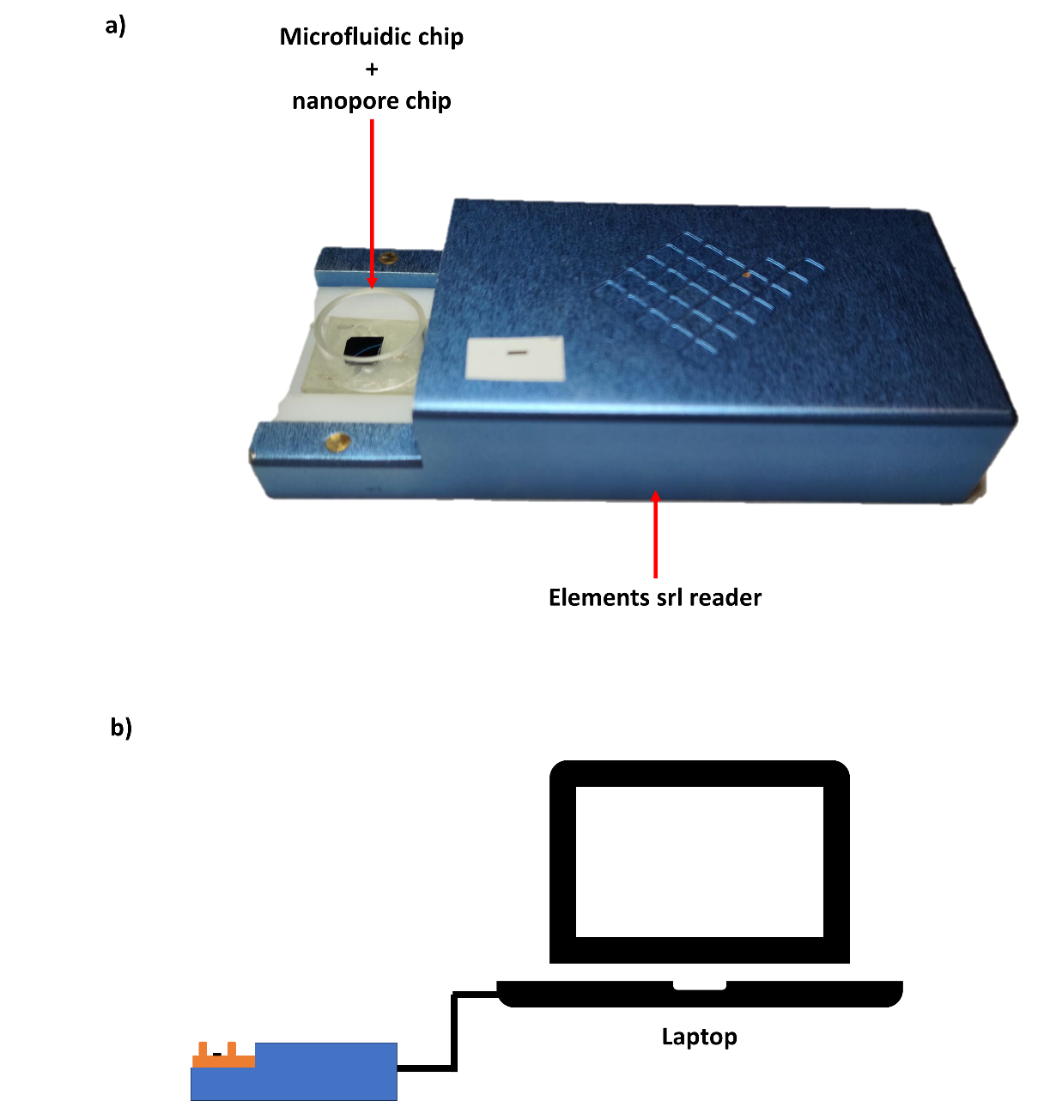

Figure S5. (a-b) The microfluidic chamber connected to electrical nanopore reader (Elements SRL).

Note 3. Dopamine MIP-nanopore characterization

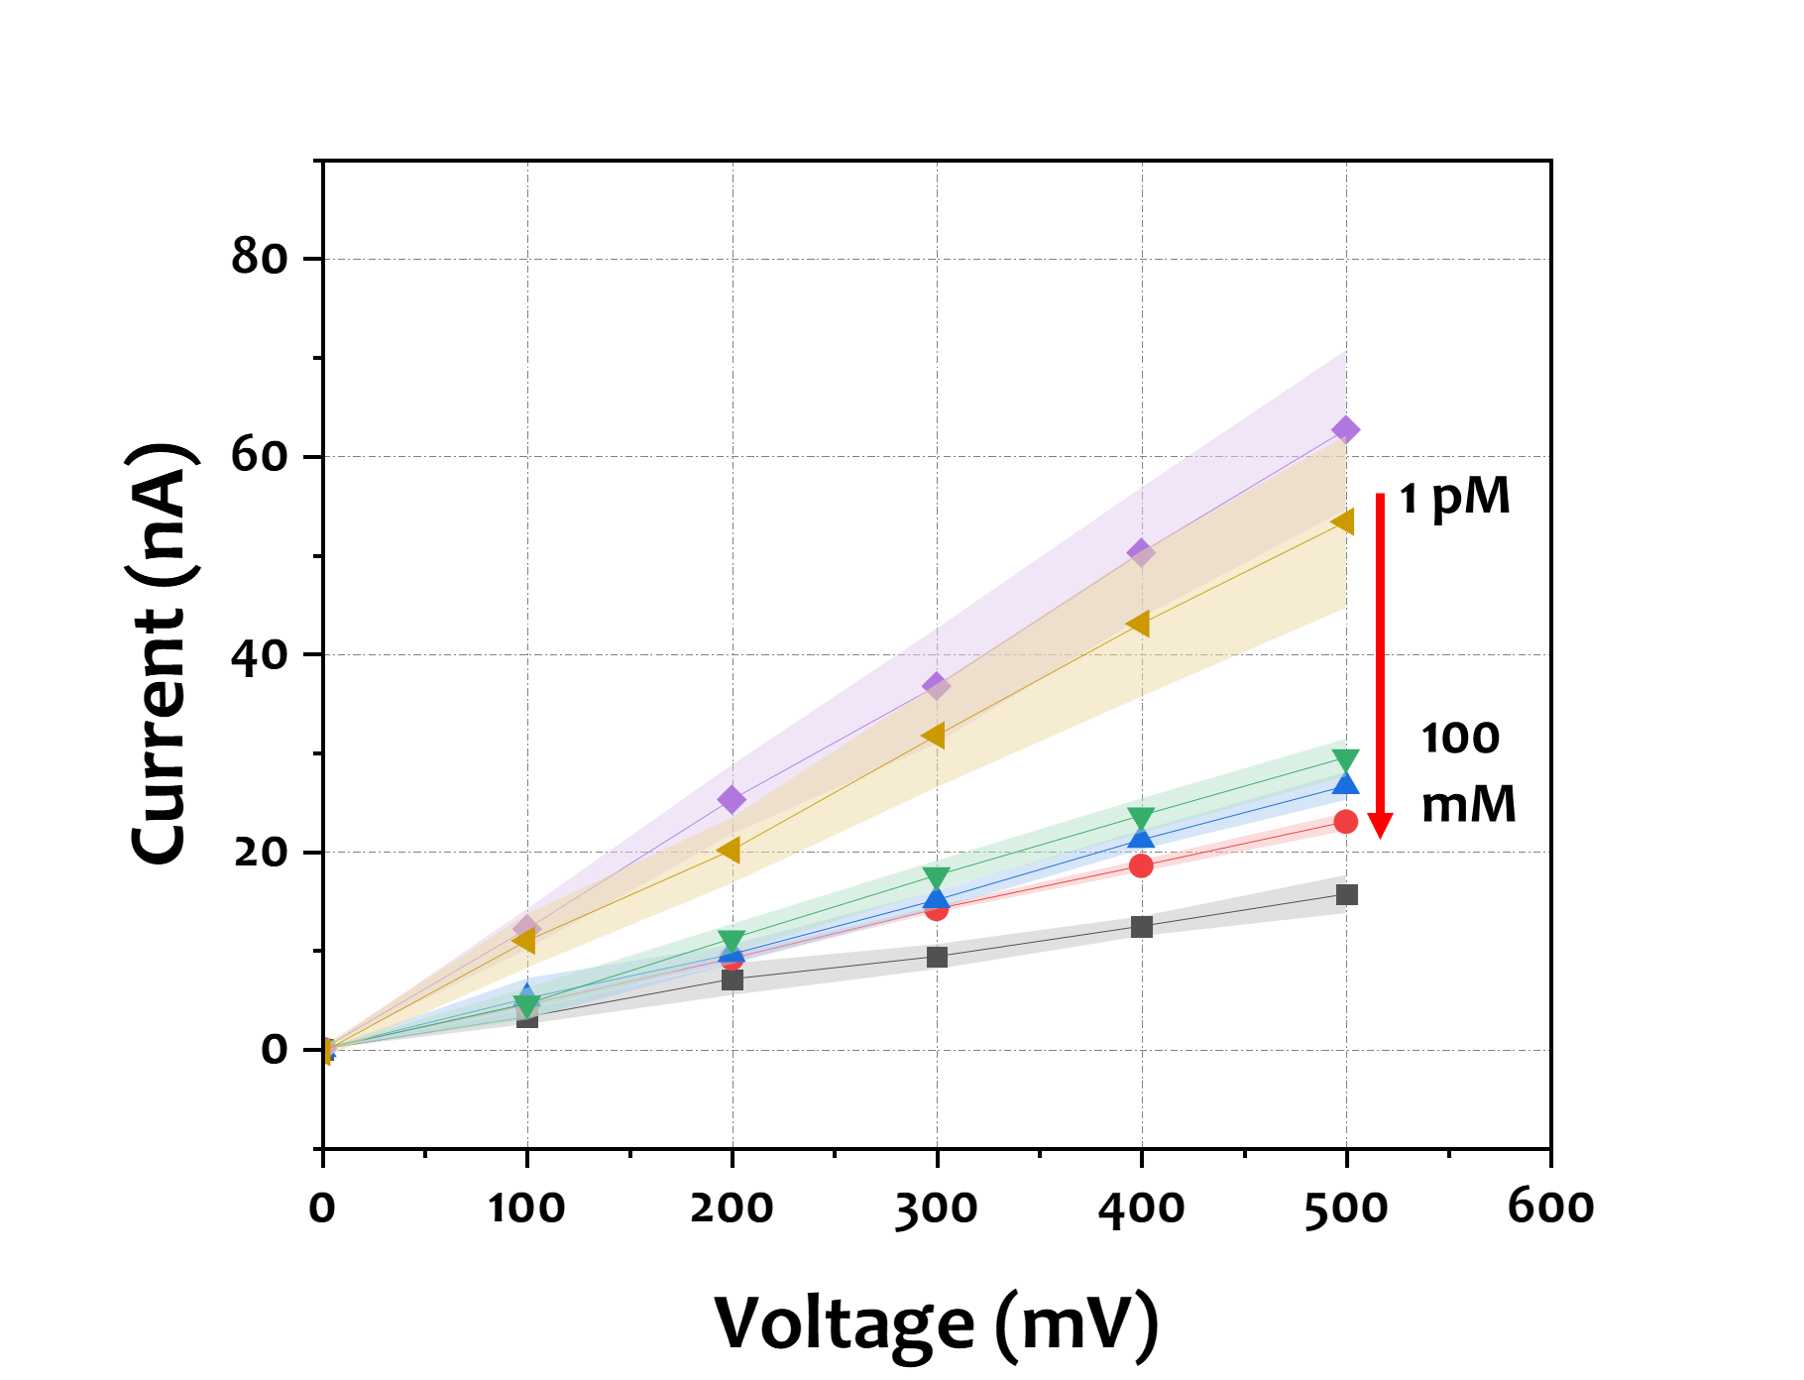
Figure S6. Concentration-specific response of MIP-dopamine sensors in 1× phosphate buffered silane (PBS) with increasing dopamine amounts observed in IV curves. Each point is an average of N = 3 independent sensors.
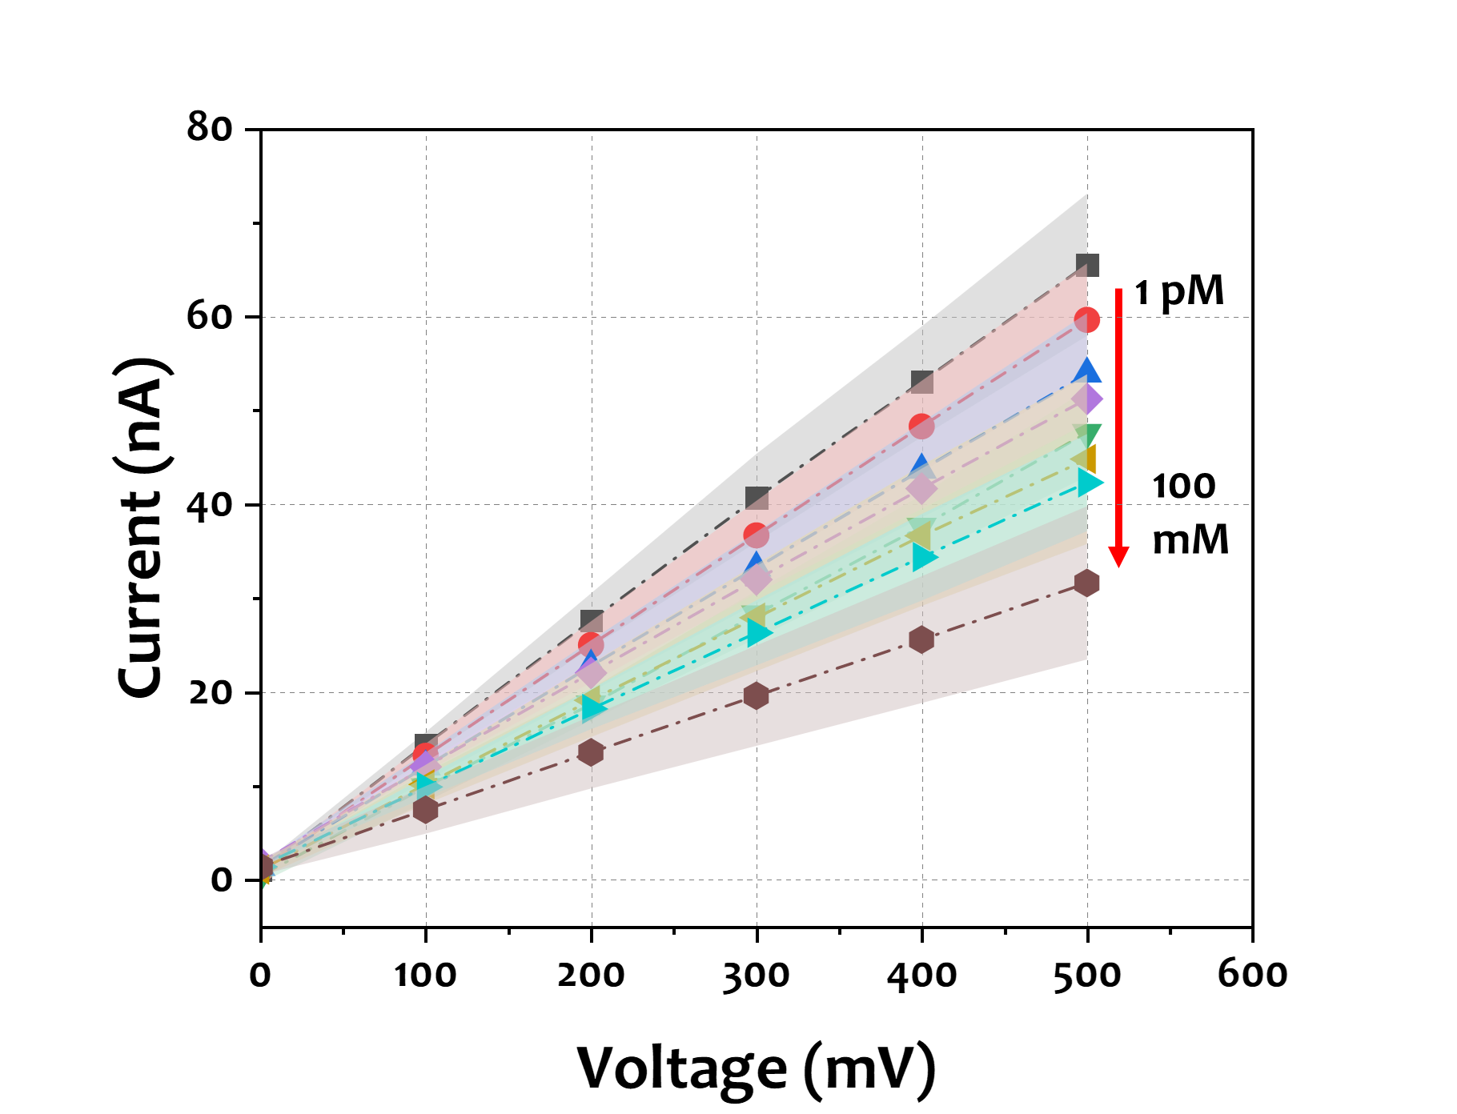
Figure S7. Concentration-specific response of MIP-dopamine sensors in neurobasal medium with increasing dopamine amounts observed in IV curves. Each point is an average of N = 3 independent sensors.

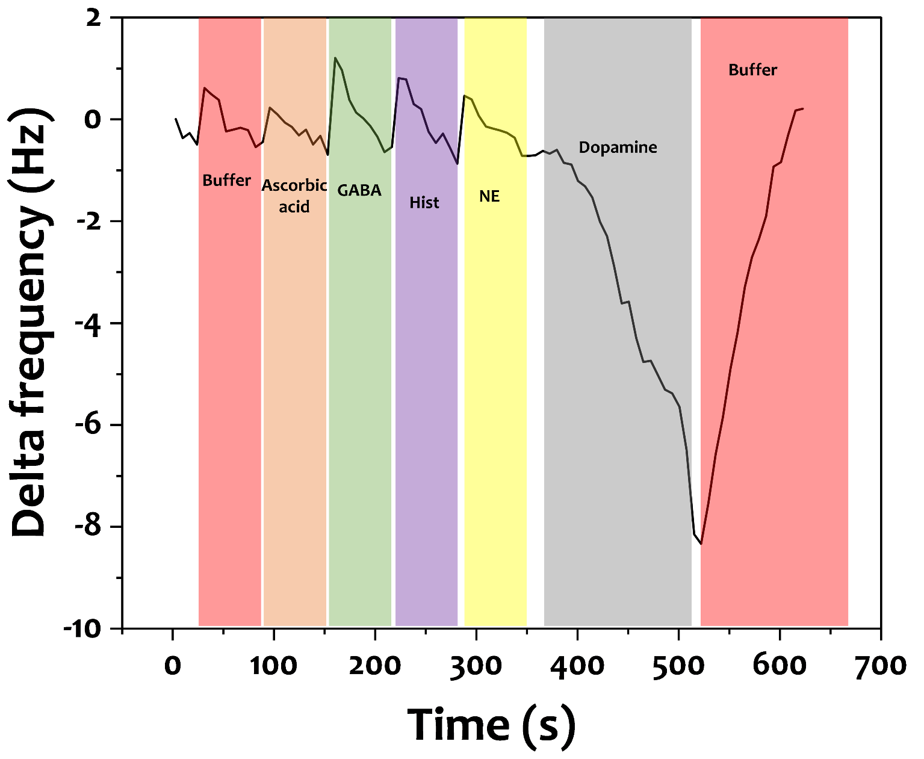
Figure S8. QCM-D selectivity analysis of the dopamine-MIP at the 5th overtone. Frequency shifts (Δf) were recorded upon sequential exposure to 1 nM of ascorbic acid, GABA, histamine, norepinephrine (NE), and dopamine in neurobasal medium prepared in 1× PBS, followed by buffer rinse at 500 s. A pronounced response was observed only for dopamine, confirming selective recognition

Note 4. GABA MIP-nanopore characterization
The sensitivity of the GABA MIP nanopore was assessed across a concentration range of 0.1 nM to 100 mM (Figure. s9). The sensor demonstrated a robust linear response, with an R² value of 0.96, indicating strong reproducibility and sensitivity within this range (Figure. S10). Additionally, GABA MIP nanopore achieved a LOD of 1.99 pM, making it well-suited for detecting GABA at concentrations relevant to neurochemical signaling and synaptic activity ^{[1,2]}. The applicability of this sensor depends on its deployment environment, as the extracellular level of GABA in the brain typically range from 200 nM to 1 µM under basal conditions and can spike to 10 to 100 µM during synaptic events. Therefore, careful calibration is essential for adapting the sensor to specific physiological or experimental contexts. Therefore, a sensor with a working range of 0.1 nM to 100 mM offers considerable flexibility for translational applications, particularly for monitoring GABA fluctuations within the brain, where concentrations vary between basal and synaptic states. Moreover, selectivity tests revealed less than 5% current reduction when exposed to dopamine, histamine, norepinephrine, and serotonin at 10 µM, confirming the sensor's high specificity for GABA (Figure. S11). Reusability tests showed that the sensor retained 92% of its initial sensitivity after 15 binding and release cycles, with consistent stability over a 9-day period (Figure. S12 and S13).

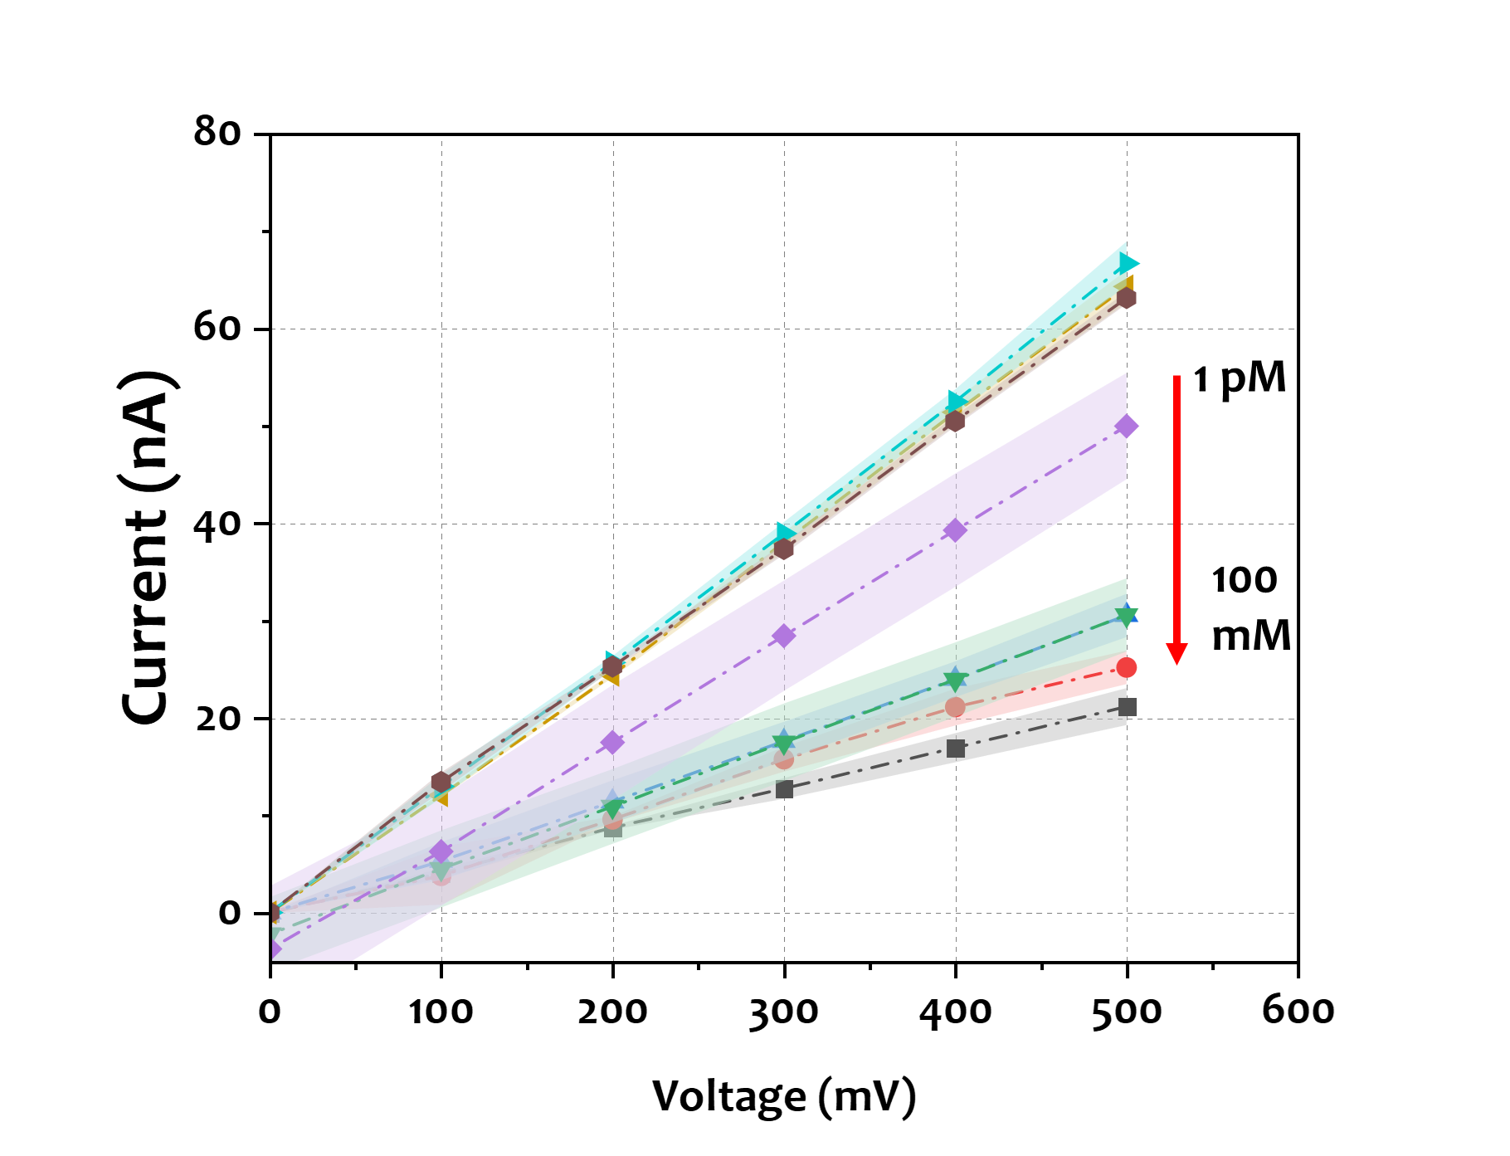
Figure S9. Concentration-specific response of MIP-GABA sensors in 1× phosphate buffered silane (PBS) with increasing GABA amounts observed in IV curves. Each point is an average of N = 3 independent sensors.

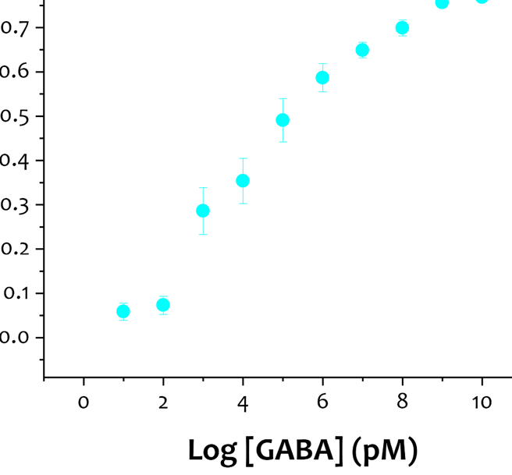
Figure S10. Calibration curve for GABA detection in the range of 0.1 pM to 100 mM in 1x PBS. Each point is an average of N = 3 independent sensors.
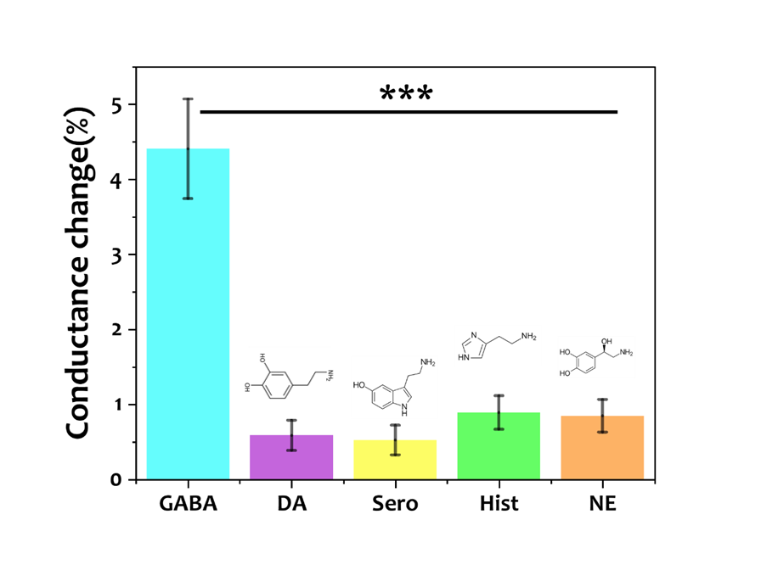
Figure S11. Selectivity test of the GABA-MIP nanopore against 1 uM of different analytes, dopamine (DA), gamma-aminobutyric acid (GABA), Histamine (Hist), norepinephrine (NE), and serotonin (Sero) in neurobasal medium. Each point is an average of N = 3 independent sensors. [one-way ANOVA, ***p < 0.0001]

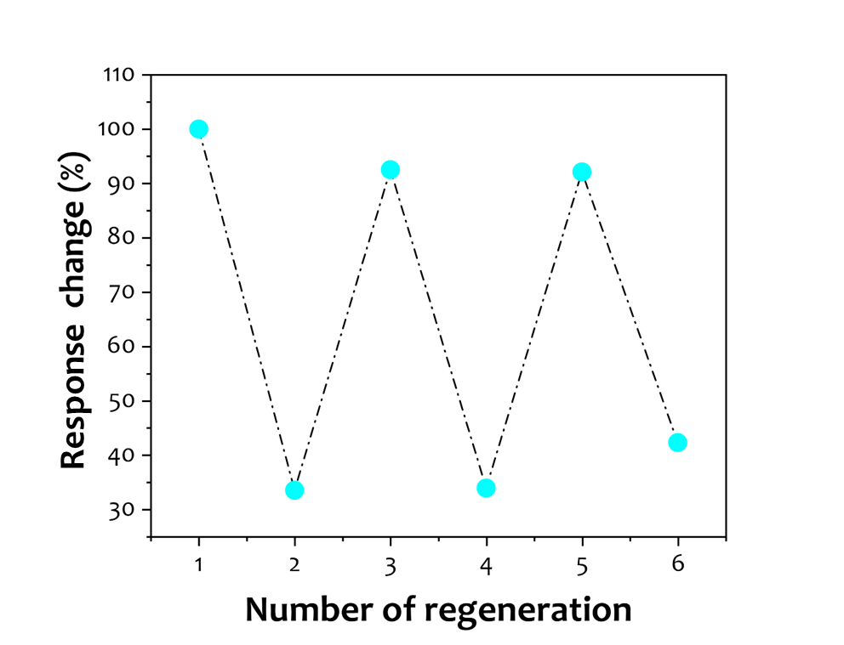
Figure S12. The recovery of the GABA-MIP nanopore in presence of 1 uM GABA in 1x PBS.

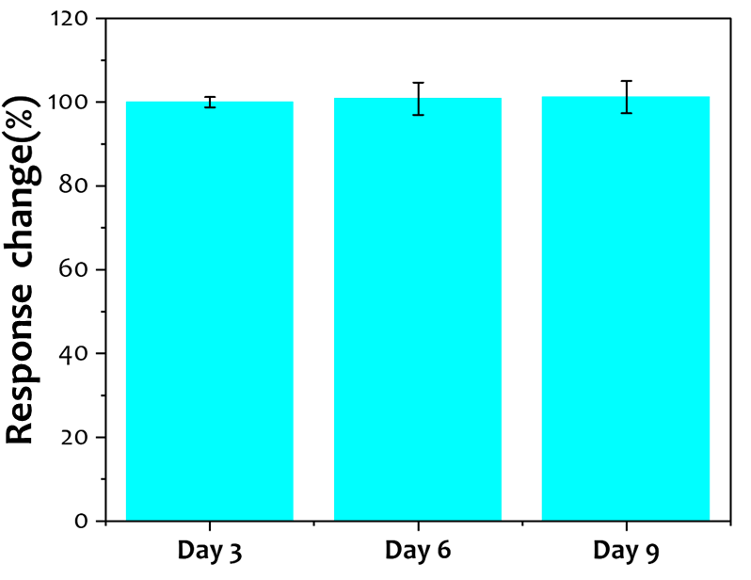
Figure S13. Stability test of the GABA MIP nanopore for days in 1x PBS. Each point is an average of N = 3 independent sensors.

Note 5. Histamine MIP-nanopore characterization
The third MIP-nanopore sensor was developed for Hist detection. the sensor demonstrated a linear response to histamine concentrations ranging from 1 nM to 100 mM, with a coefficient of determination (R²) of 0.97 (Fig. S14-S15). Moreover, the sensor showed a LOD of 2 nM, therefore, the sensor exhibits high sensitivity suitable for monitoring low concentrations of histamine relevant to immune responses or allergic reactions. Hist concentrations in the brain vary from low nanomolar to micromolar levels. Basal concentrations in human cerebrospinal fluid are typically around 1–20 nM, while localized levels can increase to several micromolar during heightened neuronal activity or in response to specific stimuli. Therefore, a sensor capable of detecting histamine within the low nanomolar to millimolar range is appropriate for monitoring both basal and physiologically elevated histamine levels in neurological studies. The histamine sensor exhibited minimal current changes (less than 5%) when exposed to 1 µM concentrations of dopamine, GABA, norepinephrine, or serotonin, further confirming its selectivity (Fig. S16). Long-term stability assessments revealed that the sensor retained 90% of its initial sensitivity after 15 cycles, with consistent performance over 30 days (Fig. S17-S18).

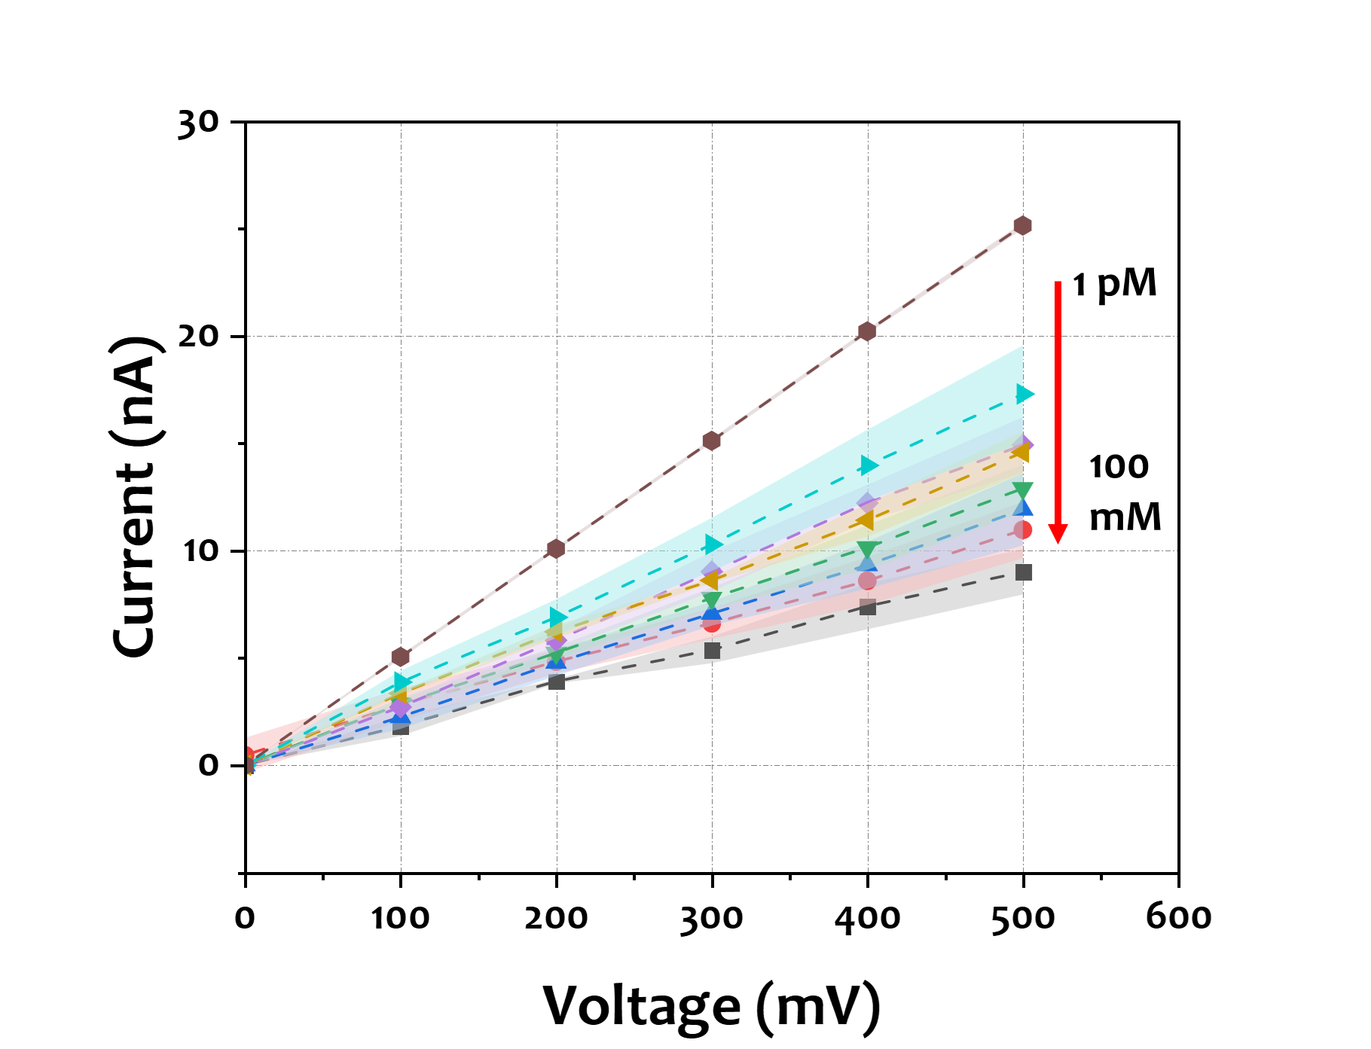

Figure S14. Concentration-specific response of MIP-histamine sensors in 1× phosphate buffered silane (PBS) with increasing histamine amounts observed in IV curves. Each point is an average of N = 3 independent sensors.

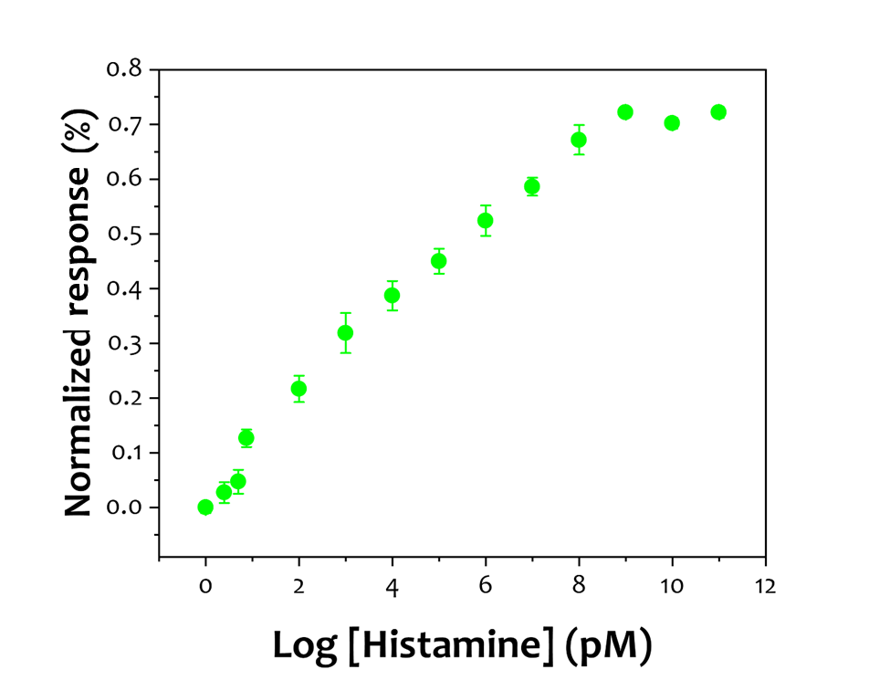
Figure S15. Calibration curve for histamine detection in the range of 0.1 pM to 100 mM in 1x PBS. Each point is an average of N = 3 independent sensors.

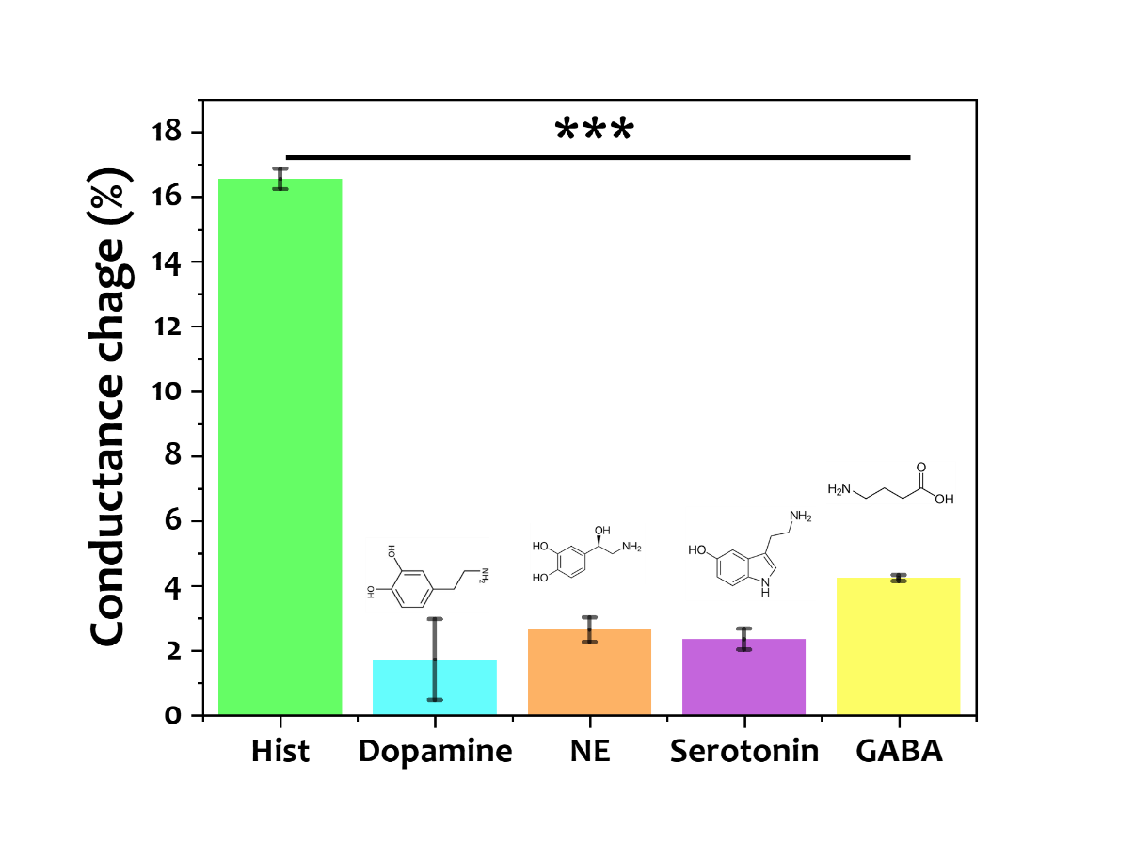
Figure S16. Selectivity test of the histamine-MIP nanopore against 1 uM of different analytes, dopamine, GABA, Histamine, NE, and serotonin in neurobasal medium. Each point is an average of N = 3 independent sensors. [one-way ANOVA, ***p < 0.0001]

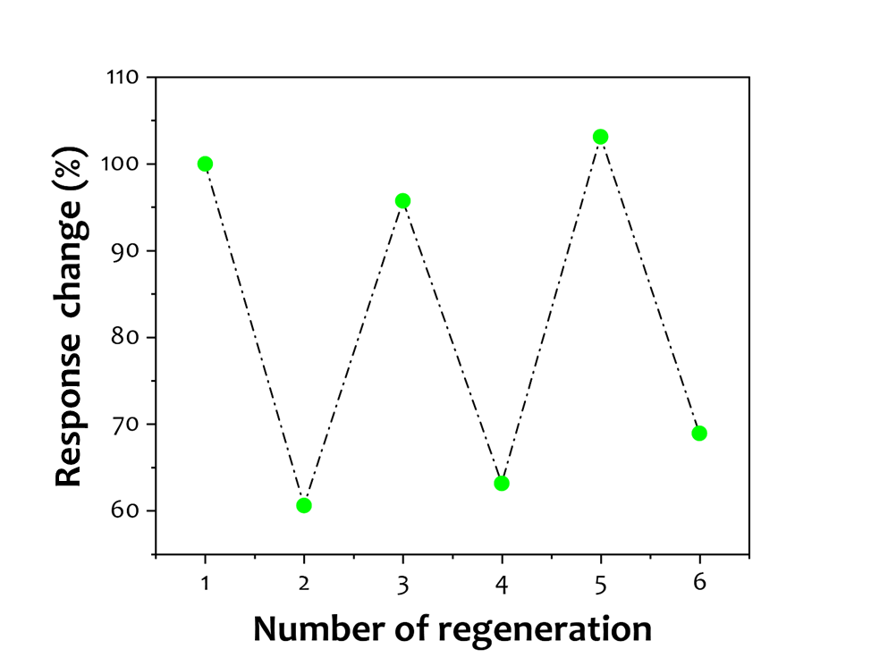
Figure S17. The recovery of the His-MIP nanopore in presence of 1 µM histamine.

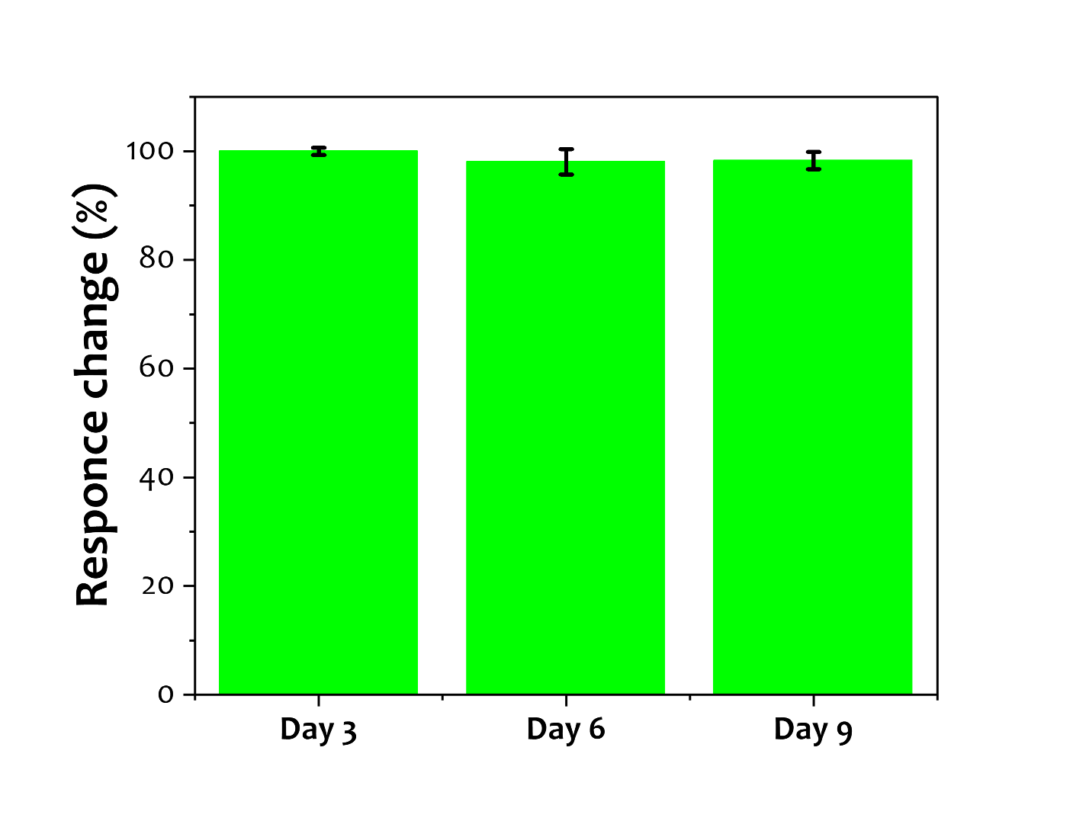
Figure S18. Stability test of the His-MIP nanopore for several days. Each point is an average of N = 3 independent sensors.

Note 6. Multiplex sensing and releasing
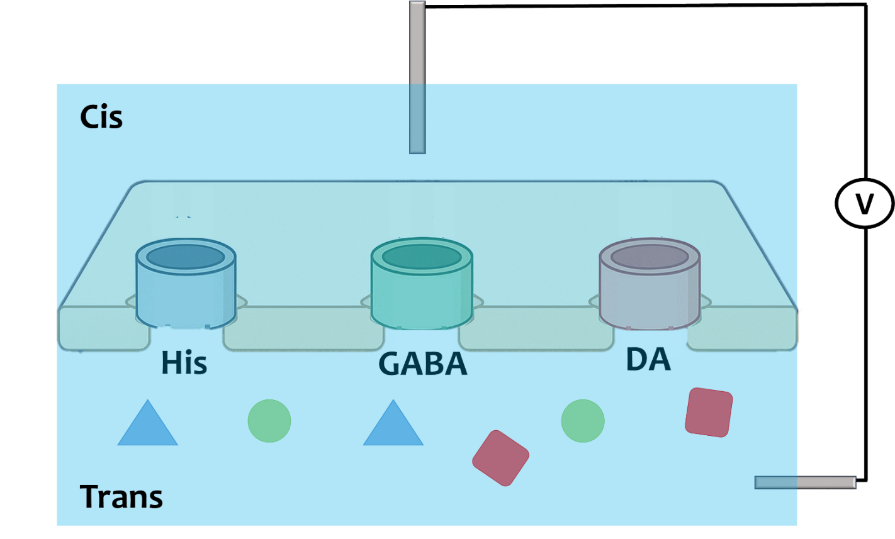
Figure S19. Conventional solid-state nanopore electrical measurements illustrate the challenge of distinguishing current changes originating from individual nanopores when they share the same electrolyte chambers as the current change takes into consideration the changes from all the three nanopores.

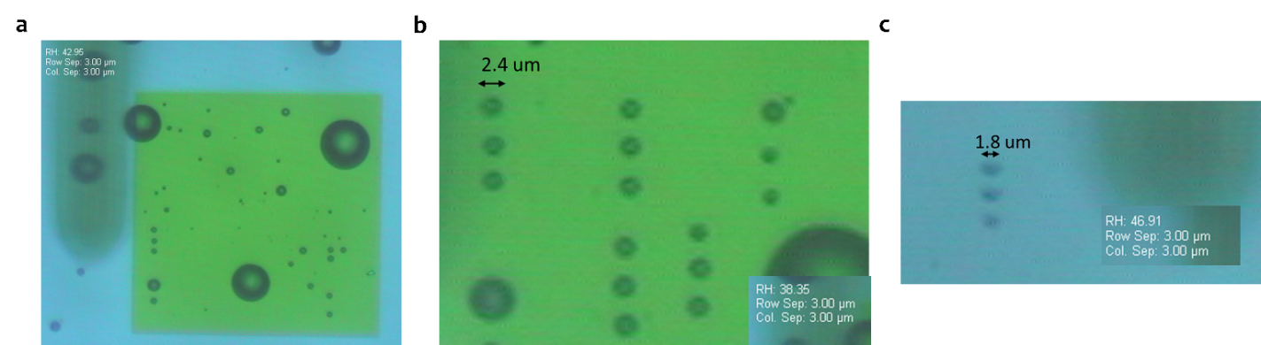
Figure S20. Effect of humidity on hydrogel micro-spotting with the BioForce Nano eNabler system. Optical images show hydrogel spots deposited at different relative humidities (RH), with constant row and column spacing of 3 µm. At RH ≈ 43% (a), droplets spread out once in contact with the substrate, therefore, resulting in larger droplets. At RH ≈ 38% (b), spots were more uniform with an average diameter of ~2.4 µm. However, At RH ≈ 47% (c), the optimized deposition conditions yielded well-defined spots with diameters as small as ~1.8 µm. These results highlight the critical role of ambient humidity in controlling hydrogel spot size and the possibility of achieving spots with low spacing.

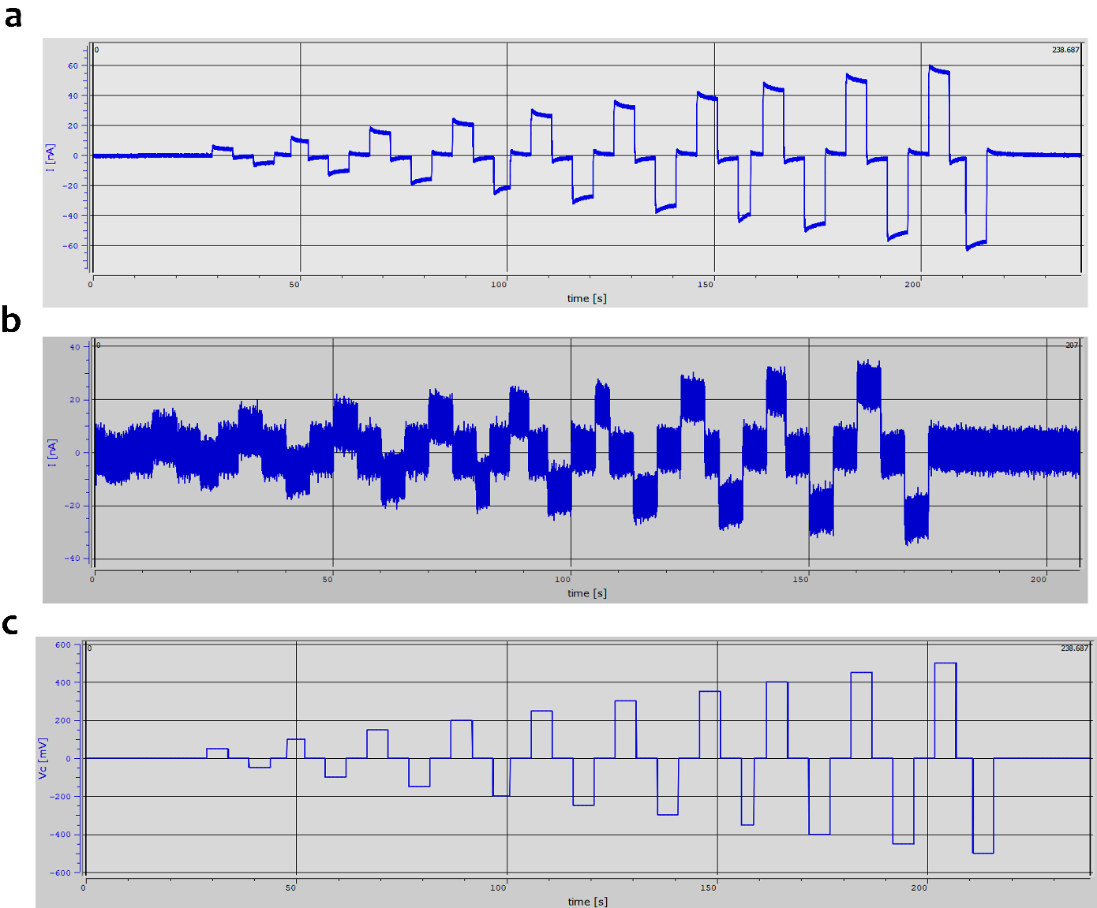
Figure S21. a) Ionic current measured from a nanopore over-time at different voltages with 1× PBS in both compartments. b) Ionic current measured from a nanopore with hydrogel in the top chamber and 1× PBS in the bottom chamber. c) The applied voltage over-time.
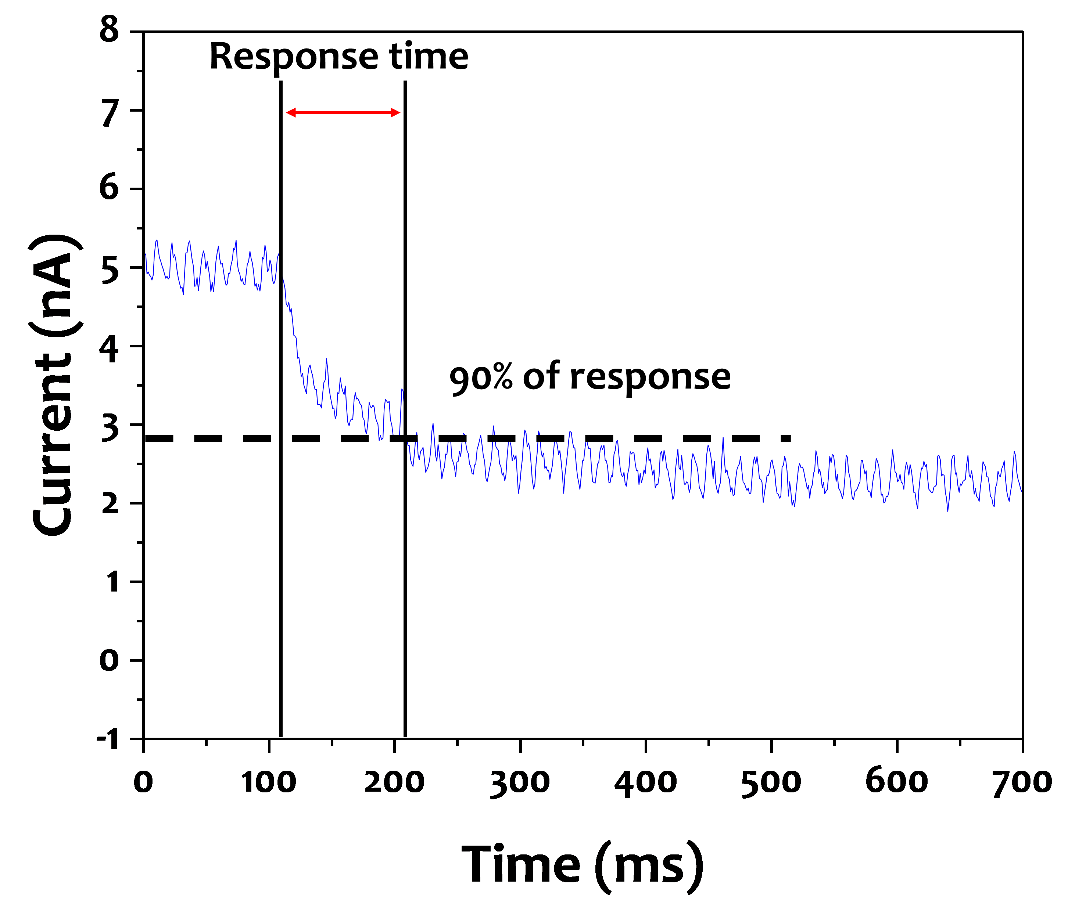
Figure S22. The determination of the response time of the dopamine MIP-sensor in neurobasal medium in response to 1 µM of dopamine.

Note 7. Releasing mechanism
Figure 3c highlights a key feature of this platform, namely its selective release mechanism, applying an electrical pulse to the DA-MIP nanopore exclusively releases dopamine without causing the release of DOX, and vice versa. Importantly, the long-term retention of bound analytes is inherently linked to the affinity–reversibility trade-off of MIPs. While the high binding affinity of the MIP enables sensitive and selective detection, it may also lead to slow unbinding kinetics in the absence of an external trigger “stimuli”, which can limit spontaneous release and extend retention times ^{[3,4]}. In our case, the negligible leakage observed over the course of the experiment suggests that unbinding and diffusion are minimal without stimulation, and that active electrical pulses provide a reliable means of release. Several mechanisms have been proposed for molecular release from MIP-based systems, including electrochemical oxidation, local Joule heating, and electrostatic repulsion ^{[5]}. In our configuration, electrochemical oxidation can be excluded, as it is not expected to contribute significantly under the applied conditions. We therefore focused on distinguishing between Joule heating and electrostatic effects. To evaluate the potential contribution of heating, we integrated a nanoheater into the nanopore platform (Figure S20) and monitored dopamine release, measured as changes in nanopore conductance, at three different temperatures, room temperature, 40 °C, and 60 °C. No appreciable release was observed at elevated temperatures, ruling out Joule heating as a dominant release pathway. We next investigated the role of applied electric fields through different pulse times. When voltage pulses of increasing duration were applied, we consistently observed rapid change in conductance hence, an increase in dopamine’s release (Figure S21). Given the strong electrostatic interactions between the positively charged amine group of dopamine and the negatively charged carboxylates in the polymer matrix, we attribute this process to voltage-induced electrostatic desorption. Once desorbed, dopamine molecules are transported through the nanopore by a combination of electrophoretic and electroosmotic forces, completing the release process.

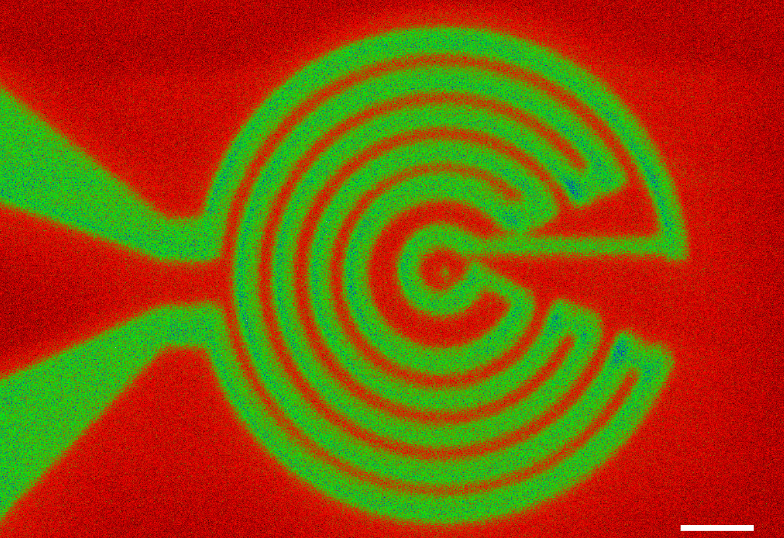
Figure S23. A false-colored scanning electron micrograph of a nanoheater-embedded nanopore fabricated in a SiN_{x} membrane, green color shows the platinum coil (scale bar denotes 500 nm).

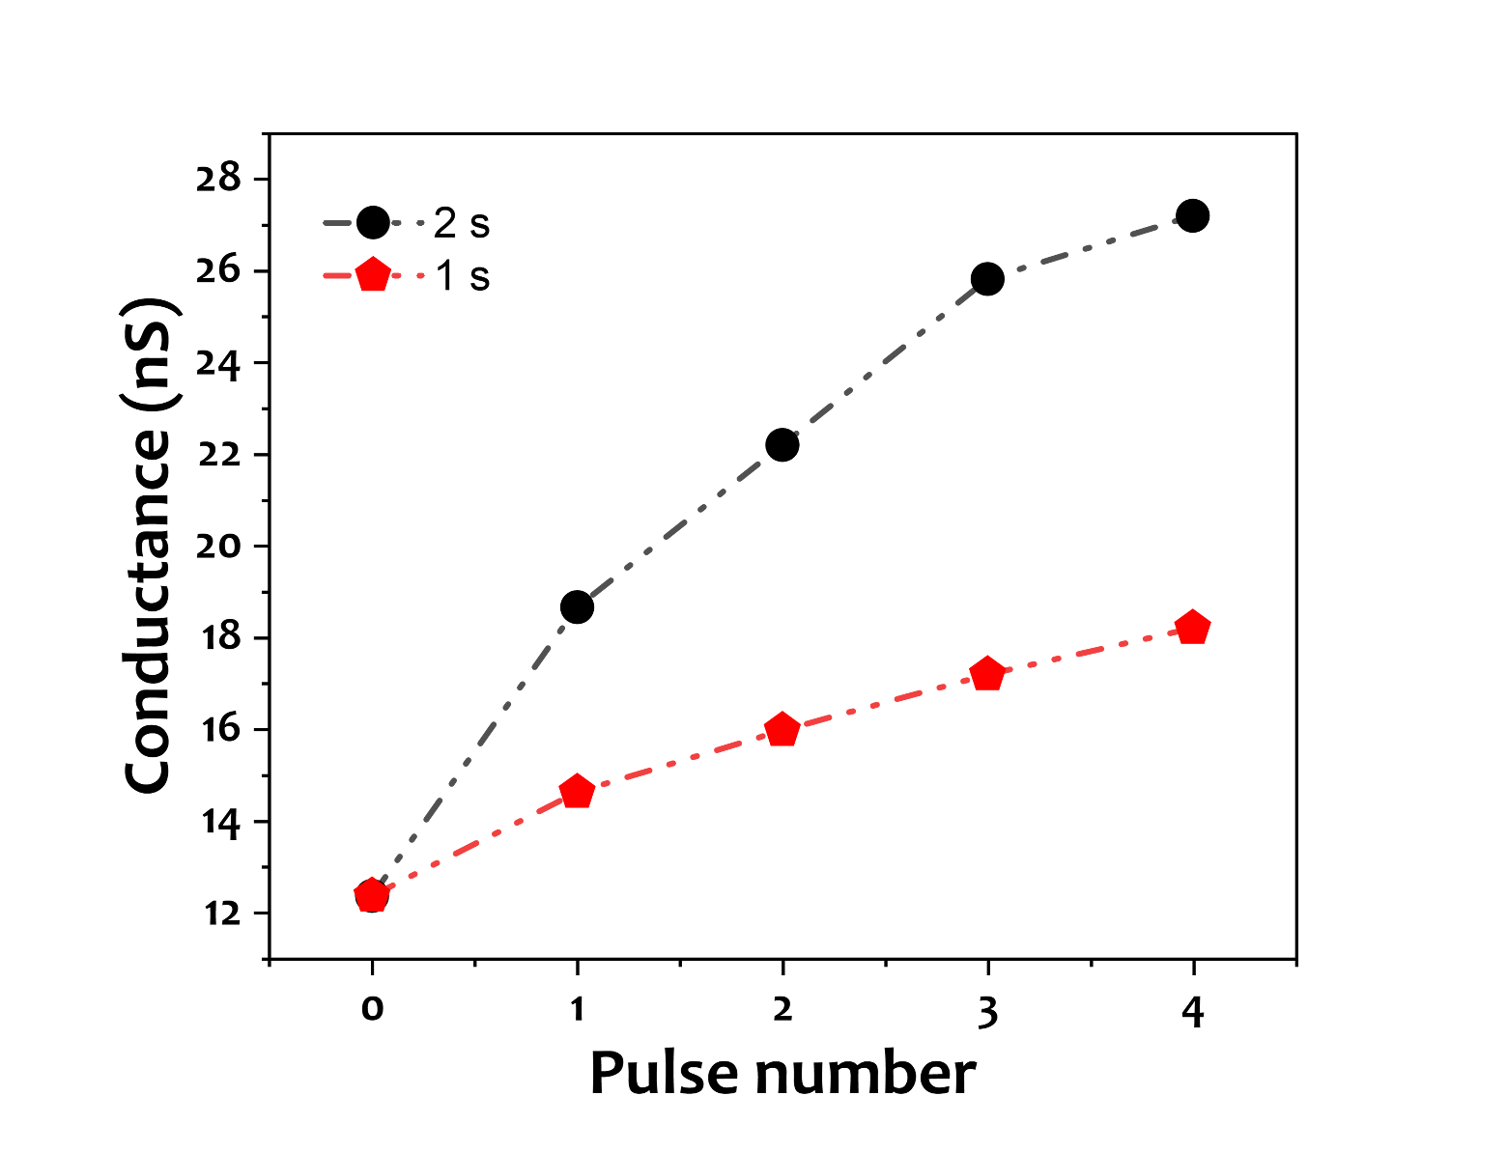
Figure S24. Correlation between the pulse time and the change in conductance (dopamine release) in 1x PBS. Showing a correlation between the pulse time and the release, therefore, implying that the primary mechanism is electrostatic repulsion.

Note 8. Binding affinity of dopamine MIP
To get a deeper understanding of the release mechanism of the MIP nanopore, we first quantified the binding affinity of the MIP by fitting QCM-D kinetics with a 1:1 Langmuir model. In the Sauerbrey regime (rigid, thin adlayer (20 nm measured with AFM); small ΔD), the frequency shift Δf is proportional to the surface-bound mass, so Δf(t) reports the surface occupancy θ(t) ^{[6]}.
- Association (at 10 nM dopamine​):
$$Δf(t) = Δfmax (1-e^{-k_{obs}(t-t_{0})}),{ with k}_{obs}= k_{a}C + k_{d}$$
Where $k_{a}$ is the association constant (M⁻¹ s⁻¹) and $k_{d}$the dissociation constant (s⁻¹). Moreover, we obtained ${ k}_{obs}$ with nonlinear least squares fitting.
- Dissociation (buffer exchange at t=t_{switch} ​):
$Δf(t)=Δf(t_{switch}) e^{-k_{d}(t-t_{switch})}$ (2)
From these two fits we calculated the on-rate ka=(k_{obs}−k_{d})/C and the equilibrium dissociation constant K_{D}=k_{d}/ka​, with C = 10 nM of dopamine. Applying the fitting to the dataset in Fig. S22 gave:
$$k_{d}=2.97×{10}^{-3} s^{-1} \\ k_{a}=5.36×105 M-1s-1$$
and thus $k_{a}= 5.54×{10}^{-9}$ with $k_{a}C=5.36 x {10}^{-3} s^{-1}$ and $k_{obs}=8.33 {10}^{-3}s^{-1}.$ And finally, K_{D} was calculated to be $KD=5.54 x {10}^{-9} M (5.5 nM)$
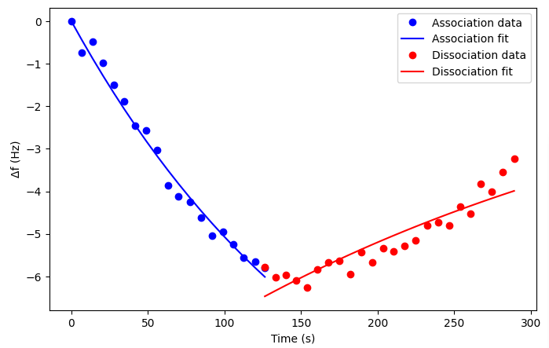
Figure S25. QCM-D association and dissociation curves for dopamine binding measured at the 7th harmonic using QCM gold electrode. The frequency shift (Δf) is shown as a function of time. Blue circles represent experimental association data with the corresponding exponential fit (blue line), while red circles represent dissociation data with the corresponding exponential fit (red line).

Note 9. Field-assisted desorption model, parameterization with pulse-time data, and implications
Once we calculated the binding affinity and probe the rapid release of dopamine observed under voltage pulses, we modeled the desorption kinetics using the framework of Liu et al ^{[7]}. Combined with our experimental data from QCM-D (Note. 8) and voltage-pulse release (Fig. S22). This approach allowed us to decouple the thermal desorption rates from field-assisted acceleration and to quantify the effective local potential drop at the binding site.
- Field-Assisted Desorption Model
In a nanopore of thickness h under a transmembrane bias U, the average field is $E=\frac{U}{h}$. For a bound ligand with effective valence n (dopamine n ≈ +1), the force exerted by the field is $F= η e E$. Following the Bell-type description adopted by Liu et al., the desorption rate constant under field becomes:
$$k_{off}\left(V\right)=k_{off}\left(0\right) exp (\frac{U η e z}{h k_{B }T})$$
where z is the reactive compliance (distance from bound minimum to transition state, typically 0.1–0.5 nm), $k_{B }$ is Boltzmann’s constant, and T is temperature.
- Baseline Kinetics from QCM-D
From QCM-D binding experiments we obtained association and dissociation rates:
$k_{a}=5.36 x {10}^{5}M^{-1}s^{-1}$
$k_{off}=2.97 x {10}^{-3}s^{-1}$
$k_{D}=5.5 nM$
These values correspond to a thermal lifetime $τ_{off}\left(0\right)=\frac{1}{k_{off}\left(0\right)}≈336 s$, indicating that without an external field, dopamine remains bound on timescales of several minutes.
- Pulse-Time Analysis (Fig. S23)
Afterwards, we analyzed the release under 1 s and 2 s voltage pulses. The probability of release during a pulse is^{[8]}:
$P \left(τ\right)=1-e^{-k_{off}\left(V\right) τ}$
For small arguments ($k_{off}\left(V\right) ≪1$ ), $P \left(τ\right)≈k_{off} \left(V\right) τ$ , implying linear scaling of release with pulse duration. Figure. S23 shows that, experimentally, increasing the pulse time from 1 s to 2 s approximately doubled the release signal, confirming operation in this linear regime. From the slope of the release vs. pulse time, one can estimate $k_{off}\left(V\right) ≈0.2-0.4 s^{-1}$, corresponding to lifetimes of 2.5–5 s. Thus, the applied field accelerates desorption by roughly two orders of magnitude compared to the thermal baseline.

- Barrier Lowering and Local Potential Drop
When a voltage is applied across a nanopore, the total voltage is spread out along the length of the pore. However, the electric field is not uniform. The local potential drop is the actual bias that affects the binding equilibrium of dopamine molecule inside the MIP along its escape path. In the case of dopamine with a +1 charge, the field exerts a directional force along the reaction coordinate, reducing the activation barrier for desorption. This phenomenon, often described by a Bell-type model, results in a field-accelerated off-rate ^{[7]}:
$$k_{off}\left(V\right)=k_{off}\left(0\right) exp (\frac{U η e z}{h k_{B }T})$$
The required acceleration factor is:
$\frac{k_{off}\left(V\right)}{k_{off}\left(0\right)}$ ≈ 67–135
Taking the natural logarithm yields:
$${∆G}_{reduction}≈4.2-4.9 k_{B}T \\ This corresponds to a local potential drop:$$
${Δφ}_{site}≈\frac{{∆G}_{reduction} k_{B}T }{e} ≈0.11-0.13 V$ (Eq. S3)
Our results match what Liu et al. found. They showed that even the strongest known biomolecular bond, like biotin-avidin (with a dissociation constant around 𝐾_{D} ∼ 10 ⁻¹⁵ M), can break within minutes when exposed to electric fields of hundreds of millivolts in nanopores. This reduces how long the bond lasts by four orders of magnitude. In this study, dopamine-MIP interaction speeds up by about 100 times, with a local voltage drop of about 0.1 volts at the binding site. Together, these findings show that the release of molecules from MIP nanopores when voltage is applied is due to field-assisted desorption, not because of heat or Joule heating. Experiments at temperatures between 25 and 60 degrees Celsius ruled out thermal effects. After the molecule comes off, it moves quickly, faster than a millionth of a second, making desorption the main factor that limits the speed. The short current bursts, about 0.1 seconds long (Fig. S22), show the fastest sites, while the longer pulses, lasting 1 to 2 seconds, represent the average behavior of all the sites. So, the voltage lowers the electrostatic barrier by about 4.2 to 4.9 times the thermal energy ($4.2-4.9 k_{B}T$), which is roughly 0.1 volts. This gives a clear explanation for how molecules are released from MIP nanopores when voltage is applied.

- Electrophoretic and Electroosmotic Transport After Desorption
Once the molecule binding is disrupted by the electric field, the subsequent transport of dopamine through the nanopore is governed by electrophoretic (EP) and electroosmotic (EOF) forces. These forces act concurrently to drive positively charged molecules from the cis reservoir to the trans compartment once they are released from the MIP binding sites.
- Electrophoretic force
The positively charged dopamine at physiological pH and under an applied transmembrane field $E=\frac{U}{h}$, it experiences an electrophoretic force $F_{ep}=qE$, resulting in a drift velocity $v_{ep}=μE$, where electrophoretic mobility is $μ ADDIN ZOTERO_ITEM CSL_CITATION \{"citationID":"FIR3K2ur","properties":\{"formattedCitation":"\backslash \backslash super [7]\backslash \backslash nosupersub\{\}","plainCitation":"[7]","dontUpdate":true,"noteIndex":0\},"citationItems":[\{"id":1034,"uris":["http://zotero.org/users/local/kP13ai7v/items/7ZPPSQWX"],"itemData":\{"id":1034,"type":"article-journal","DOI":"10.13140/RG.2.2.17795.21284","language":"en","note":"publisher: Unpublished","source":"DOI.org (Datacite)","title":"The Electric Field in Solid State Nanopores Causes Dissociation of Strong Biomolecular Interactions","URL":"https://rgdoi.net/10.13140/RG.2.2.17795.21284","author":[\{"family":"Liu","given":"Wei"\},\{"family":"Andersson","given":"John"\},\{"family":"Järlebark","given":"Julia"\},\{"literal":"Jingjie Sha"\},\{"family":"Dahlin","given":"Andreas"\}],"accessed":\{"date-parts":[["2025",9,30]]\},"issued":\{"date-parts":[["2025"]]\}\}\}],"schema":"https://github.com/citation-style-language/schema/raw/master/csl-citation.json"\}$^{[7]}. For small cations, $μ ≈2-4*{10}^{-8}m^{2}/Vs$
With U = 1 V across a 50 nm pore, the drift velocity is $v_{ep}≈0.6 m/s$, corresponding to a transit time of ~80 ns across the pore.
- Electroosmotic flow
The carboxylated MIP matrix and SiN_{x} pore walls carry negative charges, producing an electrical double layer ^{[7]}. When an electric field is applied, the counterion layer drags solvent, generating EOF. The EOF velocity is described by Smoluchowski’s relation^{[9]}:
$v_{EOF} ≈-\left(\frac{εζ}{η}\right)E$
where ε is permittivity, ζ is zeta potential, and η is viscosity. For water (ε ≈ 7 × 10⁻¹⁰ C/Vm, η ≈ 10⁻³ Pa·s) and ζ ≈ -30 mV. Hence, the EOF velocity at 1V and 50 nm is $v_{EOF} ≈ 0.4 m/s .$
- Combined effect and implications
Now, as the effect of both EP and EOF act in the same direction under positive bias results in combined effect exerted on the dopamine molecules. The combined transport velocities (~1 m/s) yield transit times below 1 μs for a 50 nm pore. This is orders of magnitude faster than the observed release dynamics “0.1 s”, this implies that the post-desorption transport is not rate limiting. Instead, the rate-limiting step is field-assisted electrostatic desorption at the MIP binding cavities.

Note 10. Ionic neurotransmitter-based logic gates
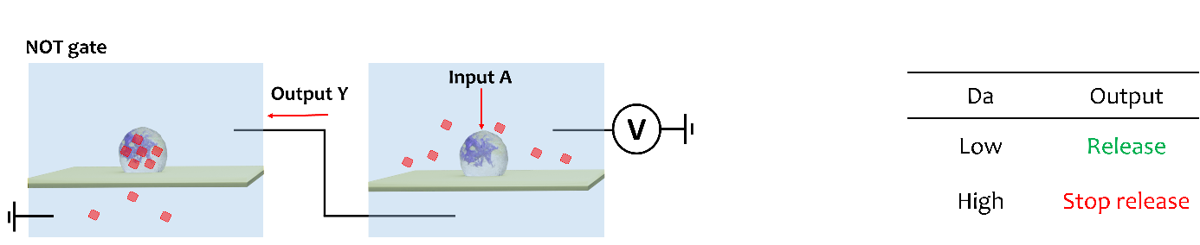
Figure S26. Schematic of NOT gate with a truth table used for edge-computing and in-memory sensing.

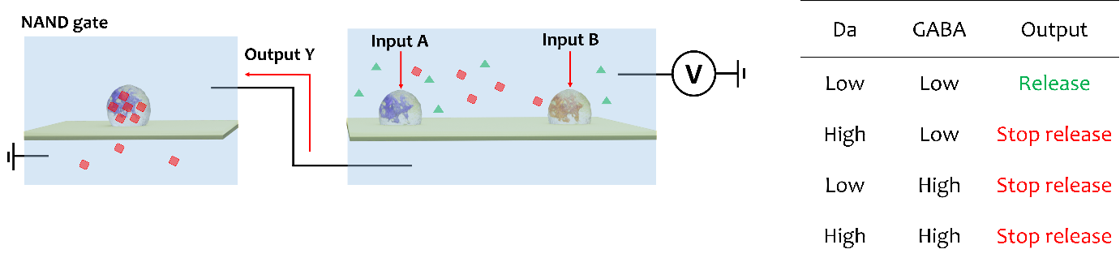
Figure S27. Schematic of NAND gate with a truth table used for edge-computing and in-memory sensing.

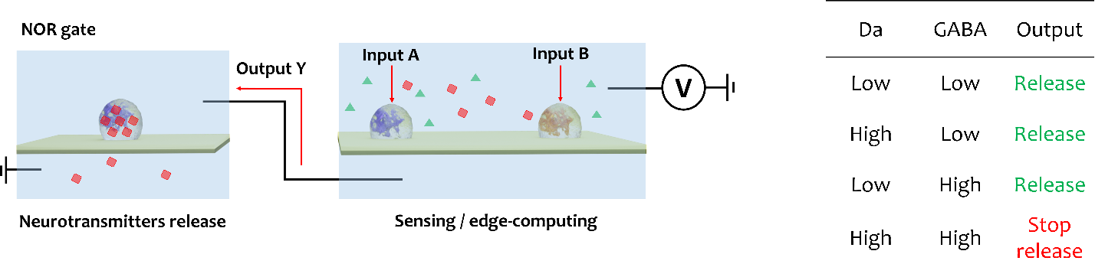
Figure S28. Schematic of NOR gate with a truth table used for edge-computing and in-memory sensing.
References:

[1] S. M. Sears, S. J. Hewett, Exp Biol Med (Maywood) 2021, 246, 1069.
[2] I. Mody, R. A. Pearce, Trends in Neurosciences 2004, 27, 569.
[3] E. Corton, J. A. García-Calzón, M. E. Díaz-García, Journal of Non-Crystalline Solids 2007, 353, 974.
[4] R. J. Ansell, in Molecularly Imprinted Polymers in Biotechnology (Eds.: B. Mattiasson, L. Ye), Springer International Publishing, Cham, 2015, pp. 51–93.
[5] N. Mintz Hemed, S. Leal-Ortiz, E. T. Zhao, N. A. Melosh, ACS Nano 2023, 17, 5632.
[6] A. D. Easley, T. Ma, C. I. Eneh, J. Yun, R. M. Thakur, J. L. Lutkenhaus, Journal of Polymer Science 2022, 60, 1090.
[7] W. Liu, J. Andersson, J. Järlebark, Jingjie Sha, A. Dahlin, 2025, DOI 10.13140/RG.2.2.17795.21284.
[8] E. Evans, K. Ritchie, Biophysical Journal 1997, 72, 1541.
[9] M. Firnkes, D. Pedone, J. Knezevic, M. Döblinger, U. Rant, Nano Lett. 2010, 10, 2162.

