Table 1: Demographic and educational characteristics of medical graduates (2018–2022) in Brazil, by type of medical school (public or private) and participation in affirmative action programs
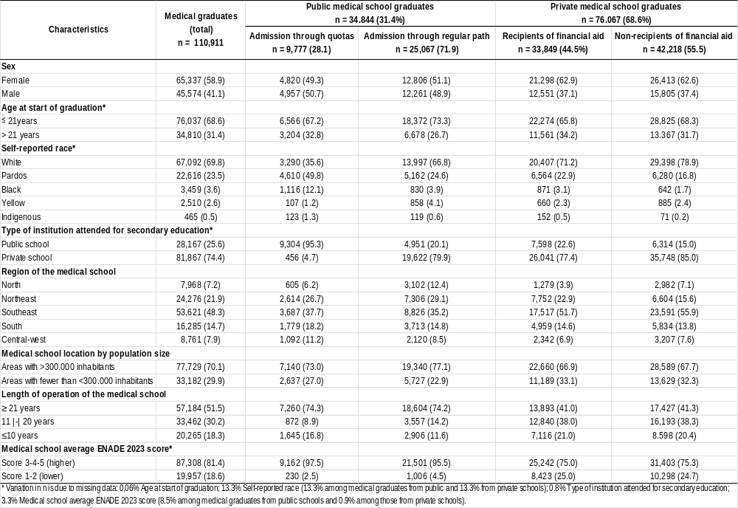

Table 2: Adjusted logistic regression analysis for entry in medical residency and selection of family & community medicine, by public and private medical schools
