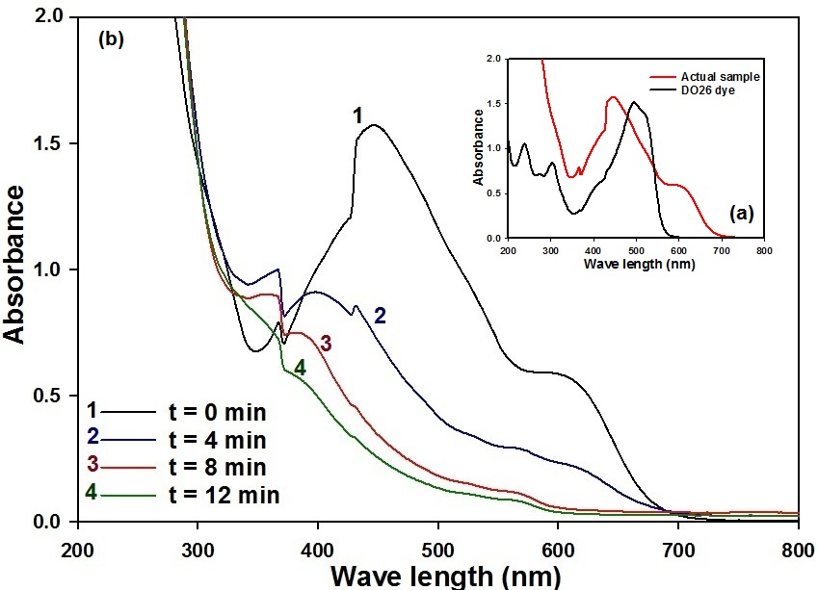
Fig. S1. a- UV–visible spectra of DO26 dye, and b- its actual textile wastewater sample treated by electrochemical oxidation/reduction in on cell using graphite electrodes at optimum conditions.
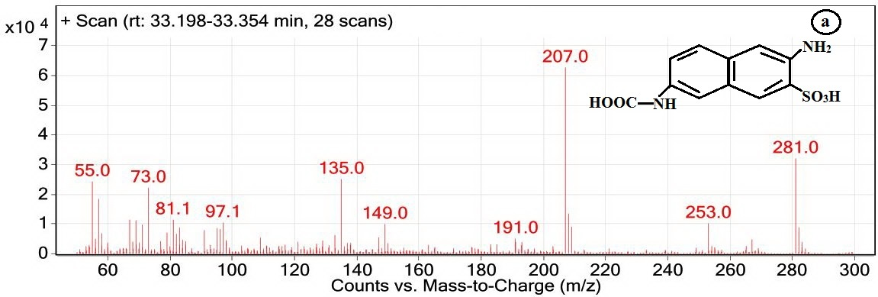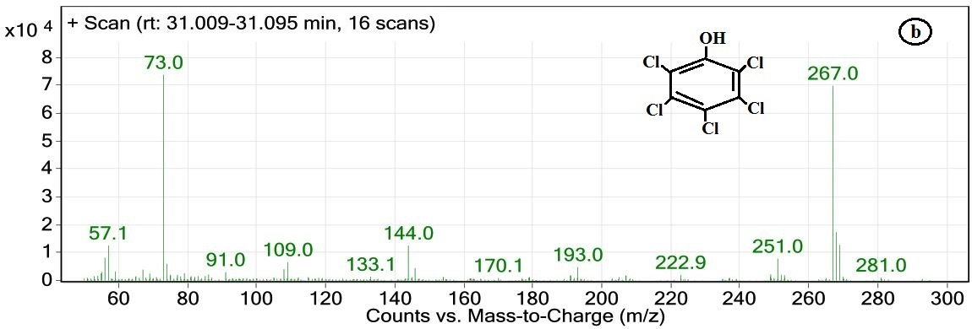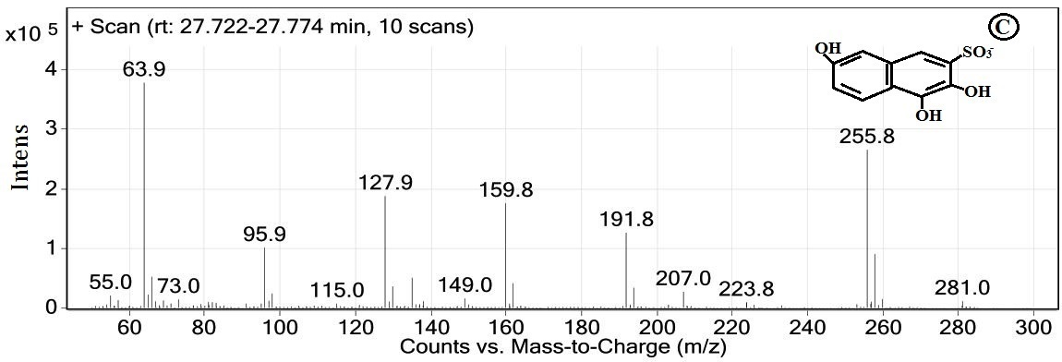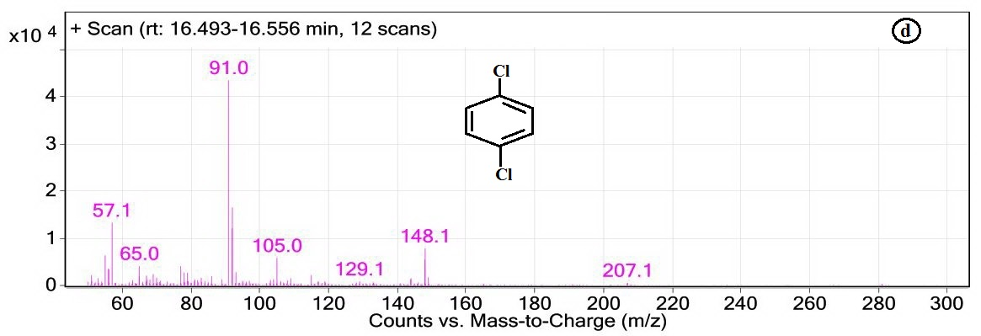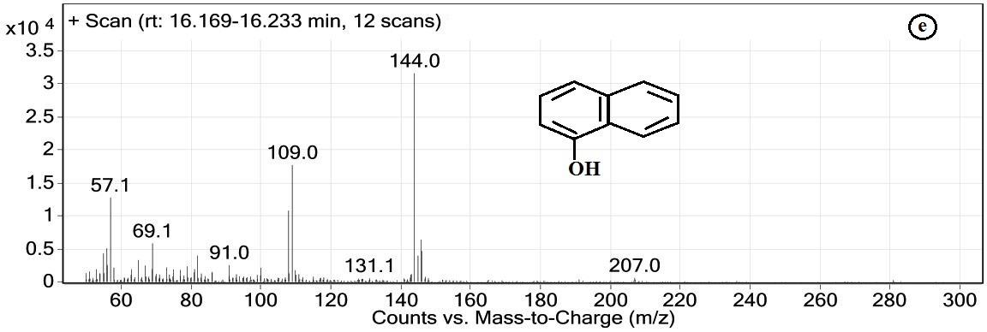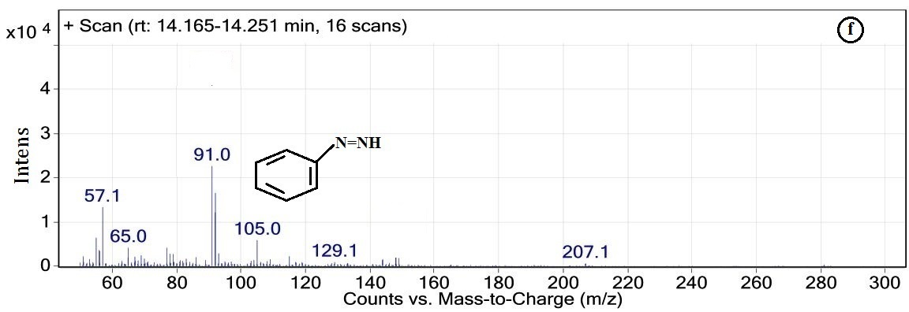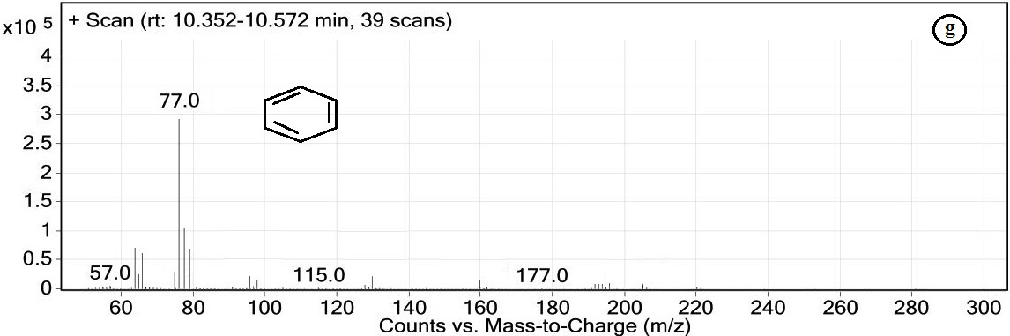
Fig. S2. GC-MS chromatogram of Direct Orange 26 dye degradation products resulted from EO process with the retention time at 33.33 (a), 31.06 (b), 27.75 (c) 16.53 (d), 16.20 (e) 14.21 (f) and 10.45 min (g).

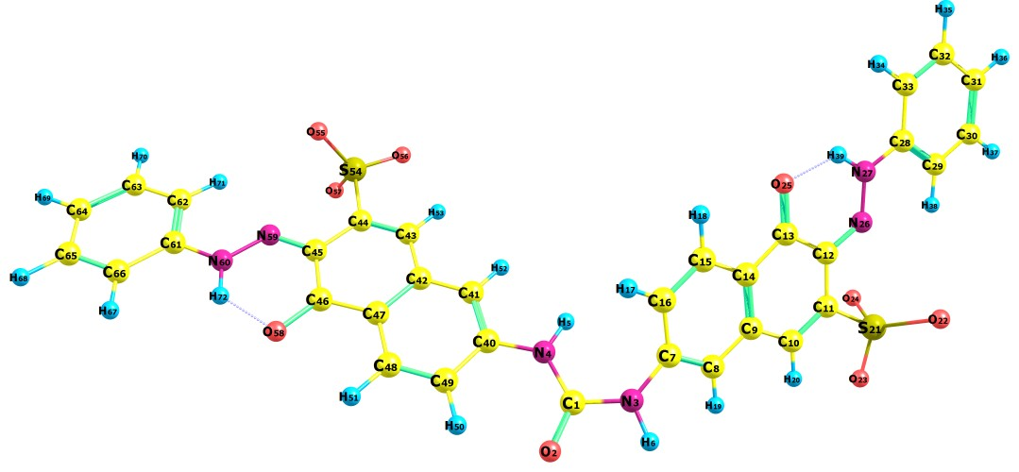
A, ΔE = 0.0 Kcal/mol
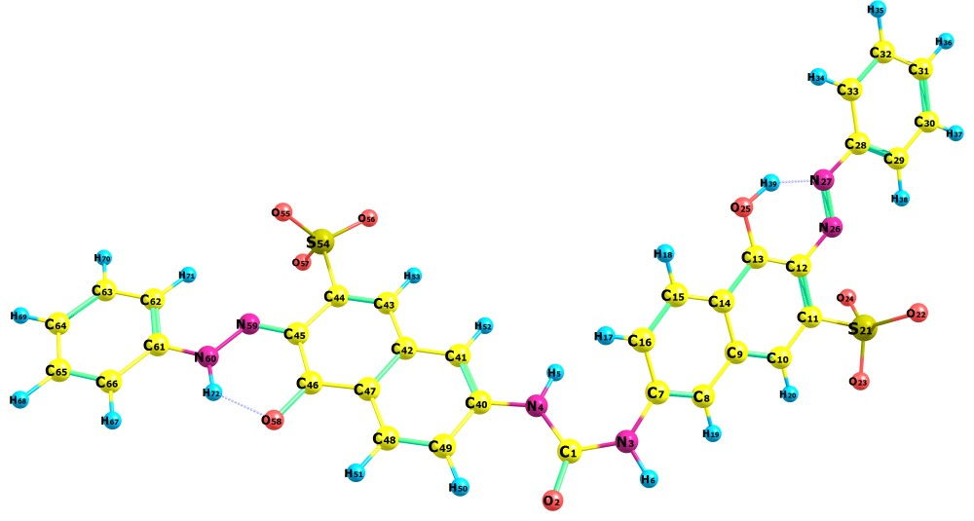
B, ΔE = 3.24 Kcal/mol
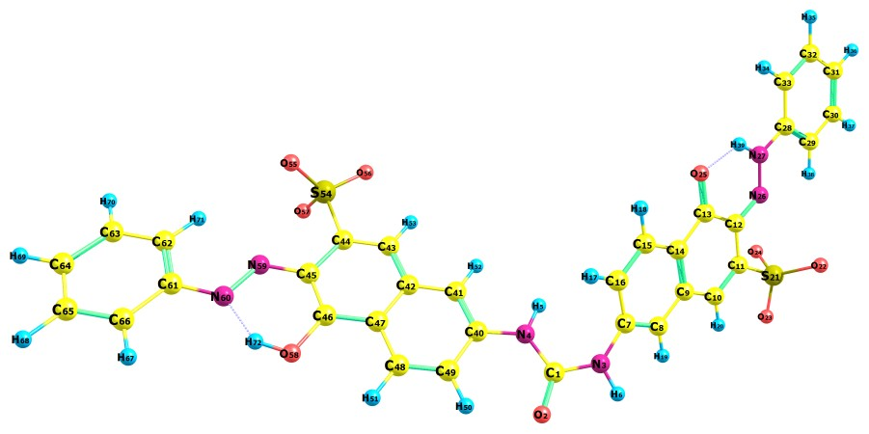
C, ΔE = 3.29 Kcal/mol
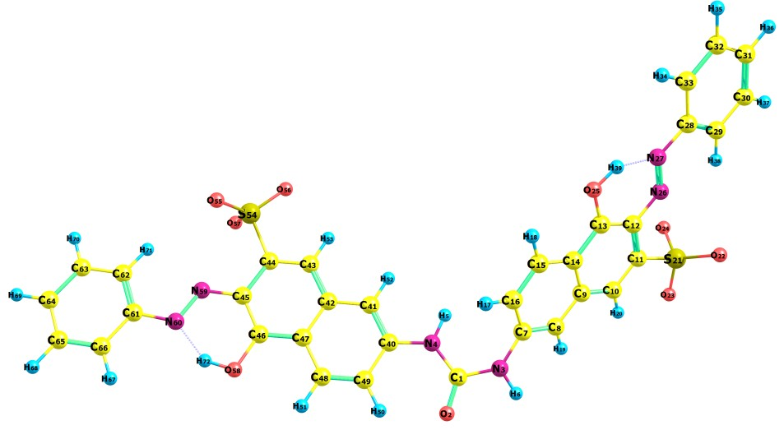
D,E, ΔE = 6.54 Kcal/mol
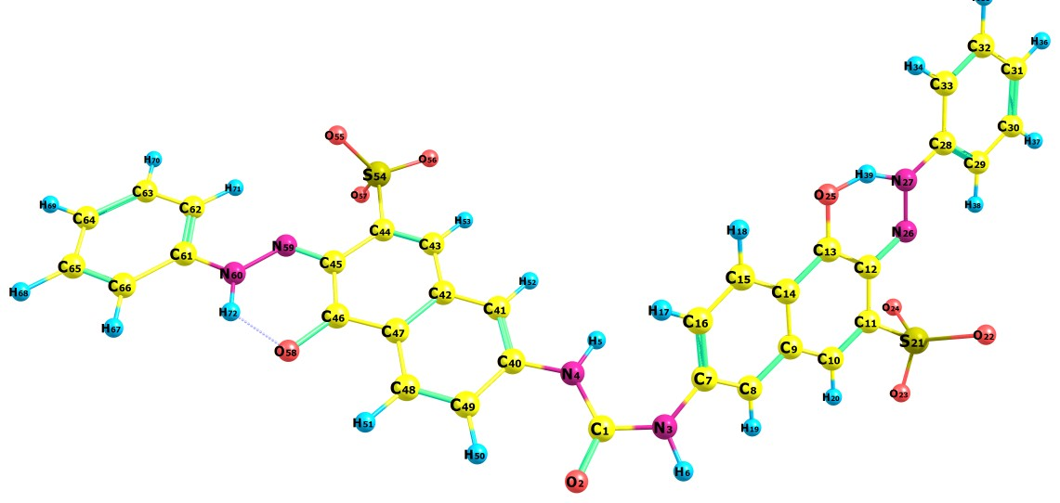
F, ΔE = 5.6 Kcal/mol
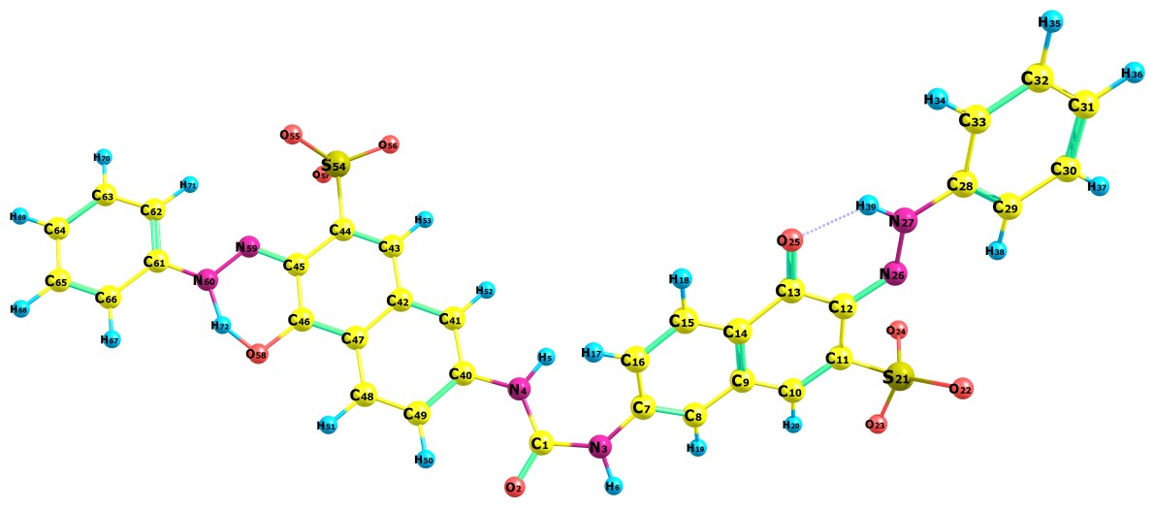
G, ΔE = 5.65 Kcal/mol
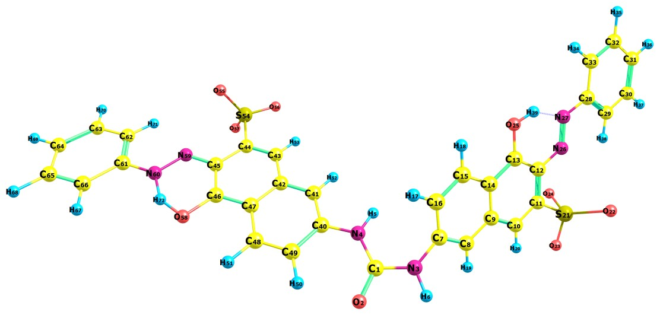
H, ΔE = 8.9 Kcal/mol
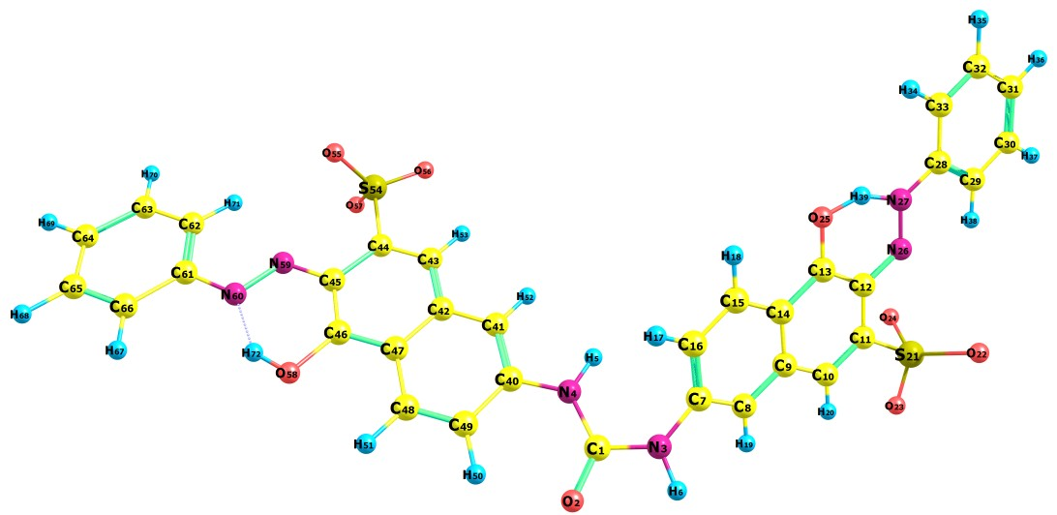
I, ΔE = 8.9 Kcal/mol

Fig. S3. The optimized geometry and numbering system of D1 using B3LYP/6-311++G(d,p) level of calculation for different tautomeric forms of the D1 dye are di-keto form (C₁₃=O₂₅, C₄₆=O₅₈) (A), keto-enol forms (B-C) and di-enol forms (D-E) and corresponding four transition states (TS) (F-I) and the relative energy with respect to di-keto.

Ψ187 (L+2)
Ψ186 (L+1)
Ψ185 (L)
Ψ184 (H)
Ψ183 (H-1)
Ψ182 (H-2)
Ψ172 (H-12)

Figure S4. Contour surfaces of frontier molecular orbitals of D1 (The number in parentheses indicates the order of the MOs.)

Table S1. Vibrational analysis at B3LYP/6-311+G(d,p) level of theory for Dye1 (corresponding FTIR values are also included)
Freq. | Sc. Freq. | IR int. | FTIR | PED %ª with vibrational assignments^{b} (mode)
3617 | 3473 | 56.5 | 3466 | (-93.2%) ν (N3H6)+(- 6.8%) τ (N3C7C16H17)
3594 | 3450 | 115.7 | 3466 | (+100.0%) ν (N4H5)
3269 | 3138 | 33.6 | 3466 | (+91.3%) ν (N60H72)+(+ 8.7%) τ (N59C45C46O58)
3263 | 3133 | 31.3 | 3466 | (+74.1%) ν (N27H39+(+ 15.8%) τ (H39N27C28C33)+(- 10.2%) γ (N26N27C28H39)
3247 | 3117 | 7.8 | 3090 | (-89.9%) ν (C49H50)+(-10.1%) ν (C48H51)
3199 | 3071 | 9.3 | 3090 | (+32.9%) ν (C15H18)+(+32.5%) ν (C16H17)+(+17.5%) τ (C9C10C11C12)+(+17.1%) τ (C9C14C13C12)
3197 | 3069 | 16.4 | 3090 | (-69.0%) ν (C29H38)+(-14.4%) ν (C30H37)+(-9.2%) τ (N26N27C28C29)+(+7.4%) τ (C29C30C31C32)
3194 | 3066 | 20.0 | 3090 | (+79.0%) ν (C62H71)+(+21.0%) ν (C63H70)
3188 | 3061 | 4.4 | 3090 | (+90.5%) ν (C48H51)+(-9.5%) ν (C49H50)
3188 | 3061 | 3.0 | 3090 | (-62.0%) ν (C10H20)+(-12.3%) τ (C8C9C10H20)+(+9.5%) τ (H20C10C11S21)+(-8.3%) τ (C13C12N26N27)+(+ 7.9%) δ (C9C10H20)
3187 | 3059 | 2.9 | 3090 | (-92.6%) ν (C43H53)+(-7.4%) ν (C48H51)
3185 | 3058 | 1.0 | 3090 | (-50.2%) ν (C16H17)+(+49.8%) ν (C15H18)
3182 | 3054 | 45.7 | 3090 | (-31.6%) ν (C31H36)+(-25.0%) ν (C32H35)+(-19.7%) ν (C30H37)+(-15.0%) ν (C33H34)+(+8.5%) ν (C29H38)
3181 | 3053 | 49.7 | 3090 | (+29.7%) ν (C64H69)+(+24.7%) ν (C65H68)+(+22.2%) ν (C63H70)+(+14.6%) ν (C66H67)+(-8.8%) ν (C62H71)
3172 | 3045 | 32.1 | 3090 | (+29.5%) ν (C33H34)+(-29.1%) ν (C30H37)+(+24.1%) ν (C32H35)+(-10.0%) ν (C31H36)+(+7.3%) ν (C29H38)
3170 | 3043 | 34.8 | 3090 | (-29.9%) ν (C63H70)+(+ 29.5%) ν (C66H67)+(+26.5%) ν (C65H68)+(+7.5%) ν (C62H71)+(- 6.5%) ν (C64H69)
3163 | 3036 | 9.5 | 3090 | (+33.1%) ν (C33H34)+(-27.1%) ν (C31H36)+(+26.2%) ν (C30H37)+(-13.6%) ν (C32H35)
3161 | 3034 | 8.9 | 3090 | (-33.2%) ν (C66H67)+(+28.7%) ν (C64H69)+(-28.6%) ν (C63H70)+(+9.5%) ν (C65H68)
3160 | 3034 | 15.0 | 3090 | (-82.7%) ν (C8H19)+(+9.3%) τ (C8C9C10H20)+(+8.0%) γ (C9C10C11H20)
3152 | 3026 | 4.1 | 3090 | (+34.7%) ν (C32H35)+(-28.4%) ν (C31H36)+(-22.3%) ν (C33H34)+(+14.6%) ν (C30H37)
3150 | 3024 | 23.7 | 3090 | (-89.8%) ν (C41H52)+(-10.2%) τ (C41C42C43H53)
3150 | 3024 | 7.6 | 3090 | (+36.1%) ν (C65H68)+(-24.8%) ν (C64H69)+(-24.4%) ν (C66H67)+(+14.7%) ν (C63H70)
1742 | 1672 | 668.2 | 1638 | (+72.3%) ν (C1O2)+(-10.6%) ν (C1N4)+(-8.6%) δ (C1N4H5)+(+8.5%) δ (C1N3H6)
1651 | 1585 | 119.5 | 1638 | (+56.3%) ν (C46O58)+(-43.7%) ν (C40C41)
1648 | 1582 | 230.8 | 1638 | (-100.0%) ν (C13O25)
1640 | 1574 | 83.4 | 1600 | (-58.3%) ν (C43C44)+(-41.7%) ν (C48C49)
1639 | 1574 | 48.2 | 1600 | (+51.1%) ν (C32C33)+(+48.7%) ν (C29C30)
1638 | 1573 | 120.0 | 1600 | (+38.9%) ν (C65C66)+(+ 36.7%) ν (C62C63)+(+24.7%) ν (C43C44)
1637 | 1571 | 239.1 | 1600 | (+64.6%) ν (C10C11)+(+35.4%) ν (C15C16)
1624 | 1559 | 34.7 | 1600 | (-27.0%) ν (C61C62)+(- 26.6%) ν (C10C11)+(- 23.3%) ν C64C65+(+ 22.5%) ν C63C64
1624 | 1559 | 12.7 | 1600 | (+21.6%) ν (C28C29+ (+20.9%) ν (C31C32)+(-19.8%) ν (C30C31)+(+19.5%) ν (C10C11)+(-18.0%) ν (C28C33)
1603 | 1539 | 212.0 | 1638 | (-47.2%) ν (C13O25)+(-28.6%) ν (C46O58)+(- 24.2%) ν (C10C11)
1597 | 1533 | 300.2 | 1638 | (-66.5%) ν (C46O58)+(+34.5%) ν (C13O25)
1593 | 1529 | 101.3 | 1600 | (+66.5%) ν (C43C44)+(33.5%) ν (C40C49)
1580 | 1516 | 19.9 | 1600 | (+34.3%) ν (C7C16)+(+24.3%) ν (C10C11)+(-23.0%) ν (C14C15)+(+18.3%) ν (C9C14)
1561 | 1499 | 218.9 | 1490 | (+ 100%) ν (C12N26)
1558 | 1496 | 526.6 | 1490 | (+33.2%) ν (C45N59)+(+22.5%) ν (C12N26)+(-22.5%) ν (N59N60)+(+21.8%) δ N59 (N60H72)
1551 | 1489 | 2764.4 | 1490 | (-100%) ν (C12N26)
1525 | 1464 | 41.6 | 1490 | (-50.9%) δ (C62C63H70)+(-49.1%) ν (N60C61)
1525 | 1464 | 80.7 |  | (-20.9%) δ (C29C30H37)+(+ 20.1%) ν (C28C29)+(-19.8%) δ (C29C28C33)+(-19.8%) ν (C30C31)+(+19.4%) δ (C30C31C32)
1508 | 1448 | 122.3 |  | (+54.5%) δ (C41C40C49)+(+ 44.7%) δ (C40C49C48)
1507 | 1446 | 88.6 |  | (+ 15.7%) ν (C15C16)+(+14.4%) ν (C9C10)+(-7.8%) ν (C9C14)+(+14.3%) ν (C13O25)+(+12.0%) δ (C9C8H19)+(-10.4%) ν (C8C9)+(-10.4%) ν (C1O2)+(+10.3%) δ (N3C7C8)
1501 | 1441 | 745.7 |  | (-52.2%) ν (C10C11)+(+47.8%) ν (C1O2)
1488 | 1428 | 40.9 |  | (-35.6%) δ (C29C30C31)+(-23.9%) δ C28C29C30+(+21.8%) δ C32C31H36+(-18.6%) ν C12N26
1487 | 1428 | 121.9 |  | (+27.6%) δ (C62C63C64)+(-26.3%) δ C65C64H69+(+24.6%) δ C61C62C63 +(+21.5%) ν C45N59
1441 | 1384 | 129.3 | 1300 | (-38.6%) ν (C45N59)+(+33.0%) ν (C41C42)+(+ 29.0%) ν (C44C45)
1434 | 1376 | 185.3 | 1300 | (-38.1%) ν (C12N26)+(-22.6%) ν (C13O25)+(+20.5%) ν (C11C12)+(+18.8%) ν (N27C28)
1426 | 1369 | 526.1 | 1300 | (-100%) ν (C45N59)
1414 | 1357 | 365.0 | 1300 | (-100%) ν (C12N26)
1383 | 1328 | 33.2 | 1300 | (-100%) ν (C11C12)
1380 | 1325 | 61.4 | 1300 | (-100%) ν (C44C45)
1360 | 1306 | 80.9 |  | (+56.0%) ν (C62C63)+(-44.0%) δ (C63C62H71)
1360 | 1306 | 14.1 |  | (-100.0%) ν (C29C30)
1355 | 1301 | 401.7 |  | (-42.3%) ν (C40C41)+(-29.0%) ν (C42C47)+(-28.6%) ν (C48C49)
1344 | 1290 | 132.0 |  | (+26.6%) ν (C7C8)+(-19.6%) ν (N26N27) +(-19.6%) ν (C7C16) +(+ 17.8%) ν (C9C14) +(-16.4%) ν (C14C15)
1338 | 1285 | 5.7 | 1250 | (+54.1%) ν (C28C29)+(-45.9%) ν (C28C33)
1338 | 1284 | 8.8 | 1250 | (+36.3%) ν (C61C66)+(-35.2%) ν (C61C62)+(-28.5%) ν (C65C66)
1316 | 1263 | 56.9 | 1250 | (+100%) ν (N26N27)
1315 | 1262 | 27.8 | 1250 | (+45.7%) ν (N59N60)+(+30.3%) ν (C46C47)+(-23.6%) ν (C45C46)
1312 | 1260 | 8.0 | 1250 | (+51%) ν (N3C7)+(+49%) ν (N26N27)
1305 | 1253 | 28.8 | 1250 | (+57.3%) ν (N4C40)+(+42.7%) ν (N59N60)
1294 | 1242 | 232.3 | 1250 | (+100.0%) ν (N4C40)
1283 | 1231 | 935.9 | 1250 | (-100.0%) ν (N26N27)
1265 | 1214 | 1336.6 | 1250 | (+56.7%) ν (C1N3)+(-43.3%) ν (C1N4)
1254 | 1204 | 142.1 | 1250 | (+100.0%) ν (N26N27)
1254 | 1203 | 804.0 | 1250 | (+100.0%) ν (N59N60)
1230 | 1181 | 8.4 | 1250 | (+100.0%) ν (N60C61)
1224 | 1175 | 150.6 | 1250 | (+52.8%) ν (N27C28) +(-46.3%) ν (C29C30)
1209 | 1161 | 16.5 | 1250 | (+100.0%) ν (N59N60)
1204 | 1156 | 142.9 | 1250 | (+100.0%) ν (C11C12)
1196 | 1148 | 213.6 | 1150 | (-100.0%) ν (S54O56)
1193 | 1145 | 245.0 | 1150 | (+100.0%) ν (S21O23)
1187 | 1140 | 80.0 | 1120 | (+100.0%) δ (C65C66H67)
1186 | 1138 | 443.2 | 1120 | (+100.0%) ν (C28C33)
1176 | 1129 | 0.6 | 1120 | (+20.6%) ν (C31C32)+(-18.4%) ν (C30C31)+(-16.0%) δ (C33C32H35)+(+14.7%) δ (C29C30H37)+(-11.0%) δ (C30C31H36+(+7.7%) δ C32C31H36+(-6.9%) δ (C32C33H34+(-6.9%) ν (C32C33
1175 | 1128 | 0.8 | 1120 | (-25.0%) δ (C64C63H70)+(-19.5%) δ (C62C63H70)+(-15.4%) δ (C62C63C64)+(-14.7%) δ (C63C64H69)+(-13.4%) δ (C66C65H68+(+12.0%) ν (C64C65)
1173 | 1126 | 289.4 | 1110 | (-53.4%) ν (S21O24)+(+64.6%) ν (S21O22)
1169 | 1122 | 277.0 | 1110 | (+50.6%) ν (S54O55)+(-49.4%) ν (S54O57)
1165 | 1118 | 44.1 | 1110 | (+49.0%) ν (S54O56)+(-26.7%) ν (S54O57)+(-24.4%) ν (S54O55)
1163 | 1117 | 102.3 | 1110 | (+48.3%) ν (S21O23) +(-32.1%) ν (S21O22) +(-19.6%) ν (S21O24)
1144 | 1098 | 29.7 | 1098 | (+100%) ν (C7C16)
1141 | 1095 | 109.2 | 1098 | (+100%) ν (C40C49)
1104 | 1060 | 6.1 | 1098 | (-21.3%) ν (C32C33)+(+16.8%) ν (C29C30)+(-16.8%) ν (C31C32)+(-13.9%) δ (C32C33H34)+(+11.1%) δ (C30C31H36)+(+10.6%) ν (C30C31)+(+9.4%) δ (C30C29H38)
1103 | 1059 | 7.0 |  | (-18.9%) ν (C65C66)+ (-14.4%) ν (C64C65)+(+14.4%) ν (C62C63)+(-11.8%) δ (C62C63C64)+(-11.2%) δ (C65C66H67)+(+10.7%) δ (C63C64H69)+(+10.3%) ν (C63C64)+(+8.4%) δ (C63C62H71)
1052 | 1009 | 0.8 |  | (+40.0%) ν (C1N4)+(+31.2%) ν (C1O2)+(+28.8%) ν (C1N3)
1043 | 1001 | 18.4 |  | (+29.7%) ν (C31C32) +(+28.9%) ν (C30C31)+(-10.9%) ν (C28C29)+(+10.7%) ν (C32C33)+(-10.0%) ν (C28C33)+(+9.8%) ν (C29C30
1043 | 1001 | 10.8 |  | (+41.3%) ν (C63C64)+ (+40.7%) ν (C64C65)+(+18.0%) ν (C65C66)
1021 | 980 | 460.9 |  | (-100.0%) ν (C14C15)
1018 | 978 | 146.3 |  | (+100.0%) ν (C47C48)
1009 | 969 | 19.9 |  | (+20.3%) δ (C28C33C32)+(-20.2%) δ C29C30C31+(-18.3%) ν C29C30+(-18.2%) ν C30C31+(-12.9%) ν C28C29+(-10.0%) ν C31C32
1008 | 968 | 30.5 |  | (+18.3%) δ (C62C63C64)+ (+18.3%) ν (C63C64)+ (-16.3%) δ (C61C66C65)+(+15.4%) ν (C62C63)+(+13.1%) ν (C64C65)+(+11.1%) ν (C61C62)+(+7.7%) ν (C61C66)
1000 | 960 | 0.0 |  | (-31.5%) τ (C62C63C64C65)+ (-21.8%) τ (N60C61C66C65)+(-20.2%) τ (N60C61C62C63)+(+13.7%) τ (C66C61C62H71)+(+12.7%) τ (H70C63C64C65)
997 | 957 | 0.0 |  | (+21.7%) τ (H37C30C31C32)+(+20.5%) τ (N27C28C33C32)+(+14.0%) γ (C29C30C31H37)+(+11.3%) τ (N27C28C29C30+(+10.7%) τ (N27C28C29H38+(-8.1%) τ (C33C28C29H38)+(-7.7%) τ (H37C30C31H36)+(-6.6%) γ (C28C29C30H38)
996 | 956 | 0.7 |  | (+22.6%) τ (C42C47C48H51)+(+22.0%) τ (N4C40C49H50)+(+19.0%) τ (H51C48C49H50)+(-19.0%) τ (N4C40C49C48)+(+17.3%) τ (C49C40C41C42)
988 | 949 | 11.6 |  | (+41.7%) τ (C8C9C14C15)+(-20.9%) τ (C13C14C15C16)+(-18.8%) τ (C8C9C14C13)+(+18.6%) τ (C8C7C16C15)+
984 | 944 | 131.2 |  | (-33.7%) ν (S21O22)+ (-33.7%) ν (S21O24)+(-32.6%) ν (S21O23)
983 | 944 | 169.5 |  | (-33.9%) ν (S54O55)+(-33.7%) ν (S54O57)+(-32.4%) ν (S54O56)
974 | 935 | 49.2 |  | (+35.2%) ν (C7C16)+(-40.0%) δ (C7C16C15)+(+30.9%) ν (C7C8)
962 | 924 | 0.2 |  | (-30.4%) τ (H37C30C31H36)+(+17.0%) τ (C29C30C31H36)+(+17.0%) τ (C33C28C29C30)+(+14.1%) τ (H37C30C31C32)+(-11.9%) γ (C29C30C31H37)+(+9.9%) τ (C30C31C32H35)
959 | 920 | 0.2 |  | (+24.0%) τ (C62C61C66H67)+(+16.5%) τ (C64C65C66H67)+(+14.1%) τ (C66C61C62C63)+(-12.4%) τ (N60C61C66C65)+(-12.1%) τ (N60C61C62C63)+(+12.0%) τ (C62C63C64C65+(+8.9%) τ (H69C64C65H68)
945 | 907 | 8.8 |  | (+100.0%) ν (C1N4)
910 | 873 | 23.6 |  | (+100.0%) ν (S21O23)
909 | 872 | 4.5 |  | (+20.9%) τ (C33C28C29H38)+(-17.6%) γ (C28C29C30H38)+(-16.3%) τ (C31C32C33H34)+(-12.0%) γ (N27C28C29C33)+(-9.7%) τ (N27C28C29C30)+(+8.7%) τ (C29C30C31H36)+(-7.6%) τ (C29C28C33H34)+(+7.2%) τ (H38C29C30C31)
907 | 871 | 21.8 |  | (-22.8%) τ (C63C64C65H68)+(-21.6%) τ (H71C62C63C64)+(-19.9%) τ (N59N60C61C62)+(-18.5%) τ (C43C44C45N59)+(-17.1%) τ (C61C66C65H68)
907 | 871 | 7.1 |  | (-34.4%) τ (C43C44C45N59)+(-32.8%) τ (N59N60C61C66)+(+16.6%) τ (H71C62C63C64)+(-16.2%) τ (H53C43C44C45)
905 | 869 | 21.7 |  | (+100%) γ (C8C9C10C14)
898 | 863 | 9.9 |  | (+100.0%) ν (C41C42)
868 | 834 | 7.6 |  | (+100.0%) τ (C7C8C9C10)
864 | 829 | 14.2 |  | (-52.6%) τ (C1N4C40C41) +(+47.4%) τ (C40C41C42C43)
860 | 826 | 7.9 |  | (+30.5%) γ (C42C47C46C48)+(+24.4%) τ (C46C47C48C49)+(-23.7%) γ C40C49C48H50)+(+21.4%) τ C41C42C47C48)
856 | 821 | 15.5 |  | (+100.0%) ν (C28C29)
855 | 820 | 1.7 |  | (+100.0%) ν (C61C62)
854 | 820 | 11.5 |  | (+51.9%) ν (C28C29)+(+48.1%) ν (N27C28)
850 | 816 | 44.2 |  | (+100.0%) τ (C66C61C62C63)
848 | 814 | 16.4 |  | (+100.0%) τ (C13C14C15C16)
833 | 800 | 29.4 |  | (-100.0%) τ (N26N27C28C33)
831 | 798 | 28.3 |  | (-28.3%) τ (C46C45N59N60)+(+26.6%) τ (C63C64C65C66)+(+25.2%) τ (C45N59N60H72)+(-19.9%) γ (C44C45C46N59)
829 | 795 | 2.0 |  | (+100.0%) ν (C1N3)
807 | 774 | 7.5 |  | (+50.9%) ν (C7C16) +(-49.1%) δ (O2C1N3)
794 | 762 | 0.2 |  | (+34.2%) τ (C43C42C47C46) +(-28.2%) γ (C42 C47C46C48)+(-24.7%) τ (C45C46C47C48)+(-13.0%) τ (C43C42C47C48)
790 | 758 | 0.9 |  | (+34.4%) τ (C10C9C14C13)+(-27.3%) τ (C12C13C14C15)+(-20.1%) γ (C9C14C13C15)+(-18.2%) τ (C16C7C8C9)
757 | 727 | 59.2 | 730 | (+23.3%) τ ( C28C29C30C31)+(+20.6%) γ (N27C28C29C33)+(+18.4%) γ (C31C32C33H35)+(+14.6%) τ (C28C33C32H35)+(+14.3%) γ (C30C31 C32H36)+(+8.8%) τ (H36C31C32C33)
757 | 727 | 62.2 | 730 | (+30.0%) τ (C61C66C65C64)+(-15.9%) γ (N60C61C62C66)+(-13.4%) τ N59N60C61C66)+(+12.6%) τ N59N60C61C62)+(-10.5%) γ (C63C64C65H69)+(-9.2%) γ (C64C65C66H68)+(+8.4%) τ (N60C61C66H67)
750 | 720 | 69.1 |  | (+100.0%) τ (C1N4C40C41)
743 | 713 | 15.6 |  | (+100.0%) δ (N59N60C61)
739 | 709 | 16.5 |  | (+100.0%) τ (C1N4C40C41)
716 | 687 | 3.1 | 690 | (+54.8%) γ (C8C9C10C14)+(+45.2%) τ (C12C13C14C15)
715 | 687 | 2.2 | 690 | (+30.3%) τ (C45C46C47C48)+(-24.2%) τ (C40C49C48C47) +(+23.9%) τ (C46C47C48C49) +(+21.6%) γ (C41C42C43C47)
696 | 668 | 20.1 | 690 | (-19.0%) τ (C61C66C65C64)+(-17.6%) τ (C62C63C64C65)+(-15.7%) τ (C66C61C62C63)+(+12.9%) τ (C63C64C65H68)+(-12.6%) τ (H70C63C64C65) +(-11.6%) γ (C64C65C66H68)+(-10.6%) γ (C62C63C64H70)
694 | 666 | 18.9 | 690 | (-20.1%) τ (C29C28C33C32)+(+17.2%) τ (C30C31C32H35)+(-15.1%) γ (C31C32C33H35+(+15.0%) τ C28C33C32C31+(+13.1%) γ (N27C28C29C33)+(-10.2%) ν (C31C32)+(-9.4%) τ (C33C28C29C30)
690 | 663 | 8.0 | 690 | (+100.0%) δ (N3C7C8)
679 | 652 | 23.6 | 690 | (+100.0%) δ (C7C8C9)
660 | 634 | 4.0 | 690 | (+100.0%) δ (C43C42C47)
648 | 623 | 22.0 | 690 | (+100.0%) ν (C29C30)
637 | 611 | 57.2 | 690 | (+100.0%) ν (C44C45)
636 | 610 | 13.2 | 690 | (+100.0%) δ (C44S54O55)
632 | 607 | 82.8 | 690 | (+100.0%) δ (C31C32C33)
631 | 606 | 57.0 | 690 | (+100.0%) δ (C11S21O22)
628 | 603 | 24.1 | 690 | (+54.2%) δ (C64C65C66)+(-45.8%) ν (C61C66)
628 | 603 | 35.5 | 597 | (+100.0%) δ (C31C32C33)
623 | 598 | 21.9 | 597 | (+100.0%) γ (N3C7C8C16)
622 | 597 | 19.2 | 597 | (+40.2%) γ (N4C40C41C49)+(-29.9%) τ (C43C42C47C48)+(-29.9%) γ (C43C44C45S54)
592 | 568 | 20.4 | 560 | (+100.0%) ν (C46C47)
588 | 564 | 69.3 | 560 | (-64.2%) δ (C8C9C14)+(+35.8%) δ (C13C14C15)
578 | 555 | 79.3 | 560 | (+100.0%) δ (C40C41C42)
557 | 535 | 27.2 | 520 | (+100.0%) ν (N4C40)
545 | 523 | 21.8 | 520 | (-100.0%) ν (C13C14)
524 | 503 | 12.4 |  | (+26.4%) τ (C64C65C66H67)+(+25.6%) γ (N60C61C62C66)+(+23.3%) γ (C61C66C65H67)+(+14.0%) τ (C66C61C62C63)+(+10.5%) τ (C62C63C64C65)
523 | 502 | 4.8 |  | (+26.4%) τ (C31C32C33H34)+(+24.0%) γ (N27C28C29C33)+(+23.3%) γ (C28C33C32H34)+(+13.8%) τ (C33C28C29C30)+(-12.4%) τ (N27C28C33C32)
514 | 494 | 227.7 |  | (+100.0%) ν (C45C46)
511 | 490 | 36.6 | 480 | (-100.0%) δ (C45C46C47)
508 | 488 | 1.4 | 480 | (-51.0%) δ (C29C28C33) +(-49.0%) ν (C12C13)
501 | 481 | 0.4 | 480 | (+36.7%) δ (O55S54O56)+ (-35.6%) δ O56S54O57+(+27.7%) ν S54O55
501 | 481 | 1.3 | 480 | (+50.7%) δ (O22S21O23)+(-49.3%) δ (O23S21O24)
497 | 477 | 4.6 | 480 | (+100.0%) δ (O55S54O57)
495 | 475 | 8.1 | 450 | (-43.9%) δ (O22S21O24)+ (+28.3%) ν (C11C12)+(+27.8%) δ (O23S21O24)
483 | 464 | 0.9 | 450 | (+100.0%) δ (C47C46O58)
477 | 458 | 4.0 | 450 | (-41.2%) δ (C45C46O58)+(-29.9%) ν (C45C46)+(-28.9%) δ (C46C45N59)
474 | 455 | 7.1 | 450 | (+100.0%) δ (C12C13O25)
459 | 441 | 7.0 | 450 | (-28.1%) γ (C41C42C43C47) +(-24.2%) δ (O55S54O56)+(+23.8%) δ (O56S54O57)+(-23.8%) γ (C42C47C46C48)
458 | 440 | 16.0 | 450 | (+100.0%) δ (O23S21O24)
428 | 411 | 17.2 | 400 | (+100.0%) δ (C13C14C15)
425 | 408 | 11.7 | 400 | (-100.0%) τ (C43C42C47C48)
419 | 402 | 38.0 | 400 | (+100.0%) δ (C13C14C15)
417 | 401 | 1.8 | 400 | (+27.4%) τ (N60C61C62C63)+(+24.9%) τ (N60C61C66C65)+(+24.1%) τ (C62C63C64H69)+(+23.6%) τ (H69C64C65C66)
415 | 399 | 3.5 | 400 | (+35.9%) τ (N27C28C29C30)+(+32.5%) τ (N27C28C33C32)+(+31.6%) τ (N26N27C28C33)
376 | 361 | 20.6 |  | (-100.0%) δ (C45C46O58)
363 | 348 | 3.7 |  | (-100.0%) δ (N4C40C41)

ª PED <10 % are not included in assignments.
^{b} Symbols: ν = Stretching, δ = Bending, τ and γ = torsional motions, + = out of phase, - = in phase
Expressions represent: (direction of phase, percentage contribution in normal mode%) vibrational normal mode (Atom composition mode motions)

Table S2. Composition of the active space frontier Molecular orbitals of studied D1 calculated at B3LYP/6-311++G(d,p) level of theory and their assignments.
MO | composition with weight % of the atomic orbitals to construct MO | Assignment
Ψ187 (L+2) | = 16.14 % (2Pz C8) +17 % (2Pz C15) + 8 % (2Pz C11) + 7.7 % (2Pz C16) | Ψ₁₈₇(π*)
Ψ186 (L+1) | = 11.53 % (2Pz C46) +10 % (2Pz O58) + 19.0 % (2Pz N59) | Ψ₁₈₆(π*)
Ψ185 (L) | = 10.0 % (2Pz C13) + 9 % (2Pz O25) + 16.0 % (2Pz N26) | Ψ₁₈₅(π*)
Ψ184 (H) | = 26% (2Px O55) + 30.0 % (2Pz O56) + 20 % (2Px O57) + 12 % (2Pz O57) | Ψ₁₈₄(n, π)
Ψ183 (H-1) | = 31% (2Py O22) + 25.0 % (2Pz O23) + 7.1 % (2Px O24) + 11.2 % (2Py O24) + 15.0 % (2Pz O24) | Ψ₁₈₃(n, π)
Ψ182 (H-2) | = 20.0 % (2Pz C34) +7.9 % (2Pz C44) + 10.0 % (2Pz N60) | Ψ₁₈₂(π)
Ψ172 (H-12) | = 11.0 % (2Px O55) + 7.0 % (2Py O55) + 10.0 % (2Px O57) + 13.0 % (2Px O58) + 11.0 % (2Py O58) + 8.0 % (2Py O57) + + 12.0 % (2Py N59) | Ψ₁₈₂(π)

