Default Mode Network Reconfiguration Underlies Clinical Response to Amygdala-Targeted Neuromodulation in Major Depression
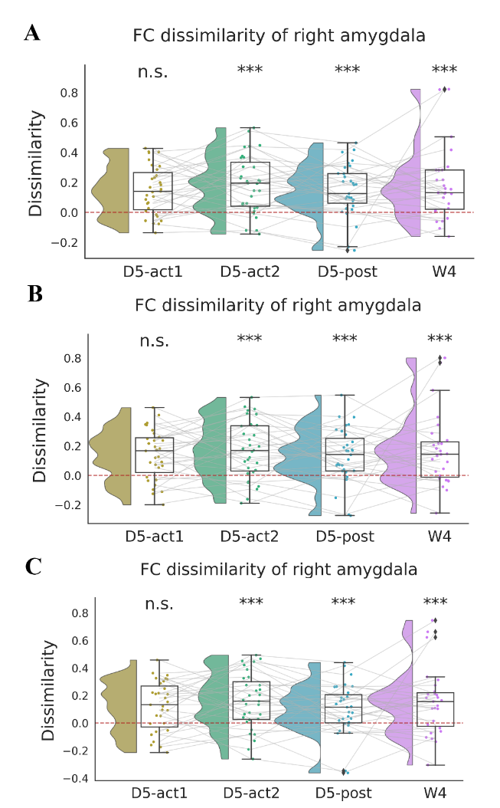
Fig S1. FC dissimilarity of right amygdala across timepoints in multiple spatial resolutions.
A: Schaefer atlas with 200 functional parcels. B: Schaefer atlas with 400 functional parcels. C: Schaefer atlas with 1000 functional parcels; *** p < 0.001, n.s. p > 0.05.

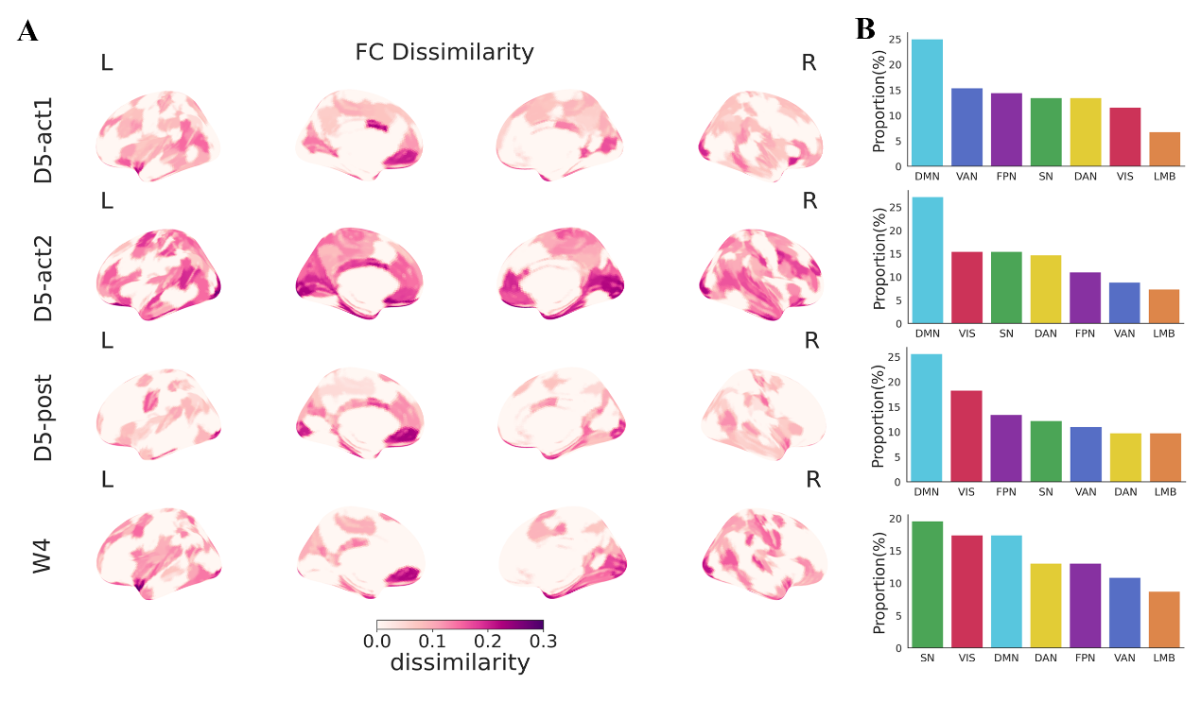
Fig S2. The distribution of FC dissimilarity under the Schaefer-200 parcellation.
A: Spatial distribution of significant FC dissimilarity adjusted for sex and age. B: Proportion of network regions exhibiting significant FC dissimilarity.

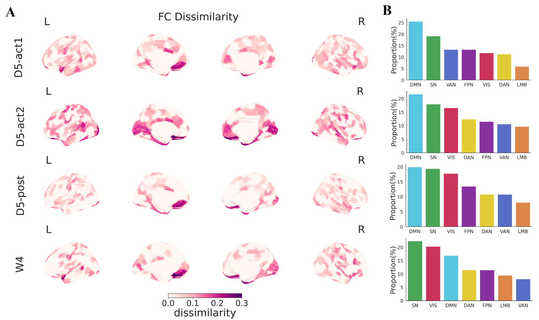
Fig S3. The distribution of FC dissimilarity under the Schaefer-400 parcellation.
A: Spatial distribution of significant FC dissimilarity adjusted for sex and age. B: Proportion of network regions exhibiting significant FC dissimilarity.

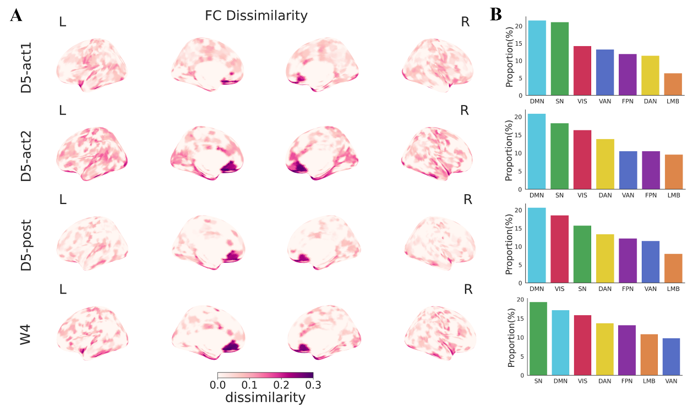
Fig S4. The distribution of FC dissimilarity under the Schaefer-1000 parcellation.
A: Spatial distribution of significant FC dissimilarity adjusted for sex and age. B: Proportion of network regions exhibiting significant FC dissimilarity.

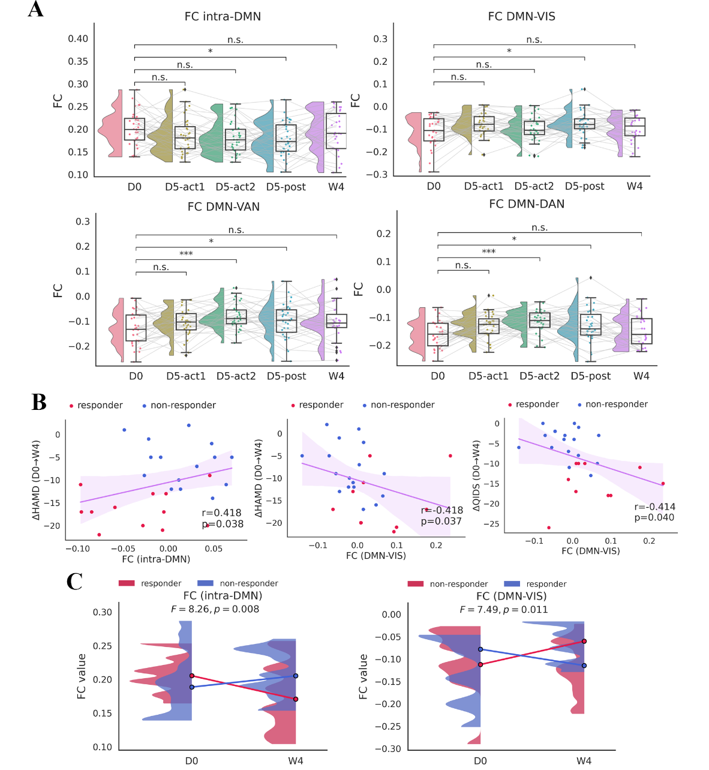
Fig S5. tTIS induced intra- and inter- FC change in DMN under Schaefer-200 parcellation.
A: Intra-FC of DMN exhibited significant decrease at D5-post. Significant increase in FC between DMN and VN was observed at ​D5-post. FC between DMN and SAN, DAN significantly increased at both D5-post and D5-post. Sex and age were regressed out as covariates; *** p < 0.001, ** p < 0.01, * p < 0.05, n.s. p > 0.05. B: Partial correlation (controlling for sex and age) between FC change and symptom decrease at W4: ΔFC (intra-DMN) vs ΔHAMD and ΔFC (DMN-VN) vs ΔHAMD and ΔQIDS. Shaded bands represent 95% confidence intervals. C: Significant $time×group$ interaction effect was observed between treatment responder and non-responder in both intra-FC of DMN and FC between DMN and VN.
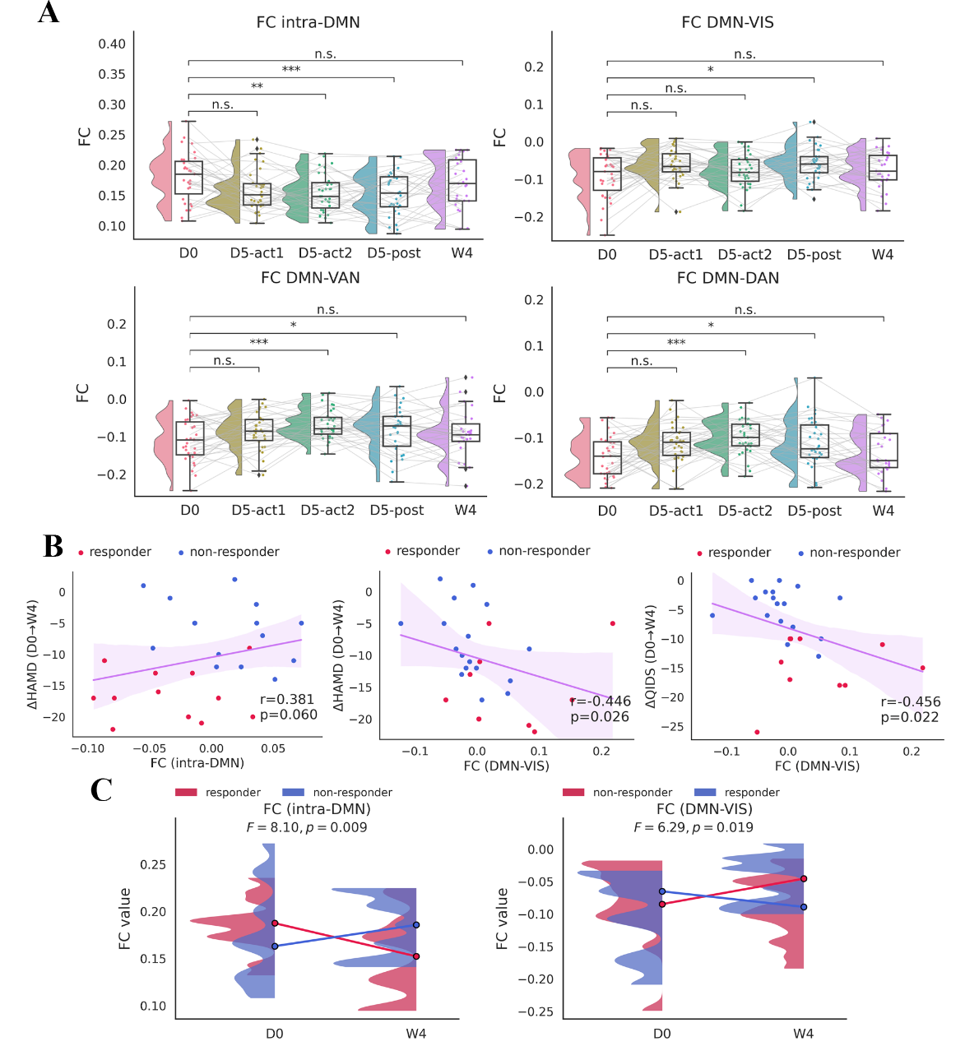
Fig S6. tTIS induced intra- and inter- FC change in DMN under Schaefer-400 parcellation.
A: Intra-FC of DMN exhibited significant decrease at D5-post. Significant increase in FC between DMN and VN was observed at ​D5-post. FC between DMN and SAN, DAN significantly increased at both D5-post and D5-post. Sex and age were regressed out as covariates; *** p < 0.001, ** p < 0.01, * p < 0.05, n.s. p > 0.05. B: Partial correlation (controlling for sex and age) between FC change and symptom decrease at W4: ΔFC (intra-DMN) vs ΔHAMD and ΔFC (DMN-VN) vs ΔHAMD and ΔQIDS. Shaded bands represent 95% confidence intervals. C: Significant $time×group$ interaction effect was observed between treatment responder and non-responder in both intra-FC of DMN and FC between DMN and VN.
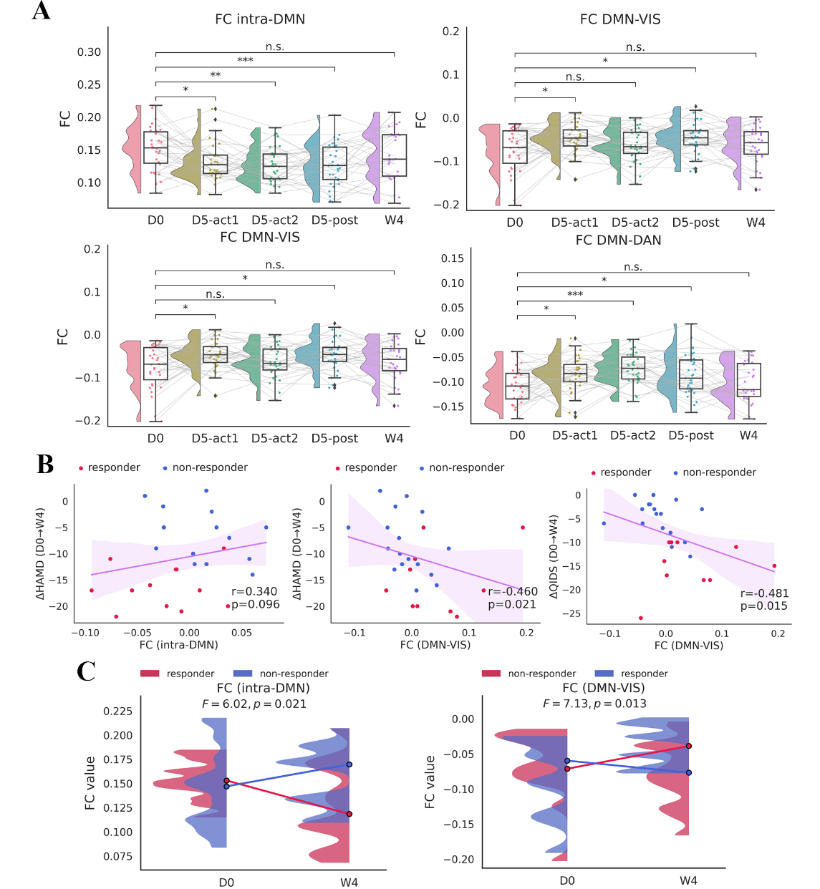
Fig S7. tTIS induced intra- and inter- FC change in DMN under Schaefer-1000 parcellation.
A: Intra-FC of DMN exhibited significant decrease at D5-post. Significant increase in FC between DMN and VN was observed at ​D5-post. FC between DMN and SAN, DAN significantly increased at both D5-post and D5-post. Sex and age were regressed out as covariates; *** p < 0.001, ** p < 0.01, * p < 0.05, n.s. p > 0.05. B: Partial correlation (controlling for sex and age) between FC change and symptom decrease at W4: ΔFC (intra-DMN) vs ΔHAMD and ΔFC (DMN-VN) vs ΔHAMD and ΔQIDS. Shaded bands represent 95% confidence intervals. C: Significant $time×group$ interaction effect was observed between treatment responder and non-responder in both intra-FC of DMN and FC between DMN and VN.
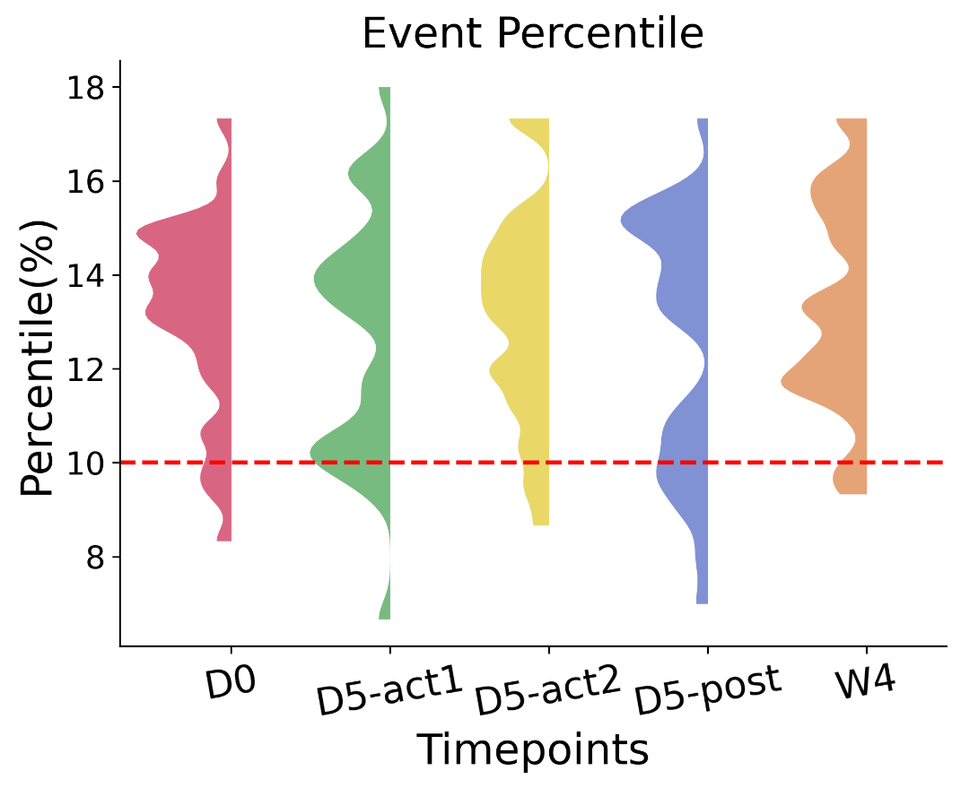
Fig S8. The distribution of each participant's event frame ratio across sessions.​

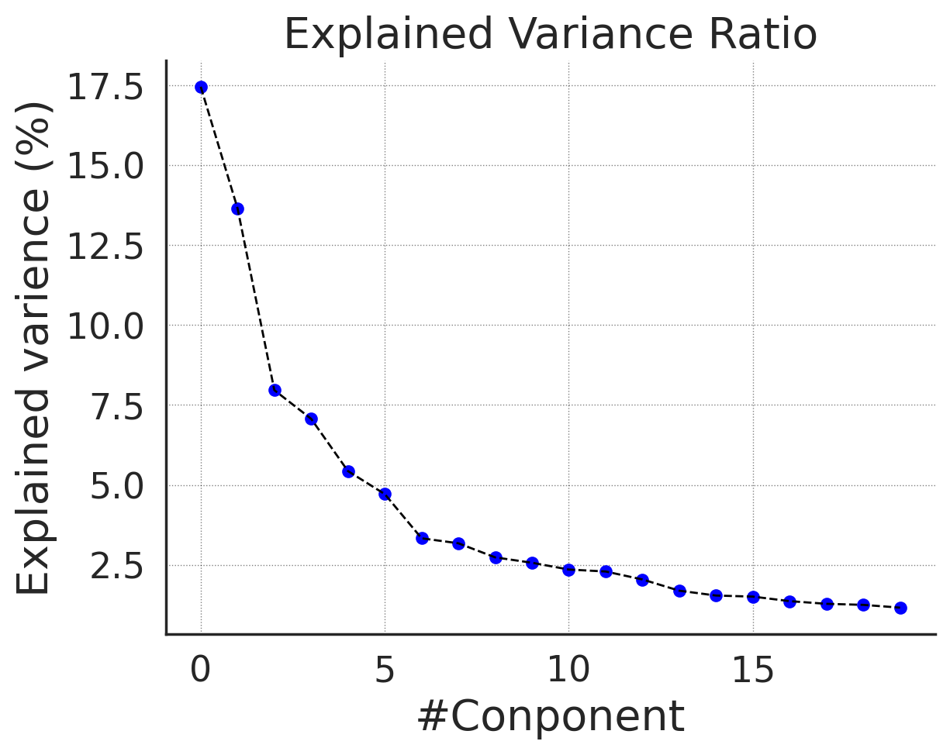
Fig S9. The explained variance of each component from the PCA.​

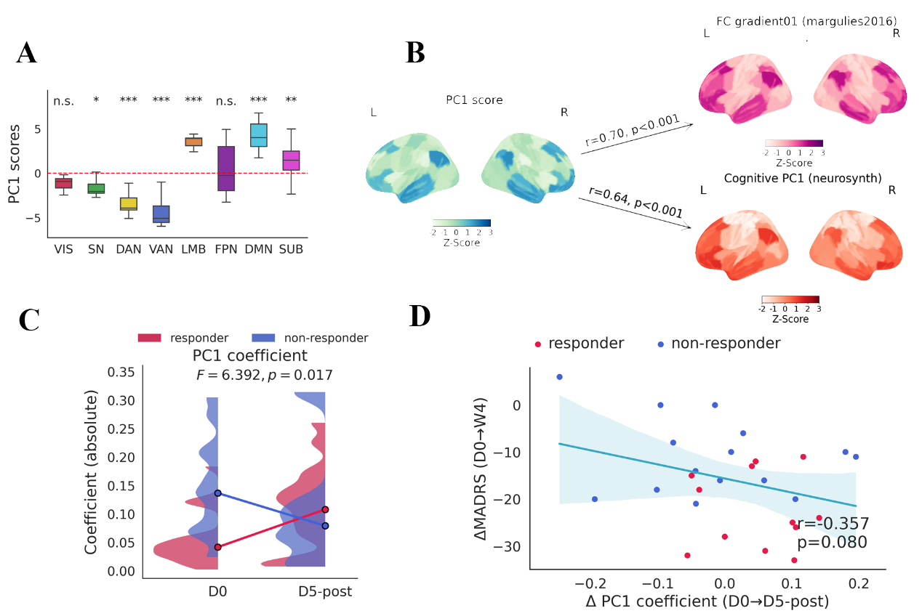
Fig S10. tTIS affected dynamic co-fluctuation activation pattern at D5-post under Schaefer-100 parcellation.
A: Confidence intervals of network-level event frames activation scores. B: PC1 score was consistent with FC principal gradient and cognitive gradient previously reported. C: Interaction effect of PC1 coefficient at D5-post. D: Patrial correlation among increased PC1 coefficient at D5-post and decreased clinical scores at W4, covaried with sex and age.

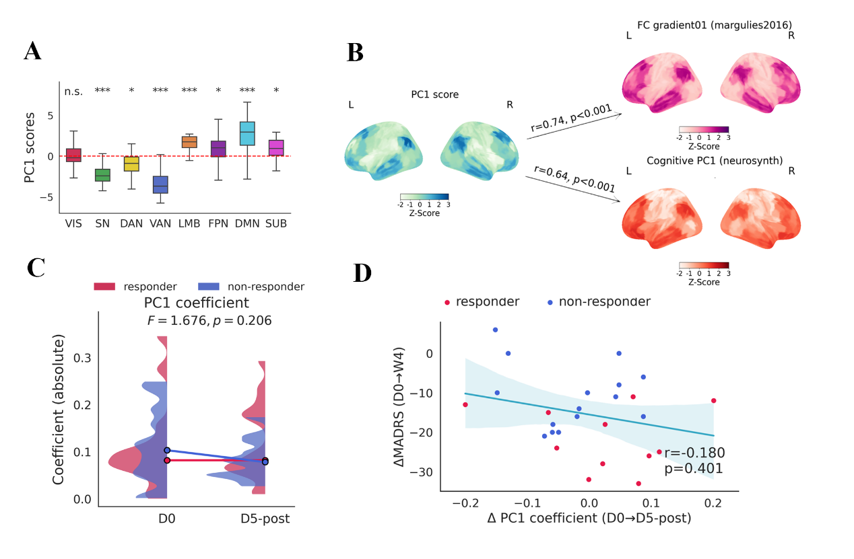
Fig S11. tTIS affected dynamic co-fluctuation activation pattern at D5-post under Schaefer-400 parcellation.
A: Confidence intervals of network-level event frames activation scores. B: PC1 score was consistent with FC principal gradient and cognitive gradient previously reported. C: Interaction effect of PC1 coefficient at D5-post. D: Patrial correlation among increased PC1 coefficient at D5-post and decreased clinical scores at W4, covaried with sex and age.

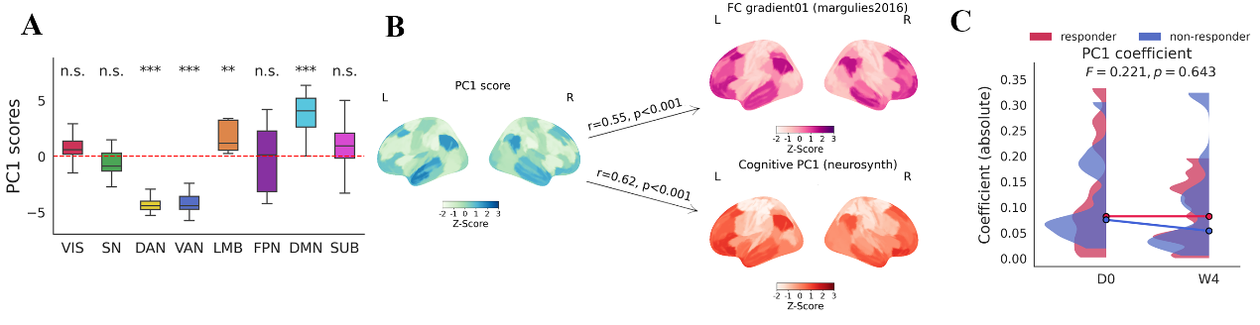
Fig S12. Dynamic co-fluctuation activation pattern at W4 under Schaefer-100 parcellation.
A: Confidence intervals of network-level event frames activation scores. B: Association between PC1 score and FC principal gradient, cognitive gradient previously reported. C: Interaction effect of PC1 coefficient at W4.

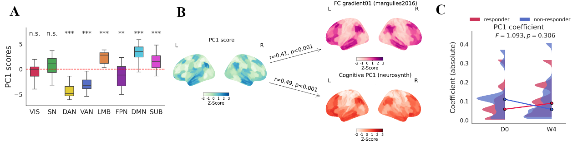
Fig S13. Dynamic co-fluctuation activation pattern at W4 under Schaefer-200 parcellation.
A: Confidence intervals of network-level event frames activation scores. B: Association between PC1 score and FC principal gradient, cognitive gradient previously reported. C: Interaction effect of PC1 coefficient at W4.

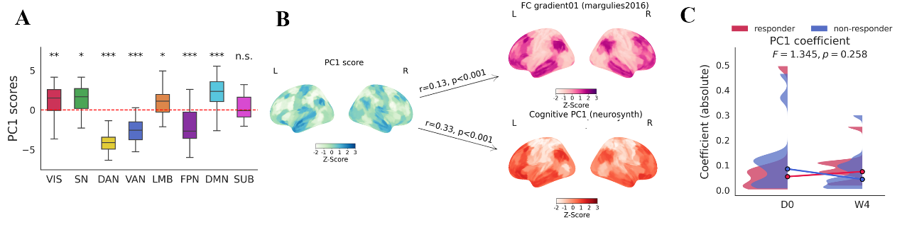
Fig S14. Dynamic co-fluctuation activation pattern at W4 under Schaefer-400 parcellation.
A: Confidence intervals of network-level event frames activation scores. B: Association between PC1 score and FC principal gradient, cognitive gradient previously reported. C: Interaction effect of PC1 coefficient at W4.

