supplemental document

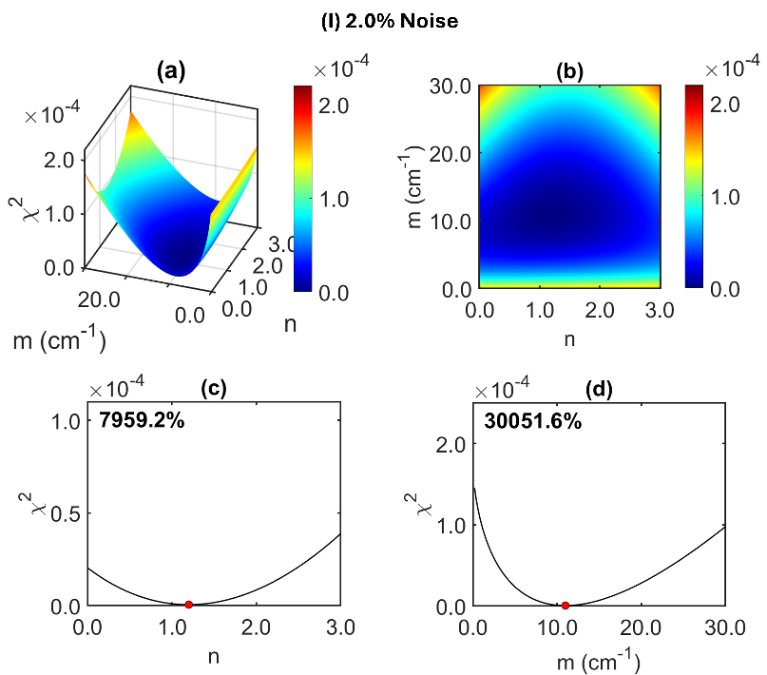
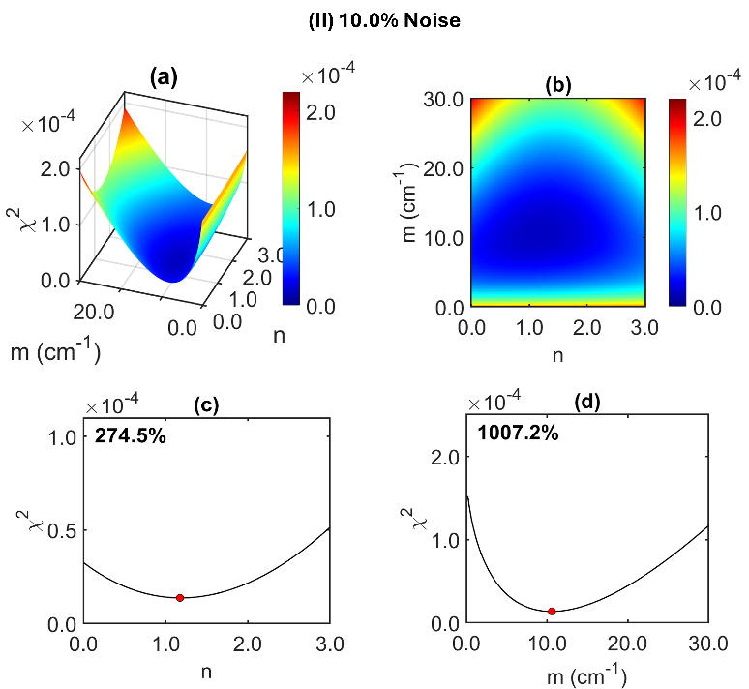
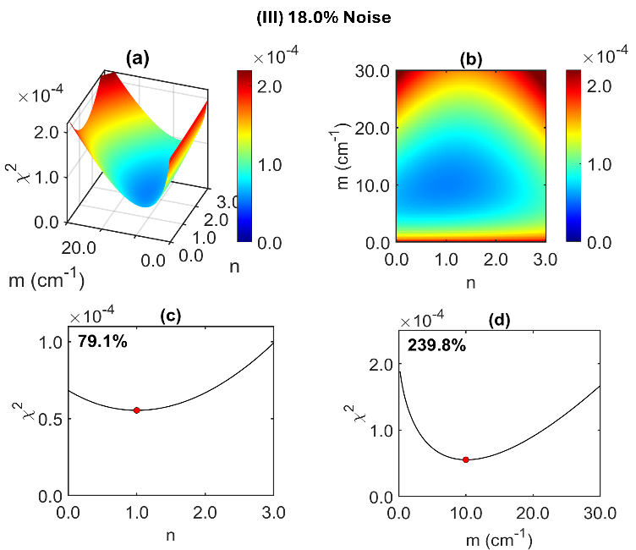
Fig. S1. Effect of noise levels on cost function ($χ^{2}$) and identifiability of scattering parameters $(m,n)$. $χ^{2}$ is shown for scattering amplitude $m$ (0–30 cm⁻¹) and scattering power $n$ (0–3) at (I) 2.0%, (II) 10.0%, and (III) 18.0% multiplicative noise. Panel (a) displays the 3D $χ^{2}$ surface; (b) shows the corresponding 2D heatmap (same color scale as (a)); (c) plots $χ^{2}$ versus $n$ evaluated at the $m$ that minimizes $χ^{2}$; and (d) plots $χ^{2}$ versus $m$ evaluated at the $n$ that minimizes $χ^{2}$. Red dots mark slice minima; larger colors/values indicate poorer fits. As noise increases, the landscape broadens and flattens, most prominently along $n$, reducing the distinctness of local minima and degrading identifiability of $n$, while $m$ remains comparatively well constrained. (Numbers in (c–d) report slice “contrast,” (max−min)/min×100%, as a simple measure of basin depth.)

