Supplementary File
Figures S1 to S4
Tables S1 to S4

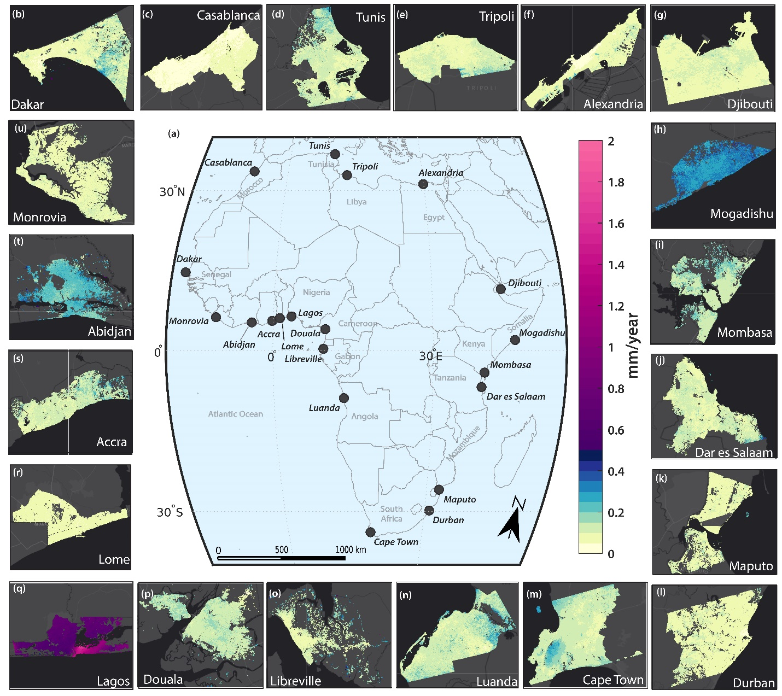 Figure S1. Standard deviation of vertical land motion (VLM) estimates across 20 African coastal cities derived from InSAR data. Panel (a) presents the regional context map showing the geographic distribution of the study cities across Africa. Panels (b–u) display city-level maps of VLM standard deviation (in mm/year), capturing the spatial uncertainty in land motion estimates.

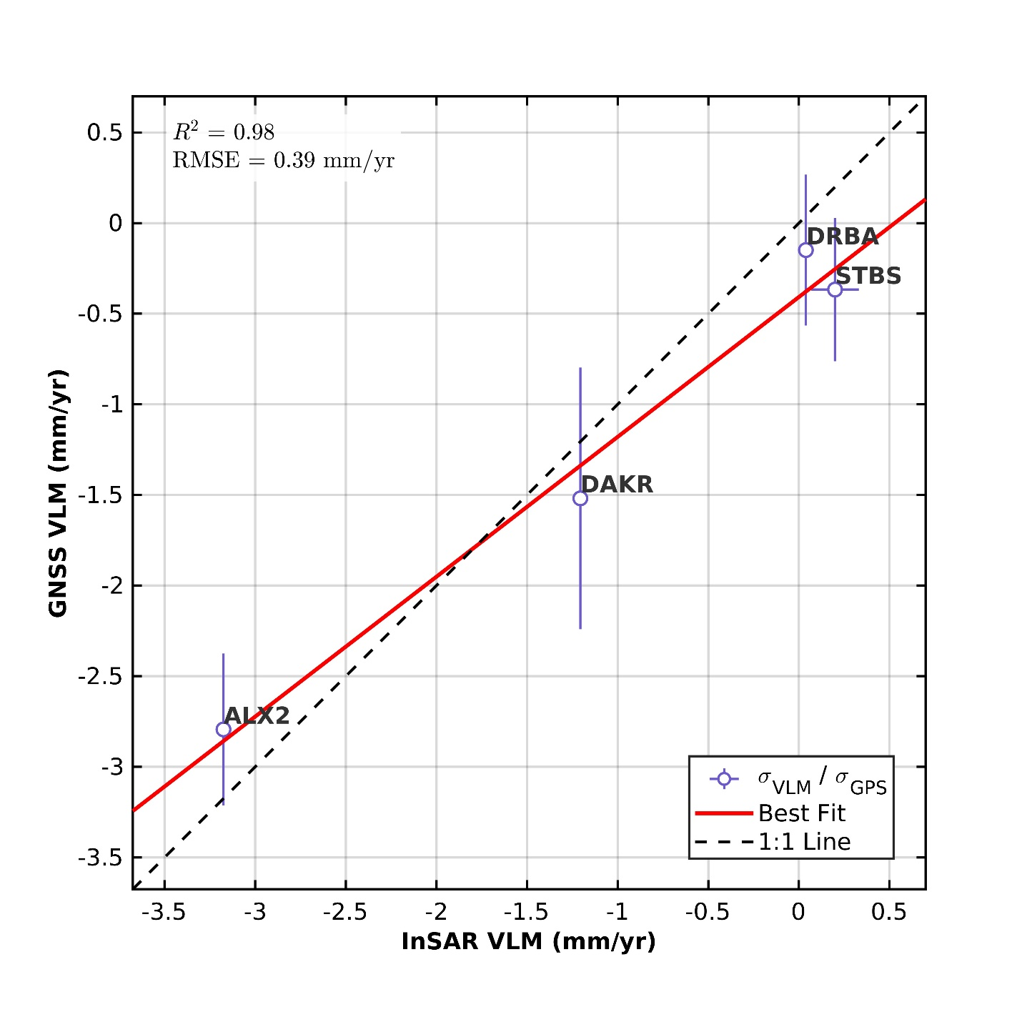
Figure S2: Bivariate comparison of GNSS and InSAR VLM rates. The dashed line indicates the 1:1 relationship, and the red line shows the best-fit regression (R² = 0.98, RMSE = 0.39 mm yr⁻¹). Error bars denote 1σ uncertainties, with GNSS station codes labeled at each point. GNSS rates are from the Nevada Geodetic Laboratory.

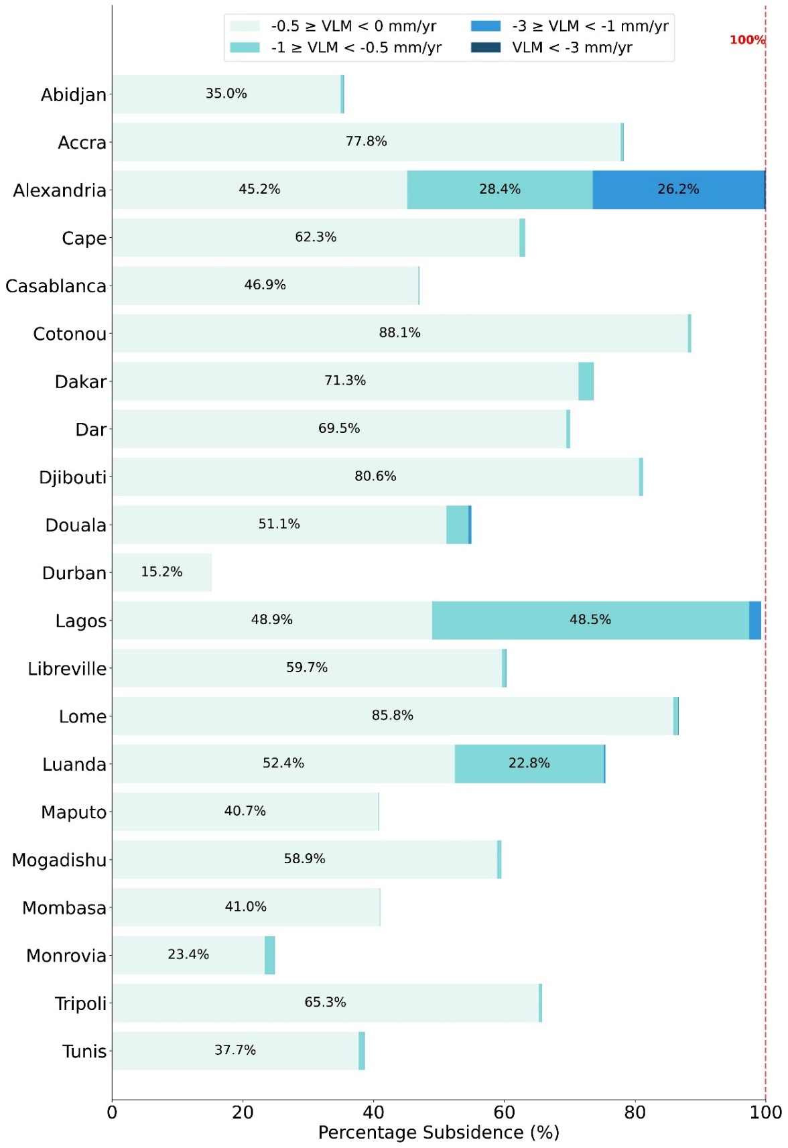
Figure S3: Distribution of subsiding land area across 20 African coastal cities based on VLM categories. The bar chart shows the percentage of each city's coastal land area experiencing different rates of land subsidence.
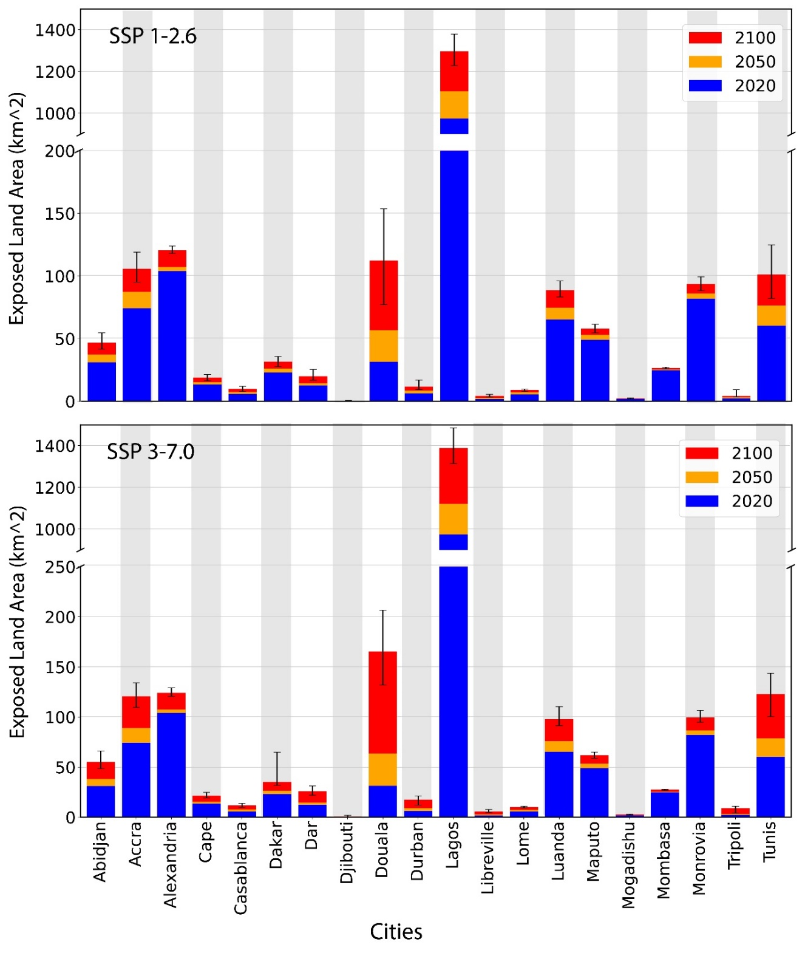
Figure S4: Projected exposed land area to coastal flooding across 20 African coastal cities under two climate scenarios (SSP1-2.6 and SSP3-7.0) for the years 2020, 2050, and 2100. The bar plots display the cumulative exposed land area (in km²) for each city, with results presented for three time horizons: 2020 (blue), 2050 (orange), and 2100 (red). The upper panel represents projections under the low-emissions scenario (SSP1-2.6), while the lower panel corresponds to the high-emissions scenario (SSP3-7.0). Error bars represent the uncertainty bounds derived from vertical land motion (VLM) variability and sea-level rise (SLR) model spread.
Table S1. Projected land area (in km²) exposed to coastal flooding in 20 African coastal cities under InSAR-VLM corrected SSP 1-2.6 SLR scenario for the years 2020, 2050, and 2100.
 | 2020 (sq. km) |  |  |  | 2050 (sq. km) |  |  |  | 2100 (sq. km)
Cities | Median | Lower Bound | Upper Bound | Median |  | Lower Bound | Upper Bound | Median |  | Lower Bound | Upper Bound
Abidjan | 31.18 | 27.35 | 35.03 | 37.22 |  | 33.27 | 41.5 | 46.6965 |  | 41.5719 | 54.7452
Accra | 74.3 | 67.6 | 80.05 | 87.48 |  | 76.12 | 95.42 | 105.8004 |  | 95.2506 | 119.214
Alexandria | 103.99 | 102.76 | 105.25 | 107.27 |  | 105.84 | 116.51 | 120.4227 |  | 117.9756 | 124.0704
Cape | 13.35 | 11.55 | 14.91 | 15.18 |  | 13.57 | 17.19 | 18.7722 |  | 16.5222 | 21.3336
Casablanca | 5.74 | 5.14 | 7.21 | 7.47 |  | 5.84 | 8.66 | 9.7668 |  | 7.9047 | 11.9061
Dakar | 23.1 | 20.63 | 25.6 | 26.04 |  | 23.42 | 28.59 | 31.6827 |  | 27.6921 | 35.7777
Dar | 12.59 | 11.6 | 14.02 | 14.28 |  | 12.86 | 17.13 | 20.0268 |  | 16.7598 | 25.5168
Djibouti | 0.01 | 0 | 0.02 | 0.03 |  | 0.01 | 0.06 | 0.18 |  | 0.0666 | 0.738
Douala | 31.56 | 19.33 | 47.18 | 56.84 |  | 38.99 | 78.3 | 112.2993 |  | 77.2506 | 153.7623
Durban | 6.31 | 4.91 | 8.36 | 8.54 |  | 6.77 | 10.19 | 11.5722 |  | 9.4518 | 16.7886
Lagos | 974.1 | 904.63 | 1037.48 | 1105.56 |  | 1045.74 | 1170.53 | 1296.0612 |  | 1228.7565 | 1379.4138
Libreville | 1.71 | 0.96 | 2.28 | 2.71 |  | 1.9 | 3.37 | 4.2723 |  | 3.4857 | 5.4873
Lome | 5.61 | 5.27 | 5.95 | 7.21 |  | 5.97 | 7.76 | 8.901 |  | 7.9623 | 9.7641
Luanda | 65.29 | 61.07 | 70.38 | 74.59 |  | 70.5 | 79.24 | 88.6365 |  | 83.2923 | 96.1947
Maputo | 48.99 | 45.67 | 52.13 | 52.93 |  | 49.64 | 55.67 | 57.9285 |  | 54.7605 | 61.5987
Mogadishu | 1.76 | 1.56 | 1.97 | 1.9 |  | 1.69 | 2.14 | 2.2428 |  | 1.908 | 2.6919
Mombasa | 24.7 | 24.2 | 25.12 | 25.41 |  | 24.96 | 25.93 | 26.5266 |  | 25.9326 | 27.2538
Monrovia | 81.91 | 78.46 | 85.28 | 86.1 |  | 82.6 | 90.17 | 93.5424 |  | 88.4394 | 99.423
Tripoli | 2.3 | 1.99 | 2.65 | 3.12 |  | 2.31 | 3.84 | 4.2471 |  | 3.3282 | 9.2547
Tunis | 60.19 | 46.36 | 74.3 | 76.49 |  | 61.11 | 92.59 | 101.3238 |  | 82.0962 | 124.8237

Table S2. Projected land area (in km²) exposed to coastal flooding in 20 African coastal cities under InSAR-VLM corrected SSP 2-4.5 SLR scenario for the years 2020, 2050, and 2100.
 | 2020 (sq. km) |  |  | 2050 (sq. km) |  |  | 2100 (sq. km)
Cities | Median | Lower Bound | Upper Bound | Median | Lower Bound | Upper Bound | Median | Lower Bound | Upper Bound
Abidjan | 31.18 | 27.35 | 35.03 | 37.7 | 33.85 | 41.99 | 51.03 | 44.83 | 61.1
Accra | 74.3 | 67.6 | 80.05 | 88.64 | 77.38 | 97.02 | 113.36 | 102.7 | 127.3
Alexandria | 104.01 | 102.77 | 105.37 | 107.38 | 105.93 | 116.66 | 122.16 | 119.3 | 126.42
Cape | 13.35 | 11.55 | 14.91 | 15.35 | 13.73 | 17.35 | 20.07 | 18 | 22.88
Casablanca | 5.74 | 5.15 | 7.21 | 7.6 | 5.91 | 8.76 | 10.95 | 9 | 13.04
Dakar | 23.1 | 20.63 | 25.6 | 26.23 | 23.59 | 28.81 | 33.46 | 30.22 | 61.98
Dar | 12.6 | 11.61 | 14.04 | 14.45 | 13 | 17.36 | 24.19 | 17.92 | 27.72
Djibouti | 0.01 | 0 | 0.02 | 0.03 | 0.01 | 0.06 | 0.48 | 0.12 | 1.3
Douala | 31.56 | 19.35 | 47.16 | 60.28 | 44.17 | 82.9 | 138.86 | 103.46 | 182.84
Durban | 6.32 | 4.92 | 8.39 | 8.76 | 6.94 | 10.38 | 12.83 | 10.76 | 19.38
Lagos | 974.1 | 904.61 | 1037.44 | 1115.02 | 1054.17 | 1178.12 | 1339.31 | 1270.47 | 1438.26
Libreville | 1.71 | 0.96 | 2.29 | 2.81 | 1.96 | 3.47 | 4.98 | 4.03 | 6.63
Lome | 5.61 | 5.27 | 5.95 | 7.3 | 6.03 | 7.83 | 9.43 | 8.71 | 10.5
Luanda | 65.29 | 61.07 | 70.39 | 75.33 | 71.07 | 79.97 | 92.86 | 86.91 | 103.53
Maputo | 49.07 | 45.75 | 52.19 | 53.33 | 50.11 | 55.98 | 59.72 | 56.91 | 63.48
Mogadishu | 1.77 | 1.57 | 1.98 | 1.92 | 1.71 | 2.17 | 2.41 | 2.01 | 2.91
Mombasa | 24.72 | 24.21 | 25.13 | 25.49 | 25.03 | 26.01 | 26.97 | 26.36 | 27.69
Monrovia | 81.91 | 78.46 | 85.27 | 86.53 | 83.01 | 90.57 | 97.06 | 91.93 | 103.27
Tripoli | 2.3 | 1.99 | 2.65 | 3.17 | 2.34 | 3.88 | 4.9 | 3.82 | 10.16
Tunis | 60.3 | 46.47 | 74.32 | 77.77 | 62.36 | 93.92 | 113.86 | 92.18 | 135.72

Table S3. Projected land area (in km²) exposed to coastal flooding in 20 African coastal cities under InSAR-VLM corrected SSP 3-7.0 SLR scenario for the years 2020, 2050, and 2100.
 | 2020 (sq. km) |  |  | 2050 (sq. km) |  |  | 2100 (sq. km)
Cities | Median | Lower Bound | Upper Bound | Median | Lower Bound | Upper Bound | Median | Lower Bound | Upper Bound
Abidjan | 31.18 | 27.36 | 35.03 | 38.04 | 34.12 | 42.3 | 55.24 | 48.49 | 66.21
Accra | 74.3 | 67.61 | 80.04 | 89.07 | 77.84 | 97.71 | 120.64 | 109.61 | 133.97
Alexandria | 103.98 | 102.75 | 105.25 | 107.49 | 106.02 | 116.85 | 124.06 | 120.53 | 129.25
Cape | 13.35 | 11.55 | 14.9 | 15.47 | 13.87 | 17.48 | 21.57 | 19.25 | 24.8
Casablanca | 5.73 | 5.13 | 7.2 | 7.63 | 6.5 | 8.8 | 11.86 | 10.01 | 14
Dakar | 23.13 | 20.66 | 25.63 | 26.33 | 23.72 | 28.92 | 35.14 | 31.79 | 64.76
Dar | 12.59 | 11.61 | 14.01 | 14.5 | 13.04 | 17.52 | 26.05 | 21.97 | 31.09
Djibouti | 0.01 | 0 | 0.02 | 0.03 | 0.01 | 0.07 | 0.81 | 0.28 | 1.8
Douala | 31.25 | 19.04 | 46.66 | 63.72 | 46.49 | 85.88 | 165.14 | 131.9 | 206.48
Durban | 6.31 | 4.9 | 8.36 | 8.84 | 7.02 | 10.48 | 17.58 | 12.03 | 21.14
Lagos | 974.1 | 904.66 | 1037.4 | 1120.9 | 1060.3 | 1182.88 | 1387.74 | 1314.77 | 1485.08
Libreville | 1.71 | 0.96 | 2.28 | 2.88 | 1.99 | 3.52 | 5.7 | 4.62 | 7.83
Lome | 5.61 | 5.27 | 5.95 | 7.36 | 6.06 | 7.87 | 9.94 | 9.22 | 11.09
Luanda | 65.25 | 61.01 | 70.3 | 75.81 | 71.69 | 80.51 | 97.88 | 91.23 | 110.32
Maputo | 48.99 | 45.67 | 52.13 | 53.55 | 50.35 | 56.18 | 61.93 | 58.83 | 65.16
Mogadishu | 1.77 | 1.57 | 1.98 | 1.93 | 1.72 | 2.18 | 2.65 | 2.23 | 3.18
Mombasa | 24.72 | 24.21 | 25.12 | 25.53 | 25.06 | 26.04 | 27.38 | 26.8 | 28.09
Monrovia | 81.91 | 78.46 | 85.28 | 86.73 | 83.3 | 90.78 | 99.57 | 94.69 | 106.6
Tripoli | 2.29 | 1.98 | 2.64 | 3.19 | 2.36 | 3.91 | 9.1 | 4.23 | 10.88
Tunis | 60.05 | 46.23 | 74.14 | 78.58 | 63.08 | 94.74 | 122.83 | 100.43 | 143.78

Table S4: Synthetic Aperture Radar (SAR) Datasets for African Cities. The processed path and frame numbers for each city is indicated here. For the 20 cities, we processed multiple frames.

Cities | Path | Frame | No. of images | Start Date (yyyymmdd) | End Date (yyyymmdd)
Abidjan | 118 | 1197 | 289 | 20160926 | 20230429
Accra | 145 | 1198 | 302 | 20170601 | 20230501
Alexandria | 131 | 99 | 204 | 20160927 | 20230406
Cape Town | 131 | 1063 -1067 | 254 | 20150331 | 20230605
Casablanca | 45 | 103 | 337 | 20161003 | 20230611
Dakar | 133 | 40 | 142 | 20171010 | 20230605
Dar es Salaam | 57/6 | 1155 - 1157 | 191 | 20141021 | 20220430
Djibouti | 116 | 32-35,1217 | 197 | 20141025 | 20230523
Douala | 132 | 1192 | 192 | 20170212 | 20230617
Durban | 43 | 1077 | 228 | 20150325 | 20230623
Libreville | 29 | 1180 | 191 | 20170205 | 20230622
Lome | 74 | 1199 | 367 | 20150327 | 20230508
Luanda | 131 | 1148 | 159 | 20160430 | 20211218
Maputo | 72 | 1095 | 219 | 20151122 | 20230613
Mogadishu | 116 | 2/1186 | 145 | 20141224 | 20211217
Mombasa | 159 | 1163 | 195 | 20151222 | 20230408
Monrovia | 162 | 1200 | 240 | 20150414 | 20230607
Tripoli | 15 | 103 | 163 | 20171119 | 20230329
Tunis | 88 | 118 | 168 | 20141023 | 20211215

