Supplementary tables and figures

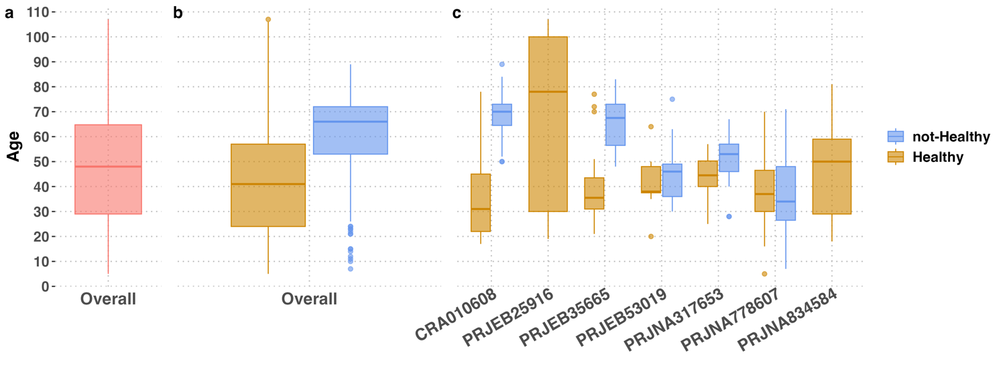
Supplementary Figure 1: Age distribution of samples with the exclusion of 340 for which the information is missing. Panel a) represents the overall distribution of age values; panel b) represents the overall distributions for healthy and not-healthy; panel c) represents distributions per BioProject split for healthy and not-healthy

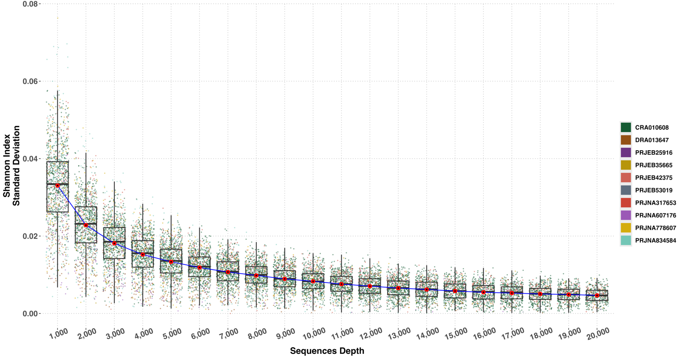
Supplementary Figure 2: Box-plot representing the variation of standard deviation of Shannon Index inference per each sample at each tested rarefaction depth.
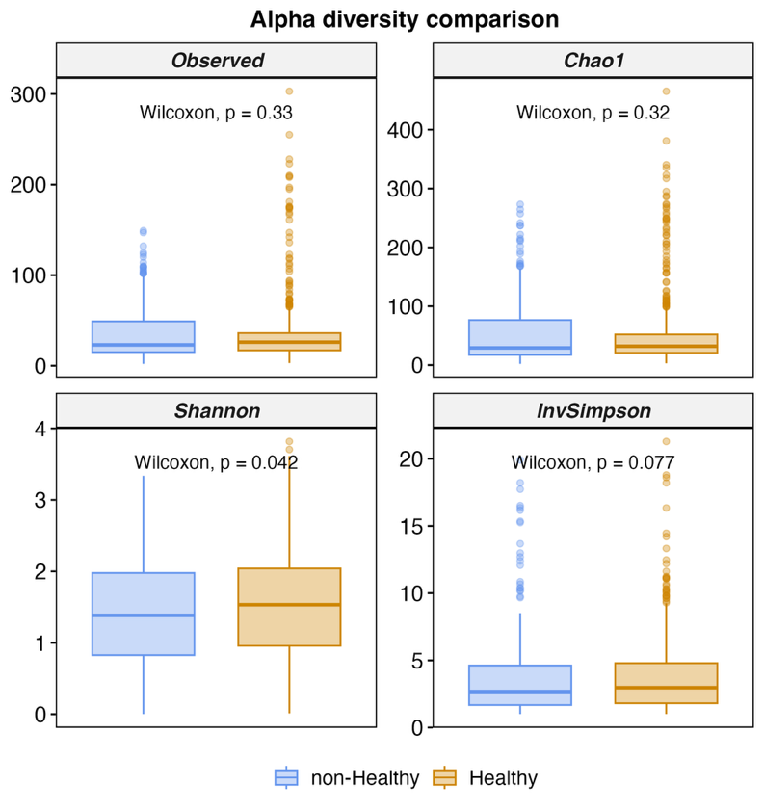
Supplementary Figure 3: non-healthy/healthy distributions for Observed, Chao1, Shannon and Inverse Simpson (InvSimpson)

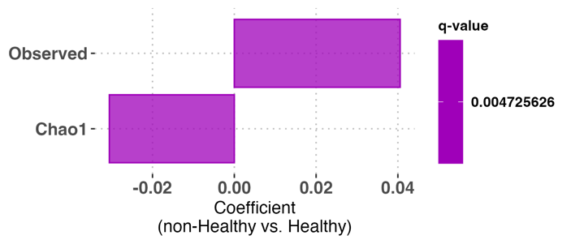
Supplementary Figure 4: Maaslin2 coefficient representation for statistically significant alpha diversity indexes in Maaslin2 model.

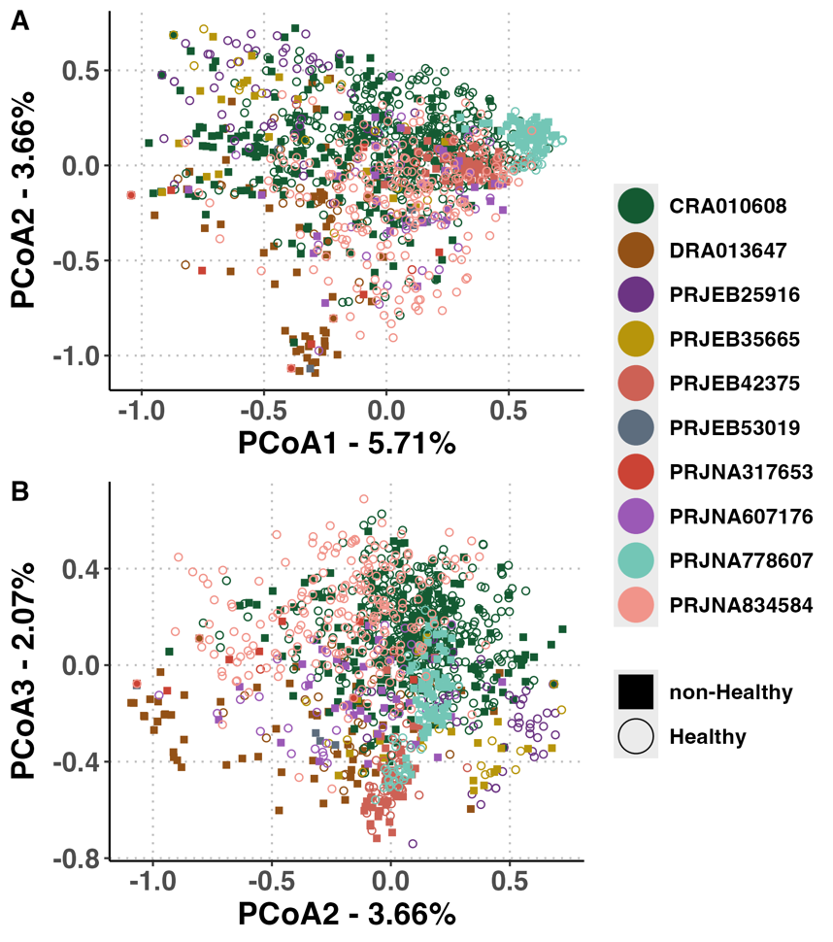
Supplementary Figure 5:Bray Curtis beta diversity among samples rendered as PCoA with BioProject and Health status at genus level. Panel A represents 1st vs 2nd dimension, while panel B represents 2nd vs 3rd dimension
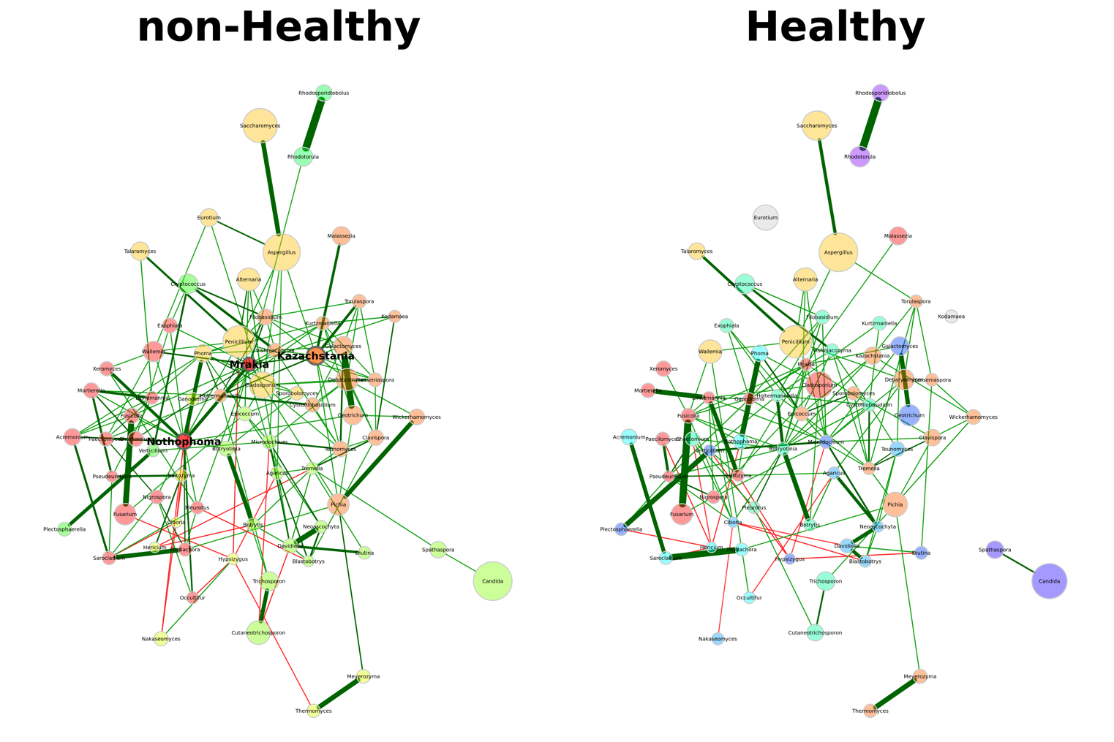
Supplementary Figure 6: Network analysis at genus level for non-healthy and healthy samples. Nodes represent genera while edge co-occurrence relationship among them for condition.
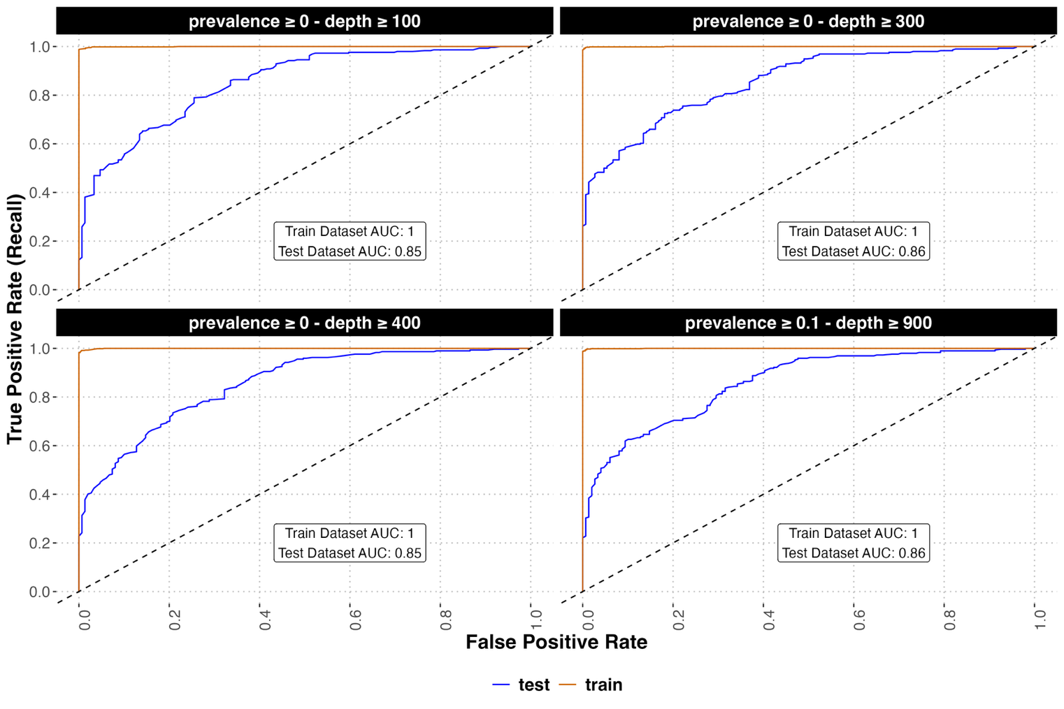
Supplementary Figure 7: ROC curves for training (i.e. mediumpurple1 darkorange3) and test (i.e. cornflowerblue blue4) datasets samples of best performing models having selection criteria of datasets samples described in black strips.

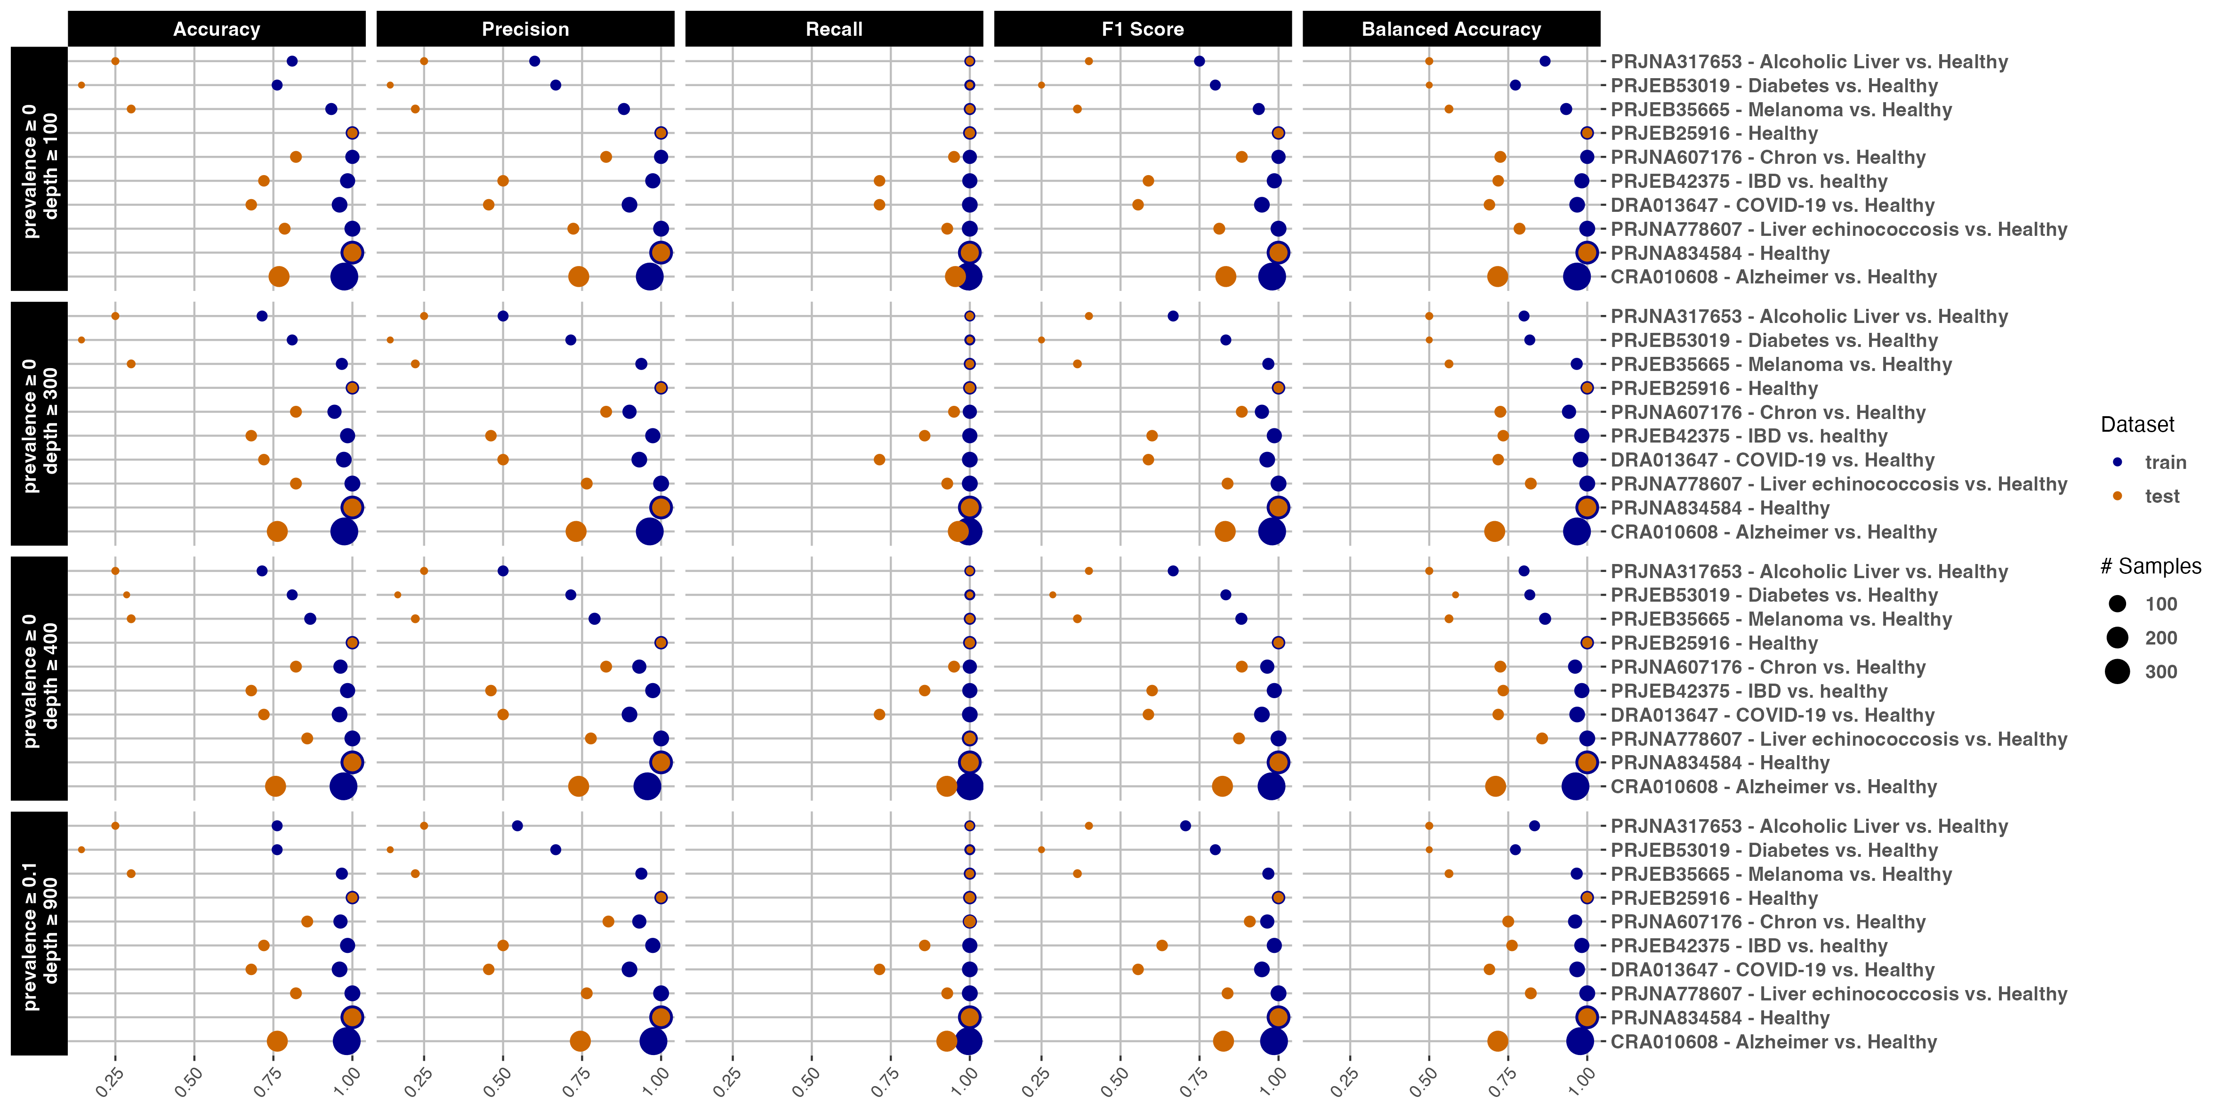
Supplementary Figure 8: Representation of Accuracy, Precision, Recall, F1 Score, Balanced Accuracy for training and test sets for each BioProject in the four best performing models analysed in Supplementary Figure 7. Each parameter is reported in [0,1] interval.
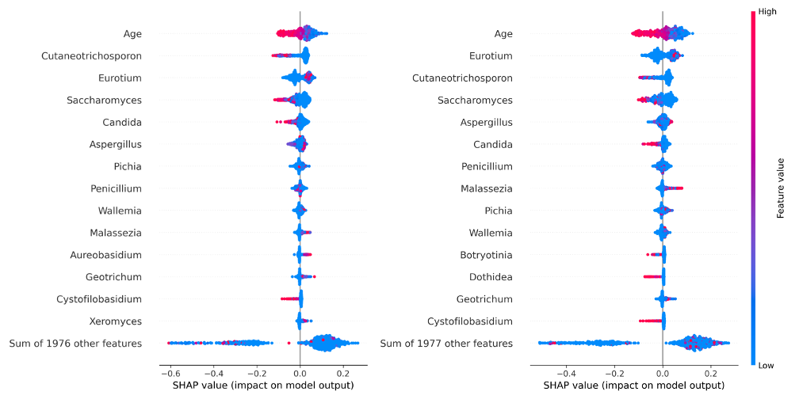
Supplementary Figure 8 9: Graphical representation of SHAP values for 14 features ordered by SHAP absolute values mean. Each point represents the feature n^{th} in the sample m^{th}. X axis position represents the feature contribution for a classification outcome (i.e. non-healthy/healthy) while colour its relative abundance. Left and right sided graphs are referred to RF model with age and gender sex + age.

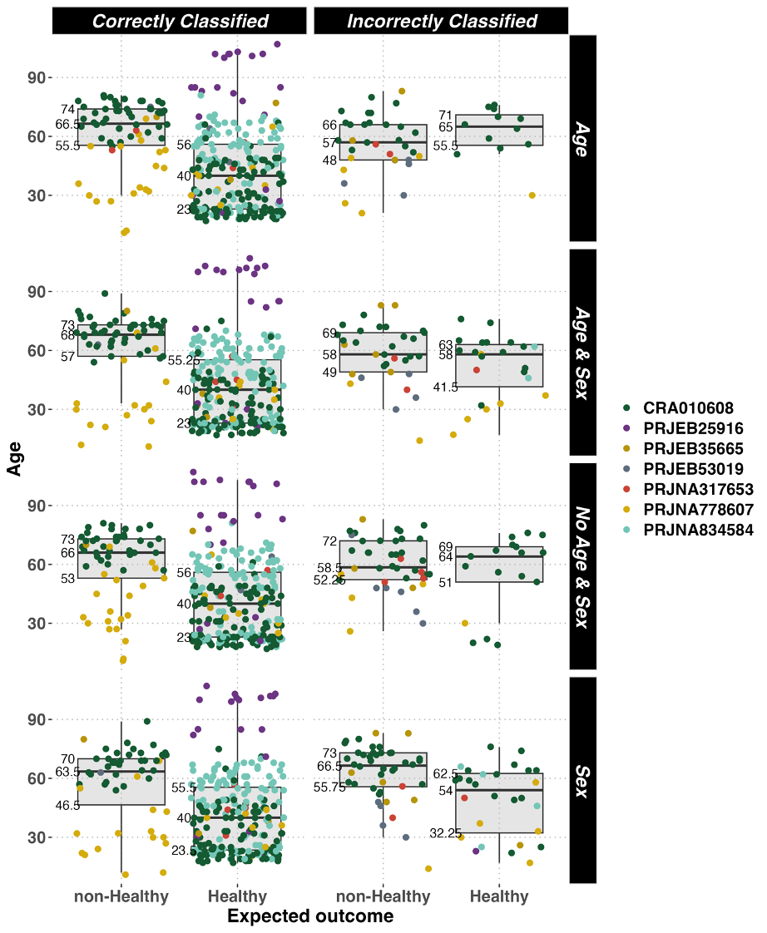
Supplementary Figure 9 10:Box plots representing age distribution of samples for test sets divided by expected/observed classification outcome for each model described in Table 8.
Supplementary Table 1: Metadata associated to CRA010608 BioProject.
(CSV file external to this DOCX)

Supplementary Table 2: PERMANOVA results on samples dataset after CLR and Jaccard computation. The character ":" indicates an interaction among left/right reported terms.
 | R2 | p-value
Status | 0.01 | 0.001
BioProject | 0.13 | 0.001
Status:BioProject | 0.02 | 0.001
Residual | 0.84 | NA
Total | 1 | NA

Supplementary Table 3: PERMANOVA results for Jaccard distance on subset of samples reporting both sex and age information. The character ":" in some rows of the first column indicates an interaction among left/right reported terms.
 | R2 | p-value
Status | 0.008 | 0.001
BioProject | 0.080 | 0.001
Gender Sex | 0.001 | 0.054
Age | 0.005 | 0.001
Status:BioProject | 0.011 | 0.001
Status:Gender Sex | 0.001 | 0.826
Status:Age | 0.001 | 0.157
Residual | 0.894 | NA
Total | 1 | NA

Supplementary Table 4: Accuracy, Precision, Recall, F1 score, Balanced Accuracy performances on test sets for all RF models trained with prevalence and sequencing depth thresholds.
(XLSX file external to this DOCX)

