Appendix 1: List of participating centers

Name of institution | Name and address of affiliated department
CHU de Nantes | CHU DE NANTES SITE HOTEL DIEU HME  1 Place ALEXIS RICORDEAU  44093 NANTES CEDEX 1
CHU de Bordeaux | HOPITAL HAUT-LEVEQUE - CHU  Avenue DE MAGELLAN  33604 PESSAC CEDEX
CHU de Lille | HÔPITAL ROGER SALENGRO CHU LILLE  Rue EMILE LAINE  CS 70001  59037 LILLE CEDEX
CHU de Lyon | HOPITAL EDOUARD HERRIOT - HCL  5 Place D'ARSONVAL  69437 LYON CEDEX 03
CHR Metz | HOPITAL DE MERCY - CHR METZ THIONVILLE  1 Allee DU CHATEAU  CS 45001 ARS-LAQUENEXY  57085 METZ CEDEX 03
CHU Montpellier | HOPITAL LAPEYRONIE CHU MONTPELLIER  371 Avenue DU DOYEN GASTON GIRAUD  34295 MONTPELLIER CEDEX 5
AP-HP | HU SAINT LOUIS SITE LARIBOISIERE APHP  2 Rue AMBROISE PARE  75475 PARIS CEDEX 10
CHU Toulouse | HOPITAL DE RANGUEIL CHU TOULOUSE  1 Avenue PR JEAN POULHES  TSA 50032  31059 TOULOUSE CEDEX 9
CHU Tours | CHRU TROUSSEAU - CHAMBRAY  Avenue DE LA REPUBLIQUE  37170 CHAMBRAY LES TOURS
AP-HM | APHM HOPITAL LA CONCEPTION  147 Boulevard Baille  13005 MARSEILLE

Appendix 2: Study Diagram

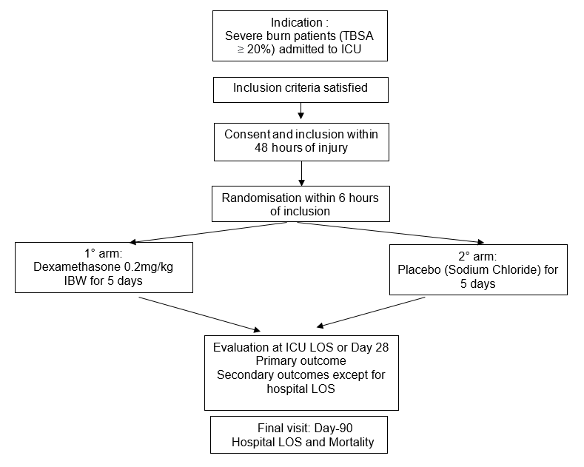

Appendix 3 : Definitions of the primary outcome

Hierarchical primary outcome including:
1. Incidence of major complications within 28 days, defined as:
o Moderate-to-severe ARDS (Berlin definition) (11)
o AKI KDIGO stages 2–3 (12)
2. All-cause mortality by Day 90
All-cause mortality is defined as any death within 90 days occurring after randomization regardless of its cause
Acute Respiratory Distress Syndrome is defined according to the Berlin definition (Table 1)
Acute Kidney Injury staging follows KDIGO definition (Table 2). Baseline creatinine will be determined from available values within the past year or, failing that, lowest serum creatinine prior to randomization.
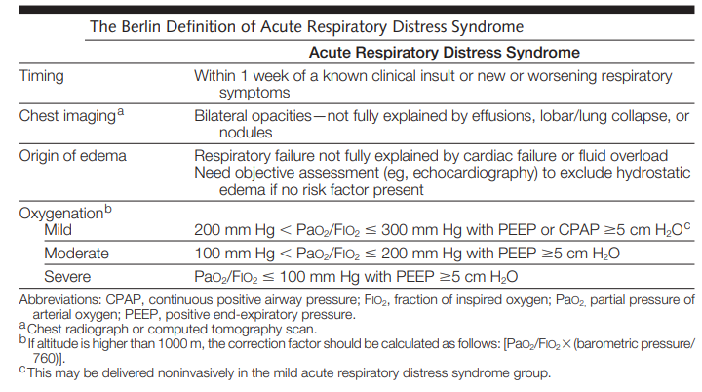
Table 1. The Berlin definition of Acute Respiratory Distress Syndrome (11)
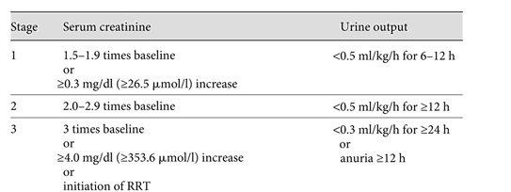
Table 2. KDIGO definition of Acute Kidney Injury

