Table 1. Overview of structural objects and associated pathologies analyzed in this study.
Structure | Location | Flight planning | Variables measured | Photos
Urban pavement | Christine Avenue, Varsity Lakes, Australia | One grid mapping,  height=40 m,  overlap,  front=80%, side=70% | Surface area=7,435.00 m² | 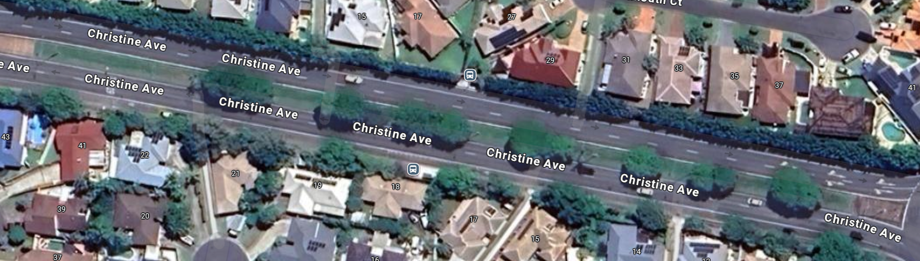
Concrete bridge | Bridgewater Drive, Varsity Lakes, Australia | One grid mapping,  height=40 m,  overlap,  front=80%, side=70%  and  two orbital mappings,  heights=20 and 15 m,  and  one manual flight | Length=40m  Width=14m | 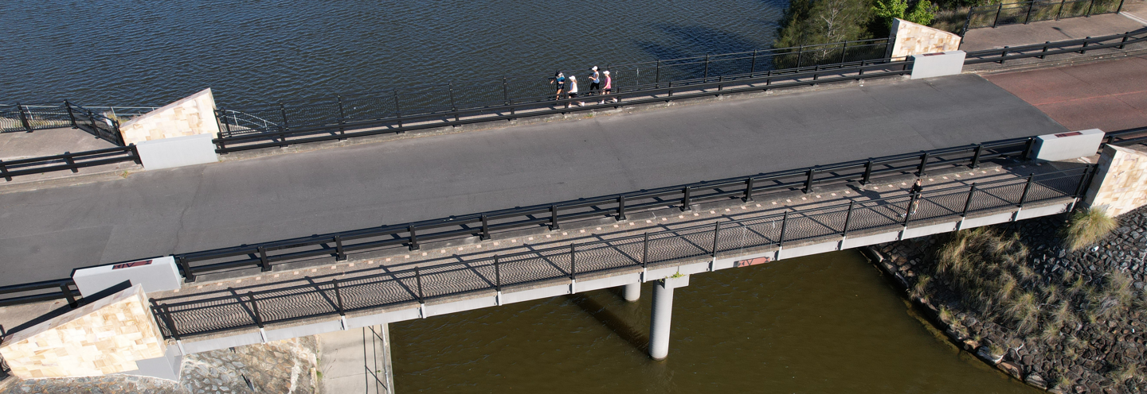
Façade of a commercial building | Watts Drive, Varsity Lakes, Australia | manual flight | Surface area=50.52 m² | 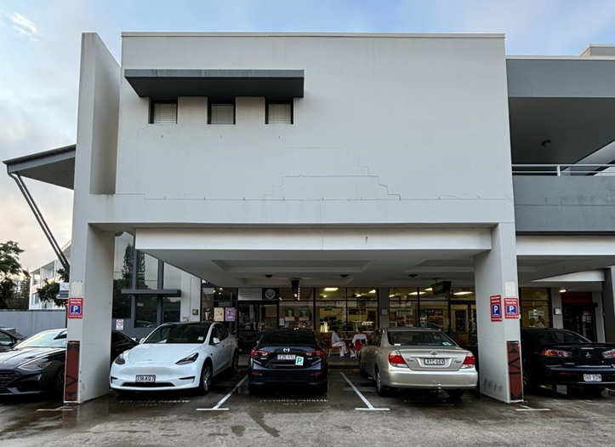
Reinforced concrete dam | Hinze Dam, Advancetown, Australia | One grid mapping,  height=50 m,  overlap,  front=80%, side=70%  and  one orbital mapping,  heights=40 m,  and  one manual flight | Maximum Wall Height: 83.1 m,  Main Embankment Length: 770 m,  Dam Crest Height: 108.4 m (AHD) | 