- Supplementary Figures -
Relationship between Pacific–South America teleconnections in austral fall and ENSO evolution

Jae-Heung Park¹*@, Geon-Il kim²*, Jong-Seong Kug^{1@}
Mi-Kyung Sung³, Young-Min Yang^{4,5,6}, Yoo-Geun Ham⁷, Hyun-Su Jo⁷,
Jung-Eun Chu⁸, Jun-Hyeok Son⁹, and Joowan Kim¹⁰

¹School of Earth and Environmental Sciences, Seoul National University, Seoul, South Korea
²Department of physics, University of Toronto, Ontario, Canada
³Korea Institute of Science and Technology, Seoul, South Korea
⁴Department of Environment & Energy, Jeonbuk National University, 567 Baekje-daero, Deokjin-gu, Jeonju-si, Jeollabuk-do 54896, South Korea
⁵School of Civil, Environmental, Resources and Energy Engineering, Jeonbuk National University, 567 Baekje-daero, Deokjin-gu, Jeonju-si, Jeollabuk-do 54896, South Korea
⁶Soil Environment Research Center, Jeonbuk National University, 567 Baekje-daero, Deokjin-gu, Jeonju-si, Jeollabuk-do 54896, South Korea
⁷Department of Environmental Planning, Graduate School of Environmental Studies, Seoul National University, Seoul, South Korea
⁸School of Energy and Environment, City University of Hong Kong, Kowloon, Hong Kong, China
⁹Korea Meteorological Administration, Daejeon, South Korea
¹⁰Department of Atmospheric Science, Kongju National University, Gongju, South Korea

Submitted to npj Climate and Atmospheric Science

Corresponding authors:
Dr. Jae-Heung Park (e-mail: jhp11010@gmail.com), School of Earth and Environmental Sciences, Seoul National University, Seoul, South Korea
Prof. Jong-Seong Kug (e-mail: jskug1@gmail.com), School of Earth and Environmental Sciences, Seoul National University, Seoul, South Korea
First author:
J.-H. Park and G.-I. Kim equally contributed to this study (co-first author)
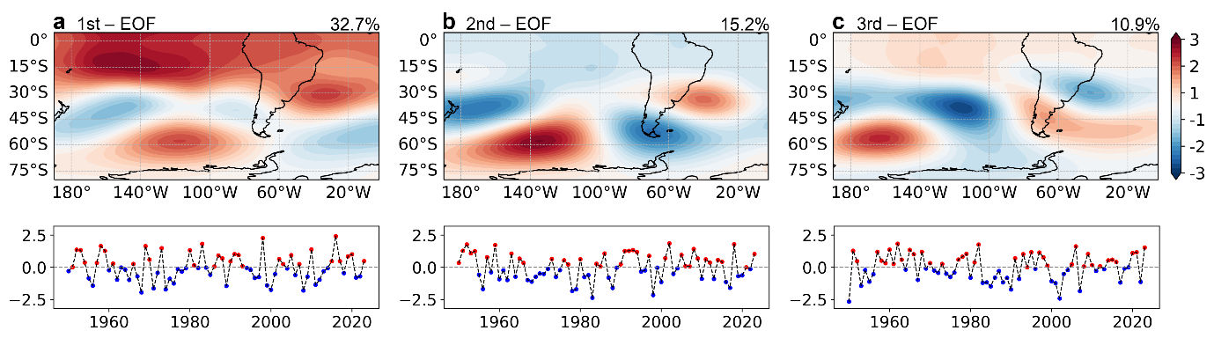
Supplementary Figure 1. Primary upper-level atmospheric stationary waves in austral fall season over South Pacific to South America from NCEP-R1 | (a) The first EOF mode of 200hPa-GPH anomalies in MAM (1950-2023), wherein, core regions over South Pacific are marked by yellow rectangles. Bottom shows its PC time series (dotted line). Yellow line indicates its regional index based on the core regions (see manuscript). (b) and (c) are similar to (a), but for the second and third EOF mode. The regional index of the second and third EOF mode are referred to as the PSA1 and PSA2 index in this study. These three EOF modes explain 32.7%, 15.2%, and 10.9% of the total variability, respectively.
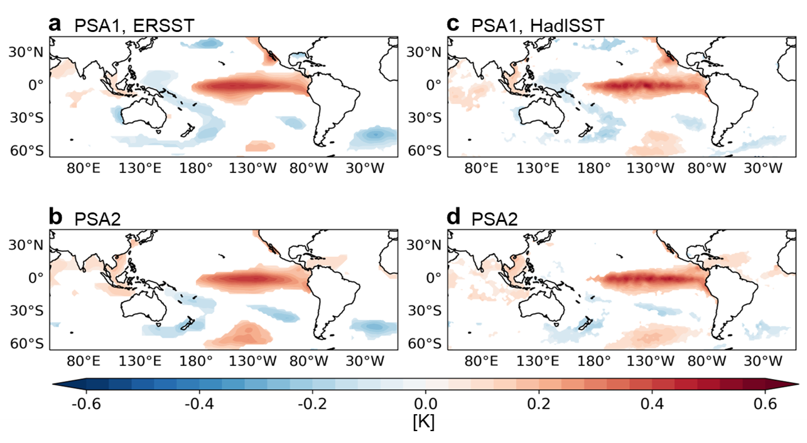
Supplementary Figure 2. PSA1- and PSA2-relevant SST anomalies in the subsequent DJF season. | (a) SST anomalies in subsequent DJF season regressed onto the PSA1 index from ERSSTv5, wherein areas satisfying 95% confidence level by Student’s t-test are shaded. (b) Similar to (a), but regressed onto the PSA2 index. (c) and (d) are similar to (a) and (b), but for HadiSST.
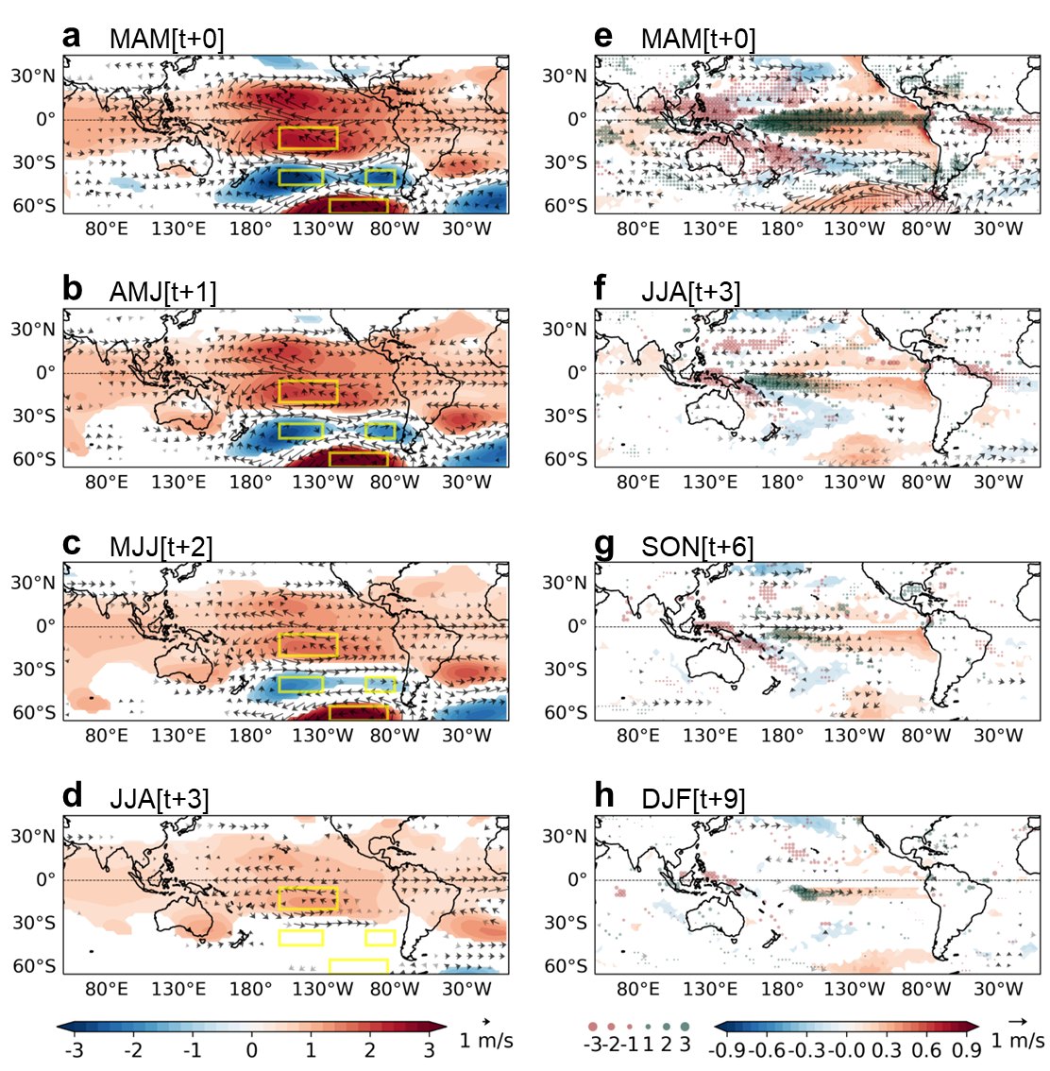
Supplementary Figure 3. Evolution of the ENSO-driven atmospheric stationary waves and its relevant surface pattern | (a) GPH (shading) and wind anomalies (vector) at 200hPa in MAM season regressed onto the regional index of the first EOF mode, wherein the core regions of the first EOF mode are marked by yellow rectangles. The areas satisfying 95% confidence level by Student’s t-test are shaded for GPH. Wind vectors significant at the 95% and 90–95% confidence levels are shown in black and gray, respectively. (b), (c) and (d) are similar to (a), but in AMJ, MJJ, JJA season, respectively. (e) SST (shading), wind (vector, 850hPa), and precipitation (dot) anomalies in MAM season regressed onto the regional index of the first EOF mode. (f), (g), and (h) are similar to (e), but in JJA, SON, and DJF season, respectively. The areas satisfying 95% confidence level by Student’s t-test are shaded for SST and marked by vectors (dots) for wind (precipitation).
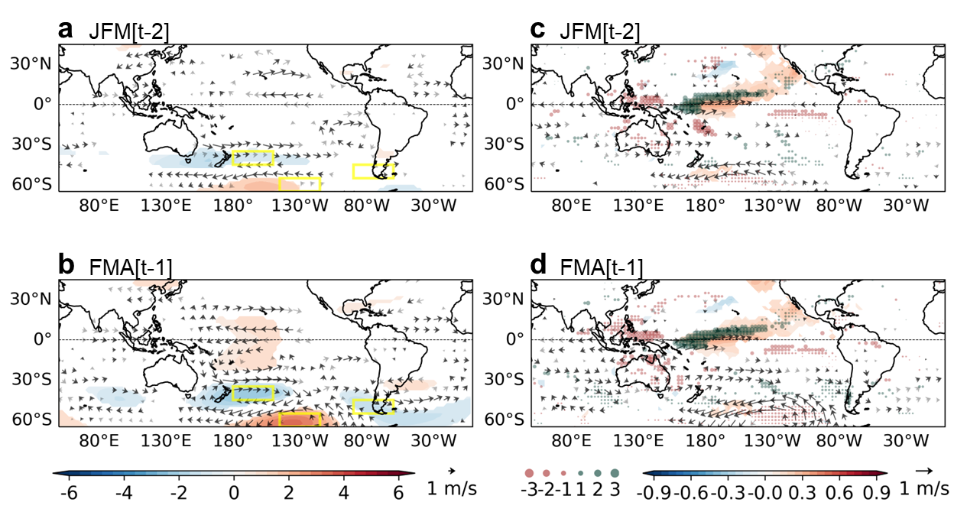
Supplementary Figure 4. Evolution of the PSA1-like atmospheric stationary waves and its relevant surface pattern | (a) GPH (shading) and wind anomalies (vector) at 200hPa in JFM season regressed onto the PSA1 index, wherein the core regions of PSA1-like mode are marked by yellow rectangles. The areas satisfying 95% confidence level by Student’s t-test are shaded for GPH. Wind vectors significant at the 95% and 90–95% confidence levels are shown in black and gray, respectively. (b) is similar to (a), but in FMA. (c) SST (shading), wind (vector, 850hPa), and precipitation (green and purple dot) anomalies in JFM season regressed onto the PSA1 index. (d) is similar to (c), but in FMA season. The areas satisfying 95% confidence level by Student’s t-test are shaded for SST and marked by vectors (dots) for wind (precipitation).
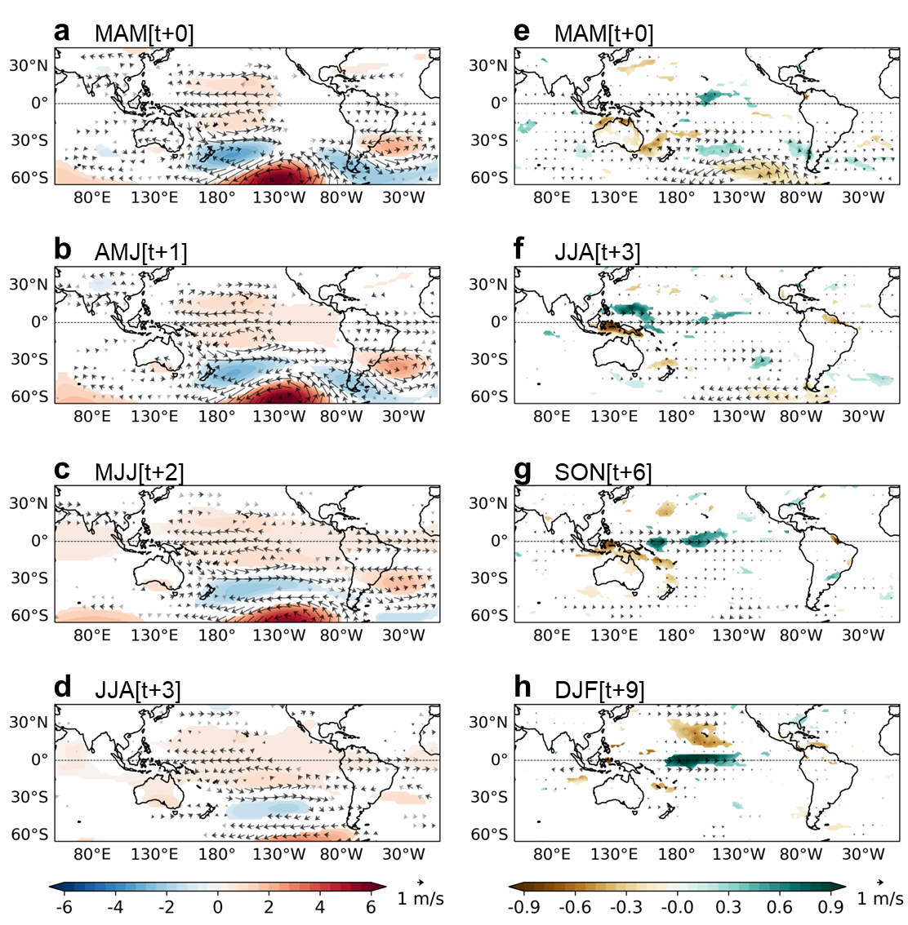
Supplementary Figure 5. Evolution of the PSA1-like atmospheric stationary waves and its relevant surface pattern (NCPE-R1) | (a) GPH (shading) and wind anomalies (vector) at 200hPa in MAM season regressed onto the PSA1 index, wherein the core regions of PSA1-like mode are marked by yellow rectangles. The areas satisfying 95% confidence level by Student’s t-test are shaded for GPH. Wind vectors significant at the 95% and 90–95% confidence levels are shown in black and gray, respectively. (b), (c) and (d) are similar to (a), but in AMJ, MJJ, JJA season, respectively. (e) Wind (vector, 850hPa), and precipitation (dot) anomalies in MAM season regressed onto the PSA1 index. (f), (g), and (h) are similar to (e), but in JJA, SON, and DJF season, respectively. The areas satisfying 95% confidence level by Student’s t-test are shaded for precipitation and marked by vectors (dots) for wind.
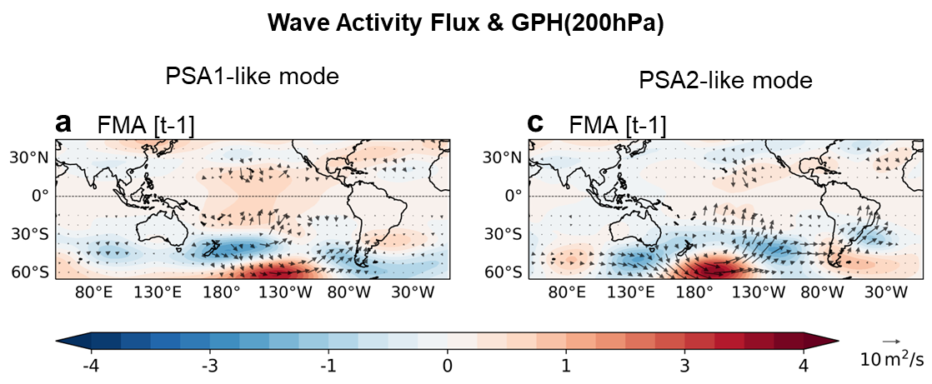
Supplementary Figure 6. GPH and Wave activity flux relevant to PSA1-like and PSA2-like teleconnections | GPH (shading) and wave activity flux (vector) are associated with the PSA1-like mode for (a) FMA. (b) The same fields as (a), respectively, but are associated with the PSA2-like mode.
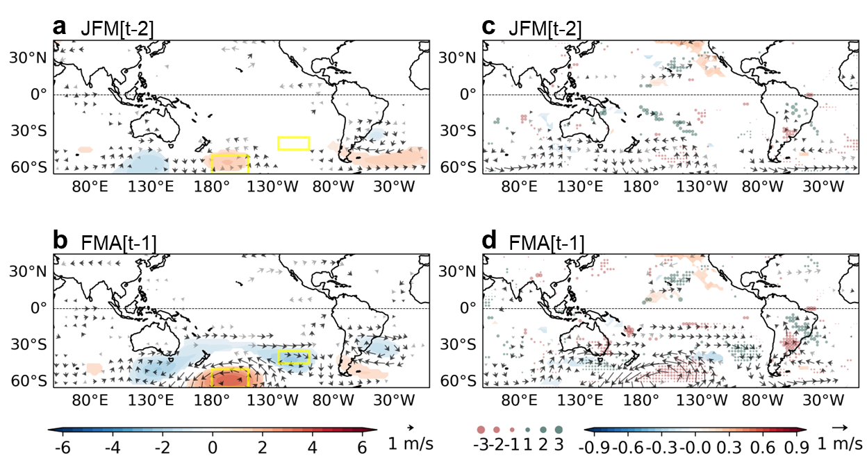
Supplementary Figure 7. Evolution of the PSA2-like atmospheric stationary waves and its relevant surface pattern | (a) GPH (shading) and wind anomalies (vector) at 200hPa in JFM season regressed onto the PSA2 index, wherein the core regions of PSA2-like mode are marked by yellow rectangles. The areas satisfying 95% confidence level by Student’s t-test are shaded for GPH. Wind vectors significant at the 95% and 90–95% confidence levels are shown in black and gray, respectively. (b) is similar to (a), but in FMA. (c) SST (shading), wind (vector, 850hPa), and precipitation (dot) anomalies in JFM season regressed onto the PSA1 index. (d) is similar to (c), but in FMA season. The areas satisfying 95% confidence level by Student’s t-test are shaded for SST and marked by vectors (dots) for wind (precipitation).
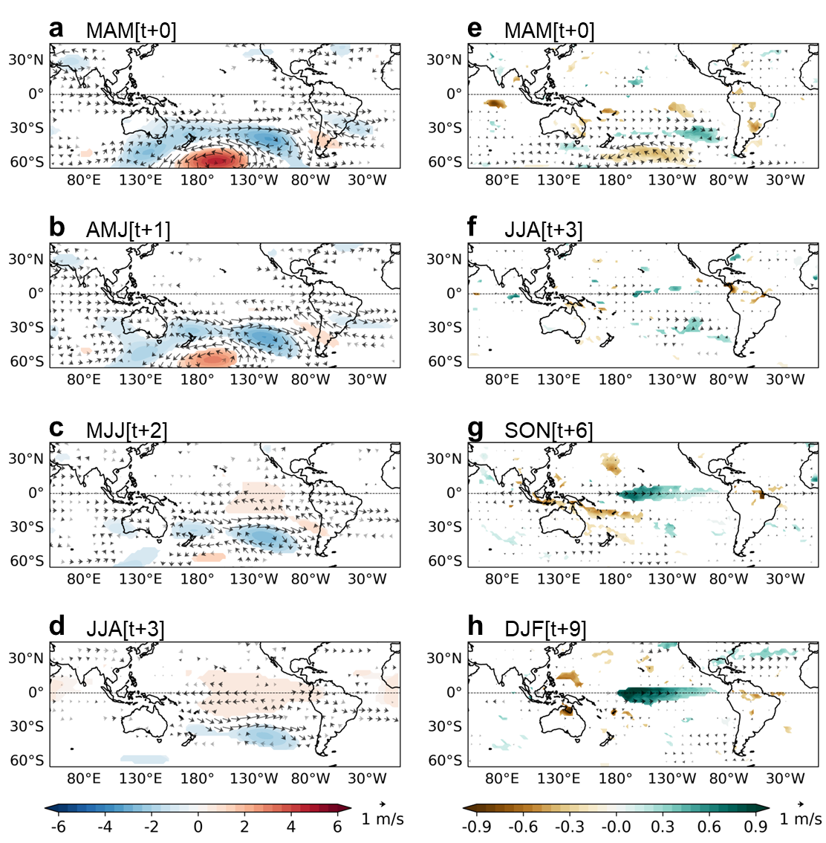
Supplementary Figure 8. Evolution of the PSA2-like atmospheric stationary waves and its relevant surface pattern (NCPE-R1) | (a) GPH (shading) and wind anomalies (vector) at 200hPa in MAM season regressed onto the PSA2 index, wherein the core regions of PSA2-like mode are marked by yellow rectangles. The areas satisfying 95% confidence level by Student’s t-test are shaded for GPH. Wind vectors significant at the 95% and 90–95% confidence levels are shown in black and gray, respectively. (b), (c) and (d) are similar to (a), but in AMJ, MJJ, JJA season, respectively. (e) Wind (vector, 850hPa), and precipitation (dot) anomalies in MAM season regressed onto the PSA1 index. (f), (g), and (h) are similar to (e), but in JJA, SON, and DJF season, respectively. The areas satisfying 95% confidence level by Student’s t-test are shaded for precipitation and marked by vectors (dots) for wind.

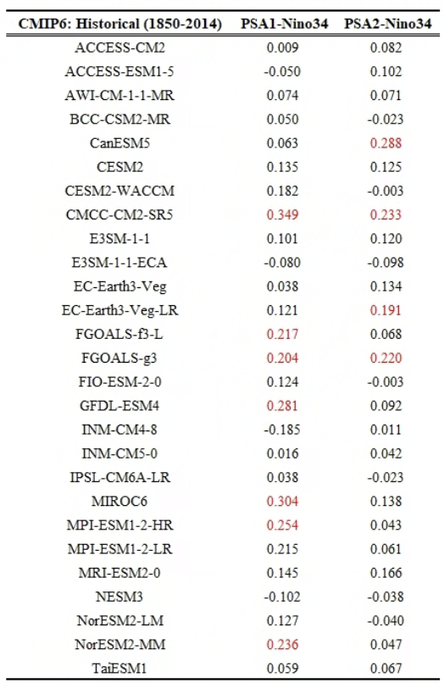
Supplementary Table 1. Correlation coefficient between PSA1/PSA2 index and subsequent Niño3.4 index from Historical simulations in CMIP6 climate models | The First column indicates the name of climate models participating CMIP6 (Historical simulation, 1850-2014). The second column indicates the correlation coefficient between PSA1 index (MAM) and Niño3.4 index (subsequent DJF) in each climate model, wherein the same methodology applied to the observational reanalysis is utilized. The Third column shows the correlation coefficient between PSA1 index (MAM) and Niño3.4 index (subsequent DJF) in each climate model. Correlation coefficient in red indicates significant at 95% confidence level by Student t-test (degree of freedom = 100).

