Supplemental Materials
Gradual Picture Morphing Task Instructions:
Testing was done by two research assistants. Two weeks prior to testing they went to the kindergarten to introduce themselves. They also brought along “Freddy the magic sheep” who performed a magic trick. This was done to break the ice and to introduce the children to the idea that Freddy had actual “magic power”.
At the day of testing children were asked whether they still remember Freddy and if they are curious about his other magic tricks. Two paper slips (42 x 6.5 cm) depicting images of picture sets were used. None of the pictures used for introduction were used later in the test. The first paper slip contained all fifteen images of the bear-pig picture set (Stöttinger et al, 2016). Children were presented with the first object (i.e., bear), while the remaining fourteen pictures of the set were still hidden inside a 10 x 50 cm golden paper cover. They were asked if they knew what the object was. They were then informed that Freddy will now transform the object into a completely different object. After Freddy said his spell the paper clip was slowly pulled out of the cover while children were asked repeatedly whether they already knew what the bear will turn into. The majority of children (i.e., 75%) were able to identify the second object (i.e., pig) after the paper slip was pulled out completely. The answer was confirmed by the instructor at the end: ”Exactly, Freddy has turned the bear step by step into a pig”. In cases where participants were unable to identify the second object, the answer was given to the children. They were then asked if they wanted to see another trick. A second paper slip was used containing only ten pictures (i.e., nine pictures of the fly-fir tree picture set (Stöttinger et al, 2016) together with an additional picture that served as “catch trial”). This time one picture at a time was pulled out of the cover and children were asked to report for each picture what they saw. After three consecutive “fly-pictures” the catch trial (i.e., a picture of a mushroom) appeared. Children were told that Freddy hid something else there and they should keep looking out for the second object (i.e., “Let’s see what the fly will turn into”). As soon as a child identified the second object the instructor replied “Yes, it is possible. Let’s see if this is correct” and continued the procedure. All children were able to identify the second object at the end showing that all children understood the purpose of the task. After completion, the instructor repeated that Freddy had turned the fly slowly into a fir-tree. Children were then asked whether they wanted to see more things Freddy had transformed, but this time on the computer.

Experiment 1:
Gradual vs. Repeated
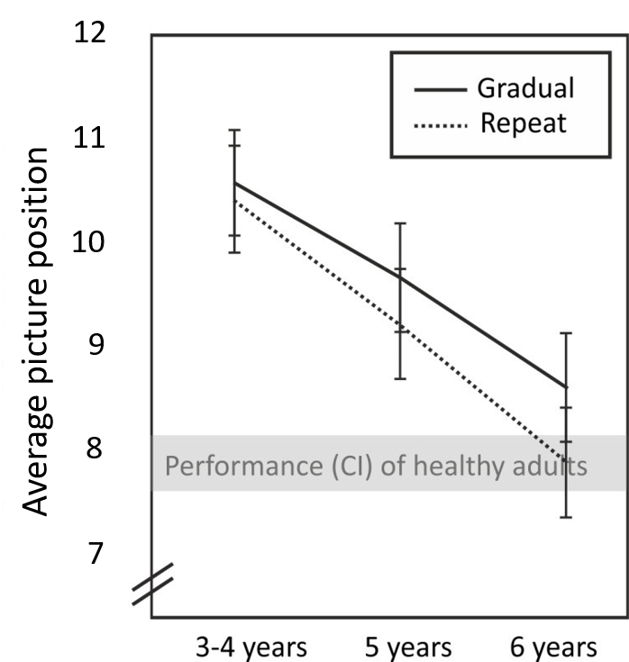

Figure SI_1: Average picture position at which participants identified the second object displayed for the picture set that was presented twice. The solid line displays the average performance for the first presentation, the dotted line displays the average performance for the second presentation. The error bars represent the standard errors of the mean. The grey horizontal bar represents the 95% confidence interval for the performance of healthy individuals in Stöttinger et al. (2018) for this set in the gradual condition.

Reaction Times:
Children saw one picture at a time and were asked to say what they saw in each picture. Children could respond at their own pace and responses were not restricted to a specific word length. Once the response was given, the experimenter pressed the spacebar and the picture was replaced by a fixation cross before the next picture was presented. Therefore, the data should be treated with caution as response times were not recorded under the constrained conditions of a typical RT experiment.
Before the switch children took an average of 2.3 seconds to respond. Only for the picture where they reported the change did the reaction time increase.
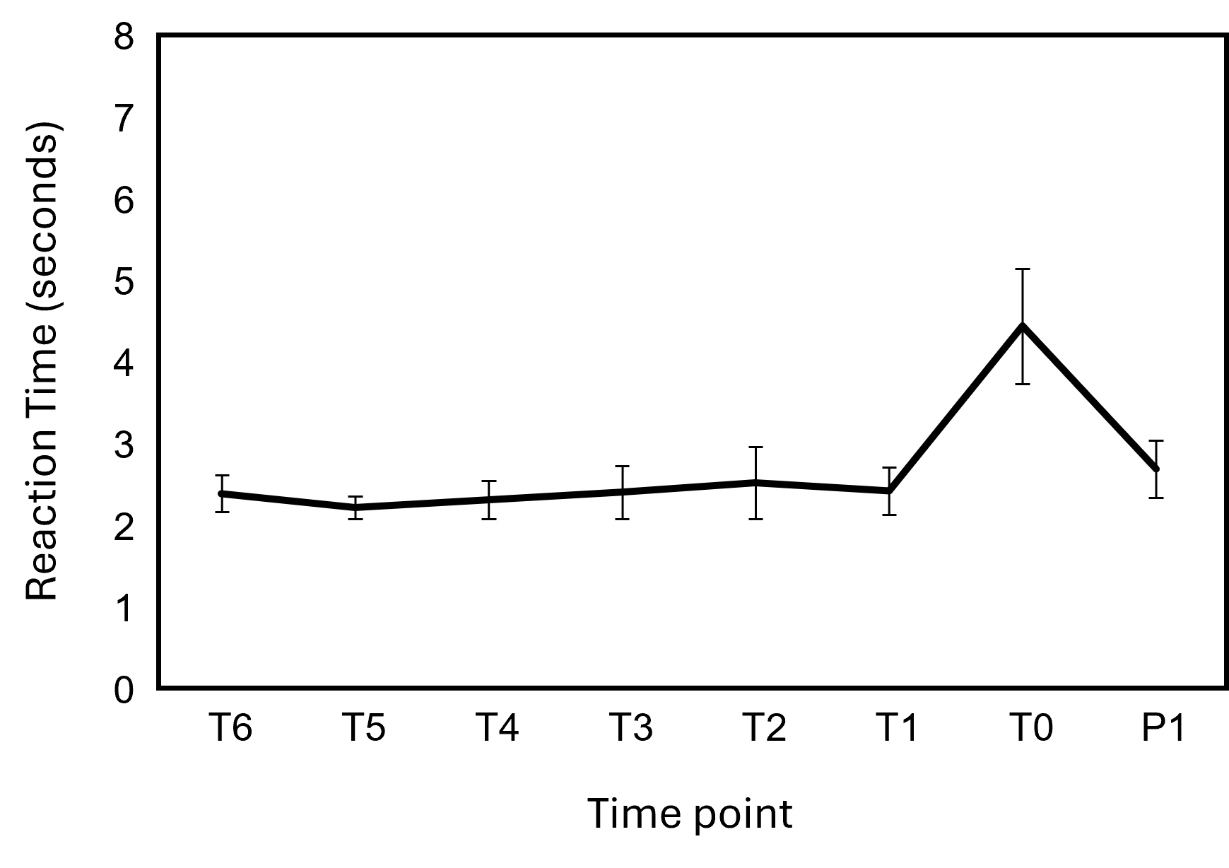
Figure SI_2: Average reaction times displayed for the switch point (T0), together with the six pictures before the switch (− 6T to − T1) as well as the picture after the switch (P1). Error bars reflect SE of the Mean.

Given that adult participants' reaction times typically increase two pictures before the switch (see Figure 2b in Stöttinger et al., 2018a), we calculated a repeated measures analysis with the within-subjects factors time point (T2, T1, T0) and the between-subjects factor age group (< 5 years, 5 years, 6 years). This analysis revealed a significant main effect for time point only [F(2,110) = 22.66, p < .01, η2 = .29]. Reaction time at the moment of change (4.29 ± 3.33 seconds) was significantly longer compared to the two pictures preceding the change (T2: 2.47 ± 3.33; T1: 2.38 ± 2.21 seconds), with no significant difference between T2 and T1 (t(57) = .52, p > .05, d = .07).

Experiment 2:
Reaction Times
Before the switch children took an average of 3.1 seconds to respond and therefore slightly longer as in experiment 1. The highest reaction time was again found for the picture at which children reported a change (6.3 seconds).

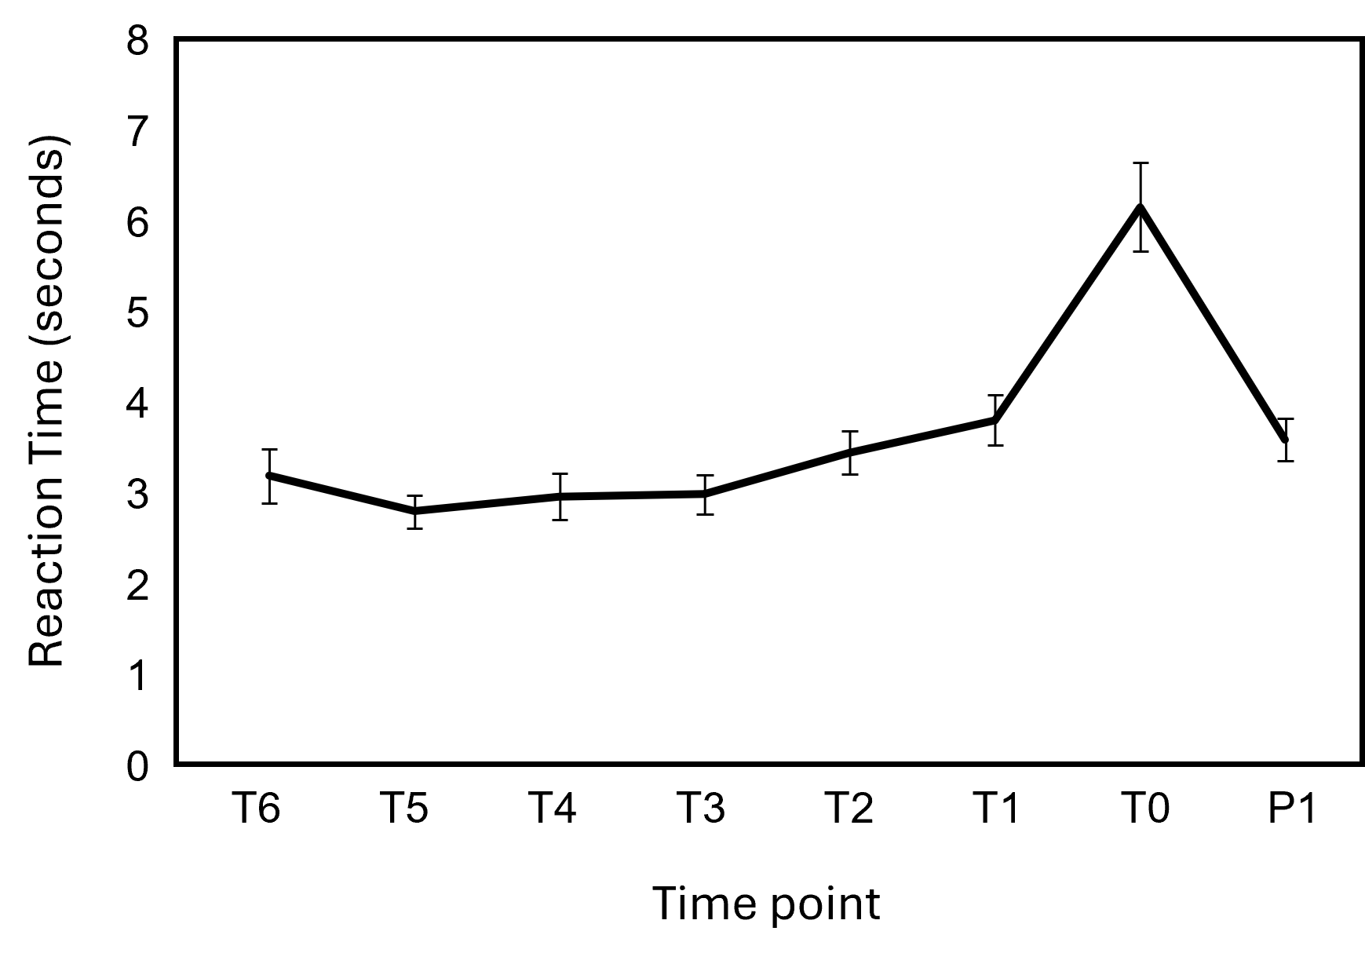
Figure SI_3: Average reaction times displayed for the switch point (T0), together with the six pictures before the switch (− 6T to − T1) as well as the picture after the switch (P1). Error bars reflect SE of the Mean.

The same repeated measures analysis as for reaction times in Experiment 1 revealed a significant main effect for time point only [F(2,164) = 34.32, p < .01, η2 = .30]. Unlike in Experiment 1, children in Experiment 2 showed a more adult-like trend with a marginally significant increase in reaction time over the two pictures preceding the change (T2: 3.34 ± 2.46 seconds; T1: 3.73 ± 2.83; t(85) = 1.39, p = .09 (one-tailed), d = .15. As in Experiment 1, the longest reaction times were recorded at the moment of change (M = 6.30 ± 4.94 seconds).

Table SI_1 RCF Task – Overview

Configural elements
Central Lines (Z1 & Z2) | 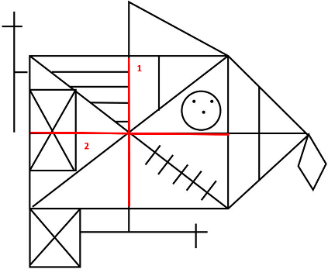
Rectangle  R1, R2, R3, R4 | 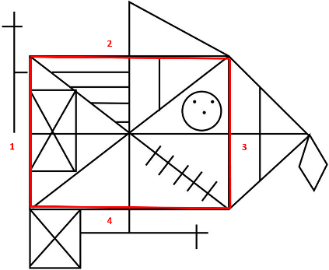
Diagonales | 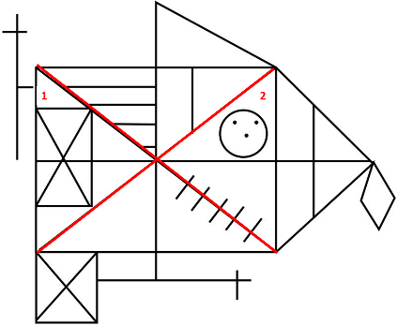
Outside local elements – vertically aligned
AV_1 | 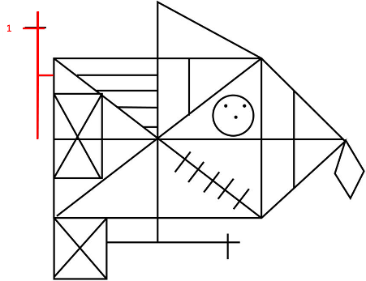
AV_2 | 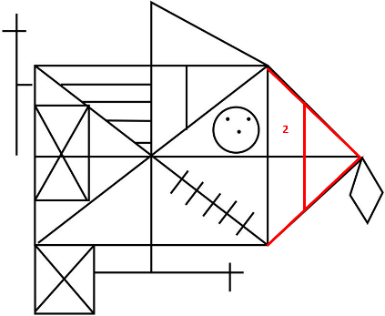
AV_3 | 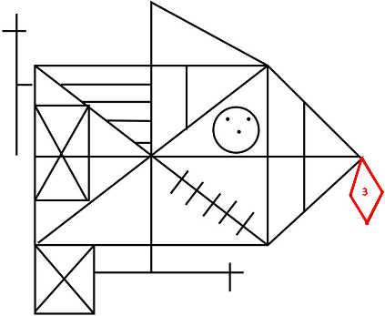
Outside local elements – horizontally aligned
AH_1 | 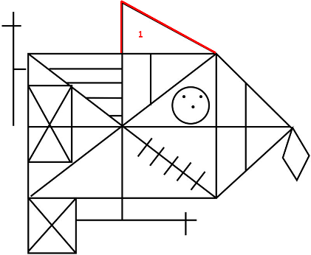
AH_2 | 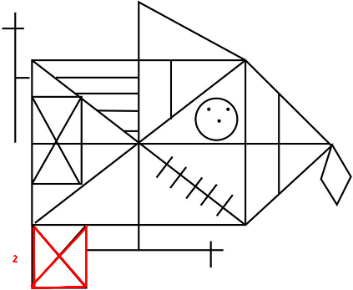
AH_3 | 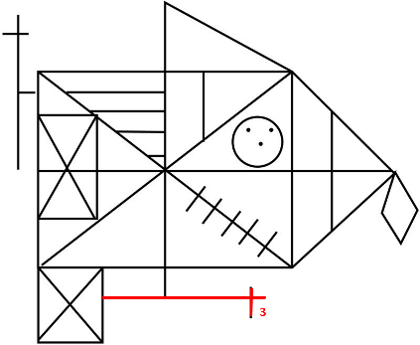
Inside local elements – vertically aligned
IV_1 | 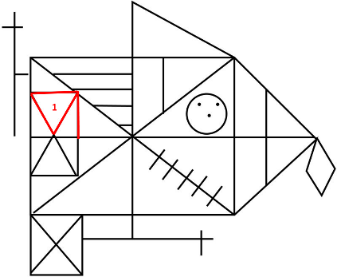
IV_2 | 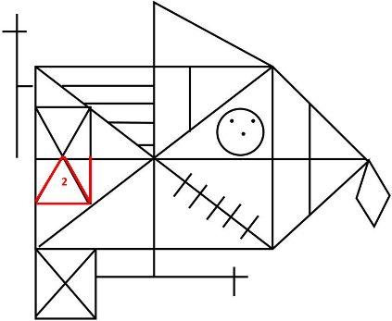
IV_3 | 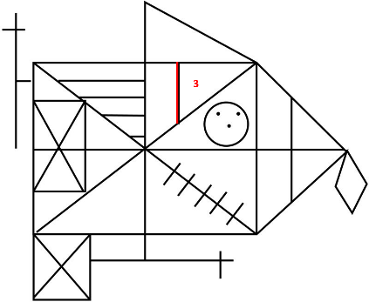
Inside local elements – horizontally aligned
IH_1 | 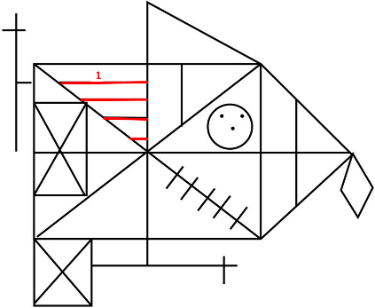
IH_2 | 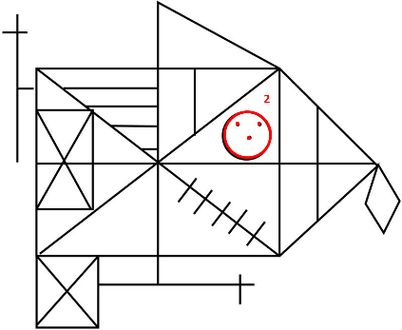
IH_3 | 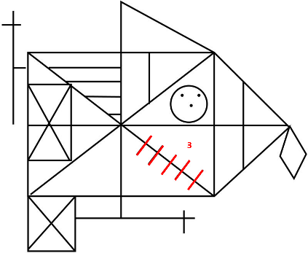

Scoring: Rey Complex Figure Task
Level 7 excellent organization.
- The rectangle is drawn first
- followed by both center lines,
- all other elements are present and correctly aligned.

Level 6: conceptual organization
- Both center lines are drawn as whole single lines, early (i.e., within the first 90 seconds; that is, within the first three colors)
- and completed prior to drawing diagonals and internals sections
- All intersections are correct (i.e., diagonals and centerlines meet at the midpoint junction)
- The majority of the local elements (intern and extern) are present, complete and correctly aligned (i.e., at least 9 out of 12 elements).

Level 5: Part-configural
- both centerlines are present
- at least one centerline is drawn as a whole single line,
- the other center line is present and complete
- the proportions of the center lines are connected.
- at least one local element (internal or external) is aligned with vertical centerline, and at least one local element is aligned with horizontal centerline;
- a piecemeal approach is not adopted. That is, at least 75% (i.e. at least 9 local elements are drawn in one colour and not piece by piece in different colors).

Level 4: piecemeal/ fragmented
- both centerlines are present
- at least one centerline is drawn as a whole single line, (unless the contour or rectangle is completed first. In this case neither centerline needs to be completed as a whole)
- Most local elements (i.e., at least 9) are present and correctly aligned.
- A piecemeal approach is adopted. That is, less than 9 elements are drawn in one piece (i.e., in one colour).

Level 3: random organization
- At least one center line is present (can be fragmented) and at least one internal or external element is present and correctly aligned.

Level 2: poor organization
- Any attempt to draw the figure

Level 1: unrecognizable or substitution
No attempt is made.

