Supplementary Information
Synthesis of bundle copolymers as an emergent class of copolymer architecture

Contents
1. Experimental procedures
1.1. Materials
1.2. Measurements
1.3. Synthesis of PDMS-MA
1.4. Degradation of PDMS
1.5. Synthesis of block copolymers
2. Supplementary figures
2.1. Synthesis of bundle copolymers
2.2. Synthesis of reference copolymers
3. Supplementary references

1. Experimental procedures
1.1. Materials
All reagents were obtained from commercial sources and used without purification unless otherwise noted. Styrene (FUJIFILM Wako, >99%) and methyl methacrylate (MMA; FUJIFILM Wako, >98%) were purified by distillation under reduced pressure. [In(OH)bdc]_{n} (1, bdc = 1,4-benzene dicarboxylate) was prepared according to the literature¹.

1.2. Measurements
¹H nuclear magnetic resonance (NMR) spectra were recorded using a Bruker Avance III HD (500 MHz) spectrometer equipped with a PABBO probe. Chemical shifts were referenced to residual solvent signals (CHCl₃ = 7.26 ppm, dimethyl sulfoxide (DMSO) = 2.50 ppm). For 1D nuclear Overhauser effect spectroscopy (NOESY) experiments, samples (2.5 wt% in CDCl₃) were irradiated at the methyl protons of the polydimethylsiloxane (PDMS) segment with a mixing time of 300 ms.
Powder X-ray diffraction (PXRD) data were collected using a Rigaku SmartLab X-ray diffractometer with Cu Kα radiation (λ = 0.154 nm) operated at 40 kV and 30 mA. Data were acquired over a 2θ range of 5–40° with a step size of 0.02°.
Nitrogen and CO₂ adsorption isotherms at 77 K and 195 K, respectively, were measured using a Microtrac BELSORP-mini surface area and pore size distribution analyser. Before the adsorption measurements, samples were treated under reduced pressure (<10^{–2} Pa) at 393 K overnight.
Gel permeation chromatography (GPC) was performed at 40 °C using a Shimadzu LC-2050 liquid chromatograph equipped with two polystyrene (PS) gel columns in series (Shodex LF-804) and refractive index detectors. The mobile phase was tetrahydrofuran (THF) at a flow rate of 1.0 mL min⁻¹. The number-average molecular weight (M_{n}) and molecular weight distribution (M_{w}/M_{n}) were determined relative to those of a PS (SM-105, Shodex) or poly(methyl methacrylate) (PMMA) standard (Polymer Laboratories), as appropriate. The calibration standards used are indicated on the respective chromatogram axes.
Atomic force microscopy (AFM) was performed in noncontact tapping mode using an Oxford Instruments Asylum Research MFP-3D Origin atomic force microscope. Aluminium-coated silicon cantilevers (OMCL-AC240TS-R3, Olympus) with spring constants of 0.6–3.5 pN nm⁻¹ (resonant frequency: 70 kHz), which were calibrated using the thermal fluctuation method, were used. Samples were prepared by dissolving the polymers in CHCl₃ (1 μg mL⁻¹), spin-casting (2000 rpm, 5 s) them onto a freshly cleaved mica substrate, and drying at 45 °C overnight.
Molecular dynamics simulations were performed using the Materials Studio v4.4 software package (Accelrys Inc.). The Universal Force Field, as implemented in the Forcite module, was used to model the systems. Charges were accounted for using the charge equilibration method. After geometry optimisation, simulations were conducted under NVT conditions (773 K for 10 ps, then 393 K for 100 ps).
Differential scanning calorimetry (DSC) was under a nitrogen atmosphere performed using a HITACHI High Tech DSC7020 differential scanning calorimeter. Samples (~3 mg) were sealed in aluminium pans and scanned at a rate of 10 °C min⁻¹.
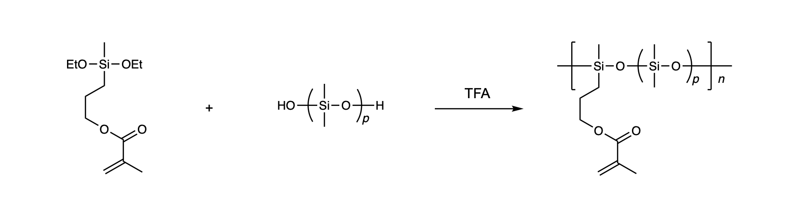
1.3. Synthesis of PDMS-MA²
Hydroxy-terminated oligomeric polydimethyl siloxane (PDMS, Aldrich 481939, 5.0 g, 12 mmol), methacrylic acid 3-[diethoxy(methyl)silyl]propyl ester (3.2 g, 12 mmol), and trimethylsilyl alcohol (0.1 mL, 0.71 mmol) were dissolved in THF (10 mL). Subsequently, trifluoroacetic acid (0.1 mL) was added to the solution, and the mixture was stirred at 60 °C for 48 h. After washing with methanol, PDMS-MA (3.7 g) was obtained as a colourless oil. The ¹H NMR spectrum and GPC curve of the product are shown in Supplementary Figs. 1 and 2 (p = 5.1, M_{n} = 30,000, M_{w}/M_{n} = 1.30, PS standard), respectively.
PDMS-MA with a lower content of methacrylate pendant was synthesised using a longer PDMS precursor (Aldrich 481955) following the same procedure. The ¹H NMR spectrum and GPC curve of the product are shown in Supplementary Figs. 1 and 2 (p = 16, M_{n} = 15,000, M_{w}/M_{n} = 1.37, PS standard), respectively.

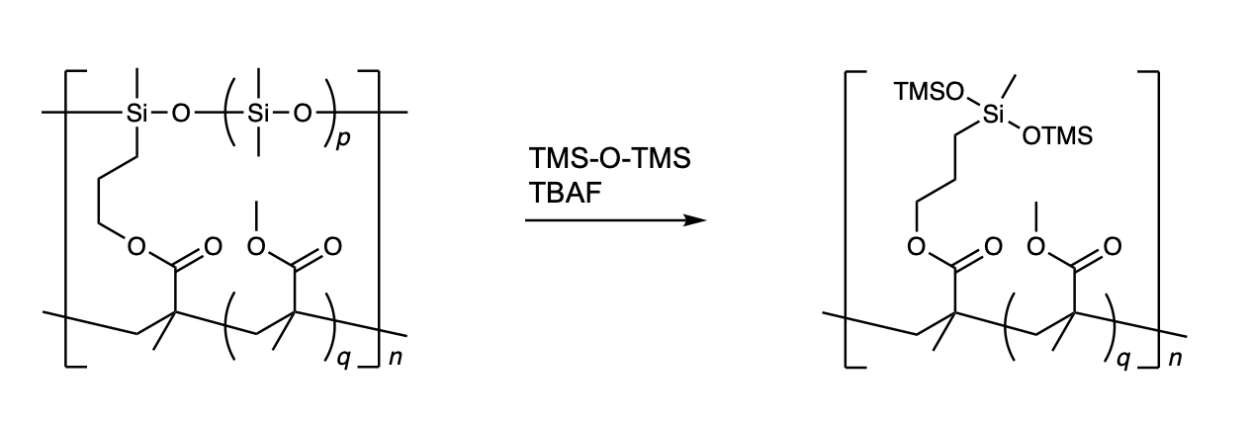
1.4. Degradation of PDMS³
PDMS degradation was performed via a siloxane exchange reaction using tetrabutylammonium fluoride trihydrate (TBAF) as a catalyst and excess disiloxane. PDMS-bundle-PMMA (p = 5.1, 9.9 mg) and hexamethyldisiloxane (TMS-O-TMS; 861 mg) were dissolved in THF (18 mL). Subsequently, a TBAF solution in THF (2 mL, 0.83 mg TBAF, 5 mol% relative to PDMS units) was added, and the mixture was stirred at room temperature for 4 h. Calcium chloride (1.0 g) was then added, and the mixture was stirred for an additional 4 h. After removal of calcium chloride by filtration, the solution was extracted with hexane and dimethylformamide (DMF). The DMF phase was concentrated under reduced pressure, and the polymer was characterised without further purification. The ¹H NMR spectrum and GPC curve of the product are shown in Supplementary Fig. 10.
1.5. Synthesis of block copolymers
Synthesis of PDMS-Br⁴

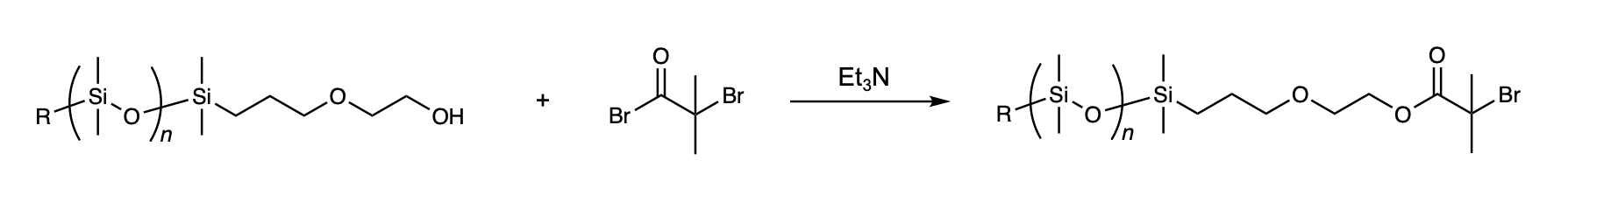
In a round-bottom flask, hydroxy-terminated PDMS (Aldrich 480355, 4.67 g, 1 mmol) was dissolved in anhydrous THF (50 mL), and triethylamine (Et₃N; 1.53 mL, 11 mmol) was then added under a nitrogen atmosphere. After cooling the solution in an ice bath (0 °C), 2-bromo-2-methylpropionyl bromide (1.23 mL, 10 mmol) was slowly added with stirring. The reaction mixture was stirred at room temperature for 24 h. Upon reaction completion, the mixture was poured into a biphasic mixture of hexane (~50 mL) and water (~50 mL), and the organic layer was extracted and washed three times with water. The organic layer was dried over Na₂SO₄, and the solvent was removed under reduced pressure. The resulting oily product was washed with methanol, affording PDMS-Br as a methanol-insoluble viscous oil (3.24 g). The ¹H NMR spectrum and GPC curve of the product are shown in Supplementary Figs. 18 and 19 (n = 66, M_{n} = 6,500, M_{w}/M_{n} = 1.08, PS standard), respectively.

Synthesis of PDMS-block-PMMA⁵

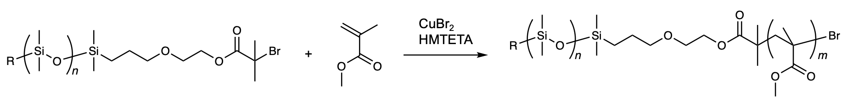
In a glass vial sealed with a rubber septum, PDMS-Br (260 mg, 0.05 mmol), MMA (0.53 mL, 5 mmol), 1,1,4,7,10,10-hexamethyltriethylenetetramine (HMTETA; 53.6 µL, 0.2 mmol), and anisole (2 mL) were mixed and degassed by nitrogen bubbling for 5 min. The resulting solution was then transferred to a round-bottom flask containing CuBr₂ (22.3 mg, 0.1 mmol) under a nitrogen atmosphere. Polymerisation was initiated by heating the mixture to 90 °C with stirring. After 30 min, the reaction was quenched by cooling and exposure to air. The resulting polymer was purified by reprecipitation into methanol, followed by preparative GPC, affording PDMS-block-PMMA as a white solid (241 mg). The ¹H NMR spectrum and GPC curve of the product are shown in Supplementary Figs. 20 and 21 (m = 54, M_{n} = 27,000, M_{w}/M_{n} = 1.09, PMMA standard), respectively.
Synthesis of PDMS-block-PS⁶

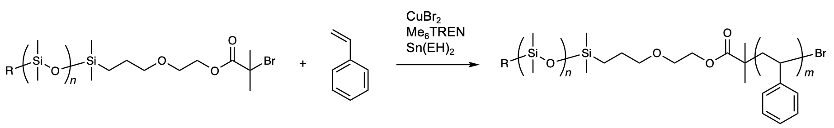
A degassed mixture of tris[2-(dimethylamino)ethyl]amine (Me₆TREN; 27 µL, 0.1 mmol), tin(II) 2-ethylhexanoate (Sn(EH)₂; 40.9 µL, 0.1 mmol), and anisole (1 mL) was added to a round-bottom flask containing CuCl₂ (1.3 mg, 0.01 mmol) under a nitrogen atmosphere. In a separate round-bottom flask, PDMS-Br (521 mg, 0.1 mmol) was dissolved in styrene (1.15 mL, 10 mmol) and degassed by nitrogen bubbling for 5 min. The resulting PDMS-styrene solution was transferred to the Cu catalyst solution using a syringe. Polymerisation was carried out at 110 °C with stirring. After 8 h, the reaction was quenched by cooling and exposure to air. The resulting polymer was purified by reprecipitation into methanol, followed by preparative GPC, affording PDMS-block-PS as a white solid (350 mg). The ¹H NMR spectrum and GPC curve of the product are shown in Supplementary Figs. 22 and 23 (m = 56, M_{n} = 17,600, M_{w}/M_{n} = 1.07, PS standard), respectively.

2. Supplementary figures
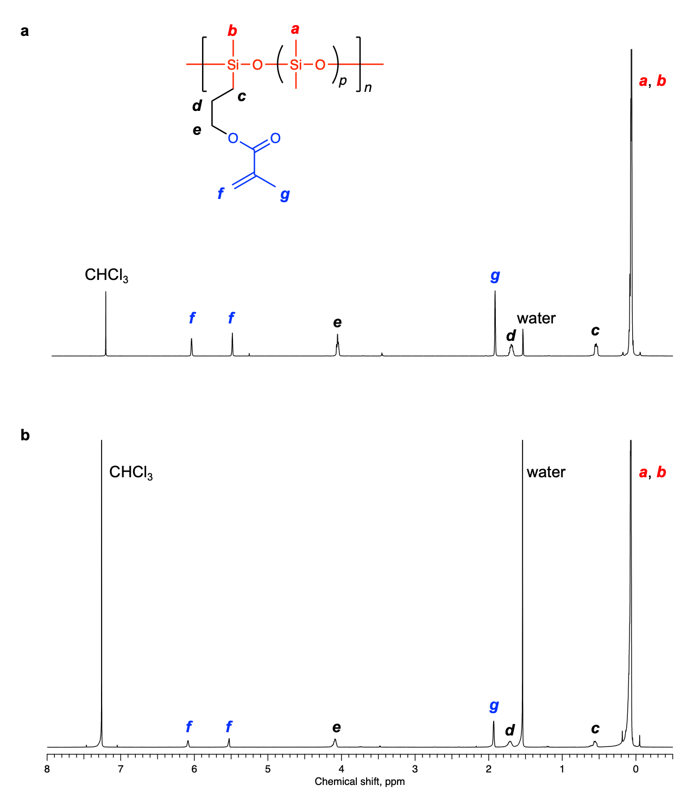
2.1. Synthesis of bundle copolymers

Supplementary Fig. 1 | ¹H NMR spectra of PDMS-MA with different spacer lengths in CDCl₃. a, PDMS-MA with p = 5.1 and b, PDMS-MA with p = 16. The average number of polydimethylsiloxane (PDMS) repeating units between methacrylate (MA) pendants (p) was determined from the integration ratio of these spectra (peaks f and a, b).

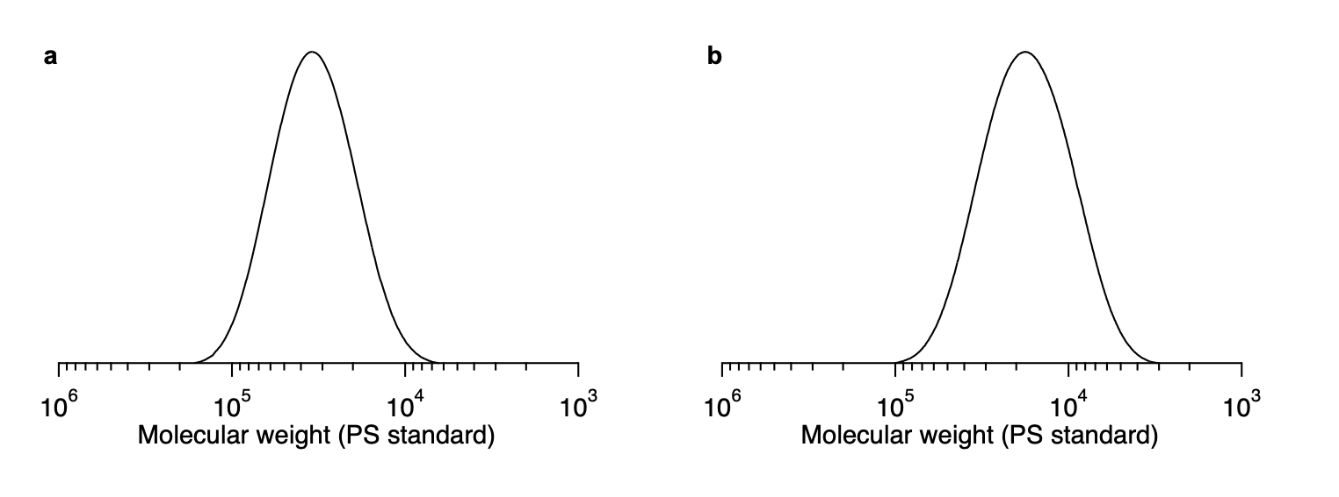
Supplementary Fig. 2 | GPC curves of PDMS-MA with different spacer lengths. a, PDMS-MA with p = 5.1 (M_{n} = 30,000, M_{w}/M_{n} = 1.30) and b, PDMS-MA with p = 16 (M_{n} = 15,000, M_{w}/M_{n} = 1.37). GPC analysis using a PS standard in THF provides a reasonably accurate estimate of the molecular weight of PDMS⁷. From these molecular weights and the spacer length determined by NMR measurement, the number of methacrylate (MA) groups per polymer chain was estimated to be ca. 53 units for PDMS-MA with p = 5.1 and ca. 11 units for PDMS-MA with p = 16.

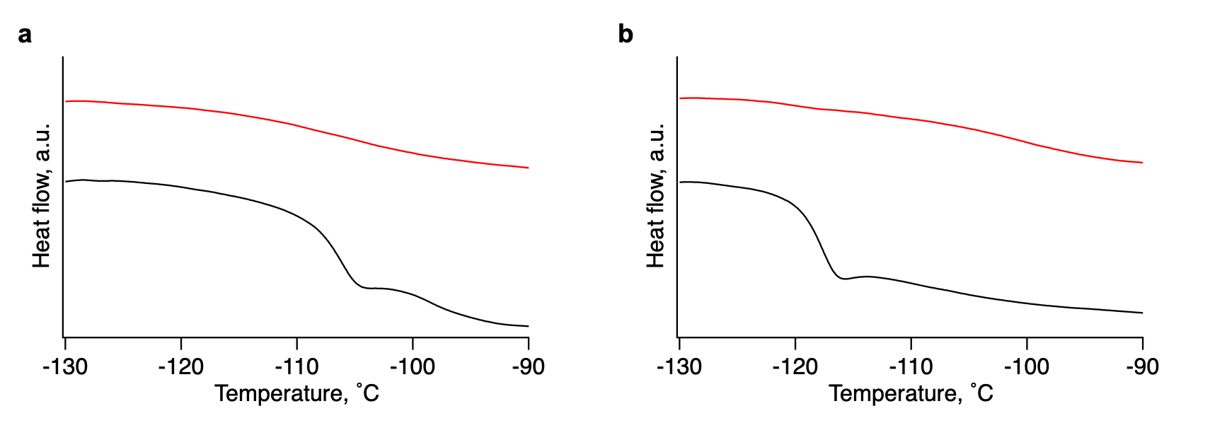

Supplementary Fig. 3 | DSC profiles of PDMS-MA (black line) and the composite of 1 and PDMS-MA (red line) (second heating cycle; exothermic direction upward). a, PDMS-MA with p = 5.1 and b, PDMS-MA with p = 16. The disappearance of glass transition indicates the successful confinement of PDMS-MA within the nanochannel.

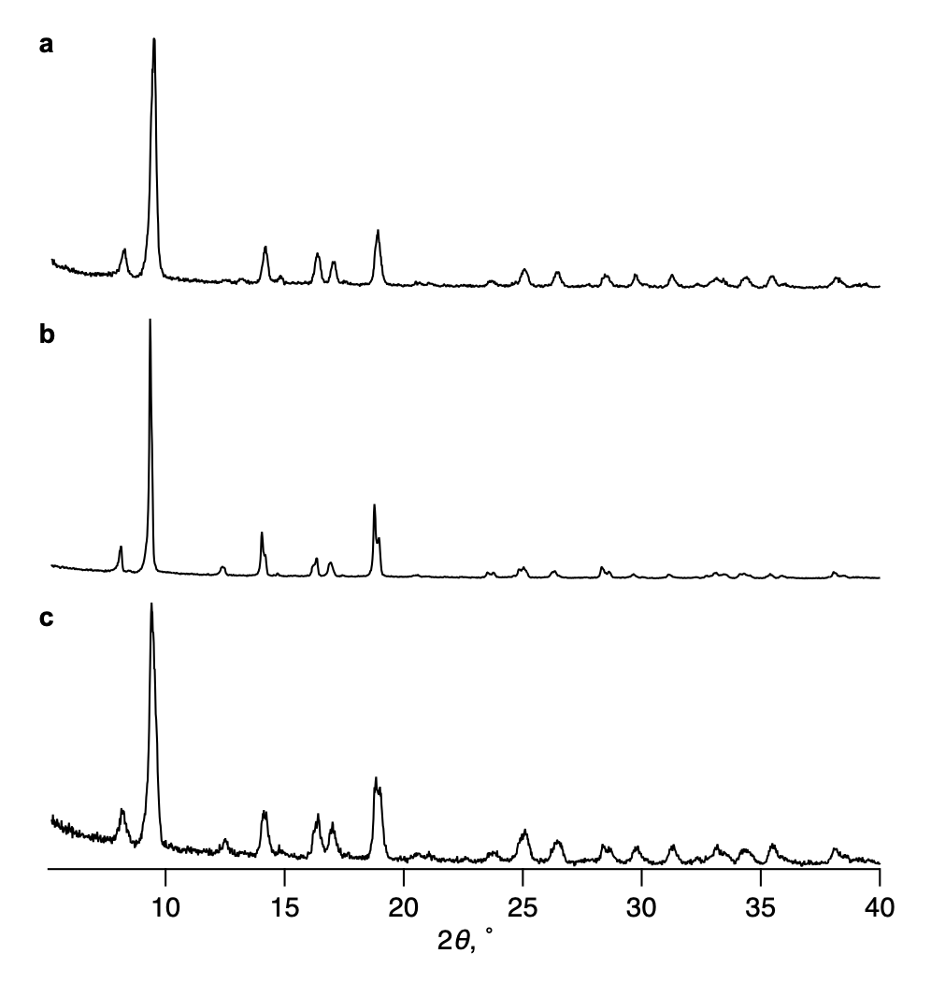
Supplementary Fig. 4 | PXRD patterns of 1 and its composites. a, 1; b, composite of 1 and PDMS-MA with p = 5.1; and c, composite of 1 and PDMS-MA with p = 16. The peak intensity at 2θ = 12° increased after PDMS-MA infiltration owing to the change in the electron density in the nanochannel⁸.

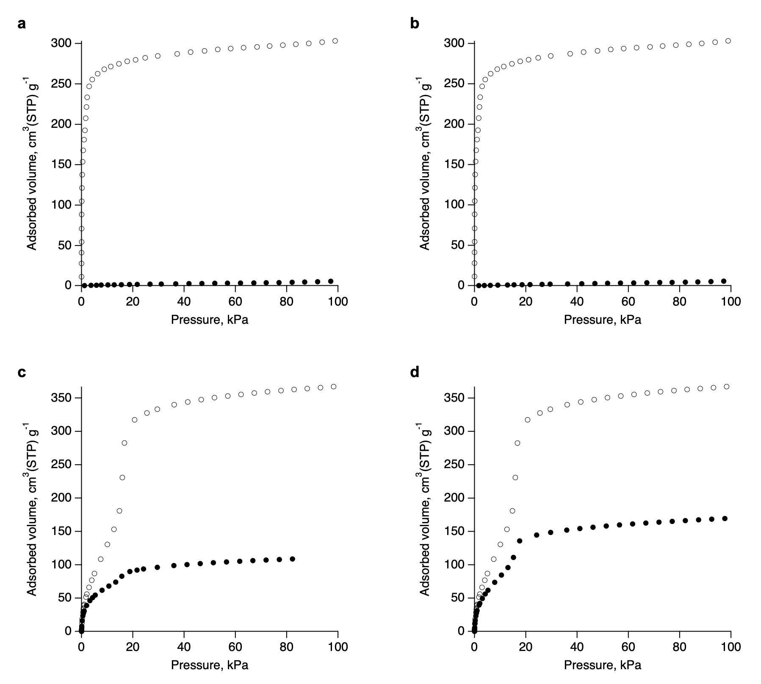

Supplementary Fig. 5 | Gas adsorption isotherms of 1 (open circles) and its composite with PDMS-MA at the predetermined ratio (1/PDMS-MA = 3/1) (filled circles). a, p = 5.1 and b, p = 16, measured using N₂. c, p = 5.1 and d, p = 16, measured using CO₂. At a low temperature (−196 °C), N₂ uptake was suppressed upon PDMS-MA incorporation, likely because the frozen PDMS chains prevent N₂ diffusion through the 1D channels. At a higher temperature of −78 °C, CO₂ uptake was partially reduced, as the enhanced mobility of CO₂ molecules allows them to access the remaining pore volume. The CO₂ adsorption capacities of 1 upon PDMS-MA incorporation for (c) p = 5.1 and (d) p = 16 decreased to ca. 40% and 60%, respectively, of the original MOF. These values are roughly consistent with results obtained by NMR analysis (Supplementary Fig. 6).
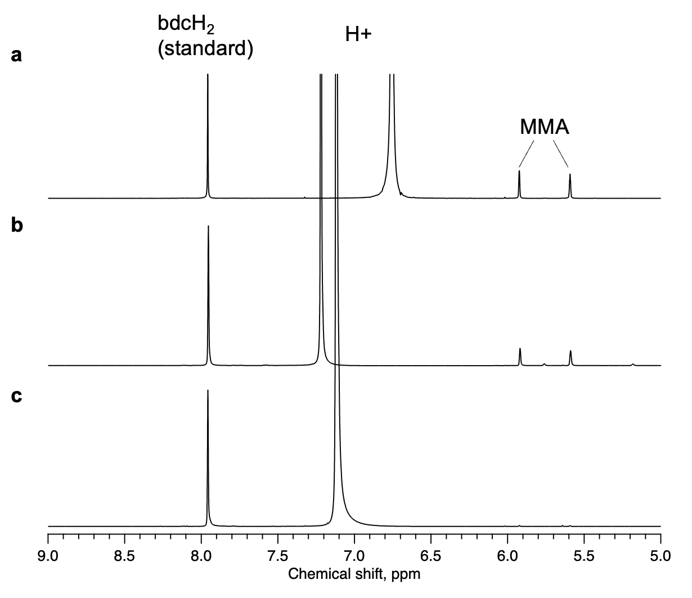
Supplementary Fig. 6 | ¹H NMR spectra of digested composites of 1 in DMSO-d₆/D₂O (35% DCl) (v/v = 9:1). a, Composite of 1 and MMA; b, composite of 1 and PDMS-MA (p = 5.1) and MMA (before polymerisation); and c, composite of 1 and PDMS-bundle-PMMA (after polymerisation). When the integral ratio of 1,4-benzenedicarboxylic acid (bdcH₂) (8 ppm) from 1 was set to 4, the integral ratios of the MMA-derived peak (5.6 ppm) in a and b were 1.39 and 0.66, respectively. The observed MMA uptake in the composite of 1 and PDMS-MA (b) represents that 47 % of the MOF pore spaces are available even after the incorporation of the PDMS-MA in 1. Monomer conversion was estimated by comparing the integral ratio of MMA-derived peak in spectra b and c using bdcH₂ as an internal standard, yielding a conversion of 95%.
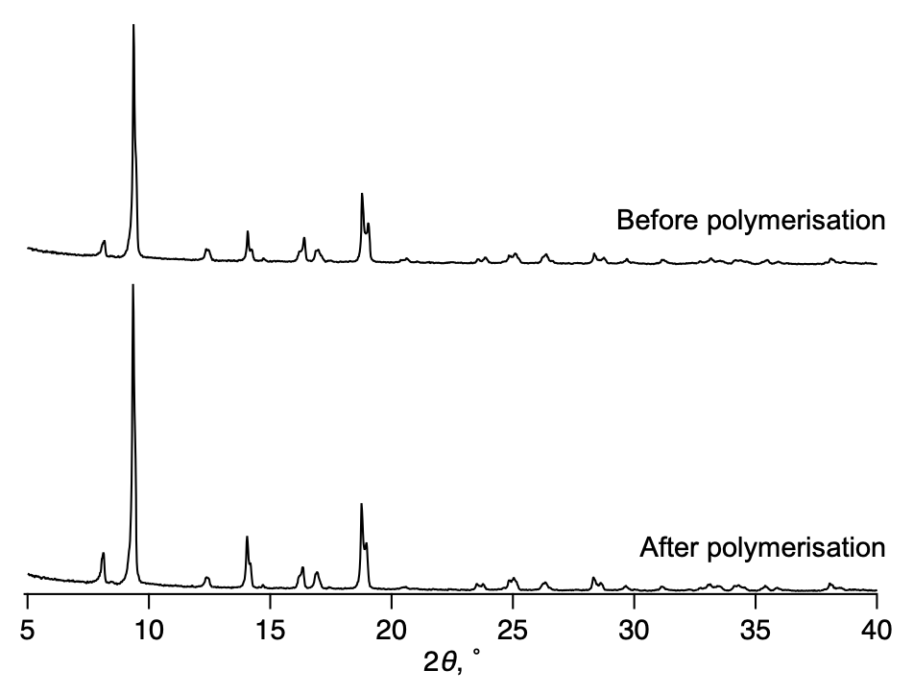
Supplementary Fig. 7 | PXRD patterns of the composite of 1 encapsulating PDMS-MA (p = 5.1) and MMA (before polymerisation) and composite of 1 and PDMS-bundle-PMMA (after polymerisation). The crystallinity of 1 remained intact during polymerisation.

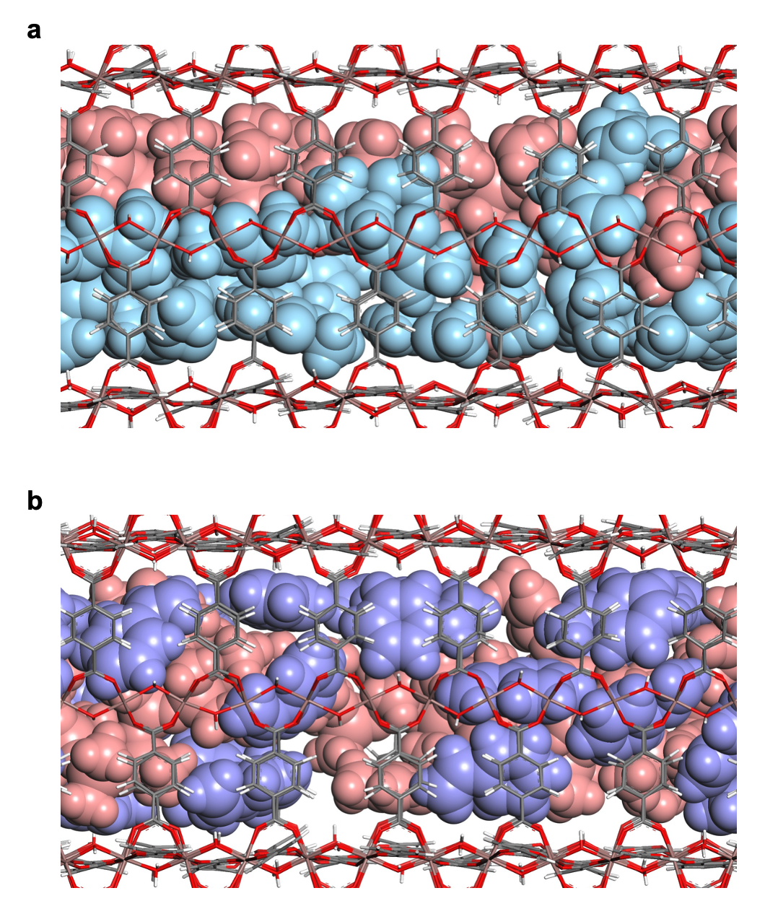
Supplementary Fig. 8 | Molecular dynamics structures of the composite of 1, PDMS-MA, and vinyl monomers. a, 1, PDMS-MA, and MMA. b, 1, PDMS-MA, and styrene. Simulations were performed at the experimentally determined ratio of the three components. PDMS-MA and the monomers are shown using CPK models (PDMS-MA, pink; MMA, light blue; styrene, pale purple) and 1 using a stick model (In, brown; O, red; C, grey; H, white). The extended conformation of PDMS-MA and free diffusion of monomers within the channel facilitate the desired polymerisation.
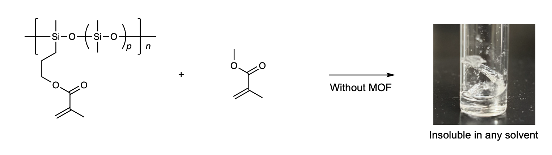
Supplementary Fig. 9 | Bulk polymerisation of PDMS-MA and MMA. A mixture of PDMS-MA (50 mg), MMA (53 mg), and benzoyl peroxide (1.5 mg) were heated under a nitrogen atmosphere. A randomly crosslinked, insoluble network polymer was obtained owing to the absence of spatial confinement by MOF nanochannels.

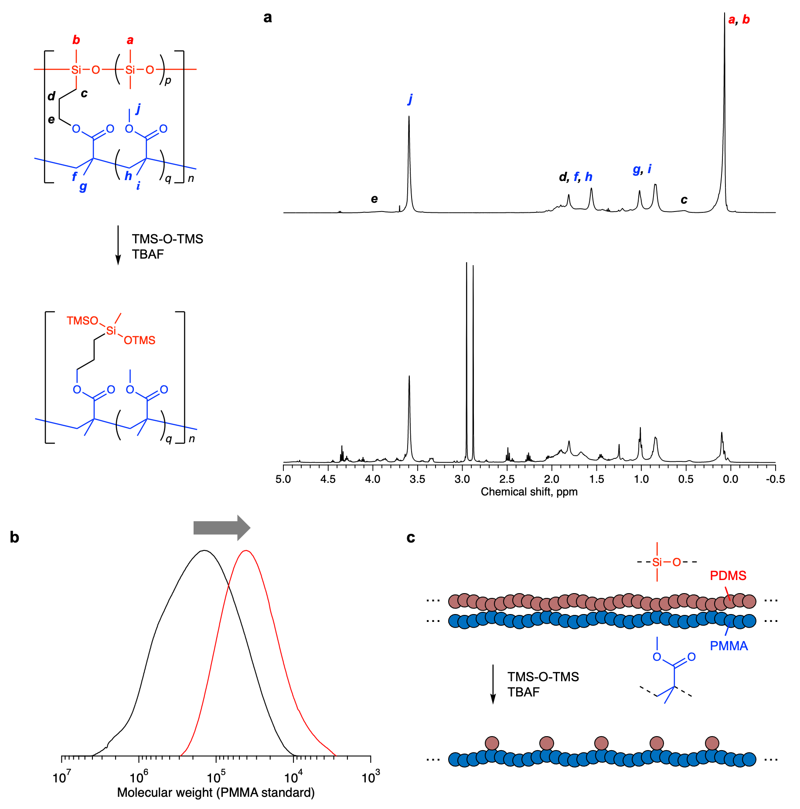
Supplementary Fig. 10 | Degradation of the PDMS strand of PDMS-bundle-PMMA (p = 5.1) by a siloxane exchange reaction using tetrabutylammonium fluoride (TBAF) and excess hexamethyldisiloxane (TMS-O-TMS)³. a, ¹H NMR spectra before (top) and after (bottom) the reaction. The peak area corresponding to the methyl protons bound to Si atoms (0.1 ppm) decreased by 63% when normalised using peak j. This reduction is larger than expected for complete conversion to TMS groups, indicating quantitative removal of the PDMS strands between the junction points. b, GPC curves of the pristine PDMS-bundle-PMMA (black line; M_{n} = 98,100, M_{w}/M_{n} = 3.23) and the liberated PMMA strand (red line; M_{n} = 25,300, M_{w}/M_{n} = 1.95). c, Schematic illustration of the degradation process.
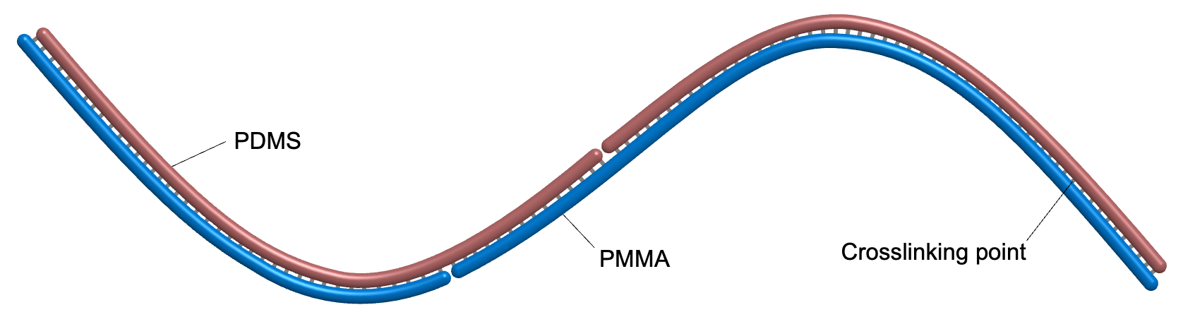
Supplementary Fig. 11 | Schematic representation of PDMS-bundle-PMMA (p = 5.1). A single PDMS-bundle-PMMA is composed of several PDMS and PMMA chains, as estimated from GPC measurements of the bundle copolymer and its components (M_{n} = 98,100 for PDMS-bundle-PMMA, Fig. 3; M_{n} = 30,000 for PDMS-MA, Supplementary Fig. 2; M_{n} = 25,300 for PMMA after PDMS degradation, Supplementary Fig. 10). High consumption of methacrylate (MA) pendants on PDMS-MA and approximately equimolar composition ratio between PDMS and PMMA (PDMS/PMMA = 46/54) assured that most MA pendants participated in the polymerization reaction as a crosslinker. The single PDMS-MA chain contains approximately 53 units that can connect with PMMA chains (Supplementary Figs. 1 and 2).
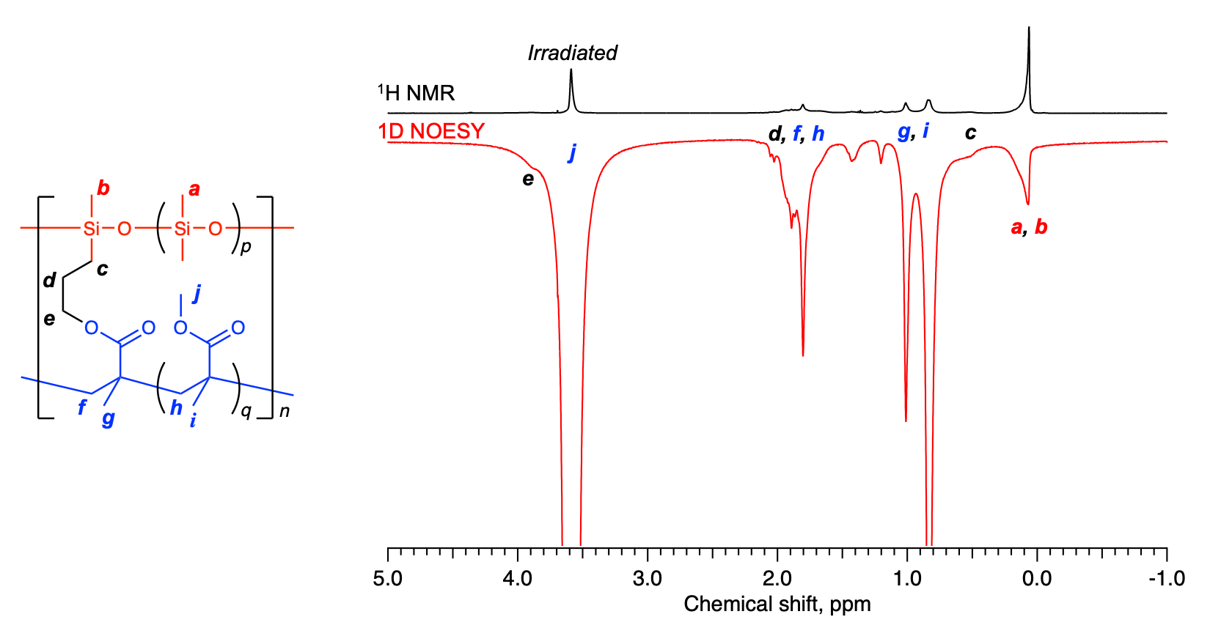
Supplementary Fig. 12 | 1D NOESY spectrum of PDMS-bundle-PMMA (p = 5.1), acquired by selective irradiation at the methoxy protons of PMMA (peak j). Appearance of the signals for PDMS (peak a, b) in the NOESY spectrum indicate close proximity of the PDMS and PMMA strands (2.5% in CDCl₃, mixing time: 300 ms).
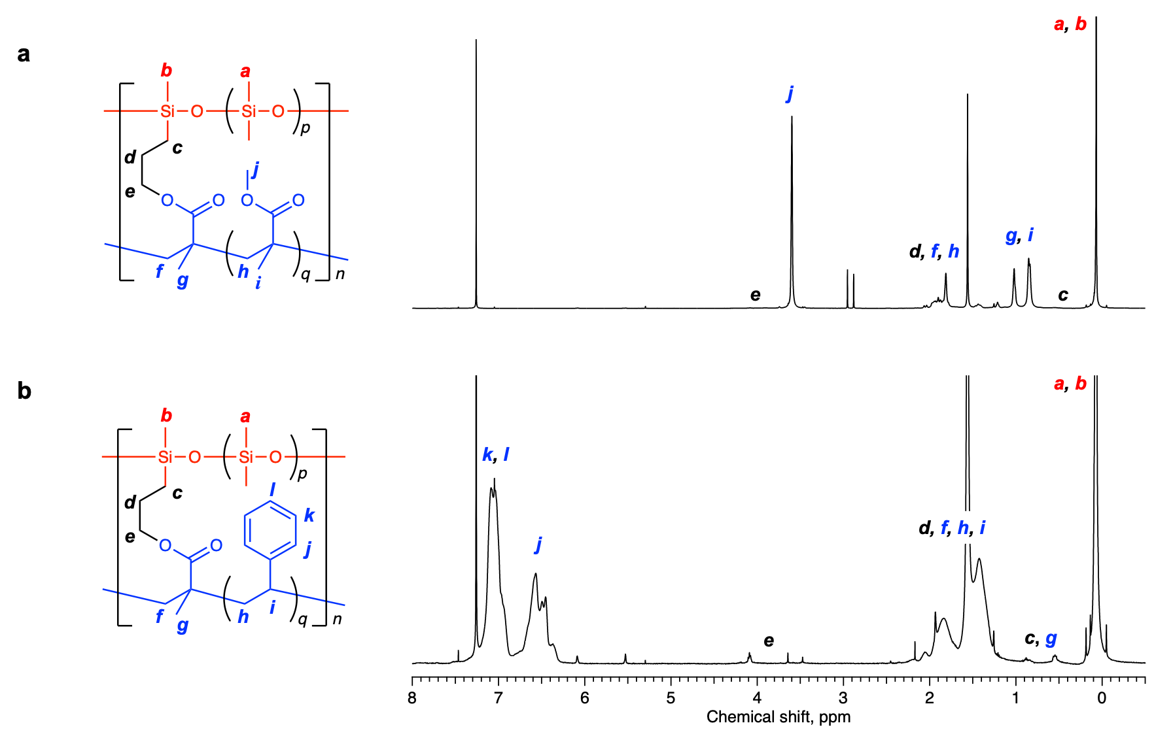
Supplementary Fig. 13 | ¹H NMR spectra of bundle copolymers with a lower crosslinking density (p = 16). a, PDMS-bundle-PMMA and b, PDMS-bundle-PS. The molar ratio of the repeating units was determined from these spectra (a, PDMS/PMMA = 35/65 (mol/mol); b, PDMS/PS) = 43/57 (mol/mol)).
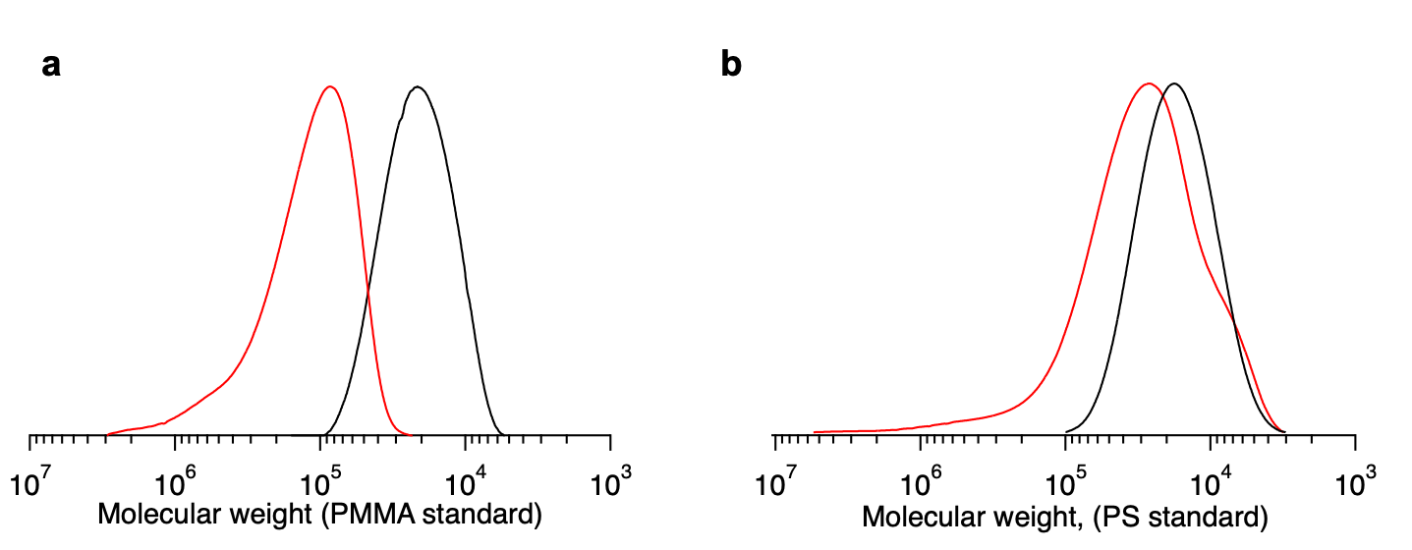

Supplementary Fig. 14 | GPC curves of bundle copolymers with p = 16 (red lines). a, PDMS-bundle-PMMA (M_{n} = 101,000, M_{w}/M_{n} = 1.83) and b, PDMS-bundle-PS (M_{n} = 20,800, M_{w}/M_{n} = 2.59). The GPC curve of the PDMS-MA precursor (black line) is also shown for reference.
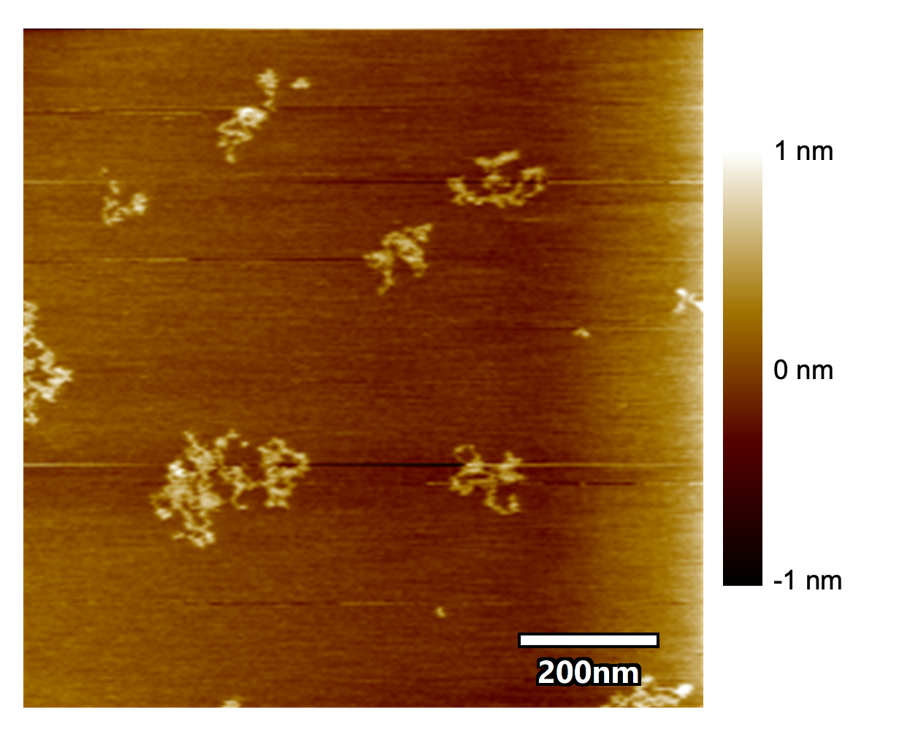

Supplementary Fig. 15 | AFM image of PDMS-bundle-PMMA with a lower crosslinking density (p = 16).

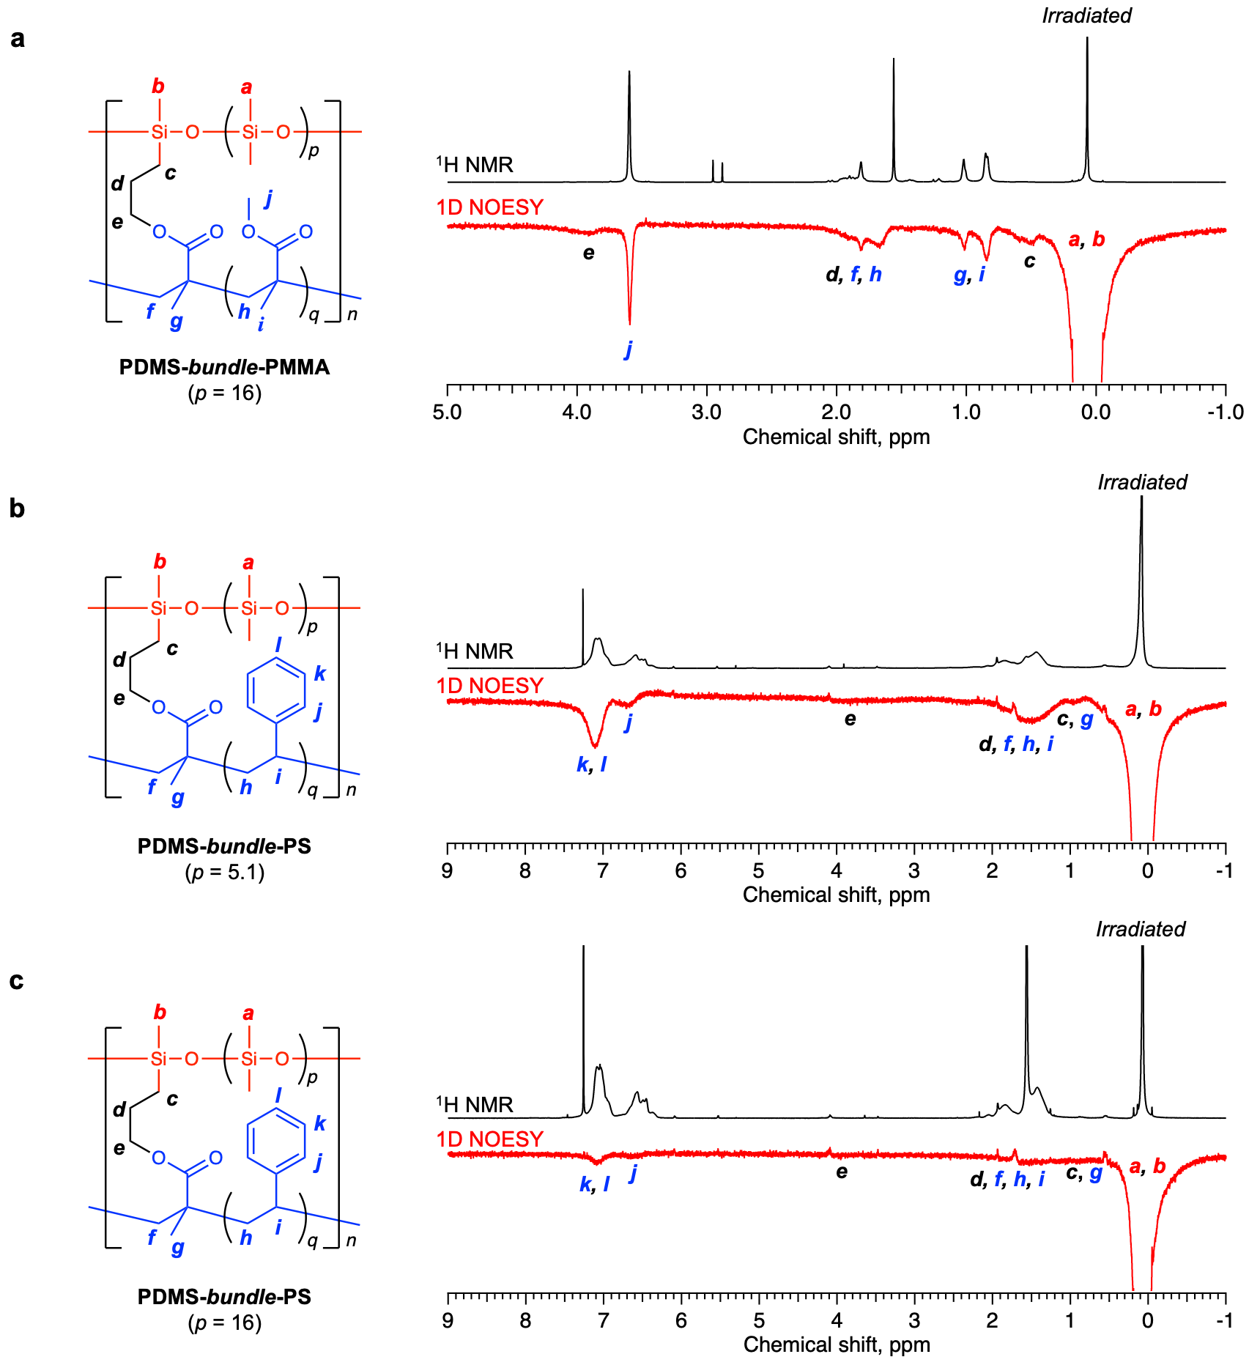
Supplementary Fig. 16 | 1D NOESY spectra of bundle copolymers, acquired by selective irradiation at the methyl protons of the PDMS segment (2.5% in CDCl₃, mixing time: 300 ms). a, PDMS-bundle-PMMA (p = 16); b, PDMS-bundle-PS (p = 5.1); and c, PDMS-bundle-PS (p = 16). To compare spatial proximity between polymer strands, the NOE peak intensities were normalised as follows⁹: (1) The integration ratio between the target and PDMS methyl protons (peak a, b) was determined from the ¹H NMR spectra to obtain the relative number of target protons per PDMS methyl proton (N). (2) In the NOESY spectrum, the irradiated PDMS signal intensity was set to 100, and the integral of the target NOE peak was measured. (3) The normalised NOE intensity was calculated by dividing the observed integral by N. For PDMS-bundle-PMMA (a and Fig. 4a), the methoxy protons of PMMA (peak j) served as the target protons. For PDMS-bundle-PS (b and c), the aromatic protons of PS (peaks j and k, l) served as the target protons.
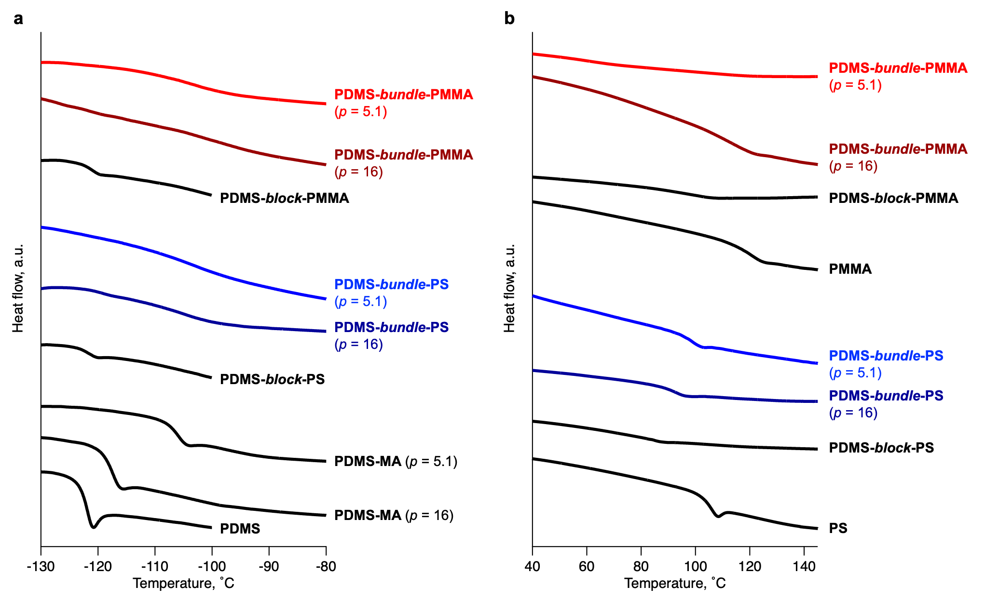

Supplementary Fig. 17 | DSC thermograms of homopolymers, block copolymers, and bundle copolymers. The thermograms encompass the temperature range at which the glass transitions of a, PDMS and b, vinyl polymer segments were observed. Measurements were performed at a heating rate of 10 °C min⁻¹ under nitrogen flow (second heating cycle; exothermic direction upward).
The PDMS segments in the homopolymers and block copolymers exhibited a clear glass transition characterised by a distinct baseline shift, whereas those in the bundle copolymers displayed a broad, gradual profile. This is likely because the bundled vinyl polymer restricted the mobility.
The vinyl polymer components of the bundle copolymers showed thermal transitions intermediate between those of the corresponding homopolymers and block copolymers. This intermediate behaviour results from two competing effects: 1) reduced domain size owing to the bundled structure typically lowers T_{g} and 2) restricted chain mobility due to crosslinking leads to the elevation of T_{g}.
2.2. Synthesis of reference copolymers
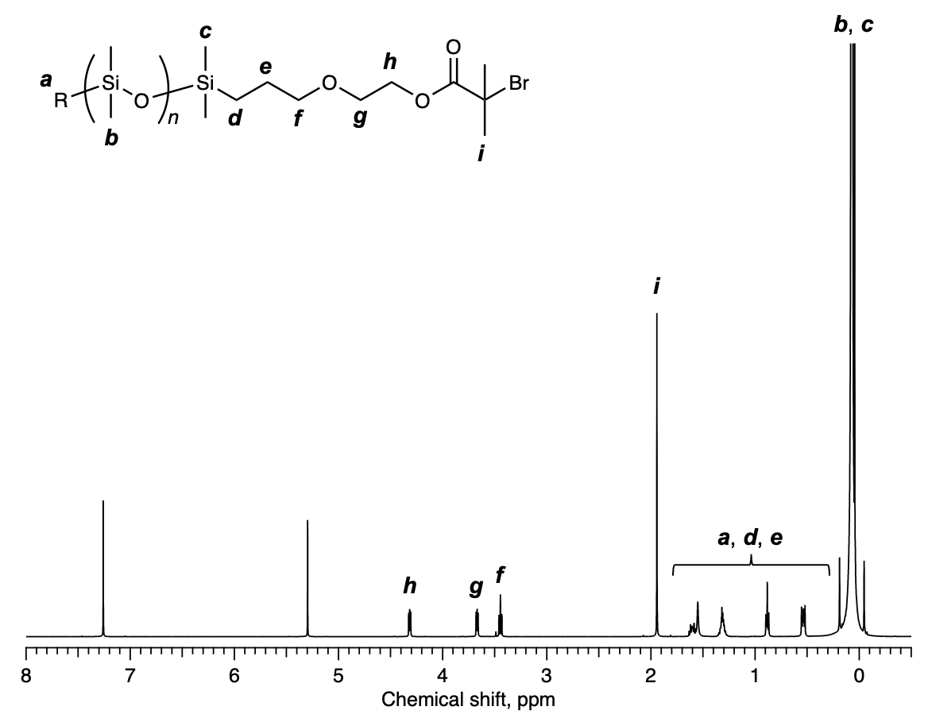
Supplementary Fig. 18 | ¹H NMR spectrum of PDMS-Br in CDCl₃. The degree of polymerisation of the polydimethylsiloxane (PDMS) block (n) was determined from this spectrum (peaks b, c and h; n = 66).
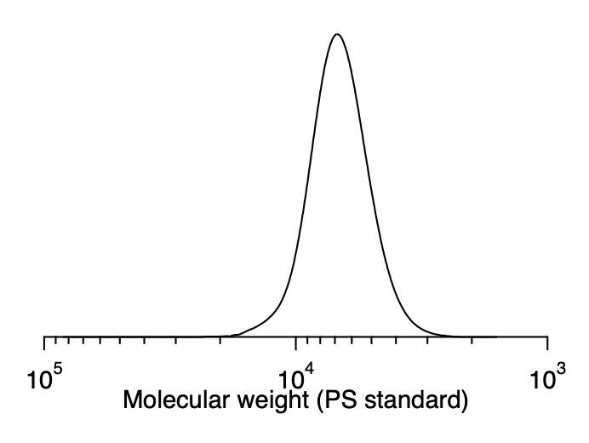
Supplementary Fig. 19 | GPC curve of PDMS-Br (M_{n} = 6,500, M_{w}/M_{n} = 1.08).

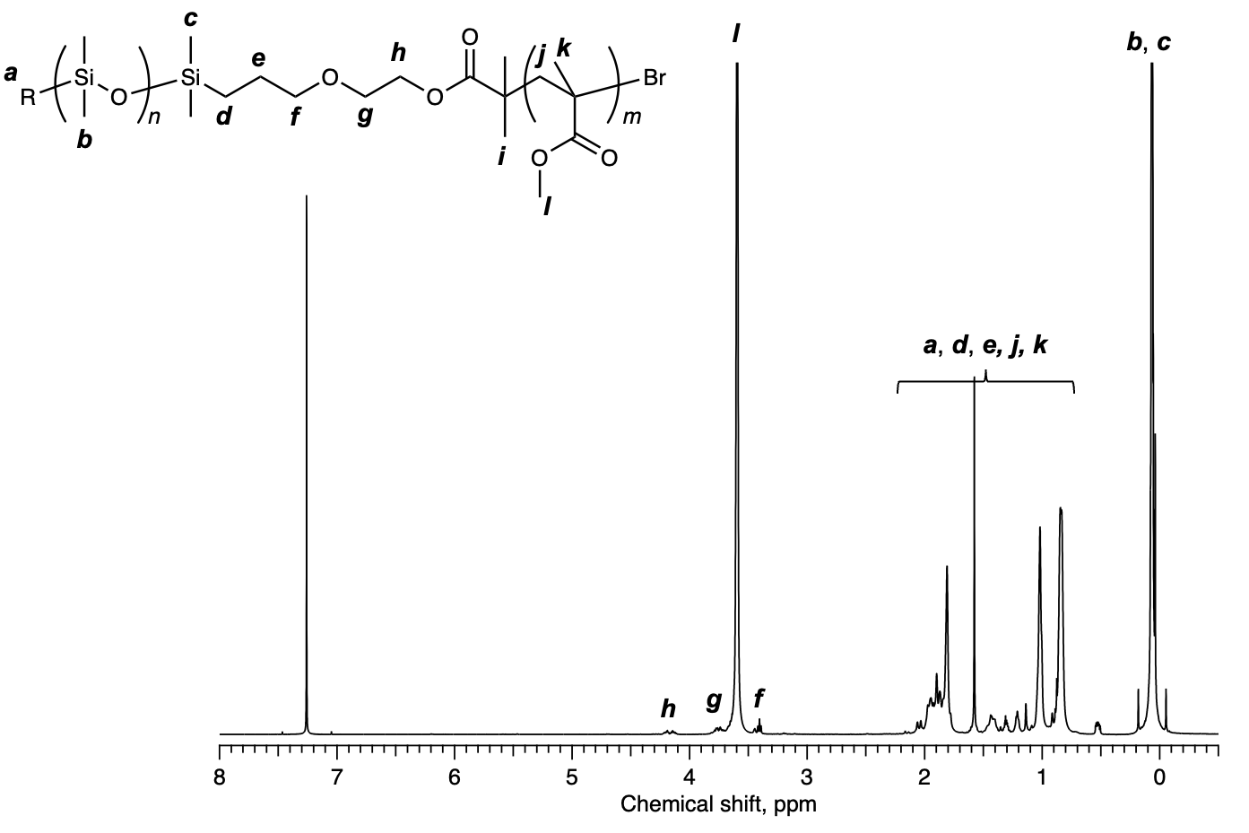
Supplementary Fig. 20 | ¹H NMR spectrum of PDMS-block-PMMA in CDCl₃. The degree of polymerisation of PMMA block (m) was determined from this spectrum (peaks b, c and l; n = 66, m = 54).
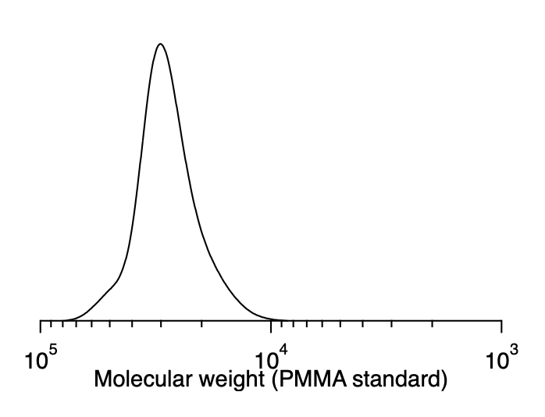
Supplementary Fig. 21 | GPC curve of PDMS-block-PMMA (M_{n} = 27,000, M_{w}/M_{n} = 1.09).

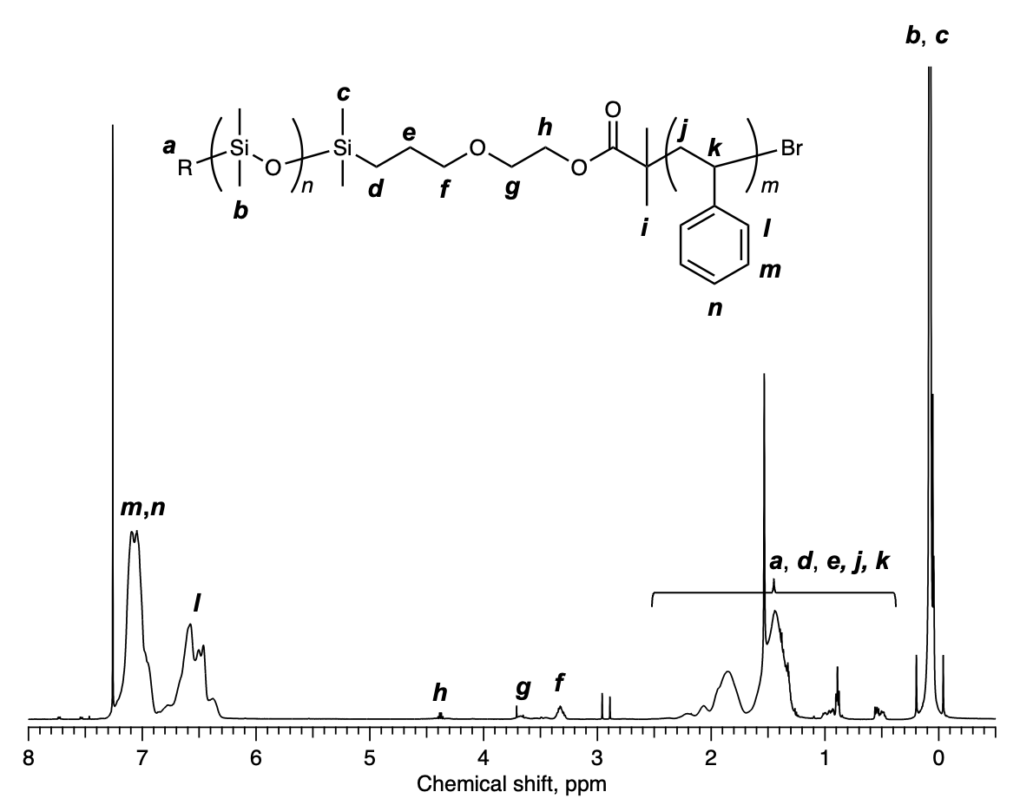
Supplementary Fig. 22 | ¹H NMR spectrum of PDMS-block-PS in CDCl₃. The degree of polymerisation of PS block (m) was determined from this spectrum (peaks b, c and l, m, n; n = 66, m = 56).
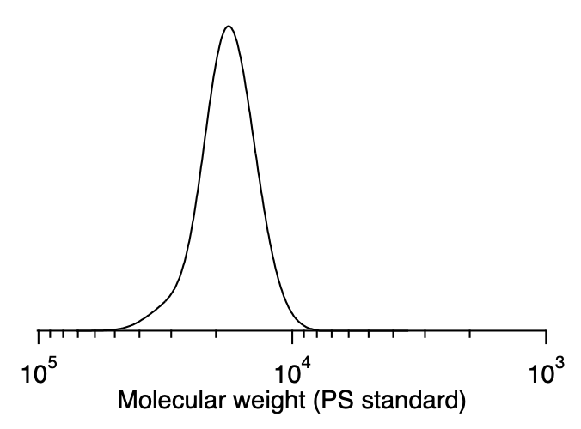
Supplementary Fig. 23 | GPC curve of PDMS-block-PS (M_{n} = 17,600, M_{w}/M_{n} = 1.07).

3. Supplementary references
- Volkringer, C., Meddouri, M., Loiseau, T., Guillou, N., Marrot, J., Férey, G., Haouas, M., Taulelle, F., Audebrand, N. & Latroche, M. The Kagomé topology of the gallium and indium metal-organic framework types with a MIL-68 structure: Synthesis, XRD, solid-state NMR characterizations, and hydrogen adsorption. Inorg. Chem. 47, 11892–11901 (2008).
- Chu, H.-K., Cross, R. P. & Crossan, D. I. Bifunctional catalysis in the condensation of silanols and alkoxysilanes. J. Organomet. Chem. 425, 9–17 (1992).
- Rupasinghe, B. & Furgal, J. C. Full circle recycling of polysiloxanes via room-temperature fluoride-catalyzed depolymerization to repolymerizable cyclics. ACS Appl. Polym. Mater. 3, 1828–1839 (2021).
- Shi, J., Wei, C., Shen, M., Pan, T. & Tian, Y. Synthesis of PDMS containing block copolymers and their applications in oxygen sensing and pressure sensitive paints. Polymer 229, 123968 (2021).
- Kwak, Y. & Matyjaszewski, K. ARGET ATRP of methyl methacrylate in the presence of nitrogen-based ligands as reducing agents. Polym. Int. 58, 242–247 (2009).
- Jakubowski, W., Min, K. & Matyjaszewski, K. Activators regenerated by electron transfer for atom transfer radical polymerization of styrene. Macromolecules 39, 39–45 (2006).
- Malik, M. I., Sinha, P., Bayley, G. M., Mallon, P. E. & Pasch, H. Characterization of polydimethylsiloxane-block-polystyrene (PDMS-b-PS) copolymers by liquid chromatography at critical conditions. Macromol. Chem. Phys. 212, 1221–1228 (2011).
- Schwartz, H. A., Atar, M., Spilles, M., Fill, M., Ott, M., Purtscher, F. R. S., Gallmetzer, J. M., Öcal, B., Olthof, S., Griesbeck, A., Meerholz, K., Hofer, T. S. & Ruschewitz, U. Polarity profiling of porous architectures: solvatochromic dye encapsulation in metal–organic frameworks. J. Mater. Chem. C 12, 8759–8776 (2024).
- Matsumoto, M., Terashima, T., Matsumoto, K., Takenaka, M. & Sawamoto, M. Compartmentalization technologies via self-assembly and cross-linking of amphiphilic random block copolymers in water. J. Am. Chem. Soc. 139, 7164–7167 (2017).

