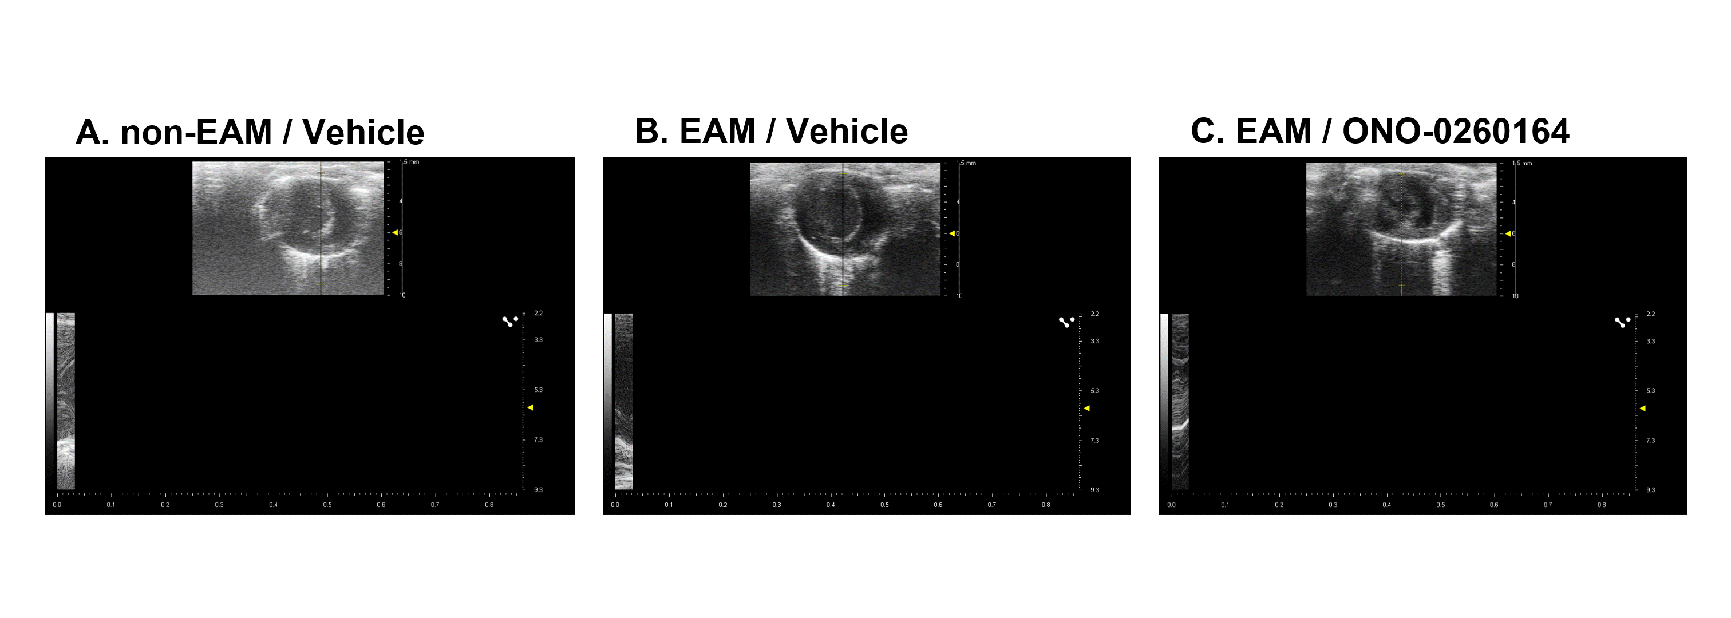Supplementary Video 1. Representative echocardiography on day 21 in experimental autoimmune myocarditis (EAM) mice.
(A) non-EAM mice treated with vehicle alone; (B) EAM mice treated with vehicle alone; (C) EAM mice treated daily with ONO-0260164, a selective prostaglandin-E2 receptor-4 (EP4) agonist.

