Supplementary Materials for

Metamaterials from the Deep: Optimized Mechano-Fluidic Materials Inspired by Deep-Sea Sponges
Timon Meier et al.
Corresponding authors: Costas P. Grigoropoulos: cgrigoro@berkeley.edu,
Petros Koumoutsakos: petros@seas.harvard.edu

Introduction
This supplementary document provides additional details to support the results presented in the main manuscript. It expands on the computational design framework, optimization methodology, mechanical modeling, fluid dynamics simulations, and experimental procedures. Extended figures, data, and analysis are included to illustrate the optimization process, validate simulation predictions, and clarify the performance trade-offs in sponge-inspired lattices. The material is intended to aid reproducibility and give further insight into the workflow and results discussed in the main text.
Optimization Framework and Design Parameters
Design Parameterization
To design sponge-inspired lattices with both structural and fluidic functionality, we implemented a multi-objective optimization framework that combines geometric parameterization, automated simulation workflows, and Bayesian optimization, run on high-performance computing (HPC) resources.
The parameterization is based on the hierarchical skeleton of Euplectella aspergillum. Its cylindrical architecture was abstracted into a lattice of rectangular beam elements with diagonal and helical ridge reinforcements. Eight geometric parameters were defined to control the design space. The full set of parameters and ranges is summarized in Table 1 of the main manuscript.
For reproducibility, we provide a parametric Python script that generates STL files directly from user-defined parameter values. The output geometries are high-resolution 3D models, ready for both simulation and fabrication. As described in later sections, these designs were evaluated using Finite Element Analysis (FEA) for mechanics and Volume-of-Fluid (VoF)-based Computational Fluid Dynamics (CFD) for flow behavior.
Cost Functions and Decoupling of Mechanical and Fluidic Models:
The optimization problem was formulated as a bi-objective minimization of mechanical and fluidic costs, with cost functions defined in the Materials and Methods section of the main manuscript. Although both objectives were optimized together, the simulations themselves were performed as decoupled models.
This choice was justified by spectral analysis from harmonic FEA and comparison with flow-induced force spectra. Boundary conditions in the harmonic FEA were chosen to represent the clamping and loading conditions of the SPIV setup (see Simulation section).
For the fluidic side, vortex shedding frequencies were estimated using the Strouhal relation, $St=fD/U$, which is approximately 0.2 for cylinders across a wide Reynolds number range ¹. In our case, the mean lattice diameter was 22 mm (with slight variations of the outer diameter D from wall thickness parameter W). For $Re=2100$, dominant force and velocity fluctuations were measured between 0.85–1.1 Hz. These values were consistent between SPIV data and CFD force spectra.
Using $U=ν⋅Re/D$​, with $ν={10}^{-6}$ m²/s (water at room temperature), this corresponds to
St₂₁₀₀=0.9⋅22.7/97.3≈0.21,
in agreement with classic vortex shedding behavior of solid cylinders.
By contrast, the first structural resonance occurred at ~20 Hz in harmonic FEA (Figure 6, main manuscript). Since shedding frequencies are more than an order of magnitude lower, energy transfer between flow and structure is expected to be negligible. Although smaller-scale features could in principle shed at higher frequencies, these would likely be weak and incoherent across the lattice. Thus, decoupling the simulations is both computationally efficient and physically justified, capturing the dominant physics while avoiding fluid–structure interaction (FSI) complexity.
Optimization Algorithm and Workflow
We used the Thompson Sampling Efficient Multi-Objective Optimization (TSEMO) algorithm ² to explore the high-dimensional design space and identify non-dominated solutions that balance mechanical and fluidic performance. TSEMO combines Gaussian Process surrogates with Thompson sampling, making it well-suited for expensive black-box problems with noisy outputs and parallel evaluations.
The optimization was initialized with 50 Latin Hypercube Sampling (LHS) points ³ to provide broad coverage of the parameter space. From this baseline, optimization proceeded through 22 iterative batches of 20 designs each, giving 490 additional simulations. A batch size of 20 was chosen to balance parallel throughput with model accuracy, making efficient use of the available HPC resources. Larger batch sizes can accelerate convergence in wall-clock time but tend to reduce surrogate model accuracy between updates. Conversely, smaller batches increase model fidelity but underutilize HPC resources.
The workflow was implemented in Python, linking geometry generation, simulation automation, data handling, and AutoOED ⁴, the GUI-based platform used to monitor optimization progress and track Pareto front evolution. STL files for each design were generated and queued for simulation on the FASRC Cannon cluster at Harvard University, using Sapphire Rapids CPUs with 112 logical cores per node. Jobs were scheduled in parallel, with data transfer and monitoring handled via the Globus platform ⁵.
In total, the optimization consumed ~10,000 node-hours. Despite this cost, the framework converged efficiently, producing a well-defined Pareto front within the compute budget.
Optimization Convergence and Performance
The design performance space is shown in Figure 3A of the main manuscript, with mechanical cost on the X-axis and fluidic cost on the Y-axis (both minimized). Convergence was monitored using the hypervolume indicator (Figure 3B), which increased steadily before plateauing in the final batches, indicating convergence of the Pareto front and providing a natural stopping criteria for our optimization.
The final front (red points in Figure 3A) comprises 12 non-dominated solutions labeled A–L, spanning the trade-off between structural robustness and hydrodynamic efficiency. For example, Design A maximizes buckling resistance at the expense of higher fluid forces, while Design L minimizes vortex shedding with reduced mechanical strength. Visualizations of all Pareto-optimal structures A–L are provided in Figures S1 and S2.
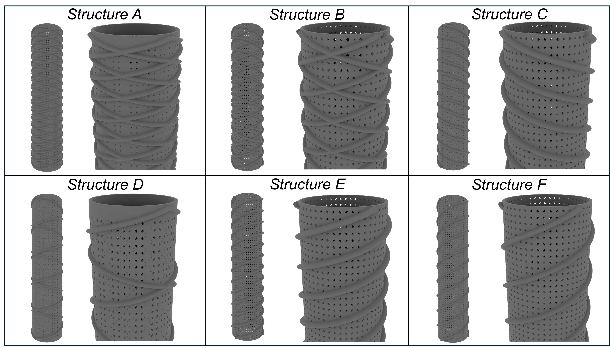
Fig S1: 3D renderings of Pareto-optimal designs A–F. These structures highlight diverse trade-offs between mechanical robustness and fluidic efficiency, as encoded in the optimization framework.

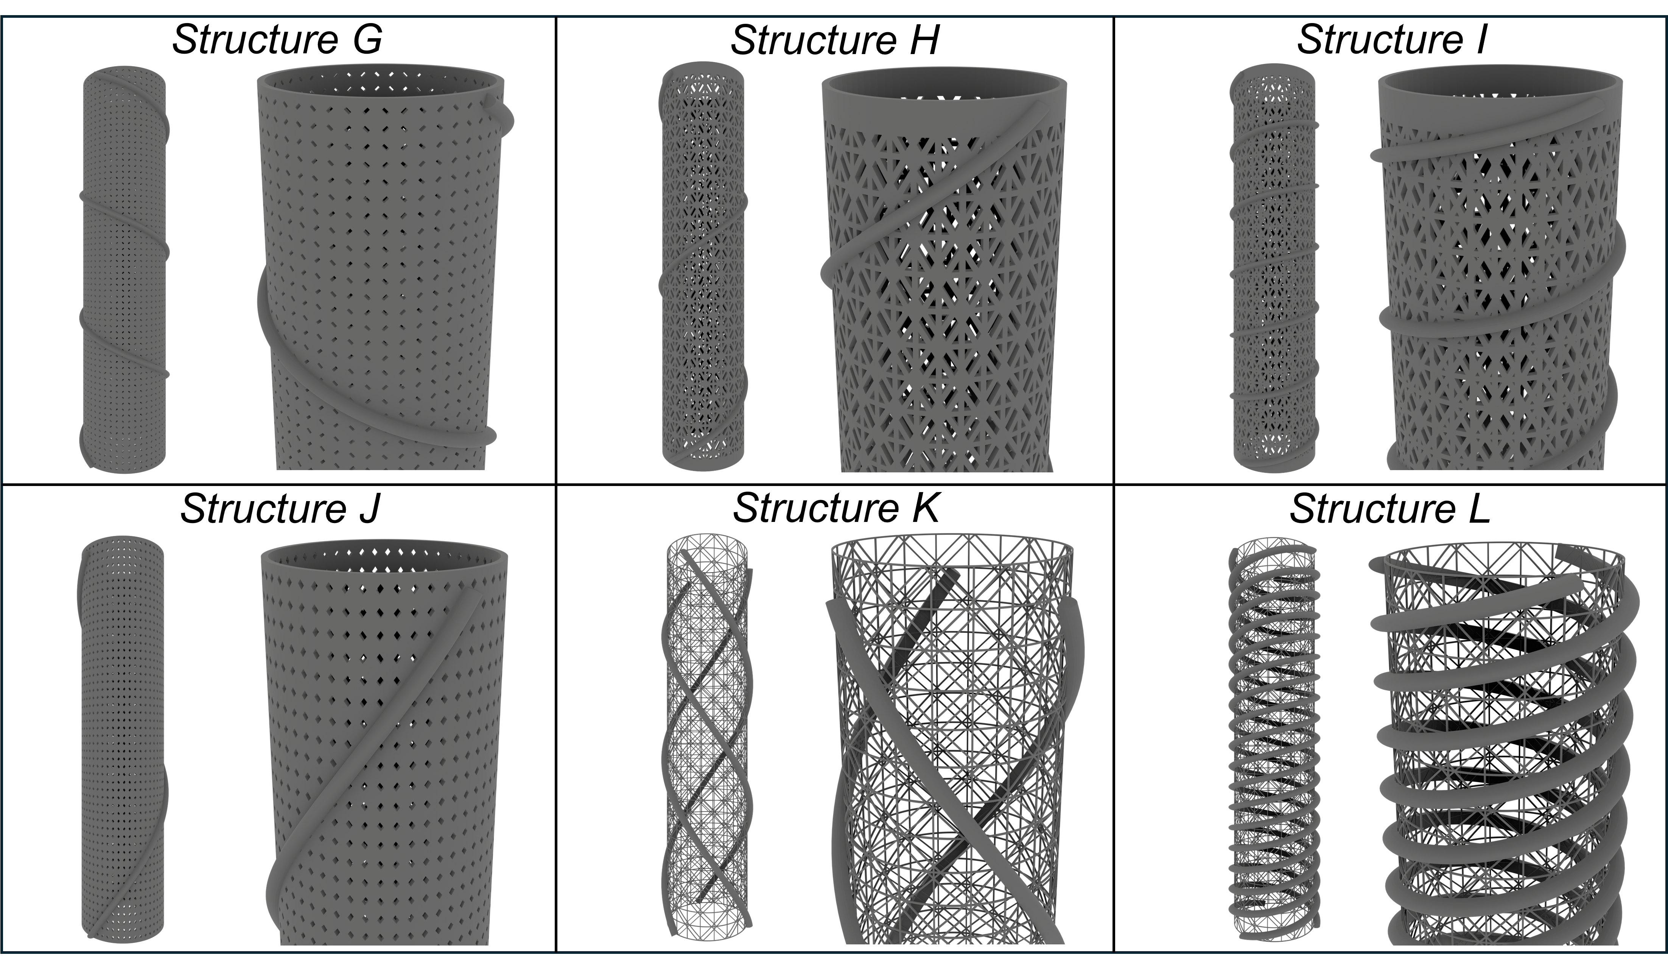
Fig S2: 3D renderings of Pareto-optimal designs G–L. These structures highlight diverse trade-offs between mechanical robustness and fluidic efficiency, as encoded in the optimization framework.
A full summary of the Pareto-optimal solutions is provided in Table S1, which lists the design ID, all eight geometric parameters, critical buckling load, structural volume, and the corresponding mechanical and fluidic cost values.
To illustrate how the optimization progressed, Supplementary Video 1 shows the geometries of all evaluated designs in chronological order. The animation highlights the algorithm’s search path. In addition, a Supplementary Data File is provided containing all 490 evaluated designs. The dataset includes the geometric parameters along with the computed mechanical and fluidic costs.
Table S1: Design parameters and performance metrics for all 12 Pareto-optimal solutions (A–L). Columns include the design ID, eight geometric parameters, critical buckling load, total structure volume, mechanical cost, and fluidic cost.
Optimum  Design | Design Parameters |  |  |  |  |  |  |  | Results
Optimum  Design | N_{V} | N_{C} | W  [mm] | H  [mm] | N_{L} | R_{H} [mm] | N_{CW} | N_{CCW} | Buckling Load [N] | Volume [mm³] | FEA Cost | CFD Cost
A | 50 | 73 | 0.62 | 0.64 | 6 | 1.28 | 3 | 3 | 1638.7 | 12959 | -2.83 | 0.32
B | 47 | 57 | 0.64 | 0.64 | 4 | 1.37 | 3 | 3 | 1370.7 | 11003 | -2.76 | -0.63
C | 49 | 56 | 0.63 | 0.64 | 4 | 1.54 | 3 | 0 | 1250.7 | 10173 | -2.7 | -0.93
D | 49 | 57 | 0.64 | 0.65 | 5 | 1.34 | 1 | 1 | 1187.4 | 9858 | -2.61 | -1.04
E | 48 | 62 | 0.59 | 0.65 | 4 | 1.58 | 0 | 3 | 1147.6 | 10019 | -2.39 | -1.06
F | 48 | 67 | 0.56 | 0.63 | 3 | 1.36 | 0 | 3 | 1007.6 | 9076 | -2.26 | -1.06
G | 46 | 69 | 0.63 | 0.64 | 3 | 1.42 | 1 | 0 | 1019.3 | 9544 | -2.1 | -1.07
H | 34 | 30 | 0.58 | 0.65 | 2 | 1.40 | 1 | 0 | 538.1 | 5294 | -1.91 | -1.07
I | 42 | 34 | 0.58 | 0.58 | 6 | 1.40 | 1 | 0 | 606.3 | 6118 | -1.82 | -1.12
J | 50 | 53 | 0.60 | 0.63 | 1 | 1.60 | 0 | 1 | 843.9 | 8714 | -1.73 | -1.14
K | 20 | 30 | 0.15 | 0.15 | 1 | 1.60 | 3 | 0 | 1.32 | 950 | 1.79 | -1.15
L | 20 | 30 | 0.15 | 0.15 | 6 | 1.60 | 0 | 3 | 1.95 | 2786 | 1.82 | -1.21
Finite Element Analysis (FEA) and Mechanical Testing
Mechanical performance of the sponge-inspired lattices was evaluated through FEA simulations in ANSYS® MAPDL 2024 R1, implemented in a fully parametric pipeline via PyMAPDL. This setup allowed automated geometry generation, meshing, loading, and execution within the optimization loop.
The geometry were modeled using Timoshenko beam elements (BEAM188). The geometry was built parametrically based on the 8 design parameters described in the main text. The simulation boundary conditions were applied to match the Instron compression experiments:
- The bottom nodes of the lattice were fixed in all directions (u_{x} = u_{y} = u_{z}= 0).
- The top nodes were constrained in the lateral directions (u_{x} = u_{y} = 0), while allowing vertical displacement (u_{z} free).
- For stiffness evaluation, a 1 mm vertical displacement was imposed on the top layer.
- For buckling simulations, a uniform compressive pressure was applied along the top surface.
Material properties were experimentally characterized using bulk-cured samples of the Anycubic Craftsman DLP resin. The resin was modeled as a linear elastic material with a Young’s modulus of E = 1.1 GPa and Poisson’s ratio ν = 0.49.
Two analysis types were conducted for each design:
- Static analysis to compute the effective axial stiffness under 1 mm displacement loading.
- Buckling analysis to extract the critical buckling load.
For selected Pareto-optimal designs, nonlinear buckling simulations were conducted to account for large deformations, geometric imperfections, and post-buckling behavior. Initial imperfections were introduced by scaling the first linear buckling mode, simulating manufacturing-induced flaws. These simulations yielded more accurate predictions of failure load and revealed stress redistribution patterns during collapse. A Python script used to generate geometries and run simulations is provided in the SI.
Harmonic Analysis
Harmonic FEA was performed for Designs A, D, H, and I to compare structural resonance with fluidic excitation frequencies. Simulations replicated SPIV boundary conditions: all nodes at the top and bottom surfaces were fixed in all directions. A unit radial force was applied at mid-height nodes in the circumferential (XY) direction. The frequency response was evaluated from 0–100 Hz in 0.1 Hz steps using the Harmonic Response module in MAPDL.
The displacement spectra showed the first significant resonance above 20 Hz (Figure 6, main manuscript), well above the vortex shedding frequencies of 0.85–1.1 Hz measured in CFD and SPIV. This spectral separation supports the assumption of negligible fluid–structure coupling in the optimization.
Experimental Testing and Validation
To validate the simulations, four Pareto-optimal structures (Designs A, D, H, and I) were fabricated using a high-resolution DLP printer with Craftsman resin. Each design was tested in quadruplicate under quasi-static uniaxial compression on an Instron testing system.
Axial stiffness (N/mm) and critical buckling load (N) were measured for each specimen and averaged across the four samples per design. Nonlinear FEA results were then compared to experiments by matching displacement and stress fields with failure locations recorded on video during testing. Snapshots from these recordings are shown in Figure S3, with full videos provided as Supplementary Videos 2–5.
In Figure S3, nonlinear FEA predictions (stress and displacement fields, as in Figure 4 of the main manuscript) are shown alongside experimental images for Designs A, D, H, and I. Insets highlight regions where buckling or localized deformation occurred. Across all four cases, the simulated peak displacement and stress regions closely matched experimentally observed failure locations.
Table S2 summarizes axial stiffness and buckling loads from both simulation and experiment. Deviations are within experimental uncertainty and are attributed to typical factors such as fabrication tolerances, resin shrinkage, or minor misalignments during testing. The close agreement across all four designs further confirms the robustness and reliability of the modeling approach.
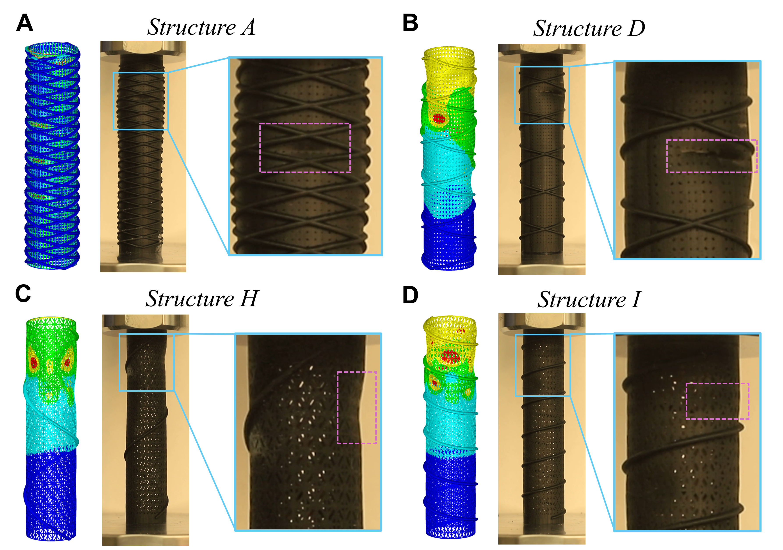
Fig. S3: Comparison of nonlinear FEA predictions and experimental failure observations for four fabricated sponge-inspired designs (A, D, H, I). Each panel shows the simulated stress or displacement field (left) alongside a snapshot from the compression test video (right). Insets in the experimental images highlight the locations of initial buckling or failure. These regions strongly correlate with zones of high displacement amplitude or stress in the FEA, validating the predictive accuracy of the nonlinear mechanical simulations.
Table S2: Comparison of Simulated and Experimental Mechanical Performance for Fabricated Designs. Axial stiffness and critical buckling load are reported for each of the four tested designs (A, D, H, I). FEA values were obtained from nonlinear simulations. Experimental values are reported as mean ± standard deviation across n = 4 specimens per design.
Optimum  Design | Axial Stiffness [N/mm] |  | Critical Buckling Load [N]
Optimum  Design | Nonlinear FEA | Experiments | Nonlinear FEA | Experiments
A | 405 | 423 ± 15 | 1505 | 1276 ± 21
D | 420 | 420 ± 55 | 970 | 1075 ± 121
H | 303 | 319 ± 22 | 502 | 608 ± 70
I | 330 | 341 ± 27 | 660 | 634 ±78
Computational Fluid Dynamics (CFD)
CFD simulations were performed with Basilisk ⁶, an open-source finite-volume solver for incompressible flows. Basilisk uses the Volume of Fluid (VOF) method to track fluid regions and interfaces, which ensures accurate advection around complex boundaries. Solid regions were imposed with the penalization method (Brinkman penalization), which enforces no-slip conditions by treating the solid as a porous region of vanishing permeability. All simulations during the optimization stage were performed at Reynolds number Re = 2100 (based on lattice diameter and inflow velocity) to replicate typical deep-sea flow conditions for Euplectella-inspired structures.
A key advantage of Basilisk is its octree-based adaptive mesh refinement (AMR), which dynamically refines the grid in regions requiring higher resolution. We leveraged AMR to efficiently resolve flow features around the fine lattice geometry. Near solid surfaces, within narrow pores of the lattice, and in regions of strong velocity gradients (shear layers and vortices), the mesh automatically subdivided to smaller cells. By contrast, in quiescent regions far from the structure, a coarser mesh was maintained to save computational cost. The domain was a cube of side length L = 12.5D (chosen to encompass the structure and its wake). During the optimization simulations, we allowed mesh refinement from a base resolution of $L/2^{8}$ up to a finest resolution of $L/2^{11}$. This corresponds to cell sizes ranging from approximately 0.05D down to 0.006D, fine enough to capture the thinnest beams and flow through the lattice pores. For the refined simulations of the selected optimum designs, we increased the resolution by two levels (smallest cell size $L/2^{13}$ ~ 0.0015D) and raised the base resolution (to $L/2^{10}$) to better resolve the incoming flow and far-field wake. This finest resolution is roughly five times smaller than the smallest pores and beams in the lattice. This grid resolution exceeds the mesh density reported in DNS studies of cylinder wakes at higher Reynolds numbers ⁷ and sufficiently resolves all dynamically relevant flow scales. Combined with AMR, this strategy captured features across multiple length scales, from thin boundary layers on sub-millimeter beams to large-scale wake vortices, while requiring far fewer cells than an equivalent uniform grid, keeping fully resolved simulations computationally feasible.
We applied different boundary condition strategies for the initial optimization runs versus the final high-fidelity simulations used to validate SPIV experiments:
Optimization phase: To minimize computational cost during optimization (Figure S4), we employed a simplified boundary condition setup. A steady inflow velocity was imposed on the left boundary, and an outlet was defined downstream on the right. All other domain boundaries, including top, bottom, and lateral directions, were treated as periodic. This configuration effectively mimics an unbounded domain while allowing for a compact simulation setup.
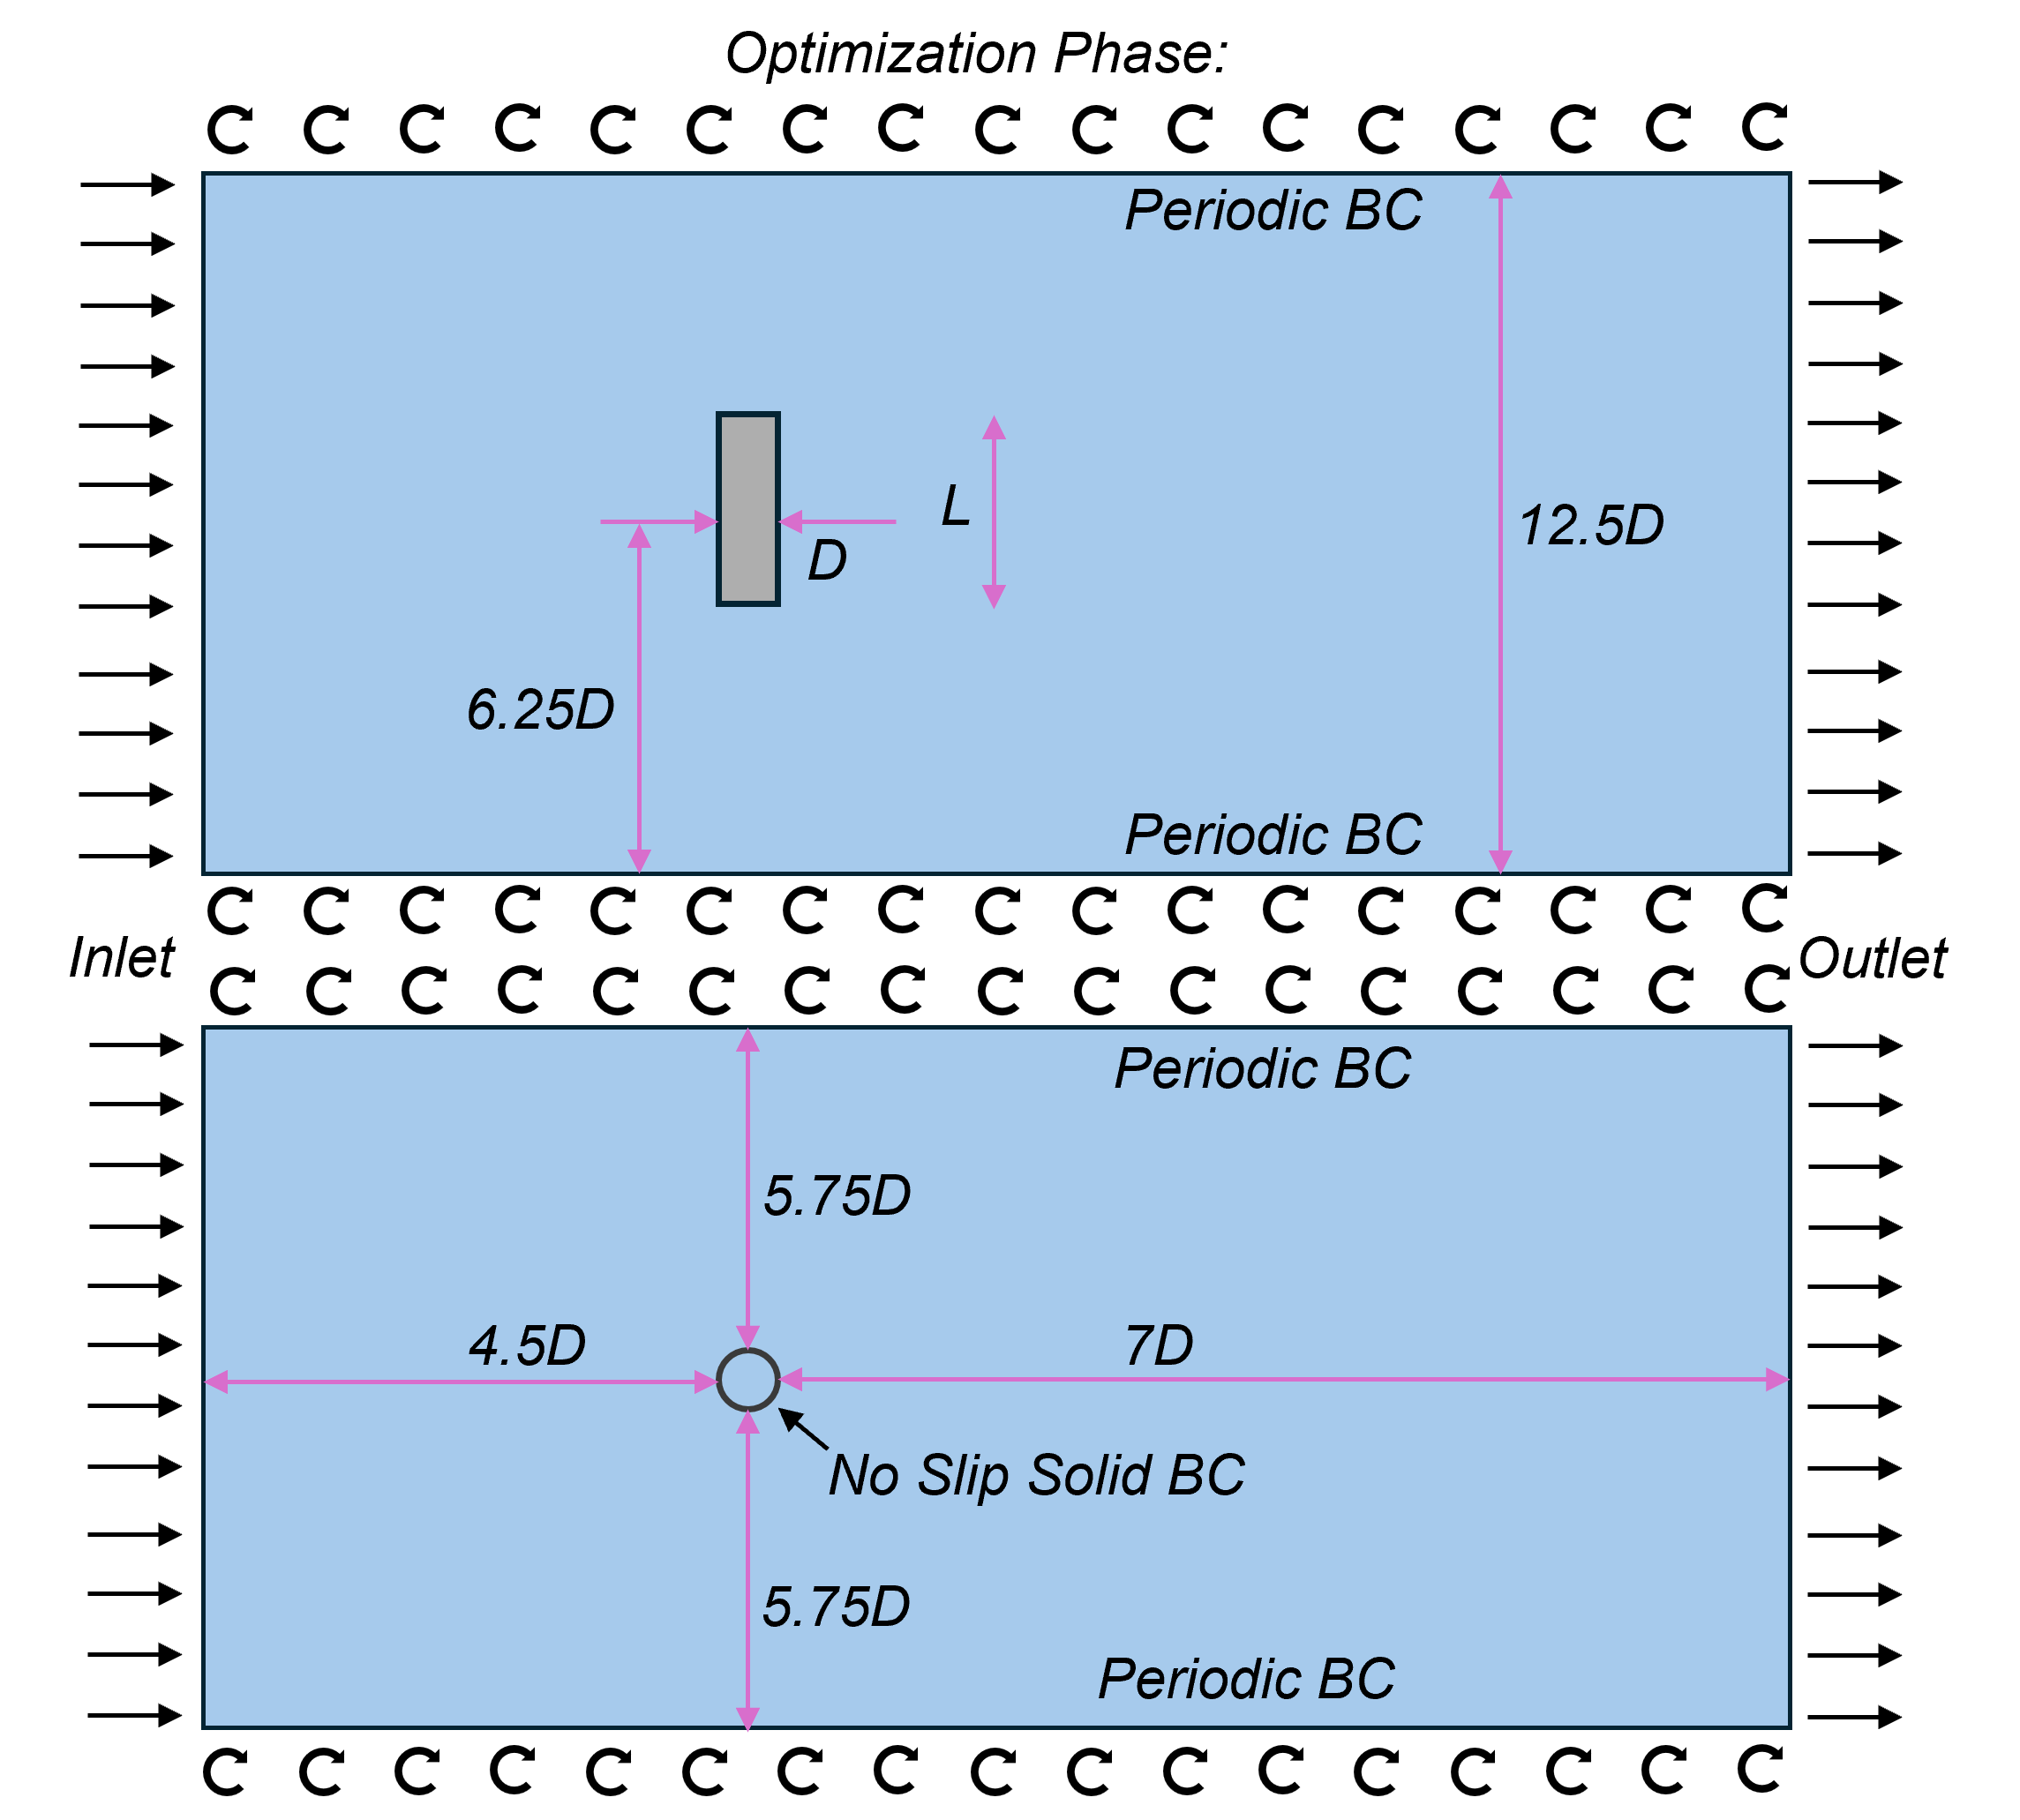
Fig S4: Optimization phase, fluid dynamic analysis: Domain and boundary conditions used for VoF simulations. Periodic boundary conditions are used along the cylinder during the optimization phase.
Experimental Validation Phase: For high-fidelity simulations of the solid cylinder and optimized designs A, D, H, and I (Figure S5), we applied realistic open-channel conditions to enable comparison with experimental SPIV data. The upstream boundary (left) was set as an inflow with a uniform velocity profile, while the downstream boundary (right) was an outflow with a zero-pressure-gradient (Neumann) condition to approximate convective exit flow and minimize reflection artifacts. The top and bottom boundaries were modeled as no-slip walls (rigid lids), simulating a confined channel with stationary upper and lower surfaces. While the SPIV experiments used a water tunnel with no-slip walls in both vertical and lateral directions, we applied periodic boundary conditions laterally to reduce computational cost. This choice introduces a slight deviation from the experimental setup but is not expected to significantly impact the near-field flow dynamics or vortex shedding behavior of interest.
All simulations assumed incompressible flow with constant fluid properties. The flow was initialized from rest at t = 0, and an impulsive start was applied by immediately setting the velocity to its target value. This approach introduced initial transients, which were allowed to dissipate before data collection began. Each case was then simulated until t = 200 (in nondimensional time units based on inflow velocity and lattice diameter), long enough for the flow to reach a quasi steady state or periodic shedding regime. We recorded flow field snapshots and force data throughout the simulation after an initial transient period (~50 time units) to analyze the established force and flow patterns.
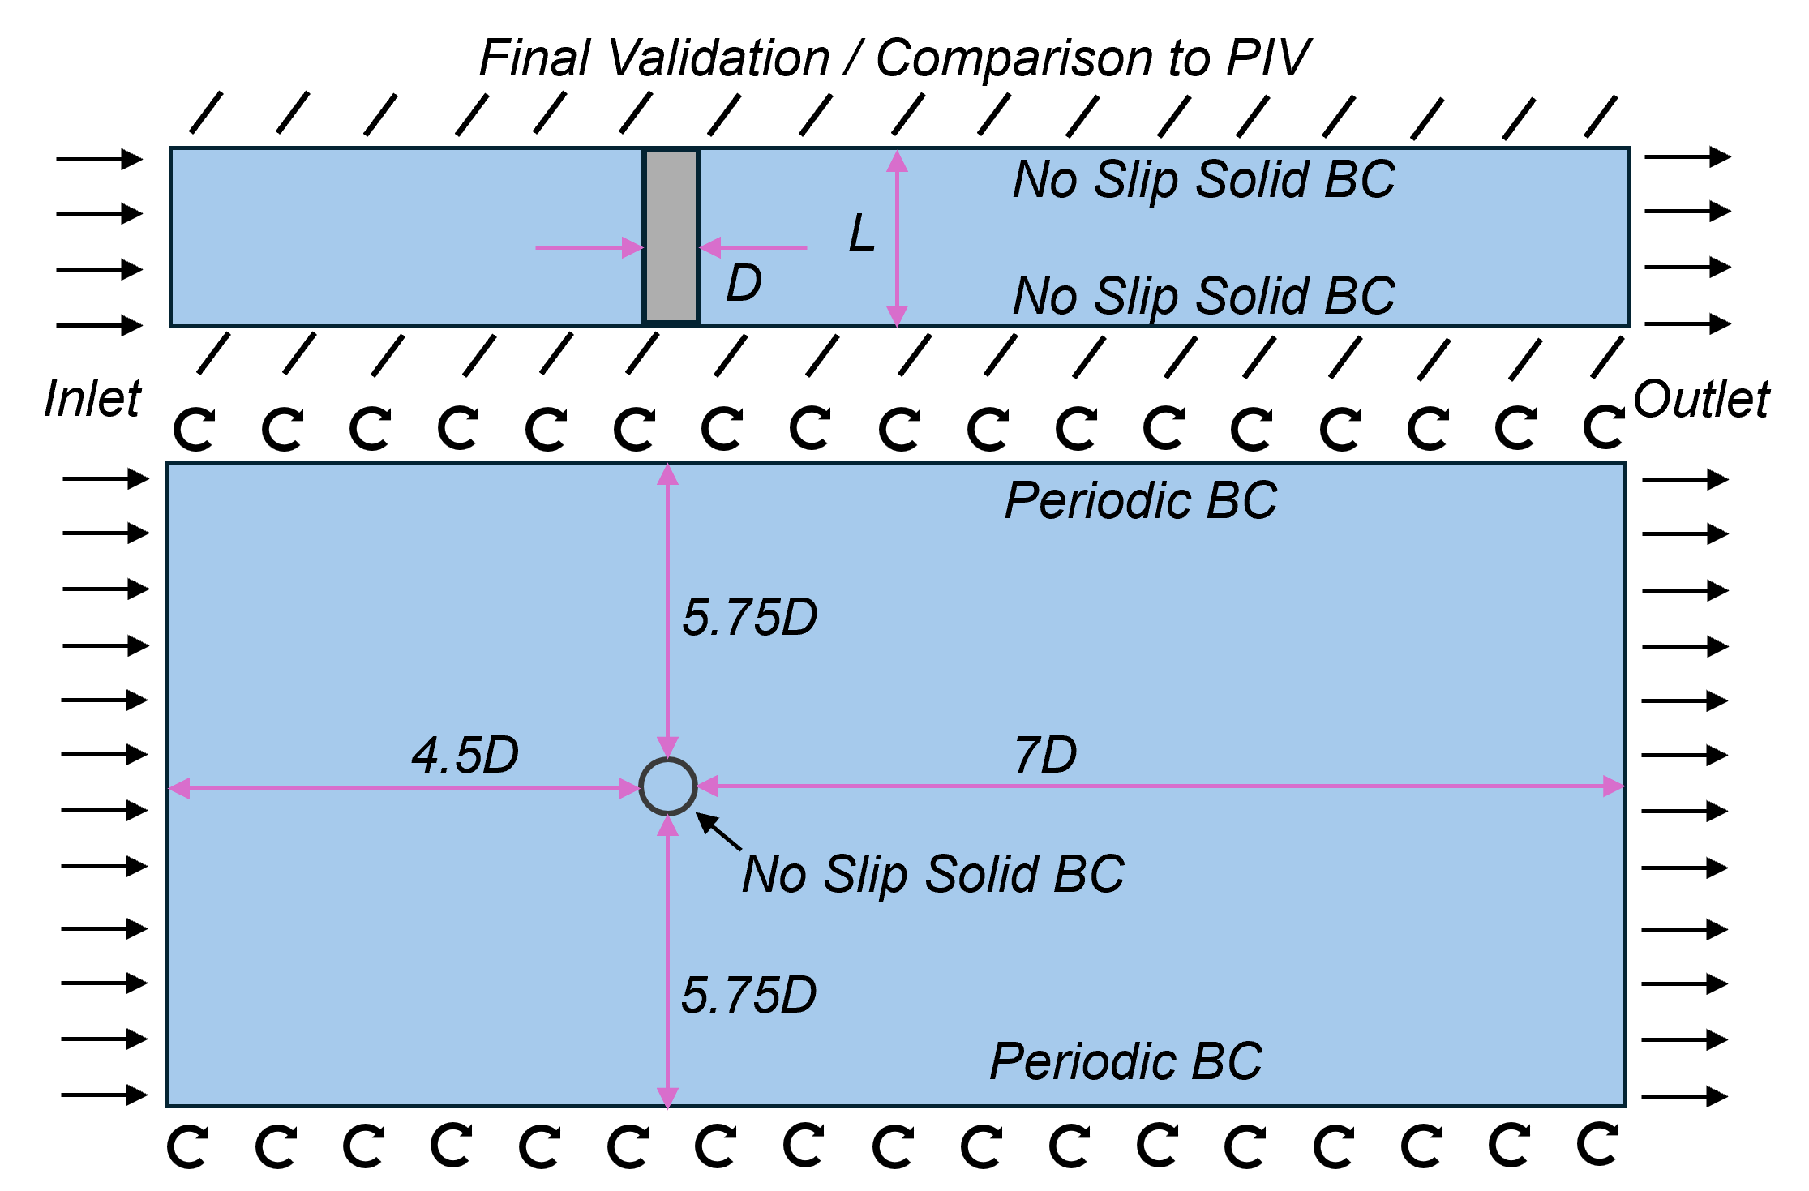
Fig S5: Final Validation, fluid dynamic analysis: Domain and boundary conditions used for VoF simulations. No slip solid boundary conditions are used along the cylinder axes during final stage to compare results to experimental SPIV data.
Hydrodynamic Benchmarking and Validation of the Solid Cylinder
Before analyzing the performance of the optimized sponge-inspired structures, we validated our numerical approach by simulating flow around a solid circular cylinder at Reynolds number $Re=2100$, representative of our experimental conditions. This benchmark case serves to confirm the fidelity of our numerical setup, mesh resolution, and force computation routines.
Figure S6 summarizes the hydrodynamic response of the solid cylinder. Figure S6A and B show the time evolution of drag and lift coefficients after the flow reaches a quasi-steady state. The lift coefficient exhibits clear periodic oscillations, indicative of vortex shedding. The power spectral density (PSD) of the lift signal (Figure S6C) identifies a dominant shedding frequency near 0.9 Hz, which corresponds to a Strouhal number of $St=\frac{fD}{U_{0}}≈0.21$, where $f$ is the shedding frequency, $D$ is the cylinder diameter, and $U_{0}$ is the free-stream velocity. This value is consistent with literature data for circular cylinders at similar Reynolds numbers ¹. The time-averaged drag coefficient obtained from our simulations was approximately $c_{D}≈0.99,$ also in excellent agreement with established reference values for a smooth circular cylinder at Re∼2100 ⁸, where drag coefficients are typically reported in the range of 0.9 – 1.1. Figure 6D and E compare our computed drag and Strouhal number with empirical curves from literature ^{1,8}, showing strong agreement across both metrics. This validates the simulation framework and provides a solid reference point for evaluating the hydrodynamic improvements of the optimized designs.
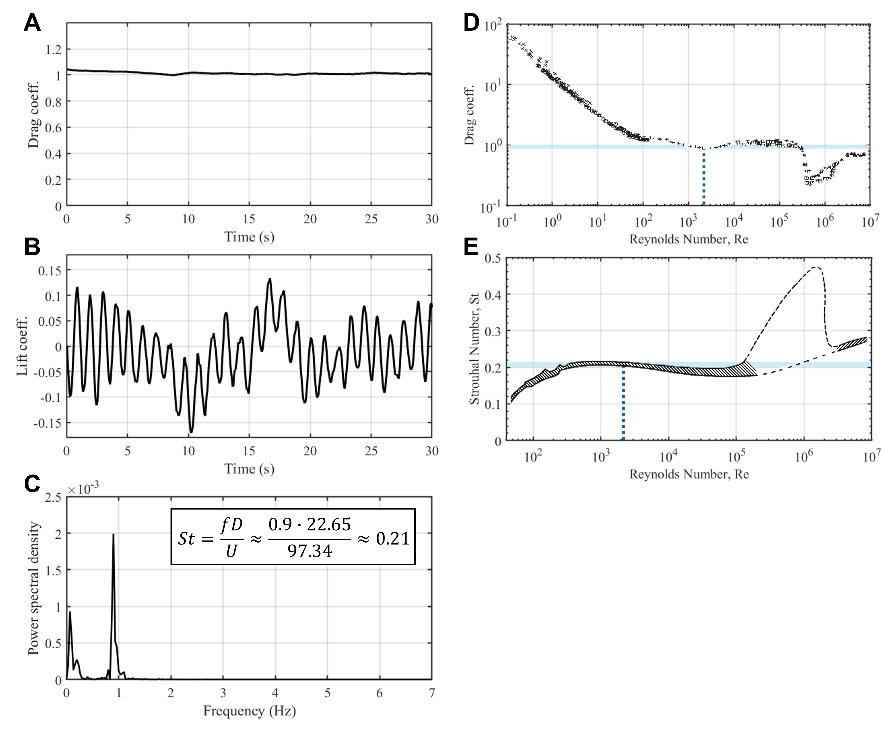
Fig S6: Hydrodynamic validation of the solid circular cylinder at Re≈2100. (a) Time-resolved drag coefficient after reaching quasi-steady-state conditions. (b) Corresponding lift coefficient showing periodic vortex shedding. (c) Power spectral density of the lift coefficient, indicating a dominant shedding frequency around 0.9 Hz, from which a Strouhal number of St≈0.21 is calculated. (d) Recreated plot of drag coefficient versus Reynolds number from Panton ⁸, showing close agreement with the simulated time-averaged drag coefficient ($c_{D}≈0.99$). (e) Recreated plot of Strouhal number versus Reynolds number for circular cylinders from Lienhard ¹, confirming strong agreement with the computed value. Together, these results validate the accuracy of the simulation framework and establish a reliable baseline for assessing the performance of optimized porous designs.
Flow Visualization and Analysis
To interpret the results, we post-processed the 3D flow data using ParaView. Flow structures were visualized by extracting iso-surfaces and planar slices of velocity and vorticity fields. We also examined cross-sectional slices through the lattice to see how the flow penetrates the interior. Figure S7 shows a representative vertical slice (through the center axis) of the vorticity field for the solid cylinder and the optimized designs A, D, H, and I at Reynolds number Re≈2100, corresponding to experimental SPIV conditions. These cross-sections reveal design-specific flow behavior, highlighting differences in how each structure guides the fluid.
The optimized structures show a clear suppression of early vortex shedding compared to the solid cylinder. Vortical structures are weaker, more dispersed, and originate further downstream, resulting in reduced wake unsteadiness and more stable flow patterns. In contrast, the solid cylinder generates strong, coherent vortices immediately behind its surface, typical of classical bluff body flow at this Reynolds number.
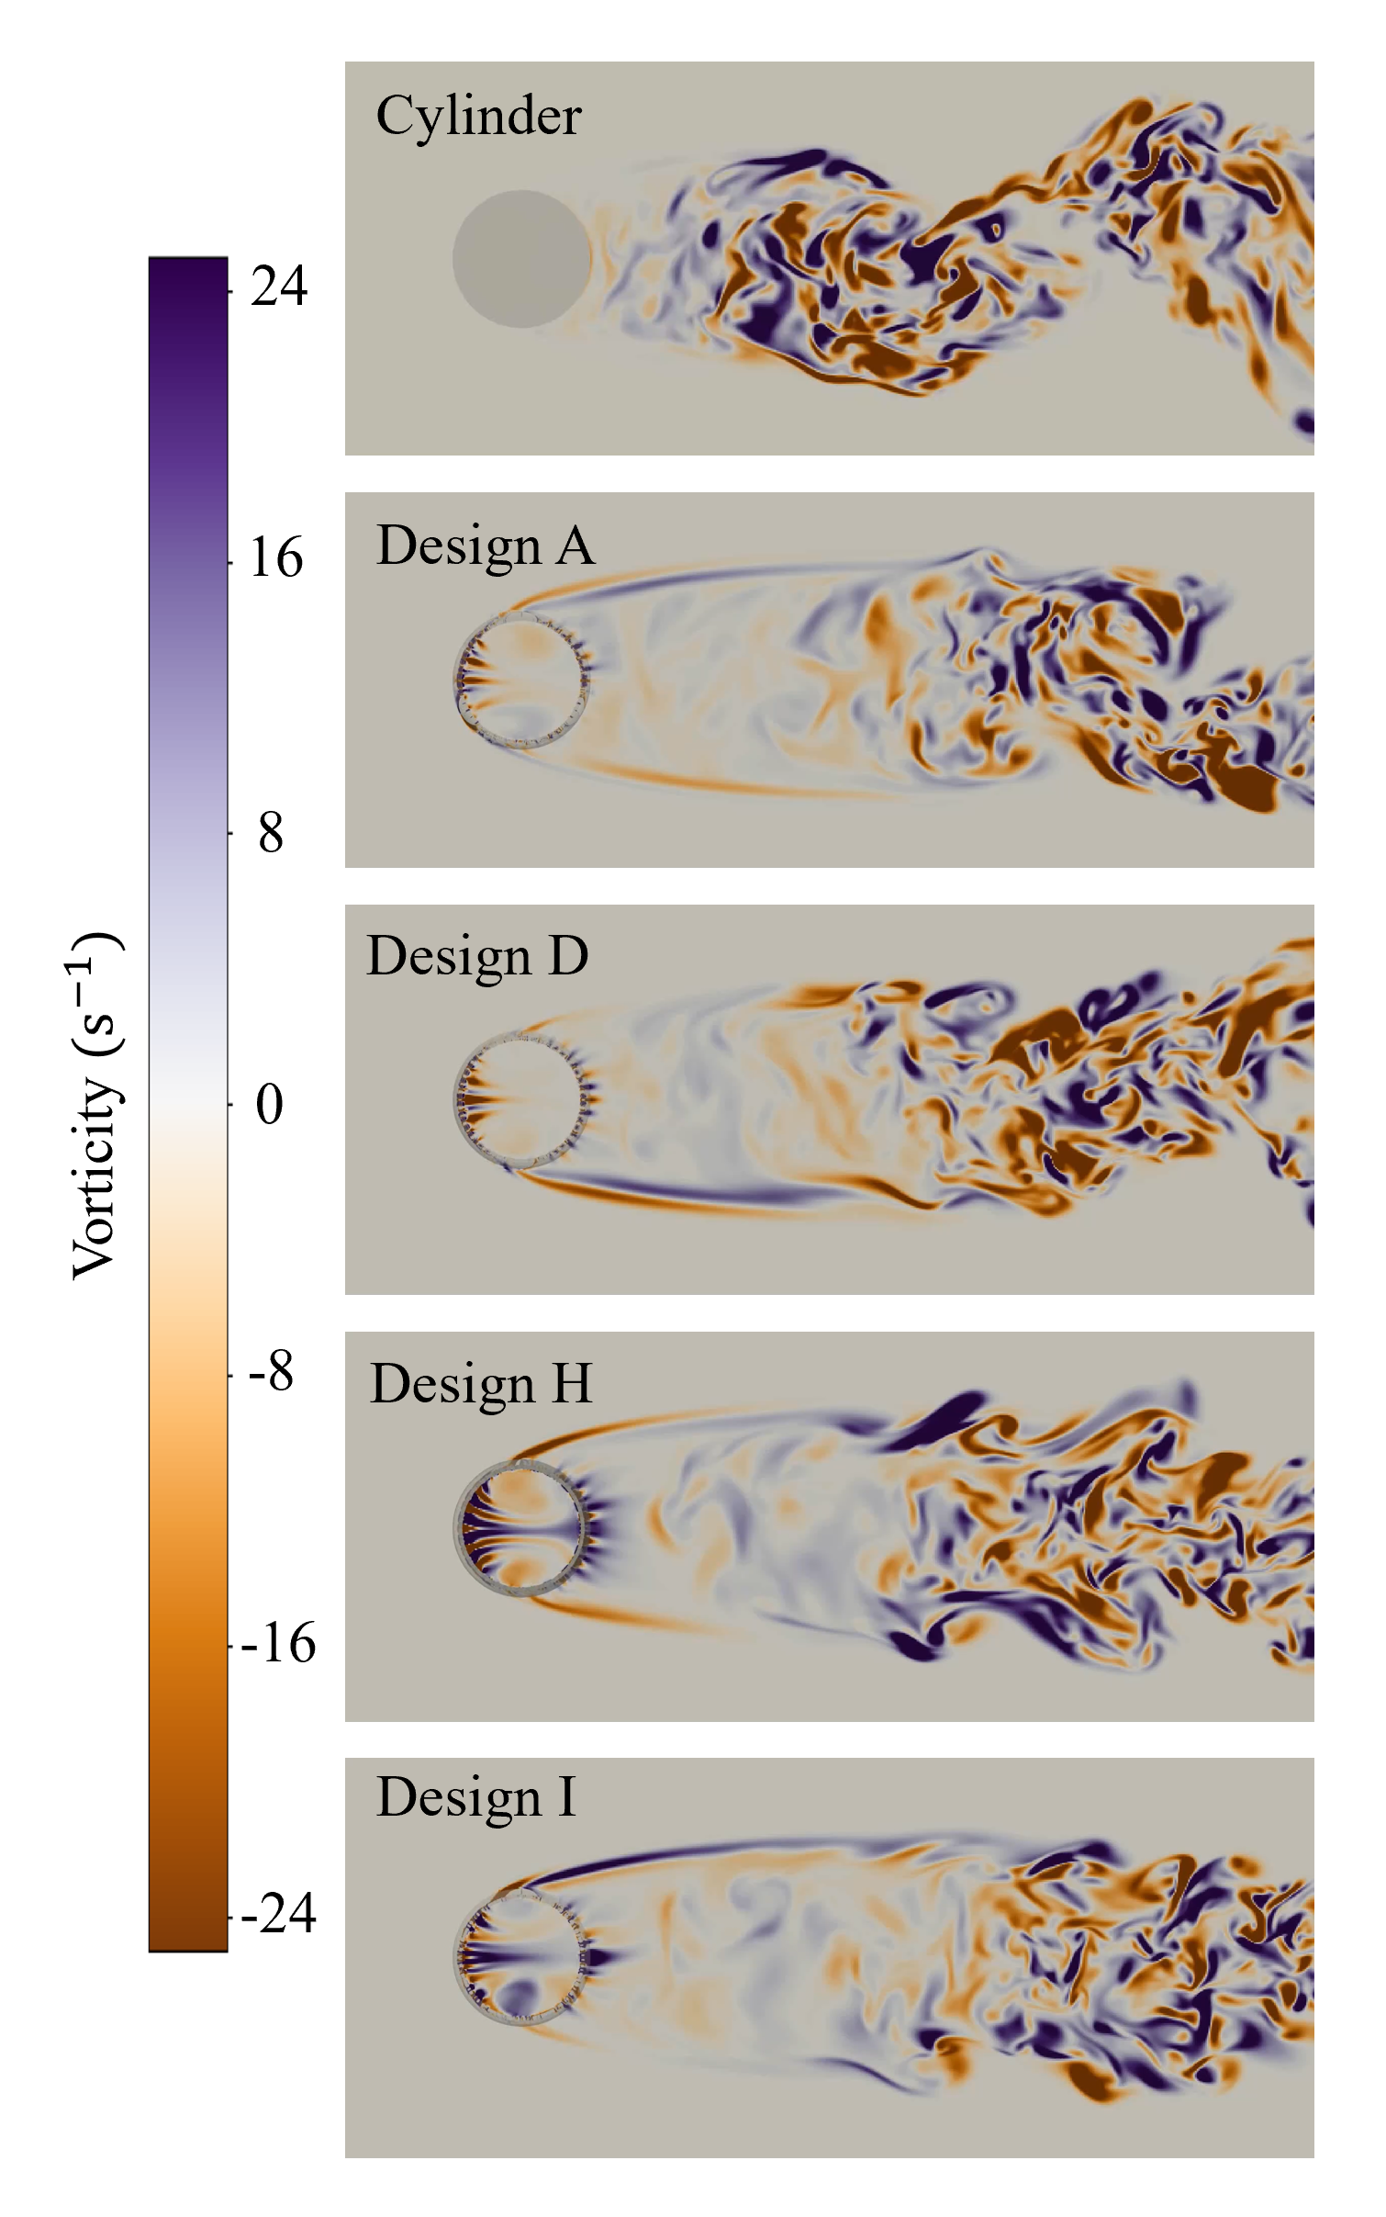
Fig S7: Cross-sectional view of vorticity flow through cylinder and sponge-inspired designs A, D, H, and I at Reynolds number ≈ 2100, representative of SPIV evaluation conditions. Vertical slices through the center axis reveal how each geometry influences flow behavior. The optimized designs exhibit clean flow penetration with minimal near-field vortex formation, redirecting vorticity further downstream and indicating effective flow guidance through their porous architecture.
Figure S8 further illustrates these differences using horizontal mid-plane slices of vorticity magnitude. These top-down views capture the spatial organization of the wake, showing how the optimized designs alter the strength, position, and coherence of shed vortices. Flow through the porous networks is visible, and the onset of vortex shedding is consistently delayed relative to the solid cylinder.
To complement these static visualizations, we provide Supplementary Videos 6 and 7 showing time-resolved vorticity fields for all five designs. These videos offer a dynamic view of the vortex formation and shedding processes, illustrating the reduced and delayed vorticity evolution in the optimized structures. The complete code, along with documentation and execution scripts, is available at https://github.com/cselab/sponge.
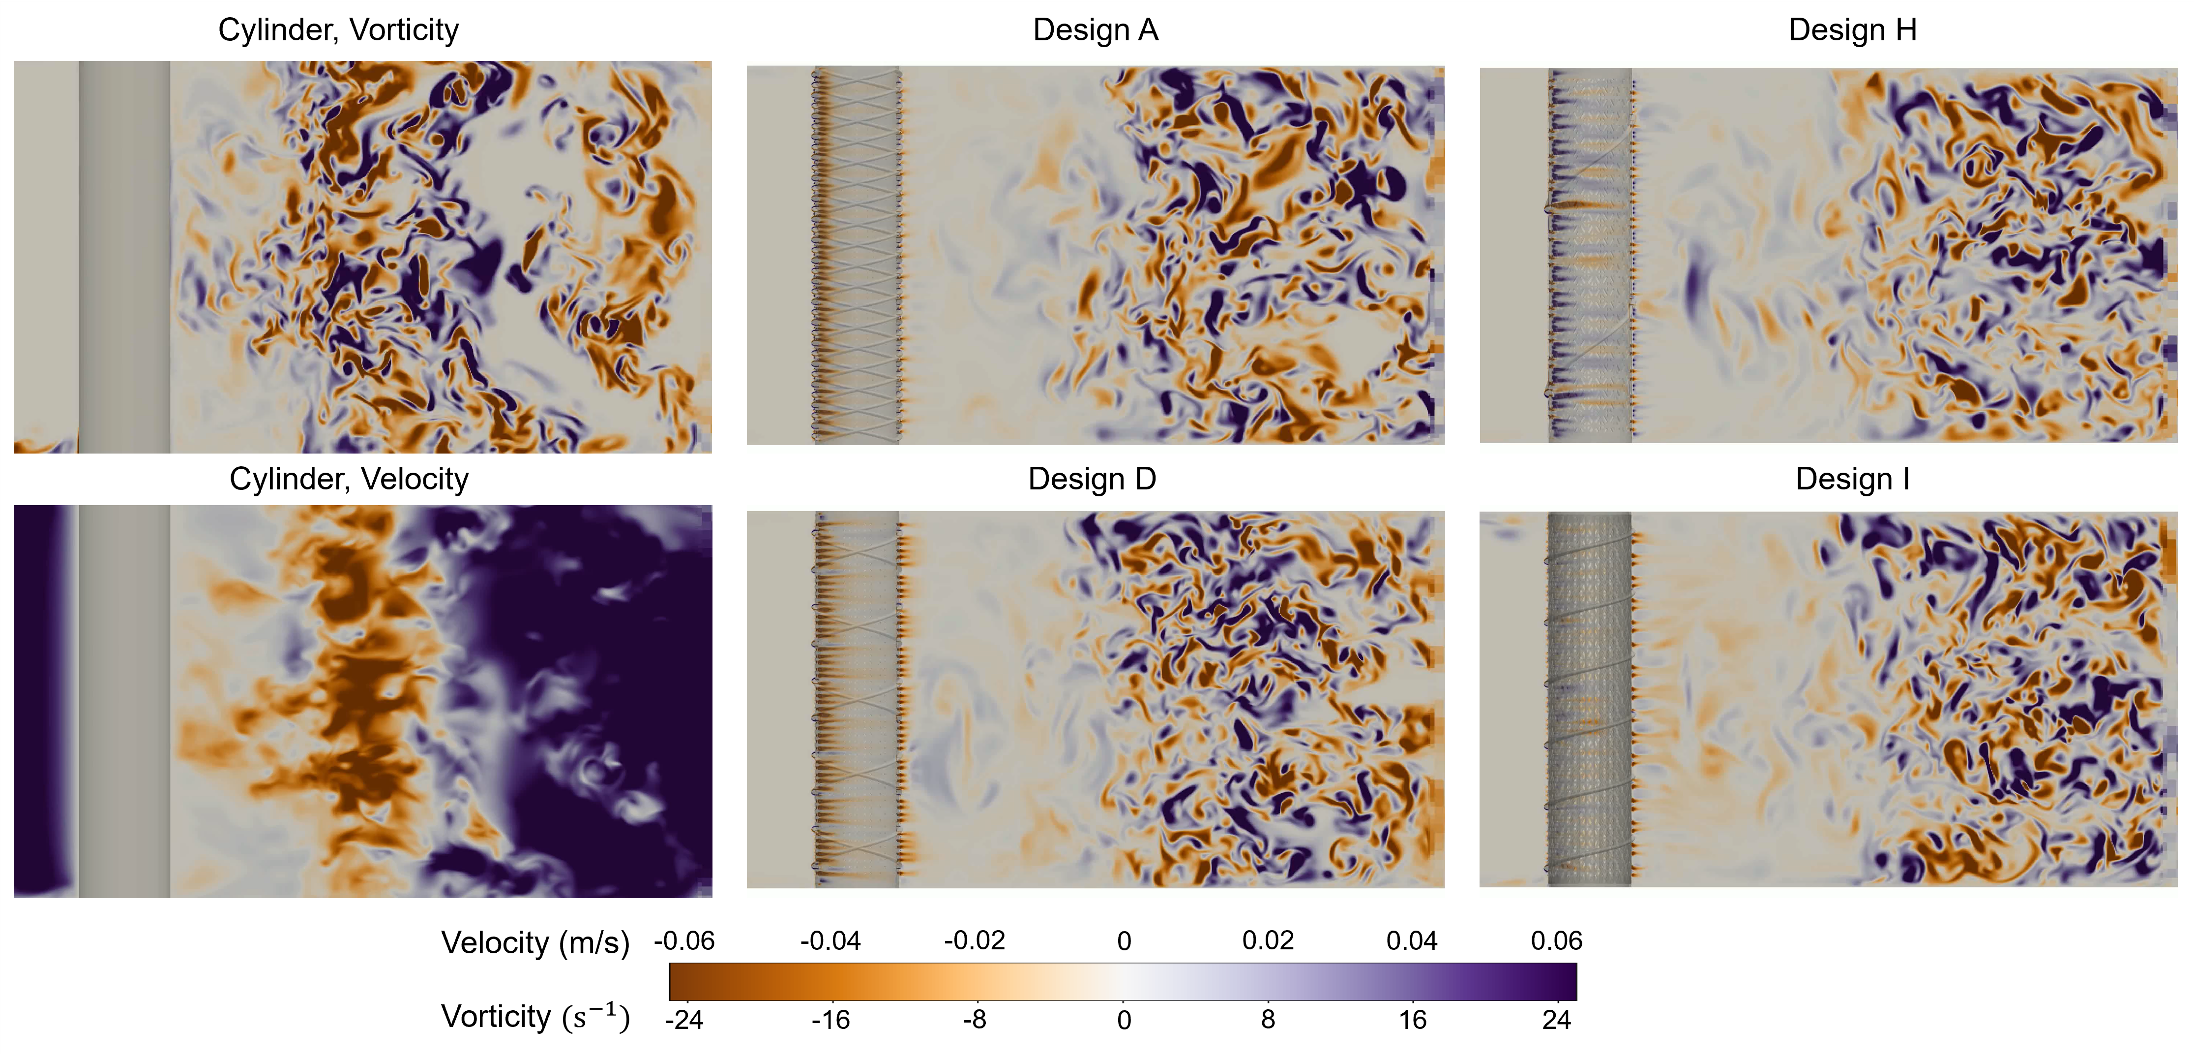
Fig S8: Top-down vorticity fields at mid-height for the solid cylinder and optimized designs A, D, H, and I at Re ≈ 2100. The porous designs exhibit flow-through behavior and delayed vortex shedding, with weakened and downstream-displaced vortices compared to the intense near-field shedding observed behind the solid cylinder.
SPIV Measurements and Flow Loop Setup
To characterize the fluidic performance of the optimized sponge-inspired designs, Stereo Particle Image Velocimetry (SPIV) was used to measure flow behavior in the wake region, focusing on vortex shedding, flow stability, and drag reduction. Experiments were conducted in a vertical recirculating water tunnel, with the setup schematically shown in Figure S9.
The sponge samples were mounted 4.5 diameters downstream of a 5th order polynomial contraction and flow straightener to ensure a uniform inlet velocity profile. Flow rate was regulated using a 2.5-inch ball valve and variable frequency drive (VFD) and monitored in real-time via a Coriolis flowmeter. This resulted in flow steady within 1% with a nominally top-hat profile. A dual-cavity Nd:YAG laser generated a planar laser sheet aligned 4.76 mm off the sample centerline, illuminating the wake region. The flow was seeded with Potters 110P8 hollow glass microspheres (5–25 µm) to serve as tracer particles.
A pair of FlowMaster Imager ProX 1600 × 1200 pixel cameras with Scheimpflug adapters were arranged in a stereoscopic configuration to capture 3D velocity data in a vertical plane extending from the rear of the sample to 2–3 diameters downstream. Image pairs were recorded at 14 Hz for 40 seconds per test case.
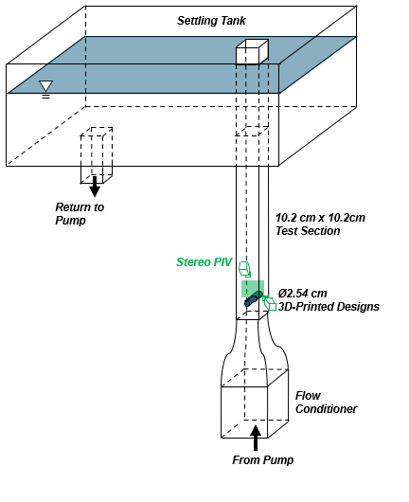
Fig S9: Schematic of the vertical flow loop and Stereo SPIV imaging system. The setup includes a flow conditioner, test section, and stereo camera configuration. A dual-cavity laser sheet intersects the wake region, and high-speed cameras record tracer motion for velocity reconstruction and CFD validation.
Figure S10 highlights the SPIV measurement region. The left panel shows a representative CFD snapshot of the flow around a solid cylinder at the center plane, with the SPIV domain overlaid. The right panel presents a sample velocity field visualization, with streamlines and velocity magnitude illustrating the resolved flow dynamics in the wake region. Velocity fields were reconstructed using LaVision DaVis 7.2 software via a multi-pass cross-correlation algorithm, with a final interrogation window of 32 × 32 pixels with 50% overlap, corresponding to a 0.8 mm spatial resolution. In addition, custom Python and MATLAB scripts were used to further analyze the SPIV raw data.
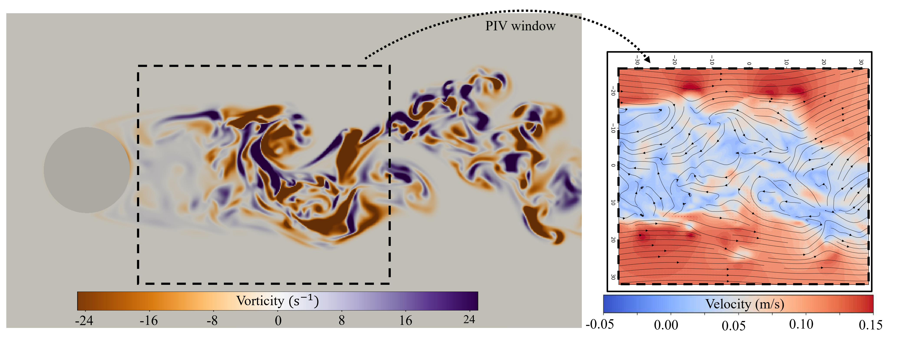
Fig S10: Schematic of the SPIV measurement domain: The flow direction is from left to right. The left side shows a representative frame from CFD simulations for a solid cylinder with a dotted boxed indicating the SPIV measurement domain. The right side shows an exemplary visualization of the velocity fields including streamlines. The background is color coded by velocity with arrows indicating XY flow direction.
To directly compare experimental and simulated flow fields, we extracted the corresponding velocity data from the CFD simulations within the same spatial domain as the SPIV measurement window. This enabled side-by-side visual comparisons and allowed for direct overlays of experimental and numerical results, facilitating validation and deeper interpretation of the wake dynamics behind each design.
Figure S11 shows representative velocity field comparisons for the four optimized designs (A, D, H, and I). In each panel, velocity magnitude is shown as the background color, with vectors and streamlines overlaid to illustrate local flow direction and structure. The flow direction is upward, corresponding to the positive Y axis. Supplementary Videos 8–11 provide time-resolved comparisons between SPIV and CFD velocity fields, offering a dynamic view of wake evolution and vortex shedding.
Overall, velocity magnitudes match well in both spatial distribution and amplitude, confirming that the simulations capture the dominant flow structures and bulk transport observed experimentally. For all four designs, the extent and shape of the wake, as well as streamline orientations, are consistent across both datasets. However, some differences become apparent upon inspection of the time-resolved velocity field videos. In particular, vortex shedding appears more pronounced in the SPIV measurements, with vortices forming and detaching approximately 1 - 1.5-cylinder diameters closer to the structure compared to the CFD results. In the simulations, the onset of shedding is further downstream and, in some cases, partially outside the SPIV field of view. This discrepancy can be attributed to several factors inherent to experimental conditions: surface roughness introduced during sample fabrication may trigger earlier flow separation in physical tests; the finite size of the seeding particles (5–25 µm) may restrict their ability to fully enter and track flow within smaller pores, which were as small as 150 µm. Furthermore, near-wall boundary layers were more pronounced in the SPIV setup due to interaction with the tunnel walls, whereas the CFD simulations used periodic boundary conditions on the side walls to reduce computational expense as previously described. Despite these differences, the overall dynamics and flow trends are well captured.

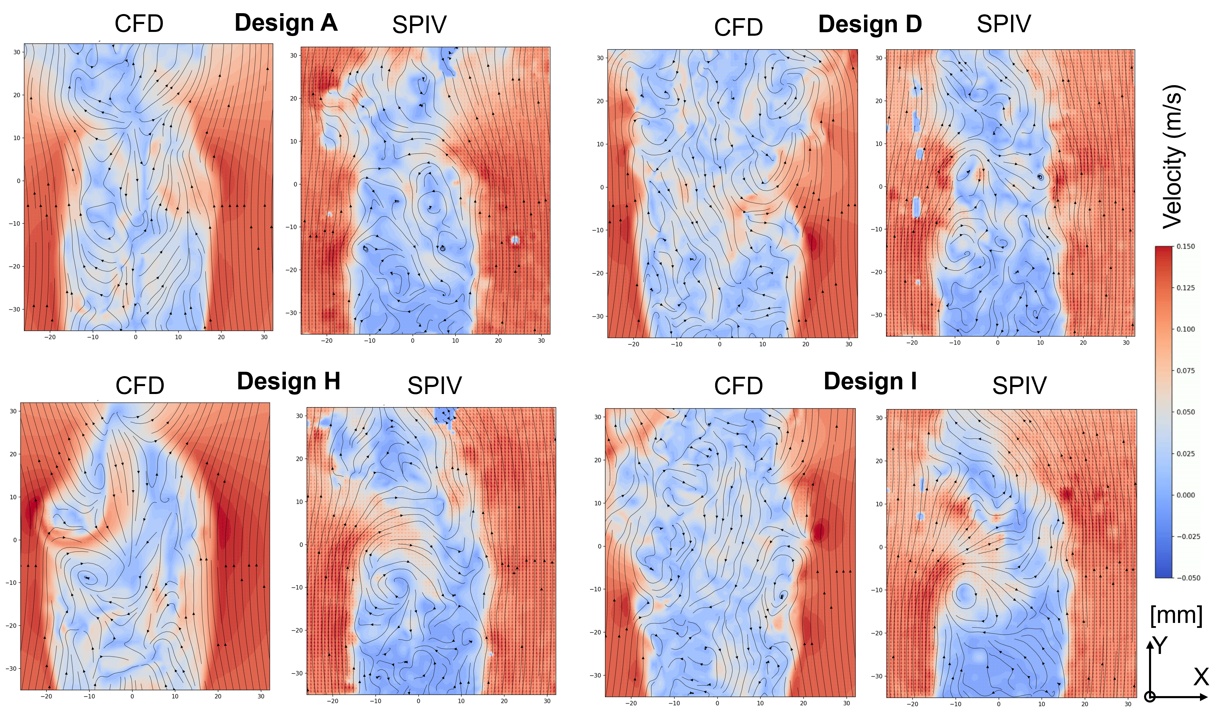
Figure S11: Time-matched velocity fields obtained from CFD (left) and SPIV (right) for optimized designs A, D, H, and I at Reynolds number ≈ 2100. Flow is directed upward along the positive Y axis, while transverse (lift) velocities act along the x axis. Each panel shows the same spatial domain, with velocity magnitude mapped as the background color and overlaid vectors and streamlines indicating flow direction and structure. Supplementary Videos 8–11 provide time-resolved comparisons for all four designs.
To complement the instantaneous snapshots in Figure S11, we include side-by-side comparisons of flow statistics aggregated over time for the same spatial domain and designs (A, D, H, and I). Figure S12 shows time-averaged velocity magnitude fields from CFD (left) and SPIV (right), using the same color scheme and spatial domain as Figure S11. The mean-flow fields agree in wake shape and width across the designs. In the SPIV data, the more fluidic-optimized designs (H and I) show vortex formation beginning further downstream compared to the mechanically optimized designs (A and D). This delayed vortex organization is consistent with the reduced force fluctuations of designs H and I reported in Figure 5 of the main manuscript. In the CFD results, the wake extends further downstream, with part of the coherent structures lying outside the plotted field of view.
Figure S13 presents maps of turbulence kinetic energy (TKE) for the four optimized designs between CFD and SPIV. High-TKE regions correspond to shear layers and the vortex street. In the solid-cylinder wake, time-averaged TKE was about 50% higher and peaked roughly one diameter closer to the body compared to the optimized designs. CFD predicted an even more pronounced downstream shift than observed in SPIV.

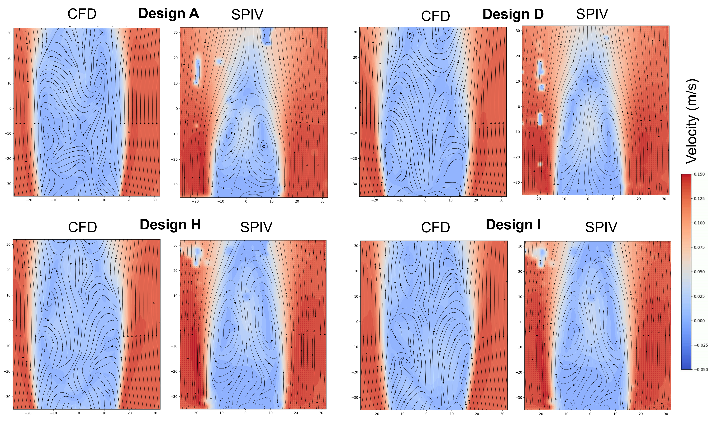
Figure S12: Time averaged velocity fields obtained from CFD (left) and SPIV (right) for optimized designs A, D, H, and I at Reynolds number ≈ 2100. Each panel displays the same spatial domain with background color indicating time averaged velocity magnitude.

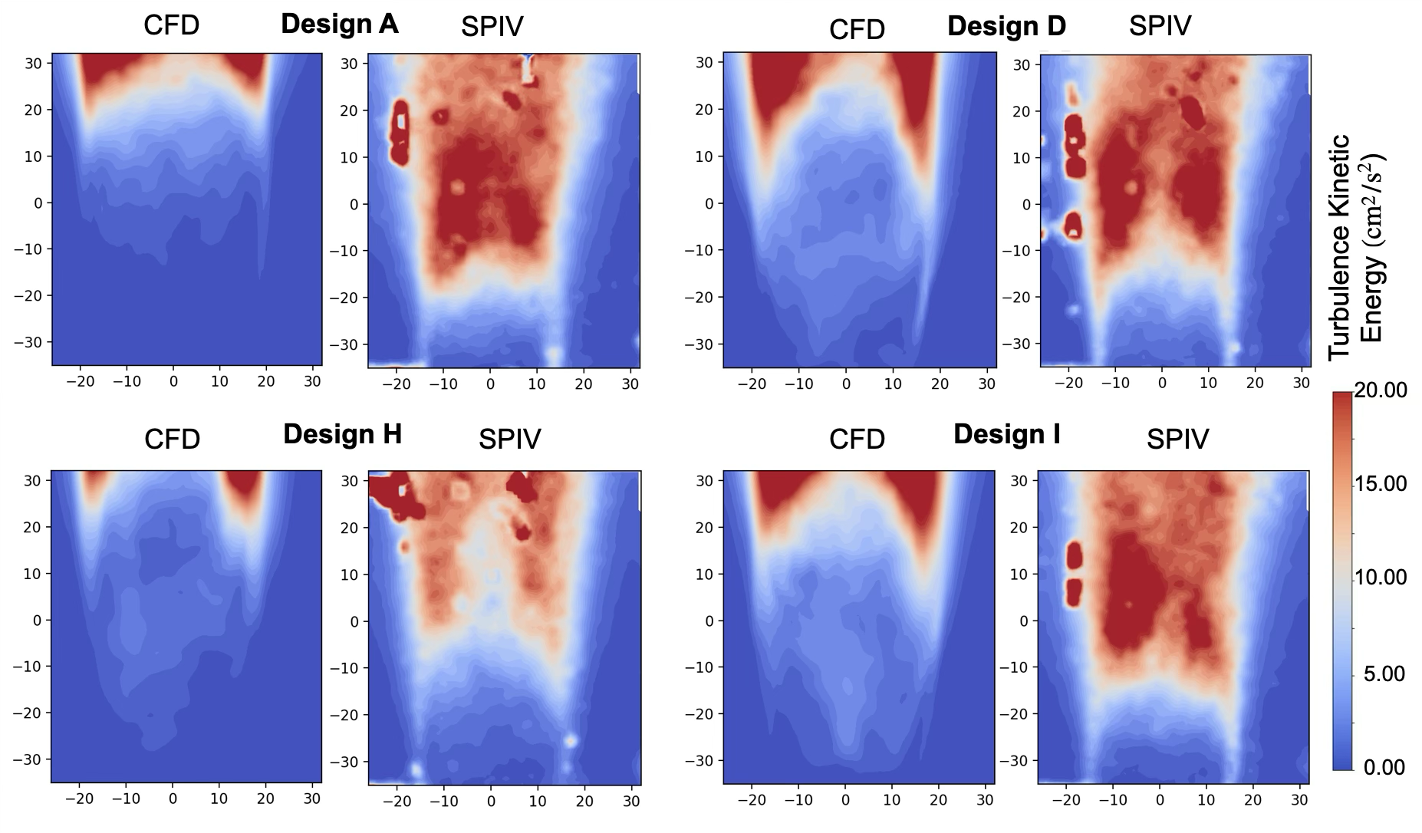
Figure S13: Turbulence kinetic energy fields obtained from CFD (left) and SPIV (right) for optimized designs A, D, H, and I at Reynolds number ≈ 2100. Each panel displays the same spatial domain with background color indicating turbulence kinetic energy fields.
To further assess agreement between simulation and experiment, Figure S14 provides quantitative comparisons of two wake metrics across all designs. Figure S14A shows the dominant vortex shedding frequencies obtained from FFT analysis of the velocity signals in the wake. For CFD, including the solid cylinder, the peak frequencies lie between 0.85 and 0.95 Hz. The corresponding SPIV peaks fall slightly higher, between 1.00 and 1.10 Hz. These values correspond to Strouhal numbers ranging from 0.20 (lowest in CFD) to 0.25 (highest in SPIV). The observed shift is within expectations when considering that: (i) the SPIV sampling rate results in a frequency bin width of 0.1 Hz, which limits precision in peak detection; (ii) small differences in the effective reference velocity and diameter between CFD and experiment can shift the calculated Strouhal number; and (iii) physical effects such as blockage, wall interactions, and geometric imperfections in the fabricated samples can promote earlier vortex formation and slightly higher shedding frequencies in SPIV.
Figure S14B compares the mean transverse velocity component in the wake, denoted $v_{x}$​. Here we use the coordinate system introduced in Figure S11, where the bulk flow direction is upward along $+y$ and the transverse (lift) direction is along $x$. The comparison region is centered on the structure in $x$ and located downstream in $y$, where vorticity is strongest. SPIV measurements report slightly elevated $v_{x}$ values, on average 0.011 m/s higher than CFD. This is consistent with the more pronounced vortex shedding observed in the SPIV videos and can be explained by real-world effects such as tunnel wall influence, imperfect structural symmetry, or surface roughness from fabrication. In addition, the seeding particles used for SPIV (5–25 µm) are relatively large compared to the smallest lattice pores (~150 µm), and the bigger particles may not fully follow global flow within these regions. Such effects could bias local velocity measurements and contribute to the slightly stronger vortex shedding observed in SPIV relative to CFD. Importantly, relative to the solid cylinder, both CFD and SPIV show that the optimized designs reduce the transverse wake velocity $v_{x}$​ by a factor of roughly 3–5. This suppression of wake dynamics highlights the effectiveness of the design optimization process in reducing unsteady forces and enhancing flow stability.
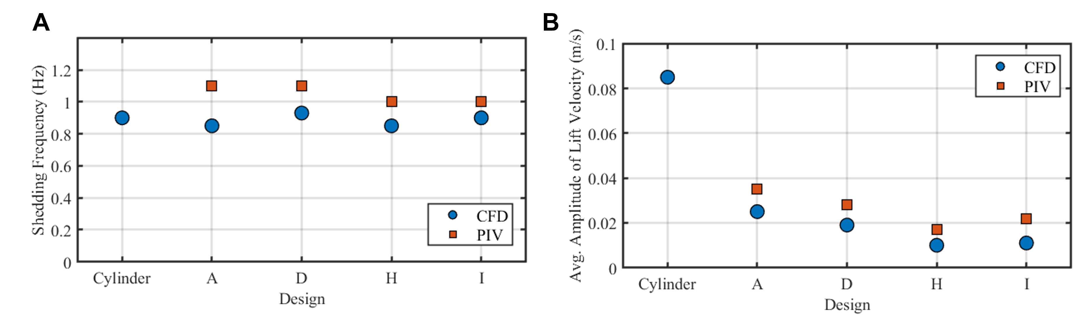
Figure S14: Quantitative comparison between CFD and SPIV results for flow stability and vortex dynamics. (a) Dominant vortex shedding frequencies extracted from the wake region for optimized designs (A, D, H, I) and the solid cylinder. CFD frequencies range from 0.85–0.95 Hz, while SPIV frequencies fall within 1.00–1.10 Hz, corresponding to Strouhal numbers of 0.20–0.25 and showing good consistency between methods. (b) Mean transverse velocity component $v_{x}$ in the downstream wake, where vorticity is highest (coordinate system as defined in Fig. S11, with flow along $+y$ and lift direction along $x$). SPIV values are slightly higher than CFD, likely due to surface roughness of fabricated samples, particle tracking limitations, and boundary effects. Both datasets, however, show that the optimized designs reduce transverse wake velocities by a factor of ~3–5 compared to the solid cylinder, demonstrating the effectiveness of the optimized geometries in suppressing wake instabilities.
References

1. Lienhard, J. H., Service., W. S. University. T. E. & of Engineering. Research Division., W. S. University. C. Synopsis of lift, drag, and vortex frequency data for rigid circular cylinders. (1966).
2. Bradford, E., Schweidtmann, A. M. & Lapkin, A. Efficient multiobjective optimization employing Gaussian processes, spectral sampling and a genetic algorithm. J Glob Optim 71, 407–438 (2018).
3. Helton, J. C. & Davis, F. J. Latin hypercube sampling and the propagation of uncertainty in analyses of complex systems. Reliability Engineering & System Safety 81, 23–69 (2003).
4. Tian, Y., Luković, M. K., Erps, T., Foshey, M. & Matusik, W. AutoOED: Automated Optimal Experiment Design Platform. Preprint at https://doi.org/10.48550/ARXIV.2104.05959 (2021).
5. Ananthakrishnan, R., Chard, K., Foster, I. & Tuecke, S. Globus platform‐as‐a‐service for collaborative science applications. Concurrency and Computation 27, 290–305 (2015).
6. Popinet, S. An accurate adaptive solver for surface-tension-driven interfacial flows. Journal of Computational Physics 228, 5838–5866 (2009).
7. Song, B. et al. Direct numerical simulation of flow over a cylinder immersed in the grid-generated turbulence. Physics of Fluids 34, 015109 (2022).
8. Incompressible Flow. (John Wiley and Sons, Inc, Hoboken, New Jersey, 2013).

