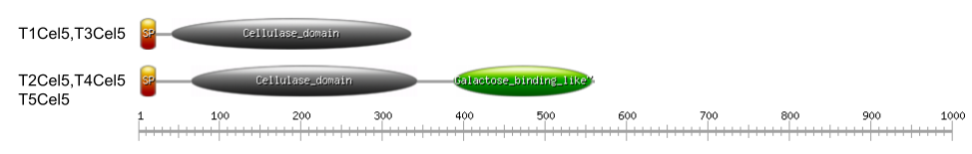
Figure S1. Domain architecture of thermophilic cellulase candidates.
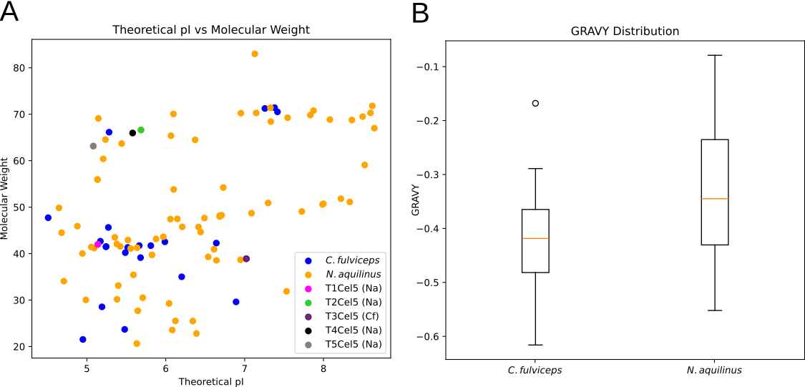
Figure S2. (A) Molecular weight distribution of in silico predicted proteins from C. fulviceps and N. aquilinus. (B) Average GRAVY values for the cellulases from N. aquilinus and C. fulviceps.
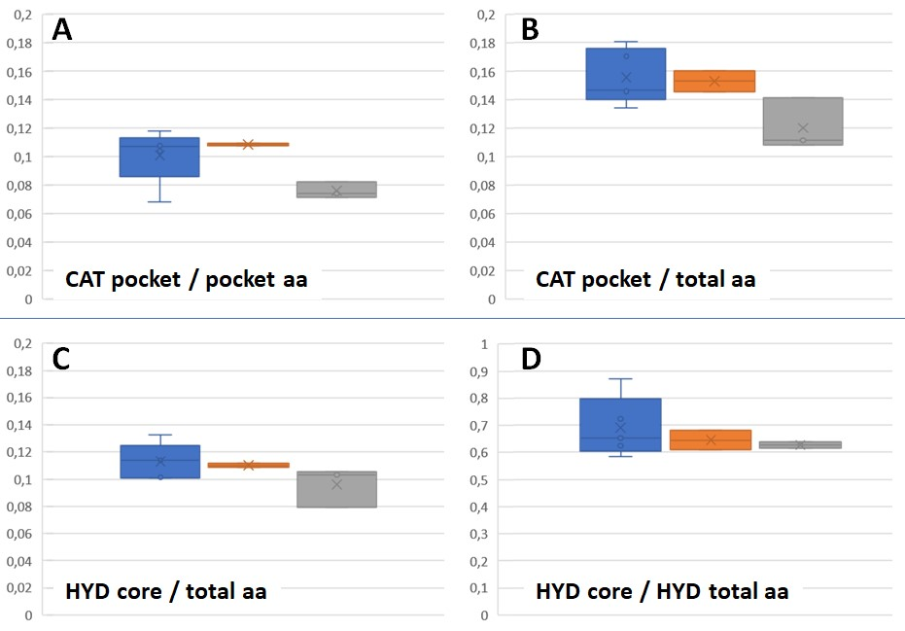
Figure S3. Comparative boxplots of residue‐composition ratios in candidate, thermophilic, and mesophilic GH5 enzymes. (A) Plots the ratio of thermostability‐enhancing (“Thermo-enabling”) residues in the catalytic pocket normalized to the total pocket residue count, (B) or pocket amino acids normalized to the total number of residues in each enzyme. (C and D) the ratio of hydrophobic residues in the enzymatic core normalized to the total enzyme residue count and to the total hydrophobic residue count respectively. Candidate enzymes group are shown in blue, thermophilic in orange, and mesophilic in gray.

Table S1. BLASTP analysis of GH5-encoding genes selected for thermophilicity prediction.
ID | Description | Scientific Name | Max Score | Total Score | Query Cover | E value | Per. Ident | Acc. Len | Accession
T1Cel5 | Glycoside hydrolase family 5 protein [Treponema sp.] | Treponema sp. | 481 | 481 | 99% | 2.00E-166 | 61.38% | 392 | MDR0301551.1
T2Cel5 | Glycoside hydrolase family 5 protein [Treponema sp.] | Treponema sp. | 534 | 534 | 99% | 0 | 47.48% | 560 | MDR2575803.1
T3Cel5 | Glycoside hydrolase family 5 protein [Treponema sp.] | Treponema sp. | 509 | 509 | 99% | 1.00E-178 | 68.73% | 339 | MDR1839590.1
T4Cel5 | Glycoside hydrolase family 5 protein [Treponema sp.] | Treponema sp. | 920 | 920 | 98% | 0 | 74.56% | 577 | MDR2953146.1
T5Cel5 | Cellulase family glycosylhydrolase [Chitinispirillales bacterium] | Chitinispirillales bacterium | 940 | 940 | 100% | 0 | 79.07% | 556 | MDR0303540.1

