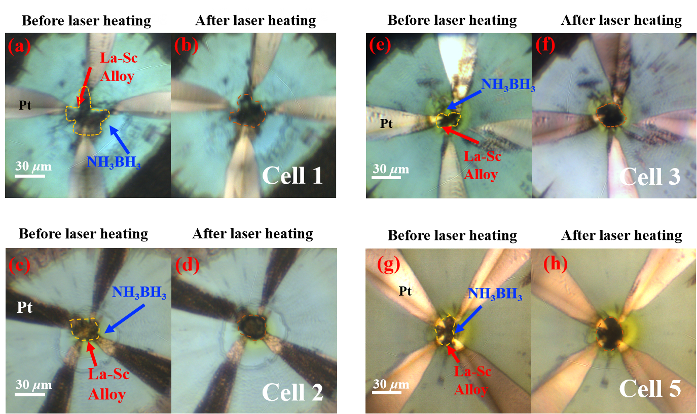
Extended Data Fig. 1 Optical micrographs of the sample chambers containing NH₃BH₃ and Pt electrodes in cells 1, 2, 3, and 5 before and after laser heating. (a), (c), (e), and (g) are photos before laser heating, respectively. (b), (d), (f), and (h) are photos after laser heating, respectively. The edges of La-Sc alloy precursor and product are marked with yellow dotted lines. The blue arrow points to the transparent NH₃BH₃ in sample chamber.

Extended Data Fig. 2. Raw data of temperature dependence of resistance of the sample for the warming cycles from cells La-H, S1, S2, and S3. The T_{c}s of 248, 249, 253, and 249 K were observed in cells S1, S2, and S3, respectively. The resistance data with near-zero values in cells La-H, S1, and S3 are shown on a smaller scale in the inset.

Extended Data Fig. 3. Raw data of temperature dependence of resistance of the sample for the warming cycles from cell 1. The black and red curves represent the resistance data with the temperature dependence at 245 and 254 GPa, respectively, during the compression.

Extended Data Fig. 4 Raw data of temperature dependence of resistance of the sample for the warming cycles from cell 3. The black and red curves represent the resistance data with the temperature dependence at 253 and 257 GPa, respectively, during the compression.

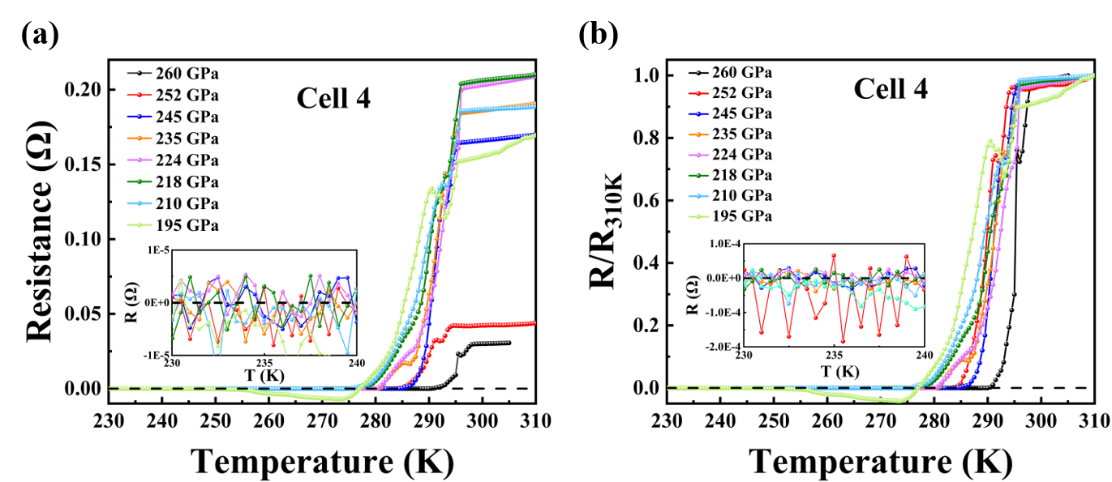
Extended Data Fig. 5 (a) Raw data of temperature dependence of resistance of the sample for the warming cycles at different pressures from cell 4. The resistance data with near-zero values are shown on a smaller scale in the left inset. (b) The vertical axis is the resistance divided by the resistance at 310 K for comparison. The resistance data with near-zero values are shown on a smaller scale in the left inset.

Extended Data Fig. 6 Raw data of temperature dependence of resistance of the sample for the warming cycles at different pressures from cell 5. The resistance data with near-zero values are shown on a smaller scale in the inset.

Extended Data Fig. 7. Raw data of temperature dependence of resistance of the sample for warming cycle from cells 4* and 5* at 256 and 260 GPa, respectively. The resistance data with near-zero values are shown on a smaller scale in the inset.

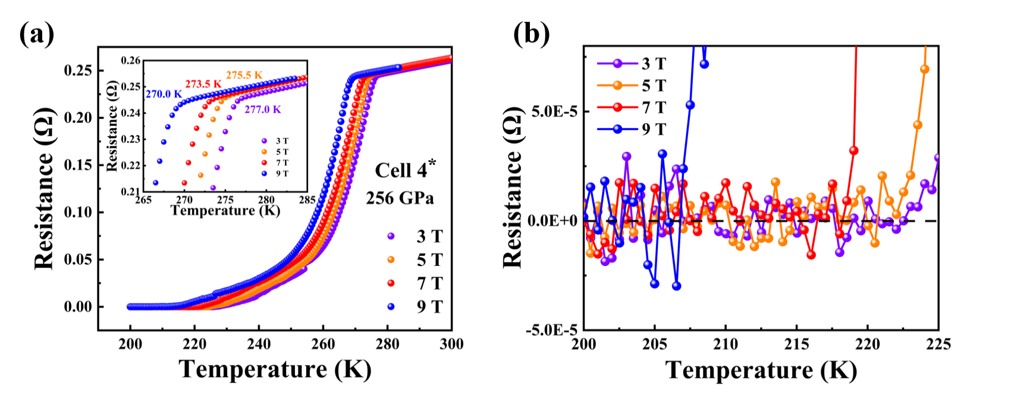
Extended Data Fig. 8 (a) Raw data of temperature dependence of the electrical resistance in cell 4* under applied magnetic fields of H=3, 5, 7, and 9 T at 256 GPa. The insert shows the enlarged transition area, and the superconducting transition temperatures at different applied magnetic fields are marked next to the data. (b) Raw data of resistance data with near-zero values under different applied magnetic fields.

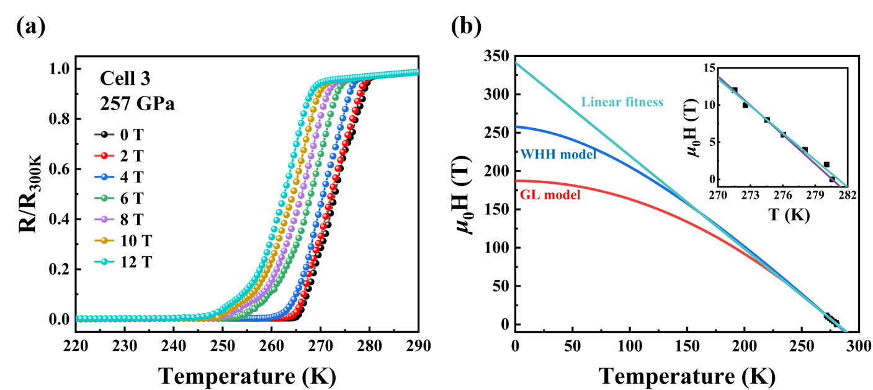
Extended Data Fig. 9: (a) Raw data of temperature dependence of the electrical resistance in cell 3 under applied magnetic fields of H=0, 2, 4, 6, 8, 10, and 12 T at 257 GPa. The vertical axis is the resistance divided by the resistance at 300 K. Upon the increasing magnetic fields, the T_{c} gradually decreased about 9 K from 281 K at 0 T to 272 K at 12 T. (b) The upper critical fields are μ₀H_{c2}(T) towards 0 K are 187 T, 258 T, and 341 T, using GL, WHH, and linear fitness, respectively. The Ginzburg-Landau coherence length deduced from the H_{c2}(0) is 1.33 nm.
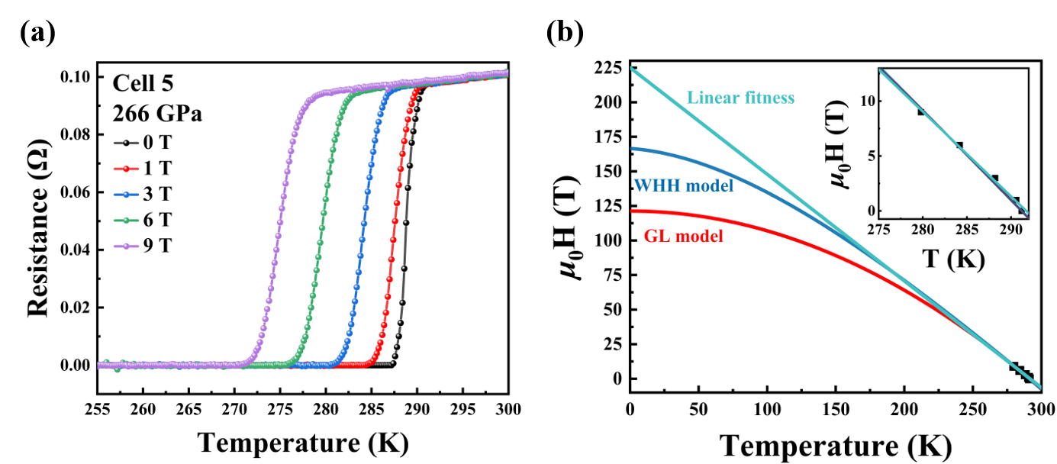
Extended Data Fig. 10: (a) Raw data of temperature dependence of the electrical resistance in cell 5 under applied magnetic fields of H=0, 1, 3, 6, and 9 T at 266 GPa. Upon the increasing magnetic fields, the T_{c} gradually decreased about 11 K from 291 K at 0 T to 280 K at 9 T. (b) The upper critical fields are μ₀H_{c2}(T) towards 0 K are 121 T, 166 T, and 225 T, using GL, WHH, and linear fitness, respectively. The Ginzburg-Landau coherence length deduced from the H_{c2}(0) is 1.65 nm.

Extended Data Fig. 11 Detailed diamond Raman spectra at different pressures during decompression in cell 4. The numbers represent the wave number read at 1/3 of the edge at different pressures.

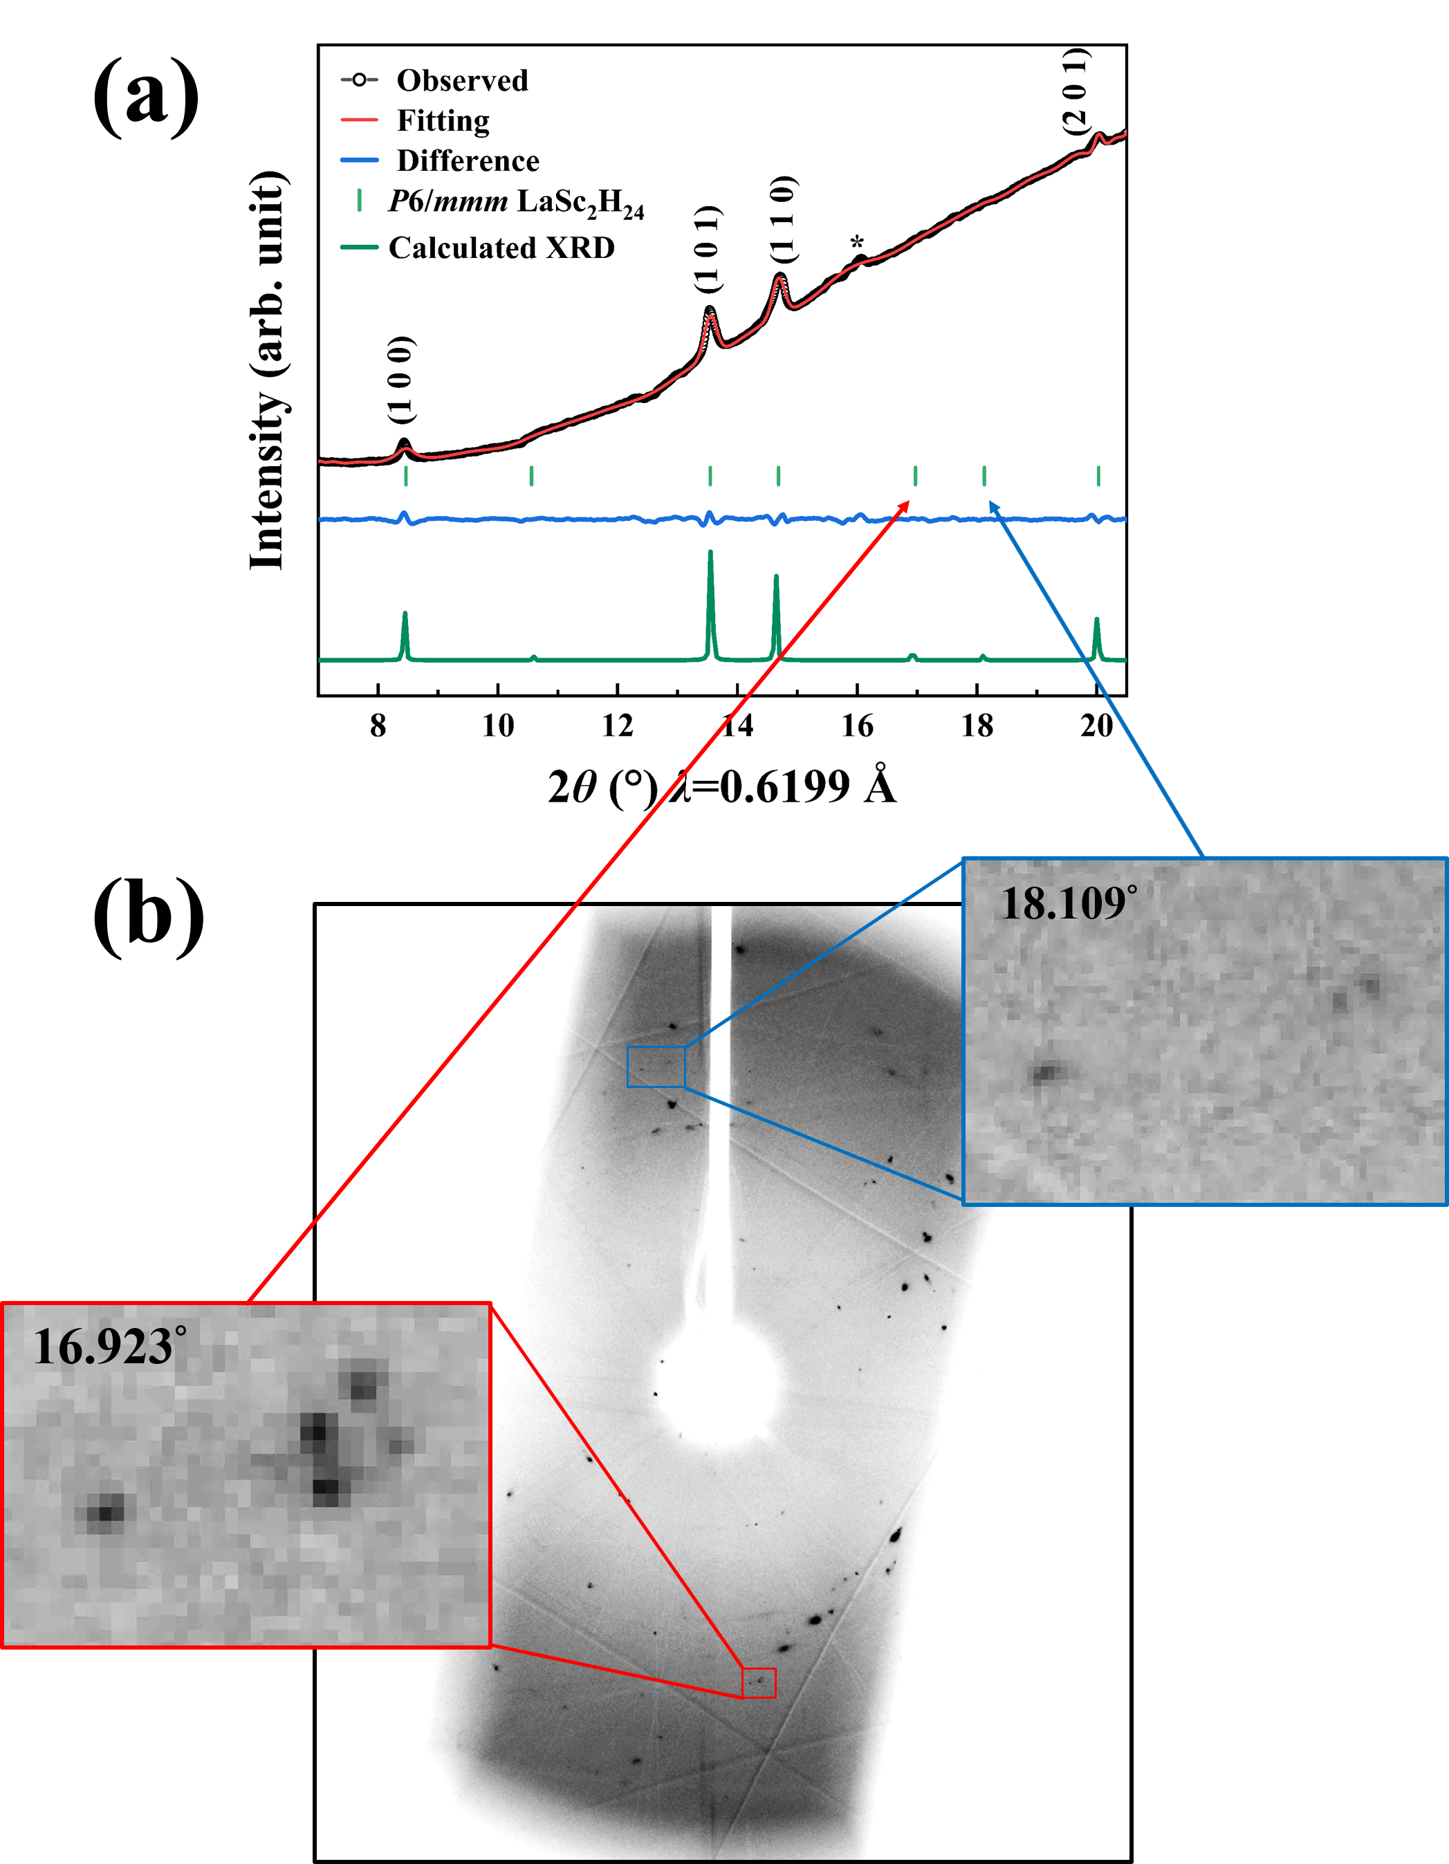
Extended Data Fig. 12 (a) Synchrotron x-ray diffraction pattern of the heated sample in cell 1 at 254 GPa and the Rietveld refinement of the P6/mmm LaSc₂H₂₄ structure. The green curve and sticks represent the simulated XRD and diffraction peaks of P6/mmm LaSc₂H₂₄. (b) The raw XRD pattern obtained from cell 1. Red and Blue squares enlarge the areas where the spots are observed at 16.923° and 18.109°, respectively.

Extended Data Fig. 13 Synchrotron X-ray diffraction patterns in the pressure range of 266-176 GPa (cell 2). The red vertical lines mark the diffraction peak positions from P6/mmm LaSc₂H₂₄. The Miller indexes are marked next to the peaks. The weak peaks marked with asterisks may be from other undetermined hydride(s). Black arrows point to the split of diffraction peaks (1 0 0) and (1 1 0) at 188 GPa.

Extended Data Fig. 14 Synchrotron XRD pattern in cell 5 at 239 GPa. The black, blue, and red curves represent the raw XRD data, XRD data after background subtraction, and calculated XRD of the P6/mmm LaSc₂H₂₄ structure. The grey vertical dashed lines represent diffraction peaks of P6/mmm LaSc₂H₂₄. The crystal surface indexes are marked next to the peaks. The peaks marked with asterisks may be from other undetermined hydride(s).

Supplementary Tables
Extended Data Table 1. Scanning electron microscope (SEM) images, the energy-dispersive x-ray spectrum (EDX), and map results of La-Sc alloy.
Alloy | SEM image | La | Sc | EDX | Map results  (La: Sc atom%)
#1  (Melted  method) | 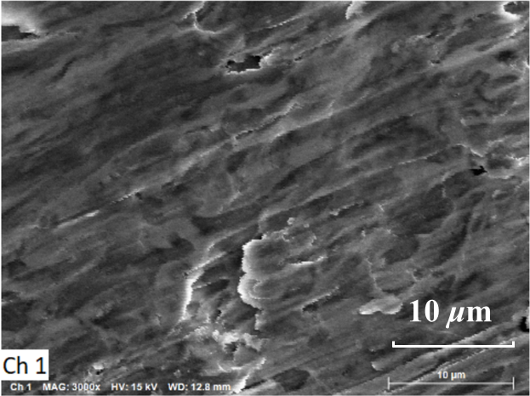 | 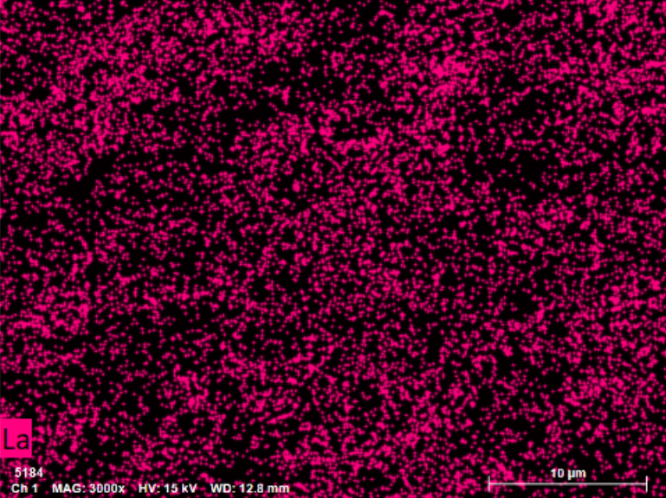 | 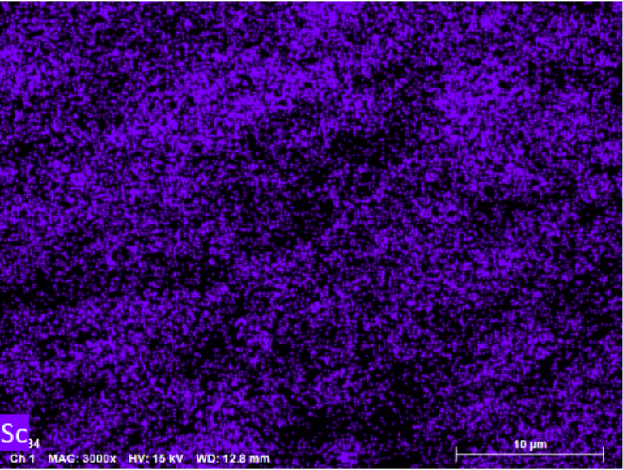 | 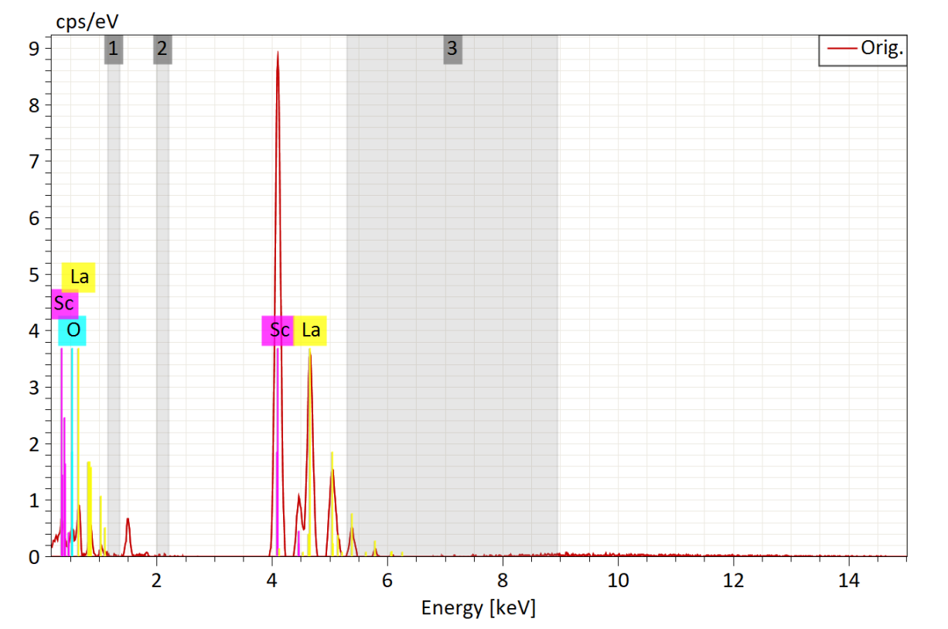 | 31.03: 68.97
#2  (Magnetron sputtering) | 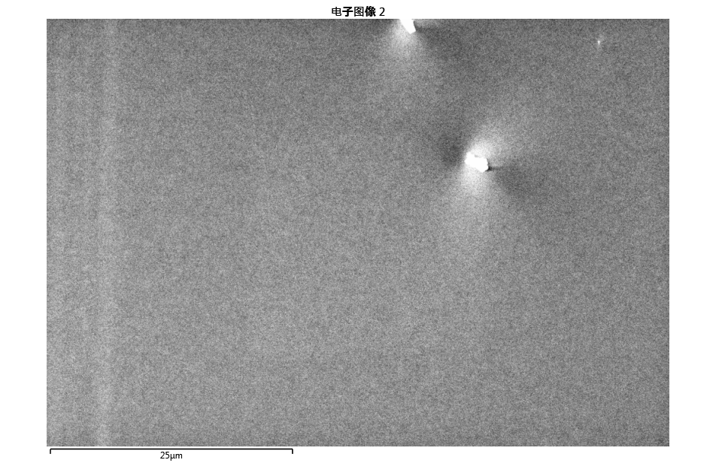 | 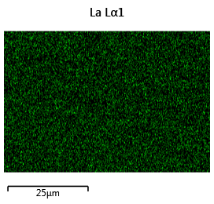 | 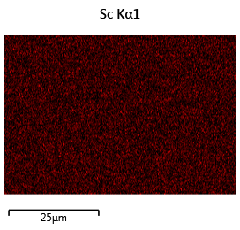 | 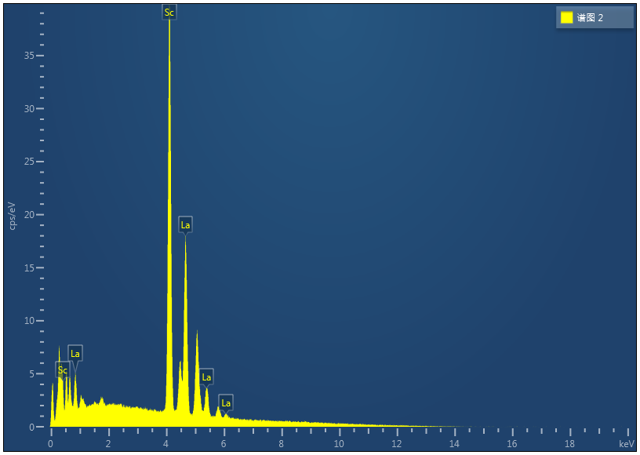 | 34.36: 65.64
#3  (Magnetron sputtering) | 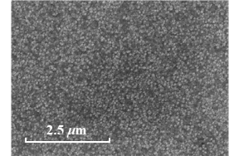 | 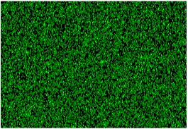 | 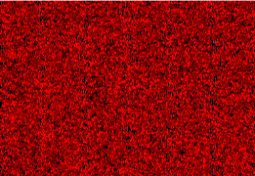 | 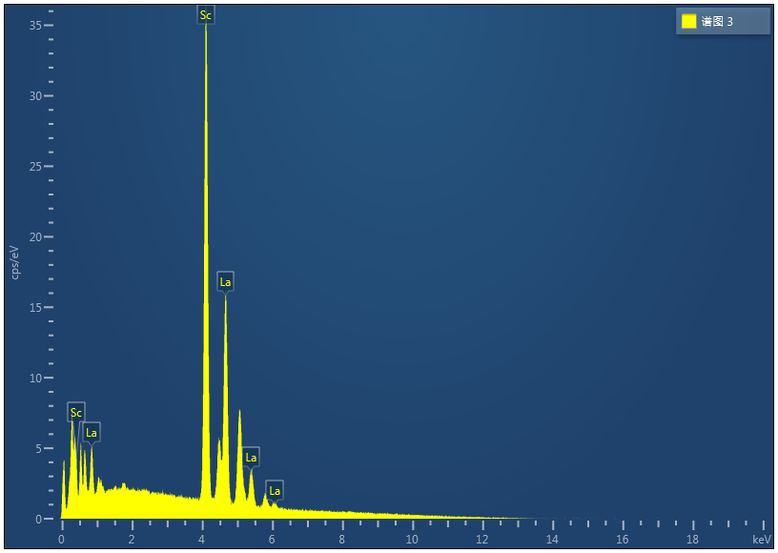 | 34.14: 65.86

Extended Data Table 2. Details of the five DACs and 13 measurement runs.
Number | Culet size  (μm) | Gasket | Precursor | Pressure  (GPa) |  | Measurement run
#Cell-1 | 30 | Re+Al₂O₃+epoxy | La-Sc alloy  +NH₃BH₃ | 245-254 | R-T*, XRD
#Cell-2 | 30 | Re+Al₂O₃+epoxy | La-Sc alloy  +NH₃BH₃ | 253-257 | XRD
#Cell-3 | 30 | Re+Al₂O₃+epoxy | La-Sc alloy  +NH₃BH₃ | 176-266 | R-T, MF**
#Cell-4 | 30 | Re+Al₂O₃+epoxy | La-Sc alloy  +NH₃BH₃ | 260 | R-T, MF
#Cell-4* | 30 | Re+Al₂O₃+epoxy | La-Sc alloy  +NH₃BH₃ | 256 | R-T, MF
#Cell-5 | 30 | Re+Al₂O₃+epoxy | La-Sc alloy  +NH₃BH₃ | 239-266 | R-T, MF, XRD
#Cell-5* | 30 | Re+Al₂O₃+epoxy | La-Sc alloy  +NH₃BH₃ | 260 | R-T
Cell-4* and Cell-5* represent the samples that underwent initial laser heating, where T_{c}s of 272 K and 271 K were observed. Upon re-laser heating and measurement, Cell-4 is the same sample as Cell-4* that was and measured, yielding a higher T_{c} of 296 K.
* Temperature-dependent resistance measurement (R-T).
** Transport measurements under varying external magnetic fields (MF).

Extended Data Table 3. Experimental cell parameters and volumes per formula of P6/mmm LaSc₂H_{24+x} at different pressures.
Cell Number | Pressure (GPa) | a (Å) | c (Å) | V (Å³/formula) | x in LaSc₂H_{24+x}
#Cell-1 | 254 | 4.86(4) | 3.35(6) | 68.78(8) | 0.3
#Cell-2 | 266 | 4.85(9) | 3.36(5) | 68.80(3) | 1.4
#Cell-2 | 259 | 4.87(0) | 3.35(8) | 68.97(7) | 0.9
#Cell-2 | 253 | 4.86(2) | 3.36(1) | 68.83(9) | 0.5
#Cell-2 | 246 | 4.87(7) | 3.36(8) | 69.38(8) | 0.3
#Cell-2 | 239 | 4.88(2) | 3.37(3) | 69.65(6) | 0
#Cell-2 | 234 | 4.88(5) | 3.38(7) | 70.01(7) | -0.3
#Cell-2 | 229 | 4.89(2) | 3.39(5) | 70.39(1) | -0.4
#Cell-2 | 223 | 4.90(1) | 3.40(1) | 70.78(1) | -0.6
#Cell-2 | 217 | 4.93(0) | 3.40(3) | 71.66(1) | -0.6
#Cell-2 | 209 | 4.94(0) | 3.43(0) | 72.51(5) | -0.7
#Cell-2 | 194 | 4.97(1) | 3.45(5) | 73.96(6) | -1.1
#Cell-5 | 239 | 4.85(9) | 3.35(5) | 68.59(9) | -0.6
The experimental hydrogen content is estimated by comparing the measured volumes of the corresponding high-pressure phases of elemental La (distorted-fcc phase), Sc (IV and V phases), and H₂ (I, III, and IV phases), with x in LaSc₂H_{24+x} subsequently determined using the following formula: $x=\frac{V- {\text{V}}_{La}-2{\text{V}}_{Sc}}{{\text{V}}_{H}}-24\text{.}$

