Table1. Primers for RPA method
Login Number | Number | Primer sequence（5'→3'） | Length
MK609547.1 | 1 | CAGTTATAGTTTATTTGATGTTCGTTTTAC | 295bp
MK609547.1 | 1 | TCTTAGATGTGGTAGCCGTTTCTCAGG | 295bp
MK609547.1 | 2 | GGAAAGCAGCAGGCGCGCAAATTACCCA | 243bp
MK609547.1 | 2 | GGAAGCGAGATTAATGACAAGGCAGA A | 243bp
MK609547.1 | 3 | ATCTAAACCCTTCCCAGAGTATCAATTGGA | 338bp
MK609547.1 | 3 | CCAACTGCTCCTATTAACCATTACTCTGGC | 338bp
MK609547.1 | 4 | CCAGAGTAATGGTTAATAGGAGCAGTTGG | 295bp
MK609547.1 | 4 | CTCTAGTCGGCATAGTTTATGGTTAGGAC | 295bp
MK609547.1 | 6 | TCCAGACATAGAGAGGATTGACAGATTGAT | 222bp
MK609547.1 | 6 | ACCTGTTATTGCCTTACACTTCCTTGCGTT | 222bp
MK609547.1 | 7 | CGGCTACCACATCTAAGGAAGGCACG | 191bp
MK609547.1 | 7 | CTATTGGAGCTGGAATTACCGCGGCT | 191bp

Table2. Primers for Nested PCR
 | Primer name | Primer sequence（5'→3'）
First round | CRYPTORN | GAATGATCCTTCCGCAGGTTCACCTAC
First round | CRYPTOFL | AACCTGGTTGATCCTGCCAGTAGTCAT
Second round | Bab1 | GTCTTAGTATAAGCTTTTATACAGCG
Second round | Bab4 | GATAGGTCAGAAACTTGAATGATACATCG

Table 3 Density of parasitess in various groups of blood Babesia microti

Group | Density of Babesia microti（parasite/ul）
1 | 445200
2 | 89040
3 | 17808
4 | 3561.6
5 | 712.32
6 | 142.46
7 | 28.49
8 | 5.7
9 | 1.14
10 | 0.23
11 | 0.046
12 | 0.0092
13 | 0.0018
14 | 0.00037

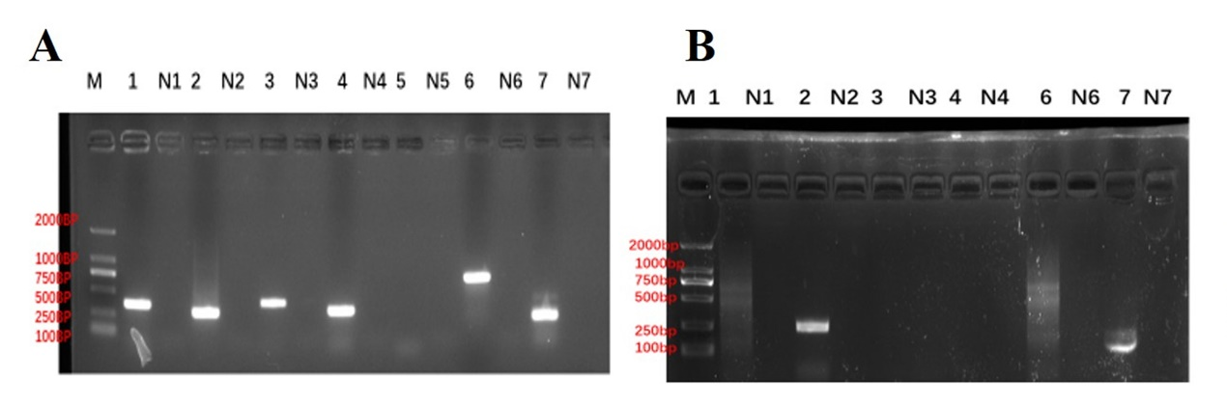
Figure1 PCR Results of RPA primers selection
(A) represent corresponds to primers for PCR, 1-7 from 18SrRNA .N1-N7 represent the negative control, M represents DNA makers. 1st, 2nd, 3rd, 4th, 6th, 7th-which produced positive PCR results. (B) 1, 2,3,4,6,7 represent corresponds to primers for RPA.N1、N2、N3、N4、N6、N7 represent the negative control, M represent DNA Makers. The 2nd, 7th primer groups yielded clear, distinct bands.
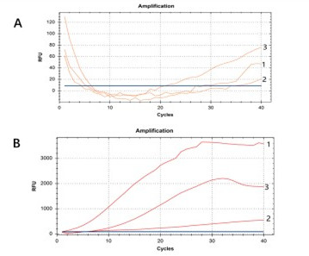

Figure 2 Selection results of primers with different sequences
- 1-3 respectively represent the first pair, the second pair, and the third pair of primers of the group 2 sequence. (B) 1-3respectively represent the first pair, second pair, and third pair of primers in the group 7 sequence.

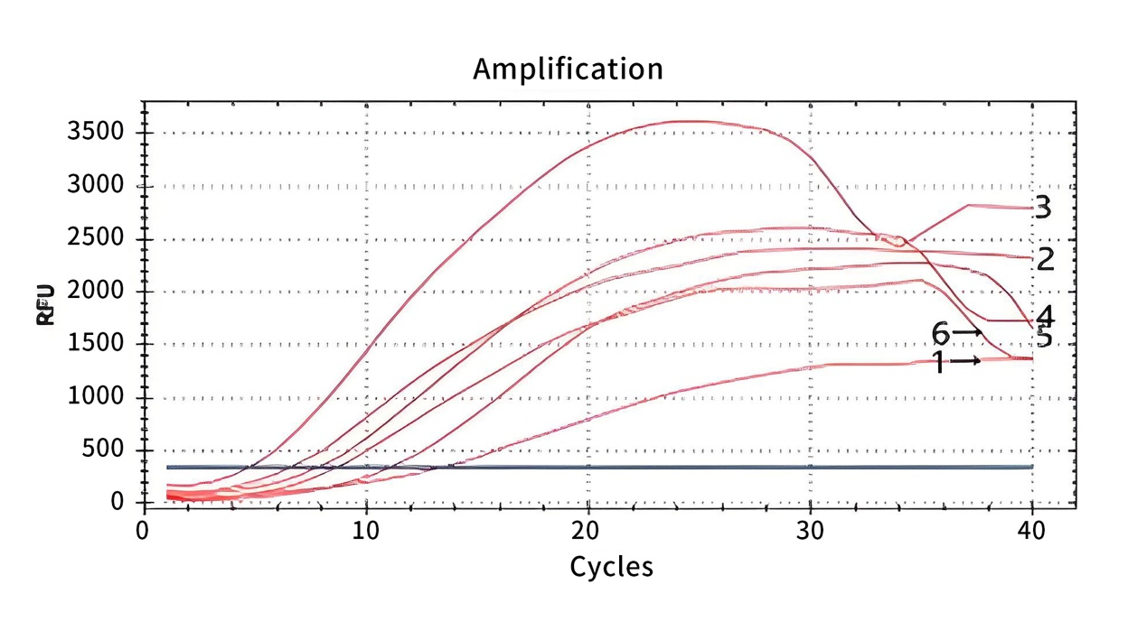
Figure 3 Optimization of fluorescence RPA reaction temperature. Curves 1-6 represents the B. microti genomic DNA amplification profile of group 7 sequence at 37°C, 38°C, 39°C, 40°C, 41°C, and 42°C, respectively.

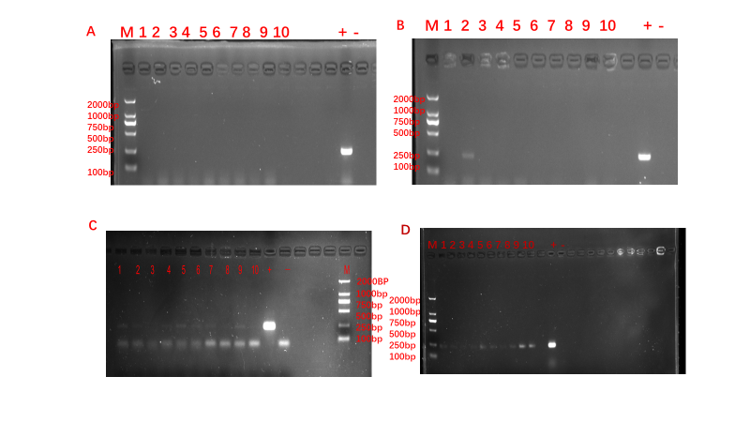
Figure 4 Results of nested PCR of B. microti infected in mouse models of post infection days
(A) 1-10 represent PCR results of 6th post infection days. All samples were negative. + represents positive control, - represents the negative control. (B) 1-10 represent PCR results of 9th post infection days, samples of No.2 was positive, and the other ones were negative. + represents positive control, - represents the negative control. (C) 1-10 represent PCR results of 12th post infection days, No.1,,No.2, No.4, No.5,No.6,No.7, No.9 samples were positive. + represents positive control, - represents the negative control. (d) 1-10 represent PCR results of 15th post infection days, all samples were positive. + represents positive control, - represents the negative control.

