Supplementary material
Study of the potential of composite material based on zeolite and geopolymer as an adsorbent of toxic metals
Ricardo Jadson da Silva Nascimento ¹, Inácio Cruz de Loiola¹, João Vitor Torres Sousa ², Vicente de Oliveira Sousa Neto ³, Luiz Thiago Vasconcelos da Silva ¹, Ronaldo Ferreira do Nascimento (corresponding author) ¹
¹ Federal University of Ceará, Fortaleza, Ceará, Brazil.
² Federal Institute of Education, Science, and Technology of Ceará, Maracanaú, Ceará, Brazil.
³ Faculty of Education, Science, and Letters of Sertão Central/State University of Ceará, Quixadá, Ceará, Brazil.
Figure S1 – Linear Kinetic Models for Ni²⁺ at 5 mmol·L⁻¹: (a) Lagergren (Pseudo-First Order - PFO); (b) Ho (Pseudo-Second Order - PSO); (c) Elovich. pH = 5,0; 220 rpm; 29 ºC.
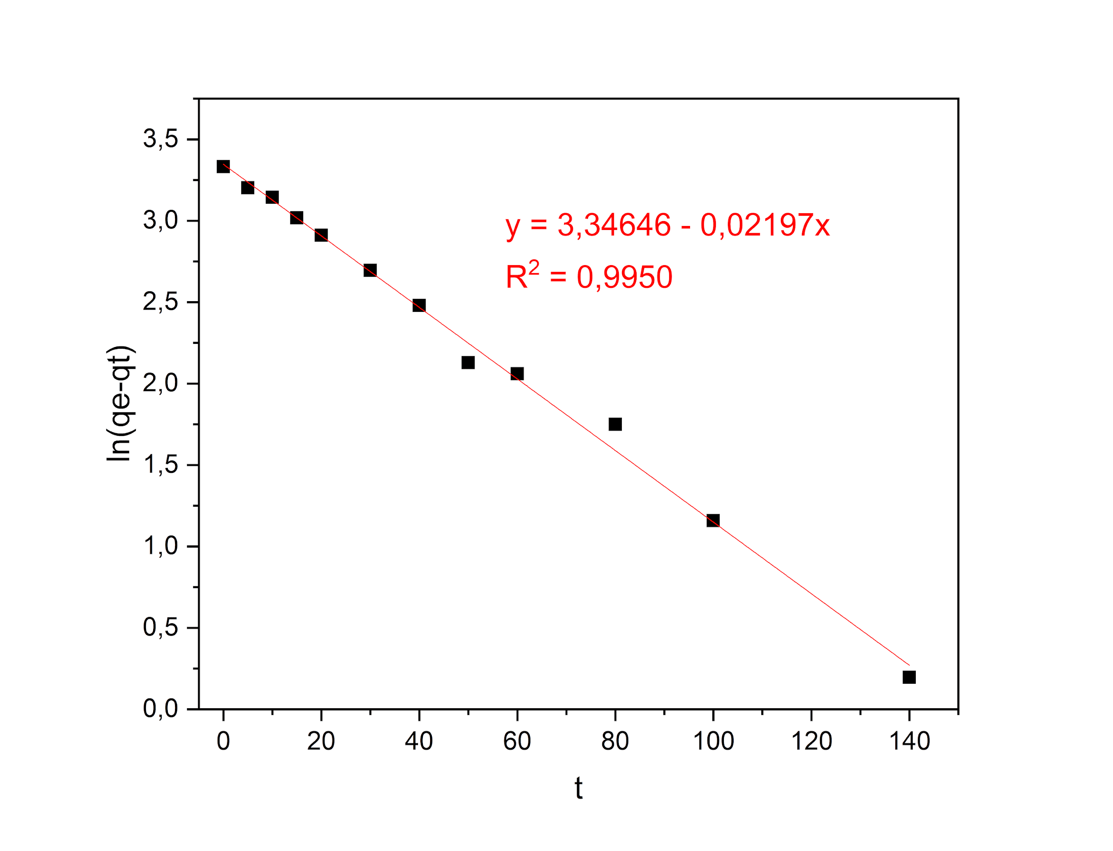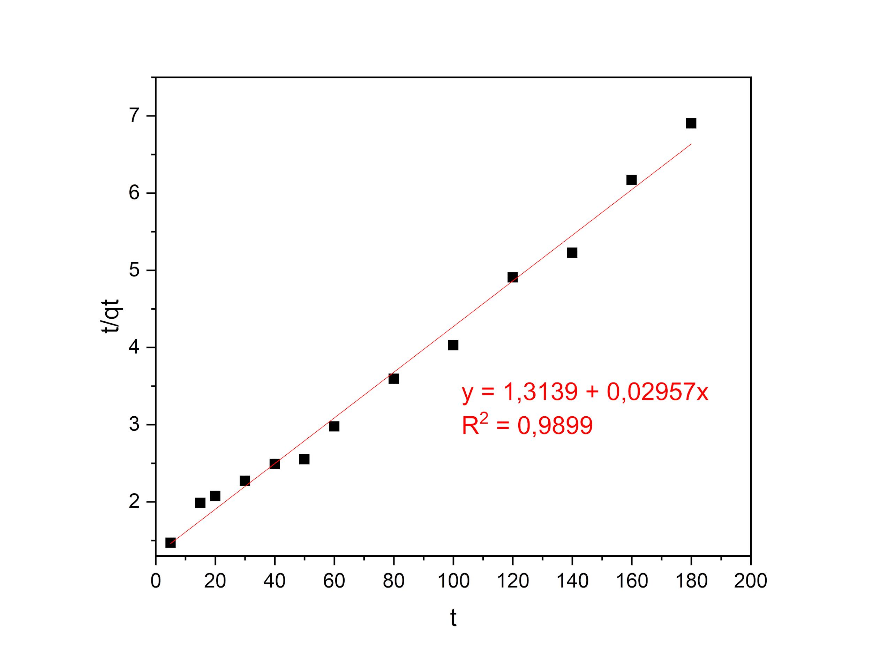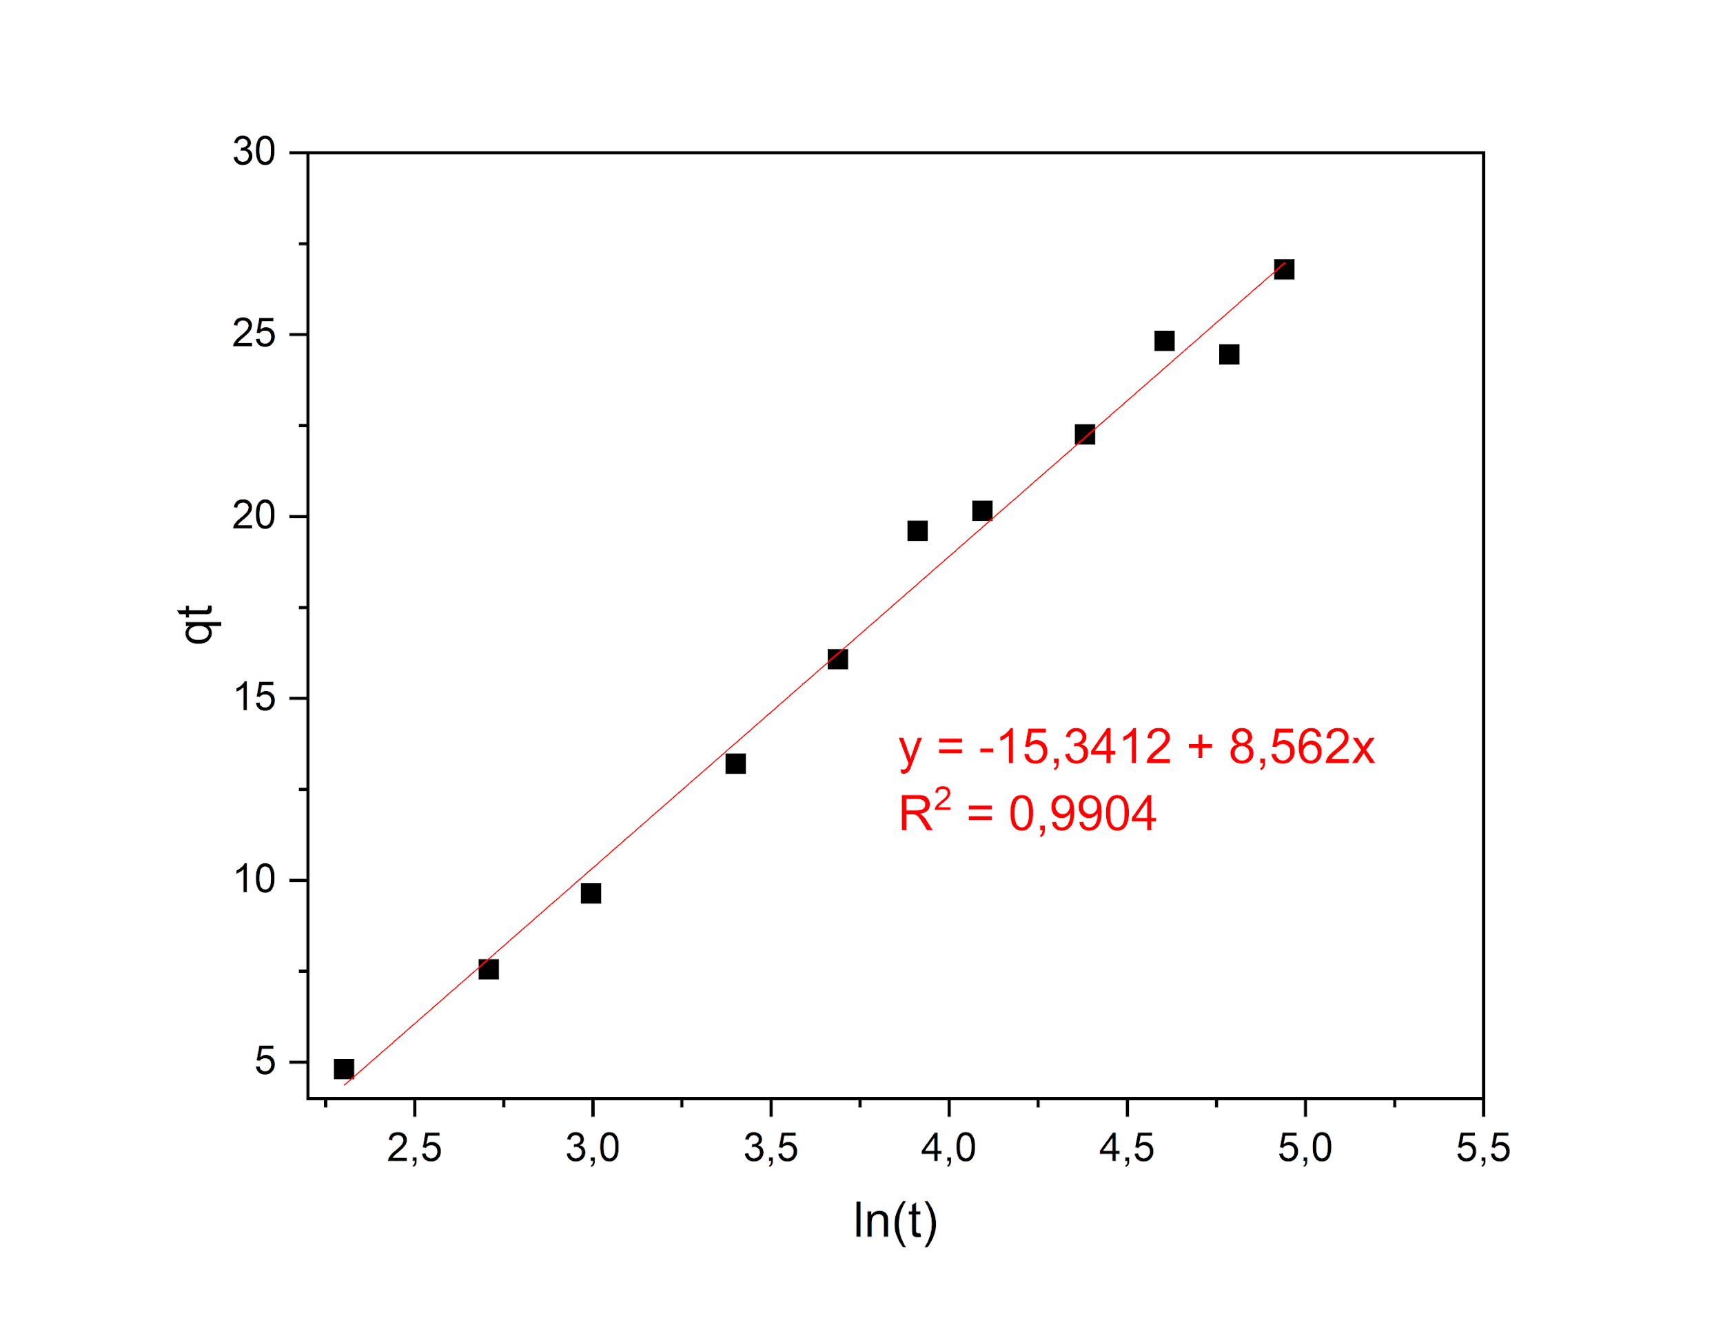

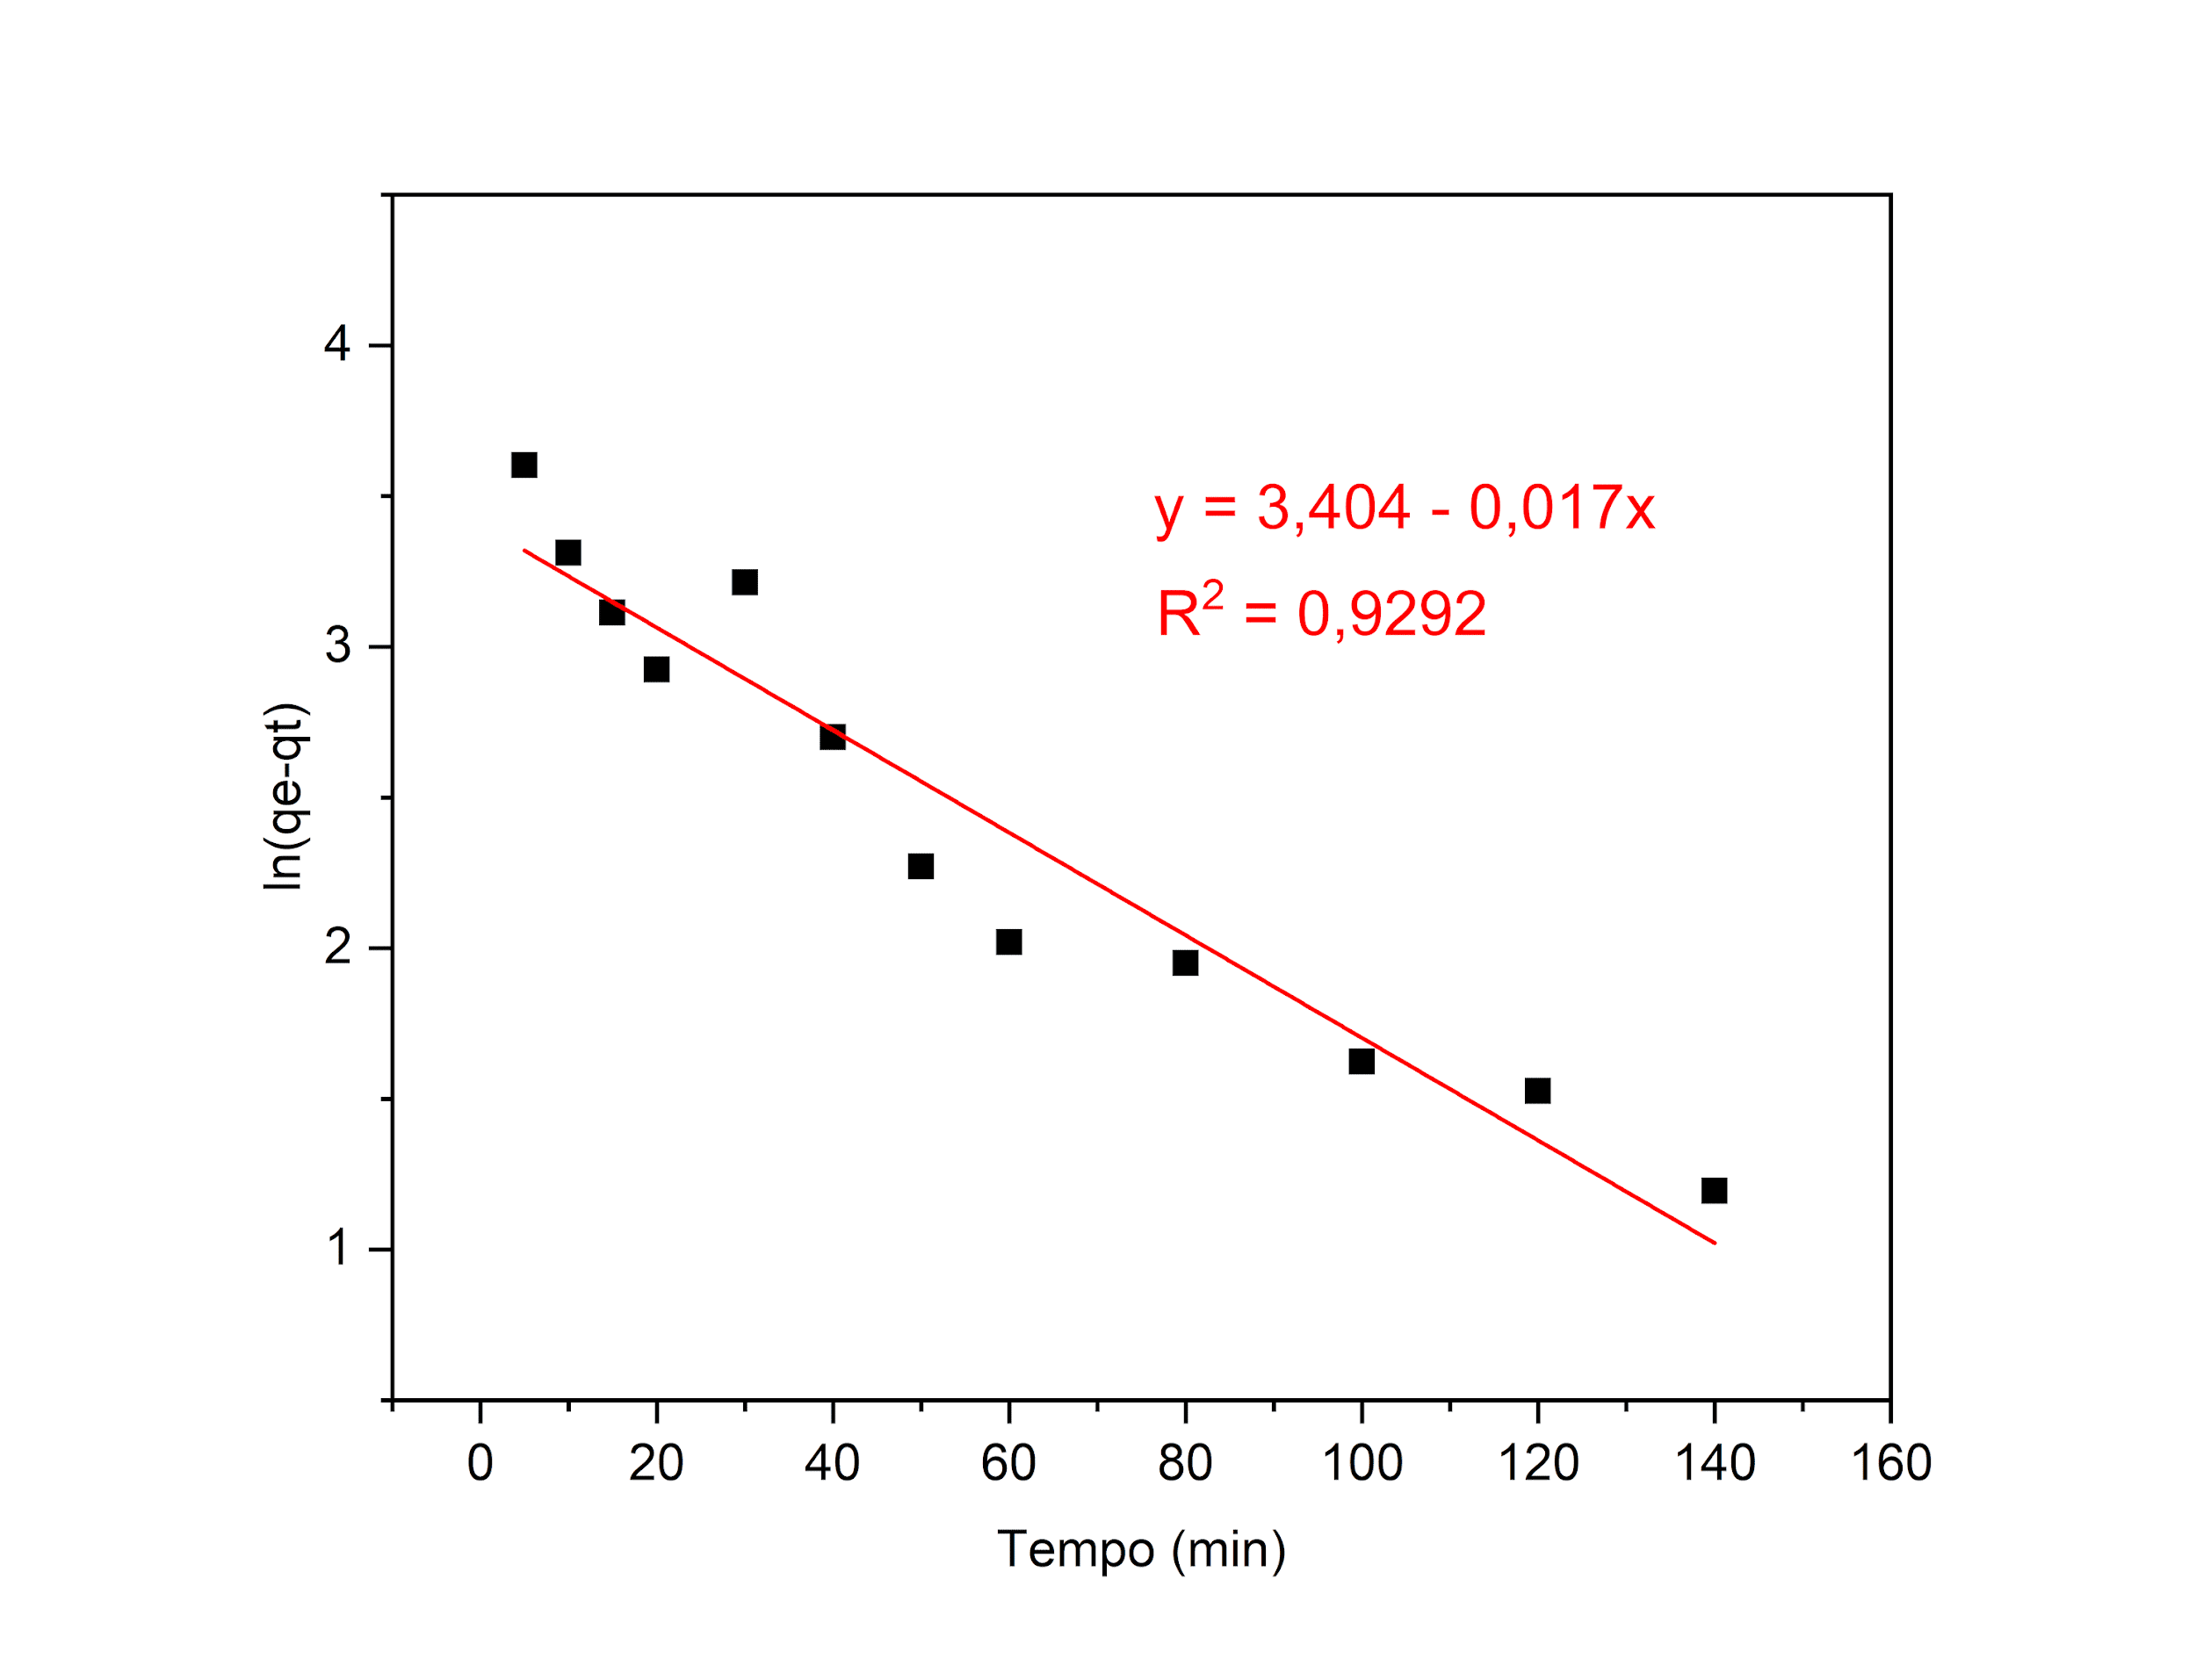
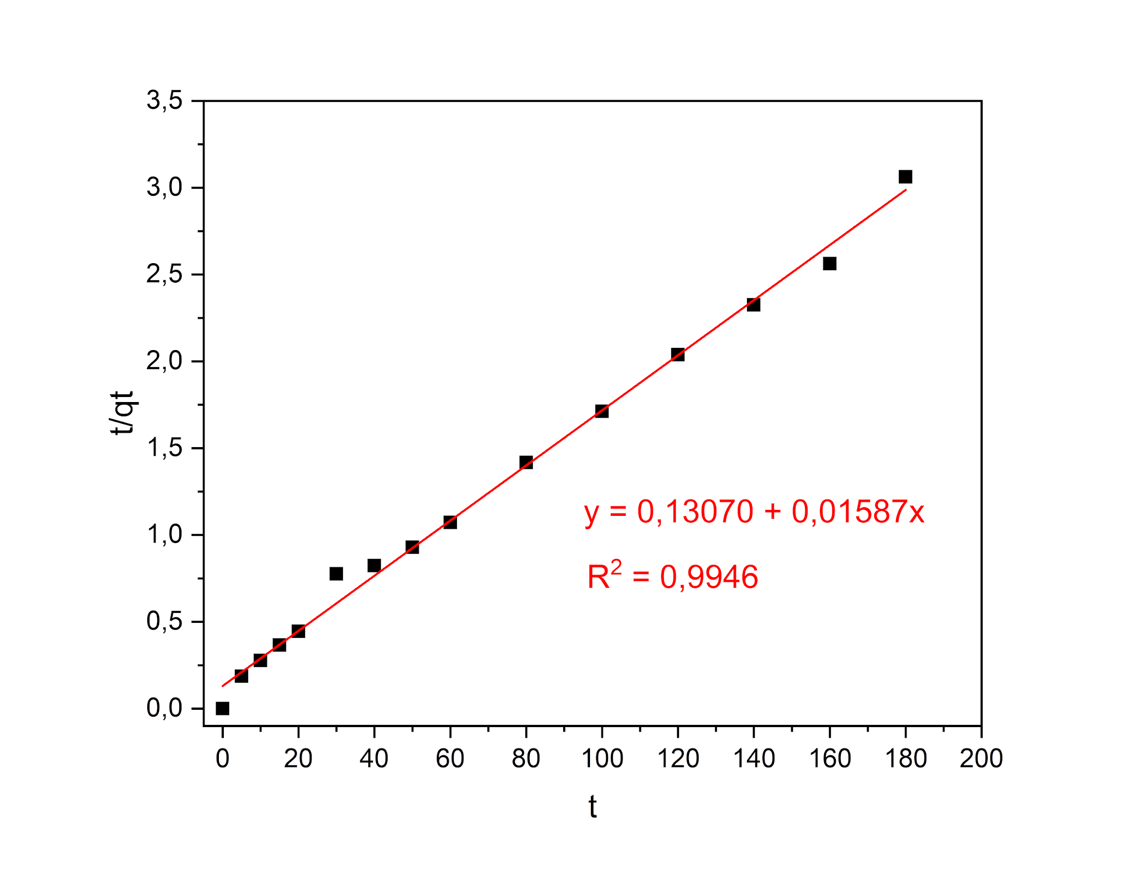
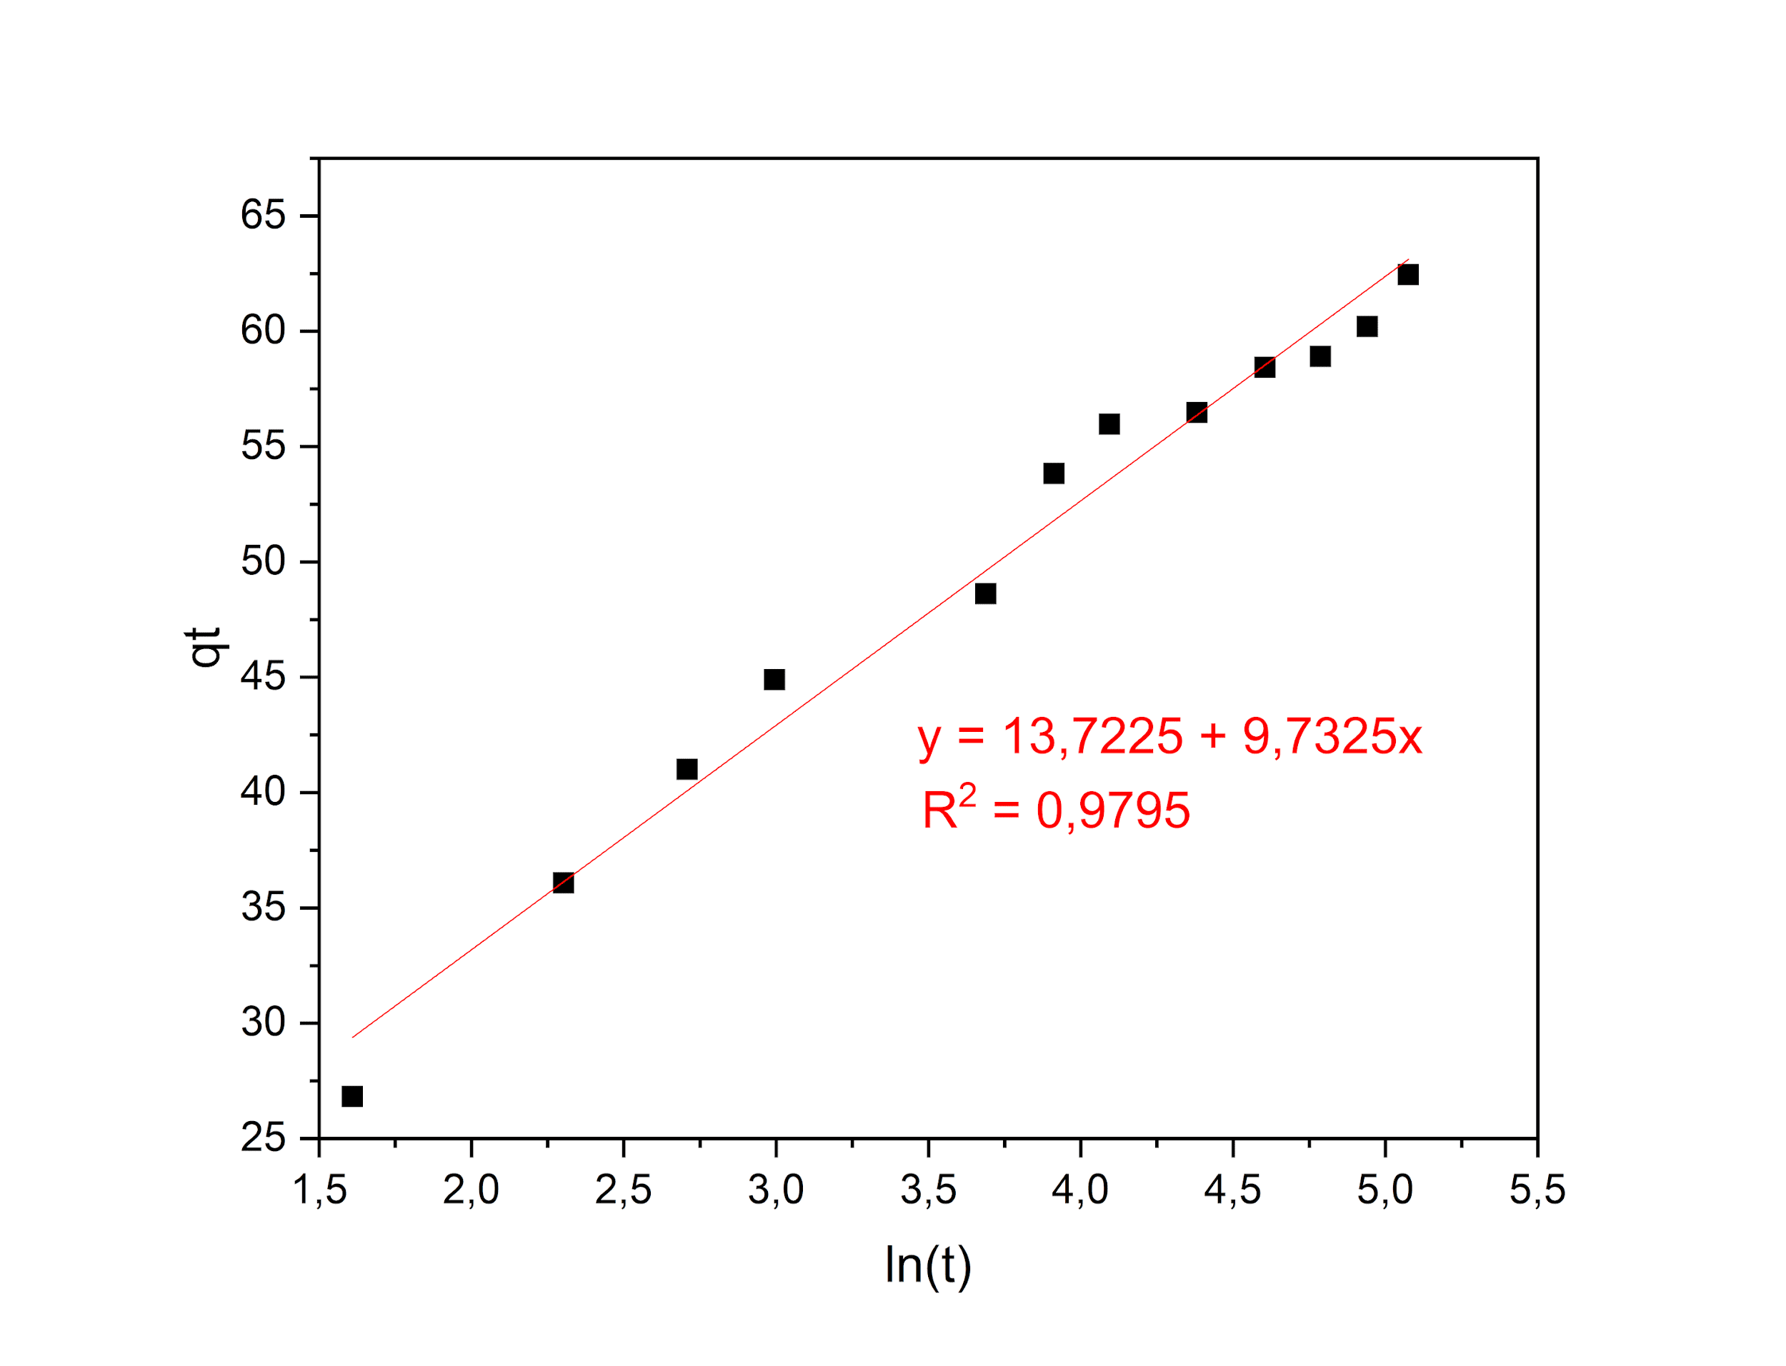
Figure S2 – Linear Kinetic Models for Cu²⁺ at 5 mmol·L⁻¹: (a) Lagergren (Pseudo-First Order - PFO); (b) Ho (Pseudo-Second Order - PSO); (c) Elovich. pH = 5,0; 220 rpm; 29 ºC.

Figure S3 – Linear Kinetic Models for Zn²⁺ at 5 mmol·L⁻¹: (a) Lagergren (Pseudo-First Order - PFO); (b) Ho (Pseudo-Second Order - PSO); (c) Elovich. pH = 5,0; 220 rpm; 29 ºC.
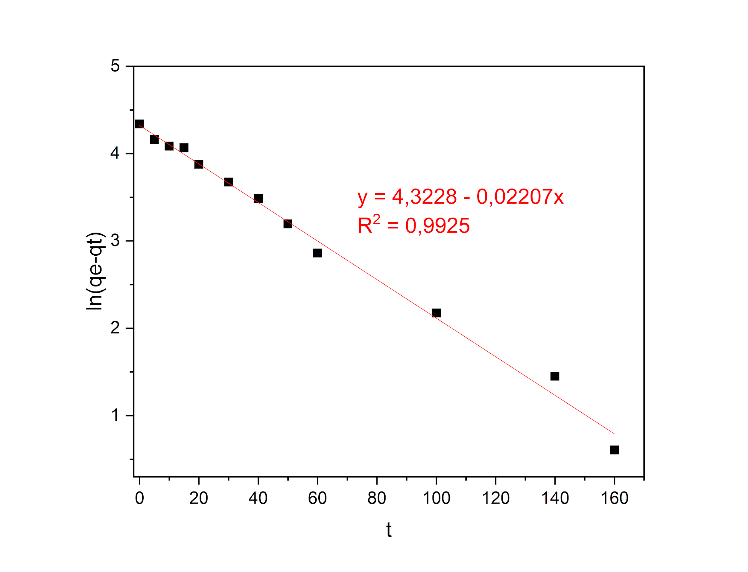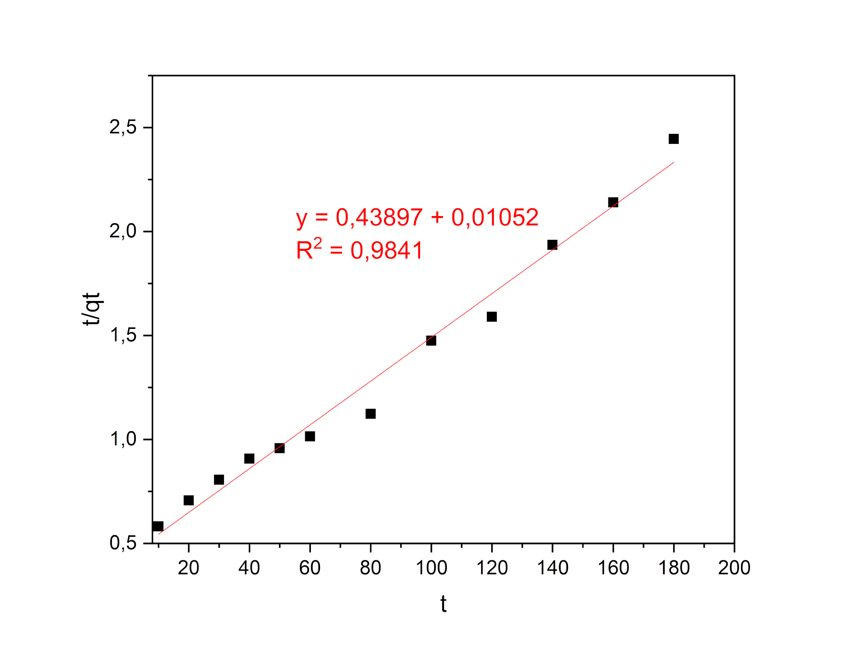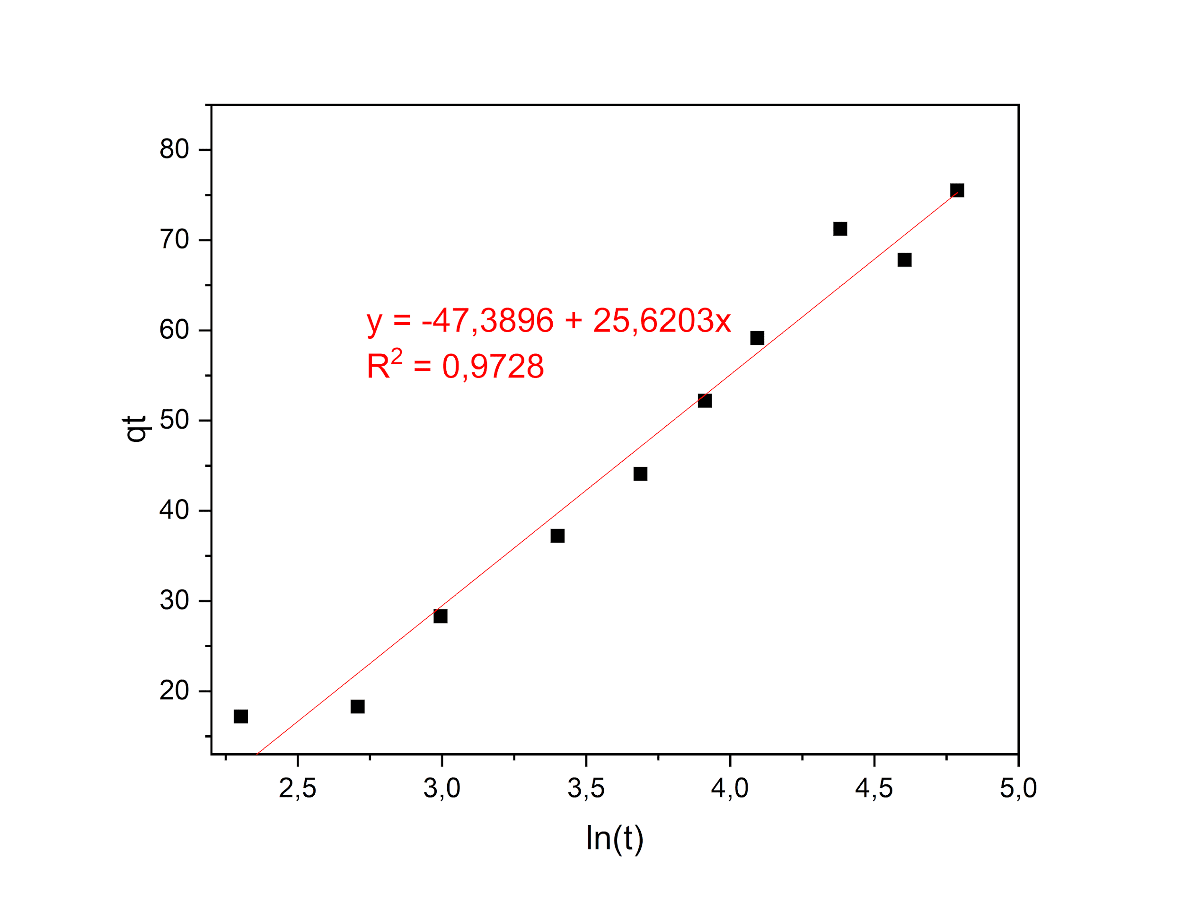

Figure S4 – Linearized Adsorption Isotherm Models for Ni²⁺: (a) Langmuir and (b) Freundlich. pH = 5.0; 220 rpm; 29 ºC.
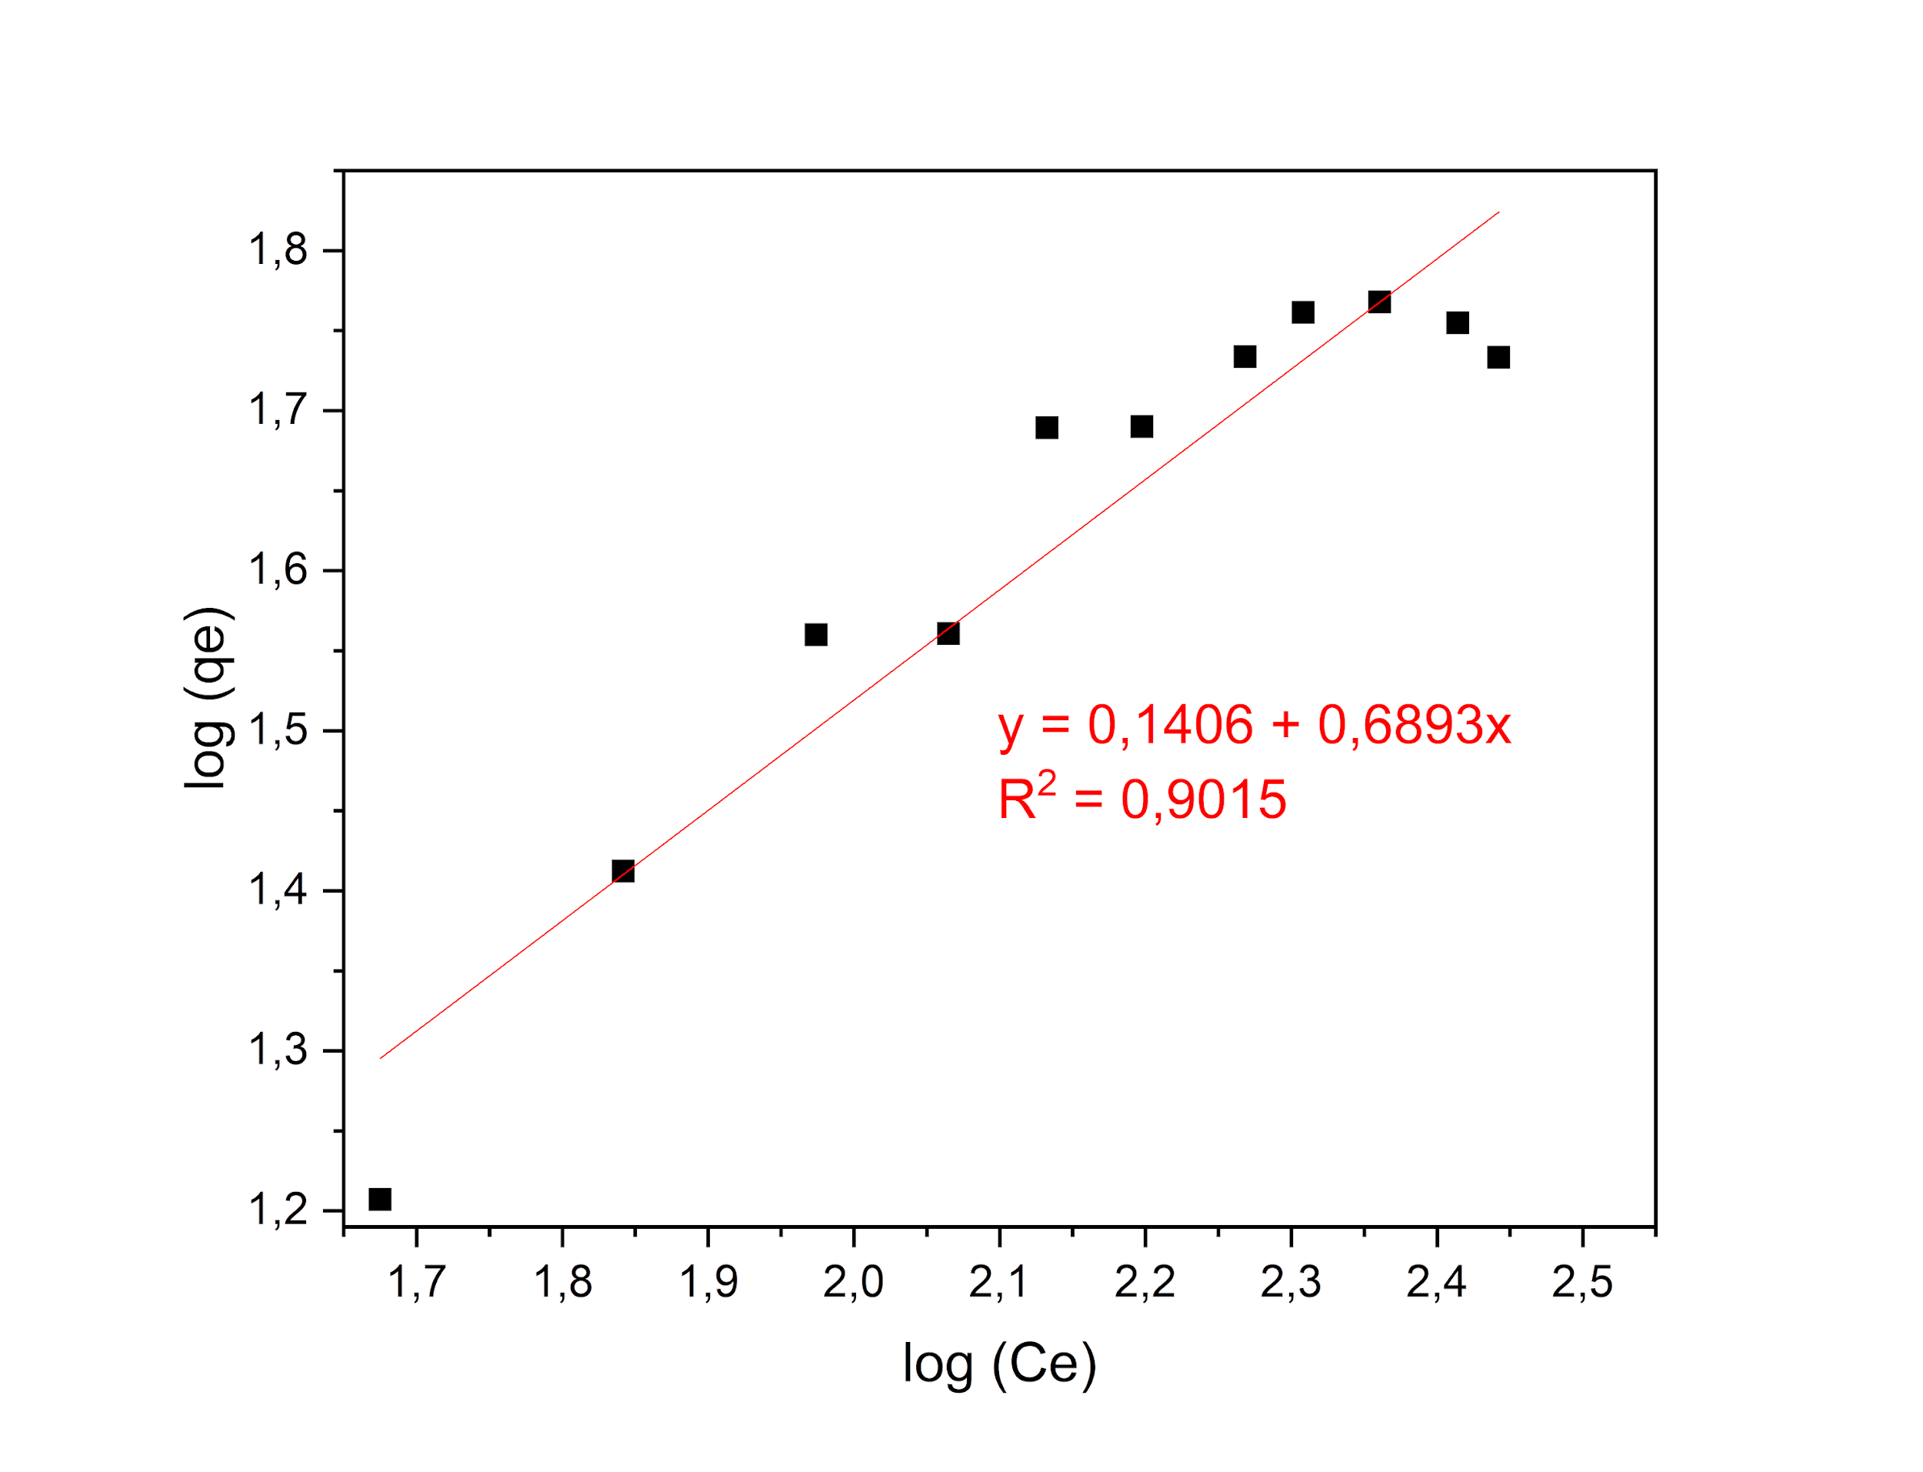
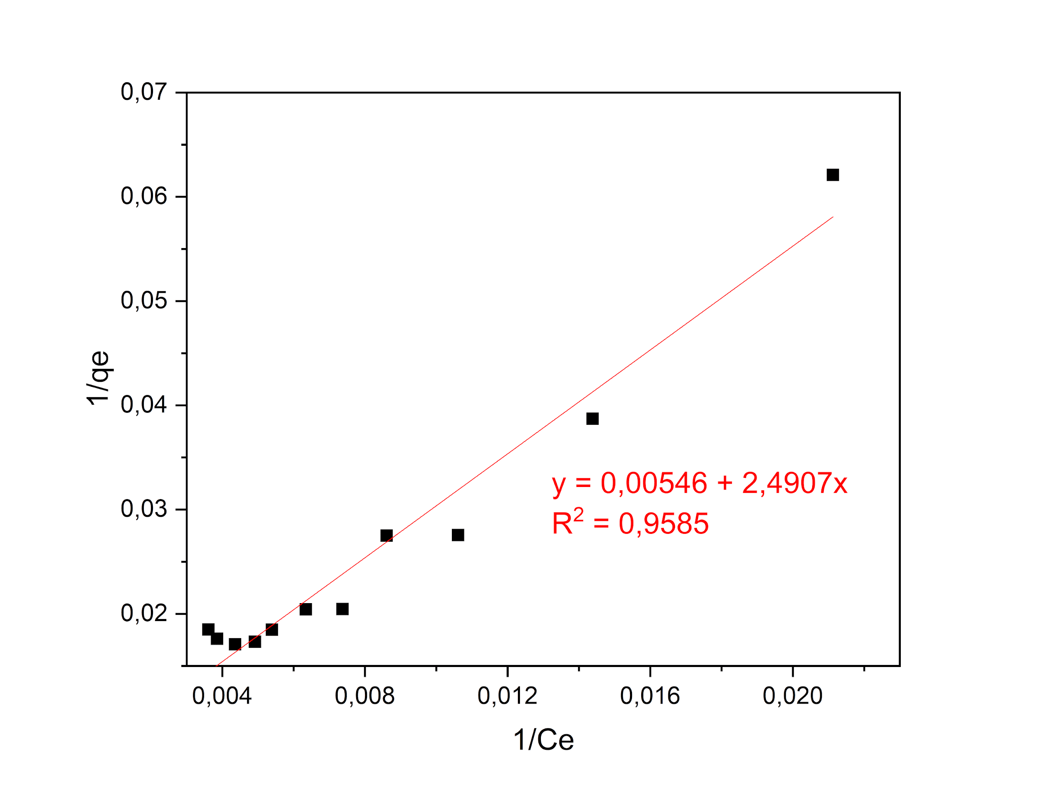

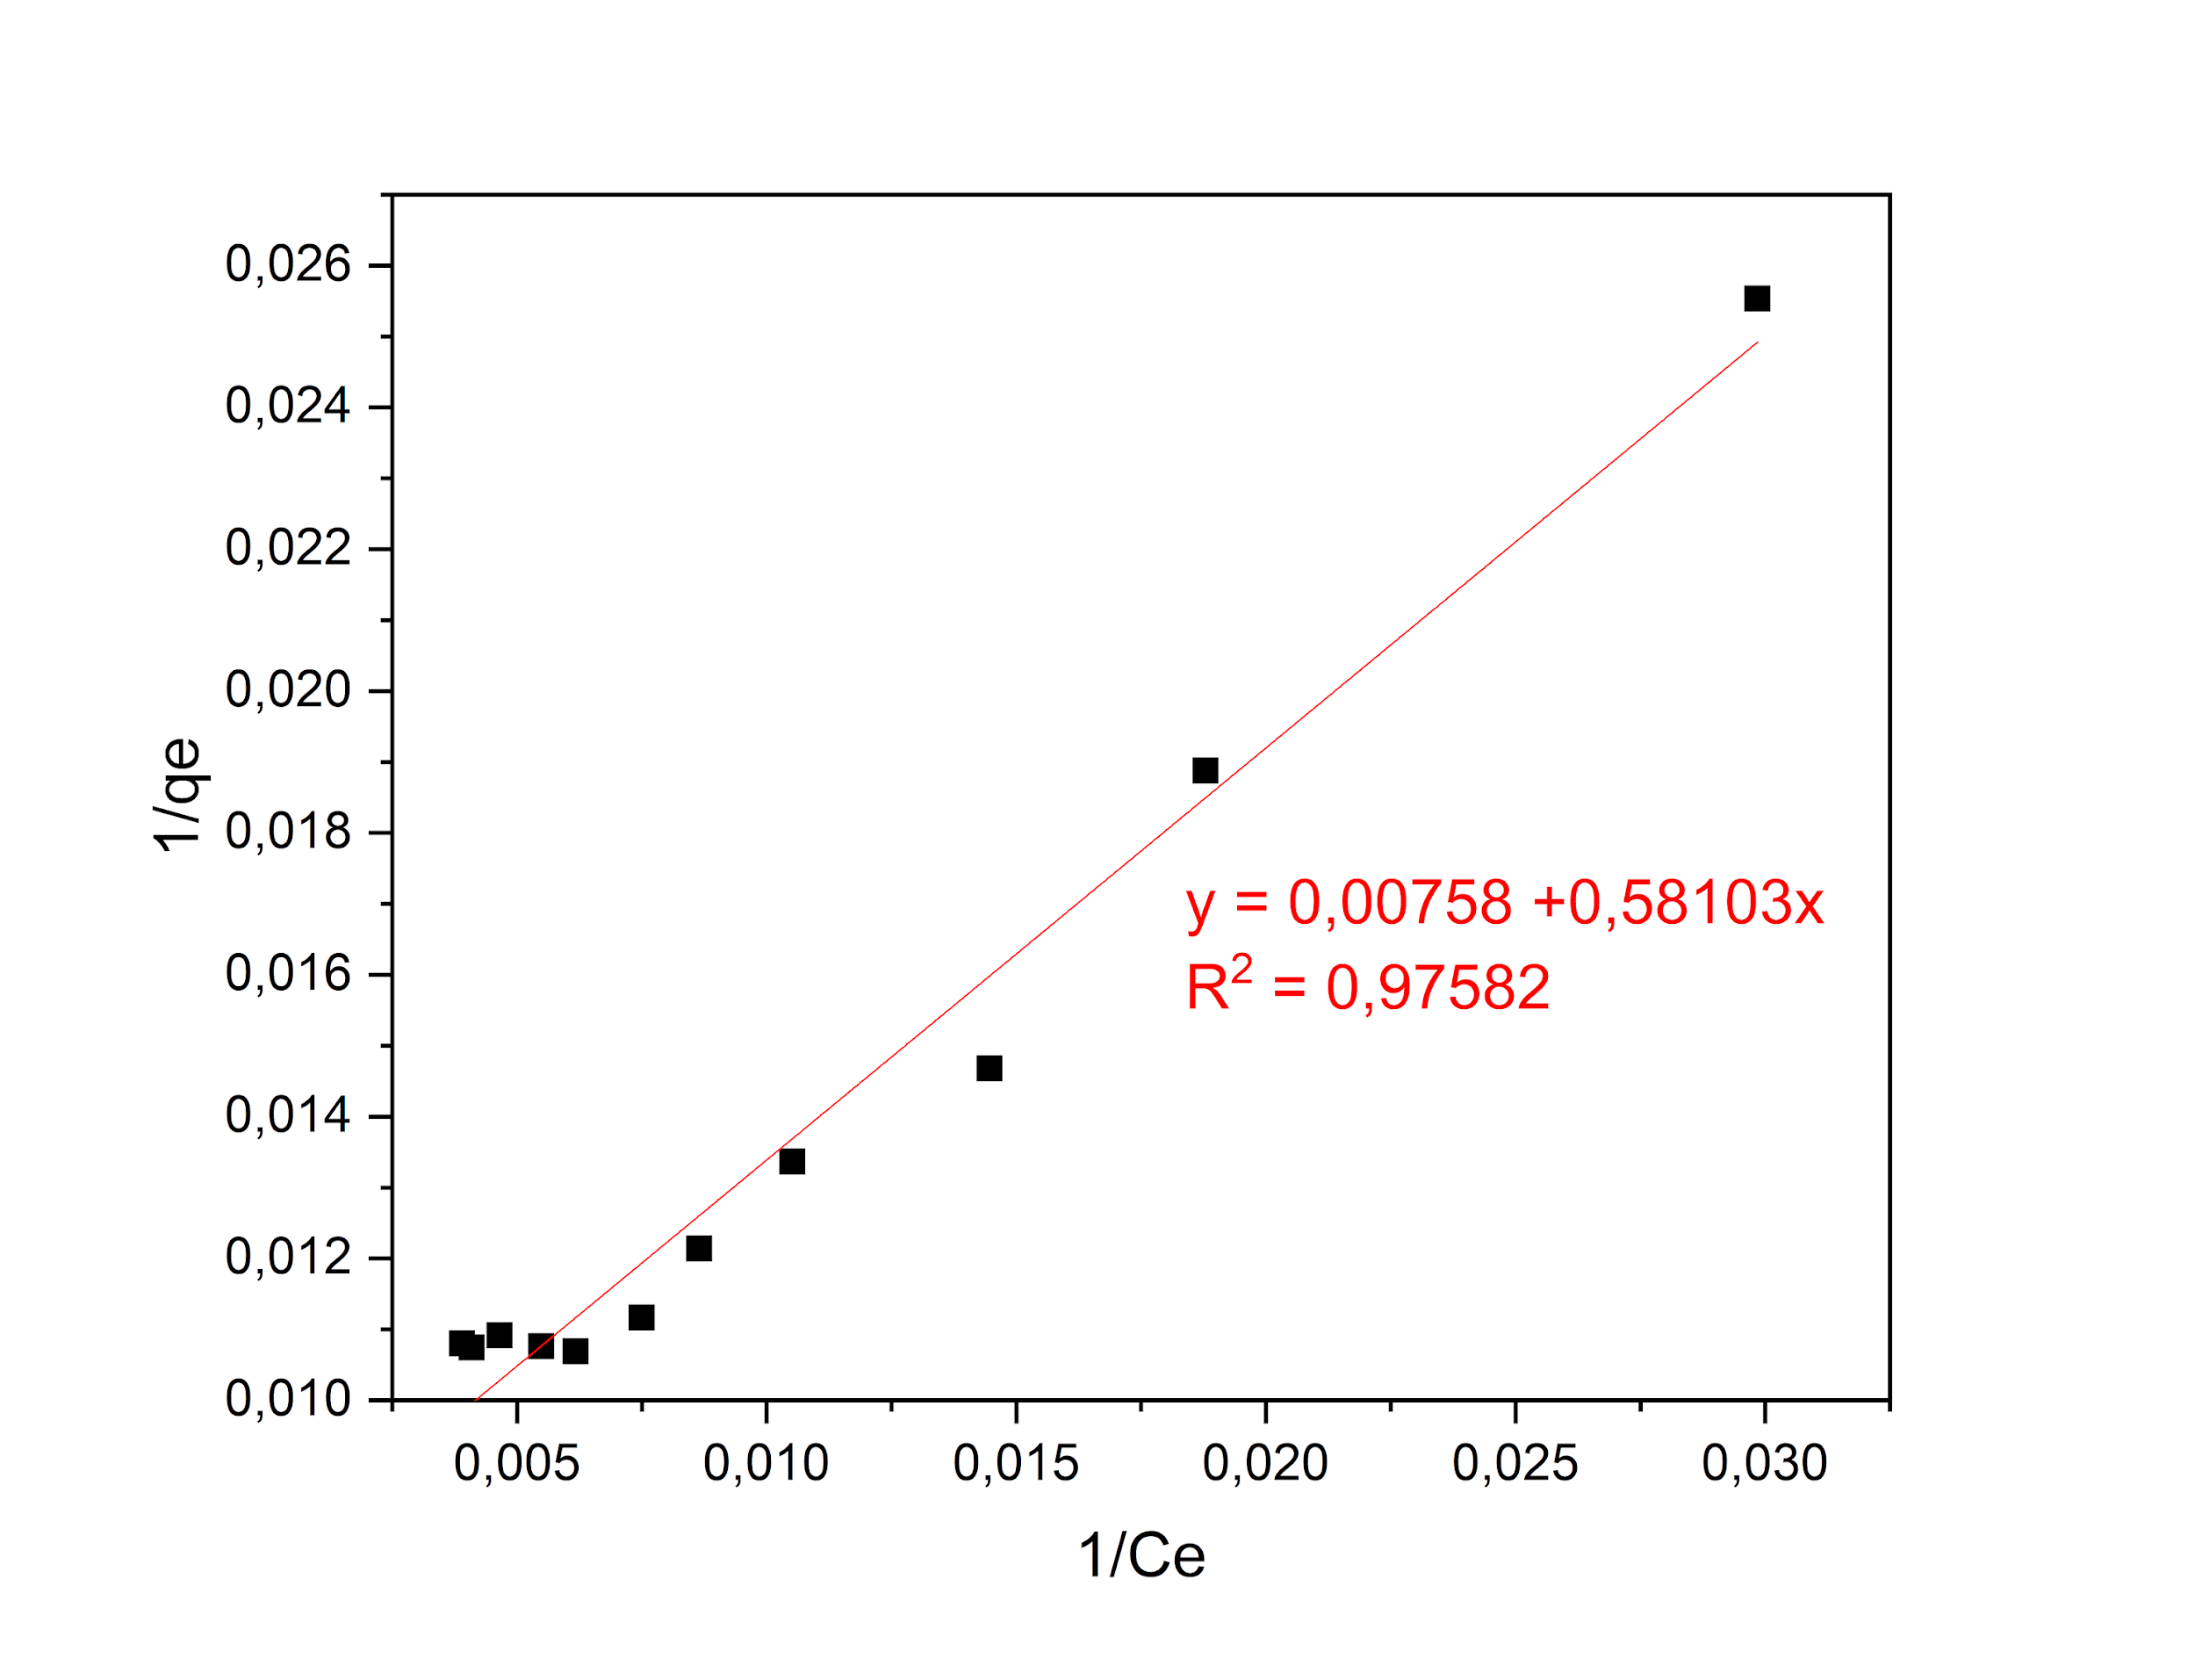
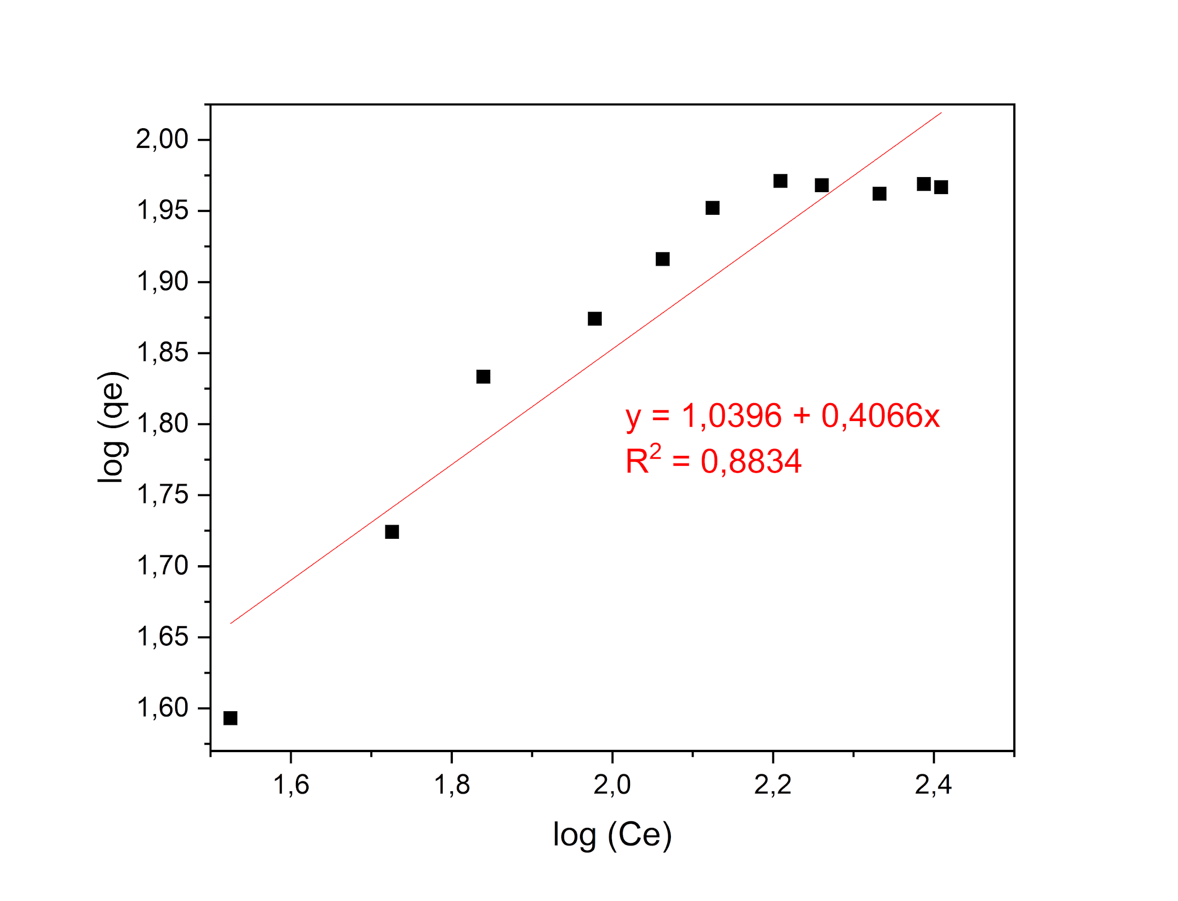
Figure S5 – Linearized Adsorption Isotherm Models for Cu²⁺: (a) Langmuir and (b) Freundlich. pH = 5.0; 220 rpm; 29 ºC.

Figure S6 – Linearized Adsorption Isotherm Models for Zn²⁺: (a) Langmuir and (b) Freundlich. pH = 5.0; 220 rpm; 29 ºC.
