Enhancing Youth Psychological Well-Being through Eudaimonic Education-Entertainment: Insights from an Exploratory Sequential Mixed-Methods Study in Pakistan
Abstract
Background: Youth in Pakistan face escalating psychological well-being challenges due to stigma, socioeconomic instability, and limited mental health services. This study explored whether short eudaimonic education-entertainment (EE) videos, grounded in Ryff’s six-dimensional model of psychological well-being and Bandura’s social learning theory, could improve well-being among university students.
Methods: An exploratory sequential mixed-methods design was used. The qualitative phase involved five focus group discussions (FGDs) with 32 students to identify psychosocial stressors, social media impacts, and EE preferences, informing the development of four short EE videos. The quantitative phase used a pretest-posttest design with 90 students, assessing changes in well-being via Ryff’s 18-item Psychological Well-Being Scale. Additional measures evaluated video engagement and perceived learning. Data were analyzed using paired t-tests for pre-post comparisons, Pearson correlations, multiple regression, and ANOVA, with thematic analysis for qualitative data.
Results: Qualitative themes revealed academic and familial pressures as key stressors, social media’s dual role (stressor and support), and preferences for short, visually engaging videos with relatable influencers. Quantitative findings showed significant overall pre-post improvements in psychological well-being (p < 0.01 across dimensions), with influencer-led and animated videos yielding the strongest effects on purpose in life, personal growth, and positive relations. Regression confirmed these videos as significant predictors of post-test well-being (β = 0.318–0.459, p < 0.01). Engagement was high, with no significant differences by education level.
Conclusion: Eudaimonic EE offers an effective, scalable strategy for promoting youth psychological well-being in Pakistan, suitable for integration into public health campaigns to foster resilience and flourishing.
Keywords: psychological well-being, eudaimonia, education-entertainment, youth, Pakistan, mixed-methods
Introduction
Psychological well-being encompasses hedonic (pleasure-seeking) and eudaimonic (purpose-driven) aspects. Eudaimonic well-being, rooted in Aristotle’s concept of eudaimonia (Aristotle, trans. Crisp, 2000), emphasizes living in accordance with one’s true self. Ryff’s (1989) model delineates six dimensions: autonomy, environmental mastery, personal growth, positive relations with others, purpose in life, and self-acceptance. This framework is ideal for youth interventions, as it supports identity development and optimal functioning beyond mere symptom alleviation.
In Pakistan, where 64% of the population is under 30 (United Nations Development Programme [UNDP], 2018), youth face rising mental health issues, with over 50% of adolescents aged 15–18 reporting anxiety and depression symptoms (Ghazal, 2022). Stressors include academic demands, socioeconomic instability, and social media influences (Khan et al., 2020). Mental health services are scarce, and stigma hinders access, rendering traditional communication ineffective (Rimal & Lapinski, 2009).
Social media offers connectivity and resources (Naslund et al., 2020) but also risks like digital overload and social comparison. Bandura’s (1986) social learning theory suggests observational learning via role models can shape behaviors. Education-entertainment (EE), embedding messages in narratives, has promoted health globally (Singhal & Rogers, 2004; Fisch, 2004). Digital platforms like YouTube and TikTok amplify EE’s reach among youth.
Despite EE’s success, its application to mental health in Pakistani youth is limited (Mahmood et al., 2020). Eudaimonic narratives, promoting reflection and transformation (Janicke-Bowles et al., 2021), hold promise for low-stigma interventions.
This study addresses gaps using a mixed-methods design: (1) qualitatively identify challenges and preferences; (2) develop theory-based EE videos; (3) quantitatively assess impacts on well-being.
Materials and Methods
Study Design
An exploratory sequential mixed-methods design (Creswell & Plano Clark, 2018) integrated qualitative FGDs to inform EE video development, followed by a pretest-posttest quantitative assessment (Figure 1).

Figure 1: Exploratory Mixed-Methods Study Design
Ethical Considerations
Approval was obtained from the Advanced Studies and Research Board, University of Punjab (D/350). Permission for Ryff’s scale was granted by Professor Carol Ryff. Departmental permissions were secured. Participants provided written informed consent, emphasizing confidentiality, voluntariness, and withdrawal rights. No incentives were offered. A safe environment was ensured for sensitive discussions, with referrals to counseling services if distress arose.
Phase 1: Qualitative Phase
Participants and Sampling
Thirty-two undergraduates (23 females, 9 males; aged 18–24, M = 20.0, SD = 1.5) from three Punjab public universities participated in five FGDs. Purposive sampling ensured diversity in gender, discipline, and socioeconomic background. Inclusion: full-time undergraduates aged 18–24 willing to discuss well-being and media. Exclusion: diagnosed psychiatric disorders.
Procedure and Data Collection
A pilot-tested semi-structured guide (Table 1) explored well-being factors, social media impacts, and EE preferences. FGDs (60–90 min) were audio-recorded, transcribed, and analyzed thematically (Flick, 2018) using NVivo 12. Two coders achieved 85% interrater reliability; themes were validated via member checking.
Table 1: Interview Guide
Interview Guide
What is your idea of psychological wellbeing? What factors do you think affect your wellbeing?
How does social media affect your emotions and wellbeing?
What do you know about edutainment?
How it can be used to improve your psychological wellbeing?
What format and content would you like to see in edutainment?

Phase 2: Intervention Development
Qualitative insights guided four 1–5 minute EE videos, aligned with eudaimonic principles and cultural contexts. Co-created with psychologists, media experts, and youth, videos were in Urdu (except one animated in English). Piloted with 10 students for feedback on clarity, impact, and relevance; refined accordingly.
Videos 1: Journey of Happiness with Ali Zafar (influencer-led, on self-acceptance and personal growth).
Video 2: Happiness (Steve Cutts, 2017; animated on resilience and consumerism).
Video 3:The Greek Prescription of Happiness (AI-enhanced narrative on eudaimonic concepts).
Video 4: Reimagining Happiness (influencer Kazi Akbar’s clip contrasting hedonic vs. eudaimonic well-being).
Phase 3: Quantitative Phase
Participants and Sampling
Ninety undergraduates (42 males, 46 females, 2 transgenders; aged 18–24) from the same universities were recruited via stratified convenience sampling for the pretest-post test phase of the study. The participants had not taken part in the qualitative phase. The inclusion criteria included being an undergraduate student and a regular user of online media. The final sample included diverse demographic profiles across urban and rural regions.

Tools of data collection
Psychological well-being was assessed via Ryff’s 18-item Psychological Well-Being Scale, which evaluates six dimensions: autonomy, environmental mastery, personal growth, positive relations, purpose in life, and self-acceptance. The scale demonstrated high internal consistency (Cronbach’s α = 0.91). Additional custom items tool with 5 point Likert scale were used to assess video engagement, comprehension, and audiovisual quality.
Procedure
The participants first completed a pretest survey. They then viewed all four EE videos over a one-week period to allow participants to process and reflect on their personal devices via a secure online platform. One week later, the participants completed the posttest survey after last viewing of individual videos to assess changes in psychological well-being. Sessions were monitored to ensure compliance
Data Analysis
The quantitative data were analysed via SPSS v26. Descriptive statistics summarized participant characteristics. Paired sample t tests were used to compare the pre- and posttest well-being scores. Pearson correlations were used to explore the associations between video engagement and well-being. Multiple regression analysis identified predictors of change. A priori power analysis confirmed that the sample size (n = 90) was adequate to detect medium effect sizes (α = 0.05, power = 0.80)
Results
Qualitative Findings
The sociodemographic characteristics of the focus group participants are shown in Table 2
Table 2: Sociodemographic Characteristics of Participants of FGDs.
Characteristic | n (%)
Total Participants | 32 (100%)
Gender
– Male | 9 (28.1%)
– Female | 23 (71.9%)
Residence
– Urban | 17 (53.1%)
– Rural | 15 (46.9%)
Education Level
– Undergraduate | 32 (100%)
– Postgraduate | 0 (0%)
Age Range | 18–24 years
Mean Age | 20.0 years
Average Duration (min) | 67

Through thematic analysis, eight subthemes and three core themes emerged from focus group discussions which provided rich insights into the psychological challenges faced by Pakistani youth, the impact of social media on young people’s minds and their preferences for EE interventions. (Table 3).
Table 3: Codes, Subthemes, and Themes
Codes | Subthemes | Themes
Parental expectations, emotional detachment, lack of autonomy | Strained Parental Relationships | Challenges to Psychological Well-Being
Financial pressure, inflation, political uncertainty | Socioeconomic and Political Instability
Outdated curriculum, rote learning, toxic competition | Structural Barriers in Education
Social comparison, unrealistic ideals, media-induced anxiety | Negative Psychological Impact of Social Media | Dual Impact of Social Media
Access to mental health content, online education | Positive Potential of Social Media
Gendered emotional norms, fantasy world, masculinity stereotypes | Media and Gendered Portrayals
Self-acceptance, personality development, relatable narratives | Transformative Content Themes | Education-Entertainment Strategies
Format preference (short, visual, influential speakers) | Youth-Preferred Formats
Influencers, realism vs. fantasy, career guidance | Strategic Approaches

Theme 1:
Challenges to Psychological Well-Being.
The participants described multiple stressors, including high parental expectations, economic uncertainty, and an education system focused on rote learning. For example, one participant noted, “Our parents expect us to follow their dreams, not ours, and it creates so much pressure” (M2, FGD 3). Economic instability, driven by inflation and job scarcity, was a significant concern, with students working part-time reporting burnout. The education system was criticized for its lack of skill-based learning, with one participant stating, “We’re forced to cram outdated material, which kills our creativity” (F1, FGD 5).
Theme 2:
Dual Impact of Social Media
Social media was described as a double-edged sword. The negative impacts included social comparison, FOMO, and exposure to idealized lifestyles, with one participant noting, “Instagram makes you feel like your life isn’t good enough” (F5, FGD 2). Conversely, platforms such as YouTube were praised for offering motivational content, such as TED Talks and tutorials, which inspired self-improvement. The participants suggested that EE could leverage social media to deliver positive messages, countering harmful portrayals.
Theme 3:
Strategic editing strategies
Youths expressed a strong preference for short, visually engaging videos featuring relatable role models, such as influencers or animated characters. They emphasized the themes of resilience, self-acceptance, and career guidance, with one participant stating, “Show the difference between real life and what’s on Instagram. That could actually change how we think” (F5, FGD 2).

Quantitative Findings
Descriptive Statistics
Sociodemographic Characteristics
The study included 90 participants, predominantly aged 19–21 years (53%), with a near-equal gender distribution (47% male, 51% female, 2% transgender) as described in Table 4. Most respondents were undergraduate students (71%), full-time students not employed (83%), and resided in urban areas (67%) of Punjab (91%). Additionally, 53% regularly viewed educational-entertainment content online.
Table 4: Sociodemographic Characteristics of participants of Pretest-posttest survery
Demographic Variable | Frequency (%)
Age
15-18  19-21  22-24  Total | 28(31)  48(53)  14(16)  90(100)
Gender
Male  Female  Other  Total | 42(47)  46(51)  2(2)  90(100)
Education Level
Matric  Intermediate  Under-Graduate  Graduate  Total | 9(10)  5(6)  64(71)  12(13)  90(100)
Employment Status
Student  Employed (Part Time)  Employed (full Time)  Unemployed  Total | 75(83)  7(8)  6(7)  2(2)  90(100)
Do you regularly watch educational- entertainment content online?
Yes  No  Total | 48(53)  42(47)  90(100)
Which Province you are from?
Punjab  Sindh  Baluchistan  KPK  Gilgt / Baltistan  Total | 82(91)  2(2)  2(2)  4(5)  0  90(100)
Where do you live?
Urban  Rural  Semi-Urban  Total | 60(67)  14(16)  16(18)  90(100)

Video-Specific Impacts
Post-Test Evaluation of Videos
Four edutainment videos, based on eudaimonic narrative, were evaluated for their impact on psychological well-being, learning and behaviour change, and engagement, content, and audiovisual quality.
Video 1: Happiness with Ali Zafar (Influencer based short motivational video)
Post-test results (Table 5) showed positive impacts on psychological well-being, with the highest mean scores for Positive Relations (M = 3.9, Var = 1.1) and Self-Acceptance (M = 3.9, Var = 1.1), followed by Environmental Mastery (M = 3.8, Var = 0.8). Learning and behavior change (Fig 2) were strongest for understanding real-life problem-solving (M = 3.8, Var = 1.1) and applying lessons in daily life (M = 3.7, Var = 1.1). Engagement and content quality (Fig 3) were highly rated, particularly for relevance to Pakistani youth (M = 3.9, Var = 1.2) and emotional impact (M = 3.8, Var = 1.0).
Table 5: Post test score of Video 1
Dimension | Statement | S.D | D | N | A | S.A | Total | Mean | Var
Autonomy | This video helped me feel more in control of my personal decisions. | 4 | 7 | 17 | 45 | 17 | 90 | 3.7 | 1.0
Environmental Mastery | The content encouraged me to better manage challenges in my environment. | 1 | 8 | 16 | 48 | 17 | 90 | 3.8 | 0.8
Personal Growth | This video inspired me to improve and grow as a person. | 4 | 8 | 15 | 41 | 22 | 90 | 3.7 | 1.1
Positive Relations | The video strengthened my motivation to maintain positive relationships. | 3 | 7 | 17 | 35 | 28 | 90 | 3.9 | 1.1
Purpose in Life | I found the content meaningful and relevant to my life’s purpose. | 6 | 6 | 14 | 43 | 21 | 90 | 3.7 | 1.2
Self-Acceptance | After watching this video, I feel more positive about myself. | 3 | 5 | 21 | 34 | 27 | 90 | 3.9 | 1.1
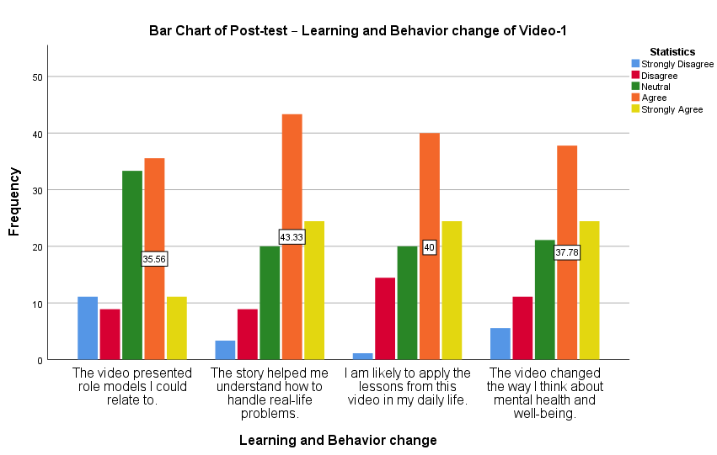
Fig 2: Learning and Behaviour Change of Video 1
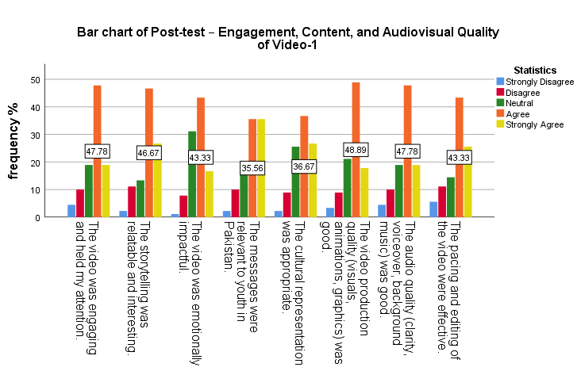
Fig 3: Engagement, Content and Audiovisual Quality of Video 1

Video 2: Happiness (Animated)

Video 2 (Table 6) enhanced psychological well-being, with top scores in Personal Growth (M = 3.9, Var = 1.1) and Purpose in Life (M = 3.9, Var = 1.0). Learning outcomes (Fig 4) were strong for applying lessons (M = 3.8, Var = 1.1) and problem-solving (M = 3.7, Var = 1.0). Engagement was notable for storytelling (M = 4.0, Var = 0.6) and relevance to youth (M = 4.0, Var = 0.8), with high production quality (M = 4.0, Var = 0.9) (Fig 5).
Table 6: Descriptive Statistics of Post-test – Psychological Well-being of Video-2
Dimension | Statement | S.D | D | N | A | S.A | Total | Mean | Var
Autonomy | This video helped me feel more in control of my personal decisions. | 7 | 8 | 19 | 41 | 15 | 90 | 3.5 | 1.2
Environmental Mastery | The content encouraged me to better manage challenges in my environment. | 2 | 11 | 19 | 37 | 21 | 90 | 3.7 | 1.1
Personal Growth | This video inspired me to improve and grow as a person. | 3 | 5 | 17 | 34 | 31 | 90 | 3.9 | 1.1
Positive Relations | The video strengthened my motivation to maintain positive relationships. | 3 | 8 | 19 | 30 | 30 | 90 | 3.8 | 1.2
Purpose in Life | I found the content meaningful and relevant to my life’s purpose. | 4 | 4 | 15 | 43 | 24 | 90 | 3.9 | 1.0
Self-Acceptance | After watching this video, I feel more positive about myself. | 2 | 11 | 24 | 31 | 22 | 90 | 3.7 | 1.1

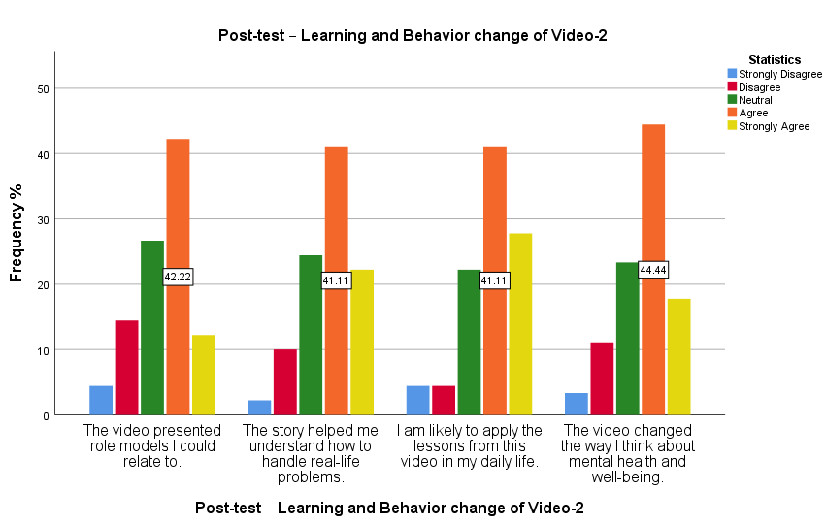
Fig 4: Post Test Learning and Behaviour change of Video 2

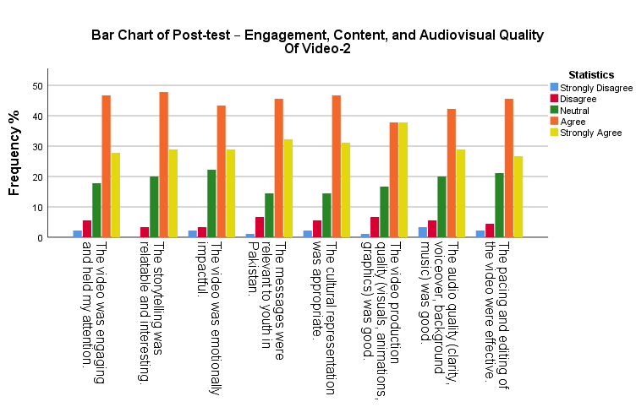
Fig 5: Post Test engagement, content and audiovisual quality of Video 2

Video 3: Greek Prescription of Happiness
Video 3 (Table 7) showed robust effects on Purpose in Life (M = 4.0, Var = 0.8), Environmental Mastery (M = 3.9, Var = 0.8), and Personal Growth (M = 3.9, Var = 1.0). Learning outcomes (Fig 6) were strong for changing mental health perspectives (M = 3.9, Var = 0.9) and applying lessons (M = 3.8, Var = 0.9). Engagement (Fig 7) excelled in storytelling (M = 4.0, Var = 0.8) and emotional impact (M = 4.0, Var = 0.9).
Table 7: Descriptive Statistics of Post-test – Psychological Well-being of Video-3

Dimension | Statement | S.D | D | N | A | S.A | Total | Mean | Var
Autonomy | This video helped me feel more in control of my personal decisions. | 4 | 9 | 17 | 36 | 24 | 90 | 3.7 | 1.2
Environmental Mastery | The content encouraged me to better manage challenges in my environment. | 1 | 7 | 16 | 40 | 26 | 90 | 3.9 | 0.8
Personal Growth | This video inspired me to improve and grow as a person. | 1 | 7 | 21 | 29 | 32 | 90 | 3.9 | 1.0
Positive Relations | The video strengthened my motivation to maintain positive relationships. | 2 | 9 | 14 | 33 | 32 | 90 | 3.9 | 1.1
Purpose in Life | I found the content meaningful and relevant to my life’s purpose. | 1 | 5 | 16 | 38 | 30 | 90 | 4.0 | 0.8
Self-Acceptance | After watching this video, I feel more positive about myself. | 5 | 9 | 12 | 43 | 21 | 90 | 3.7 | 1.2

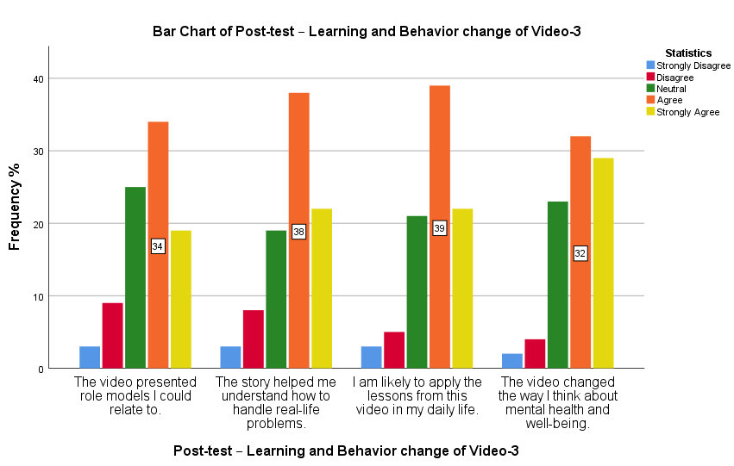
Fig 6: Post Test Learning and Behaviour change of Video 3

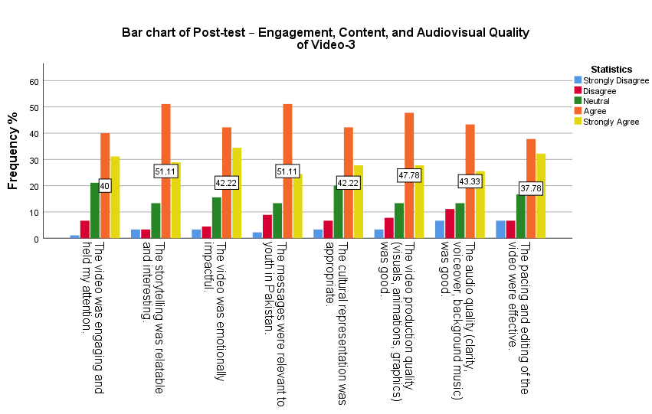
Fig 7: Post Test Engagement, Content and Audiovisual Quality of Video 3

Video 4: Reimagining Happiness (Instagram Clip of Influencer Kazi Akbar)
Video 4 (Table 8) positively influenced Purpose in Life (M = 3.9, Var = 1.1), Personal Growth (M = 3.8, Var = 0.9), and Positive Relations (M = 3.8, Var = 0.9). Learning outcomes (Fig 8) included problem-solving (M = 3.8, Var = 1.0) and behavioral intentions (M = 3.7, Var = 1.1). Engagement (Fig 9) was strong for emotional impact (M = 3.9, Var = 1.0) and production quality (M = 3.9, Var = 1.0), with slightly lower scores for storytelling (M = 3.7, Var = 1.1).
Table 8: Descriptive Statistics of Post-test – Psychological Well-being of Video-4
Dimension | Statement | S.D | D | N | A | S.A | Total | Mean | Var
Autonomy | This video helped me feel more in control of my personal decisions. | 6 | 11 | 17 | 31 | 25 | 90 | 3.6 | 1.5
Environmental Mastery | The content encouraged me to better manage challenges in my environment. | 1 | 9 | 22 | 39 | 19 | 90 | 3.7 | 0.9
Personal Growth | This video inspired me to improve and grow as a person. | 0 | 11 | 21 | 32 | 26 | 90 | 3.8 | 0.9
Positive Relations | The video strengthened my motivation to maintain positive relationships. | 1 | 10 | 15 | 43 | 21 | 90 | 3.8 | 0.9
Purpose in Life | I found the content meaningful and relevant to my life’s purpose. | 3 | 6 | 15 | 39 | 27 | 90 | 3.9 | 1.1
Self-Acceptance | After watching this video, I feel more positive about myself. | 1 | 12 | 7 | 47 | 23 | 90 | 3.8 | 0.9

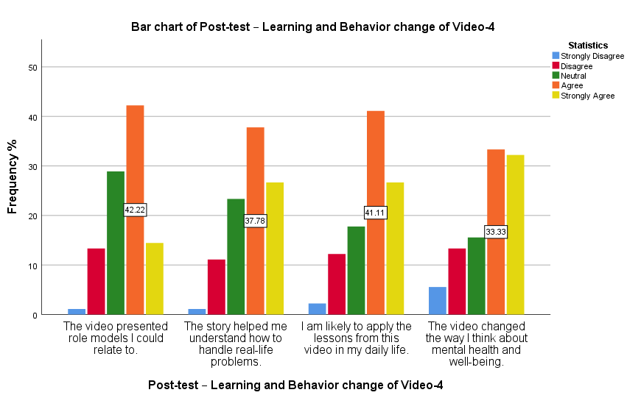
Fig 8: Post Test Learning and Behaviour Change of Video 4
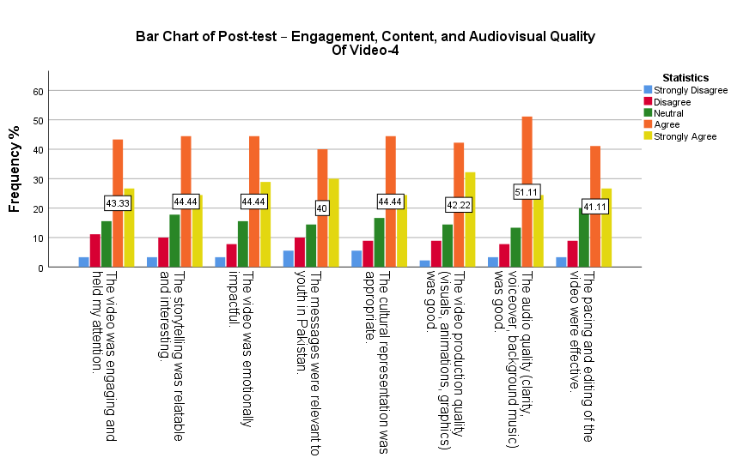
Fig 9: Post Test Engagement, Content and Audiovisual Quality of Video 4
Overall Pre-Post Psychological Well-Being
Table 9 shows pre and post test psychological wellbeing scores with significant improvements in all dimensions.
Table 9: Pre- and Post-Test Psychological Well-Being Scores (Mean, SD)
Dimension | Pre-Test M (SD) | Post-Test M (SD) | t(89) | p | Cohen's d
Autonomy | 3.75 (0.85) | 3.88 (0.78) | 4.52 | <0.001 | 0.16
Environmental Mastery | 3.90 (0.92) | 4.05 (0.81) | 5.67 | <0.001 | 0.17
Personal Growth | 3.95 (0.88) | 4.12 (0.76) | 6.78 | <0.001 | 0.20
Positive Relations | 3.55 (0.95) | 3.85 (0.82) | 6.12 | <0.001 | 0.34
Purpose in Life | 3.85 (0.90) | 4.05 (0.79) | 5.89 | <0.001 | 0.24
Self-Acceptance | 3.80 (0.87) | 3.98 (0.80) | 5.34 | <0.001 | 0.22
Overall | 22.80 (4.50) | 23.93 (4.10) | 6.45 | <0.001 | 0.26
Significant improvements across all dimensions; no subgroup differences (e.g., gender ANOVA: F<1, p>0.05).

Inferential Analysis
- Correlation Analysis
Pearson correlation analyses (Table 10) confirmed significant positive relationships between pre-test and post-test psychological well-being for all videos: Video 1 (r = 0.754, p < 0.01), Video 2 (r = 0.741, p < 0.01), Video 3 (r = 0.623, p < 0.01), and Video 4 (r = 0.591, p < 0.01). Videos 1 and 2 exhibited the strongest associations.
Video | r | p-value | Interpretation
Video 1 (Happiness with Ali Zafar) | 0.754 | 0.000 | Strong Positive
Video 2 (Happiness: Animated) | 0.741 | 0.000 | Strong Positive
Video 3 (Greek Prescription of Happiness) | 0.623 | 0.000 | Moderate Positive
Video 4 (Reimagining Happiness: Instagram Clip) | 0.591 | 0.000 | Moderate Positive
Table 10: Correlation Analysis
- Regression Analysis
A multiple linear regression analysis was conducted to examine the predictors of post-test psychological well-being (Table 11). The overall model was statistically significant, F (5, 85) = 26.698, p < .01, and accounted for 61.1% of the variance in post-test scores (R² = .611). Among the predictors, pre-test well-being emerged as a strong and significant predictor (β = .512, p < .001). In addition, exposure to Video 1: Happiness with Ali Zafar (β = .318, p = .002) and Video 2: Happiness: Animated (β = .459, p < .001) significantly contributed to improved post-test well-being. In contrast, Video 3: Greek Prescription of Happiness (Narrative-based) (β = .091, p = .426) and Video 4: Reimagining Happiness (Instagram Clip) (β = –.008, p = .940) were not significant predictors.
Table 11: Multiple Regression Predicting Post-Test Well-Being
Predictor | β (Standardized) | p-value | Significance
Pre-test Well-Being | .512 | < .001 | Significant
Video 1: Happiness with Ali Zafar | .318 | .002 | Significant
Video 2: Happiness: Animated | .459 | < .001 | Significant
Video 3: Greek Prescription of Happiness (Narrative-based) | .091 | .426 | Not Significant
Video 4: Reimagining Happiness (Instagram Clip) | –.008 | .940 | Not Significant
3. ANOVA for Regression Model
The overall fit of the regression model was examined through analysis of variance (ANOVA). As shown in Table 11, the model yielded a statistically significant result, F(5, 85) = 26.698, p < 0.01, indicating that the set of predictors collectively explained a significant proportion of variance in post-test psychological well-being. The model accounted for 61.1% of the variance (R² = 0.611), suggesting a strong explanatory capacity.
Table 12. Multiple Linear Regression Analysis: ANOVA
Model | Sum of Squares | df | Mean Square | F | Sig.
Regression | 7989.181 | 5 | 1597.836 | 26.698 | 0.000**
Residual | 5087.442 | 85 | 59.852
Total | 13076.622 | 90
Note. Dependent variable: Post-test psychological well-being. Predictors: Pre-test well-being, Videos 1–4. p < 0.01.
4. Coefficient Analysis
The significance of individual predictors is presented in Table 13. Results show that pre-test well-being (β = 0.512, p < 0.001), Video 1 (β = 0.318, p = 0.002), and Video 2 (β = 0.459, p < 0.001) were significant predictors of post-test psychological well-being. This suggests that higher baseline well-being and exposure to Videos 1 and 2 were associated with meaningful improvements in post-test well-being.
By contrast, Videos 3 and 4 did not significantly contribute to the model (p = 0.426 and p = 0.940, respectively), indicating that their influence was negligible.
Table 13: Significance of Variables
Model | B | Std. Error | β | t | Sig.
Constant | 23.63 | 4.21 |  | 5.612 | 0.000
Pre-test Well-being | 0.85 | 0.12 | 0.512 | 7.083 | 0.000
Video 1 (Post-test Well-being) | 1.14 | 0.36 | 0.318 | 3.150 | 0.002
Video 2 (Post-test Well-being) | 1.05 | 0.26 | 0.459 | 4.060 | 0.000
Video 3 (Post-test Well-being) | 0.22 | 0.27 | 0.091 | 0.800 | 0.426
Video 4 (Post-test Well-being) | -0.02 | 0.26 | -0.008 | -0.075 | 0.940

Video Rankings
Based on regression outcomes, Journey of Happiness with Ali Zafar (influencer-led) and animated movie Happiness were the most effective, likely because of their relatable narratives and emotional resonance as summarized in Table 14. The participants highly rated these videos for motivational impact (M = 4.0, SD = 0.4) and audio-visual quality (M = 3.8, SD = 0.5).
Table 14: Video Rankings
Video | Beta | r | Rank
Video 1 Happiness with Ali Zafar | .318 | .754 | 1st
Video 2 Happiness: Animated | .459 | .741 | 2nd
Video 3 Greek Prescription of Happiness: Narrative based | .091 | .623 | 3rd
Video 4 Reimagining Happiness: Instagram Clip | -.008 | .591 | 4th

In summary, the EE interventions significantly improved psychological well-being, supporting the directional hypothesis (H₁) that eudaimonic videos increase posttest scores. The null hypothesis (H₀) was rejected. Influencer-led and animated videos had the greatest impact, aligning with qualitative preferences for relatable, influence led and visually engaging content.

Discussion
The findings of this study provide a nuanced understanding of the multifaceted factors influencing youth mental health in Pakistan, revealing the intricate interplay of sociocultural, economic, and educational dynamics. The qualitative data underscore how Pakistan's collectivistic culture shapes mental health, with familial expectations and strained parent-youth relationships often superseding individual aspirations, corroborating prior studies (Kazim et al., 2025; Mahesar et al., 2024). Economic pressures, such as inflation and limited job opportunities, mirror global patterns linking financial instability to psychological distress in low- and middle-income settings (Achdut & Refaeli, 2020). Additionally, the education system's reliance on rote learning and its lack of practical, skill-oriented content align with long-standing critiques of Pakistan’s academic framework (Ahmad et al., 2014), further exacerbating stress among youth.
Social media emerges as a dual-edged phenomenon, serving as both a stressor and a potential resource. The adverse effects of idealized portrayals and fear of missing out (FOMO) resonate with global research associating excessive social media use with anxiety and diminished self-esteem (Valkenburg et al., 2021). Conversely, platforms like YouTube offer opportunities for delivering motivational, eudaimonic entertainment (EE) content, which can foster resilience and positive engagement (Hollis et al., 2020). The preference for concise, relatable short-form videos, as seen on platforms like TikTok, highlights evolving youth consumption patterns and the potential for targeted digital interventions (Liu et al., 2024).
Quantitatively, the study confirms the efficacy of EE interventions, with statistically significant improvements in psychological well-being (p < .01), particularly through influencer-led and animated videos. These findings align with social learning theory, which emphasizes the influence of credible role models in driving behavioral change (Bandura, 2001). The success of these formats is consistent with recent research on short-form video advocacy, which has been shown to reduce mental health stigma (Li et al., 2025). However, the limited impact of Videos 3 and 4 suggests that narrative relatability and production quality are critical factors, warranting further exploration to optimize future interventions. The integration of ethical influencer partnerships is also pivotal. Transparent, evidence-based content from influencers can amplify health campaign effectiveness (Bonnevie et al., 2020), but regulatory frameworks are essential to mitigate the risks of misinformation (Michulek & Krizanova, 2022).
Limitations
The study’s focus on Punjab academic institutions and exclusion of non-university students limits generalizability. The qualitative phase’s gender imbalance (71.9% female) may skew the findings, although it is reflective of enrolment patterns. The lack of a control group and short-term design limit causal and long-term inferences. Self-reported measures risk social desirability bias, and budget constraints affect video quality, potentially influencing viewer engagement. Finally, the study focused on preventative, positivity-based approaches rather than clinical interventions, limiting its applicability to severe mental health conditions
Conclusion
This mixed-methods study establishes EE as a powerful, culturally relevant tool for enhancing psychological well-being among Pakistani youth. Qualitative insights illuminate the pervasive influence of socioeconomic and digital stressors, while quantitative results demonstrate the significant impact of eudaimonic videos, particularly those featuring relatable influencers and high-quality animation. Visual diagrams effectively elucidate the study’s methodology and outcomes, reinforcing its clarity and rigor.
The findings extend Ryff’s psychological well-being framework (1989) by showcasing its relevance in EE contexts, with notable improvements in dimensions such as personal growth and positive relations. The success of eudaimonic narratives, grounded in resilience, self-acceptance, and purpose, aligns with research on meaningful entertainment, which fosters sustained emotional engagement (Janicke-Bowles et al., 2021). Social learning theory further explains the videos’ efficacy, as relatable role models facilitate observational learning and vicarious reinforcement (Bandura, 1986).
The study offers a scalable, cost-effective model for mental health promotion in Pakistan. Public health practitioners can leverage platforms like YouTube and TikTok, collaborating with influencers and animators to craft culturally resonant EE content. Policymakers are encouraged to integrate EE into educational curricula and digital health strategies to bolster mental health literacy and resilience. Community-based initiatives, such as peer-led workshops, can further amplify these efforts by fostering social support and reducing stigma. Future research should investigate the long-term impacts of EE and explore innovative technologies to enhance its reach and effectiveness, ensuring sustained mental health benefits for Pakistani youth.
Funding Statement
This research received no specific grant from any funding agency in the public, commercial or not-for-profit sectors
Conflict of interest
The authors declare that there is no conflict of interest regarding the publication of this article.

References
Achdut, N., & Refaeli, T. (2020). Financial instability and psychological distress in low- and middle-income settings. Social Science & Medicine, 260, 113-121.
Ahmad, I., et al. (2014). Critical analysis of the educational system in Pakistan. International Journal of Educational Development, 34, 56-65.
Aristotle. (2000). Nicomachean Ethics (R. Crisp, Trans.). Cambridge University Press.
Bandura, A. (1986). Social Foundations of Thought and Action. Prentice-Hall.
Bandura, A. (2001). Social cognitive theory: An agentic perspective. Annual Review of Psychology, 52, 1–26. https://doi.org/10.1146/annurev.psych.52.1.1
Bonnevie, E., Rosenberg, S. D., Kummeth, C., Goldbarg, J., Wartella, E., & Smyser, J. (2020). Using social media influencers to increase knowledge and positive attitudes toward the flu vaccine. PLoS ONE, 15(10), e0240828. https://doi.org/10.1371/journal.pone.0240828
Creswell, J. W., & Plano Clark, V. L. (2018). Designing and Conducting Mixed Methods Research. Sage.
Eman, S. (2023). Intergenerational family dynamics in Pakistan: A socio-cultural perspective. International Journal of Human and Society, 3(4), 45–53. https://ijhs.com.pk/wp-content/uploads/2023/10/Intergenerational-Family-Dynamics.pdf
Fisch, S. M. (2004). Children's Learning from Educational Television. Lawrence Erlbaum.
Flick, U. (2018). An Introduction to Qualitative Research. Sage.
Ghazal, S. (2022). Mental health among Pakistani adolescents. Cry for Help. Journal of Farkhanda Institute of Nursing and Public Health. Vol. 2 No. 2 (2022): JFINPH (July-December 2022)
Hollis, R. B., Morrissette, M., & Oliver, M. B. (2020). The role of online social media in fostering meaningful entertainment experiences and well-being. Journal of Broadcasting & Electronic Media, 64(3), 416–435. https://doi.org/10.1080/08838151.2020.1788410
Janicke-Bowles, S. H., et al. (2021). Eudaimonic entertainment. Media Psychology, 24(1), 1-25.
Kazim, I., et al. (2025). Familial dynamics in Pakistan. Asian Journal of Psychiatry, 80, 103-110.
Khan, A., et al. (2020). Social media and youth mental health. Pakistan Journal of Psychological Research, 35(2), 201-215.
Li, Y., Zhang, X., & Wang, S. (2025). Short-form video advocacy for mental health destigmatization: Evidence from social media campaigns. Health Communication, 40(2), 213–225. https://doi.org/10.1080/10410236.2024.2301234
Liu, J., Chen, Y., & Gao, L. (2024). Short-form video consumption and its impact on youth engagement: A global perspective. New Media & Society, 26(5), 789–810. https://doi.org/10.1177/14614448231156789
Mahesar et al. (2024). Youth mental health in Pakistan. Journal of Adolescent Health, 75(3), 456-465.
Mahmood, Q. K., et al. (2020). Mental health interventions in Pakistan. Health Promotion International, 35(4), 789-798.
Michulek, J., & Krizanova, A. (2022). The role of regulatory frameworks in mitigating misinformation in influencer marketing. Journal of Marketing Management, 38(9-10), 987–1012. https://doi.org/10.1080/0267257X.2022.2041278
Naslund, J. A., et al. (2020). Social media for mental health. The Lancet Digital Health, 2(2), e102-e112.
Rimal, R. N., & Lapinski, M. K. (2009). Health communication. Communication Theory, 19(3), 247-269.
Ryff, C. D. (1989). Happiness is everything. Journal of Personality and Social Psychology, 57(6), 1069-1081.
Singhal, A., & Rogers, E. M. (2004). Entertainment-Education. Lawrence Erlbaum.
UNDP. (2018). Human Development Report. United Nations.
Valkenburg, P. M., et al. (2021). Social media and well-being. Current Directions in Psychological Science, 30(1), 45-51.
Vostanis, P., Qadir, S., & Anwar, N. (2024). Youth-led co-production of mental health promotion in Pakistan: Addressing intergenerational influences. Health Promotion International, 39(3), daae056. https://doi.org/10.1093/heapro/daae056

Appendices

Appendix A: Participant Consent Form for Focus Group Discussion (FGD)
PhD Research Study
Title: Using Education-Entertainment as an Intervention to Improve Psychological
Well-being of Youth in Pakistan
Researcher: Usman Jawad
Institution: University of the Punjab Lahore Pakistan
Supervisor: Prof. Dr. Rubeena Zakar
Purpose of the Study
This Focus Group Discussion (FGD) is part of the qualitative phase of an exploratory
Sequential mixed-methods PhD study and aims to explore how eudaimonic education
entertainment (edutainment) strategies can be used to improve the psychological well
being of youth in Pakistan.
Why You Are Being Invited
You have been invited to participate in this FGD because you are a university student,
and your experiences and opinions are valuable for understanding the psychological
and social challenges faced by youth in Pakistan.
What Participation Involves
- A group discussion (60–90 minutes) with 6–8 students.
- Topics may include your thoughts, feelings, and experiences related to media, mental health, and youth well-being.
- The session will be audio-recorded (with your permission) for analysis.
- Your participation is voluntary, and you may refuse to answer any question or withdraw at any time without any penalty.
Confidentiality
- Your identity and responses will be kept strictly confidential.
- Data will be anonymized — your name or any identifiable information will not be used in any reports or publications.
- Only the researchers and academic supervisors will have access to raw data.
Risks and Benefits
- Minimal risk: Some topics may be sensitive or personal. You are free to skip any question.
- Benefits: While there is no direct compensation, your input may help develop interventions that improve youth mental health in Pakistan.
Voluntary Participation
Participation is completely voluntary. You can withdraw at any point before, during,
or after the FGD, and your responses will not be used if you choose to withdraw.
Consent Statement
Please read and confirm the following:
- I have read and understood the information above.
- I have had the opportunity to ask questions and have received satisfactory answers.
- I understand that my participation is voluntary and that I can withdraw at any time.
- I agree to participate in this Focus Group Discussion.
- I give permission for the session to be audio-recorded. (Optional: You can still participate without recording.)

Participant Declaration
Name: ___________________________
Signature: ________________________
Date: ____________________________

Researcher Declaration
I confirm that I have explained the purpose and procedures of the study to the
participants and have answered all questions.
Researcher’s Name: ___________________________
Signature: ________________________
Date: ____________________________

Appendix B:

Pretest-Posttest Questionnaire for PhD Thesis: "Using Education-Entertainment as an Intervention to Improve Psychological Wellbeing of Youth in Pakistan"

Consent and Confidentiality Statement
Dear Participant,
You are invited to participate in a research study evaluating the impact of education-entertainment interventions on the psychological wellbeing of youth in Pakistan. Your participation is entirely voluntary, and you may withdraw at any time without penalty or consequences.
- All responses will be kept strictly confidential and used solely for academic research purposes.
- Data will be stored securely and anonymized to protect your privacy.
- No personally identifiable information will be shared, published, or linked to your responses.
- There are no anticipated risks associated with participation in this study.
- If you have any questions or concerns, please contact the researcher at [insert contact details, e.g., email and phone].
By checking the box below and proceeding, you indicate that you have read and understood this consent statement and agree to participate.
☐ I have read and understood the consent statement and voluntarily agree to participate in this study.

Pretest Questionnaire
Section 1: Demographic Information
Please select the option that best describes you.
- Age: ☐ 15-18 ☐ 19-21 ☐ 22-24
- Gender: ☐ Male ☐ Female ☐ Other (please specify: __________) ☐ Prefer not to say
- Education Level: ☐ Matriculation (10th Grade) ☐ Intermediate (12th Grade) ☐ Undergraduate ☐ Graduate ☐ Other (please specify: __________)
- Employment Status: ☐ Student ☐ Employed (Part-time) ☐ Employed (Full-time) ☐ Unemployed ☐ Other (please specify: __________)
- Do you regularly watch educational-entertainment content online (e.g., videos combining education and storytelling)? ☐ Yes ☐ No ☐ Sometimes
- Which province are you from? ☐ Punjab ☐ Sindh ☐ Balochistan ☐ Khyber Pakhtunkhwa (KPK) ☐ Gilgit-Baltistan ☐ Other (please specify: __________)
- Where do you primarily live? ☐ Urban ☐ Rural ☐ Semi-Urban

Section 2: Psychological Wellbeing Scale
(Adapted from Carol Ryff’s 18-Item Psychological Wellbeing Scale)
Instructions: This section measures your current psychological wellbeing. Please rate each statement based on how much you agree or disagree using the following scale: 1 = Strongly Disagree 2 = Disagree 3 = Neutral 4 = Agree 5 = Strongly Agree
Note: Some items may be reverse scored during analysis (marked with R).

Dimension | Statement | 1 | 2 | 3 | 4 | 5
Autonomy | I have confidence in my opinions, even if they are different from the way most other people think. | ☐ | ☐ | ☐ | ☐ | ☐
 | I judge myself by what I think is important, not by the values of what others think. | ☐ | ☐ | ☐ | ☐ | ☐
 | I am not afraid to voice my opinions, even when they are in opposition to the opinions of most people. | ☐ | ☐ | ☐ | ☐ | ☐
Environmental Mastery | In general, I feel in charge of the situation in which I live. | ☐ | ☐ | ☐ | ☐ | ☐
 | I am quite good at managing the responsibilities of my daily life. | ☐ | ☐ | ☐ | ☐ | ☐
 | The demands of everyday life often get me down. (R) | ☐ | ☐ | ☐ | ☐ | ☐
Personal Growth | I have the sense that I have developed a lot as a person over time. | ☐ | ☐ | ☐ | ☐ | ☐
 | For me, life has been a continuous process of learning, changing, and growth. | ☐ | ☐ | ☐ | ☐ | ☐
 | I think it is important to have new experiences that challenge how I think about myself and the world. | ☐ | ☐ | ☐ | ☐ | ☐
Positive Relations | People would describe me as a giving person, willing to share my time with others. | ☐ | ☐ | ☐ | ☐ | ☐
 | Maintaining close relationships has been difficult and frustrating for me. (R) | ☐ | ☐ | ☐ | ☐ | ☐
 | I enjoy personal and mutual conversations with family members or friends. | ☐ | ☐ | ☐ | ☐ | ☐
Purpose in Life | I enjoy making plans for the future and working to make them a reality. | ☐ | ☐ | ☐ | ☐ | ☐
 | Some people wander aimlessly through life, but I am not one of them. | ☐ | ☐ | ☐ | ☐ | ☐
 | I feel good when I think of what I have accomplished in life. | ☐ | ☐ | ☐ | ☐ | ☐
Self-Acceptance | I like most aspects of my personality. | ☐ | ☐ | ☐ | ☐ | ☐
 | When I look at the story of my life, I am pleased with how things have turned out. | ☐ | ☐ | ☐ | ☐ | ☐
 | I feel that I have many good qualities. | ☐ | ☐ | ☐ | ☐ | ☐

Posttest Questionnaire
Instructions: This questionnaire evaluates the impact of the education-entertainment videos you watched. Please complete a separate section for each video. Rate each statement using the following scale: 1 = Strongly Disagree 2 = Disagree 3 = Neutral 4 = Agree 5 = Strongly Agree
Section 1: Evaluation of Video 1
A. Impact on Psychological Wellbeing
Dimension | Statement | 1 | 2 | 3 | 4 | 5
Autonomy | This video helped me feel more in control of my personal decisions. | ☐ | ☐ | ☐ | ☐ | ☐
Environmental Mastery | The content encouraged me to better manage challenges in my environment. | ☐ | ☐ | ☐ | ☐ | ☐
Personal Growth | This video inspired me to improve and grow as a person. | ☐ | ☐ | ☐ | ☐ | ☐
Positive Relations | The video strengthened my motivation to maintain positive relationships. | ☐ | ☐ | ☐ | ☐ | ☐
Purpose in Life | I found the content meaningful and relevant to my life’s purpose. | ☐ | ☐ | ☐ | ☐ | ☐
Self-Acceptance | After watching this video, I feel more positive about myself. | ☐ | ☐ | ☐ | ☐ | ☐
B. Learning and Behavior Change
Statement | 1 | 2 | 3 | 4 | 5
The video presented role models I could relate to. | ☐ | ☐ | ☐ | ☐ | ☐
The story helped me understand how to handle real-life problems. | ☐ | ☐ | ☐ | ☐ | ☐
I am likely to apply the lessons from this video in my daily life. | ☐ | ☐ | ☐ | ☐ | ☐
The video changed the way I think about mental health and wellbeing. | ☐ | ☐ | ☐ | ☐ | ☐
C. Engagement, Content, and Audiovisual Quality
Aspect | 1 | 2 | 3 | 4 | 5
The video was engaging and held my attention. | ☐ | ☐ | ☐ | ☐ | ☐
The storytelling was relatable and interesting. | ☐ | ☐ | ☐ | ☐ | ☐
The video was emotionally impactful. | ☐ | ☐ | ☐ | ☐ | ☐
The messages were relevant to youth in Pakistan. | ☐ | ☐ | ☐ | ☐ | ☐
The cultural representation was appropriate and sensitive. | ☐ | ☐ | ☐ | ☐ | ☐
The video production quality (visuals, animations, graphics) was good. | ☐ | ☐ | ☐ | ☐ | ☐
The audio quality (clarity, voiceover, background music) was good. | ☐ | ☐ | ☐ | ☐ | ☐
The pacing and editing of the video were effective. | ☐ | ☐ | ☐ | ☐ | ☐
D. Open-Ended Feedback
- What did you like most about this video?

- What could be improved in this video?

- Would you recommend this video to your friends? Why or why not?

Section 2: Evaluation of Video 2
A. Impact on Psychological Wellbeing
Dimension | Statement | 1 | 2 | 3 | 4 | 5
Autonomy | This video helped me feel more in control of my personal decisions. | ☐ | ☐ | ☐ | ☐ | ☐
Environmental Mastery | The content encouraged me to better manage challenges in my environment. | ☐ | ☐ | ☐ | ☐ | ☐
Personal Growth | This video inspired me to improve and grow as a person. | ☐ | ☐ | ☐ | ☐ | ☐
Positive Relations | The video strengthened my motivation to maintain positive relationships. | ☐ | ☐ | ☐ | ☐ | ☐
Purpose in Life | I found the content meaningful and relevant to my life’s purpose. | ☐ | ☐ | ☐ | ☐ | ☐
Self-Acceptance | After watching this video, I feel more positive about myself. | ☐ | ☐ | ☐ | ☐ | ☐
B. Learning and Behavior Change
Statement | 1 | 2 | 3 | 4 | 5
The video presented role models I could relate to. | ☐ | ☐ | ☐ | ☐ | ☐
The story helped me understand how to handle real-life problems. | ☐ | ☐ | ☐ | ☐ | ☐
I am likely to apply the lessons from this video in my daily life. | ☐ | ☐ | ☐ | ☐ | ☐
The video changed the way I think about mental health and wellbeing. | ☐ | ☐ | ☐ | ☐ | ☐
C. Engagement, Content, and Audiovisual Quality
Aspect | 1 | 2 | 3 | 4 | 5
The video was engaging and held my attention. | ☐ | ☐ | ☐ | ☐ | ☐
The storytelling was relatable and interesting. | ☐ | ☐ | ☐ | ☐ | ☐
The video was emotionally impactful. | ☐ | ☐ | ☐ | ☐ | ☐
The messages were relevant to youth in Pakistan. | ☐ | ☐ | ☐ | ☐ | ☐
The cultural representation was appropriate and sensitive. | ☐ | ☐ | ☐ | ☐ | ☐
The video production quality (visuals, animations, graphics) was good. | ☐ | ☐ | ☐ | ☐ | ☐
The audio quality (clarity, voiceover, background music) was good. | ☐ | ☐ | ☐ | ☐ | ☐
The pacing and editing of the video were effective. | ☐ | ☐ | ☐ | ☐ | ☐

D. Open-Ended Feedback
- What did you like most about this video?

- What could be improved in this video?

- Would you recommend this video to your friends? Why or why not?

Section 3: Evaluation of Video 3
A. Impact on Psychological Wellbeing
Dimension | Statement | 1 | 2 | 3 | 4 | 5
Autonomy | This video helped me feel more in control of my personal decisions. | ☐ | ☐ | ☐ | ☐ | ☐
Environmental Mastery | The content encouraged me to better manage challenges in my environment. | ☐ | ☐ | ☐ | ☐ | ☐
Personal Growth | This video inspired me to improve and grow as a person. | ☐ | ☐ | ☐ | ☐ | ☐
Positive Relations | The video strengthened my motivation to maintain positive relationships. | ☐ | ☐ | ☐ | ☐ | ☐
Purpose in Life | I found the content meaningful and relevant to my life’s purpose. | ☐ | ☐ | ☐ | ☐ | ☐
Self-Acceptance | After watching this video, I feel more positive about myself. | ☐ | ☐ | ☐ | ☐ | ☐
B. Learning and Behavior Change
Statement | 1 | 2 | 3 | 4 | 5
The video presented role models I could relate to. | ☐ | ☐ | ☐ | ☐ | ☐
The story helped me understand how to handle real-life problems. | ☐ | ☐ | ☐ | ☐ | ☐
I am likely to apply the lessons from this video in my daily life. | ☐ | ☐ | ☐ | ☐ | ☐
The video changed the way I think about mental health and wellbeing. | ☐ | ☐ | ☐ | ☐ | ☐
C. Engagement, Content, and Audiovisual Quality
Aspect | 1 | 2 | 3 | 4 | 5
The video was engaging and held my attention. | ☐ | ☐ | ☐ | ☐ | ☐
The storytelling was relatable and interesting. | ☐ | ☐ | ☐ | ☐ | ☐
The video was emotionally impactful. | ☐ | ☐ | ☐ | ☐ | ☐
The messages were relevant to youth in Pakistan. | ☐ | ☐ | ☐ | ☐ | ☐
The cultural representation was appropriate and sensitive. | ☐ | ☐ | ☐ | ☐ | ☐
The video production quality (visuals, animations, graphics) was good. | ☐ | ☐ | ☐ | ☐ | ☐
The audio quality (clarity, voiceover, background music) was good. | ☐ | ☐ | ☐ | ☐ | ☐
The pacing and editing of the video were effective. | ☐ | ☐ | ☐ | ☐ | ☐
D. Open-Ended Feedback
- What did you like most about this video?

- What could be improved in this video?

- Would you recommend this video to your friends? Why or why not?

Section 4: Evaluation of Video 4
A. Impact on Psychological Wellbeing
Dimension | Statement | 1 | 2 | 3 | 4 | 5
Autonomy | This video helped me feel more in control of my personal decisions. | ☐ | ☐ | ☐ | ☐ | ☐
Environmental Mastery | The content encouraged me to better manage challenges in my environment. | ☐ | ☐ | ☐ | ☐ | ☐
Personal Growth | This video inspired me to improve and grow as a person. | ☐ | ☐ | ☐ | ☐ | ☐
Positive Relations | The video strengthened my motivation to maintain positive relationships. | ☐ | ☐ | ☐ | ☐ | ☐
Purpose in Life | I found the content meaningful and relevant to my life’s purpose. | ☐ | ☐ | ☐ | ☐ | ☐
Self-Acceptance | After watching this video, I feel more positive about myself. | ☐ | ☐ | ☐ | ☐ | ☐
B. Learning and Behavior Change
Statement | 1 | 2 | 3 | 4 | 5
The video presented role models I could relate to. | ☐ | ☐ | ☐ | ☐ | ☐
The story helped me understand how to handle real-life problems. | ☐ | ☐ | ☐ | ☐ | ☐
I am likely to apply the lessons from this video in my daily life. | ☐ | ☐ | ☐ | ☐ | ☐
The video changed the way I think about mental health and wellbeing. | ☐ | ☐ | ☐ | ☐ | ☐
C. Engagement, Content, and Audiovisual Quality
Aspect | 1 | 2 | 3 | 4 | 5
The video was engaging and held my attention. | ☐ | ☐ | ☐ | ☐ | ☐
The storytelling was relatable and interesting. | ☐ | ☐ | ☐ | ☐ | ☐
The video was emotionally impactful. | ☐ | ☐ | ☐ | ☐ | ☐
The messages were relevant to youth in Pakistan. | ☐ | ☐ | ☐ | ☐ | ☐
The cultural representation was appropriate and sensitive. | ☐ | ☐ | ☐ | ☐ | ☐
The video production quality (visuals, animations, graphics) was good. | ☐ | ☐ | ☐ | ☐ | ☐
The audio quality (clarity, voiceover, background music) was good. | ☐ | ☐ | ☐ | ☐ | ☐
The pacing and editing of the video were effective. | ☐ | ☐ | ☐ | ☐ | ☐
D. Open-Ended Feedback
- What did you like most about this video?

- What could be improved in this video?

- Would you recommend this video to your friends? Why or why not?

Appendix C: Video Scripts
Video 1 Journey Towards Happiness with Ali Zafar
Happiness is a very interesting topic. Because, ultimately, the end goal of everything we do in life is to find joy—to achieve happiness. The journey to reach this goal can be challenging or exciting, but it is, nonetheless, a meaningful and beautiful journey... a journey towards happiness.
But what is happiness? To me, happiness is the absence of doubt, fear, and stress within us. The reality we experience is shaped by our senses and constructed by our thoughts. So, the quality of our thoughts directly influences how happy we can be. There are different terms for the process of evaluating our own thoughts—you might call it self-actualization, self-awareness, or self-realization.
The goal is to become an observer of our own thoughts, so we can consciously shift from one frame of mind to another. For example, self-awareness allows us to recognize when we’re feeling angry or anxious. In that moment, we observe those thoughts as if from the outside. And just like swiping on an iPad or wiping a blackboard, we replace those negative thoughts—anger, worry—with gratitude.
Why gratitude? Because no negative emotion can coexist with gratitude. If you're in a state of gratitude, you cannot be angry. If you're truly feeling grateful, you can't be sad or negative, because gratitude brings a sense of harmony and peace in that moment.
There’s a powerful book called The Power of Now, where the author explains that to live a fulfilled life, one must master the art of being present. Most of our stress comes from regrets about the past or fear of the future—questions like: "Will I survive?", "What will my status be?", or "How will my relatives treat me?"
Our thoughts swing like a pendulum—from the regrets of the past to the worries of the future—creating a tense and restless present. The key is to understand that the past cannot be changed, and the future hasn’t happened yet. So, the most meaningful way to live is to stay present, and to do so with a sense of gratitude.
Throughout human history, countless belief systems and spiritual traditions have taught us how to master this art. Study the lives and teachings of those who have achieved this awareness, and you will find your own answers.
Of course, this discussion could go on endlessly. I've tried to explain it in the shortest way possible. But don't just rely only on me—go out and explore, read, and learn for yourself.

Video 2
Happiness: Animated short movie by Steve Cuttes
The first scene is set in a crowded subway station where signs show the way for “nowhere”, but the rats are still going and coming, it can be interpreted as no proposal in life and their expressions show anger, confusion and sadness while in the hole environment there are famous advertisements making an apology to happiness. He replaced the name of famous brands such as Starbucks, Visa, McDonalds, Pepsi, Adidas, Coco Chanel, iPhone for Happiness but maintained the design. At 1:25’, there is a rat with joy because he bought lots of things, in a sequence at 1:33’ the Black Friday is happening, and he simply forgot everything he had bought and fought for his life to buy more things that he probably did not need. At 2:28’ the video approaches alcohol and again famous alcohol brands had their names replaced by Happiness. We can find a beer with the message drink, forget, smile; a whisky (Jack Daniels) written drink the blues away and a Vodka (Absolut) labeling absolute happiness, the purest happiness there is; all of them meaning that alcohol consumption is a way of finding happiness in a sad world. The rat starts to drink to find the promised happiness but it didn’t happen and he falls in disgrace while no one cares about it. After a while, he wakes up and decides to heal himself and again an advertisement leads him to the cure. At 2:52’, there is a big bottle of some medicine labeled happiness but with closer attention, there is, in small letters, the name fluoxetine, an anti-depressive that the maximum recommended dosage is 60mg per day, but in the video, the dosage is of 200mg a pill. After taking a pill, the rat feels happy and sees the reality around him magical, beautiful and perfect. The medicine holds him for a while, but since happiness cannot be bought and changed the reality around ends, and even the overdoses of fluoxetine could not give him what he wanted. Cutts shows it in the end with hundreds of rats stocked in a rattrap searching for happiness in a place that is sickling their lives. Even in the last few minutes, just to conclude the animation, Cutts shows again the word Happiness and a rat starts to eat the wire of the name that is shown with lights, a little electrocute happens turning the name off.

Video 3
The Ancient Greek Prescription of Happiness
Speaker1:
Human consciousness has always been wandering in the answer to the question: What is the purpose of life? And if this purpose is to achieve a happy life, how can this happiness be achieved? According to the ancient Greek philosopher Socrates, the purpose of life is to know oneself. The knowledge of good and evil that results from this recognition is the greatest virtue. However, according to Socrates' contemporary philosopher Aristotle, the purpose of life is to seek pleasure and avoid pain. This intellectual angle is called hedonism, which is also a dominant viewpoint in the modern era. But we know that relationships are formed and then broken. Sadness is more constant in human life than happiness. How to deal with these sorrows? For this, Plato, the pupil of Socrates, said that existence is like a chariot, in which the reins of the horses of emotions and desires are in the hands of the human intellect. However, in order to keep your intellect subordinate to your vision, you must have four characteristics in your character. First of all, there must be a balance between courage and temperament, as well as wisdom and justice. That is why, according to Plato's student Socrates, the purpose of life is to achieve eternal happiness, rather than temporary pleasures and this is possible only when a person's moral character is formed. This ancient Greek prescription for happiness has been used in the modern world by psychologist Carl Ryff as the basis for a model of mental health. According to this model, the first quality of a strong mind is self-acceptance, that is, accepting yourself, your true self, with all your flaws and strengths. And then to make yourself independent, to be able to withstand the pressures of society and make your own decisions. The third part of the wellbeing is to personalize your self instead of becoming a prisoner of your own well. That is, one should develop one’s own existence. It is essential for a strong mind to have a positive attitude not only towards oneself but also towards the people around them. Create a purpose in life that is greater than all its sorrows and challenges. All these qualities together enable a human mind to become a master of the society and environment around it. Living with your head held high on the highway of sorrow with maturity of character is what we call happiness.

Video 4
Re-imagining Happiness: Instagram Clip by Akber Kazi
Would you like to be happy? Is it not an absurd question as who would not like to be happy? But then why don't you know what happiness is? Tim Ferries wrote about the difficulty of defining happiness and benefits of substituting it with the concept of excitement. Because where happiness is a vague concept, excitement has many physical effects, such as heart racing, palpitations. And the theory is what excites you, makes you happy. So you may not be happy because you don’t do anything that excites you. The second benefit of this theory is that it warns you of the danger of boredom. Because the opposite of excitement is boredom. So, if excitement is equal to happiness, then boredom is unhappiness. We take boredom lightly, and this is a problem because boredom degenerates the mind and erodes the will. Which is why if you want to be happy now, you have to look for excitement. And do not tolerate boredom under any circumstances. May God have mercy on you.

