Landscape-scale prediction of spruce budworm-induced host mortality using machine learning.
Rindra Fanomezana Ranaivomanana^{12*}, Mathieu Bouchard¹³, Élise Filotas¹⁴
¹ Center for Forest Research, Université du Québec à Montréal UQAM, Biological Sciences Pavilion, 141 Président-Kennedy Avenue, Montréal, QC H2X 1Y4, Canada.
² Institute of Environmental Sciences, Université du Québec à Montréal UQAM, Président-Kennedy Pavilion, 201 Président-Kennedy Avenue, Montréal, QC H2X 3Y7, Canada.
³ Department of Wood and Forest Sciences, Abitibi-Price Pavilion, Université Laval, 2405 de la Terrasse Street, Québec, QC G1V 0A6, Canada.
⁴ Department of Science and Technology, TÉLUQ, 5800, Saint-Denis Street, Montréal, QC H2S 3L5, Canada.
*Corresponding author: rindra.fanomezana@gmail.com, eb191970@ens.uqam.ca, (514)701-7974

Supplementary materials
Fig. S1 Predictor variables importance for all machine learning algorithms
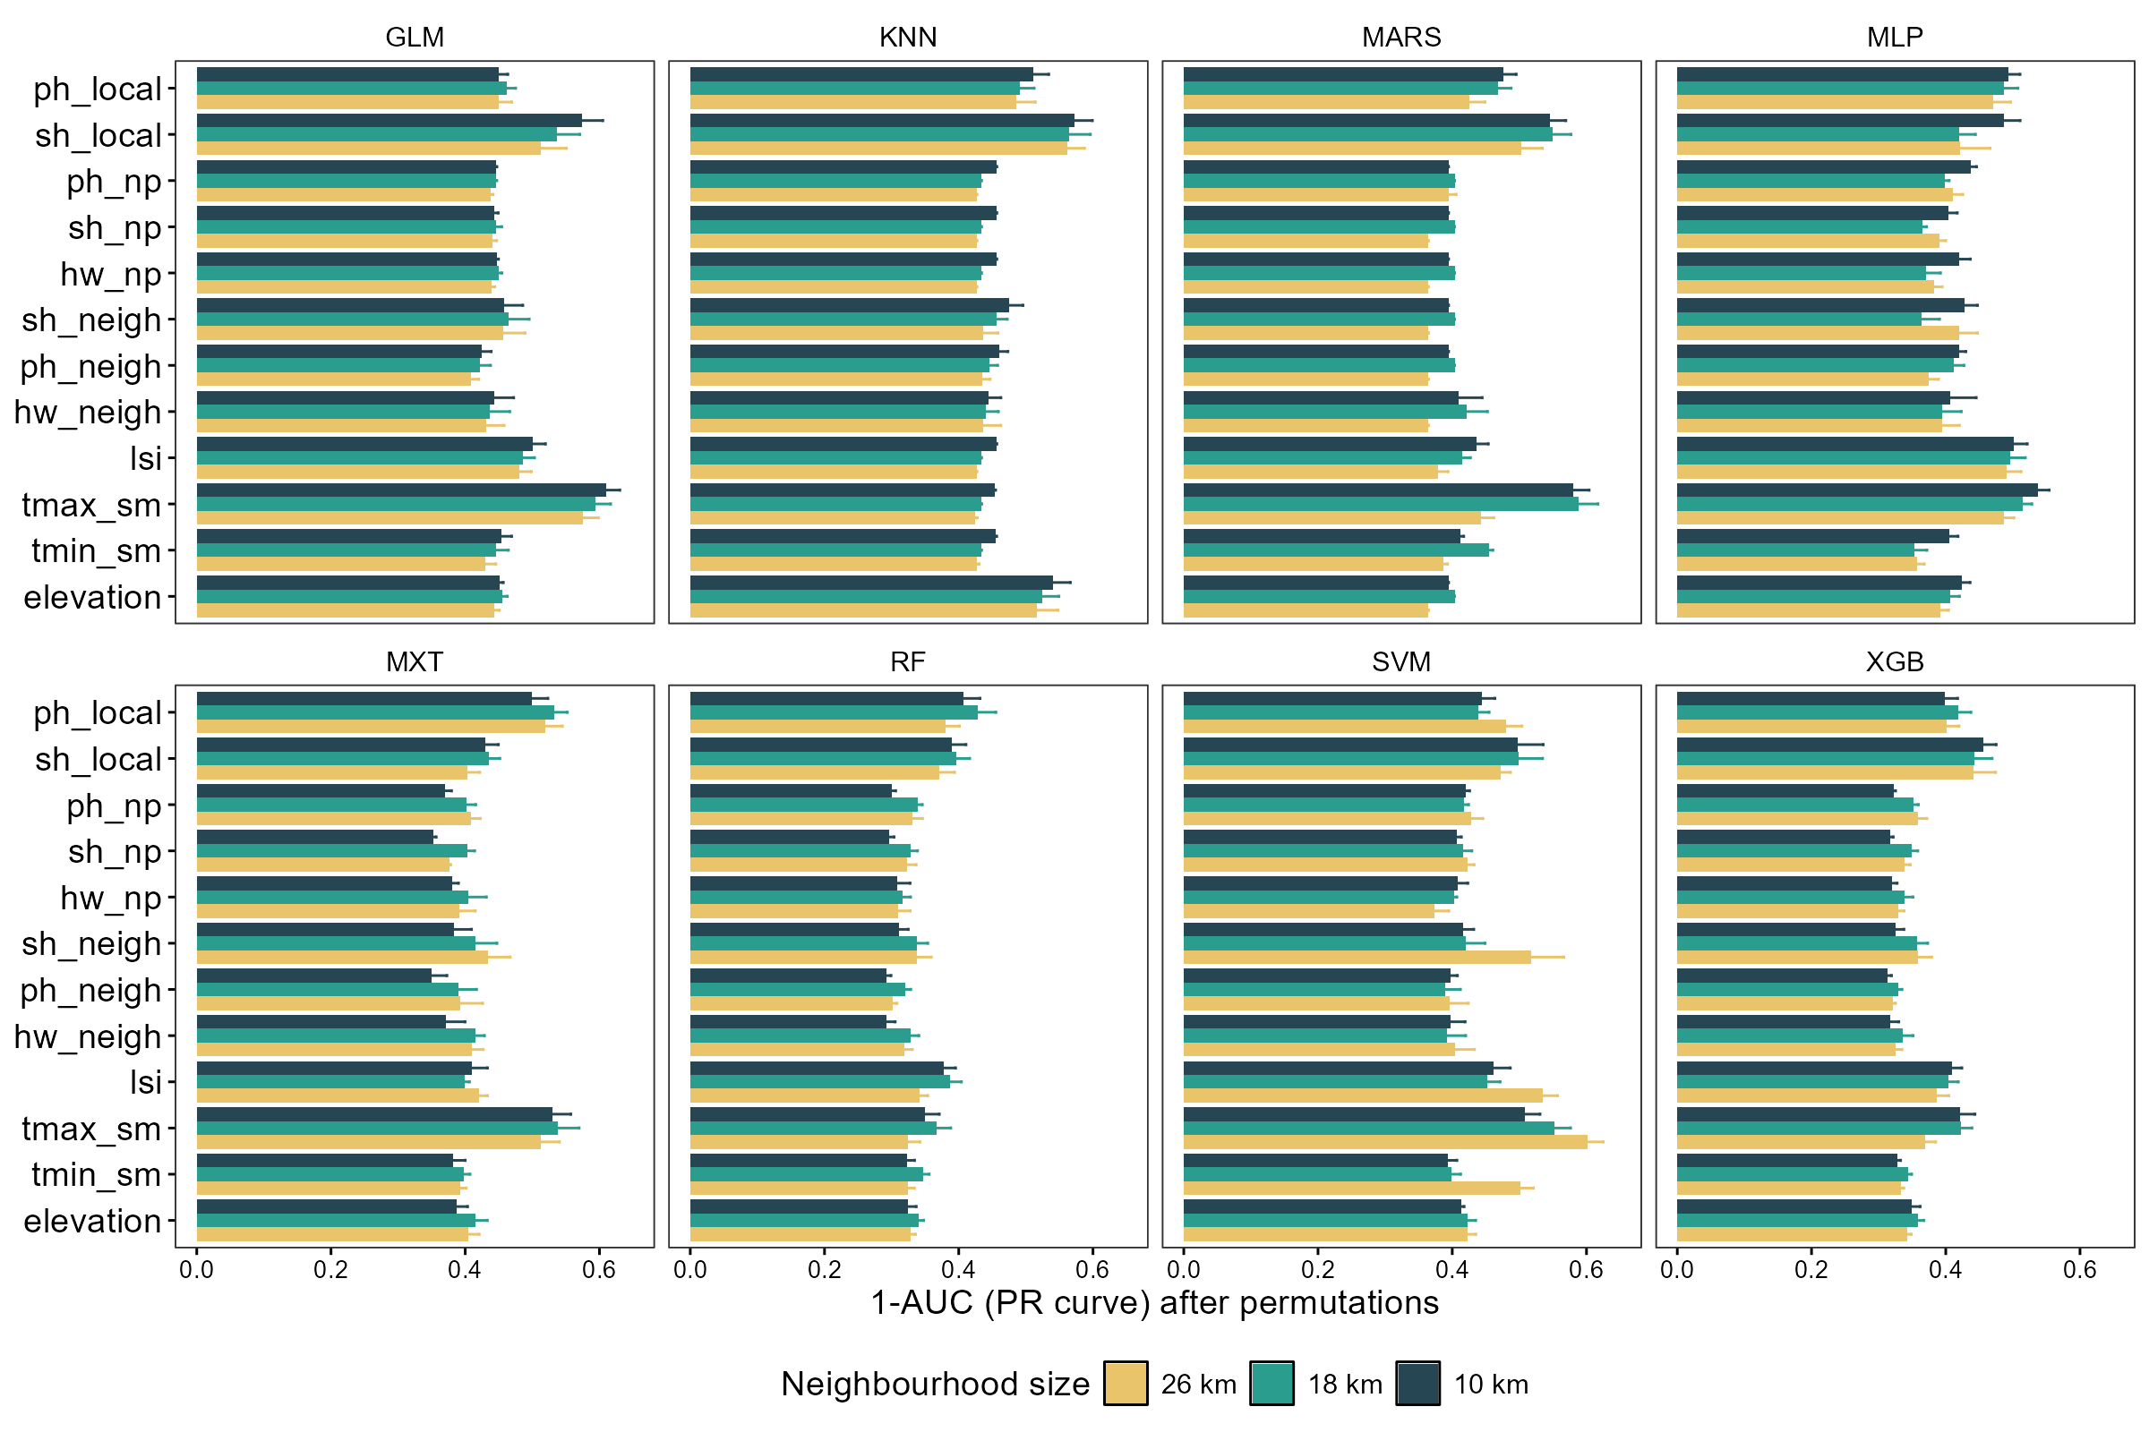

Fig. S2 Partial dependence plots for all variables and all machine learning algorithms
