Supplementary Material
This table provides detailed analytical results for all microplastic particles identified in sediment samples collected from Regions A, B, and C of Tripoli Port. Each entry includes the sample code and observed particle color, the polymer type identified through Fourier Transform Infrared (FTIR) spectroscopy, the spectral match percentage with reference polymer standards, and the reference library used for identification. The dataset captures the full diversity of polymer compositions, colors, and match confidence levels, enabling precise source attribution and material characterization. While the main text summarizes polymer and color distributions at an aggregate level, this table offers a complete record of the underlying data for transparency, reproducibility, and future comparative studies.

Supplementary Table. FTIR analysis data of microplastic samples from Tripoli Port beach sediments

Sample Code & Color | Identified Polymer Type | Match % | Reference Library Used
A1 Blue | Polyethylene (PE) | 85.85 | HR Nicolet Sampler Library
A1 White | Polyethylene (PE) | 86.96 | HR Nicolet Sampler Library
A2 White | Polypropylene (PP), Atactic | 62.55 | Hummel Polymer Sample Library
A3 Sky | Polypropylene (PP), Atactic | 68.49 | Hummel Polymer Sample Library
A3 White | Polyethylene (PE) | 91.52 | HR Nicolet Sampler Library
A4 Blue | Polyethylene (PE), Low Density | 76.14 | Aldrich Condensed Phase Sample Library
A5 White 1 | Polyethylene (PE) | 85.69 | HR Nicolet Sampler Library
A5 White 2 | Polyethylene (PE) | 91.76 | HR Nicolet Sampler Library
A6 Blue | Polypropylene (PP), Atactic | 69.25 | Hummel Polymer Sample Library
A6 Green | Polypropylene (PP), Atactic | 77.80 | Hummel Polymer Sample Library
A7 White | Polyethylene (PE) | 91.47 | HR Nicolet Sampler Library
A8 Blue | Polyethylene (PE), Low Density | 76.10 | Aldrich Condensed Phase Sample Library
A8 White | Polypropylene (PP), Atactic | 76.32 | Hummel Polymer Sample Library
A9 Red | Styrene–Butadiene Block Polymer | 72.37 | HR Nicolet Sampler Library
A10 White | Polystyrene (PS), Atactic | 66.89 | Hummel Polymer Sample Library
B1 Blue | Poly (Ethylene:Propylene:Diene) | 42.64 | Hummel Polymer Sample Library
B2 Yellow | Polypropylene (PP), Atactic | 54.94 | Hummel Polymer Sample Library
B3 White | Polyethylene (PE) | 89.88 | HR Nicolet Sampler Library
B3 Green | Polystyrene (PS), Atactic | 68.39 | Hummel Polymer Sample Library
B4 Blue | Polyethylene (PE) | 84.68 | HR Nicolet Sampler Library
B5 Blue | Polyethylene (PE), Low Density | 74.90 | Aldrich Condensed Phase Sample Library
B6 White | Polystyrene (PS), Atactic | 67.73 | Hummel Polymer Sample Library
B7 Violet | Polyethylene (PE) | 90.37 | HR Nicolet Sampler Library
B8 Blue | Polypropylene (PP), Atactic | 48.87 | Hummel Polymer Sample Library
B9 White 1 | Polypropylene (PP), Atactic | 53.77 | Hummel Polymer Sample Library
B9 Blue | Polyethylene (PE) | 86.45 | HR Nicolet Sampler Library
B9 White 2 | Polyethylene (PE) | 86.45 | HR Nicolet Sampler Library
B10 White | Polypropylene (PP), Atactic | 80.28 | Hummel Polymer Sample Library
B10 Green | Polystyrene (PS), Atactic | 68.34 | Hummel Polymer Sample Library
C1 Green | Polypropylene (PP), Atactic | 66.01 | Hummel Polymer Sample Library
C2 Blue | Poly (Ethylene:Propylene:Diene) | 65.94 | Hummel Polymer Sample Library
C2 Red | Styrene–Butadiene Block Polymer | 72.79 | HR Nicolet Sampler Library
C2 White | Polypropylene (PP), Atactic | 69.25 | Hummel Polymer Sample Library
C3 White Filmy | Polyethylene (PE) | 88.69 | HR Nicolet Sampler Library
C3 White | Polyethylene (PE) | 86.83 | HR Nicolet Sampler Library
C4 White | Polystyrene (PS), Atactic | 74.32 | Hummel Polymer Sample Library
C5 Blue | Polyethylene (PE) | 86.13 | HR Nicolet Sampler Library
C5 Green | PP + Poly (Ethylene:Propylene) | 65.46 | HR Nicolet Sampler Library
C6 White | Polyethylene (PE) | 85.20 | HR Nicolet Sampler Library
C7 White | Polypropylene (PP), Atactic | 74.86 | Hummel Polymer Sample Library
C8 Black | Cellophane | 35.02 | Hummel Polymer Sample Library
C8 Blue | Polyethylene (PE) | 87.09 | HR Nicolet Sampler Library
C9 Blue | Polystyrene (PS), Atactic | 63.61 | Hummel Polymer Sample Library
C10 Green | Polyvinyl Chloride (PVC) | 68.11 | Hummel Polymer Sample Library

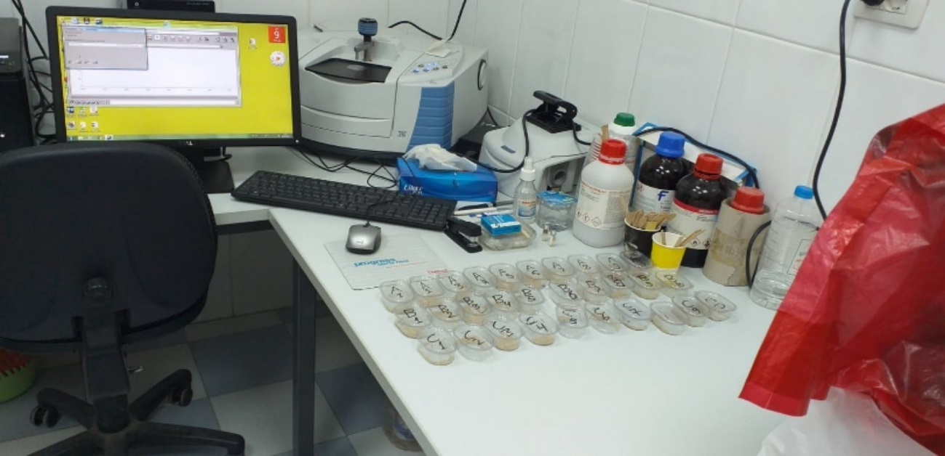
Supplementary Figure. Image form lab

The supplementary material provides the complete dataset and supporting evidence underlying the findings presented in this study. Detailed Fourier Transform Infrared (FTIR) spectroscopy results for all microplastic particles collected from Regions A, B, and C of Tripoli Port are included. Each entry records the sample code, observed particle color, polymer type identified, spectral match percentage, and the reference library used for verification.
Additionally, supplementary figures show the raw FTIR spectra obtained for individual samples across all regions, providing visual confirmation of spectral matches with reference polymers. These figures illustrate the diversity of polymer compositions identified, ranging from dominant polymers such as polyethylene (PE), polypropylene (PP), and polystyrene (PS) to less common materials like polyvinyl chloride (PVC), cellophane, and styrene–butadiene block polymers.

Together, these supplementary tables and figures serve as a permanent record of the analytical process, enabling future researchers to perform comparative assessments and meta-analyses. They also enhance the credibility of the results by documenting the full diversity of polymer types and spectral characteristics encountered in the study area

