[Supplementary Information]

Highly Conductive Halide Na-ion Conductor Boosted by Low-cost Aliovalent Polyanion Substitution for All-Solid-State Sodium Batteries

Xiaolin Guoª, Man Chenª, James Burrow,^{b} Santosh Thapa,^{c} Mahadeen Nashiru,^{b} Thoms Marchese,^{b} Badri Narayanan,ª Yan Chen,^{e} Yang-Tse Cheng,^{c,d} Shirley Meng,^{b,∗} Hui Wang ^{a,∗}

ª Mechanical Engineering Department, University of Louisville, Louisville, KY 40292, USA
^{b} Pritzker School of Molecular Engineering, The University of Chicago, Chicago, Illinois 60637, United States
^{c} Department of Physics and Astronomy, University of Kentucky, Lexgington, KY, 40506, USA
^{d} Department of Chemical and Materials Engineering, University of Kentucky, Lexington, KY, 40506, USA
^{e} Neutron Scattering Division, Oak Ridge National Laboratory, Oak Ridge, TN 37830, USA

∗ Corresponding authors: hui.wang.1@louisville.edu; shirleymeng@uchicago.edu

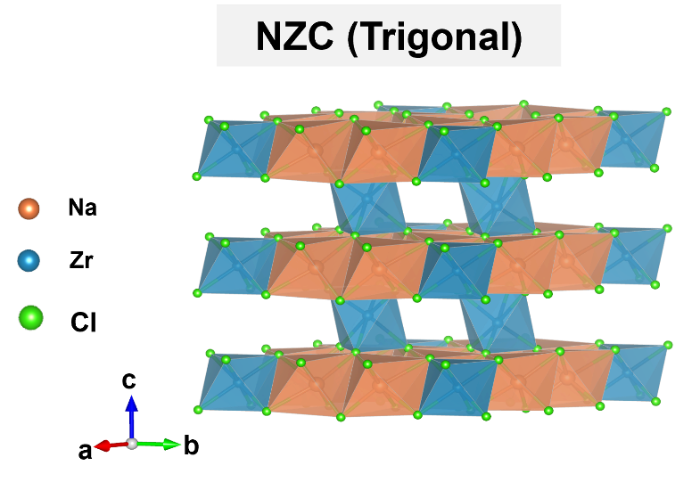
Supplementary Fig. 1 Scheme of crystal structure for trigonal NZC.

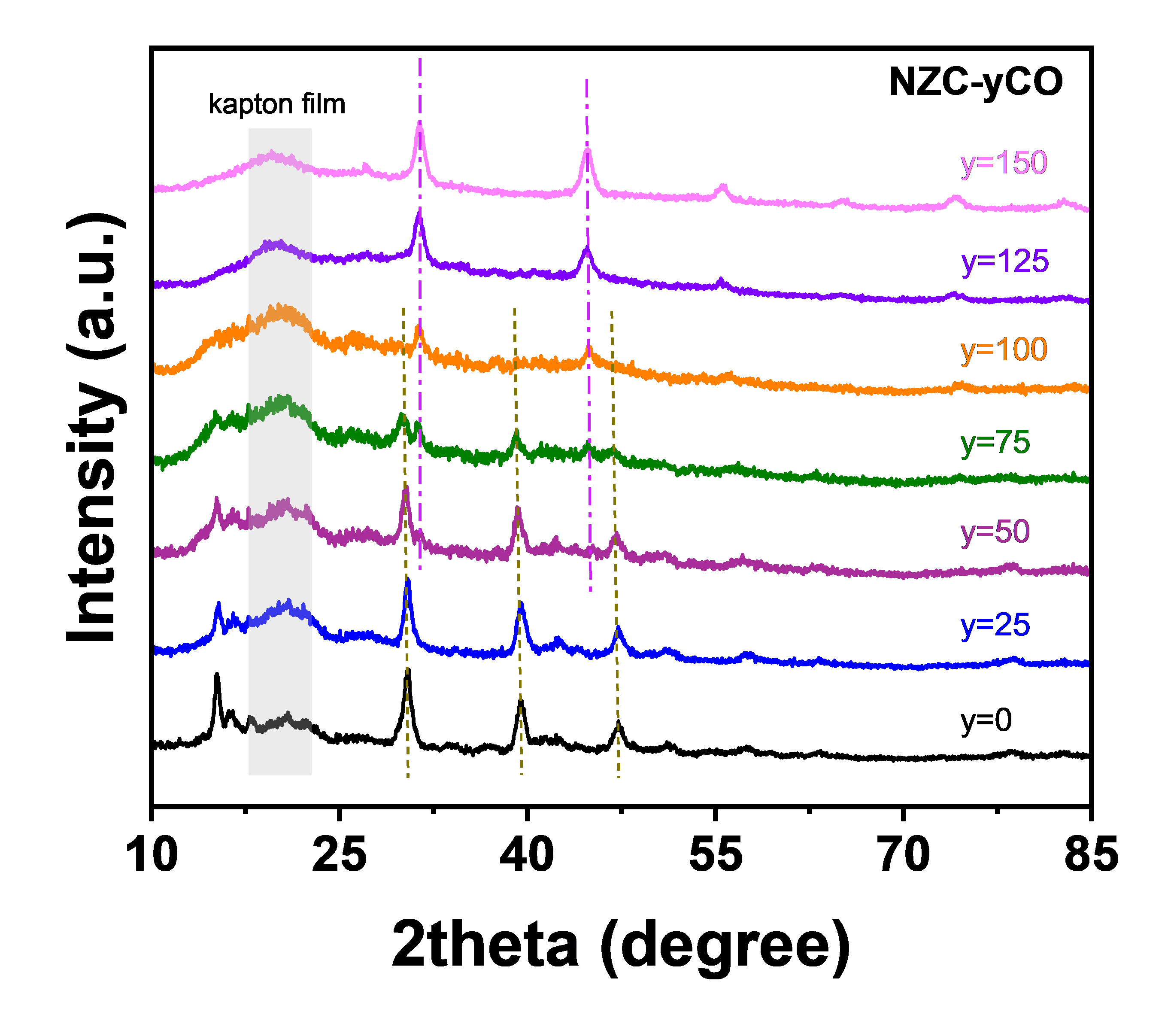
Supplementary Fig. 2 The XRD pattern of NZC-yCO (0≤y≤150) with lab X-ray diffractometer with the wavelength of Cu Kα (λ=1.5416Å).

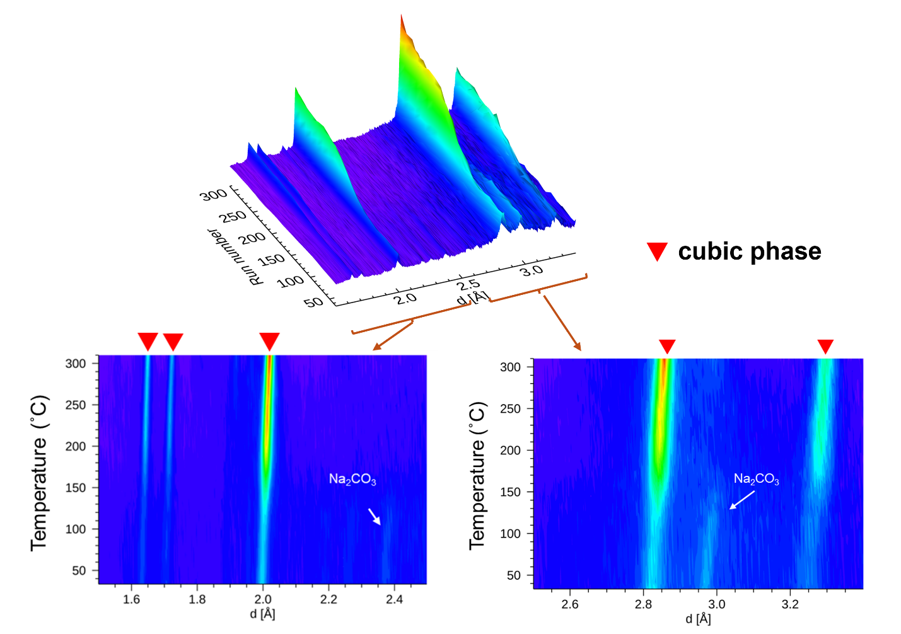
Supplementary Fig. 3 In-situ neutron diffraction pattern of NZC-100CO sample from room temperature to 300 °C.

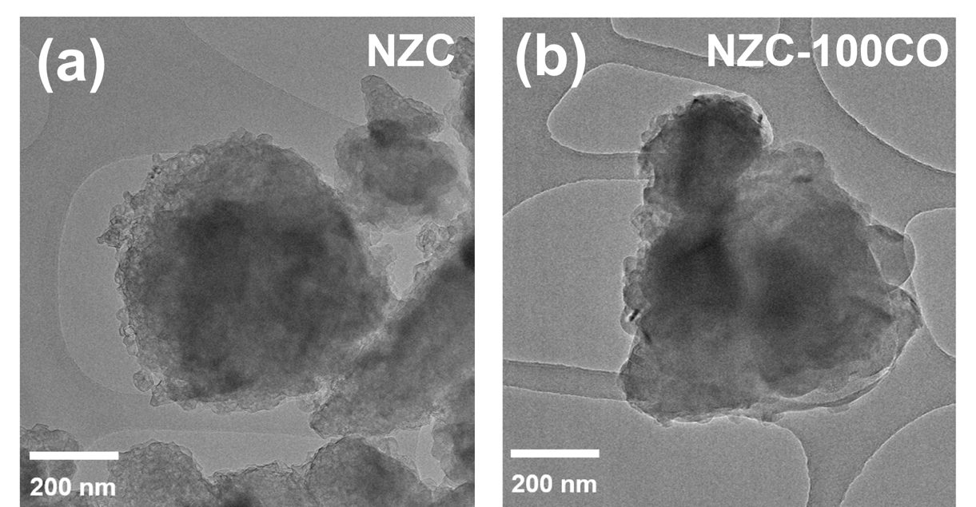
Supplementary Fig. 4 TEM images of (a) NZC and (b) NZC-100CO.

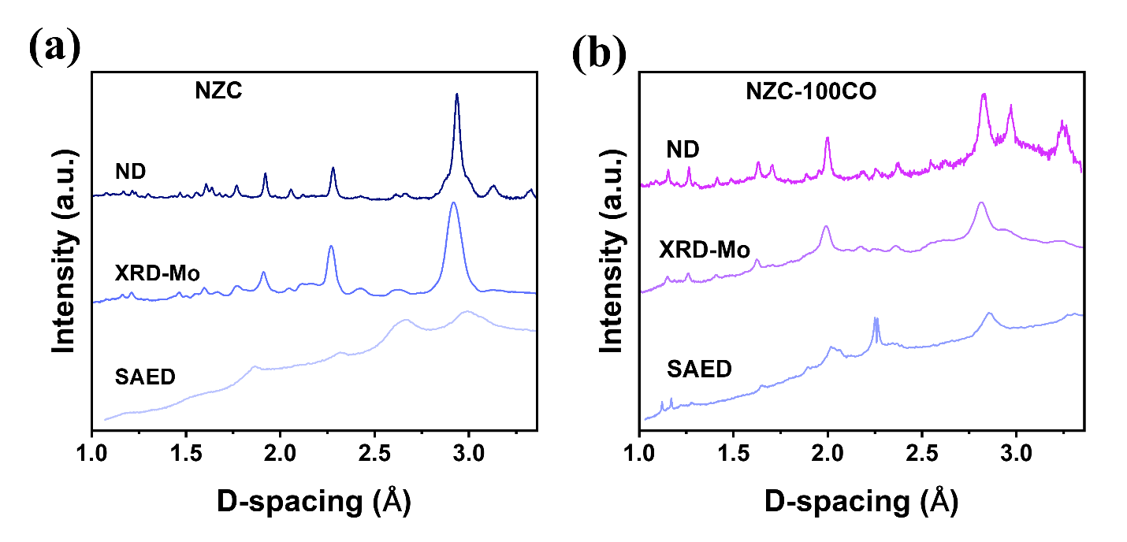
Supplementary Fig. 5 The XRD pattern with Mo source (λ=0.71Å), neutron diffraction (ND) patterns and selected area electron diffraction (SAED) results of (a) NZC and (b) NZC-100CO.

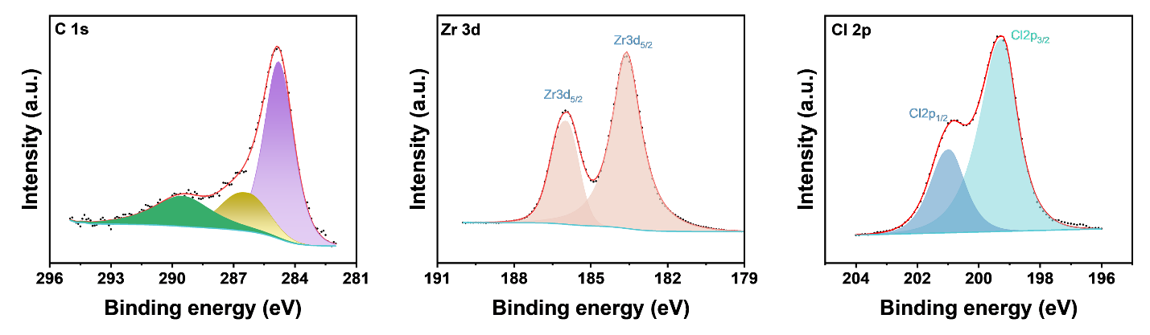
Supplementary Fig. 6 XPS spectra of NZC (a) C 1s, (b) Zr 3d, (c) Cl 2p.

Supplementary Fig. 7 XPS spectra of Na₂CO₃ (a) C 1s and (b) Na 1s.

Supplementary Fig. 8 FTIR spectra of NZC-yCO samples (y=25, 100), NZC and Na₂CO₃ as reference.

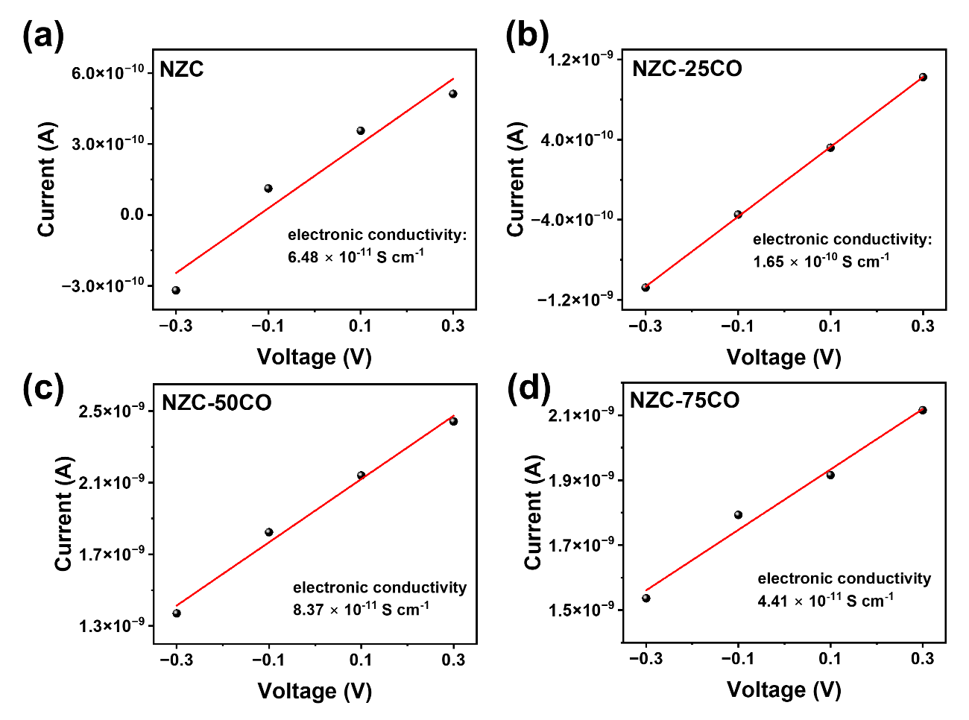
Supplementary Fig. 9 Electronic conductivity measurements for (a) NZC, (b) NZC-25CO, (c) NZC-50CO and (d) NZC-75CO samples.

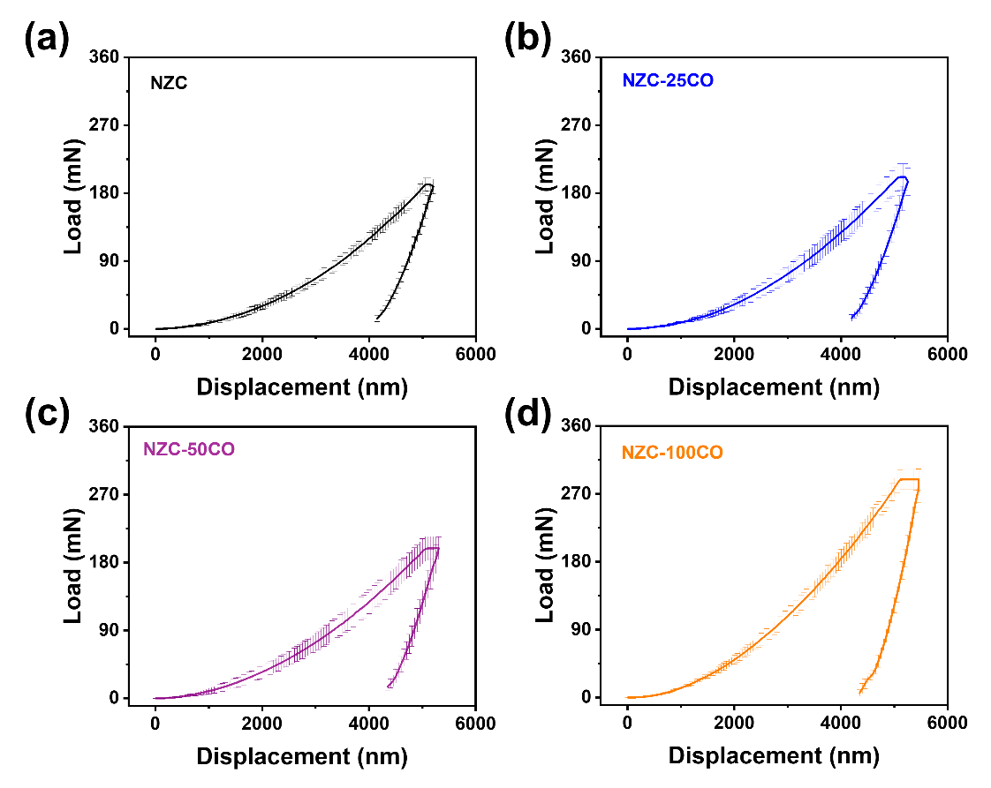
Supplementary Fig. 10 The load-displacement curves of (a) NZC, (b) NZC-25CO, (c) NZC-50CO and (d) NZC-100CO by nanoindentation measurement.

Supplementary Fig. 11 Optical images of (a) NZC, (b) NZC-25CO, (c) NZC-50CO and (d) NZC-75CO before and after nanoindentation in the magnification of 50X.

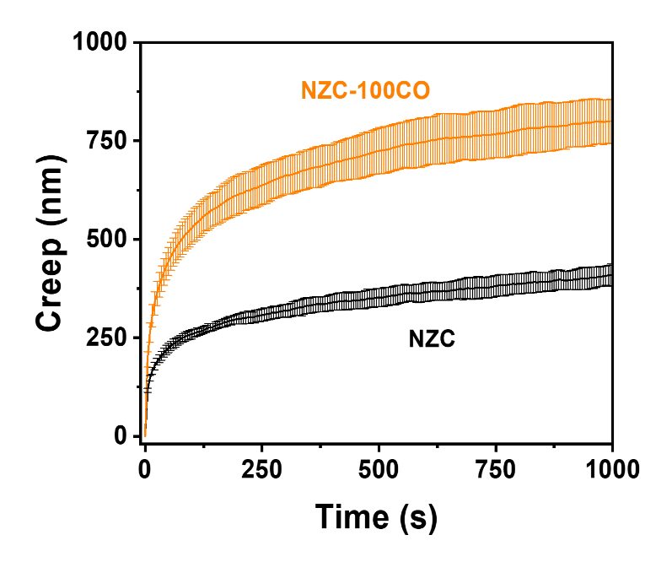
Supplementary Fig. 12 Creep curves of NZC and NZC-100CO.

Supplementary Fig. 13 Oxidation and reduction linear sweep voltammetry curves for NZC and NZC-100CO solid electrolytes.

Supplementary Fig. 14 Nyquist plot of synthesized NPS at room temperature.

Supplementary Fig. 15 XRD pattern of the mixture of NPS and NZC-100CO, and NPS, NZC-100CO, respectively.

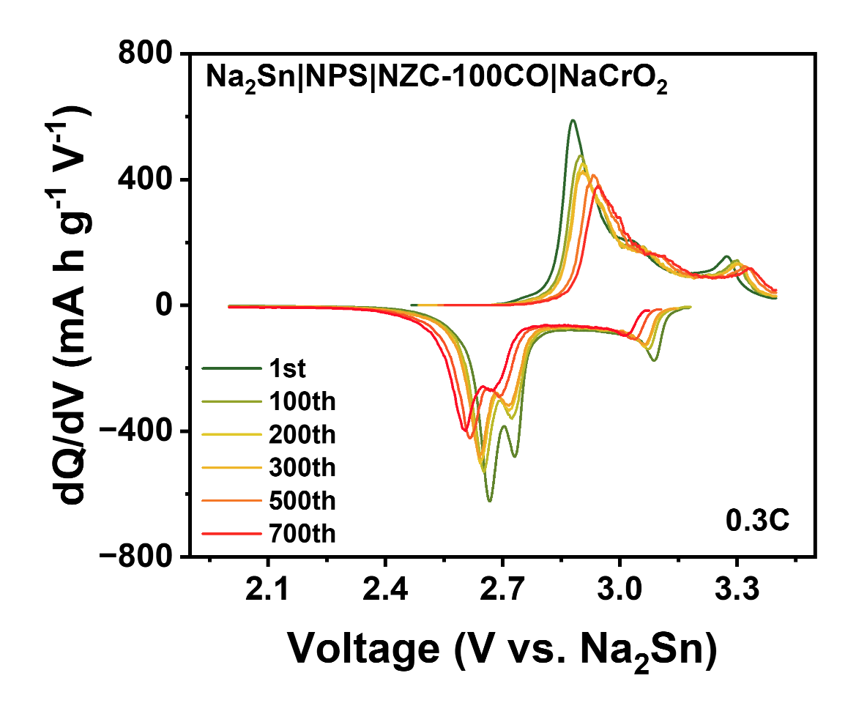
Supplementary Fig. 16 The differential capacity vs voltage curves of ASSB with NZC-100CO SE at 1st, 100th, 200th, 300th, 500th and 700th cycles, respectively.

Supplementary Table 1 Rietveld refinement result of NZC-100CO from Neutron diffraction.
Composition: NaCl-Na₂CO₃-ZrCl₄
Phase I: cubic, Fm$\overline{3}$m (225)
Lattice parameters: a = b = c = 5.6451(5) Å, α = β = γ = 90˚ V = 179.902 Å³
atom | Wyck symbol |  | x |  | y |  |  |  | z | Occupancy |  |  | U_{iso}
Na | 4b |  | 0 |  | 0 |  |  |  | 0 | 1 |  |  | 0.019(2)
Cl | 4a |  | 0.5 |  | 0.5 |  |  |  | 0.5 | 1 |  |  | 0.019(2)
Phase II: Na₂CO₃, monoclinic, 1 2/m1 (12)
Lattice parameters: a = 8.9087 (9) Å, b =5.2408 (1) Å, c = 6.0493(2) Å, α = γ = 90˚, β = 101.19(6) ˚
atom |  | Wyck symbol |  | x |  | y |  | z |  |  | occupancy | U_{iso}
Na |  | 2a |  | 0 |  | 0 |  | 0 |  |  | 1 | 0.054(0)
Na |  | 2c |  | 0 |  | 0 |  | 0.5 |  |  | 1 | 0.054(0)
Na |  | 4i |  | 0.1703(6) |  | 0.5 |  | 0.7481(6) |  |  | 1 | 0.054(0)
C |  | 4i |  | 0.5 |  | 0.5 |  | 0.2492(0) |  |  | 1 | 0.054(0)
O |  | 8j |  | 0.1017(8) |  | 0.2942(3) |  | 0.2855(7) |  |  | 1 | 0.054(0)
O |  | 4i |  | 0.2898(6) |  | 0.5 |  | 0.1776(0) |  |  | 1 | 0.054(0)

Supplementary Table 2. Bulk price calculation of precursors for synthesis halide solid electrolyte. Reagent grade prices are used for the calculation and the bulk prices are below.
Chemical | Item number | Quantity (g) | Price ($) | Unit price ($/kg)
ZrCl₄  (Fisher Scientific) | AC206410050 | 5 | 68.7 | 13740
ZrCl₄  (Fisher Scientific) | AC206411000 | 100 | 76.65 | 766.5
ZrCl₄  (Fisher Scientific) | AC206415000 | 500 | 340.5 | 681
ZrCl₄  (Fisher Scientific) | AC206410025 | 2500 | 1218 | 487.2
ZrCl₄  (Fisher Scientific) | Estimated bulk prices | 1000000 | - | 12.2682
AlCl₃  (Thermo Fisher Scientific) | 012298-30 | 250 | 39.4 | 157.6
AlCl₃  (Thermo Fisher Scientific) | 012298-A1 | 1000 | 60.65 | 60.65
AlCl₃  (Thermo Fisher Scientific) | 012298-D9 | 5000 | 238.65 | 47.73
AlCl₃  (Thermo Fisher Scientific) | Estimated bulk prices | 1000000 | - | 5.2822
ErCl₃  (Thermo Fisher Scientific) | 089917-09 | 10 | 90.2 | 9020
ErCl₃  (Thermo Fisher Scientific) | 089917-18 | 50 | 367 | 7340
ErCl₃  (Thermo Fisher Scientific) | Estimated bulk prices | 1000000 | - | 2064.9522
YCl₃  (Thermo Fisher Scientific) | 018682-09 | 10 | 80.65 | 8065
YCl₃  (Thermo Fisher Scientific) | 018682-18 | 50 | 232.65 | 4653
YCl₃  (Thermo Fisher Scientific) | 018682-30 | 250 | 806.65 | 3226.6
YCl₃  (Thermo Fisher Scientific) | Estimated bulk prices | 1000000 | - | 295.3181
SmCl₃  (Thermo Fisher Scientific) | 089916-09 | 10 | 115.65 | 11565
SmCl₃  (Thermo Fisher Scientific) | 089916-18 | 50 | 453.65 | 9073
SmCl₃  (Thermo Fisher Scientific) | Estimated bulk prices | 1000000 | - | 2037.9335
TaCl₅  (Thermo Fisher Scientific) | 014164-06 | 5 | 44.65 | 8930
TaCl₅  (Thermo Fisher Scientific) | 014164-14 | 25 | 145.65 | 5826
TaCl₅  (Thermo Fisher Scientific) | 014164-22 | 100 | 423.65 | 4236.5
TaCl₅  (Thermo Fisher Scientific) | Estimated bulk price | 1000000 | - | 422.1823
CrCl₃  (Thermo Fisher Scientific) | 012336-18 | 50 | 83 | 1660
CrCl₃  (Thermo Fisher Scientific) | 012336-30 | 250 | 259.65 | 1038.6
CrCl₃  (Thermo Fisher Scientific) | Estimated bulk price | 1000000 | - | 92.6659
YbCl₃  (Thermo Fisher Scientific) | 040653-06 | 5 | 134.65 | 26930
YbCl₃  (Thermo Fisher Scientific) | 040653-14 | 25 | 552.65 | 22106
YbCl₃  (Thermo Fisher Scientific) | Estimated bulk price | 1000000 | - | 6026.4284
NbCl₅  (Thermo Fisher Scientific) | 011548-14 | 25 | 85.65 | 3426
NbCl₅  (Thermo Fisher Scientific) | 011548-22 | 100 | 169.65 | 1696.5
NbCl₅  (Thermo Fisher Scientific) | 011548-36 | 500 | 702.65 | 1405.3
NbCl₅  (Thermo Fisher Scientific) | Estimated bulk price | 1000000 | - | 138.9313
LaCl₃  (Thermo Fisher Scientific) | 087911-06 | 5 | 39.65 | 7930
LaCl₃  (Thermo Fisher Scientific) | 087911-14 | 25 | 132.65 | 5306
LaCl₃  (Thermo Fisher Scientific) | 087911-22 | 100 | 466.65 | 4666.5
LaCl₃  (Thermo Fisher Scientific) | Estimated bulk price | 1000000 | - | 861.2317
HfCl₄  (Fisher Scientific) | AA1183488 | 2.5 | 25.25 | 10100
HfCl₄  (Fisher Scientific) | AA1183412 | 25 | 85.6 | 3424
HfCl₄  (Fisher Scientific) | AA1183422 | 100 | 288 | 2880
HfCl₄  (Fisher Scientific) | Estimated bulk price | 1000000 | - | 98.5054
ZrF₄  (Fisher Scientific) | AA1154214 | 25 | 62.6 | 2504
ZrF₄  (Fisher Scientific) | AA1154222 | 100 | 229.5 | 2295
ZrF₄  (Fisher Scientific) | Estimated bulk price | 1000000 | - | 1286.1748
Nb₂O₅  (Thermo Fisher Scientific) | 011365-22 | 100 | 95.65 | 956.5
Nb₂O₅  (Thermo Fisher Scientific) | 011365-36 | 500 | 407.65 | 815.3
Nb₂O₅  (Thermo Fisher Scientific) | 011365-A3 | 2000 | 1461.65 | 730.825
Nb₂O₅  (Thermo Fisher Scientific) | Estimated bulk price | 1000000 | - | 415.2790
Na₂O₂  (Thermo Fisher Scientific) | 33384-09 | 10 | 24.8 | 2480
Na₂O₂  (Thermo Fisher Scientific) | 33384-22 | 100 | 107.65 | 1076.5
Na₂O₂  (Thermo Fisher Scientific) | 33384-36 | 500 | 357.65 | 715.3
Na₂O₂  (Thermo Fisher Scientific) | Estimated bulk price | 1000000 | - | 59.9639
NaF  (Fisher Scientific) | AAA1301930 | 250 | 57.1 | 228.4
NaF  (Fisher Scientific) | AAA130190B | 1000 | 113.4 | 113.4
NaF  (Fisher Scientific) | AAA130190I | 5000 | 380 | 76
NaF  (Fisher Scientific) | Estimated bulk price | 1000000 | - | 10.4078
Na₂O  (Thermo Fisher Scientific) | 036712-14 | 25 | 79.65 | 3186
Na₂O  (Thermo Fisher Scientific) | 036712-22 | 100 | 255.65 | 2556.5
Na₂O  (Thermo Fisher Scientific) | Estimated bulk price | 1000000 | - | 592.2158
NaOH  (Thermo Fisher Scientific) | 424330250 | 25 | 44.65 | 1786
NaOH  (Thermo Fisher Scientific) | 424335000 | 500 | 76.1 | 152.2
NaOH  (Thermo Fisher Scientific) | 424330010 | 1000 | 145 | 145
NaOH  (Thermo Fisher Scientific) | 424330025 | 2500 | 153.65 | 61.46
NaOH  (Thermo Fisher Scientific) | 424330100 | 10000 | 400.65 | 40.065
NaOH  (Thermo Fisher Scientific) | Estimated bulk price | 1000000 | - | 1.5336
NaCl  (Thermo Fisher Scientific) | 012314-36 | 500 | 49.65 | 99.3
NaCl  (Thermo Fisher Scientific) | 012314-A3 | 2000 | 70.65 | 35.325
NaCl  (Thermo Fisher Scientific) | 012314-A9 | 10000 | 161.65 | 16.165
NaCl  (Thermo Fisher Scientific) | Estimated bulk price | 1000000 | - | 0.9488
Na₂CO₃  (Thermo Fisher Scientific) | L13098-36 | 500 | 39.65 | 79.3
Na₂CO₃  (Thermo Fisher Scientific) | L13098-0E | 2500 | 71.65 | 28.66
Na₂CO₃  (Thermo Fisher Scientific) | L13098-0I | 5000 | 111.65 | 22,33
Na₂CO₃  (Thermo Fisher Scientific) | Estimated bulk price | 1000000 | - | 1.0565

Table S3. The cost of sodium-based halide SEs calculation
 | 2.4 NaCl | + | 0.4 ErCl₃ | + | 0.6 ZrCl₄ | → | Na_{2.4}Er_{0.4}Zr_{0.6}Cl₆
 | 140.255446 |  | 109.443600 |  | 139.814400 |  | 389.513446
Mass (g) | 360.078574 |  | 280.975153 |  | 358.946273 |  | 1000
Unit price ($/kg) | 0.9488 |  | 2064.9522 |  | 12.2682
Sum | 0.341643 |  | 580.200259 |  | 4.403625 |  | 584.946 $/kg
 | 2.25 NaCl | + | 0.75 ZrCl₄ | + | 0.25 YCl₃ | → | Na_{2.25}Y_{0.25}Zr_{0.75}Cl₆
 | 131.489481 |  | 174.768000 |  | 48.813960 |  | 355.071441
Mass (g) | 370.318380 |  | 492.205173 |  | 137.476447 |  | 1000
Unit price ($/kg) | 0.948800 |  | 12.268200 |  | 295.318100
Sum | 0.351358 |  | 6.038472 |  | 40.599283 |  | 46.989 $/kg
 | NaCl | + | AlCl3 |  | → |  | NaAlCl₄
 | 58.439769 |  | 133.331539 |  |  |  | 191.771308
Mass (g) | 304.736772 |  | 695.263228 |  |  |  | 1000
Unit price ($/kg) | 0.948800 |  | 5.282200
Sum | 0.289134 |  | 3.672519 |  |  |  | 3.962 $/kg
 | 0.845NaCl | + | 1.085SmCl₃ | + | 0.38TaCl₅ | → | 0.62Na_{0.75}Sm_{1.75}Cl₆·  0.38NaTaCl₆
 | 49.381605 |  | 278.530350 |  | 136.115194 |  | 464.027149
Mass (g) | 106.419646 |  | 600.245805 |  | 293.334549 |  | 1000
Unit price ($/kg) | 0.948800 |  | 2037.933500 |  | 422.182300
Sum | 0.100971 |  | 1223.261035 |  | 123.840654 |  | 1347.203 $/kg
 | 0.8575 NaCl | + | 0.9975 LaCl₃ | + | 0.43 TaCl₅ | → | 0.57Na_{0.75}La_{1.75}Cl₆·  0.43NaTaCl₆
 | 50.112102 |  | 244.642331 |  | 154.025088 |  | 448.779522
Mass (g) | 111.663077 |  | 545.128107 |  | 343.208816 |  | 1000
Unit price ($/kg) | 0.948800 |  | 861.231700 |  | 422.182300
Sum | 0.105946 |  | 469.481607 |  | 144.896687 |  | 614.484 $/kg
 | 2.25 NaCl | + | 0.25 YbCl₃ | + | 0.75 ZrCl₄ | → | Na_{2.25}Yb_{0.25}Zr_{0.75}Cl₆
 | 131.489481 |  | 69.851000 |  | 174.768000 |  | 376.108481
Mass (g) | 349.605201 |  | 185.720353 |  | 464.674446 |  | 1000
Unit price ($/kg) | 0.948800 |  | 6026.428400 |  | 12.268200
Sum | 0.331705 |  | 1119.230412 |  | 5.700719 |  | 1125.263 $/kg
 | 0.61 NaCl | + | 0.39 ZrCl₄ | + | Na₂O | → | 0.13ZrO₂-0.61NaCl-0.26Na₂ZrCl₆
 | 35.648259 |  | 90.879360 |  | 16.114420 |  | 142.642039
Mass (g) | 249.914117 |  | 637.114840 |  | 112.971044 |  | 1000
Unit price ($/kg) | 0.948800 |  | 12.268200 |  | 592.215800
Sum | 0.237119 |  | 7.816252 |  | 66.903237 |  | 74.957 $/kg
 | 2.5 NaCl | + | 0.5 CrCl₃ | + | 0.5 ZrCl₄ | → | Na_{2.5}Cr_{0.5}Zr_{0.5}Cl₆
 | 146.099423 |  | 79.173050 |  | 116.512000 |  | 341.784473
Mass (g) | 427.460680 |  | 231.646129 |  | 340.893192 |  | 1000
Unit price ($/kg) | 0.948800 |  | 92.665900 |  | 12.268200
Sum | 0.405575 |  | 21.465697 |  | 4.182146 |  | 26.053 $/kg
 | NaOH | + | TaCl₅ | → | HCl | + | NaTaOCl₄
 | 39.996769 |  | 358.197880 |  |  |  | 361.736649
Mass (g) | 110.568750 |  | 990.217277 |  |  |  | 1000
Unit price ($/kg) | 1.533600 |  | 422.182300
Sum | 0.169568 |  | 418.052208 |  |  |  | 418.221 $/kg
 | NaCl | + | 0.6 NbCl₅ | + | 0.2 Nb₂O₅ | → | NaNbCl₄O
 | 58.439769 |  | 162.093822 |  | 53.161548 |  | 273.695139
Mass (g) | 213.521400 |  | 592.242239 |  | 194.236361 |  | 1000
Unit price ($/kg) | 0.948800 |  | 138.931300 |  | 415.279000
Sum | 0.202589 |  | 82.280984 |  | 80.662282 |  | 163.146 $/kg
 | 1.3 NaCl | + | ZrCl₄ | + | 0.7 Na₂O | → | Na_{2.7}ZrCl_{5.3}O_{0.7}
 | 75.971700 |  | 233.024000 |  | 43.384977 |  | 352.380677
Mass (g) | 215.595533 |  | 661.284841 |  | 123.119625 |  | 1000
Unit price ($/kg) | 0.948800 |  | 12.268200 |  | 592.215800
Sum | 0.204557 |  | 8.112775 |  | 72.913388 |  | 81.231 $/kg
 | 2 NaCl | + | ZrCl₄ | → | Na₂ZrCl₆
 | 116.879539 |  | 233.024000
Mass (g) | 334.033600 |  | 665.966400 |  | 1000
Unit price ($/kg) | 0.948800 |  | 12.268200
Sum | 0.316931 |  | 8.170209 |  | 8.487 $/kg
 | 0.625 NaCl | + | 0.25 YCl₃ | + | 0.75 ZrCl₄ | → | Na_{0.625}Y_{0.25}Zr_{0.75}Cl_{4.375}
 | 36.524856 |  | 48.813960 |  | 174.768000 |  | 260.106816
Mass (g) | 140.422525 |  | 187.668900 |  | 671.908575 |  | 1000
Unit price ($/kg) | 0.948800 |  | 295.318100 |  | 12.268200
Sum | 0.133233 |  | 55.422023 |  | 8.243109 |  | 63.798 $/kg
 | NaCl | + | TaCl₅ | → | NaTaCl₆
 | 58.439769 |  | 358.197880 |  | 416.637649
Mass (g) | 140.265215 |  | 859.734785 |  | 1000
Unit price ($/kg) | 0.948800 |  | 422.182300
Sum | 0.133084 |  | 362.964809 |  | 363.098 $/kg
 | 0.7 NaCl | + | 0.3 ZrCl₄ | + | 0.7 LaCl₃ | → | Na_{0.7}Zr_{0.3}La_{0.7}Cl₄
 | 40.907838 |  | 69.907200 |  | 171.678829
Mass (g) | 144.809651 |  | 247.464487 |  | 607.725862 |  | 1000
Unit price ($/kg) | 0.948800 |  | 12.268200 |  | 861.231700
Sum | 0.137395 |  | 3.035944 |  | 523.392777 |  | 526.566 $/kg
 | Na₂O₂ | + | HfCl₄ | → | Na₂O₂-HfCl₄
 | 77.977539 |  | 320.290000 |  | 398.267539
Mass (g) | 195.791851 |  | 804.208149 |  | 1000
Unit price ($/kg) | 59.963900 |  | 98.505400
Sum | 11.740443 |  | 79.218845 |  | 90.959 $/kg
 | Na₂O₂ | + | ZrCl₄ | → | Na₂O₂-ZrCl₄
 | 77.977539 |  | 233.024000 |  | 311.001539
Mass (g) | 250.730395 |  | 749.269605 |  | 1000
Unit price ($/kg) | 59.963900 |  | 12.268200
Sum | 15.034772 |  | 9.192189 |  | 24.227 $/kg
 | Na₂O₂ | + | TaCl₅ | → | Na₂O₂-TaCl₅
 | 77.977539 |  | 358.197880 |  | 436.175419
Mass (g) | 178.775638 |  | 821.224362 |  | 1000
Unit price ($/kg) | 59.963900 |  | 422.182300
Sum | 10.720084 |  | 346.706390 |  | 357.426 $/kg
 | 2 Na₂O | + | 2.5 ZrCl₄ | + | 0.5 ZrF₄ | → | ZrO₂-2Na₂ZrCl₅F
 | 123.957077 |  | 582.560000 |  | 83.608806 |  | 790.125883
Mass (g) | 156.882694 |  | 737.300236 |  | 105.817071 |  | 1000
Unit price ($/kg) | 592.215800 |  | 12.268200 |  | 1286.174800
Sum | 92.908410 |  | 9.045347 |  | 136.099250 |  | 238.053 $/kg
 | NaCl | + | ZrCl₄ | + | Na₂CO₃ | → | Na₃ZrCl₅(CO₃)
 | 58.439769 |  | 233.024000 |  | 105.987539 |  | 397.451308
Mass (g) | 147.036299 |  | 586.295718 |  | 266.667983 |  | 1000
Unit price ($/kg) | 0.948800 |  | 12.268200 |  | 1.056500
Sum | 0.139508 |  | 7.192793 |  | 0.281735 |  | 7.614 $/kg

