Supplementary Information

Polar nematic state in an iron-based superconductor LaFeAsO_{1-x}H_{x}

Sachiko Maki¹, Jun-ichi Yamaura^{1,*}, Soshi Iimura¹, Hitoshi Abe^{2,3,4}, Hajime Sagayama², Reiji Kumai², Youichi Murakami^{1,2}, Satoru Matsuichi¹, Hideo Hosono¹

¹Materials Research Center for Element Strategy, Tokyo Institute of Technology, Yokohama, Kanagawa 226-8503, Japan
²Institute of Materials Structure Science, High Energy Accelerator Research Organization (KEK), Tsukuba, Ibaraki 305-0801, Japan
³Department of Materials Structure Science, School of High Energy Accelerator Science, SOKENDAI, Tsukuba, Ibaraki 305-0801, Japan
⁴Graduate School of Science and Technology, Ibaraki University, Mito, Ibaraki 310-8512, Japan

Contents

Page Title
2 Character of XRD profile in the polar structure
3 Fourier-filtered EXAFS oscillations and amplitudes
3−4 Beat and difference profile of Fourier-filtered EXAFS amplitudes

Character of XRD profile in the polar structure
The crystal structure of PP2 was determined to be the polar structure by XRD measurement in the literature¹⁸. We summarise the essential point for detecting the loss of inversion symmetry. The 220_{T} reflection in the tetragonal phase with non-polar space group P4/mmm splits into two reflections in the orthorhombic phase. Figure S1 shows the powder XRD profiles (solid lines) and their deconvolutions (dashed lines) estimated by using pseudo-Voigt functions for x = 0 and 0.51 in the orthorhombic phases. For x = 0 the 400_{O} and 040_{O} reflections (blue dashed lines) have the equivalent structure factor with the non-polar structure (space group Cmme), where the slight difference of their intensities comes from the angle-dependent Lorentz-polarization factor. In contrast, for x = 0.51 the 040_{O} and 004_{O} reflections (magenta dashed lines) have the inequivalent structure factor with the polar structure (space group Aem2). The formation of polar axis along the c-axis raises the imaginary part component in the structure factor only for the 004_{O} reflection. As a result, the intensity of 004_{O} reflection is lower than that of 040_{O} reflection, as shown in Fig. S1b (see the detail in Supplementary Information of Ref. [18]).

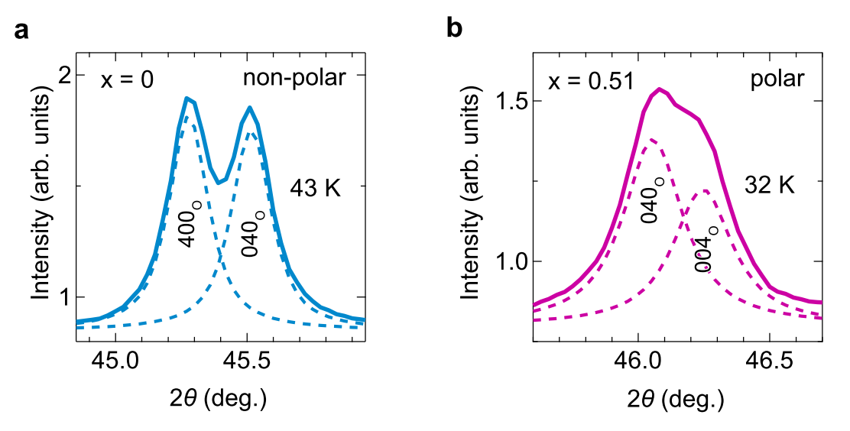
Fig. S1 XRD profiles split from the 220_{T} reflection for x = 0 (PP1) and x = 0.51 (PP2). The observed profiles and their deconvolutions are represented by the respective solid and dashed lines for x = 0 (a) and 0.51 (b). The tetragonal c-axis is transformed into the orthorhombic a-axis only for x = 0.51.

Fourier-filtered EXAFS oscillations and amplitudes
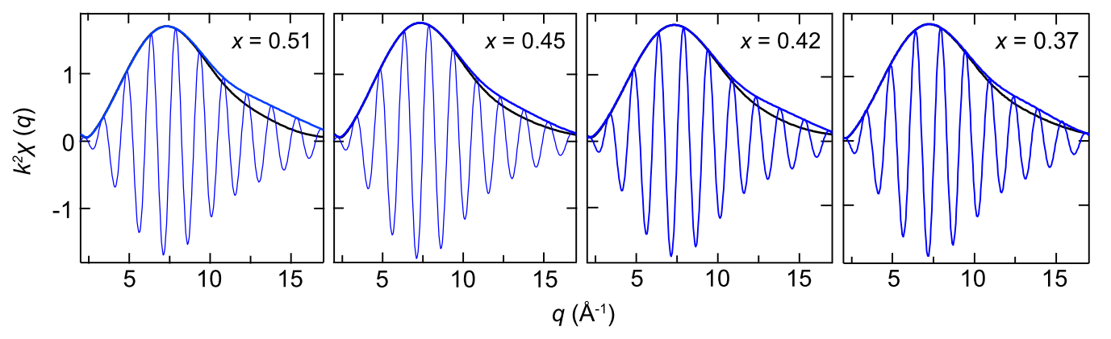
Fig. S2 Fourier-filtered EXAFS oscillations and amplitudes at 30, 30, 17, 17 K for x = 0.51, 0.45, 0.42, 0.37, respectively. The blue solid and black solid lines show the lowest temperature and 250 K data, respectively.

Beat and difference profile of Fourier-filtered EXAFS amplitudes
EXAFS is expressed as the following formula:
$χ\left(q\right)=\sum_{j}{\frac{{N_{j}F}_{j}(q)exp⁡(-2q^{2}σ_{j}^{2})}{qr_{j}^{2}}}sin⁡(2qr_{j}+∅_{j}(q))$, (1)
where N_{j}, F_{j}(q), σ_{j}², r_{j}, and φ_{j}(q) are the coordination number, the scattering amplitude, the mean square displacement, the bond distance, and the phase shift, respectively. In the high temperature region, the uniform As−Fe distance gives N_{j} = 4 and r_{j} = R_{HT}, thus, eq. (1) equals
$χ\left(q\right)=\frac{4F(q)exp⁡(-2q^{2}σ_{HT}^{2})}{qR_{RT}^{2}}sin⁡(2qR_{HT}+∅(q))$. (2)
In the low temperature region, the As−Fe distance splits in two with r_{j} ≈ R_{HT} + ΔR/2, R_{HT}−ΔR/2, thus, eq. (1) approximates
$χ\left(q\right)≈\frac{2F\left(q\right)\exp\left(-2q^{2}σ_{LT}^{2}\right)}{qR_{HT}^{2}}\left\{\sin\left(2qR_{HT}+q∆R+∅\left(q\right)\right)+\sin\left(2qR_{HT}-q∆R+∅\left(q\right)\right)\right\}$ $=\frac{4F\left(q\right)\exp\left(-2q^{2}σ_{LT}^{2}\right)}{qR_{HT}^{2}}sin\left(2qR_{HT}+∅\left(q\right)\right)\cos\left(q∆R\right)$, (3)
where r_{j}² is approximated by R_{HT}² with R_{HT} >> ΔR (R_{HT} = 2.439 Å, ΔR ≈ 0.07 Å). The oscillation involves the beat with the condition of qΔR = π/2.
Here, we analyse EXAFS amplitude with the beat and introduce a phenomenological formula χ_{dif}(q) = k²χ(q)(T)−s₀k²χ(s₁q)(250 K), which is estimated by subtracting the amplitude at 250 K from the objective amplitude with the scale factors of s₀ and s₁. The former and latter factors correct the temperature variations of the mean square displacement and the bond distance, respectively. The difference amplitudes χ_{dif}(q) for x = 0.51, 0.45, 0.42, and 0.37 are shown in Fig. S3. We evaluate the kink position q_{beat} as the peaks in the wavenumber derivatives of χ_{dif}(q). The q_{beat} values at lowest temperature are q_{beat} ~ 11.2, 11.0, 11.6, and 11.3 Å⁻¹ for x = 0.51, 0.45, 0.42, and 0.37, respectively.

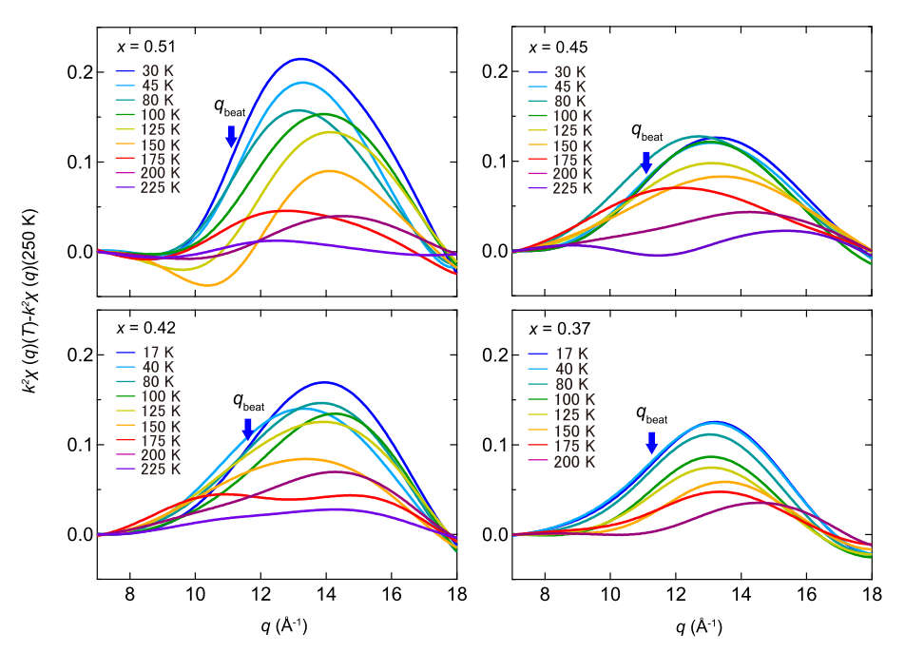
Fig. S3 Difference profiles of Fourier-filtered EXAFS amplitudes. The beats at the lowest temperatures are located at q_{beat} ~ 11.2, 11.0, 11.6, and 11.3 Å⁻¹, indicated by the arrows, for x = 0.51, 0.45, 0.42, and 0.37, respectively.

