Supplementary materials
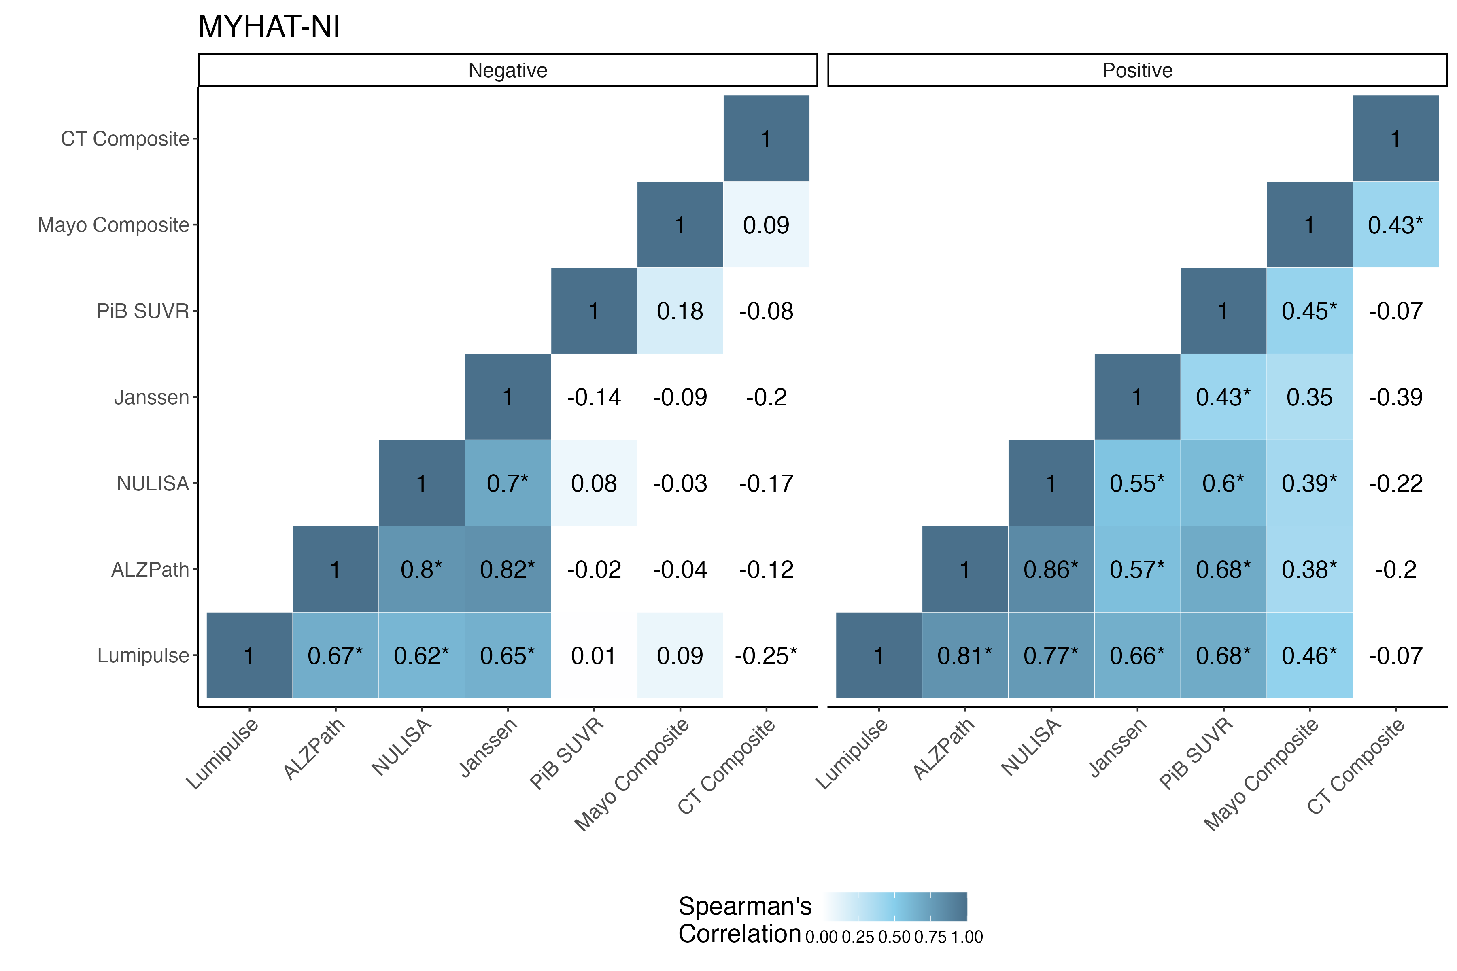
Supplementary Figure 1: Correlations between p-tau217 assays and radiotracers split by Aβ status for the MYHAT-NI cohort.

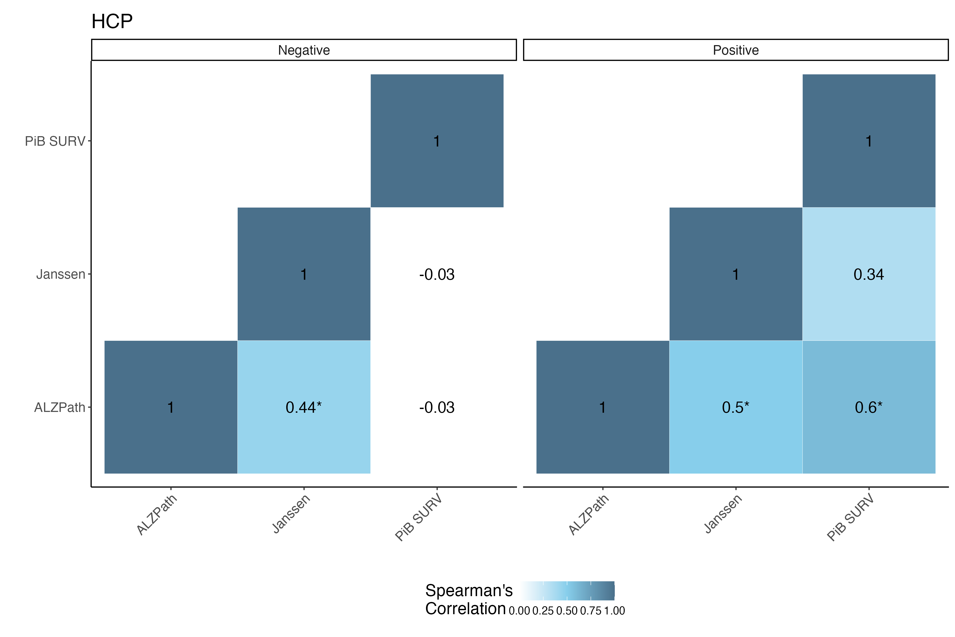
Supplementary Figure 2: Correlations between p-tau217 assays and radiotracers split by Aβ status for the HCP cohort.

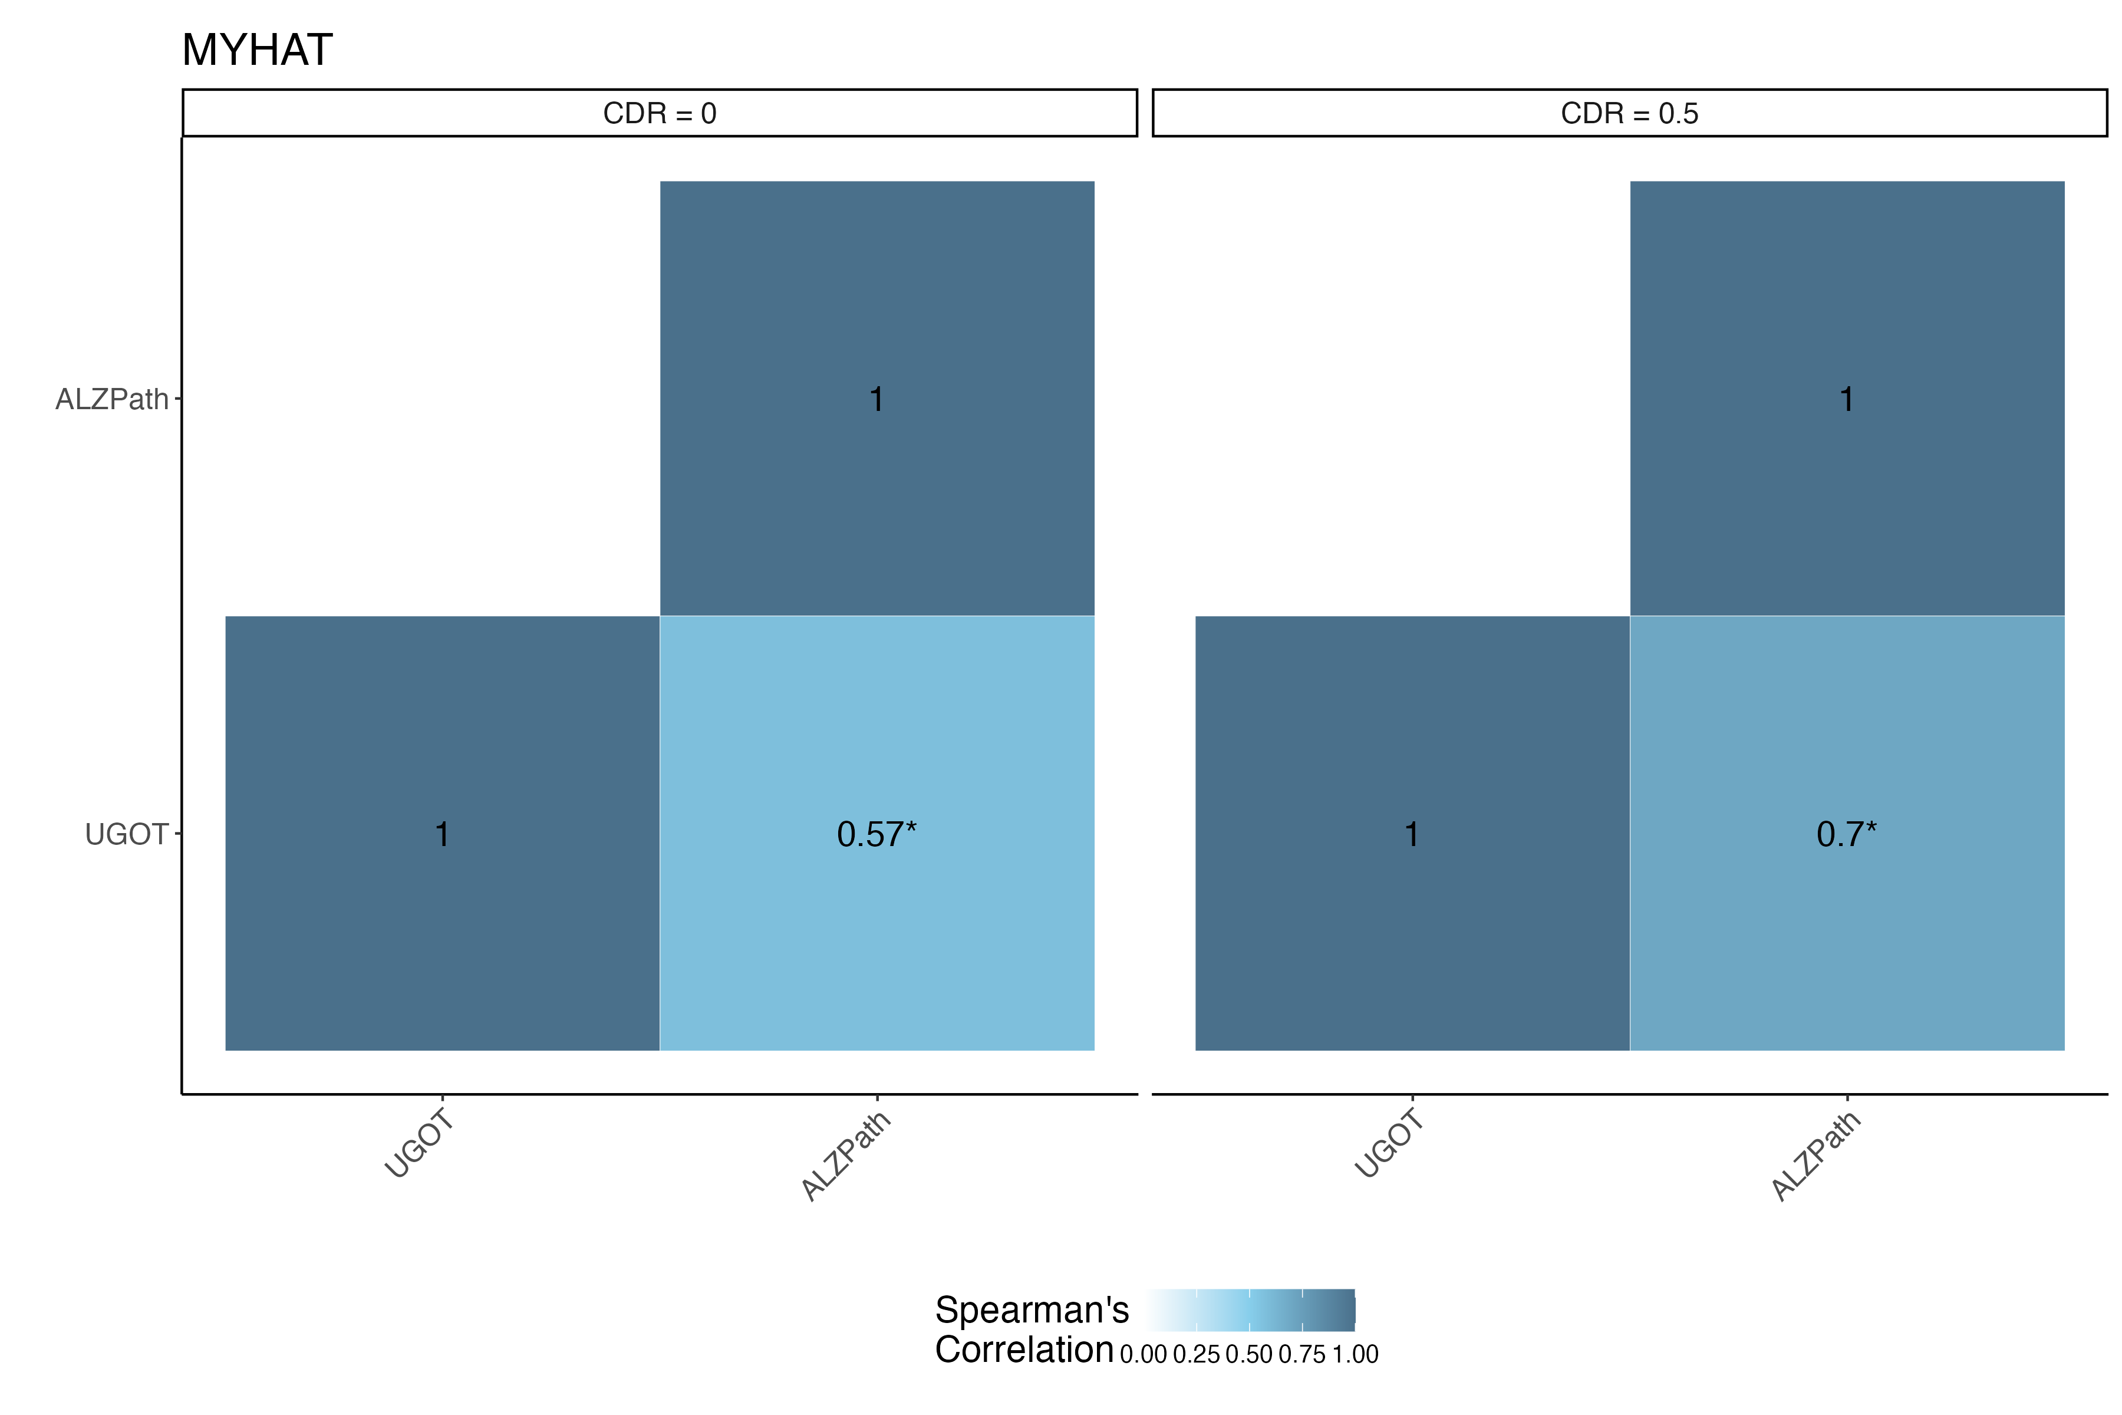
Supplementary Figure 3: Correlations between p-tau217 assays split by Aβ status for the MYHAT cohort.

