Supplementary Material for

Enhancement of internal tides on the continental slope of northeastern Arabian Sea during winter

Andrea Linus Pereira^{1*}, Subeesh M. P¹, Jithin A. K², Navaneeth K. N¹, Anil Kumar K¹

¹ Naval Physical and Oceanographic Laboratory, DRDO, Kochi, India
² CSIR - National Institute of Oceanography, Dona Paula, Panaji, Goa-403004, India
*Corresponding author: andrealinuspereira09@gmail.com

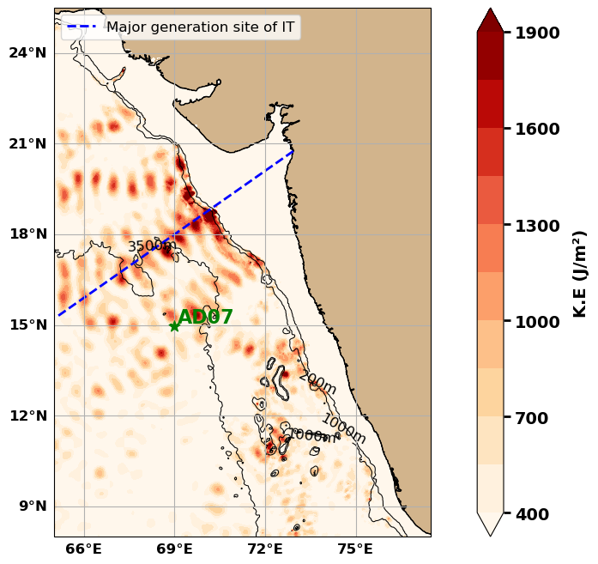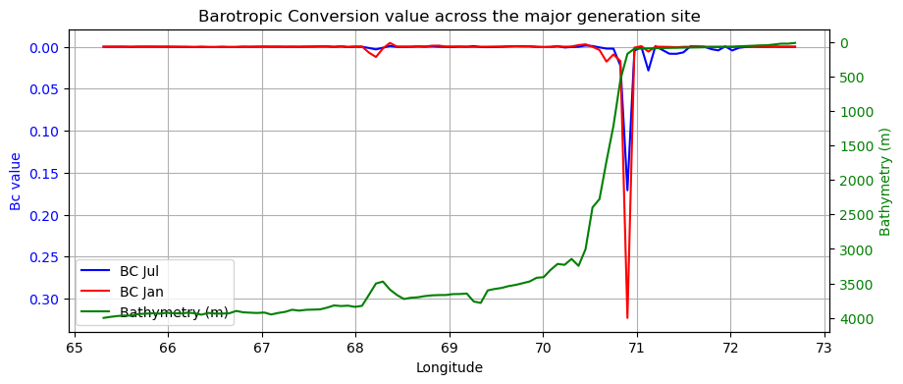

Figure S1: Multiple transects considered across the continental shelf in the NEAS and the barotropic to baroclinic conversions across the transect considered, showing maximum conversion during summer at the shelf and maximum during winter in the slope.

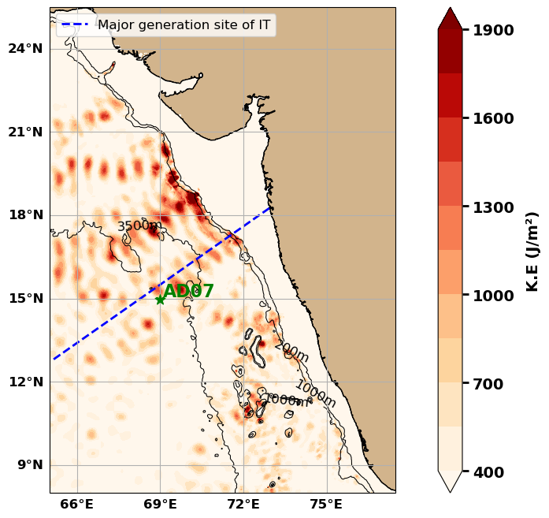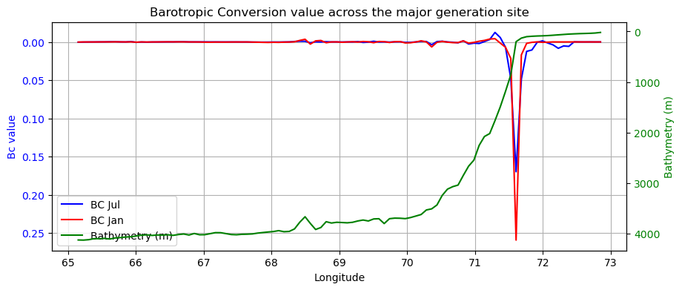

Figure S2: Multiple transects considered across the continental shelf in the NEAS and the barotropic to baroclinic conversions across the transect considered, showing maximum conversion during summer at the shelf and maximum during winter in the slope.

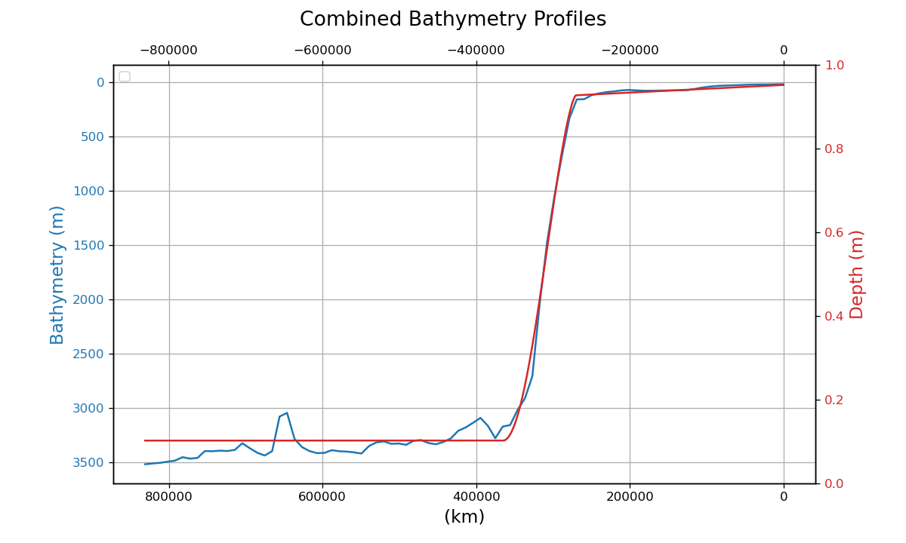
Figure S3. Depth profile from ROMS model (blue line) extracted across the major generation site, and the topography model set up created using the equations (5)-(7) for the NEAS.

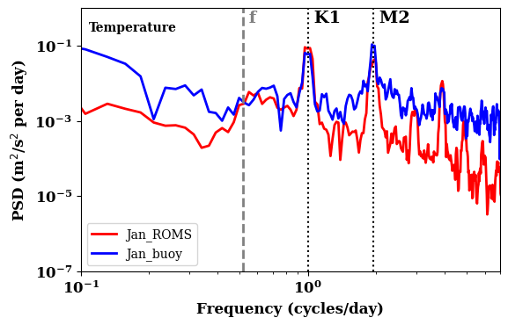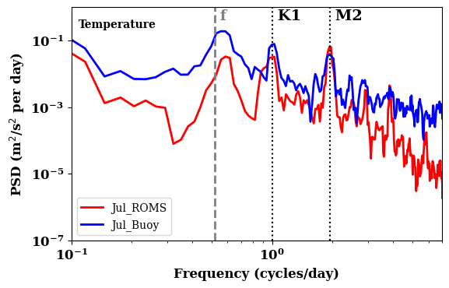
Figure S4. Spectral Comparison of mooring observation of temperature for (a) winter (January) and (b) summer (July), with those from the ROMS simulation.

